Report Case Study: Urban Heights Hotel
Module: Financial Management for the Hotel Industry
Module Code: BMIH5007
Lecturers Name: Tristan Hawkins
Student Name: Marcin Patryk Segrecki
Student ID: 2219780

Executive Summary
Urban Heights Hotel has experienced significant financial challenges over the past three years, marked by a decrease in revenue, a rise in operating expenses, and a reduction in profitability. The hotel's financial well-being has been adversely affected by various external issues, such as Brexit, which resulted in a scarcity of labour and escalated expenses, and the COVID-19 epidemic, which significantly decreased occupancy rates. Furthermore, the hotel's performance has been further stretched due to increasing inflation and shifting consumer tastes.
Internally, the hotel has significant challenges due to its elevated operational expenses, antiquated infrastructure, and ineffective managerial methods. These problems have resulted in low client satisfaction and unfavourable evaluations, affecting the hotel's reputation and revenue. Notwithstanding these difficulties, Urban Heights Hotel possesses numerous advantages, including an excellent location and a wide range of amenities such as a restaurant, bar, and event spaces, which can be utilised to enhance its strategy for recovery.
To tackle these difficulties, it is crucial to implement a comprehensive plan that includes both immediate and long-term actions. Cost reduction techniques, such as improving labour productivity, introducing energy-saving efforts, and renegotiating supplier contracts, can provide short-term stability to financial health. Increasing revenue can be accomplished by utilising delivery services to expand the restaurant's reach, advertising the bar with exclusive weekend packages, and implementing a proactive marketing strategy for the event venues. Operational efficiency can be enhanced by implementing contemporary technology such as Property Management Systems (PMS) and Customer Relationship Management (CRM) software. These technologies will optimise operations and elevate the quality of service provided.
The proposed long-term strategies offer significant potential benefits for Urban Heights Hotel. These include substantial facility upgrades to modernise guest rooms and social areas, enhanced customer experience through improved staff training and personalised services, and establishing loyalty programs. Strategic alliances with local businesses and attractions can lead to attractive bundle offers, increasing visitor numbers. Diversifying services to include wellness offerings and utilising Airbnb for room rentals can create additional revenue streams and attract a broader customer base.
Implementing these strategic initiatives at Urban Heights Hotel can achieve financial stability, enhance its market position, and ensure long-term sustainability.

Introduction
The Urban Heights Hotel is located in a lively metropolitan area and offers a range of amenities, including a restaurant, bar, and event venues. However, over the past three years, despite its favourable location and extensive amenities, the hotel has experienced a significant decrease in revenue, occupancy rates, and customer satisfaction. The current economic downturn has raised concerns about the long-term viability of the business.
This report aims to assess the financial performance of the Urban Heights Hotel and identify the main factors contributing to its decline. This analysis seeks to identify the fundamental factors impacting the economic well-being of the hotel by analysing patterns in revenue, expenses, profitability, liquidity, and solvency. In addition, the study will examine the hotel's performance by analysing external and internal aspects using PESTLE and SWOT assessments. The study will present a thorough plan to rejuvenate the hotel's financial stability and regain its reputation, drawing from these valuable insights.

Financial Performance Analysis
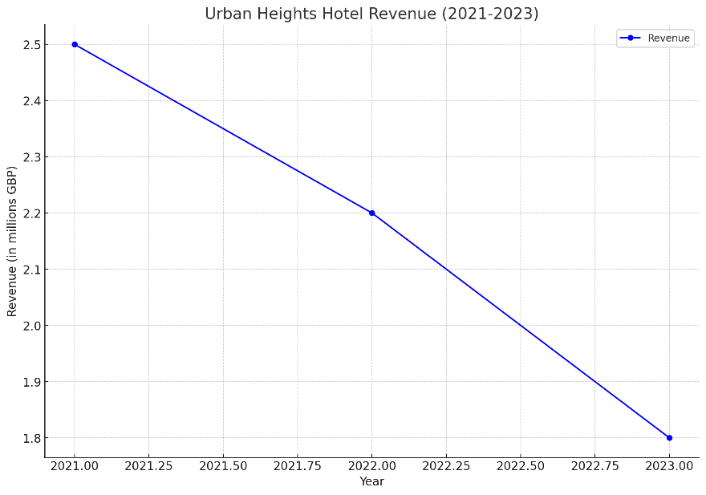
Revenue Analysis
The Urban Heights Hotel's revenue has steadily decreased during the last three years. In 2021, the hotel brought in approximately £2,500,000 in revenue. In 2022, this amount fell by 12% to £2,200,000. In 2023, the decline persisted as revenue dropped by 18.2% to £1,800,000. This 28% annual decline over three years suggests serious difficulties sustaining revenue levels. The hotel's revenue is steadily declining, emphasising the urgent need for strategic intervention to stop this downward trend and stabilise the hotel's finances.
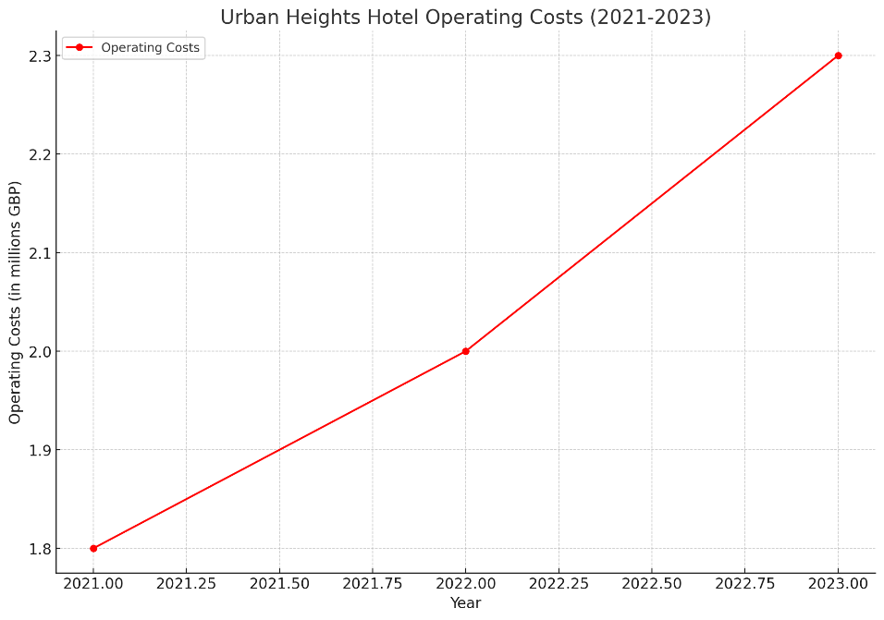
Expense Analysis
The Urban Heights Hotel's operating costs have increased over the last three years, greatly exacerbating its financial difficulties. The hotel's running costs increased from £1,800,000 in 2021 to £2,000,000 in 2022 and £2,300,000 in 2023. Significant problems with cost control are highlighted by this 27.8% increase over three years. Labour and maintenance costs are two critical areas where costs are rising. According to Tan et al. (2022), These trends are consistent with the hotel business, where high operating costs—especially for wages and overhead—substantially negatively influence financial performance. Enhancing the hotel's financial health requires innovative spending reduction and effective cost management.
Profitability Analysis
Over the previous three years, the Urban Heights Hotel's earnings have drastically decreased. The hotel's net income dropped from £700,000 in 2022 to £200,000 in 2021. The hotel declared a £500,000 net loss by 2023. This change from profit to loss indicates a sharp decline in the company's financial performance. As net income is divided by revenue, the profit margin decreased from 28% in 2021 to 9% in 2022 and finally to a negative margin in 2023. diminishing profit margins are a sign of diminishing financial health and efficiency. Based on Tan and Lee's (2022) study, targeted cost-cutting and revenue-boosting initiatives are needed to address these profitability concerns.
Liquidity and Solvency Analysis
Over the previous three years, the Urban Heights Hotel's liquidity has declined. Cash and equivalents dropped to £100,000 in 2023 from £300,000 in 2021. Additionally, accounts receivable have decreased from £150,000 to £80,000, suggesting possible problems with collections. Meanwhile, accounts payable went from £250,000 to £300,000, indicating that supplier payments were delayed. The hotel's financial situation is precarious; long-term debt is still at £3,000,000, while equity has decreased from £2,200,000 in 2021 to £1,380,000 in 2023. This drop in equity, also discussed by Kliestik et al. (2020), reflects lower shareholder value and severe financial strain. The hotel's financial revival depends on addressing its liquidity and solvency problems.
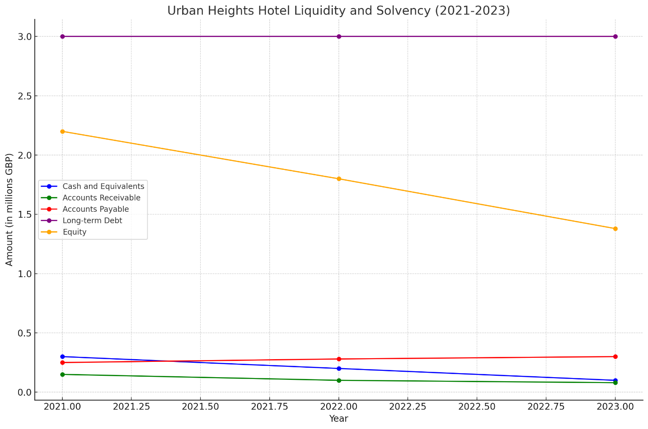

Key Reasons for Decline in Profitability
External Factors (PESTLE Analysis)
Political Factors: The Brexit decision made by the UK resulted in a great deal of uncertainty and higher operating costs for the Urban Heights Hotel. Due to immigration restrictions, fewer EU workers were available, resulting in a staffing shortfall and higher labour expenses (Portes and Springford, 2023). A study by Dutta et al. (2021) discusses the intricacy and cost of importing products from the EU, which also increased, placing more pressure on the hotel's finances. Political instability has impeded long-term planning, making it challenging for the hotel to implement an effective strategy.
Economic Factors: Tourism fell precipitously due to the severe economic depression brought on by the COVID-19 epidemic. In 2020 and 2021, lockdowns and travel restrictions caused the Urban Heights Hotel's occupancy rates to decline sharply. Profitability is nevertheless challenged by high inflation and rising operating expenses, such as labour and utilities, even with the slow recovery. Consumer price sensitivity has increased due to the financial crisis, which has decreased discretionary expenditure on travel and lodging (Tribe, 2020).
Social Factors: The Urban Heights Hotel has been badly damaged by shifts in customer behaviour. Travel restrictions and economic instability have led to a trend towards staycations, which has somewhat offset the loss of foreign visitors. Furthermore, the hotel has struggled to match the growing demand for eco-friendly and wellness-focused lodgings because of its outmoded facilities and little investment in sustainable techniques (UK Hospitality, 2023).
Technological Factors: The Urban Heights Hotel has faced difficulties due to the swift progress of technology. The emergence of digital marketing and online booking platforms has intensified competitiveness, necessitating significant investments in digital infrastructure to stay in the game. The hotel is disadvantaged because of its sluggish adoption of contactless technologies, including digital keys and smartphone check-ins. This was particularly true during the pandemic, when these technologies were essential for guest safety (Pressreader, 2023).
Legal Factors: The hotel's finances are further strained by the requirement to comply with GDPR's data protection requirements, which has also made investments in IT infrastructure and staff training necessary (Sarangi, 2018).
Environmental Factors: Consumers' growing ecological concern has pressured the Urban Heights Hotel to implement sustainable practices. However, the costs associated with making the necessary investments in waste reduction and energy-efficient technologies have been high. A study conducted by Hall et al. (2016) shows that hotels' appeal to eco-aware tourists has been impacted by their inability to keep up with these environmental demands, which has also contributed to the reduction in occupancy rates.
Internal Factors (SWOT Analysis)
Strengths: The Urban Heights Hotel draws business and leisure guests because of its excellent urban location. The hotel has various features that can bring in income, such as a restaurant, bar, and event spaces. Furthermore, the hotel's well-established reputation offers a strong base for rehabilitation. Kiritharannair and Amresh (2016) assert that strategic planning in the hospitality sector necessitates the utilisation of such strengths.
Weaknesses: Its principal vulnerabilities are the hotel's high running costs and ageing infrastructure. These problems have been worsened by ineffective management techniques, which have hurt profitability. The hotel's outdated infrastructure has reduced its competitiveness with more recent properties. Its reputation has been further damaged by unsatisfactory customer service and bad reviews, which has reduced consumer satisfaction and repeat business (Panteleiev, 2023). The results of Helms and Nixon (2010), who highlight the significant influence of operational inefficiencies in hospitality management, align with this.

Opportunities: The Urban Heights Hotel offers several intriguing alternatives. There is an opportunity to draw in local tourists who favour staycations thanks to the growing trend of domestic travel. According to Malyan and Duhan (2018), implementing sustainability plans and encouraging eco-friendly behaviours can draw in eco-aware customers, which is an expanding market niche. Based on De Pelsmacker et al. (2018) study, a wider audience can be attracted by improving the hotel's online presence through focused internet marketing. Partnerships with nearby companies and event planners can help increase hotel traffic and generate new revenue streams (Mariani and Giorgio, 2017).
Threats: Among the many dangers the hotel faces is fierce rivalry from nearby new and existing lodging establishments. A further decline in consumer spending on travel and hospitality services could come from economic instability, such as high inflation rates and possible future recessions. Another concern is that customer preferences are shifting in favour of more contemporary and technologically sophisticated lodgings. Furthermore, as was the case with the COVID-19 pandemic, pandemics or other health emergencies could majorly affect occupancy rates and overall company performance in the future (Japutra and Situmorang, 2021).

Conclusion
Over the past three years, the Urban Heights Hotel has seen diminishing income, growing expenses, and eroding profitability. As a result, the hotel is confronted with severe financial and operational issues. These problems have been made worse by outside variables like Brexit, the COVID-19 epidemic, and changing customer preferences. The hotel's internal issues include excessive operating costs, antiquated infrastructure, and subpar management techniques. The hotel's financial health can be stabilised and revitalised by strategic short- and long-term initiatives centring on cost reduction, revenue enhancement, operational efficiency, facility enhancements, and better customer experience. A thorough turnaround plan is essential to guarantee the hotel's long-term profitability.
Turnaround Strategy
Short-term Strategies
Cost Reduction: The Urban Heights Hotel can strengthen its financial stability by implementing several cost-cutting measures. One practical strategy is improving labour productivity and cutting labour expenses by rescheduling work and providing staff with role-specific training. Operating profit can be significantly impacted by increasing labour productivity, claim Brysin and Dempsey (2017). The hotel should also consider bulk purchasing to cut expenses and renegotiate supplier contracts for better deals. Utility costs can be reduced by putting energy-saving measures into place, such as LED lighting and energy-efficient HVAC systems (Dobrota and Gabroveanu, 2023).
Revenue Enhancement: The Urban Heights Hotel should concentrate on running targeted marketing strategies to draw in more visitors and increase income. Reaching a larger audience can be facilitated by using digital marketing techniques like search engine optimisation and social media advertising. The hotel may attract local visitors and raise occupancy rates by providing unique packages and promotions, such as weekend escapes or event-specific savings. Additionally, increasing the range of services the hotel offers—for example, by adding a loyalty programme or organising neighbourhood events—can improve client satisfaction and draw in new business (Dalgiç et al., 2017).
Operational Efficiency: The Urban Heights Hotel must increase operational effectiveness to stay competitive. Modern information and communication technologies (ICT) can be implemented to improve service quality, cut costs, and streamline processes. For example, implementing customer relationship management (CRM) software and property management systems (PMS) can enhance overall guest happiness, manage guest preferences, and optimise room bookings (Ashqar et al., 2022). Regular staff training on customer service and efficient work procedures can also enhance operational effectiveness and the visitor experience.Urban Heights Hotel can effectively tackle its short-term financial difficulties and establish a solid groundwork for future prosperity by prioritising expense minimisation, revenue expansion, and operational effectiveness.
Long-term Strategies
Facility Upgrades: Upgrading the hotel's infrastructure will improve its aesthetic appeal and operational effectiveness. Guest rooms updated with modern features and designs, such as enhanced Wi-Fi connectivity and intelligent room controls, can attract higher-paying patrons. Modernising the restaurant bar and other common areas can enhance visitor satisfaction and boost business. Energy-efficient systems can decrease long-term operating costs (Li & Singal, 2019).
Customer Experience Improvement: Improving the customer experience is the key to increasing occupancy rates and fostering customer loyalty. Improving the hospitality and customer service training employees provide will guarantee visitors a pleasant stay. A Customer Relationship Management (CRM) system can be implemented by monitoring preferences and customising services to help personalise the visitor experience. Personalised marketing and loyalty programmes can boost consumer satisfaction and drive repeat business (Njoroge et al., 2019).
Strategic Partnerships: Creating strategic alliances can increase the number of visitors to the Urban Heights Hotel. Packages that provide customers with more value can be made by working with nearby eateries, attractions, and event planners. For example, collaborating with local theatres or museums to offer special discounts might improve the visitor experience and attract tourists. Co-marketing initiatives with these partners can help the hotel reach a wider audience and attract more guests (Murzyn-Kupisz and Holuj, 2020).
Diversification: By diversifying its offerings, the hotel can reduce risks and create new revenue sources. It can attract health-conscious tourists by adding wellness options to its portfolio, including spa services or exercise courses. Organising cultural evenings, workshops, or themed activities can attract local tourists and provide a differentiator. By drawing in a distinct traveller demographic seeking a more customised and regional experience, listing rooms on Airbnb can boost overall occupancy (Schmitt et al., 2019).

References
- Ashqar, R.I., Ramos, C., Sousa, C. and Matos, N., 2022. CRM and Smart Technologies in the Hospitality. Marketing and Smart Technologies, 2, p.113. https://doi.org/10.11344/22414412
- Bryson, A. and Dempsey, S.E., 2017. Entrepreneurial reproductive labour as alternative economic practice: The ambivalent discourse of seasonal consignment sales. Organisation, 24(5), pp.589-608. https://doi.org/10.1177/1350508417713214
- Dobrota, G.G. and Gabroveanu, E., 2023. Cost Management In The Hospitality Industry In The Context Of The Economic Crisis-Necessity Or Strategy. Romanian Economic and Business Review, 18(2), pp.25-30. http://www.rebe.rau.ro
- Dutta, A., Mishra, T., Uddin, G.S. and Yang, Y., 2021. Brexit uncertainty and volatility persistence in tourism demand. Current Issues in Tourism, 24(16), pp.2225-2232. https://doi.org/10.1080/13683500.2020.1822300
- Hall, C.M., Dayal, N., Majstorović, D., Mills, H., Paul-Andrews, L., Wallace, C. and Truong, V.D., 2016. Accommodation consumers and providers’ attitudes, behaviours and practices for sustainability: A systematic review. Sustainability, 8(7), p.625. https://doi.org/10.3390/su8070625
- Helms, M.M. and Nixon, J., 2010. Journal of Strategy and Management. Journal of Strategy and Management, 3(3), pp.215-251. https://doi.org/10.11442/1052445321
- Japutra, A. and Situmorang, R., 2021. The repercussions and challenges of COVID-19 in the hotel industry: Potential strategies from a case study of Indonesia. International Journal of Hospitality Management, 95, p.102890. https://doi.org/10.1016/j.ijhm.2021.102890
- Kiritharannair, C., & Amresh, P., 2016. Development of Strategic Plan for Hotel Industries through Swot Analysis. Indian Journal of Medical Ethics, 3, pp. 6-10. https://doi.org/10.14445/23488360/ijme-v3i3p103.
- Kliestik, T., Valaskova, K., Lazaroiu, G., Kovacova, M. and Vrbka, J., 2020. Remaining financially healthy and competitive: The role of financial predictors. Journal of Competitiveness, (1). https://pdfs.semanticscholar.org
- Li, Y., & Singal, M., 2019. Capital structure in the hospitality industry: The role of the asset-light and fee-oriented strategy. Tourism Management. https://doi.org/10.1016/J.TOURMAN.2018.08.004.
- Malyan, R.S. and Duhan, P., 2018. Eco-Awareness: Imbibing Environmental Values in Consumers. In Green Consumerism: Perspectives, Sustainability, and Behavior (pp. 291-314). Apple Academic Press.
- Mariani, M.M. and Giorgio, L., 2017. The “Pink Night” festival revisited: Meta-events and the role of destination partnerships in staging event tourism. Annals of Tourism Research, 62, pp.89-109. https://doi.org/10.1016/j.annals.2016.11.003
- Murzyn-Kupisz, M. and Hołuj, D., 2020. Museums and coping with overtourism. Sustainability, 12(5), p.2054. https://doi.org/10.3390/su12052054
- Njoroge, M., Anderson, W., & Mbura, O., 2019. Innovation strategy and economic sustainability in the hospitality industry. The Bottom Line. https://www.researchgate.net
- Panteleiev, V., 2023. Application of SWOT analysis to justify the strategy of hotel business enterprises. Technology audit and production reserves. https://doi.org/10.15587/2706-5448.2023.274918.
- Portes, J. and Springford, J., 2023. The impact of the post-Brexit migration system on the UK labour market. Contemporary Social Science, 18(2), pp.132-149. https://doi.org/10.1080/21582041.2023.2192516
- Sarangi, U., 2018. Information Economy and Data Protection Laws: A Global Perspective. International Journal of Business and Management Research, 6(2), pp.15-35. https://www.academia.edu
- Schmitt, A., Raub, S., Schmid, S., & Harrigan, K., 2019. Changing tires on a moving car: the role of timing in hospitality and service turnaround processes. International Journal of Hospitality Management. https://doi.org/10.1016/J.IJHM.2018.08.019.
- Tan, K.P.S., Li, X. and Lee, S., 2022. Exploring the determinants of hotel operating performance stabilisation in emerging markets: Deciphering the myth. Journal of Hospitality & Tourism Research, 46(4), pp.742-770. https://doi.org/10.1177/1096348021996440
- Tribe, J., 2020. The economics of recreation, leisure and tourism. Routledge. https://doi.org/10.4324/9780429278259

