Design and implementation of a Lego Mindstorms Solution to a series of problems
Academic and Employability Skills (Computational Thinking Element)
Level 4 (ACCA4016)
James Beard
1901671

Building robot [1]
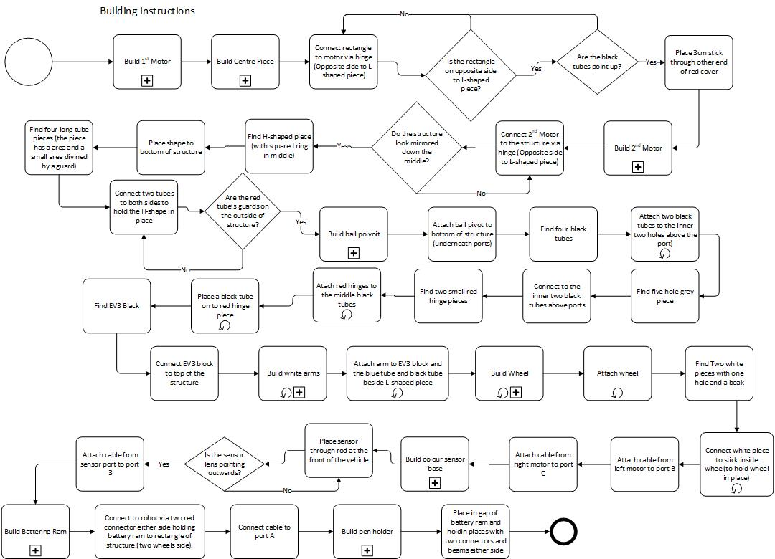

Building 1st Motor [1]
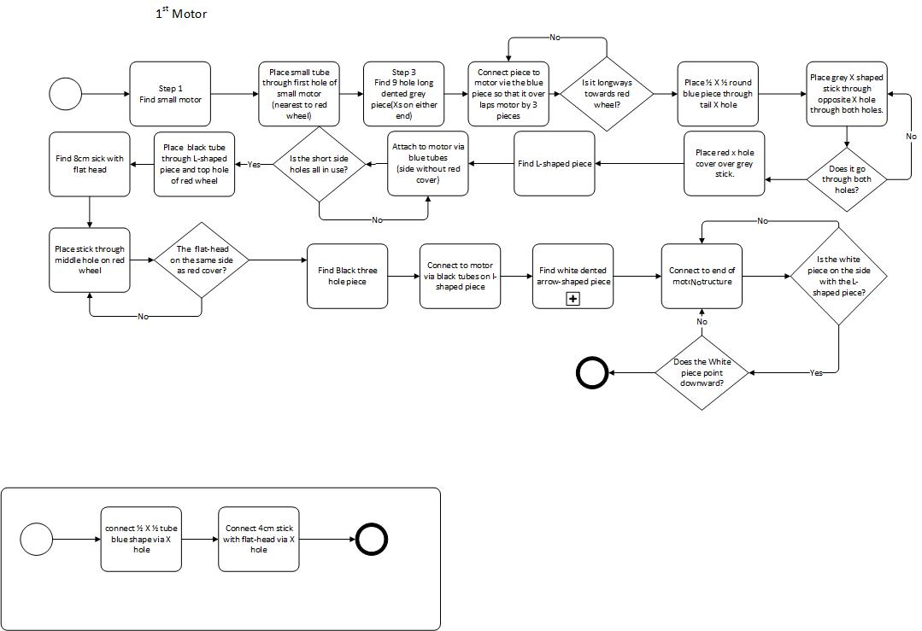
White arm
Building 2nd Motor [1]
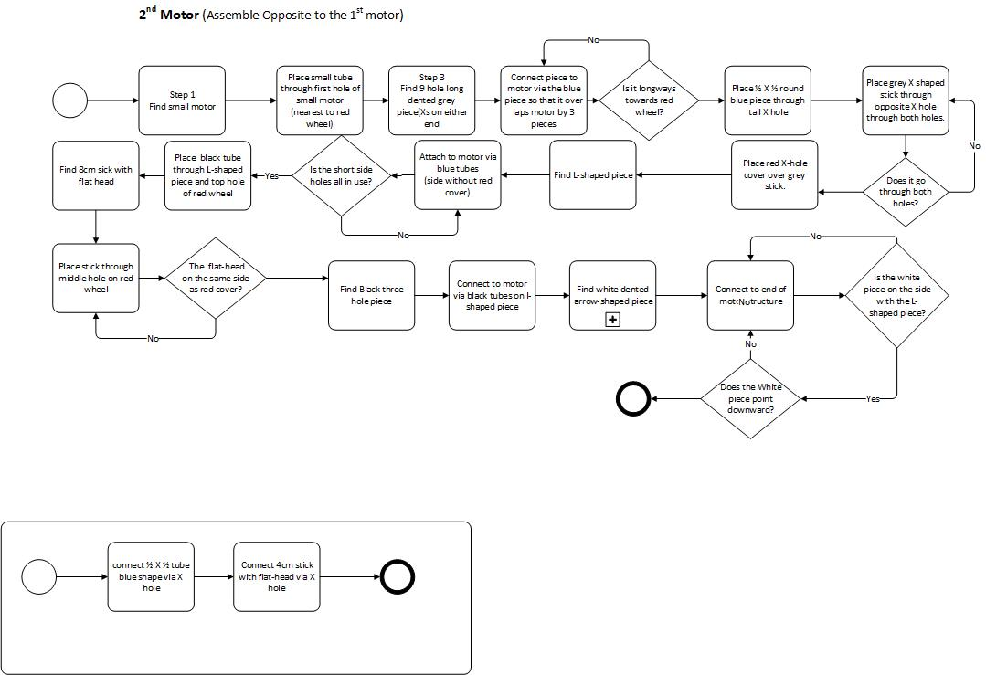
White arm
Building centre piece, colour sensor, white armies and wheels. [1]
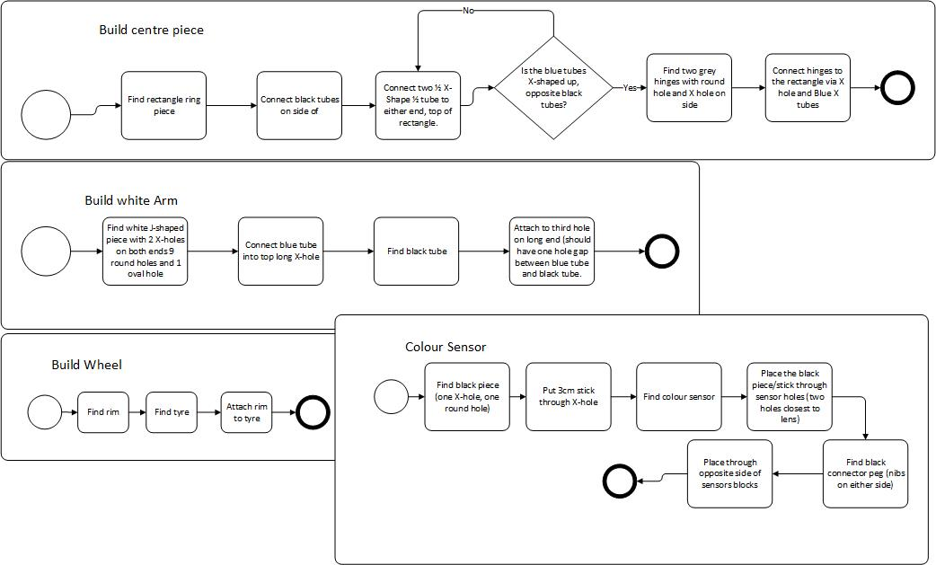

Ball pivot [1]
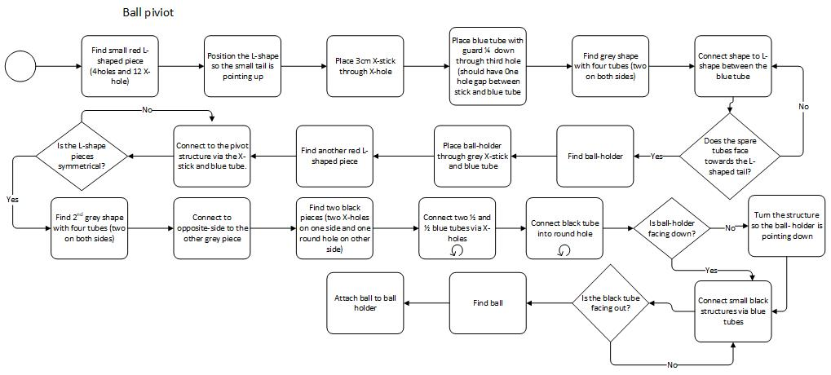

Pen holder [2]
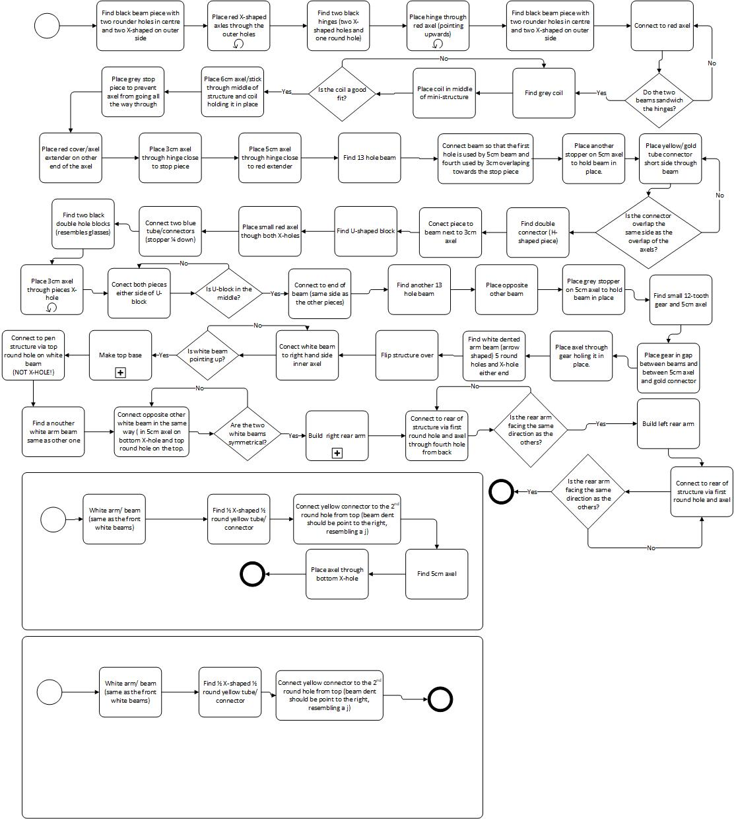
Right arm
Left arm

Battering Ram [3]
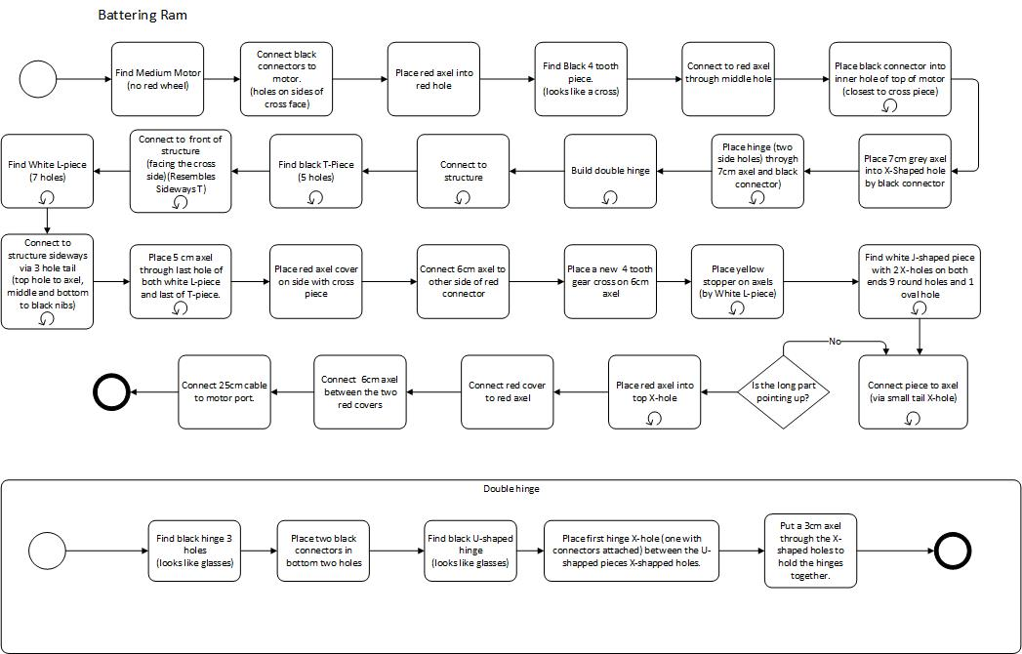

Robot program
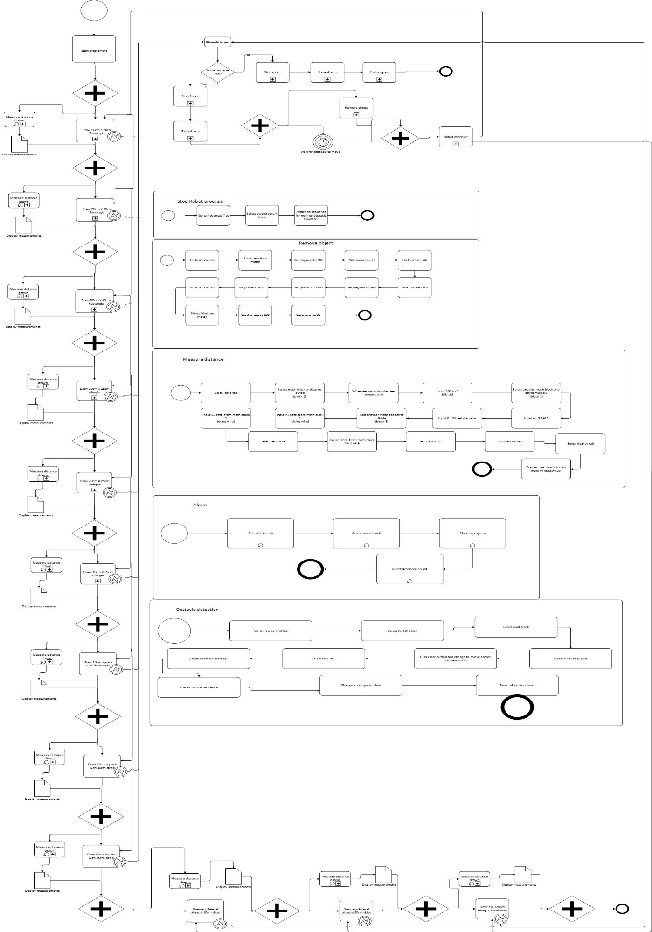
Square sub process
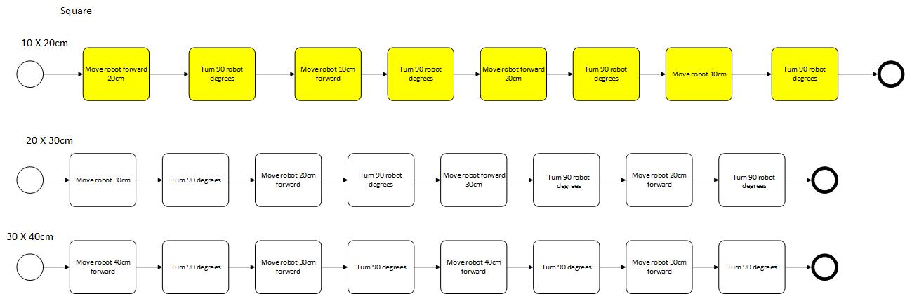

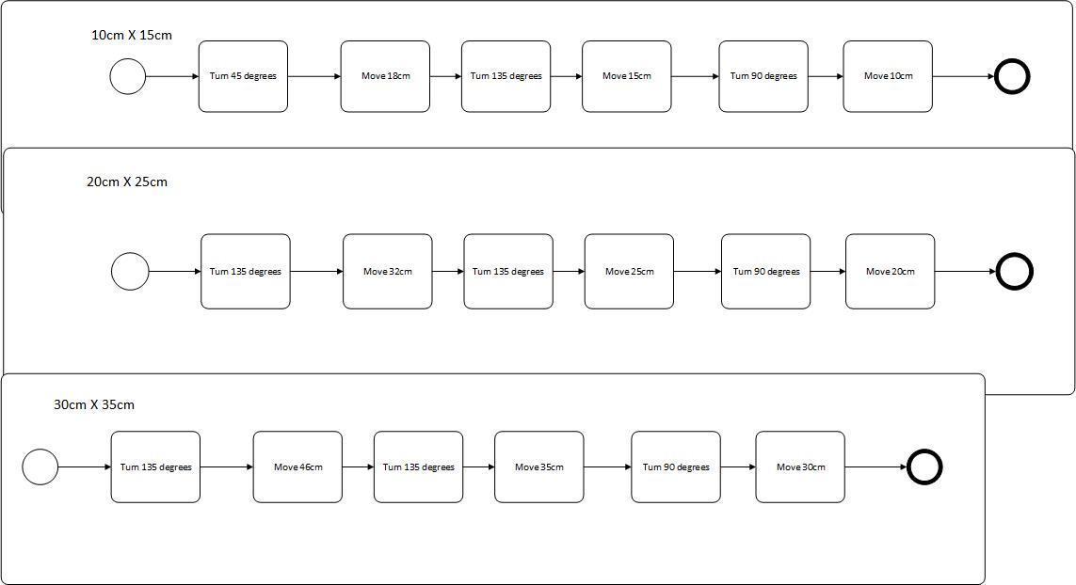
Triangle sub process

Enclosed Circle process
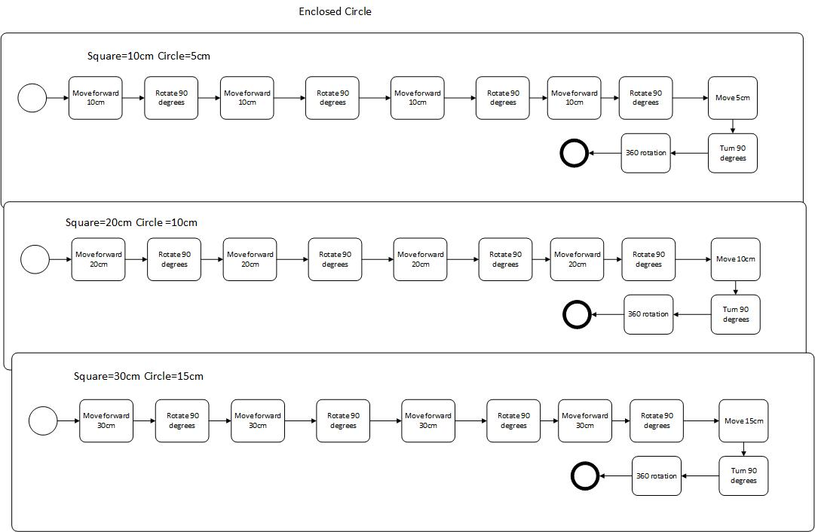

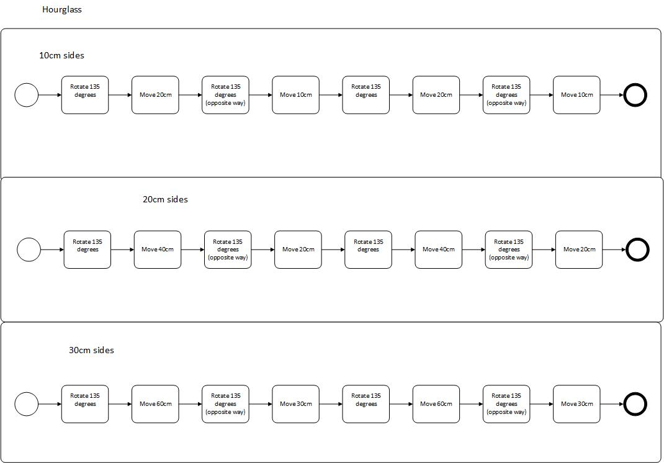
Equilateral triangle/ hourglass sub process

Lego UML
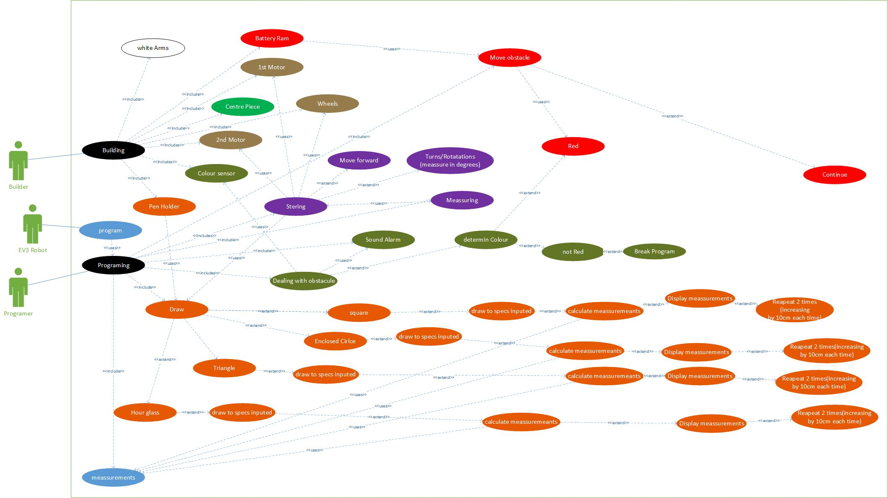
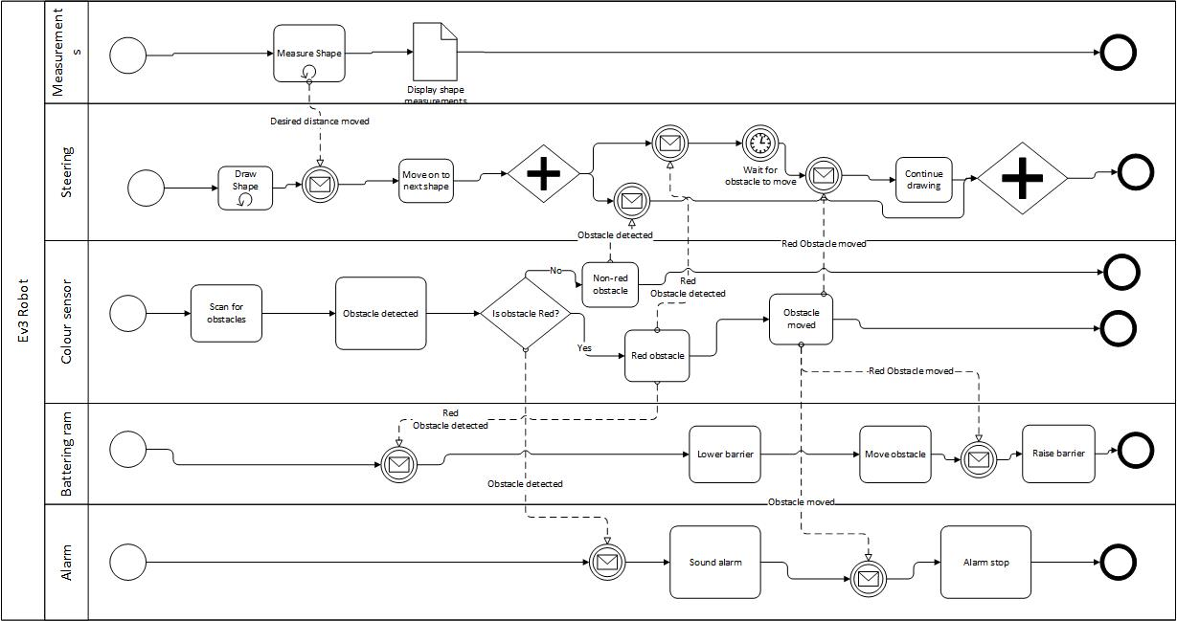
Ev3 Pool diagram.

User Case Document
Description:
The objective of the task is to build and program an EV3 robot capable of drawing various shapes three times with an increase of 10cm each time. The shapes to be drawn are rectangles, right angle triangles, circles enclosed inside squares and hourglasses. The other objective is to program the robot to be able to sense obstacles and deal with obstacles depending on whether it is red or another colour.
Preconditions
1. Lego in pieces and all in the box
2. Lego windstorm project empty, with no code or programming.

Assumptions
1. Builders will have the required piece to build robot structure, pen holder and arm.
2. Robot Will draw shapes within 2cm of required measurements
3. Robot will halt, sound alarm then rotates and swipe Red obstacles out of the way before continuing task.
4. Robot will halt, sound alarm then stops task and end program an immovable obstacle is meet.

Frequency
The program is designed to draw a shape three times increasing the measurements by 10 centimetres on each side (2nd 10cm increase compared to 1st and 3rd 10 cm increase compared to 2nd) before moving onto the next shape and repeating the process.

Basic Course: Building.
1. Build 1st Motor
2. Build centre Piece
3. Connect 1st Motor and centre piece.
4. Build 2nd Motor
5. Connect 2nd Motor to structure
6. Build Ball pivot
7. Connect Ball pivot to structure.
8. Build White arms (repeat)
9. Connect wheels to structure
10. Build Wheels (repeat)
11. Connect Wheels (twice)
12. Build colour sensor Base
13. Connect to structure
14. Build Pen Holder
15. Connect to back of structure
16. Build Battery Ram
17. Connect to front of structure
18. Building of Robot is completed

Basic Course: Programmer
1. Program to draw Rectangle (10cm X 20cm)
2. Program to draw Rectangle (20cm X 30cm)
3. Program to draw Rectangle (30cm X 40cm)
4. Program to draw Right-Angle Triangle (10cm X 15cm)
5. Program to draw Right-Angle Triangle (20cm X 25cm)
6. Program to draw Right-Angle Triangle (30cm X 35cm)
7. Program to draw Enclosed Circle (Square=10cm Circle=15cm)
8. Program to draw Enclosed Circle (Square=20cm Circle=15cm)
9. Program to draw Enclosed Circle (Square=30cm Circle=15cm)
10. Program to draw Sideways hourglass (sides=10cm)
11. Program to draw Sideways hourglass (sides=20cm)
12. Program to draw Sideways hourglass (sides=30cm)
13. Program to display measurements
14. Program colour sensor to sense (red)
15. Program robot to halt
16. Program to sound alarm
17. Program to move obstacle.
18. Program to break program
19. Programming completed

Basic Course: Robot
1. Draw Rectangle (10cm X 20cm)
2. Display Measurements
3. Draw Rectangle (20cm X 30cm)
4. Display Measurements
5. Draw Rectangle (30cm X 40cm)
6. Display Measurements
7. Draw Right-Angle Triangle (10cm X 15cm)
8. Display Measurements
9. Draw Right-Angle Triangle (20cm X 25cm)
10. Display Measurements
11. Draw Right-Angle Triangle (30cm X 35cm)
12. Display Measurements
13. Draw Enclosed Circle (Square=10cm Circle=5cm)
14. Display Measurements
15. Draw Enclosed Circle (Square=20cm Circle=10cm)
16. Display Measurements
17. Draw Enclosed Circle (Square=30cm Circle=15cm)
18. Display Measurements
19. Draw Sideways hourglass (sides=10cm)
20. Display Measurements
21. Draw Sideways hourglass (sides=20cm)
22. Display Measurements
23. Draw Sideways hourglass (sides=30cm)
24. Display Measurements
25. Tasks Completed

Alternate Course A
Condition: Robot Meets Red Obstacle.
1. Robot senses coloured obstacle
2. Robot halts
3. Robot sounds alarm
4. Robot moves obstacle with battering ram
5. Robot continues to draw shape.
6. Alternate course completed

Alternate Course B
Condition: Robot Meets Non-Red Obstacle.
1. Robot senses coloured obstacle
2. Robot halts
3. Robot sounds alarm
4. Robot breaks program and stops

Post conditions
1. All required Shapes drawn, robot’s task is completed, and robot’s program ends.
2. Immovable obstacle prevents completion and robot stops.

Actors
• Builder
• Programmer
• EV3 Robot

Included Use Case: Building
1. 1st Motor
2. Centre piece
3. 2nd Motor
4. Ball Pivot
5. White arms
6. Wheels
7. Pen Holder
8. Battering Ram (move obstacle)

Included Use Case: Programming
1. Steering
2. Drawing
3. Obstacle Detection.
4. Halt
5. Sound Alarm
6. Obstacle Moving
7. Program Breaking
Included Use Case: Robot
1. Steer
2. Draw
3. Obstacle Detection.
4. Robot Halt
5. Sound Alarm
6. Obstacle Moving
7. Program Breaking

Extended Use Case: Programing
- Rectangle (draw)
- Enclosed circle (draw)
- Hourglass (draw)
- Triangle (draw)
- Draw to specs(draw)
- Calculate measurements (draw)
- Display measurements (draw)
- Repeat(draw)
- Determine Colour (obstacles)
- Not Red (obstacle)
- Red (obstacle)
- (break program(obstacle)
- Continue (obstacle)
- Move Forward (steering)
- Turns/ rotations (steering)
- Measuring (steering)

Notes
Calculate measurements by

distance moved = 3.1415 * Wheel diameter

amount of turns = centimetres / distance moved

degrees = amount of turn * 360 [4]

References

[1] | Lego group , "ev3-rem-driving-base-79bebfc16bd491186ea9c9069842155e," 2015. [Online]. Available: https://le-www-live-s.legocdn.com/sc/media/lessons/mindstorms-ev3/building-instructions/ev3-rem-driving-base-79bebfc16bd491186ea9c9069842155e.pdf. [Accessed 03 01 2020].
[2] | lego group, "pen holder-af7cd577b989307efdda695205e753d6," 2015. [Online]. Available: https://le-www-live-s.legocdn.com/sc/media/files/support/mindstorms-ev3/building-instructions/design%20engineering%20projects/pen%20holder-af7cd577b989307efdda695205e753d6.pdf. [Accessed 03 01 2020].
[3] | lego group, "ev3-medium-motor-driving-base-e66e2fc0d917485ef1aa023e8358e7a7," 2015. [Online]. Available: https://le-www-live-s.legocdn.com/sc/media/lessons/mindstorms-ev3/building-instructions/ev3-medium-motor-driving-base-e66e2fc0d917485ef1aa023e8358e7a7.pdf. [Accessed 02 01 2020].
[4] | The Technic Gear, "Draw a Square: Using Motors in leJOS EV3," 23 05 2014. [Online]. Available: http://thetechnicgear.com/2014/05/tutorial-using-motors-draw-square-mindstorms-ev3-lejos/. [Accessed 03 01 2020].

Robot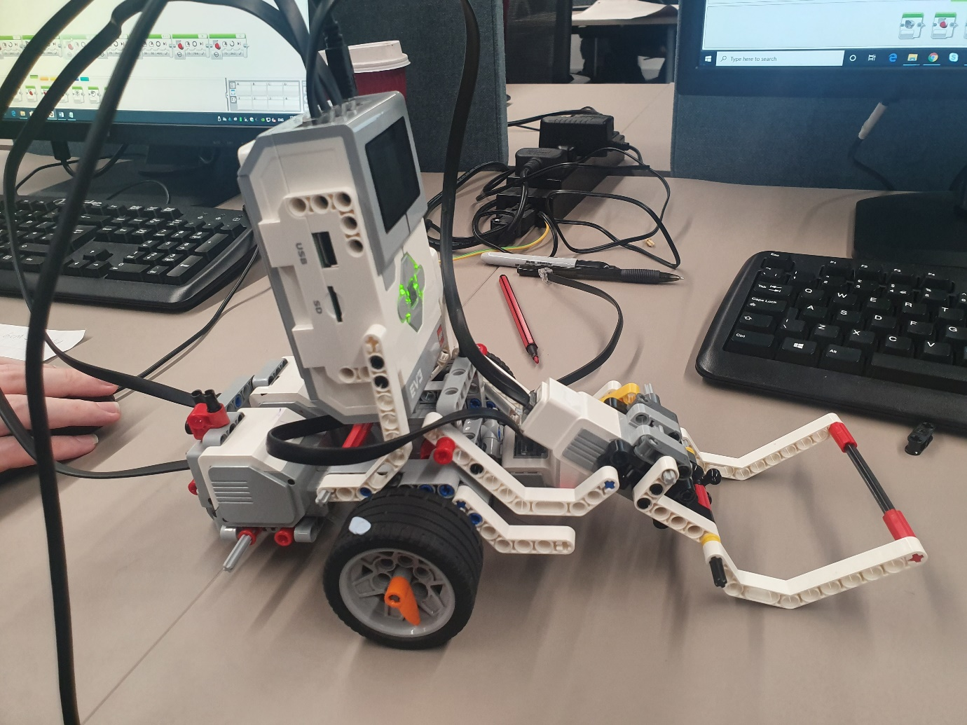

Squares and triangle code 1

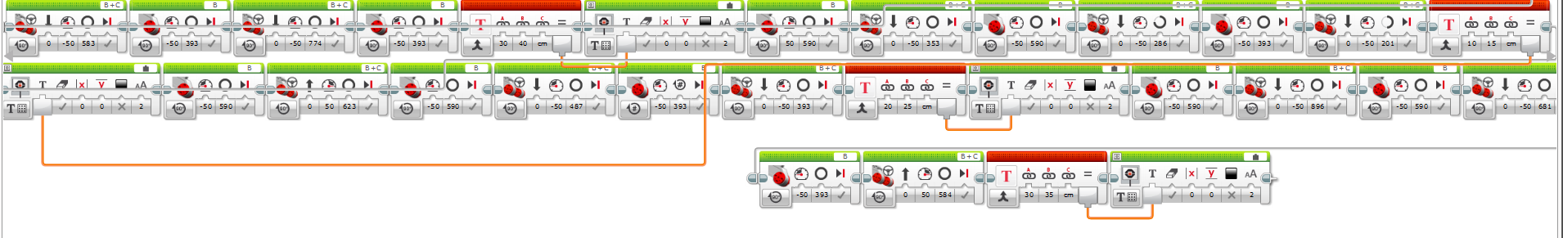
Squares and triangle code 2

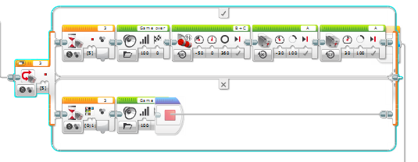
Dealing with Obstacle
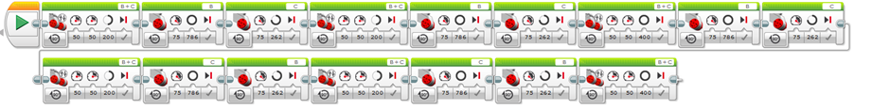
Circle code

Double Triangle
Drawing


