Financial Analysis Report
of
Giordano

Student Name (ID): | Chiang Chun Wah (2119645)
University of Wales Trinity Saint David – MBA
Module: | HKBM 7008 Assignment 1
Lecturer: | Dr. Katherine Mo

Executive Summary
Financial Management is an important for company. It controls resource and how to use the resources more efficiently to generate the income for company. This report was analyzed the financial statement of Giordano for understanding its financial situation. As financial indexes could be different by different industries. A peer group analysis was adopted in the analysis that compare with two companies in same industry. Crocodile Garments Limited (“Crocodile”), and Bauhaus International (Holdings) Limited (“Bauhaus”) were in same industry and Hong Kong-based retailer. The different financial indexes were compared for identifying the financial risk of Giordano and proposed the recommendations for Giordano.

Table of Contents
1. Introduction 4
2. Company Background 5
2.1 Present Business Overview 5
2.2 Company Structure 7
2.3 Company Information for Financial Analysis 7
3. Financial Analysis 8
3.1 Bankruptcy Index Analysis 8
3.2 Profitability Ratios 10
3.3 Liquidity Ratios 10
3.4 Leverage Ratios 12
3.5 Coverage Ratios 13
3.6 Efficiency Ratios 14
3.7 Market Value Ratios 16
4. Corporate Governance 17
5. Major Investment Project 19
5.1 Project Investment Information 19
5.2 Capital Investment Appraisals (CIA) 23
6. Financing and Capital Management 25
7. Conclusion 26
8. Recommendation 27
Appendix 28
Reference List 30

Introduction
Finance is an important prerequisite for any business. A funds sufficient and financial management are required in different stages of business. Therefore, funds should be managed, and used more efficiently, and monitored in different stages of the business lifecycle. The business is potentially growth if manages its finances better, conversely, mismanages its financial resources and investment usually make lower profits or financial risks. The financial management is strategic planning, is strategic planning, organizing, directing, and controlling of financial undertakings in the company. The financial objectives included maintaining sufficient of funds, ensuring the interest in shareholders, utilized the funds efficiently, and creating investment opportunities (phf-university, no date). It is also responsible for allocating the funds to optimize the return of investment and ensure financial stability and growth for the company (Jaiswal, 2022).
This report was analysis the financial situation of last three years fiscal years (2019-2021) for understanding the situation of Giordano that including business operations, and challenges ahead of company.

Company Background
Giordano International Limited (“Giordano”), a garments retailer in Hong Kong. The major business was casual wear market, and its targeted segmentation was mass market with marketing strategies were simplicity in design, color, and quality of service. The retail store was launched in Hong Kong since 1981 and company was rapidly built-up an excellent reputation and positive word of mouth in the market by offering “easy-to-wear”, “high quality”, “value for money” apparel. The Group listed on Hong Kong Stock Exchange under stock code 0709 in 1991 and raised funds to further expand its business (Giordano, 2022b). The first IPO of the Group issued 600 million shares and each share HKD 0.1 listed price guidelines points for fundraising HKD 60,000,000. Giordano has entered China to develop the mainland market since 1992, and established branches in Guangzhou, Shanghai, Beijing, etc., creating a precedent for domestic clothing chain "specialty stores". Now, in addition to setting up in Shenzhen, Guangzhou, Dongguan and other places, Dongguan has franchised stores in more than a dozen provinces in China, with satisfactory sales results, and the number of stores owned by franchisees in cooperation with Giordano was increasing.

2.1 Present Business Overview
Giordano’s corporate structure apart from the Board and the other divisions composition such as Finance, Investor Relations, legal and company secretarial, Internal Audit, Human Resource, Learning and Development, and Information Technology Department (Giordano, 2022a).
Giordano was a major Hong Kong-based clothing company with around 5,900 staff and its business was operated in over 30 countries, and stores were located different region in world that included Asia Pacific, Middle East, and Australasia. The Group’s operated the several business lines such as Giordano Ladies, Giordano, Giordano Junior, BSX and Beau Monde. Moreover, it was moving to expand into Europe and the Americas (Giordano, 2022a).
Currently, The Group’s closing stock price was HKD 1.84 (Aastocks, 2022) (See Appendix I) on 26 August 2022, authorized shares of 2,000 million, issued shares of 1,578.94 million. The market value of approximately HKD 2.91 billion (Aastocks, 2022) (See Appendix I) on 26 August 2022.
Giordano had two main channels for its business, the first was retail sales that provided the goods and services to their customers directly. The second was wholesale to franchisees that worked as a distributor to provide the goods.

Table 2-1: Sales by Channels in 2021 (Giordano, 2022a).
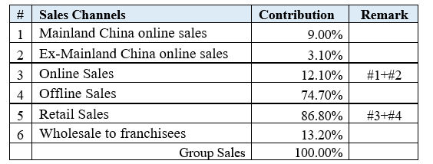(Source: Constructed by Author)
Table 2-1 shown the contribution from different sales channels in 2021. The retail sales were large portion of revenue that was 86.8% and rest of revenue was contributed by wholesale to franchises. The retail sales included offline and online sales. The offline sales were the operations of store and online sales were order through the web application or mobile application. The offline sales were 74.7% of retail sales and it was still a major sales channel of Giordano. The 12.1% was online sales that included Mainland China and Ex-Mainland China. Mainland China had 9% contribution of online sales and 3.1% contribution came from the others online sales regions. The Mainland China was major market of online sales channel and had stable growth from 2019 to 2021.
Table 2-2: Contribution of Sales from 2019 to 2021.
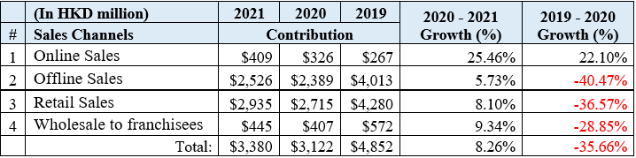 (Source: Constructed by Author based on Giordano Annual Report 2019-2021.)
Table 2-2 shown the percentage of growth on different sales channels. The online sales contribution had increased 22.1% and 25.46% in 2020 and 2021, respectively. The Covid-19 endemic devastated the global economy and had impacted on offline business of Group since 2019. However, Giordano’s online sales still had increased 22.1% in 2019/2020 and had growth 25.46% in further in 2020/21.

2.2 Company Structure
Giordano’s corporate structure apart from the Board and the other divisions composition such as Finance, Investor Relations, legal and company secretarial, Internal Audit, Human Resource, Learning and Development, and Information Technology Department (Giordano, 2022a). The Board included three executive directors, two non-executive directors and four independent non-executive directors. The Board was charged day-to-day operations with providing leadership for the company.

2.3 Company Information for Financial Analysis
The two companies were used for comparison in this report were Crocodile Garments Limited (“Crocodile”) under stock code 0122 and Bauhaus International (Holdings) Limited (“Bauhaus “) under stock code 0483. Table 2-3 shown the overview of three companies’ information of value in the market. Both companies had same business nature with Giordano that were Hong Kong-based casual wear retailer and close number of stores in Hong Kong. Therefore, peer group analysis was conducted for Giordano by comparing Crocodile and Bauhaus to measure the performance of Giordano financial management.
Table 2-3: Company Information Overview
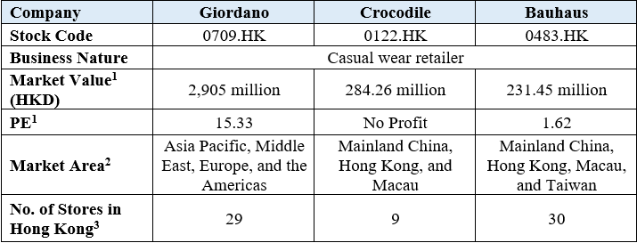 (Source: Constructed by Author based on three companies’ annual report 2021.)

Note1: Stock market was close date on 26 August 2022 (source: http://www.aastocks.com/en/) (See Appendix I)
Note2: Market Area (source: Three companies’ annual report 2021)
Note3: Number of stores in Hong Kong (source: Corporate Web Site of Three Companies)

Financial Analysis
Giordano’s financial statement was analyzed and compared with two same industry companies for assessing Giordano’s situation and financial capabilities. The analysis was through the comparison by six categories with different financial ratios, and index. The index was Predicting Bankruptcy and six categories included Profitability Ratios, Liquidity Ratios, Leverage Ratios, Coverage Ratios, Efficiency Ratios, and Market Value Ratios.

3.1 Bankruptcy Index Analysis
The Altman’s Z-Score model was adopted to assess the likelihood of bankruptcy and financial distress for Giordano. Altman’s Z-Score is a model that was used the numerical measurement with combination of financial ratios weighted to predict the likelihood of bankruptcy (Toly, Permatasari and Wiranata, 2020). The Altman’s Z-Score formula is as follows:
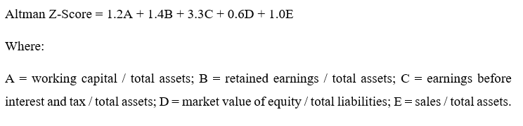
Figure 3-1: Z-Score zone (Quora, no date)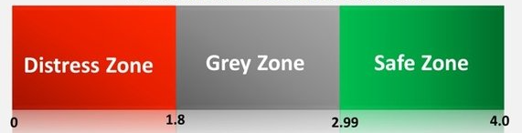
A Z-Score is in distress zone (<1.8) that indicated a company in financial risk and high probability of going bankruptcy. A score of between 1.8 and 2.99 means that the company has moderate chance of filing for bankruptcy. A score is 3 or above means that the company is safe with unlikely bankruptcy in the next two years (CFI Team, 2020a).

Table 3-1: Financial information for Z-Score Calculation.
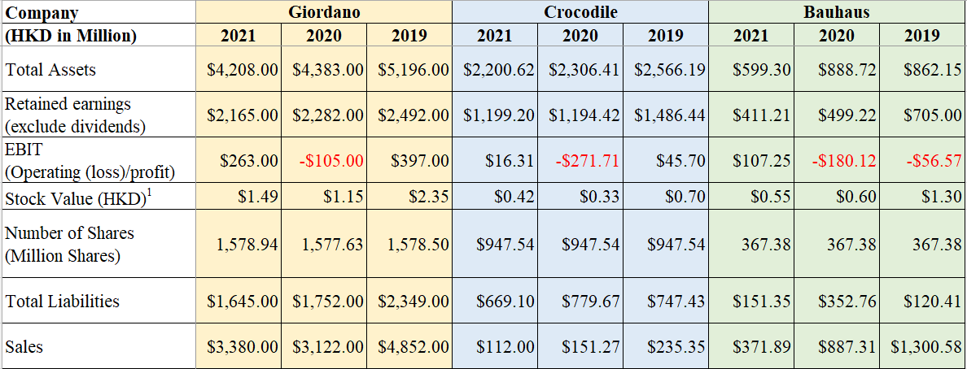(Source: Constructed by Author based on three companies’ annual report 2019-2021.)

Note1: Stock value was close date at end of financial year (source: https://finance.yahoo.com/) (See Appendix II)

Table 3-1 listed the necessary financial information for calculating the Z-Score value of three companies. After the conducted the calculation by above Z-Score formula, the result of Z-score of three companies were listed on Table 3-2 as follows.
Table 3-2: Altman Z-Score Calculation.
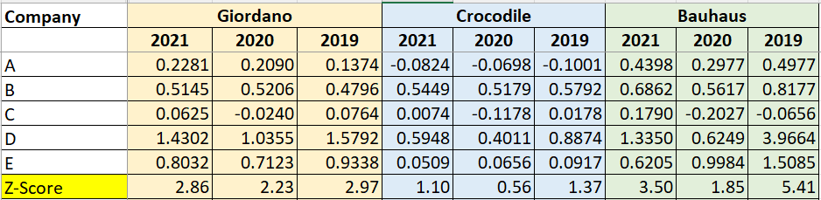(Source: Calculated by Author based on three companies’ annual report 2019-2021.)

Giordano’s Z-Score was between 2.2 and 2.99 in the above result means that it has potential financial risk and medium probability of bankruptcy in near future. However, the result did not represent that Giordano in this range had a weak financial stability, but one needed to be cautions and be diligent of the risks. The Giordano’s Z-Score of year 2021 was compared with the others two companies, it was better than Crocodile but lower than Bauhaus. Therefore, a credit risk of Giordano was a medium in peer group.

3.2 Profitability Ratios
It is used to assess a company’s ability to generate a profit relative to its revenue. The higher ratios are more favorable as this usually means the business has good performance by generating profits, revenue, and cash flow (Hayes, 2022b). Table 3-3 listed the comparison of profitability ratios for three companies.
Table 3-3: Profitability Ratio Comparison. 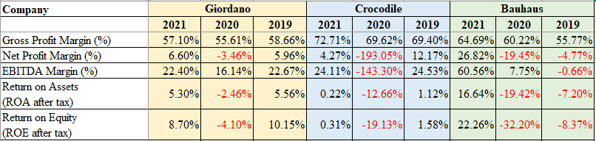 (Source: Calculated by Author based on three companies’ annual report 2019-2021.)
The gross profit margin value was used to compare gross profile to sales revenue. The value of three companies were close to each other. The ability of business was good, especially Crocodile has 72.71%. However, the cost control of Giordano and Crocodile needed to be cautions if compare the difference between gross profit margin and net profile margin. The net profile margin measured the company’s net income and divides it into total revenue (Maverick, 2021). It was excluded all expenses that included cost, interest, and tax. Giordano’s gross profile margin was 57.1% but net profit margin was only 6.6% that indicated a large amount of cost was used for operating the business. Crocodile was same situation. Bauhaus’s gross profile margin of 64.69% with net profit margin of 26.82% implied that cost control was better than Giordano and Crocodile.

3.3 Liquidity Ratios
Liquidity ratio is used to determine the capability of company to pay its short-term bills. The ratios determine a company whether can use current assets to cover current liabilities. Three common ratios were used to determine short-term solvency for Giordano that included current, quick and cash ratio (CFI Team, 2020c). Table 3-4 listed the comparison of liquidity ratios for three companies.
Table 3-4: Liquidity Ratio Comparison.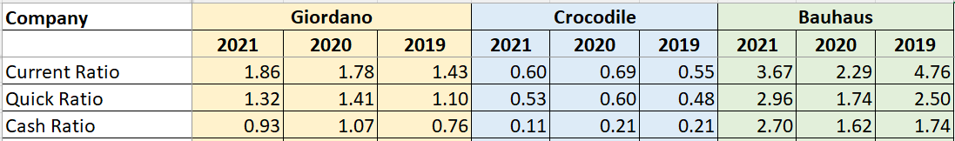(Source: Calculated by Author based on three companies’ annual report 2019-2021.)
Current ratio - It is the simplest liquidity ratio. It measures the ability of company to pay off its current liabilities that is payable within one year with total current assets of company. The current ratio of 1 means that the company has ability to pay the short-term bills (CFI Team, 2020c).
Giordano’s current ratio has 1.86 times. It had capability to use current asset for settle its current liabilities. The current ratios from 2019 to 2021 were higher than 1 and was upward trend in each year. This index was better than Crocodile that was lower than 1. Crocodile had potential liquidity crisis. It was compared with Bauhaus, current ratio of 3.67 in 2021 that has sufficient resource to pay its short-term bills. However, high ratio may not be a good index because it represented the company that holds a large amount of liquid assets without other initiatives and investments. Giordano had good ratio compared with two companies. It had ability to pay off a short-term bill but did not hold too many assets on hand. The company can be asked for business partner to extend the credit to them.
Quick Ratio - It is like current ratio but only considers certain current assets. It considers more liquid assets such as cash, marketable securities, and accounts receivables that can be used or retrieved in short period. It is more truly reflect the ability of company to pay the short-term bills (CFI Team, 2020c).
Giordano excluded the inventory for calculating a quick ratio of 1.32 in 2021. The ratio was still higher than 1 and kept the capability to pay the short-term bills. The difference between current ratio and quick ratio was 0.54 that was around 30% ((1.86-1.32)/1.86*100%) liquid assets from the inventory. It compared with the Crocodile’s 0.53 times and Bauhaus’s 2.96 times. The liquid assets from the inventory of Crocodile and Bauhaus were 12% and 34%, respectively. It was average in industry (CFI Team, 2020c).
Cash Ratio - It strictly determine the capability of liquidity in further because this ratio only considers cash, marketable securities. These assets are the easiest available to pay the short-term bills.
Giordano’s cash ratio was 0.93 times in 2021 that needed to be cautions and be diligent of the risks. However, this index was compared with the other two companies that was better than Crocodile. Bauhaus was too much cash on hand even its cash ratio of 2.7. So, Giordano was the reasonable ratio in industry.

3.4 Leverage Ratios
A leverage ratio is used to measure the relation of debt to capital or assesses the ability of a company to fulfil the financial obligations (Hayes, 2020b). This report was used the common ratios that included Total Debt Ratio, Debt-to-Equity Ratio, Long Term Debt Ratio, and Equity Multiplier (EM). Table 3-5 listed the comparison of leverage ratios for three companies.
Table 3-5: Leverage Ratio Comparison. 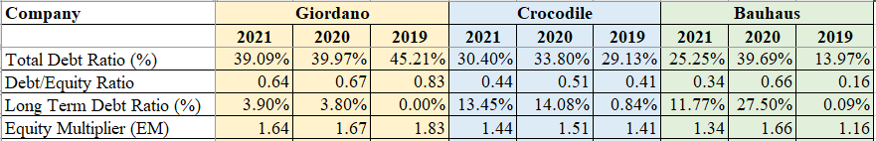 (Source: Calculated by Author based on three companies’ annual report 2019-2021.)
Total Debt Ratio - It is used to analyze a company leverage that purchased the assets by using debt. If the percentage is high, a company's asset of finance has relied on leverage and high financial risk (Hayes, 2020b).
Giordano’s total debt ratio was 39.09% in 2021 means that 39.09% of company’s assets are funded via debt. The total debt ratio was around 39% - 45 % in the latest three years. The assets amount of company is higher than liabilities, so company can sell its assets to fulfil the obligations if necessary. If compared with the other two companies in latest three years, Crocodile was around 30% and Bauhaus’s total debt ratio has fluctuated but it was still under 40%. Three companies’ total debt ratio were close to each other, and Giordano’s total debt ratio was normal in peer group.
Debt/Equity Ratio - It is used to calculated and analyzed a company's total liabilities that relate to shareholder equity. It is a crucial valuation metrics of corporate because it indicates a company's dependence on borrowed funds and its ability to fulfil the financial obligations (Fernando, 2022).
Giordano’s Debt/Equity (D/E) ratio of 0.64 was lower than 1 that indicated a lower amount of debt financing via lenders, or shares fund-raising via shareholders. This value compared with Crocodile and Bauhaus; three companies were very close to each other. Although, Giordano was higher than Crocodile and Bauhaus, but Giordano market areas were more than the other two companies. It given the capital expenditures needed to operate the store in the other regions. It was reasonable that the value had a higher since it was likely to have more liabilities.
Long Term Debt Ratio - It is similar as debt/equity ratio but is considered only long-term debt. It is because this ratio carries more risk than short-term obligations (Kenton, 2020).
Giordano was only interest expense as long-term debt and long-term debt ratio of 3.9% in 2021. Moreover, its long-term debt ratios were under 5% in the latest three years. The other two companies’ long term debt ratio were under 15% with low risk. The ratio of Giordano was lower than Crocodile and Bauhaus in peer group comparison that indicated very low financial risk in term of long-term debt.
Equity Multiplier (EM) - It is used for measuring the portion of the asset of company that is financed by equity rather than by debt. A high EM value indicates that a company has a high level of debt to finance the purchase of assets (Nickolas, 2022).
Giordano used the stockholder’s equity to finance for creating 1.64 times company’s assets and the EM value were close to Crocodile and Bauhaus. Three companies had lower financial leverage for purchasing of assets. On the other hand, it means three companies were not incurred excessive debt to finance its assets. They were less risky investment because they had a lower debt burden.

3.5 Coverage Ratios
A coverage ratio measures a company's ability to service its debt and ability to pay its interest payments or dividends. The higher the coverage ratio is easier to settle the interest payments on its debt or pay dividends. Two common ratios were used in this report that were interest coverage ratio (also called “times interest earned”) and cash coverage ratio (Hayes, 2020a). Table 3-6 listed the comparison of coverage ratios for three companies.
Table 3-6: Coverage Ratio Comparison.
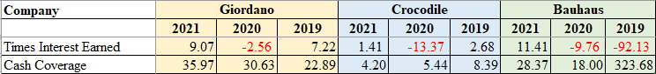 (Source: Calculated by Author based on three companies’ annual report 2019-2021.)

Times Interest Earned - It measure the number of times that the ability of the company to pay interest expense on its debt with its operating income (CFI Team, 2020b).
Giordano had times interest earned of 9.07 in 2021, the company would be able to pay its interest payment 9.07 times over with its operating income. This value was close to Bauhaus but compared with Crocodile’s 1.41 that was a good index. So, Giordano had the stability and healthiness for short-term obligations.
Cash Coverage – It measure the company’s cash balance to its annual interest expense. Cash coverage is a very conservative index because it compares only cash on hand to pay off the interest expense. (CFI Team, 2020b).
The figure of cash coverage of three companies were like the figure of times interest earned. Giordano and Bauhaus were close to each other and higher than Crocodile. Giordano had a good index in peer group.

3.6 Efficiency Ratios
It measures a company's ability to manage the assets and liabilities effectively in the current period or in the short-term. These ratios determine how long it takes to produce cash or revenue from a customer or by selling off goods. These ratios assess a company's capacity to produce revenue from its assets and its asset management efficiency (Nickolas, 2021). The inventory turnover, receivables turnover, and total asset turnover ratios were adopted to analyze three companies’ abilities and conducted a comparison. Table 3-7 listed the comparison of efficiency ratios for three companies.
Table 3-7: Efficiency Ratio Comparison.
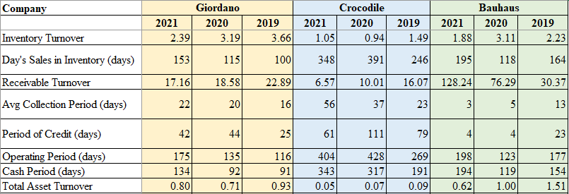 (Source: Calculated by Author based on three companies’ annual report 2019-2021.)

Inventory Turnover - It measures a company's capacity to effectively manage its inventory and gives insight into its sales. The ratio counts the number of times inventory is "turned" or sold during a certain time frame. The ratio is used by analysts to analyze whether there are sufficient sales to flip or utilize the inventory. The ratio also indicates the inventory management efficiency, including whether too much or too little inventory is purchased (Nickolas, 2021).
Giordano’s inventory turnover ratio, and day’s sales in inventory were the bests in the peer group. It implied Giordano strong sales that was important to reduce a storage and the holding cost. The high ratio was not only potentially increased the opportunity cost but also prevented significant risks from fluctuating market price and situation such as COVID-19 and obsolescence.
Receivable Turnover - It also known as the debtor’s turnover ratio, measures the company’s effectiveness in collecting its revenue. A high ratio is better, as it represents that company’s collection of account receivable is frequent and efficient. Moreover, the company has high quality customers who pay their debts quickly (Murphy, 2022).
Giordano’s receivable turnover was 17.16 times that did not good index when compared to Bauhaus that was 128.24 times. Although, the ratio of Giordano was better than Crocodile but needed to be cautions for reassessing its credit policies to ensure the timely collection of its receivables. The average collection period, and period of credit of Giordano were 22 and 42 days, respectively. Both values did not the bests if compared the other companies in peer group but still were reasonable level as industry standard of credit period. The operating period and cash period were the bests that was used the shortest period for goods delivery and cash receiving.
Total Asset Turnover - It measure the value of company’s revenue relative the value of assets. This ratio indicates the efficiency of company that is using its assets to generate the revenue. The higher turnover rate means the company is generating the revenue from assets more efficient (Hayes, 2022a).
Giordano’s had the highest asset turnover ratio in the peer group. The ratio was lower than 1 but it was highly industry specific. If it was compared with companies in peer group, their competitors were also lower than 1. So, asset turnover ratio of 0.8 should be good value in retail industry.

3.7 Market Value Ratios
This ratio is used to evaluate the share price of company whether are overpriced or underpriced (Bragg, 2022). Table 3-8 listed the comparison of market value ratios for three companies.
Table 3-8: Market Value Ratio Comparison. 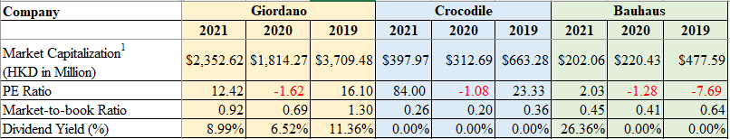 (Source: Calculated by Author based on three companies’ annual report 2019-2021.)

Note1: Stock value was close date at end of financial year (source: https://finance.yahoo.com/) (See Appendix II)

Giordano’s PE ratio of 12.42 was high than Bauhaus but the dividends return was more stable in the latest three years. Moreover, the market to book ratio of 0.92 was lower than 1. Giordano’s stock was potentially favored by investors.

Corporate Governance
Corporate Governance is the system of rules, practices, and processes used to direct and manage a company. It provides a framework a framework for attaining a company’s objectives. The basic principles of corporate governance are fairness, transparency, responsibility, accountability, and risk management, which covers the areas of corporate strategy, ethical behavior, environmental awareness, social responsibility (Chen, 2022).
Giordano maintained the highest levels of corporate governance within a structure that was both reasonable and functional. Four independent non-executive directors, two non-executive directors, and three executive directors made up the Giordano Board. The duties included drafting, revising, and monitoring the company's policies, code of conduct, compliance manual, and Group's disclosure procedure. Figure 4-1 shown the role of members in three Board committee.
Figure 4-1: Giordano’s Board Committees Members (Giordano, 2022a)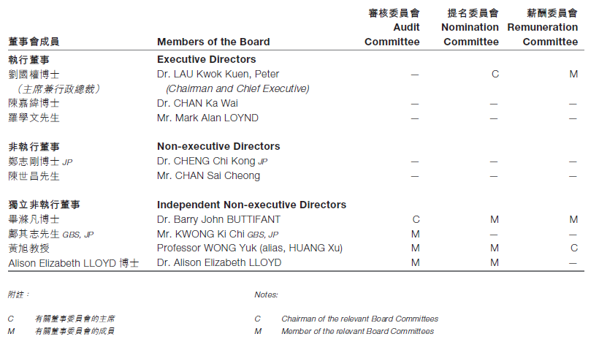(Source: Giordano’s Annual Report 2021.)

The members of the Board have different roles and responsibilities for segregation of duties excepted Dr. Lau Kwok Kuen, Peter, holds the positions of Chairman and Chief Executive. Giordano used a variety of controls to preserve the openness, accountability, and independence that were crucial for protecting the interests of all stakeholders and achieving shareholder value.

- The Board members have no substantial or relevant financial, commercial, familial, or other links with one another.
- Except for two independent Non-executive Directors who have served more than nine years, each Director shall be replaced at least once every three years.
- Members of the Audit Committee are all Independent Non-Executive Directors with no conflicts of interest.
- Constructed a "whistleblowing" mechanism to enable Group employees to report any suspected acts of fraud or gross misconduct anonymously and confidentially by senior management, including the Chairman and Chief Executive, to the Internal Audit Department. Twice a year, both the internal IA team and the Internal Audit Advisor report directly to the Audit Committee.
- To guarantee impartiality, the Nomination Committee has created a nomination policy.
- The Management Committee has reacted to executing its business plans and overseeing the Group's companies' daily operations.
- The Board is accountable for reviewing and deciding the type and magnitude of risks.

The corporate governance of Giordano was compliance with Corporate Governance Guide for Boards and Directors that including key functions of Board, Board’s role, director’s duties, whistleblowing and anti-corruption arrangement, Board committee’s role and functions, risk management and internal control (HKEX, 2021).

Major Investment Project
Giordano plan a new project that opening a new store in shopping mall with technology innovation to provide a new shopping experience for customers. The virtual fitting kiosks will be installed in new store to enhance the fitting and make a customer more satisfaction. Moreover, the company will develop a virtual fitting mobile application (app) with integrating into current online shopping mobile application to enhance the online shopping experience on mobile app.

5.1 Project Investment Information
The project basic information was listed as follows. Table 5-1 listed investment project’s basic information.
Table 5-1: Project basic information
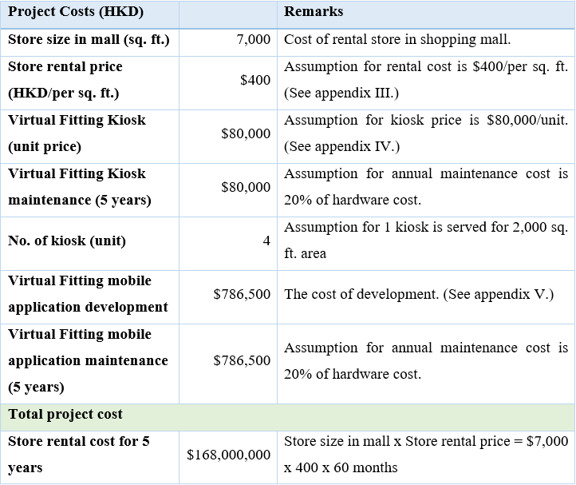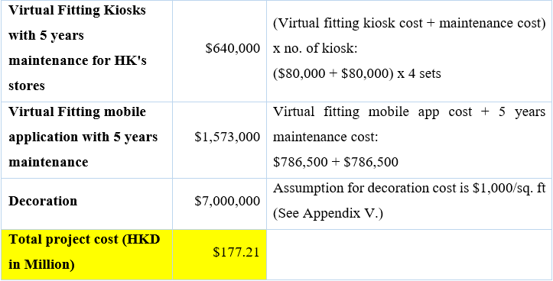(Source: Calculated by Author)

Table 5-2: Project the others information. 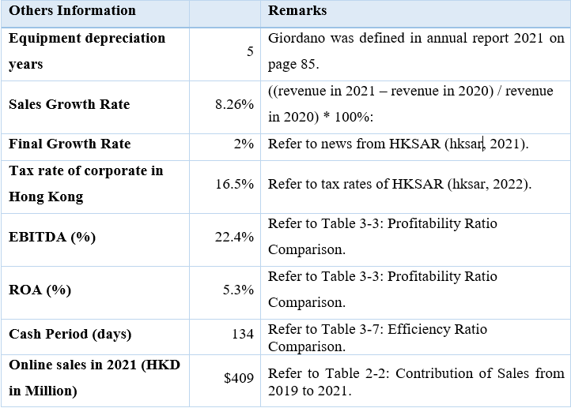(Source: Calculated by Author)

Table 5-3: Project first year of sales
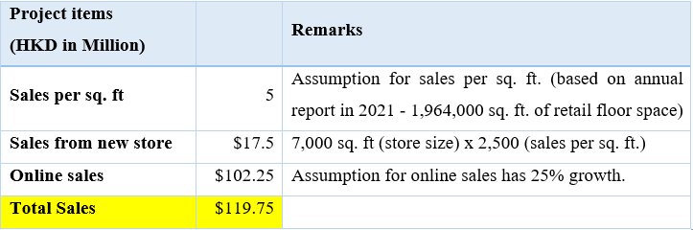(Source: Calculated by Author)

Table 5-4: Project profit calculation.
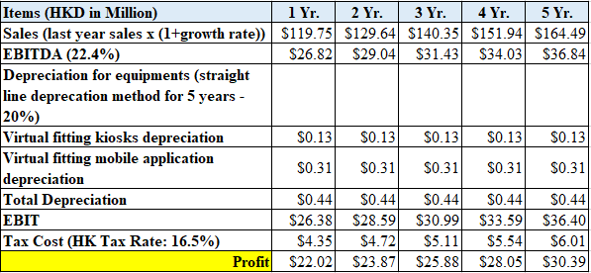(Source: Calculated by Author)

Table 5-4: Project profit calculation.
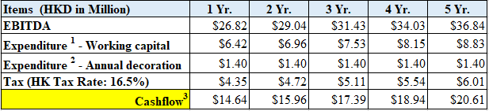 (Source: Calculated by Author)

Note1: Working Capital the first-year calculation (annual direct sales x operating cashflow period/365) => 17.5m x 134/365. Next year calculation = previous year working capital x (1+sales growth rate)
Note2: Assumption for annual decoration cost: 7m/5 years = 1.4m per year.
Note3: Assume final growth rate is used after 5 years.

The new project’s investment is around 5.2% of annual sales in 2021. The new project is estimated to generate the annual sales of $119.75m in first year, profit has $22.02m and cashflow has $14.64. Project five years profit and cashflow have increasing each year and were listed on Table 5-3 and Table 5-4.

5.2 Capital Investment Appraisals (CIA)
The capital investment appraisal (CIA) is used to evaluate the performance of projects and help to decide whether invest this project. Especially, the long-term projects investment that large amount of money is involved over of time. The current value is not equivalent to the value in future. CIA has several types of method that including Net Present Value (NPV), Payback Value (PBP), Internal Rate of Return (IRR), Profitability Index (PI), and Accounting Rate of Return (ARR) to evaluate the project (Pinkasovitch, 2022). Table 5-5 listed the result of CIA.
- NPV - It calculate the value of cashflow in and out over a period. If NPV > 1, project can be accepted.
- PBP - It calculate the amount of time to receive back the cost of the investment. Shorter is better.
- IRR - It calculate a discount rate for making the NPV of all cashflow equal to zero.
- PI - It calculate the profit to investment ratio. If PI > 1, project can be accepted.
- ARR – It calculate the percentage of return expected on the investment.
Table 5-5: CIA Calculation for New Project.
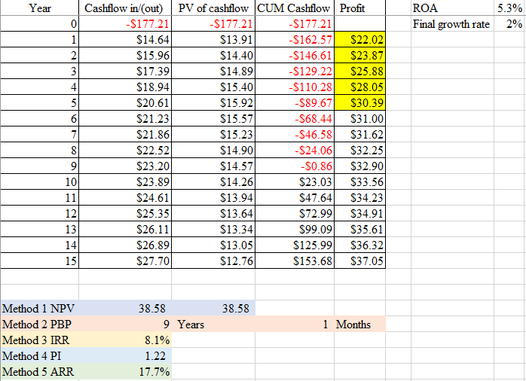(Source: Calculated by Author)

The above investment appraisal analysis is shown PBP is 9 years and 1 month. The value of NPV and PI are large than 1. The ARR is 17.7% that is higher than ROA of 5.3% in 2021. Moreover, the methods of NPV and IRR have time consideration for the assessment. Therefore, Giordano’s new project can be invested as a positive return.

Financing and Capital Management
The initial investment of new project, total of 177.21 million HKD. The different financing methods for this project were considered based on Giordano financial situation. The financing methods included cash, issue new shares, sale of assets, and bank loan.
- Cash – The payment is used internal cash for funding the projects. The cash of Giordano had $1,043m in 2021 (See Appendix VI.). The funding for new project as source from cash. However, Giordano’s cash ratio of 0.93 (refer to Table 3-4) has lower than 1. If the project cost HKD $177.21 million is funded by cash, it is around 17% of cash in 2021. The cash ratio will be decreased in further and increase the financial risk for the company.
- Issue new shares – Giordano has authorized number of shares of 2,000 million and issued shares of 1,579 million. There are around 421 shares that can be issued in further. The new shares fund-raising will reduce the ROE and affect the interest of shareholders. Issue new shares is not recommended as funding raising for new project.
- Sale of assets – Giordano’s ROA of 5.3% and quick ratio has 1.32 that have buffer to sale its assets for funding a new project. It is a possible way for raising a funding.
- Bank loan - The interest rate of the Group’s bank loans in 2021 was 1.1%. The interest rate of the bank loans in 2020 and 2019 were 1.6% and 2.4%, respectively (Giordano, 2021). The interest rate in average was 1.7%. Moreover, the cash coverage ratio of 35.97 (refer to Table-3.6) has enough buffer to pay more interest. It is the other possible way for project funding raising.
There are only sale of assets and bank loan possible methods as new project funding after conducted the above financing methods analysis. However, the ROA of 5.3% is higher return than interest expense. So, if compare of ROA and interest rate, bank loan method should be adopted for new project funding raising.

Conclusion
The finical situation of Giordano was analyzed by comparing in peer group, corporate governance, and new project investment. There were some findings in the analysis and needed to be cautions.
Financial analysis
- The gross profit margin was close in the peer group but very low net profit margin that implied the high cost of operating business. The staff cost was $579 million in 2021 (Giordano, 2021)., and Depreciation and amortization were $494 million (See appendix IV.) that a large portion of cost of operating.
- Cash ratio of 0.93 was lower than 1, the cash was not enough to pay the liabilities if necessary.
- Receivable turnover has been potential improved to increase the turnover rate.

Corporate governance
- The retirement policy did not strictly follow that allowed two independent Non-executive Directors to serve more than nine years.
- The roles of chairman and chief executive were performed by the same individual.

Recommendation
The recommendations are proposed Giordano for improvement as follows.
Financial analysis
- The expenditure for staff should be reviewed and control the staff cost. Moreover, Depreciation and amortization was high that implied large amount of assets. The company should use the assets to generate a revenue for increasing the ROA ratio.
- The credit policy should be reviewed and reduce the credit period that offer to business partners for improving a Cash ratio and receivable turnover ratio.

Corporate governance
- Giordano should be strictly followed the retirement policy that director is rotation at least once every three years to prevent any compliance issue and provide a confidence for shareholders.
- The roles chairman and chief executive should be separate and performed by different individual to prevent conflict of interest.

Appendix

Reference List
Jaiswal, S. (2022) What is Financial Management? Its Nature & Scope, Emeritus - Online Certificate Courses | Diploma Programs. Emeritus. Available at: https://emeritus.org/in/learn/what-is-financial-management/ (Accessed: August 6, 2022).

