Case study

Prepared for:

R. Thomas

Written by:

S. Williams

Date completed:
08th January 2024

Table of Contents
Page
- Introduction 3

2.0 A brief history of the site 3-4
2.1 Predicting the underlying strata 4-5
2.2 Requirements of a suitable foundation 5
2.3 Method of piling 5-6
2.4 Possible challenges of piling on site 6
2.5 Excavation work and their codes of practice 6
2.6 The superstructures design 7
2.7 Structural strength and stability of steel frame 7
2.8 Aesthetics of structural steel 7
2.9 Environmental impact of steel production 7-8
2.10 Sustainability of steel 8
2.11 Fire safety of steel 8

3.0 Conclusion 8-9

4.0 References 9-10

1.0 Introduction
The latest development located at SA1 Swansea Waterfront involves the Innovation Matrix which will be a collaborative effort between the University and the Swansea Bay City deal. This effort focuses on achieving sustainability while continuing to transform the region and improve economic growth (Swansea Bay City Deal, 2023). The report will first examine historical documents pertaining to our site to determine what material and foundation would be suitable for the type of soil in question.
Other relevant factors regarding the selection of a foundation will also be discussed in detail. Secondly, estimations relating to the excavation work carried out on site will be stated along with their codes of practice and how we can overcome any challenges faced during this process. Finally, several factors in relation to the use of materials for the superstructure are to be discussed.
2.0 A brief history of the site
Swansea throughout the 18th century to the late 19th century was once a prominent location for it’s copperworks, mining of coal and metal ores along with oil production. The Prince of Wales Dock where our site is currently situated formerly stockpiled these resources in storage facilities and would use maritime or railway transportation to import and export them (Swansea and Port Talbot Docks History, no date).

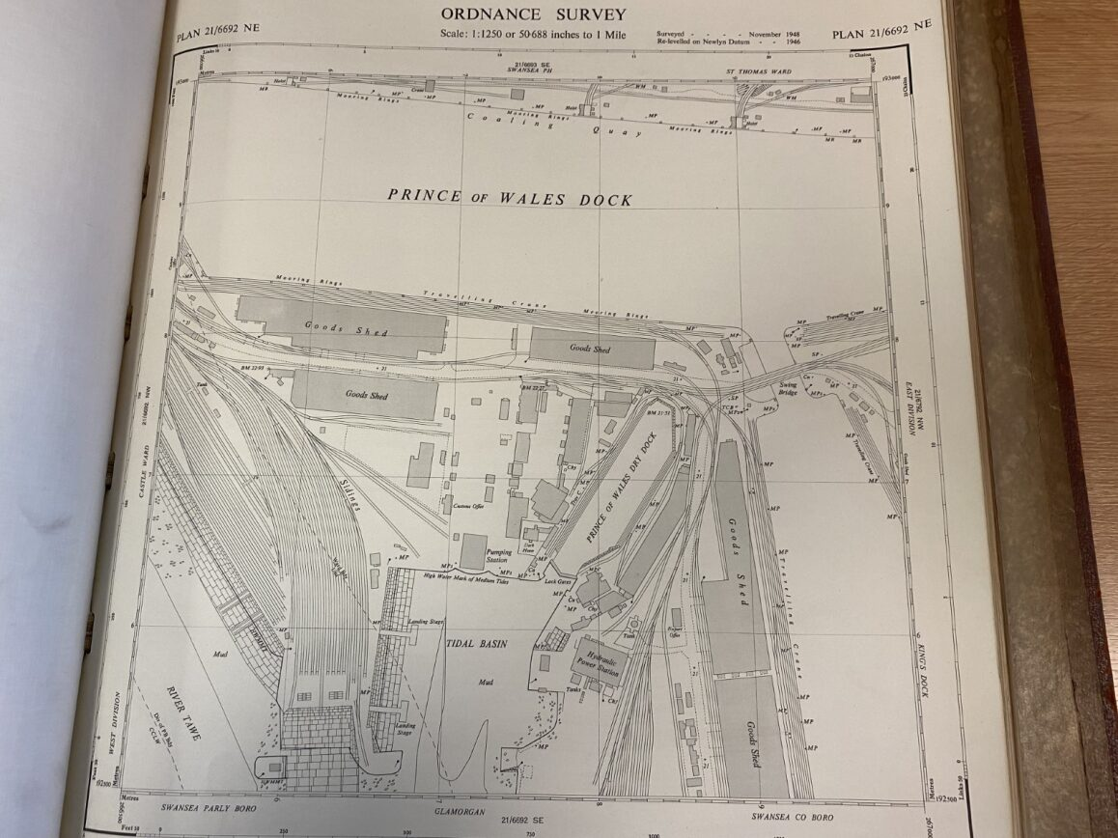
Figure 1 An ordinance survey map dated back to 1948 showing the Prince of Wales Dock where several buildings, a basin and multiple tracks can be seen. This photograph was taken at the West Glamorgan Archives.
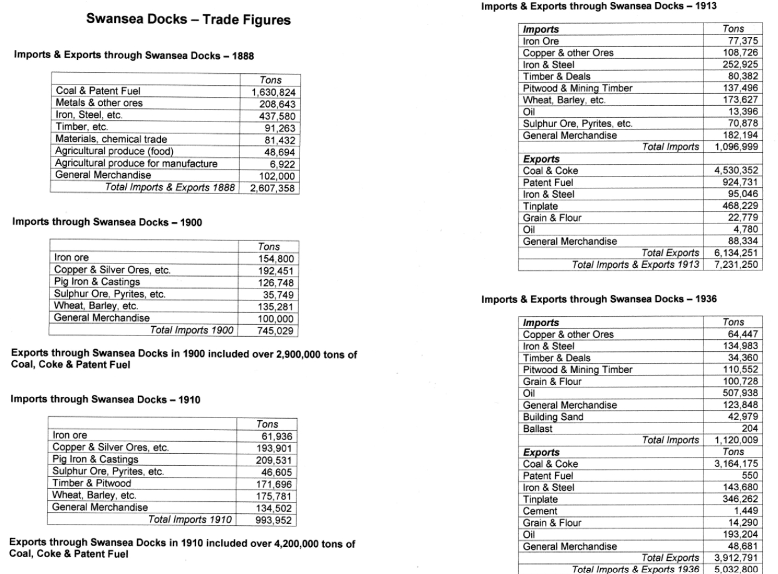
Figure 2 These tables show the number of goods that were imported and exported through Swansea Docks from 1888 to 1936 (Swansea and Port Talbot Docks History, no date).
2.1 Predicting the underlying strata
Before making a decision as to which foundation will be suitable for the site, in-situ testing must be carried out during a subsoil investigation to determine soil properties and ground conditions. Even though on-site borehole data isn’t available yet, predictions can be made by accessing nearby records of existing structures to see if they share any similarities between them.

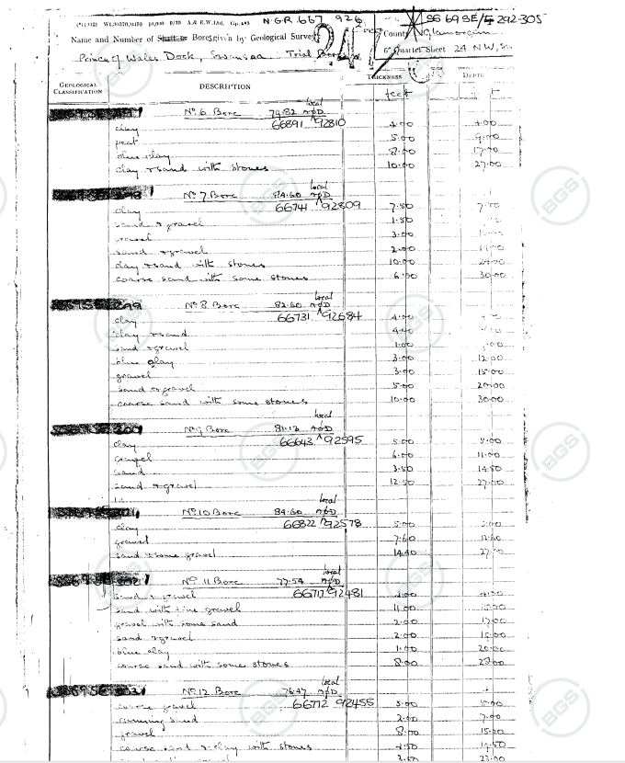
Figure 3 Shows data taken from several boreholes around the Prince of Wales Dock which indicates that there are different soil types ranging from fine to coarse grained such as clay, sand, and gravel. Boreholes at a depth of 27 to 30 feet consist of coarse-grained sand and gravel which could be an ideal layer for the foundations as they tend to drain away water more easily whereas fine grained clays cause cracking due to expansion and contraction. It is worth noting that these docks were backfilled with excavated material from elsewhere and on-site results could vary. The alternative involves excavating deeper until a suitable soil or rock layer is discovered with a high bearing capacity (British Geological Survey, 2020) (Rhino Piling, 2021).
2.2 Requirements of a suitable foundation
Previous borehole data around the site suggests that shallow foundations must be avoided due to poor quality soil found at the surface which would be insufficient in supporting loads from the superstructure. A solution to overcome this problem would be to use a deeper foundation in the form of piling where superstructure loads are transferred into layers of soil or rock that will have a much higher bearing capacity (Designing Buildings, 2022).
Based on the sites former industrial activity discussed in 2.0, it is most likely that impurities from metallurgical processes and the stockpiling of goods may have heavily contaminated the soil. This will have a detrimental effect on the reinforced concrete foundations as chemicals found in metals or fuels can cause an imbalance of pH levels within the soil where groundwater becomes corrosive. It is recommended that piles should be designed off-site in a controlled environment to increase their compaction which will reduce the rate of moisture infiltrating pores in the concrete. A corrosion inhibitor applied to the steel rebar can also improve its durability by increasing the resistance against chemical attacks (ResearchGate, 2014) (CivilBlog.Org, 2016).
In order to achieve greater rigidity of the structural elements, reinforced concrete pile caps constructed on site will provide a much larger area for evenly distributing loads onto piles that are grouped together. During the pile caps curing process, control measures must be put in place to ensure that it’s full strength and durability potential can be reached. This is because temperature or moisture changes in the concrete has the ability to cause defects such as shrinkage or cracking (Designing Buildings, 2022) (aci, no date).
Before concrete can be poured into the excavation to form the caps, it is suggested that a blinding layer should be laid down first to provide a dry working surface which in turn will reduce ground moisture penetrating the wet concrete. The next step required would then be to install pre-positioned shuttering and the supporting falsework around this blinding layer where concrete to be poured can form into its specified shape. Shuttering has the opportunity to be prefabricated off-site offering a wider range of materials and is considered cost effective on larger sites such as this one (Designing Buildings, 2022) (Designing Buildings, 2023).
The last step involves covering the piling caps surface with plastic sheeting in order to maintain its temperature and moisture that will help accelerate the curing process along with preventing the interference of external factors. Once the concrete has achieved adequate strength, the formwork can be removed where bituminous paint may then be applied to the caps surfaces with the purpose of resisting contaminants and providing a waterproof layer (Reef Industries, 2023) (Palatine Paints, 2022).
2.3 Method of piling
Due to the poor soil conditions present on our site, it is believed that performed piling will be the most appropriate method to use. It consists of driving precast concrete piles into the ground by a single acting hammer where soil will displace around the pile shaft increasing its compaction and bearing capacity. Depending on data from the site investigation, there are two ways piles can be driven.
- If soil sampling data from a borehole indicate that it shows suitable settlement characteristics and adequate bearing capacity, piles will be driven to a pre-determined depth.
- Piles will continue to be driven until the subsoil begins to show resistance against its penetrative force. Splicing collars will be then required by connecting piles together in order to reach further depths (Designing Buildings, 2022) (Chudley and Greeno, 2016, p. 280).
2.4 Possible challenges of piling on site
A common occurrence with piling installation is that new piles may tend to move around existing ones from the cause of soil displacement. Solutions on correcting this problem involves predrilling soil to reduce movement of ground, changing the pile installation sequence or redriving piles. The piling cap will allow for a small amount of movement from their original position as driving the piles perfectly vertical is a task too difficult in achieving (Designing Buildings, 2022)
The progression of piling installation may sometimes come to a halt if a deep obstruction in the earth has been hit. The site engineer will then need to be contacted immediately on how to approach and overcome this obstacle. It is beneficial to request additional pre-cast piles to compensate for this issue and prevent further delays (Eiffel Trading, 2021).
2.5 Excavation works and their codes of practice
UXO surveys: Before site preparation works can begin, it is imperative that a UXO investigation is carried out on site to detect possible unexploded ordinance in the earth. Eliminating this risk potential in advance prevents additional costs and work delays (RSK Geophysics, 2024).
Underground services: Utility mapping of the area must be acquired from the local authority to identify and locate existing underground services to prevent risk of serious injury. If work on site is carried out in a negligent manner, accidental damage to gas pipes or electrical cables can lead to explosions or electrocution. In addition, radio detection equipment may be utilized on site with the purpose of detecting unknown services that wasn’t previously mapped (Bury Associates, 2022).
Excavation collapse: Before any type of excavation work commences, preventative measures on how to reduce the likelihood of soil collapse and the selection of suitable support systems must be decided in advance. It may be necessary to increase the safety of excavations by battering the sides to the angle of repose, although this will change depending on the soil type and ground conditions. A competent person who is knowledgeable of risks associated with excavations and can make sensible decisions must be appointed to carry out thorough inspections at the start of every shift before work can continue.
Falling material: Protection systems at the edges of the excavations must be installed to prevent loose material from spoil heaps falling into them. Construction plant or vehicles must not park near excavations as their increased weight will likely cause the sides to loosen and collapse.
Preventing falls: A sufficient number of barriers which includes guard rails and toe boards will need to be installed around the excavations perimeter as unwanted trespassers could potentially fall into them.
Accessibility: Safe access of getting in or out the excavation such as ladders or the use of scaffolding with adequate strength and considered fit for purpose must be provided during works.
Ground and surface water inflow: Control measures may need to be implemented in the excavations design if the permeability of underlying soil is poor where water has difficulty draining. An effective technique involves channelling water into sumps where it will then be pumped out which mitigates the risk of flooding (Health and Safety Executive, 2024).

2.6 The superstructures design
Steel Portal Frame: This is one of the more favourable building methods among the construction industry today where a two-dimensional rigid frame is created. Primary structural components such as beams will connect to the joints of columns which allows for lower bending moments and transfers loads in a downwards direction towards the foundation. Secondary framework consisting of purlins are then attached to the beams and rails will be fastened to columns which enables cladding to then be installed. It is also a requirement to brace the frame either at the end bay or intermediary bay in order to achieve lateral stability.
The structural components required to build steel framing are prefabricated off-site where they will be carefully designed to meet the specification requirements before being delivered to the site. These structural components are then assembled with floor plating, bolt connectors and welding that results in a faster rate of construction. From a cost perspective, steel prefabricated off-site results in a reduction of labour on-site which saves money in the long run. Steel is durable where repair and maintenance costs would be considerably lower compared to other materials (Designing Buildings, 2022).
2.7 Structural strength and stability of steel frame
Even though steel has a higher density in comparison to other materials such as timber or concrete, a component of all three with the same measurements will find that the steel will be able to carry a larger load. Structural steel during the prefabrication process can be crafted into a wide selection of complex shapes while having the ability to maintain its strength. In addition, it offers high tensile strength which is beneficial for resisting extreme weather conditions, seismic activity, and snow loads (Designing Buildings, 2022).
2.8 Aesthetics of structural steel
If steel is designed carefully during the prefabrication process, it’s appearance in the built environment will look aesthetically appealing and can be left exposed to naturally blend in with other materials such as concrete or glass. As steel is highly durable, it is not vulnerable to defects like rot, cracks, splits, warps, or twists and preserving its appearance will prevent rust deterioration. Due to its incredible strength-to-weight ratio, it enables to replace the need for large columns and use smaller ones which increases floor space in the building. With steel having additional strength, it allows the opportunity to create larger bays within the steel frames and maximises space available in the building (Steel Fabrication Services, 2024).
2.9 Environmental impact of steel production
There are a number of ways steel production can cause a detrimental impact in our environment such as the release of emissions into the atmosphere, disposal of hazardous or solid waste and liquid contamination. One of the most serious impacts is caused by the production of coke and iron in steel mills.
Climate change: A large majority of greenhouse gas emissions have been associated with the manufacturing of steel as vast quantities of carbon dioxide will be released into the atmosphere due it’s energy consumption.
Atmospheric emissions: The production of coke in the steel mills is one of the primary contributors to pollution. Emissions such as coke dust, ammonium compounds, sulphur dioxide and crude oil will be released into the atmosphere. Inhaling these emissions are also proven to be toxic to human health.
Water emissions: One of the key resources used for the cooling process of the coke is water where it will eventually become contaminated from the cokes fumes and other substances. Even though the water is contaminated, it is possible to recycle it through the use of a filtration system where impurities would be removed.
Waste: Impurities consisting of slag, iron ore and limestone accumulated at the top of the molten iron makes up for the majority of by-products in iron manufacturing. The use of an air system control device will capture and evaporate hydrogen sulphide and sulphur dioxide where remaining slag is sold to the construction industry. Even though this method does not prevent pollution, solid waste will never be sent to landfills (greenspec, 2024).
2.10 Sustainability of steel
Steel is becoming one of the most favourable materials to use because of its recyclability advantage. This is because steel can be recycled an infinite number of times without losing any properties where it can then be reused for a variety of different purposes during its life cycle. With steel having superior properties such as high strength and density, the manufacturing of structural components doesn’t require a large number of resources which conserves energy usage. The industry continues to make steady progression towards decarbonization to reduce carbon emissions from steel manufacturing (Australian Steel Institute, 2024).
2.11 Fire safety of steel
Steel being classified as a non-combustible material allows for adequate resistance against heat contact to a certain degree. The problem will begin to arise when steel has been exposed to a rising temperature for an extensive amount of time where its reduction in strength can cause structural collapse. There are a number of fireproofing techniques available that’ll increase the fire resistance of structural steel such as:
Intumescent coatings: This technique provides brilliant fire resistance where a chemical reaction as the result of extreme heat expands the coating up to 100 times its original thickness where a buffer is created to prevent fire affecting the steels structural integrity.
Rigid board fireproofing: This method not only provides a protection barrier against fire, but also has thermal and acoustic properties. The boards can be installed alongside structural components offering rapid construction and is able to withstand moisture where its fire prevention characteristics will remain unaffected (liveaboutdotcom, 2019).
3.0 Conclusion
Soil is considered to be dynamic meaning that over time, its properties may change. Data collected from several areas indicated that a suitable soil type for the foundations was discovered at depths ranging from 27-30 feet although this data may not show the same results at the site. One of the reasons as to why this would be the case is because the ground was backfilled and not a natural formation. Even though some may oppose the decision to pile deeper as it isn’t considered economical, it could only be the alternative to create a stable foundation where soil conditions near the surface are too poor to distribute imposed weight on it.
Steel is continuing to revolutionize the construction industry as it provides a multitude of benefits and can be adapted to different purposes in buildings. If steel is designed carefully and maintained properly, the need for additional steel in future can be avoided as its life cycle will be extended beyond measure.
4.0 References
Swansea Bay City Deal (2023) Work starts on UWTSD’s Innovation Matrix in Swansea – a new centre for digital innovation and enterprise. Available at: Work starts on UWTSD’s Innovation Matrix in Swansea - a new centre for digital innovation and enterprise | Swansea Bay City Deal (Accessed: 31/12/2023).
Swansea and Port Talbots Docks History (No Date) A Brief History of Swansea Docks. Available at: Swansea and Port Talbot Docks Website (swanseadocks.co.uk) (Accessed: 01/01/2024).
Swansea and Port Talbots Docks History (No Date) Swansea Docks trade figures 1888-1970. Available at: Swansea and Port Talbot Docks Website (swanseadocks.co.uk) (Accessed: 01/01/2024).
British Geological Survey (2020) GeoIndex Onshore. Available at: GeoIndex - British Geological Survey (bgs.ac.uk) (Accessed: 01/01/2024).
Rhino Piling (2021) The Worst Types of Soil for Piling. Available at: The Worst Types of Soils for Piling - Rhino Piling Limited (Accessed: 01/01/2024).
Designing Buildings (2022) Pile foundations. Available at: Pile foundations - Designing Buildings (Accessed: 02/01/2024).
ResearchGate (2014) Potential Chemical attack on Concrete Foundations due to Groundwater Chemistry. Available at: (PDF) Potential Chemical attack on Concrete Foundations due to Groundwater Chemistry (researchgate.net) (Accessed: 02/01/2024).
CivilBlog.Org (2016) HOW TO INCREASE DURABILITY OF CONCRETE PILES? Available at: HOW TO INCREASE DURABILITY OF CONCRETE PILES? - CivilBlog.Org (Accessed: 02/01/2024).
Designing Buildings (2022) Pile cap. Available at: Pile cap - Designing Buildings (Accessed: 02/01/2024).
aci (no date) Curing of Concrete. Available at: curing of concrete Topic (Accessed: 02/01/2024).
Designing Buildings (2022) Blinding. Available at: Blinding - Designing Buildings (Accessed: 03/01/2024).
Designing Buildings (2023) Formwork. Available at: Formwork - Designing Buildings (Accessed: 03/01/2024).
Reef Industries (2023) Concrete Curing Covers: A Comprehensive Guide. Available at: Concrete Curing Covers: A Comprehensive Guide | Reef Industries (Accessed: 03/01/2024).
Palatine Paints (2022) Questions About Bitumen Based Paints. Available at: Questions about bitumen paints - Answered Palatine Paints (Accessed: 03/01/2024).
Designing Buildings (2022) Driven piles. Available at: Driven piles - Designing Buildings (Accessed: 04/01/2024).
Chudley, R. and Greeno, R. (2016) Building Construction Handbook. 11th edn. 2 Park Square, Milton Park, Abingdon, Oxon, OX14 4RN: Routledge.
Eiffel Trading (2021) What are Common Pile Driving Mistakes? Available at: What are Common Pile Driving Mistakes? | Eiffel Trading (Accessed: 05/01/2024).
RSK (2024) UXO Surveys. Available at: UXO Surveys | RSK Geophysics (Accessed: 06/01/2024).
Health and Safety Executive (2024) Excavations. Available at: Excavations - Construction Safety topics - HSE (Accessed: 06/01/2024).
Bury Associates (2022) Underground Utility Survey Services. Available at: Underground Services Tracing of Utilities, Pipes and Cables (buryassociates.co.uk) (Accessed: 06/01/2024).
Designing Buildings (2022) Portal frame. Available at: Portal frame - Designing Buildings (Accessed: 07/01/2024).
Designing Buildings (2022) 8 reasons why structural frames are advantageous for any building project. Available at: 8 reasons why structural steel frames are advantageous for any building project - Designing Buildings (Accessed: 07/01/2024).
Steel Fabrication Services (2024) The Aesthetics Benefits of Structural Steel. Available at: The Aesthetic Benefits of Structural Steel | Steel Fabrication (steelfabservices.com.au) (Accessed: 07/01/2024).
greenspec (2024) Steel production & environmental impact. Available at: Steel production & environmental impact (greenspec.co.uk) (Accessed: 08/01/2024).
Australian Steel Institute (2024) Sustainability. Available at: Australian Steel Institute - Sustainability (Accessed: 08/01/2024).
liveaboutdotcom (2019) Fireproofing Methods for Structural Steel. Available at: Fireproofing Methods for Structural Steel (liveabout.com) (Accessed: 08/01/2024).

