Task 1: Locating Sources
Identify and locate three different sources (a report, a journal article, and a website) related to the question
“What employability skills do university graduates need to succeed in the workplace?”
Show how you used keywords, search terms, and Boolean operators to find them, and explain how you know which type of source each one is and why it is appropriate for the research question.

Source Type & Why It Is Appropriate | URL/DOI | What search engine did you use? Google/Online Library/Library AI Assistant | Keywords/Boolean Operators Used
Journal article | - https://librarysearch.uwtsd.ac.uk/permalink/44WHELF_UWTSD/1bmis16/cdi_doaj_primary_oai_doaj_org_article_2fcd3a7b3b3b4b3dae8350f58af054b4 | UWTSD library | Employability skills, business graduates and modern workplace

Task 2: Evaluating Information (CRAAP Test)
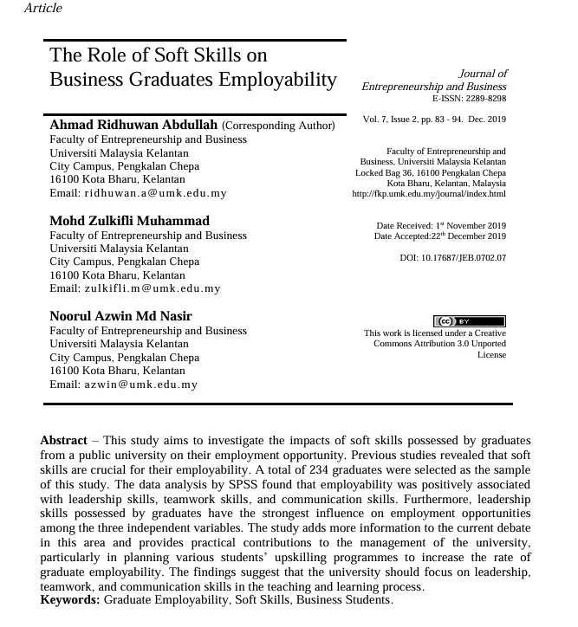
Your colleague has forwarded you a source from a peer reviewed journal, and they are not sure whether it is appropriate to use and has asked for your help. Your task is to evaluate the source by using the CRAAP Test to assess its appropriateness for the following question “What employability skills do business university graduates need to succeed in the workplace?”

CRAAP Test
Currency | The article was published in December 2019 therefore it is current.
Relevance | It is relevant as the article is about soft skills possessed by graduates and their employment prospect.
Authority | It is a journal article which is peered review
Accuracy | It is peered reviewed and the article focused on the link between employability skills of graduates and businesses
Purpose | The purpose of the study is to determine if employability skills of graduates make a difference in their job prospect.  It also highlights graduates with employability skills has impact in business
Task 3: Source Analysis
Your manager has provided you with a short extract from a source and has asked you to analyse the source by Identifying one strength, one weakness, and providing a brief explanation of the strength and weakness identified.
If you want to read the article online, please click the following link: https://www.universitiesuk.ac.uk/latest/news/strong-demand-graduates-employers

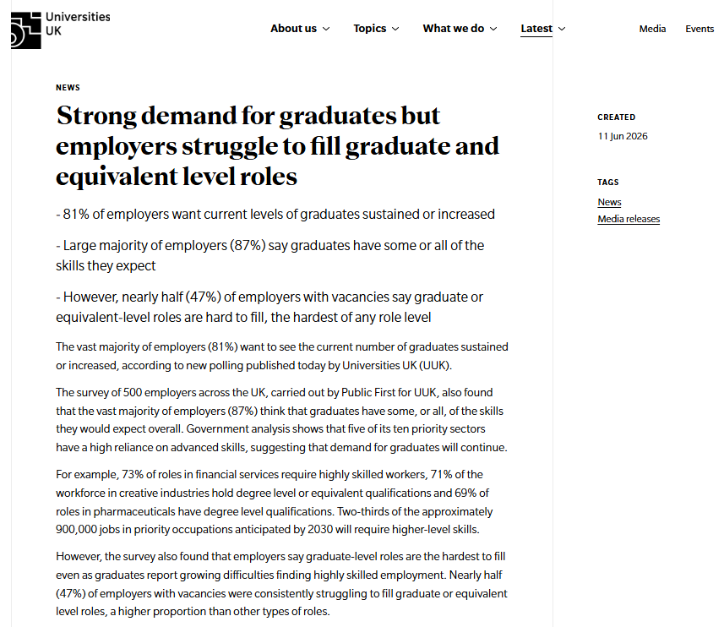
.

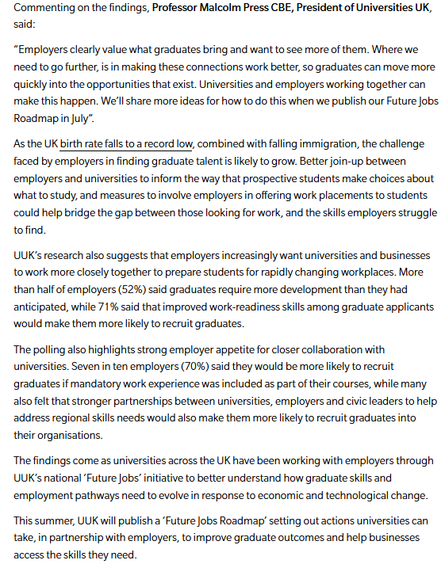

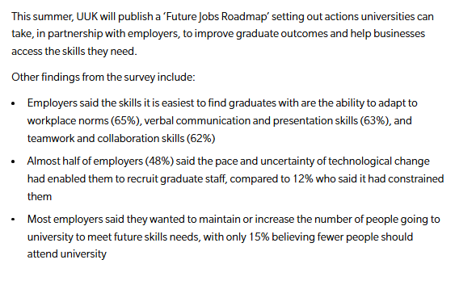

Strength of the Source:

The source is from a university study
It is also from a government survey

It article shows what is working and what needs to be improved.

Weakness of the Source:

The survey was only done on 500 employers across the UK

