01/10/2025
Assessment 2
Introduction to Web and Database Concepts
Lecturer: Suneth Fernando
university of wales trinity saint david (london campus)
Introduction to Web and Database Concepts
Semester: 2
Lecturer: Suneth Fernando
Subject Code: ACCA4023
Student ID: 24442128
Student Name: Md Atiqur Rahman

Table of Contents
Introduction to case study 2
User Requirements 3
Home Page 3
Gallery Page 3
Services Page 4
Testimonies Page 4
Contact Us Page 4
Website Design 5
Website Implementation 10
Home page HTML (screenshots) 11
Gallery page HTML (screenshots) 11
Services page HTML (screenshots) 12
Testimonies page HTML (screenshots) 13
Contact Us page HTML (screenshots) 13
Validating my website 14
Self-evaluation of my website 16
Usefulness (usability and utility): 16
Search Engine Optimisation (SEO): 17
Website Accessibility: 18
Conclusion: 19
Reference 20

Introduction to case study

This case study focuses on the planning, design, and development of a fully functional website for a student consultancy firm named Future Way London Limited. It is a professional educational consultancy that provides guidance and support to international and local students seeking academic opportunities in the United Kingdom. The firm specialises in student admissions, career counselling, visa support, and general educational advice. As a modern consultancy that relies heavily on clear communication and credible branding, having an informative and user-friendly website is essential for reaching potential clients and maintaining a strong online presence.
The main business function considered in the development of this website is information and student support services. The goal of the website is to provide students with easy access to essential information about the consultancy’s services, success stories, and contact details. To achieve this, the website has been designed with five key pages: Home, Gallery, Services, Testimonies, and Contact Us. Each page plays a specific role in supporting the business operations of Future Way London Limited.
The website has been developed using Visual Studio Code, following modern web design practices to ensure clarity, responsiveness, and ease of navigation. Overall, this project demonstrates how digital solutions can effectively enhance communication and support the operations of a student consultancy firm.

User Requirements

The user requirements for the Future Way London Limited website focus on ensuring that visitors, mainly students and parents can easily access reliable information about the consultancy and its services. Users expect the website to be simple to navigate, visually clear, and fully functional across different devices.
One of the key user expectations is the presence of clearly defined pages, which include: Home, Gallery, Services, Testimonies, and Contact Us. Each page must serve a specific purpose and provide relevant content that supports the needs of prospective students. Below are the details explanation for each page’s expectation and content it should have.

Home Page
User Expectations:
Users expect the Home page to clearly explain what Future Way London Limited is and what it offers. They want a quick overview that helps them understand the consultancy’s purpose without reading too much information. The page should also make it easy to move to other sections of the website.
Content Required:
The Home page should include a brief introduction to the consultancy, explaining its mission and the type of support it provides to students. It should also highlight key services and benefits in a short summary, helping users quickly understand the value of the organisation.

Gallery Page
User Expectations
Users expect the Gallery page to give them a visual understanding of the consultancy’s activities. They want to see real images that show events, student achievements, and daily operations. The gallery should be easy to navigate and visually appealing.
Content Required
This page should contain high-quality images from events, workshops, and student success moments. Each image should include a short caption or description so users can understand what is being shown and why it is important.

Services Page
User Expectations
Users expect the Services page to clearly explain what support the consultancy offers. They want information that is easy to read and helps them decide whether the services meet their educational needs.
Content Required
The page should provide clear and concise descriptions of each service offered by Future Way London Limited. It should also explain how these services help students achieve their academic or career goals.

Testimonies Page
User Expectations
Users expect the Testimonies page to build trust and confidence in the consultancy. They want to read honest feedback and real success stories from students and parents who have used the services.
Content Required
This page should include written testimonials, reviews, and short success stories. These should highlight positive experiences and outcomes to show the consultancy’s credibility and effectiveness.

Contact Us Page
User Expectations
Users expect the Contact Us page to make communication simple and quick. They want clear details on how to contact the consultancy and where it is located.
Content Required
The page should include a contact form for enquiries, along with the consultancy’s phone number and email address. Location details, such as an address or map, should also be provided to help users find the organisation easily.

Overall, users expect the website to be informative, trustworthy, easy to use, and designed in a way that helps them quickly find the information they are looking for.

Website Design

Home page: The page is structured using HTML headings, informative paragraphs, professional photographs, and a slideshow section to create an engaging and user-friendly first impression for prospective students and partners.
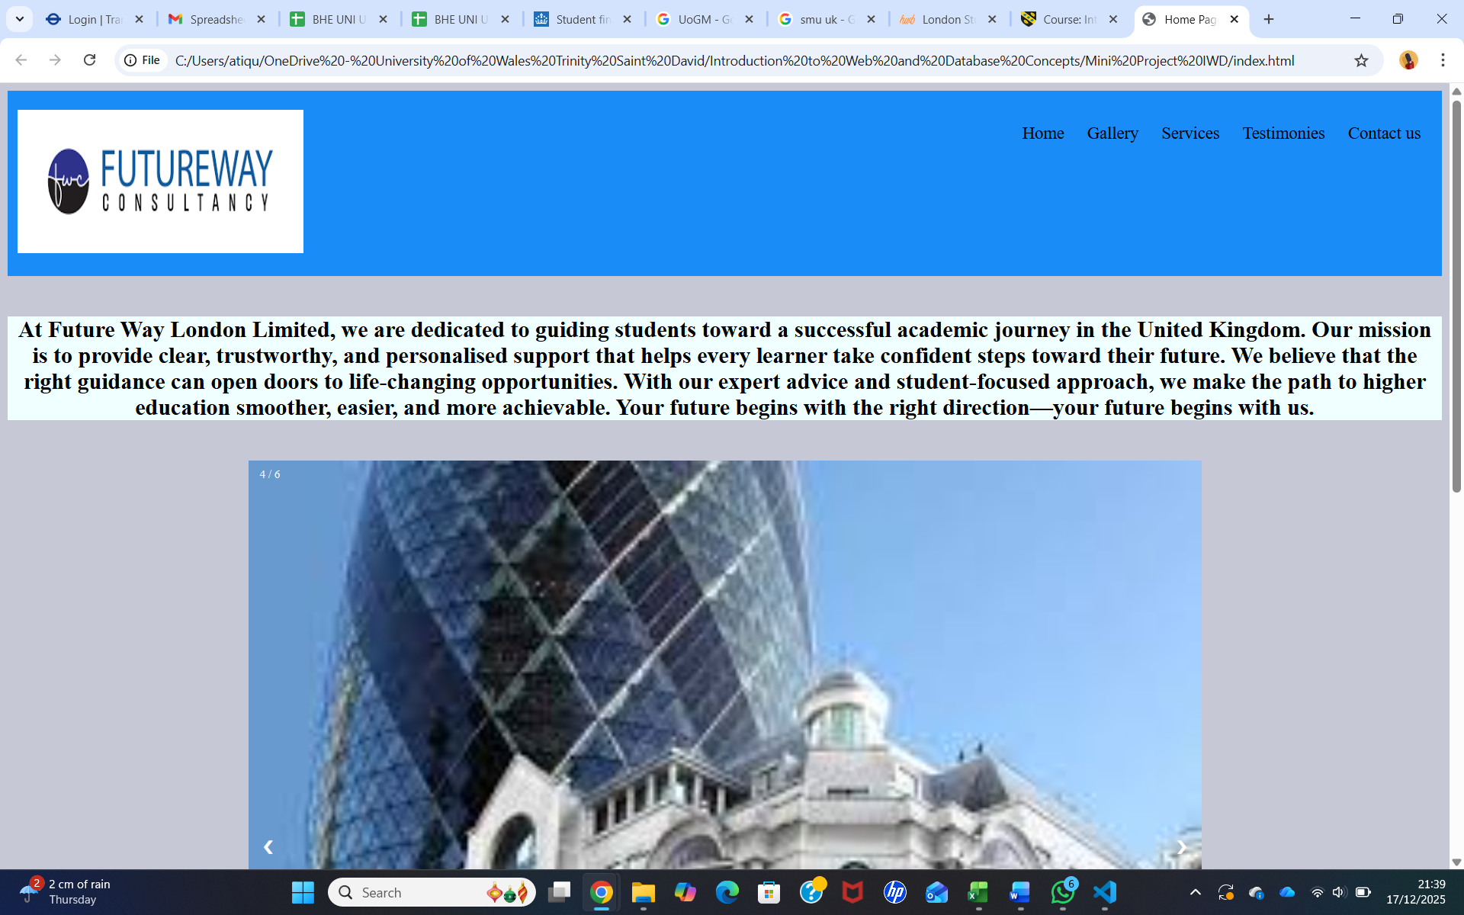
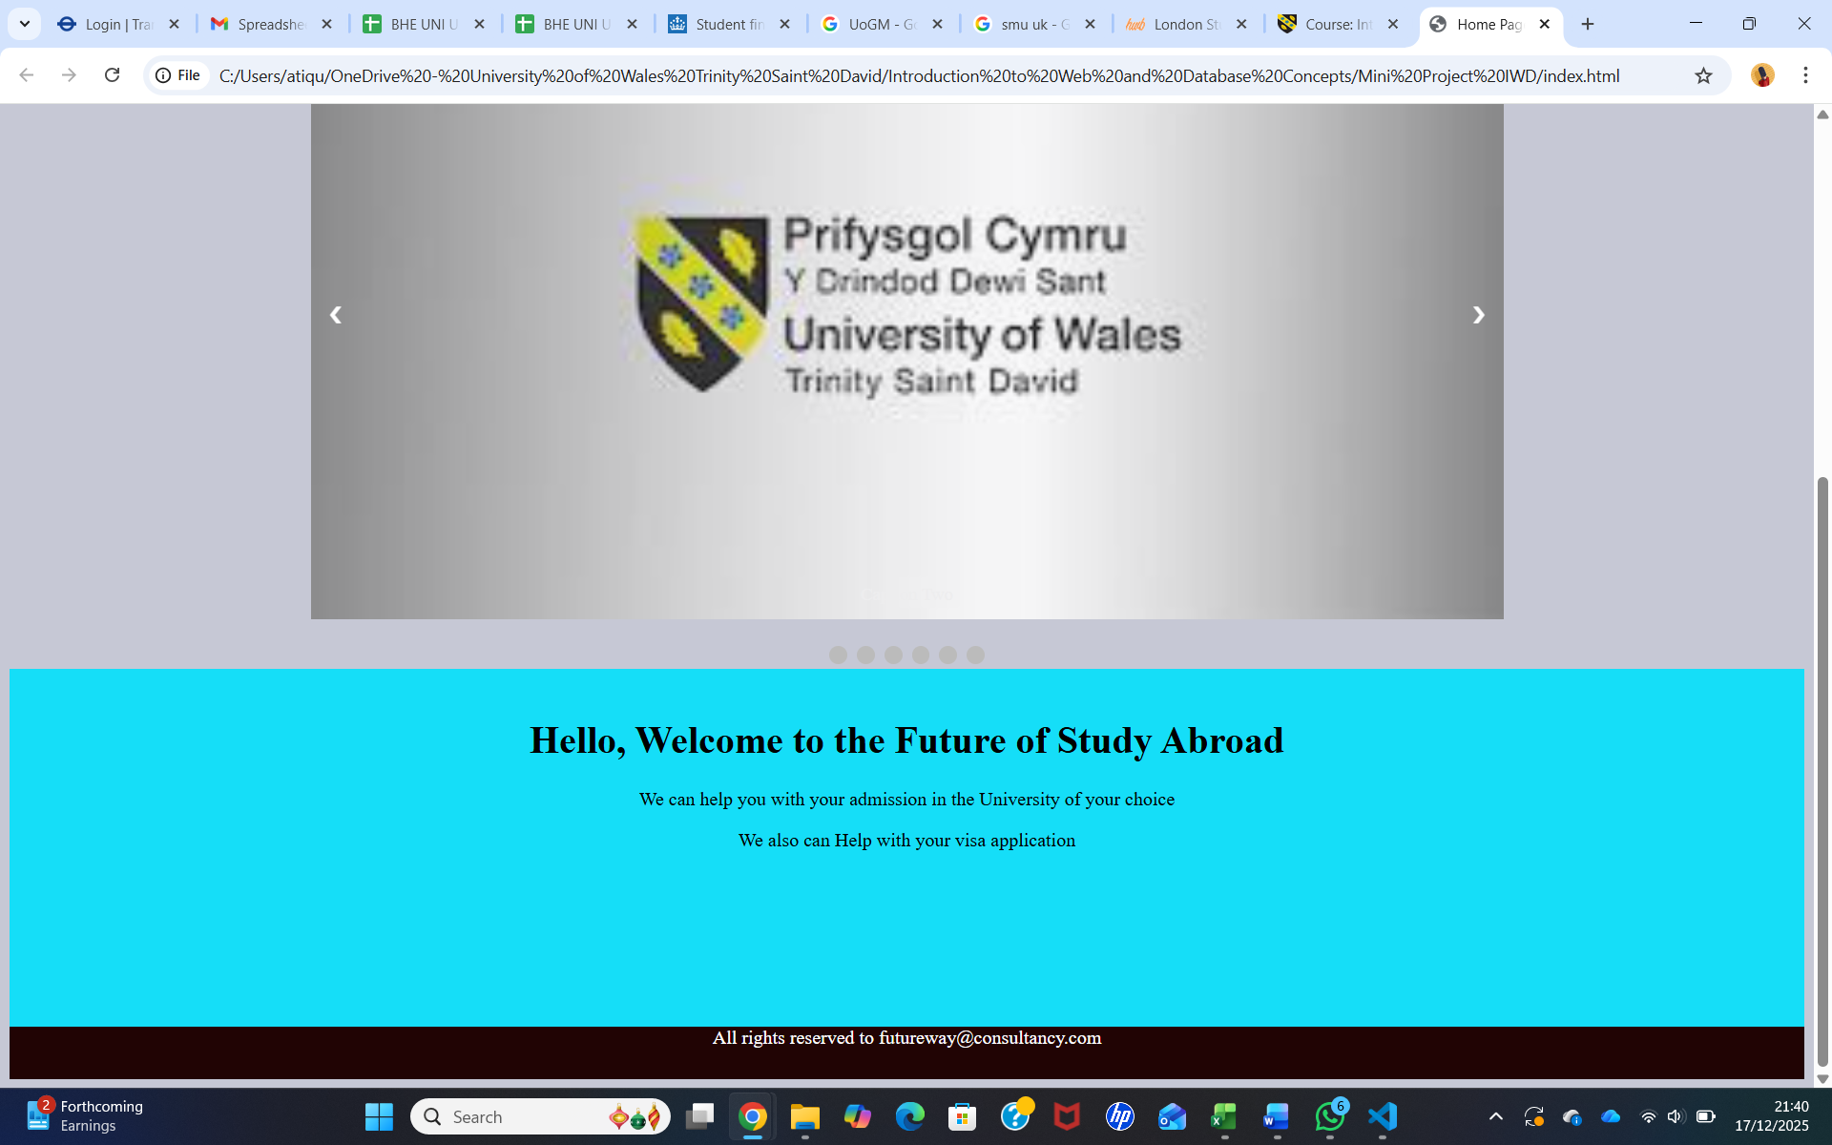

Gallery page:
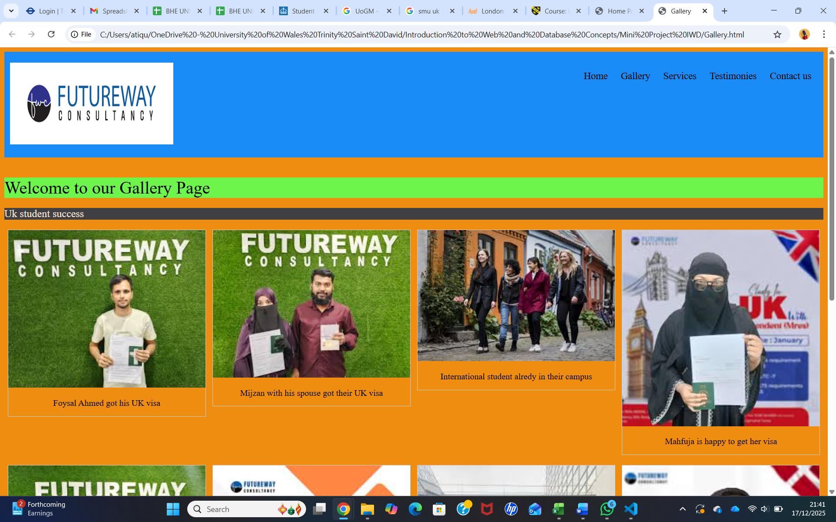
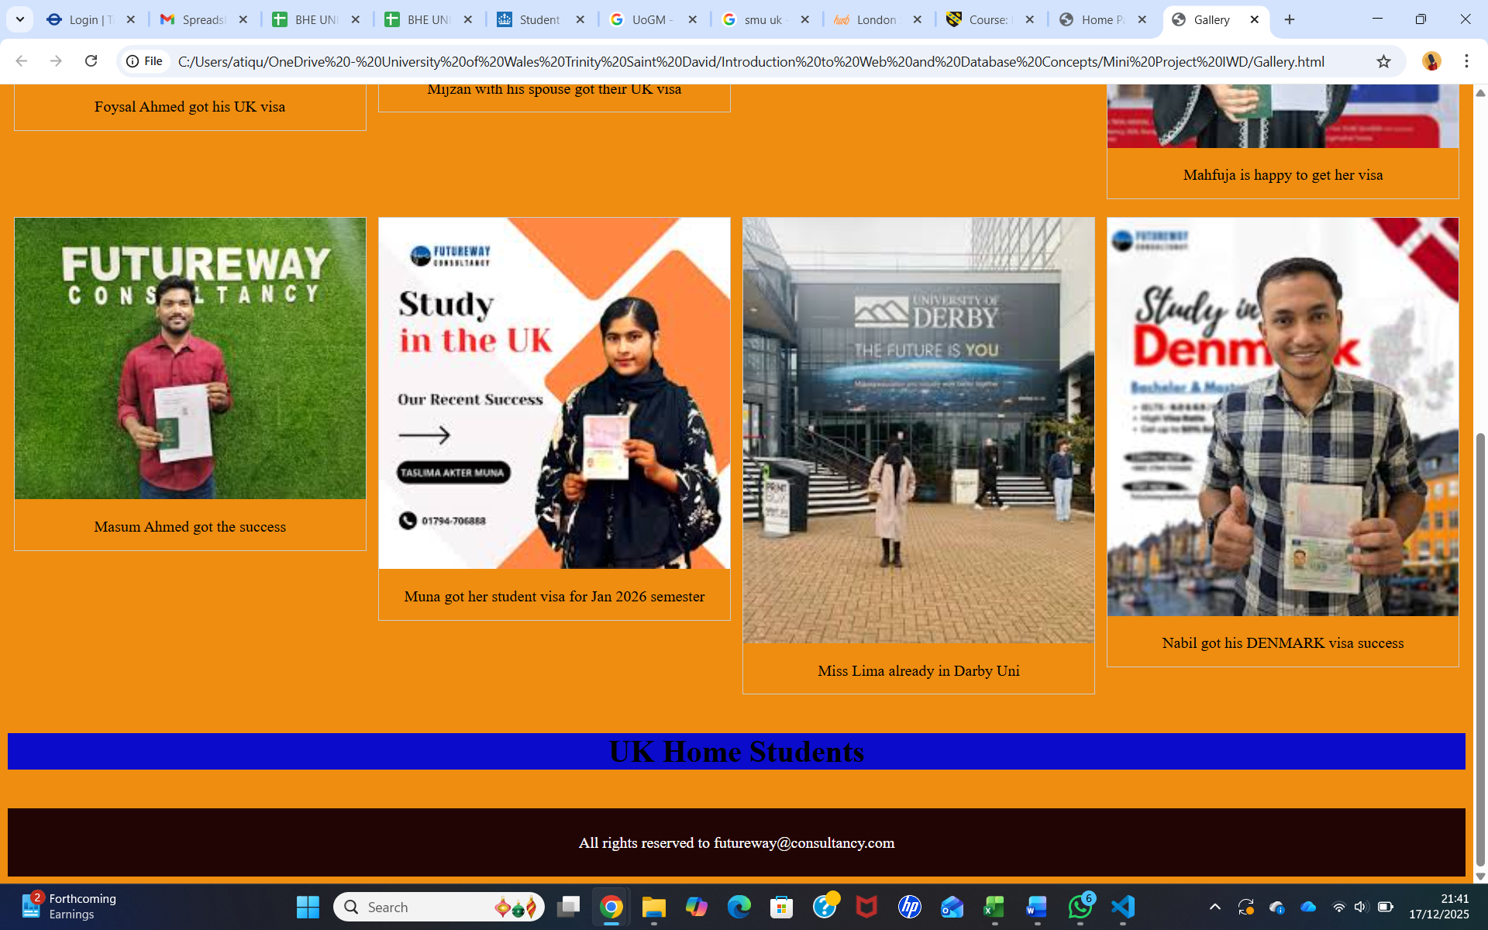

Services page:
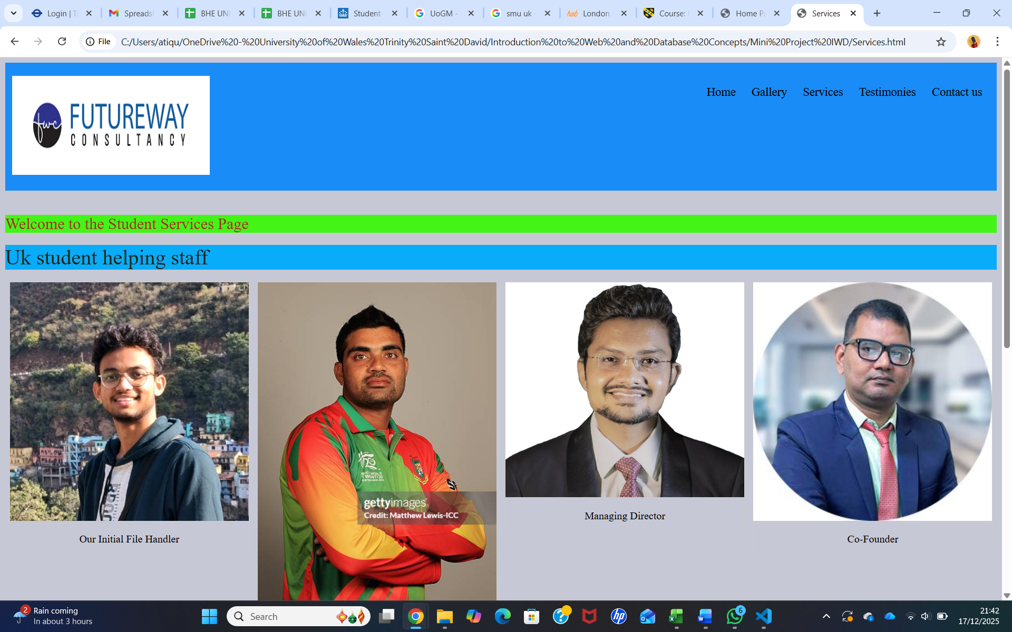
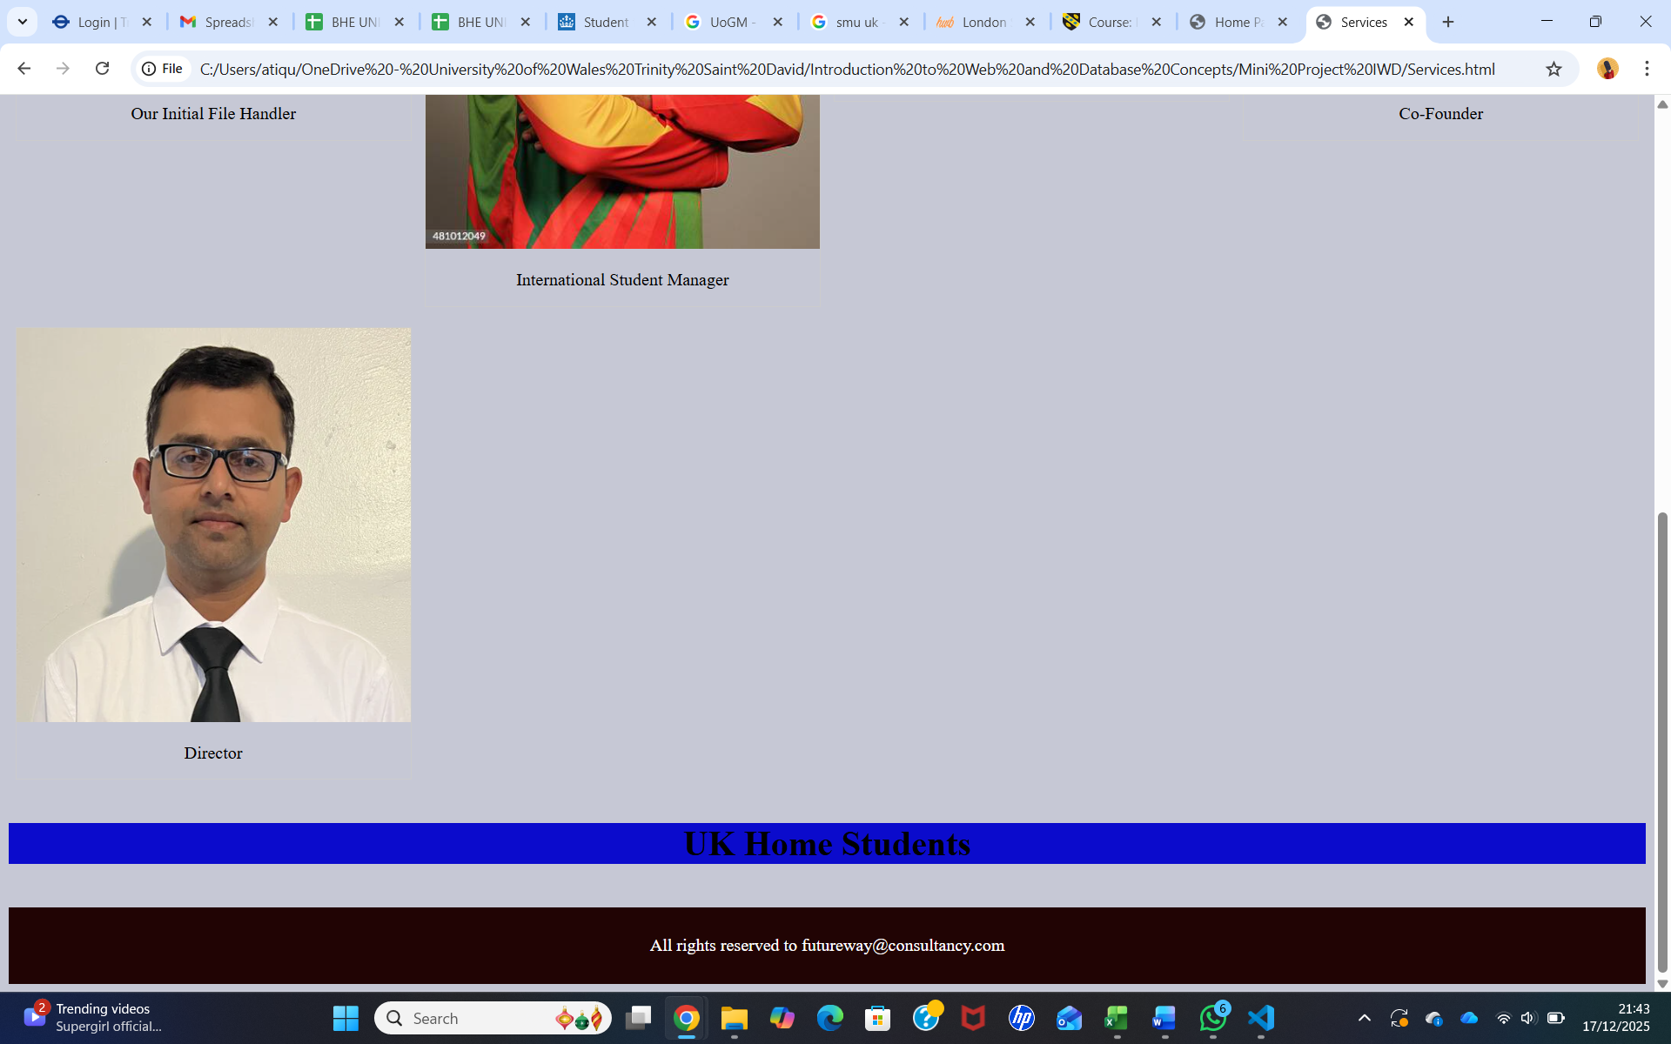

Testimonies page:
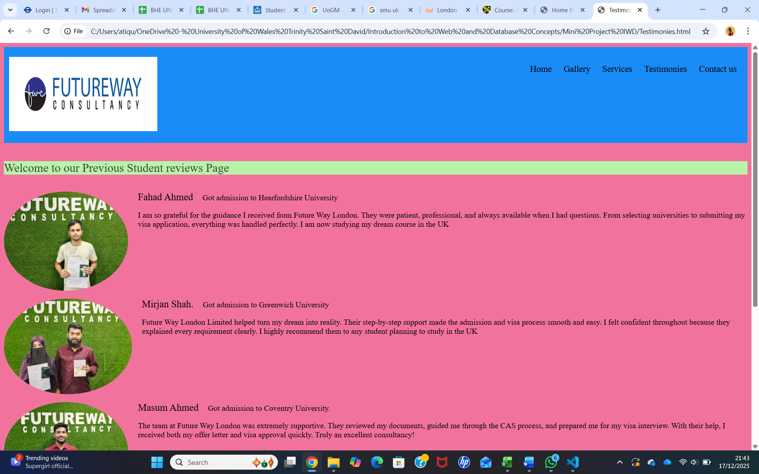
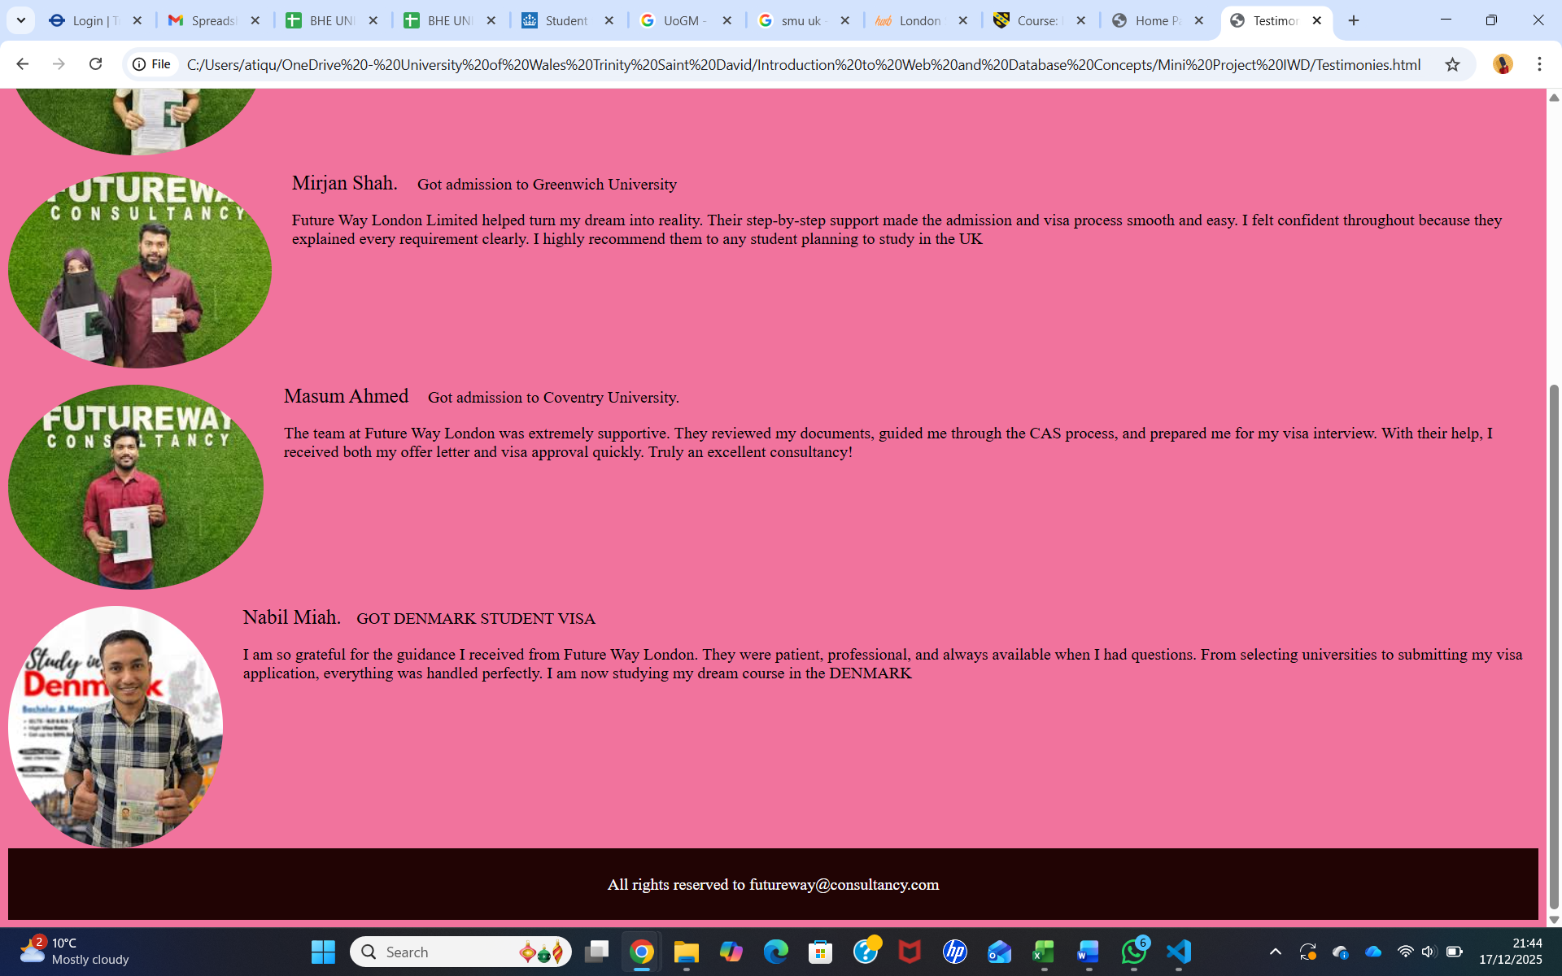

Contact Us page:
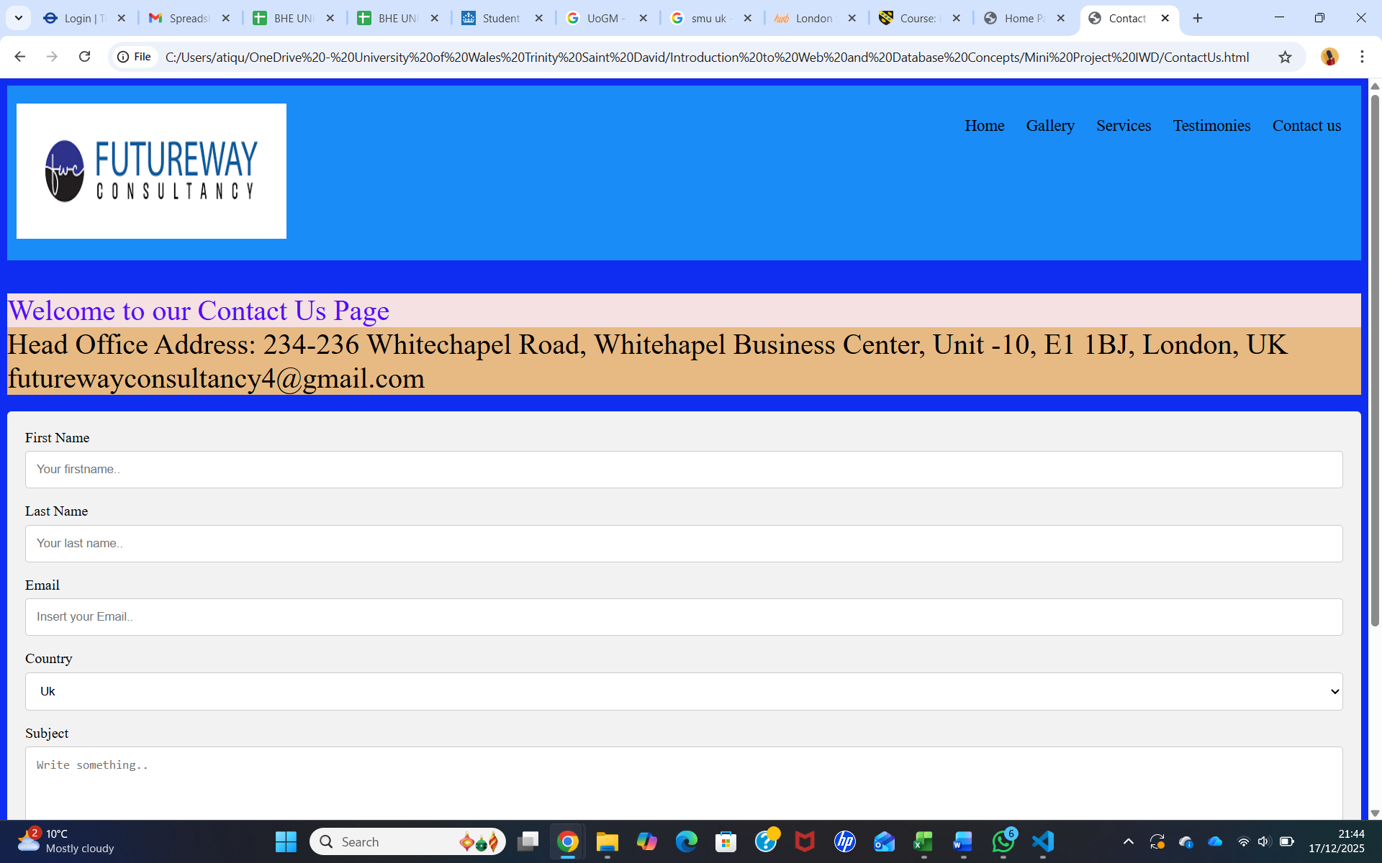
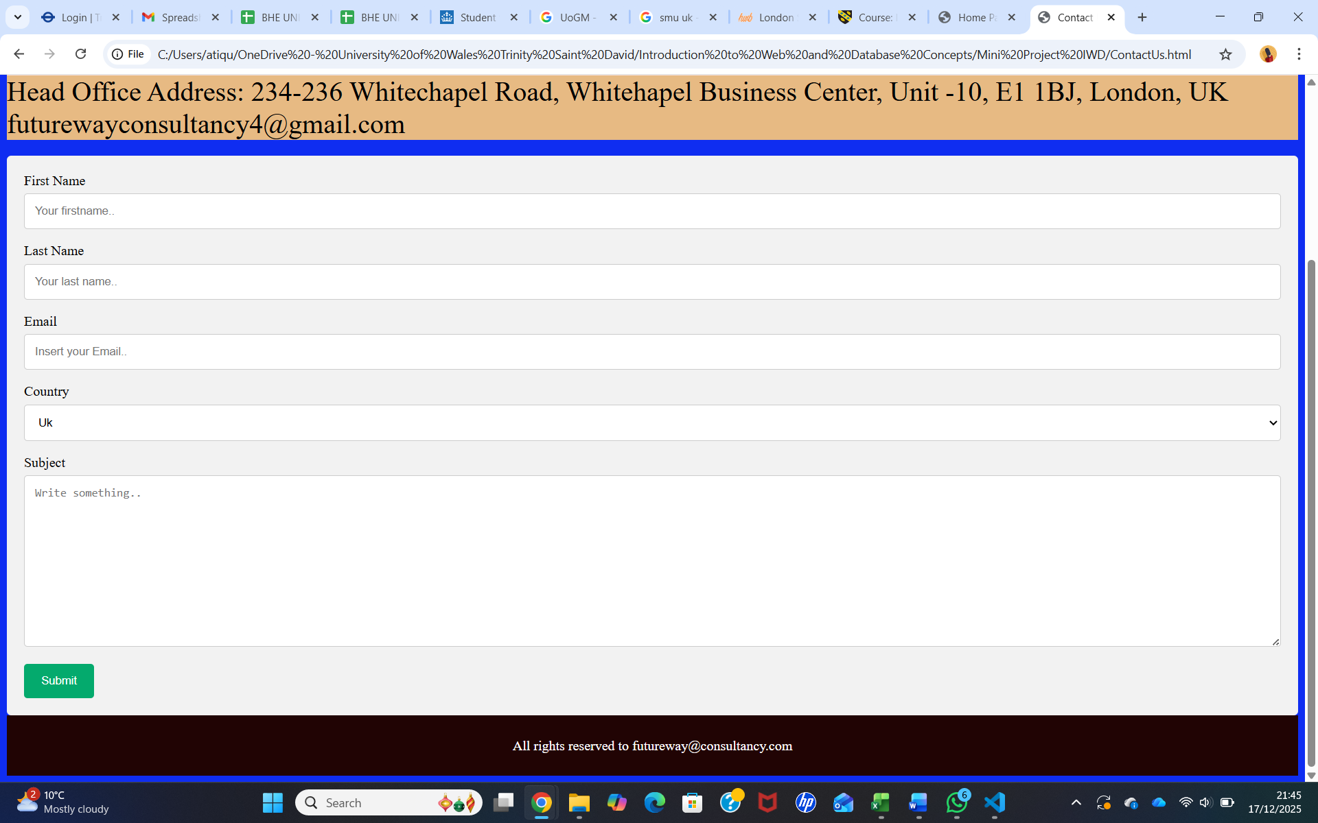

Website Implementation

The website was created using Visual Studio Code as the main text editor. Visual Studio Code is a free and widely used tool that supports web development by making coding easier and more organised. It provides helpful features such as syntax highlighting, which makes the code easier to read, and auto-completion, which helps reduce errors and saves time. It also allows developers to manage multiple files in one place, making the development process more efficient.
The main language used to build the website was HTML (Hyper Text Markup Language). HTML was used to structure the content of the website, including headings, paragraphs, images, navigation menus, and forms. This helped ensure that information was presented clearly and logically for users.
In addition, CSS (Cascading Style Sheets) was used to design and style the website. CSS controlled the layout, colours, fonts, and spacing, helping to create a clean and attractive appearance. It also ensured that the website looked consistent across different pages and devices.
Together, Visual Studio Code, HTML, and CSS made it possible to develop an organised, visually appealing, and easy to maintain website that meets user needs effectively.

Home page HTML (screenshots)
To present Future Way London Ltd in an attractive way, this home page code uses HTML to create a navigation menu with links, a slideshow section with images of several Universities and caption text, and well-structured content areas. CSS is applied to style the page, making it visually appealing and easy to navigate for a student consultancy firm.
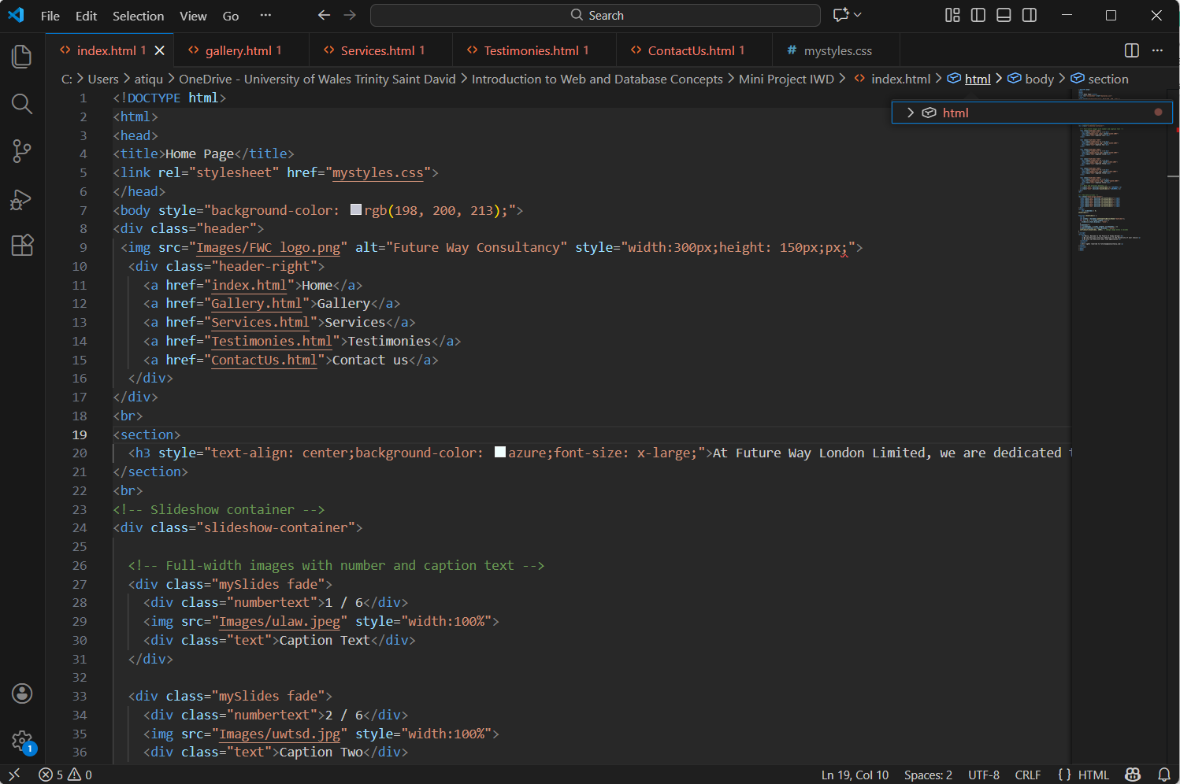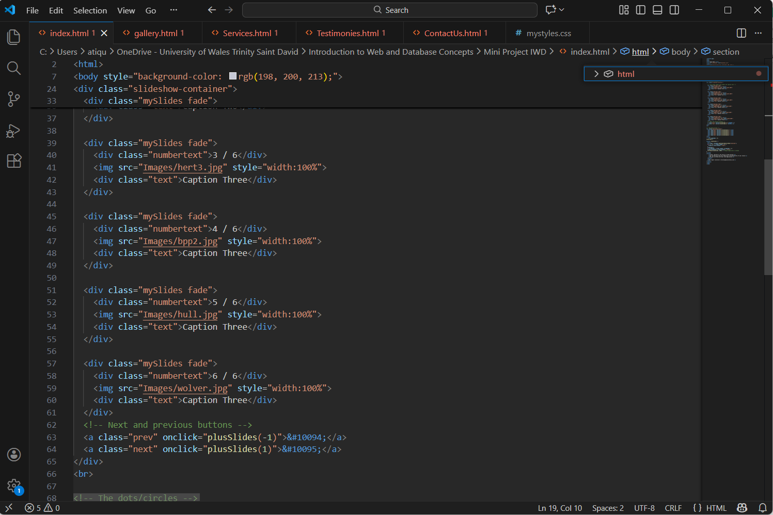
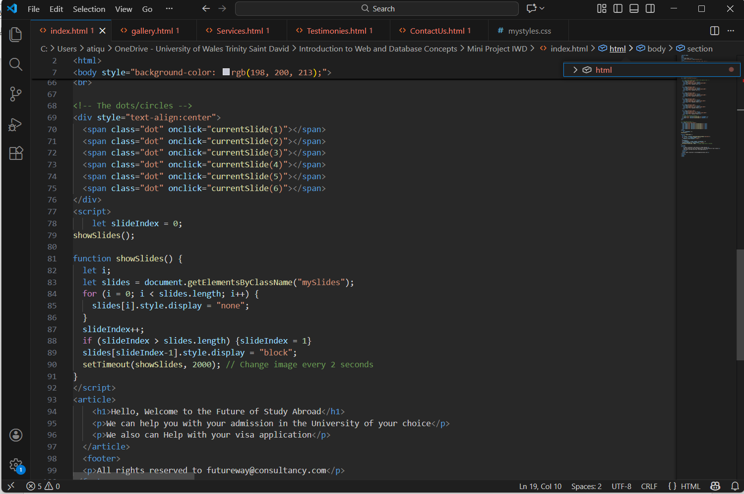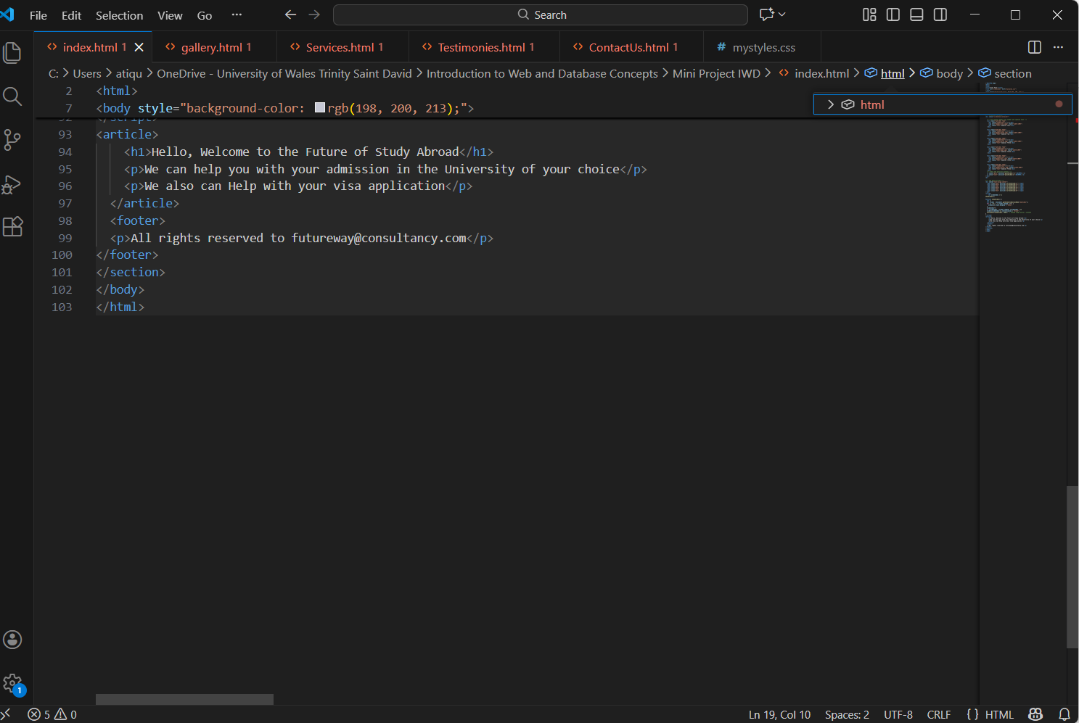

Gallery page HTML (screenshots)
The Gallery page for Future Way London Ltd shows photos related to student consultancy activities in a neat and organised layout using HTML <img> tags and structured sections. Navigation links and CSS styling are used to create a clean and professional-looking gallery suitable for a student consultancy firm.
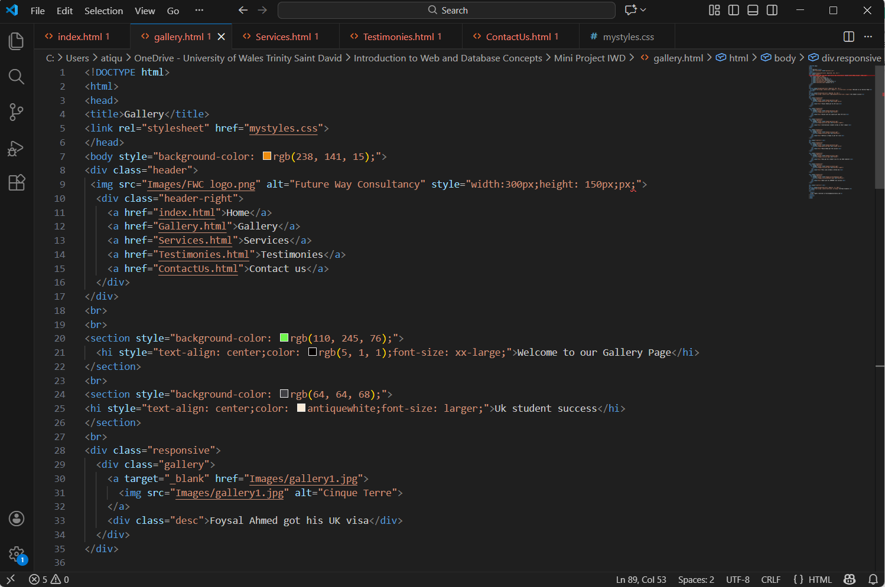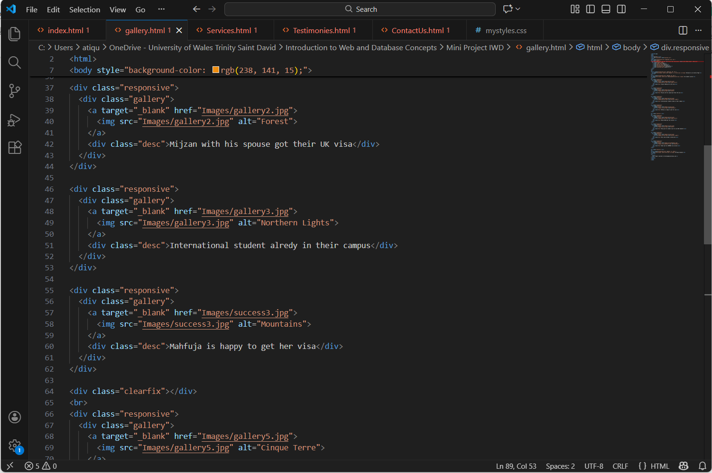
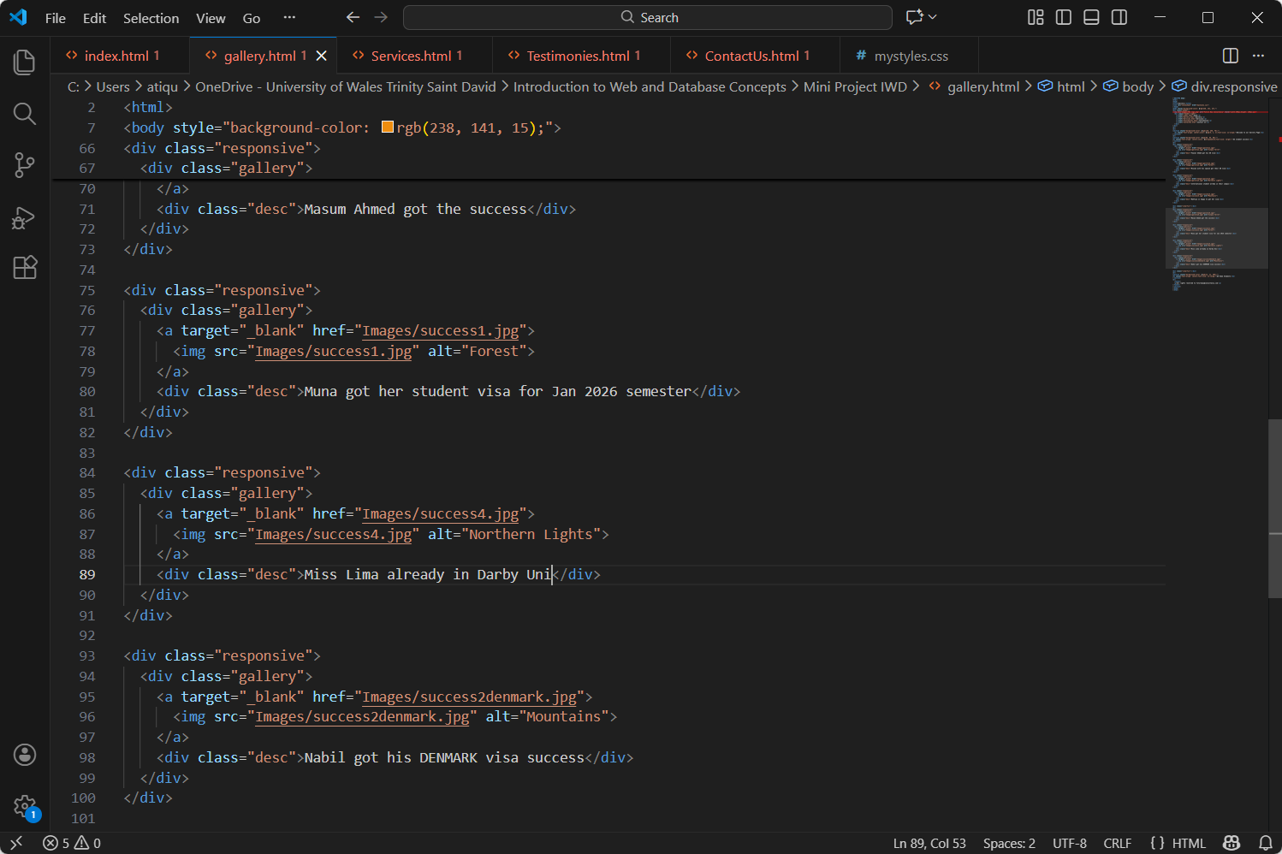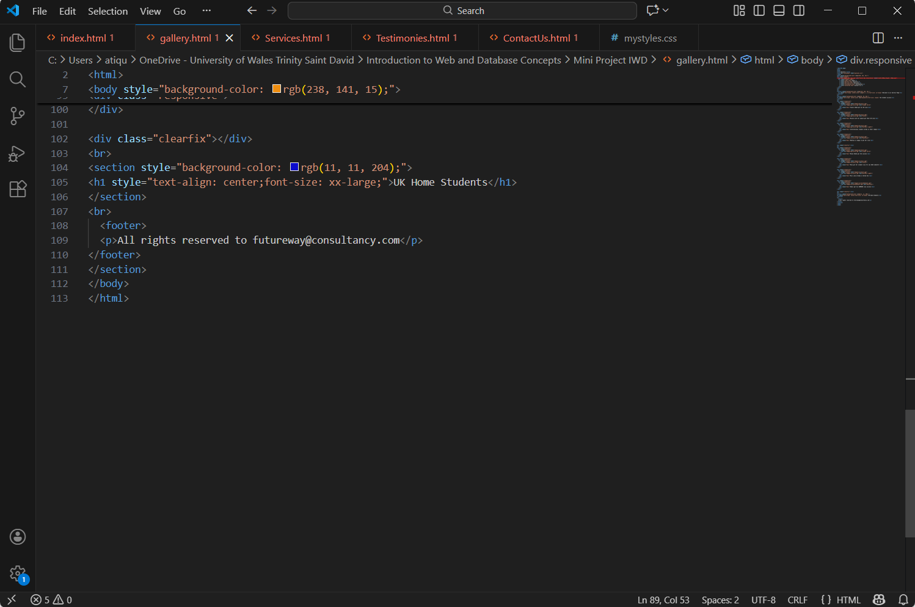

Services page HTML (screenshots)
This Services page is created using HTML in Visual Studio Code. It organizes the navigation menu, headings, and content sections to clearly present the services Future Way London Limited offers.
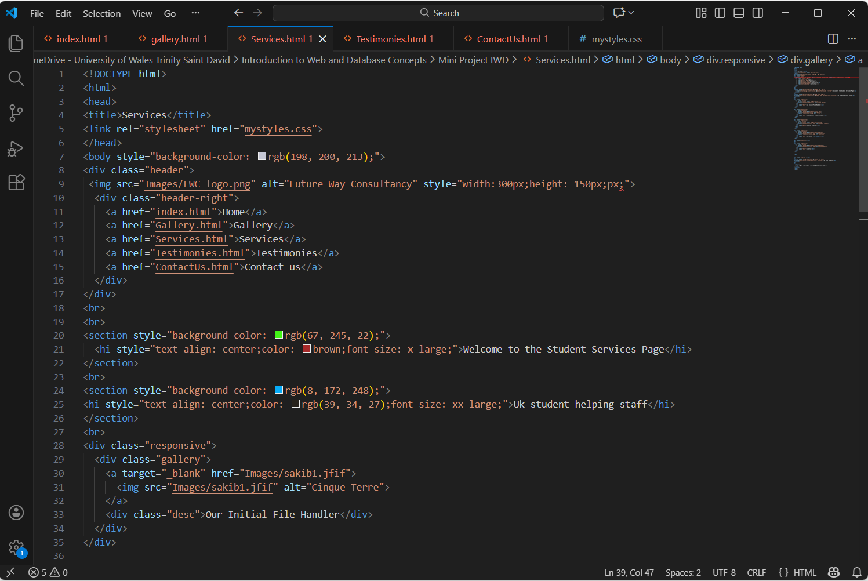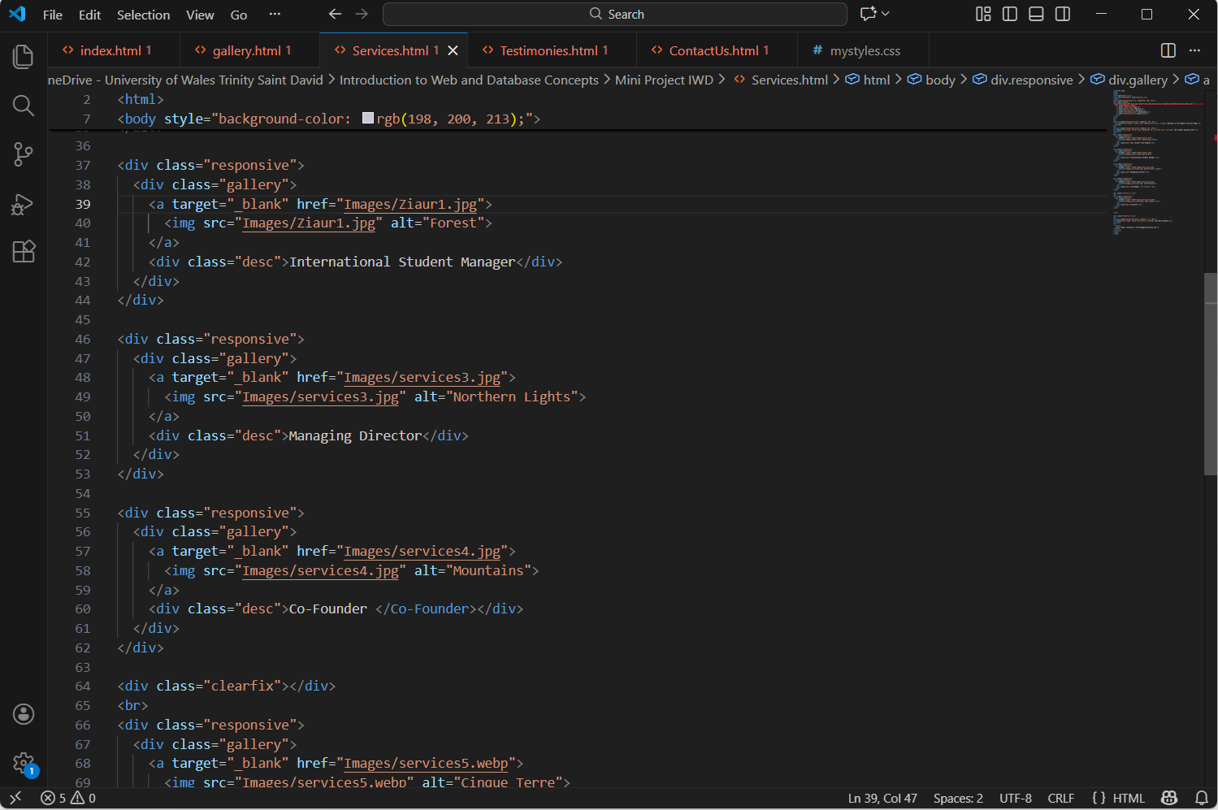
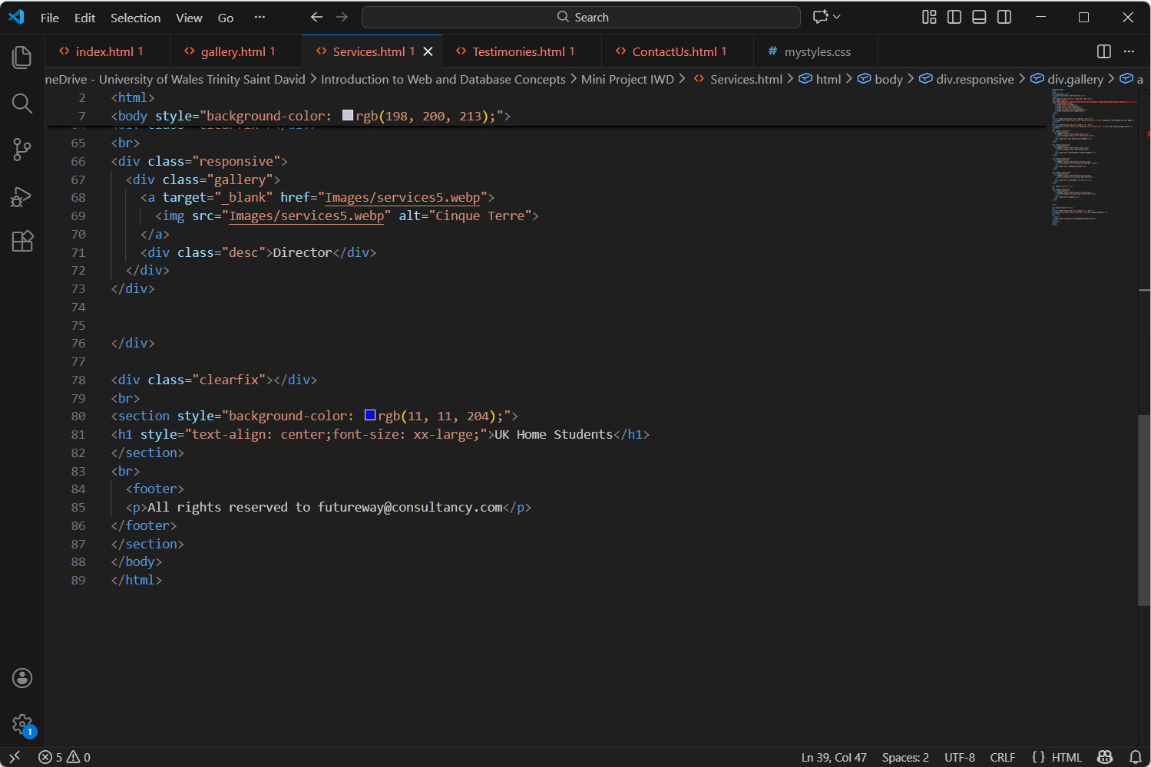

Testimonies page HTML (screenshots)
This page is built using HTML in Visual Studio Code to arrange customer testimonials with headings, images, and text. CSS is used to style the page so it looks clear, easy to read, and helps build trust.
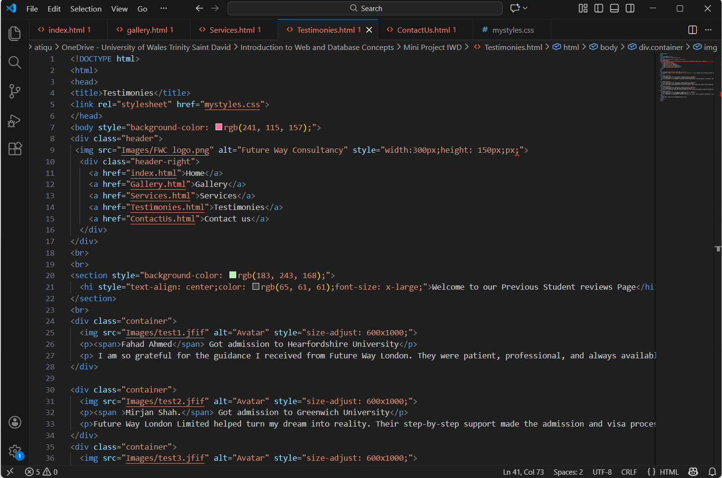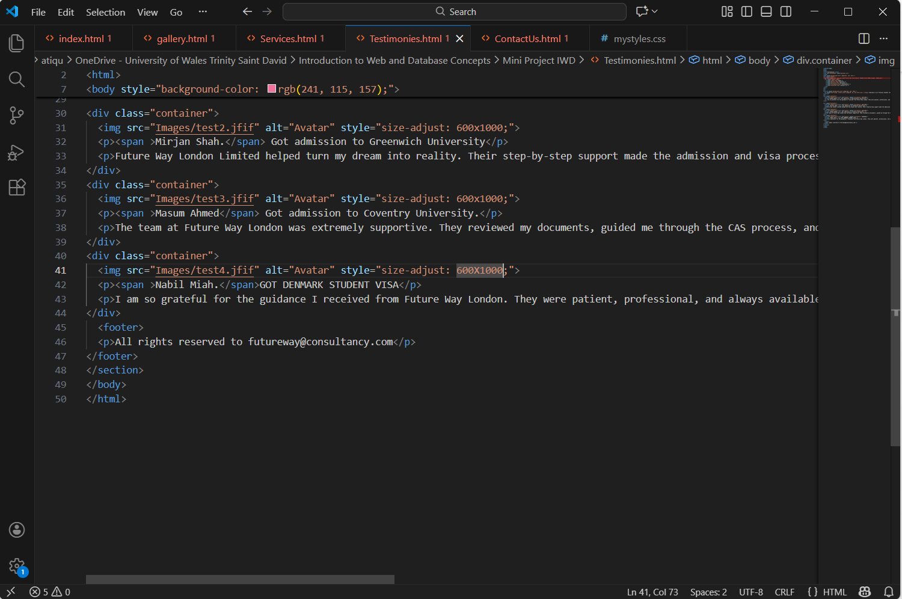

Contact Us page HTML (screenshots)
This Contact Us page is created using HTML in Visual Studio Code. It includes a navigation menu, contact details, and a contact form with input fields. CSS is used to style the page so it looks neat and is easy to read.
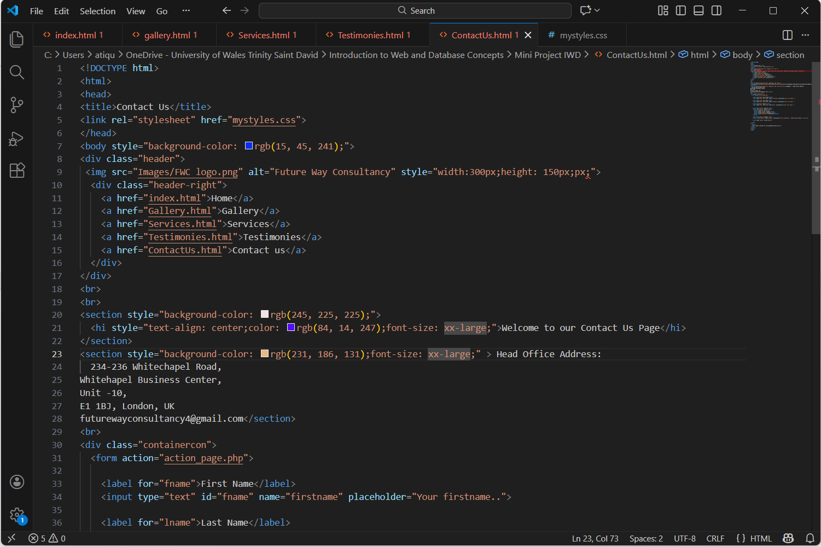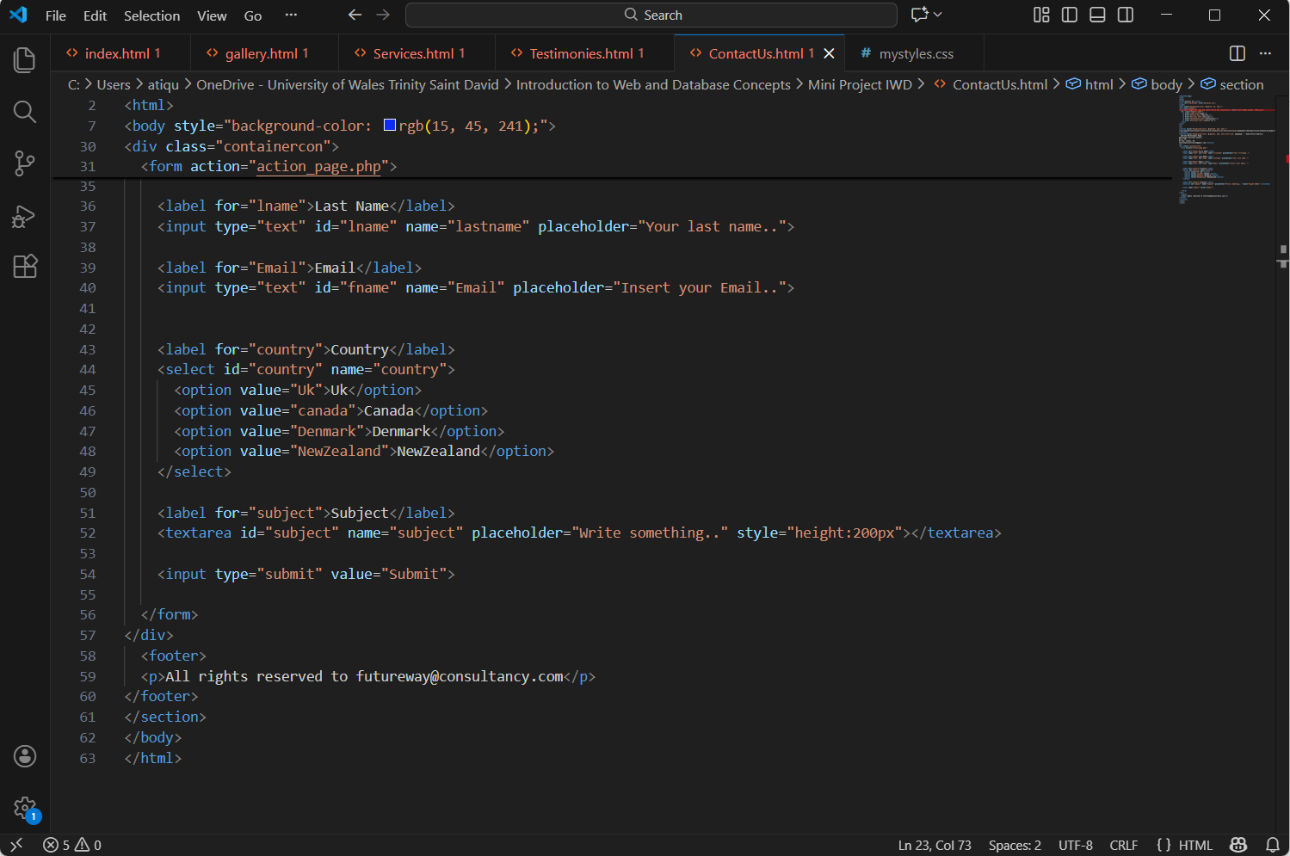

Validating my website

HTML VALIDATION LINK : https://validator.w3.org/

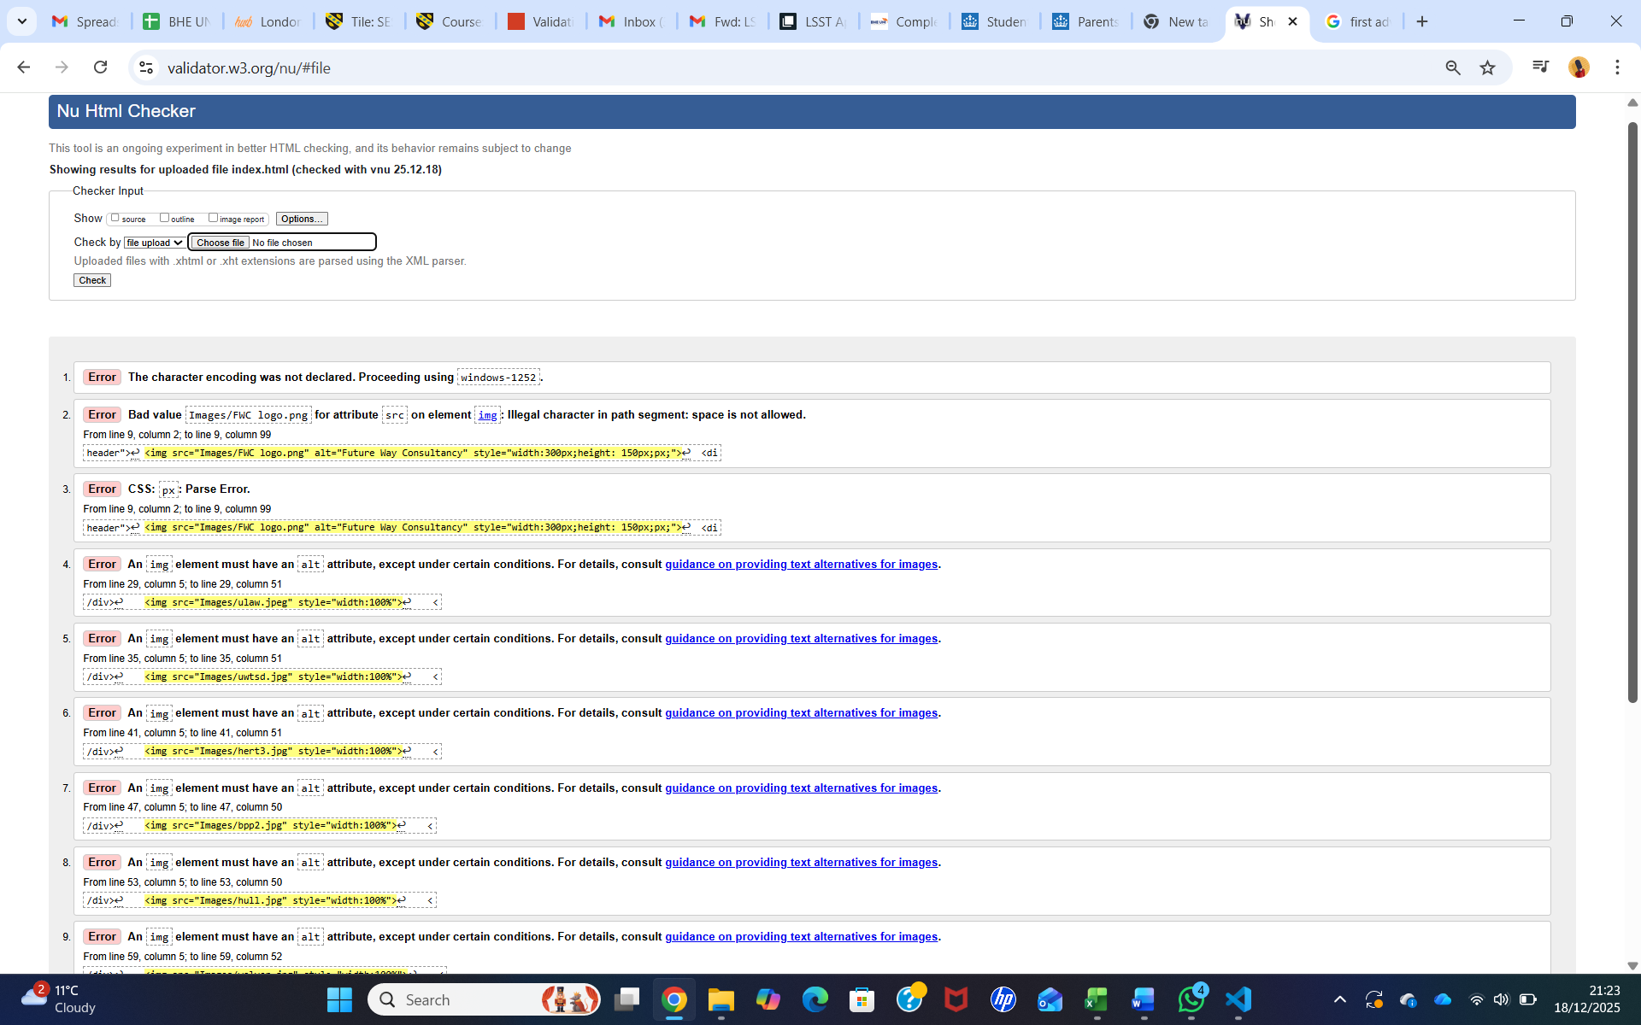
The validator reports multiple errors, including a missing character encoding declaration, invalid image file paths containing spaces and several <img> elements missing required alt attributes. These errors indicate problems with HTML standards compliance, accessibility, and correct file naming.
Fixing these issues will help ensure the webpage follows proper HTML and CSS validation rules and displays correctly

CSS VALIDATION LINK : https://jigsaw.w3.org/css-validator/
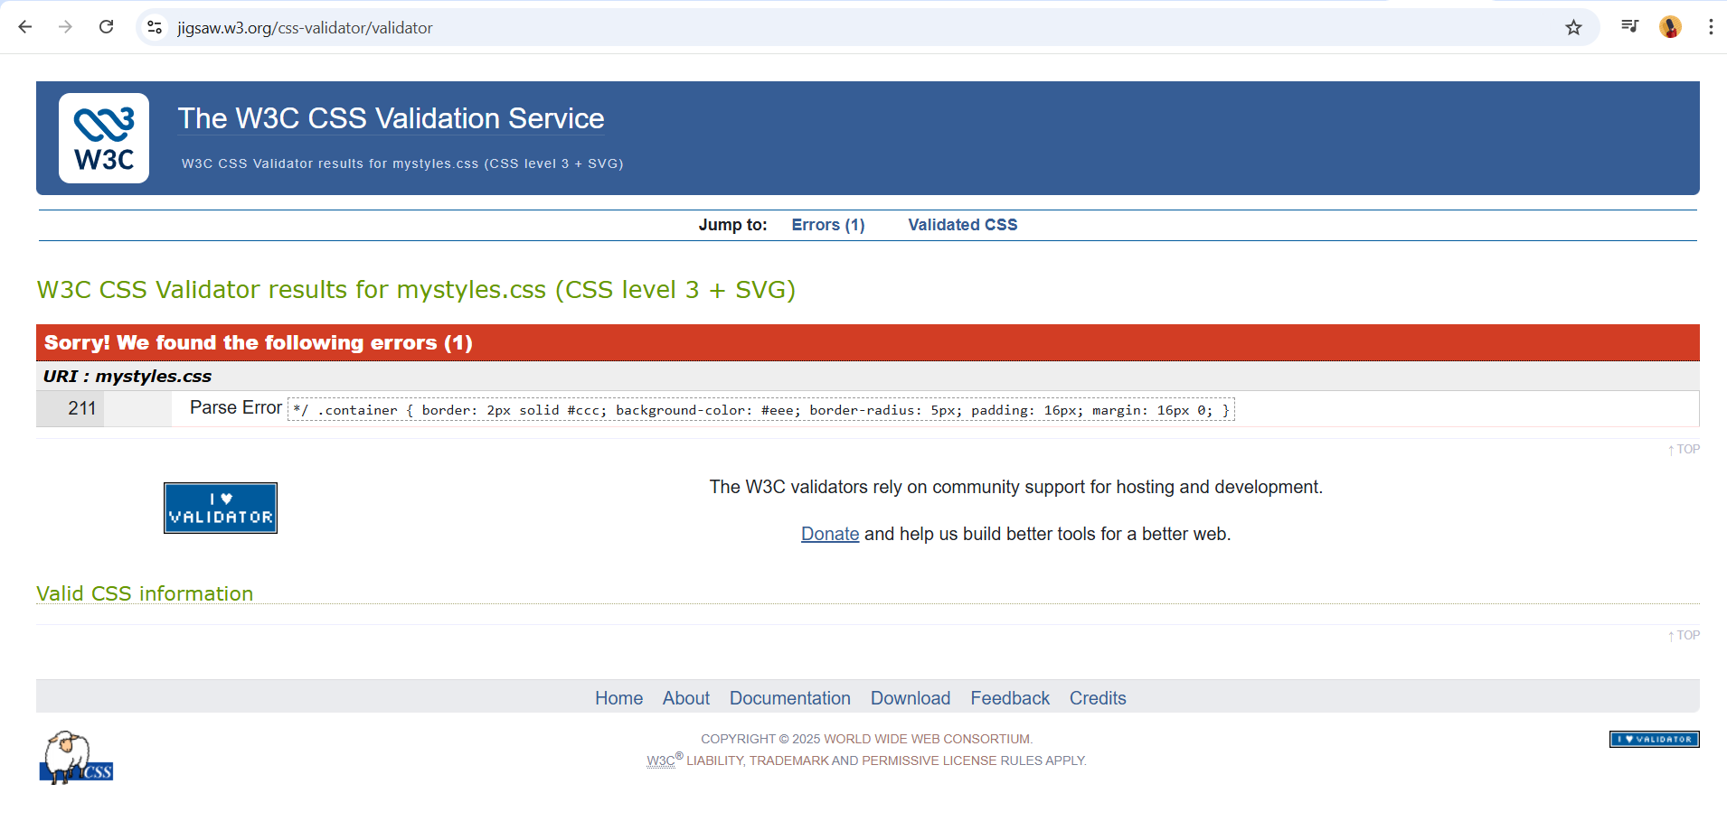
This error means : Parse Error. On mystyles.css, line 211
Reported code: .container { border: 2px solid #ccc; background-color: #eee; border-radius: 5px; padding: 16px; margin: 16px 0;}
A parse error means the CSS parser encountered something unexpected and could not correctly read the stylesheet.
Importantly, the validator often points to the line where it fails, not necessarily where the mistake actually is.

Self-evaluation of my website

The Future Way London Limited website has five main pages: Home, Gallery, Services, Testimonies, and Contact Us. It is created using HTML and CSS. Website usability means how easy it is for users to move around the site, find information, and use its features. In this project, making the website easy to use was very important. The same navigation menu appears on every page, so users can easily switch between sections. Simple colours, clear headings, and easy-to-read fonts help improve the overall experience.
The Home page gives a short introduction to Future Way London Limited and its student consultancy services. The Gallery page shows images related to student activities and success stories. The Services page clearly explains the support and guidance offered to students. The Reviews page builds trust by showing feedback from students, while the Contact Us page makes it easy for people to get in touch with the consultancy.
Compared to professional consultancy websites, this website is quite simple because it does not include features like online booking, animations, or full mobile responsiveness. However, its simple design makes it easy for first-time visitors to understand and use. Overall, the website meets basic usability needs and can be improved further in the future.

Usefulness (usability and utility):
Communication between individuals and organisations has been transformed by the rapid development of Internet technologies and the tools that support them. Today, most successful businesses operate through web platforms that enable them to reach large audiences and international markets, while also improving quality and operational efficiency. For many organisations, the website functions as a key representative of their mission, values and strategic goals. In addition, dynamic websites facilitate a range of interactions such as user registration, purchasing goods and services, making payments, and other essential transactions, helping various stakeholders—including customers, administrators and casual visitors—interact effectively.
From an academic perspective, website usability is a crucial factor in how well a site serves its users. Patterson and Ellis observed that usability plays a central role in communicating information to stakeholders and ensuring that their informational needs are fulfilled through effective interaction with the website. They note that usability has become an important research theme within the field of human–computer interaction (HCI) and is essential for satisfying users’ expectations and requirements in online environments. [1]
Similarly, Yan and Guo argue that a usable website must be designed with the user at its core, ensuring that design decisions align with users’ needs so that they can successfully complete tasks without frustration. Effective web design must prioritise ease of use, intuitive navigation, and a clear structure so that users can find and use the information and services the organisation offers. [2]
In the context of Future Way London Limited website, usability can therefore be defined as the degree to which the website enables users to achieve their goals—such as learning about services, viewing the gallery, or making enquiries—efficiently, effectively, and with satisfaction.

Search Engine Optimisation (SEO):
Search engine optimization (SEO) can be an effective tool for Future Way London Limited to reach prospective students and educational partners. By targeting keywords such as “university recruitment London” or “student support services UK,” the website can appear prominently in relevant search results. SEO also includes structuring clear service pages, providing accurate contact and location details, and optimising page titles and meta descriptions. Features like client testimonials, fast page loading times, and mobile-friendly design enhance both the website’s visibility and user trust. Incorporating images with descriptive captions, as well as linking to social media platforms, further improves search engine performance. Overall, well-implemented SEO increases the consultancy’s online presence, attracts local and international student traffic, and helps expand its client base.

Website Accessibility:

Website accessibility ensures that all users, including those with disabilities, can access and use the website effectively. Key accessibility features include clear navigation, readable fonts, and strong color contrast. Images and graphics should include descriptive alternative text for users who are visually impaired. Compatibility with assistive technologies and full keyboard navigation are also essential. Additionally, mobile responsiveness allows users to access content seamlessly on various devices. By adhering to accessibility standards, Future Way London Limited ensures that all prospective students and partners can easily locate information about programs, services, and contact details, while fostering trust and creating an inclusive online experience.

Conclusion:

This project details the design and development of a fully functional website for Future Way London Limited, a student recruitment and educational support consultancy. The website aims to provide prospective students, parents, and educational partners with clear, accessible information about services, programs, success stories, and contact details. It includes five main pages: Home, Gallery, Services, Testimonies, and Contact Us, each designed to meet specific user expectations. The site was developed using HTML and CSS in Visual Studio Code, ensuring a structured layout, consistent navigation, and visually appealing design.
Key evaluation criteria include usability, SEO, and accessibility. Usability focuses on learnability, efficiency, memorability, error handling, and satisfaction. SEO optimises content, meta data, images, and social media links to improve online visibility. Accessibility ensures inclusive use through clear navigation, readable fonts, descriptive images, and mobile responsiveness. Overall, the website provides an informative, user-friendly, and accessible platform that supports student engagement, trust, and consultancy growth.

Reference

[1] K. Patterson and A. Alles, "Usability and meeting the needs of educational Web site users", Proceedings of the Tenth Australian World Wide Web Conference, pp. 1–13.
[2] P. Yan and J. Guo, "The research of web usability design", 2010 The 2nd International Conference on Computer and Automation Engineering (ICCAE), pp. 480–483.

