
Research on the Change Management of Service Marketing Strategy of Industrial and Commercial Bank of China

Name: Ren Zheng
Student Number: 1811691
Module Title: Strategic Change and Organizations (LCDB7005)
Module Lecturer: Dr. Gladius Kulothungan

UNIVERSITY OF WALES TRINITY SAINT DAVID
Research on the Change Management of Service Marketing Strategy of Industrial and Commercial Bank of China

Abstract
With the development of Internet finance, Industrial and Commercial Bank of China carried out the reform of the service marketing strategy. This paper initially analyzes the changing environment of ICBC's service marketing strategy based on PEST model, micro analysis method and SWOT analysis method, then proposes the necessity of change from seven-aspect strategy using 7PS service marketing theory, also summarizes the changes in 7 aspects, and finally, focuses on analyzing and expounding its organizational structure and design changes from multi-head to customer-oriented.

List of contents
Abstract i
List of contents ii
List of figures iii
List of tables iii
1Introduction 1
1.1Research background 1
1.2Research content 1
2Concept definition and theoretical basis 3
2.1Concept definition 3
2.1.1Service marketing 3
2.1.2Change management 3
2.2 7PS Marketing Theory 3
3Analysis on the changes of the service marketing strategy 5
3.1ICBC introduction 5
3.2Cause analysis 6
3.2.1Change environment analysis 6
3.2.2Cause of changes 16
3.3 Changes based on 7PS service marketing theory 17
3.3.1Product: enrich product system 18
3.3.2Price: increase service value 20
3.3.3Place: increase channel reform 21
3.3.4Promotion: launching multimedia promotion 21
3.3.5People: optimize the team and organizational structure 22
3.3.6Process: optimizing service processes 23
3.3.7Physical environment: enhance the image display of outlets 25
4Organizational structural choices and design changes 26
5Conclusion 30
References 31

List of figures
Figure 1 Research content 2
Figure 2 7PS marketing mix 4
Figure 3 PEST analysis 6
Figure 4 Staff structure change 11
Figure 5 SWOT analysis 12
Figure 6 7PS marketing mix 17
Figure 7 Internet financing scale and usage rate(2015.12-2018.06) 19
Figure 8 Traditional counter personal customer account opening process 24
Figure 9 Intelligent machine personal customer account opening process 24
Figure 10 Changes based on 7PS service marketing strategy 25
Figure 11 Organizational structure change 26
Figure 12 Multi-head service marketing organization structure 29
Figure 13 Customer-oriented service marketing organization structure 29

List of tables
Table 1 Customers amount arriving at a branch of ICBC per month 9
Table 2 Service and product needs of customers of different age 19
Table 3 Differential pricing strategy 20

1Introduction

1.1Research background
In the past few years, the development of Internet finance has changed the behavior of customer financial consumption(Yixi, 2013), resulting in a continuous decrease in the number of customers, a continuous decrease in the volume of counter transactions, and a great threat to the business performance of Industrial and Commercial Bank of China(ICBC)(Juan, 2017).
In order to cope with the change of the competition form of the bank and enhance the core competitiveness, ICBC carried out the reform of the service marketing strategy，changing organizational structure from multi-head service marketing structure to customer-oriented one(Zhicheng, 2000; Gan et al., 1990).

1.2Research content
This paper first analyzes the changing environment of ICBC's service marketing strategy based on PEST model, micro analysis method and SWOT analysis method. Then from the perspective of 7PS service marketing theoretical perspective, this paper proposes the necessity of change from seven-aspect strategy: product, price, channel, promotion, person, tangible display and process. Also, this paper summarizes the changes in 7 aspects: enriching the product system, improving service value, increasing channel reform, carrying out multimedia promotion, optimizing the team of personnel, improving the image display of outlets, and optimizing process services. Finally, this paper focuses on analyzing and expounding its organizational structure and design changes from multi-head to customer-oriented（Figure 2）.
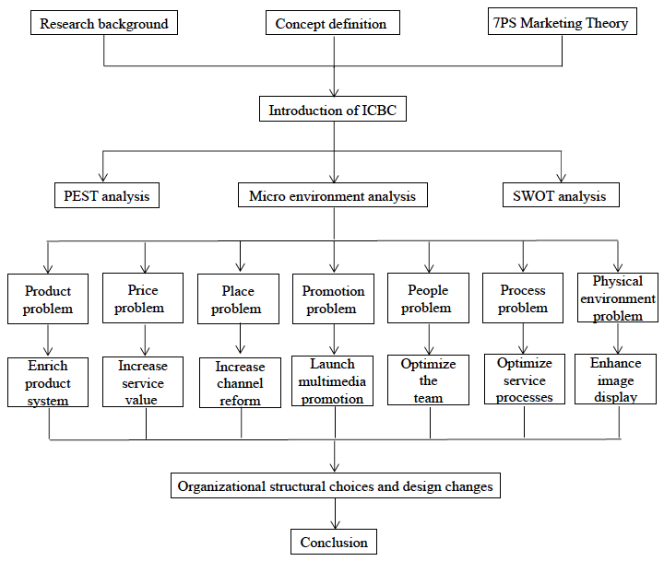
Figure 1 Research content

2Concept definition and theoretical basis

2.1Concept definition

2.1.1Service marketing
Service marketing refers to a series of measures taken by the company in the marketing process to fully meet the needs of consumers under the premise of fully understanding the needs of consumers(Grönroos, 1982; Lusch and Vargo, 2014; Wilson et al., 2016; Zeithaml et al., 2006).

2.1.2Change management
Change Management refers to the organizational change strategy that must be made when an organization is slow to grow ，its internal problems are constantly occurring and it cannot adapt to changes in the business environment(Gill, 2002). Change Management includes making necessary adjustments and improvements to internal levels, workflows, and corporate culture，the core of which is management change, and the success of management change comes from change management(Todnem By, 2005).

2.2 7PS Marketing Theory
Service refers to an activity that is invisible, does not involve physical objects and transfers ownership, and can be distinguished, defined and satisfied with individual desires and interests(Akroush, 2011). Compared to tangible products, services are intangible, heterogeneous, synchronic and perishable(Akroush, 2011; Dev, 2000). the marketing theory of 7ps believes: "products, prices, places, promotions, people, physical evidence, processes are the core of marketing theory. "which reveals the importance of employee’s involvement in the entire marketing campaign. Compared with the 4S theory, which focuses on products, 7PS theory (Figure 3) focuses on services, and is the basis of service marketing.
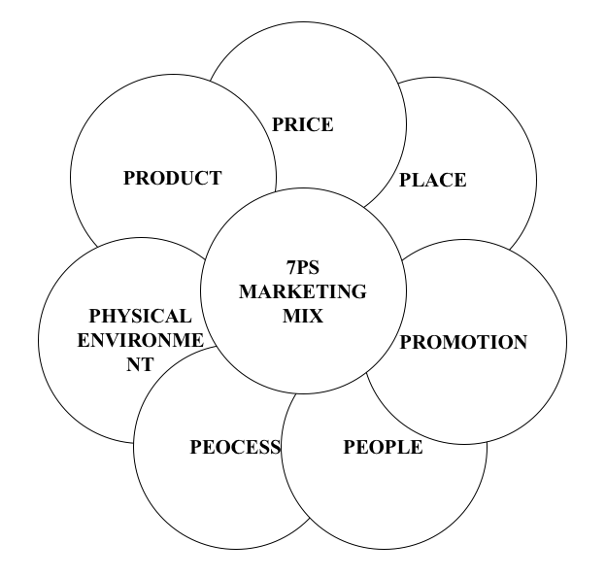
Figure 2 7PS marketing mix

3Analysis on the changes of the service marketing strategy

3.1ICBC introduction
ICBC was established on January 1, 1984. It was successfully converted into a joint stock limited company on October 28, 2005. It was successfully listed on the Shanghai Stock Exchange and the Hong Kong Stock Exchange on October 27, 2006. Become a listed company. After years of continuous efforts and steady operation, ICBC has entered the ranks of the world's leading banks with its high customer base, diversified business structure, strong innovation capability and market competitiveness. ICBC regards service as the foundation of its business and strives to become the “preferred bank of customers”, providing comprehensive financial products and services to 6.271 million corporate customers and 567 million individual customers worldwide; ICBC always insists on steady progress, innovation and progress, and actively embraces the Internet; ICBC always adheres to professional focus, develops professional business models, and forges "big craftsmen." ICBC's international and integrated business structure has been continuously improved, and its overseas network has expanded to 45 countries and regions, and its profit contribution has further improved. At the end of 2017, the total assets of ICBC was 2,607.743 billion yuan, with an increase of 1.9497 trillion yuan and an increase of 8.1% over the end of the previous year; total liabilities of 239,459.87 billion yuan, with an increase of 178.88 billion yuan or 8.1% over the end of the previous year; net profit for the year was 287.451 billion Yuan, an increase of 3.0%( Industrial and Commercial Bank of China official website).
ICBC has the traditional advantages of state-owned commercial banks: strong financial strength, complete business types, and a large number of customers. Moreover, from 2015, ICBC began to carry out intelligent transformation of outlets and increase intelligent equipment. In addition to the traditional countertop deposit and withdrawal, POS machines, etc., ICBC also uses smart machines to quickly handle the expenses of customers, transfer accounts, etc., and also handles the application for credit card, scan code payment, etc. through e-banking channels(Industrial and Commercial Bank of China official website).

3.2Cause analysis

3.2.1Change environment analysis

3.2.1.1PEST analysis
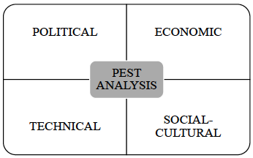
Figure 3 PEST analysis

(1) Macro environment analysis
(1)Political environment - the overall international instability & China's steady progress
In international politics, although the global economy has gradually warmed up since the outbreak of the 2008 financial crisis, the overall situation is unstable, and political problems in some areas have intensified, such as the US trade war, the Greek debt crisis, and the Italian political crisis. Under this international political environment, China is still afraid of being hit by the global financial turmoil and the US trade war(Liyun, 2017; Heskett, 1986). In China's politics, the 2018 Central Economic Conference proposed that economic development will continue to be based on “stable progress”. In the current stage, the goal is to promote the development of a domestic economy to a high-quality route which all policy institutions and enterprises need to fully recognize, comprehensively understand, actively convey and implement(Booms and Bitner, 1982).

(2)Economic environment - international performance differentiation & China’s transition
In the global economy, affected by regional politics, the economic performance of major economies has been severely divided. The financial markets in emerging economies have experienced volatility and the debt crisis has emerged. This has laid a hidden danger for the global economic recovery(Schneider and Chung, 1993). In terms of China's economy, China's economy is still in a critical period of economic transformation, and it is necessary to continue to promote supply-side structural reforms. And the tightening of financial supervision has a strong contraction effect on the economy. At the same time, the promulgation of the new regulations for asset management has accelerated the transformation of the commercial bank's asset management business model(Wei, 2010).

(3) Social environment - Internet financial shock
In 2010, since Alibaba introduced the fast payment function of Alipay with Taobao platform, the third-party payment platform has broken the restrictions that people can only be settled and paid at commercial bank outlets, and has developed rapidly, thus changing people's payment methods and habits. As Internet finance companies continue to grow and Internet innovation products continue to be introduced, if commercial bank outlets will not be able to adjust their own pace as soon as possible, improve their service levels, and bring more personalized and differentiated services to customers， commercial banks will Gradually lose the loyalty of customers, their own market competitiveness, and their leading position in the financial market.

(4)Technology environment - opportunities and challenges coexist
The development of Internet finance brought about by the cross-border cooperation between Internet technology and e-commerce and finance breaks the monopoly position of commercial banks in the settlement of funds. On the one hand, it affects the bank's business model and business performance, on the other hand, it also promotes the bank’s own business innovations, such as the "e-ICBC" Internet finance brand and the development of online banking, mobile banking, smart terminals and other online businesses.

3.2.1.2Micro environment analysis
(1) Customer demand change
With the rise of third-party payment platforms and Internet finance, the financial consumption of customers has gradually changed from offline transactions to online transactions, from counter transactions to online banking transactions, which has gradually reduced the number of ICBC customers.
Table 1 Customers amount arriving at a branch of ICBC per month
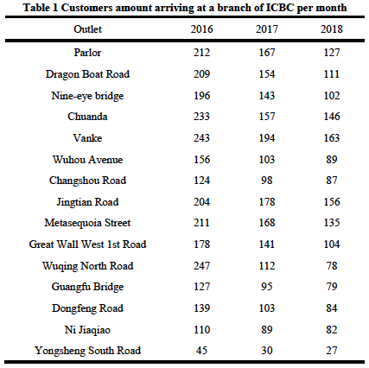
Data source: Statistics of service points of a branch of ICBC

Table 1 is a statistical table of the number of customers who have been randomly selected from 15 branches of the ICBC in the past three years. The table shows that the average number of customers arriving at each outlet has been decreasing year by year. The decrease in the number of customers arriving at the store has affected the growth of business performance of bank outlets under the traditional marketing model. However, according to data from the China Internet Network Information Center, the demand for financial products has not decreased, and the number of Internet wealth management customers has shown a booming trend. The foundation of Internet finance is bank accounts. 95% of account opening is handled at commercial bank outlets(China Internet Network Information Center). It can be seen that customers are still inseparable from the basic services provided by commercial banking outlets, but only for differentiated and personalized finance. Product demand is getting higher and higher. This puts demands on the reform of the bank's service marketing strategy.

(2)Staff structure change
With the development of Internet finance, ICBC has promoted the transformation of online and offline integrated services of outlets, breaking the barriers of personnel posts, and increasing the demand for marketing personnel in the case of a decrease in the overall number of outlets. It can be seen from Figure 5 that the total number of personnel in the 15 branches of the ICBC has declined in the past three years, and the proportion of marketers has been increasing year by year. In the ICBC system, the person in charge of the network belongs to the management sequence, and the operation supervisor belongs to the professional sequence. The account manager, the A-type customer service manager, and the B-type customer service manager are all sales sequences. The tellers belong to the operation sequence Industrial and Commercial Bank of China official website. Due to the labor combination plan of the head office outlets, the teller is canceled. Compilation, breaking the post barriers, enriching the front-end marketing, will change the job responsibilities of the tellers who belong to the operation sequence, become the B-type customer service manager of the sales sequence, and enrich the outlet marketing from the staffing, which shows that the marketing staff and service marketing needs are improved.
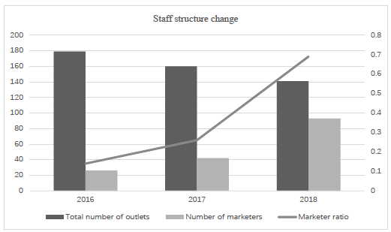
Figure 4 Staff structure change

3.2.1.3SWOT analysis
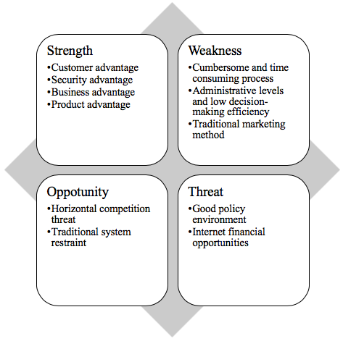
Figure 5 SWOT analysis

(1)Strength analysis
1)Customer advantage
As one of the five most important state-owned commercial banks in China, ICBC has customer resources and scale advantages. As of the end of June 2018, according to the MOVA system data of the industry, the balance of various loans of ICBC reached 30.2 billion yuan, the balance of various deposits was 22.3 billion yuan, the number of corporate customers was 12,000, and the number of individual customers was 847,700, which prevailing the certain customer resources and scale advantage(Liang and Peihua, 2009; Liyun, 2017).

2)Security advantage
On the one hand, the booming of Internet finance was initially based on its convenience, but its security verification in the transaction payment process is relatively simple and risky. On the other hand, the process of commercial banks is a bit more complicated, but it is guaranteed in terms of transaction security and account security(Liwen, 2004; Bell, Auh and Smalley, 2005).

3)Business advantage
After years of operation, ICBC has become a Fortune 500 company, and its internal risk management level, external risk prevention and control system and operation management system have been relatively improved(Jiefang, 2009; Bowen and Lawler III, 2006; Liang and Peihua, 2009).

4)Product advantage
As a comprehensive full-featured state-owned commercial bank, ICBC's outlets cover personal financial services such as personal finance, personal loans and merchant POS machines, credit cards, as well as corporate financial services such as corporate loans, corporate finance and corporate annuities. 4, product advantages
ICBC's business is complete to meet the full range of financial services needs of its customers(Yi, 2018).

(2)Weakness analysis
1) Cumbersome and time consuming process
Traditional state-owned commercial banks are required by the supervision departments of the People's Bank of China and the Banking Regulatory Bureau(Wei, 2010). In order to prevent risks and retain original evidence when designing business processes, customers need to fill in a large number of certificates and sign various agreements, making the process cumbersome and time consuming(Wei, 2010). It is easy to trigger customer complaints and reduce customer satisfaction(Liyun, 2017).

2)Administrative levels and low decision-making efficiency
The traditional state-owned commercial banking institutions are complicated, have many administrative levels, and have low decision-making efficiency(Liyun, 2017). They cannot meet the personalized financial service needs of customers in time and affect the quality of customer service(Wei, 2010).

3)Traditional marketing method
In the actual operation process, ICBC still adheres to the traditional service marketing thinking of the “business-oriented” business banking industry in the old era. It does not recognize the “customer-centered” modern service marketing concept, does not form the active marketing modernity in the subconscious, and lacks of in-depth service and marketing maintenance for existing customers of outlets(Liang and Peihua, 2009).

(3)Opportunity analysis
1)Good policy environment
Although the overall international economic situation is still in the recovery stage after the 2008 financial crisis, there are still many uncertain factors in the economic recovery(Regan, 1963). However, the domestic political policy is based on the idea of “steady progress and improvement” as the basic idea of economic development, and continuously optimizes the regional development pattern. Informationization and urbanization will further increase the financial needs of the entire region(Jiefang, 2009).

2)Internet financial opportunities
Internet finance is an innovative financial model in which Internet technology and finance are integrated. The emergence of this model is both challenging and full of opportunities(Juan, 2017). Internet finance has caused threats and impacts on traditional commercial banks, and its development has also provided a new direction for the transformation of traditional commercial banking reforms, thus accelerating the self-innovation and self-upgrading of traditional commercial banks' business models and service models. Traditional commercial banks can try to seize the new opportunities arising from Internet finance through three aspects: 1 clarify their own positioning and clarify their core competitiveness. 2 Stabilize traditional business and expand innovative business. 3Using new technologies to create new advantages(, 2014).

(4) Threat analysis
1)Horizontal competition threat
On the one hand, since China's accession to the WTO in 2003, with the gradual opening of the financial market, foreign banks have gradually entered the domestic financial market, and their high-quality, personalized services have had an impact on the ICBC(Liang and Peihua, 2009). On the other hand, Internet finance companies have attracted a large number of customers with their convenience and difference, forming a threat to the development of ICBC's business performance(Booms and Bitner, 1982; Juan, 2017).

2) Traditional system restraint
As a large state-owned commercial bank, ICBC has complicated processes and organization, lacks of scientific organization design, and respond insensitively to external economic development environment, which is not conducive to improving ICBC’s overall competitiveness(Liang and Peihua, 2009).

3.2.2Cause of changes
Combined with the above changing environment analysis, including PEST macro-environment analysis, micro-environment analysis, SWOT analysis and literature collection, this paper summarizes the reasons for the changes in ICBC's service marketing strategy from the perspective of 7PS marketing theory(Jindong, 2013; Akroush, 2011):
- Product. Product types are not enough rich, service model is not innovative;
- Service. Personalized service, differentiated service is not obvious;
- Place. Insufficient understanding of electronic channels hinders the development of intelligent trading and Incomplete marketing channel integration hinders the online development of trading;
- Promotion. Lack of publicity of new terminal;
- Personnel. Lack of awareness of personnel service and marketing skills and efficient organizational structure;
- Process. Service process is complex and non-standard;
- Physical environment. The tangible display does not meet the tangible display needs of the Internet finance era: interactivity and experience.

3.3 Changes based on 7PS service marketing theory
This part explains the following seven aspects of ICBC's service marketing form the theoretical perspective of the 7PS service marketing strategy.
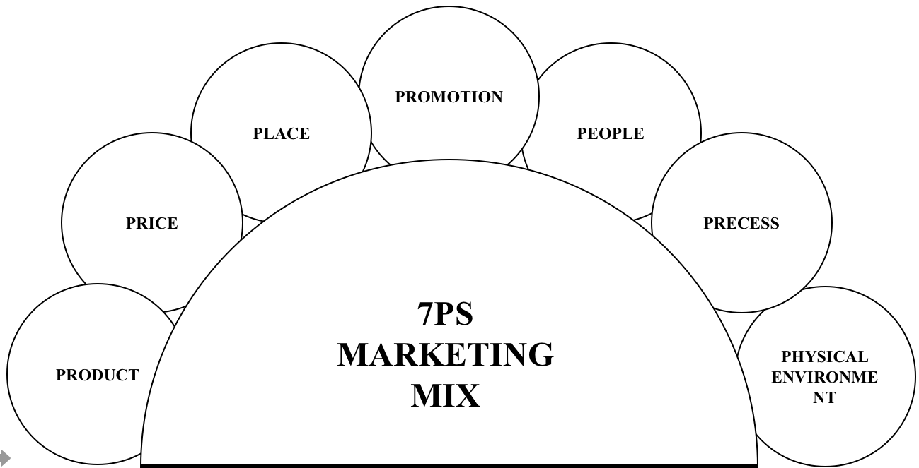
Figure 6 7PS marketing mix

3.3.1Product: enrich product system
The original main financial products of ICBC were concentrated in traditional financial wealth management products. The main business focused on traditional basic businesses such as personal settlement business, public settlement business, and personal housing loans. As can be seen from Figure 7, the number of Internet wealth management users has increased year by year, from 90.26 million at the end of December 2015 to 168.55 million at the end of June 2018, especially in the past two years, and the Internet financial utilization rate has also increased year by year. The trend increased from 13.1% at the end of December 2015 to 21.0% at the end of June 2018. With the increase of Internet wealth management users, the scale of Internet asset management will increase, and the commercial bank financial asset management market will be swallowed up(Jindong, 2013).
ICBC took customer's financial needs as the main point, carried out product innovation, market segmentation, differentiated services (such as Table2), and also utilized the advantages of commercial banks' platforms, and cooperated with third-party organizations to conduct joint marketing and strengthen bank agent products. Develop and supplement the shortcomings of ICBC's own products to gain customer recognition, enhance customer loyalty, cultivate potential customers, and stabilize quality customers(Lovelock and Wright, 2001; Liang and Peihua, 2009).
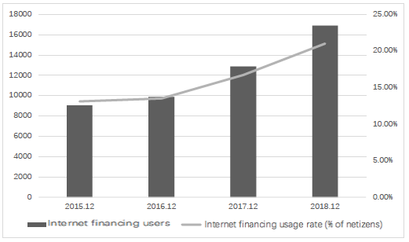
Figure 7 Internet financing scale and usage rate(2015.12-2018.06)
Source: CNNIC China Internet Development Status Survey

Table 2 Service and product needs of customers of different age
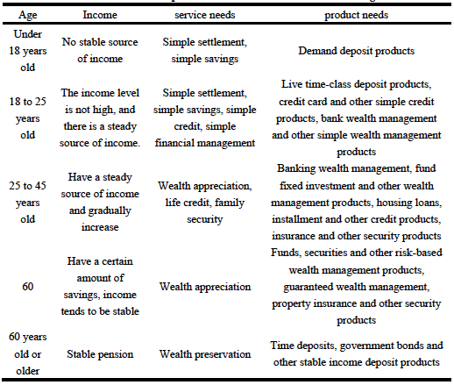

3.3.2Price: increase service value
In the current Chinese financial market, financial products sold by different commercial banks or financial institutions are highly homogenous. In order to compete for financial market share, ICBC implemented differentiated pricing for different customers and different levels of customer service demand, such as cross-bank transfer business, personal wealth management products business and differential pricing of personal housing loan business (as shown in Table *)(Gronroos, 1988).
Meanwhile, ICBC has also worked with companies, merchants or other institutions to create a complete “financial circle” service that allows customers to access a full range of value-added services through the contact point of commercial banks. For example, ICBC provided the "ICB e-Life" platform for covering food, clothing, housing and transportation, integrated the business resources of the sub-branches, actively promoted the construction of the "ICBC e-life" business circle, and actively promoted the customer experience "ICBC e-life" activities at the outlets(Jindong, 2013; Akroush, 2011).
Table 3 Differential pricing strategy
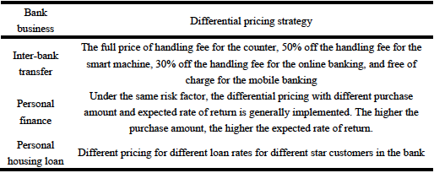

3.3.3Place: increase channel reform
On the one hand, ICBC strengthened the intelligence of its outlets by investing in high-tech equipment such as VTM and PAD, using new intelligent equipment such as pre-filled single machines and ticket acceptance machines to replace manual services, to improve the processing efficiency of outlets and improve customer service experience(Jing, 2016).
On the other hand, ICBC strengthened channel integration. The ICBC has integrated offline channels such as counters and smart devices with online channels such as online banking and mobile banking(Feizhou, 2018; Parasuraman, Zeithaml and Berry, 1985). Because the offline channel can timely understand the financial service opportunities hidden by the customer's online trading behavior and the customer financial service demand of the online channel can be effectively transferred to the offline channel, the integration channel is integrated, and information sharing and collaboration can be realized to establish a customer's omni-channel service system(Jiajun, 2018; Booms and Bitner, 1982).

3.3.4Promotion: launching multimedia promotion
ICBC established a new media advocacy team. ICBC has established an internal communication mechanism to guide all employees to join the propaganda team, making full use of the new media's fast and efficient delivery of features, thereby increasing the "touch points" in propaganda and extending the "path" of propaganda(Wei, 2010).
ICBC strengthened the promotion of mobile terminals. ICBC first fully utilized Internet technology, established a big data analysis system, analyzed customer behavior habits, and implemented customers on its own APP mobile terminal (such as Rong e-platform platform, integration e-purchase platform, integration e-platform platform, e-life platform). Personalized and differentiated marketing campaigns to achieve point-to-point precision marketing for customers. Secondly, ICBC used the public Internet publicity platform such as WeChat and Weibo to establish a publicity account, timely put a short video or warm text of corporate culture, corporate image, service concept and product information, and established a platform for communication with customers. Finally, the ICBC filmed a series of marketing short videos on the website of the Wanghong APP video website to enhance the marketing coverage(Liyun, 2017; Yi, 2018).

3.3.5People: optimize the team and organizational structure
ICBC strengthened the service concept. ICBC abandoned the "product-centric" service concept, strengthened the implementation of the "customer-centric" service concept in every detail of daily work, thinking what customers want, doing what customers want(Huiqun and Chao, 2008). And all customer's needs were carried out by the center, and the customer's recognition was won by efficient, high-quality and fast service, achieving a win-win situation between the network's performance and the customer's demand(Gan et al., 1990; Ping, 2016).
ICBC improved marketing skills. In the daily training of network staff, ICBC required employees to improve their comprehensive literacy, understood basic personal wealth management products business, credit finance business, etc., and improved marketing awareness and communication skills, so that customers can get a fast, efficient and comfortable service experience(Shostack, 1987; Xianhe and Jiebin, 2005).
The organizational structure and design changes from multi-head to customer-oriented will explained in detail in the 4 section.

3.3.6Process: optimizing service processes
ICBC simplified the process. The counter business processing process began to use the self-service filling mode to concentrate the business to be handled, so that the bank personnel can only authorize once, and the customer can complete all the business processing only by providing the information once. It can be seen from the comparison between Figure 8 and Figure 9 that the same personal customer account opening business, the processing procedure on the intelligent machine tool reduces the two process steps compared with the traditional counter handling process, which can reduce the time of the customer business processing process, and can also improve the network business point. Service efficiency and service quality, as well as the distance between customers and outlets, can help outlet staff to provide product and business promotion, improve the overall marketing effect of outlets, and enhance the market competitiveness of outlets(Grönroos, 1982; Lusch and Vargo, 2014; Wilson et al., 2016).
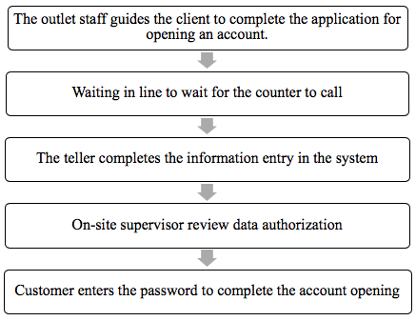
Figure 8 Traditional counter personal customer account opening process

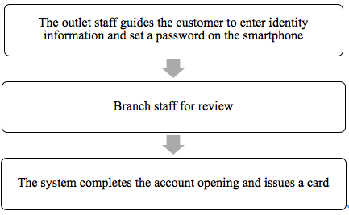
Figure 9 Intelligent machine personal customer account opening process

ICBC standardized the service process. Good service is due to standardized service processes. The standardized service process not only can standardize the behavioral norms of the network staff, but also help to improve the efficiency of the network service and achieve the purpose of improving the customer's service experience. ICBC redesigned service processes and optimized service processes to cope with complex and changing business situations(Liang and Peihua, 2009).

3.3.7Physical environment: enhance the image display of outlets
The physical environment is the focus of corporate image display and the basis for providing good services. In terms of external environment design, ICBC followed the corporate image design CIS strategy, adhering to the principle of unified design of external environment, reflecting the rigorous and stable corporate culture. In terms of internal environment design, ICBC improved the internal layout and environment construction of outlets according to the surrounding market conditions and customer needs improving the image of outlets(Fang and Qing, 2014).
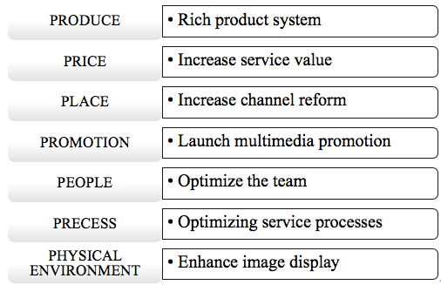
Figure 10 Changes based on 7PS service marketing strategy

4Organizational structural choices and design changes
In response to the new competitive changes in the financial market, ICBC's service marketing strategy has changed, and the organizational structure has also changed from Multi-head customer service marketing organization structure to Customer-oriented(Figure 11)(Dengyin, 2015).
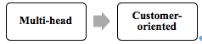
Figure 11 Organizational structure change

In accordance with the principle of customer-oriented, ICBC has changed its customer service marketing organization structure (Figure 12) into a customer-oriented one (Figure 13). As shown in Figure 13, the Corporate Finance Department, the Small and Medium Business Department, the Financial Institutions Department, and the Administrative Business Unit Department are customer marketing departments that are positioned for different customer categories(Xianhe and Jiebin, 2005; Yongliang, 2004; Borowitzka, Larkum and Nockolds, 1974). The most important function is to provide integrated financial services for specific customer groups. Each solution may include a full range of products for the bank's business, even personal financial products . And the main staff is the account manager.
The Ministry of Trade and Finance and the Department of Financial Markets are the departments responsible for the R&D and promotion of new products of the Head Office(Gan et al., 1990). The position is the product department. The main responsibility is to develop and promote the banking products undertaken by the department for a full range of customers(Huiqun and Chao, 2008). The main staff is the product manager who must be close to the customer and work with the account manager to promote the products they are responsible for within the customer marketing department. In this way, customers can get all the bank's products from the account manager, enjoy the bank's overall financial product solutions, and product managers can promote the products to all customers. In the words of a bank governor, when the account manager goes out to market the customer, he should “go out and grab the house and come back and split up”, thus effectively avoiding the situation of multi-marketing and inefficiency(Gan et al., 1990).
In accordance with the principle of “customer-centered, market-oriented”, ICBC also adjusted the post setting and functional division within the secondary branch office(Ye, 2004; Dengyin, 2015).
Taking the corporate finance department of the secondary branch as an example，at present, an account manager is often only responsible for one type of products and business, and it is difficult to provide customers with a complete solution. The division of responsibilities of product managers is not clear, and product managers cannot be freed from daily operations(Xianhe and Jiebin, 2005; Nohria, 1991).
Therefore, the front, middle and rear management modes are further implemented within the department. The front desk is horizontally integrated to form a customer relationship management group, facing all products of the customer marketing company sector; The middle forms a vertical division of labor, form a product manager group, and link product research and promotion functions with relevant departments of provincial banks.T he rear is centralized to form a centralized operation and risk internal control group, which is responsible for business processing, system operation processing, risk control and comprehensive management functions.
It not only realizes the specialized division of marketing, product and business operations, but also facilitates putting appropriate people in the right place. On the post. ICBC puts people who are good at dealing with customers at the forefront, and puts people who are good at handling business in the background to achieve an optimal combination of personnel and positions(Dengyin, 2015).
To effectively implement the customer-centered organizational structure design, ICBC is also gradually adjusting other relevant management mechanisms and supporting measures. The most important content is the bank's performance appraisal guidance, which makes the bank's performance appraisal and customer-oriented organizational management model matched(Pierce and Delbecq, 1977; Pugh et al., 1968; Shostack, 1987). In order to strengthen the bank's endogenous power and change its business philosophy, ICBC also emphasizes setting up assessment indicators and implementation assessments based on the local characteristics of each branch. The customer-oriented organizational structure emphasizes the specialization of division of labor and the separation of positions in the front, middle and rear, and the role of the process bank which is indispensable for the implementation of the customer-centric management system(Hart and Rosenberger III, 2004; Dengyin, 2015).
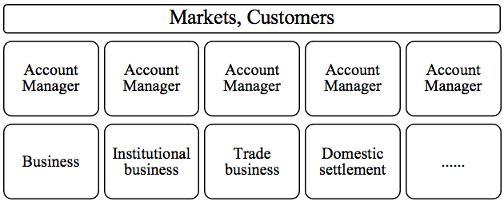
Figure 12 Multi-head service marketing organization structure

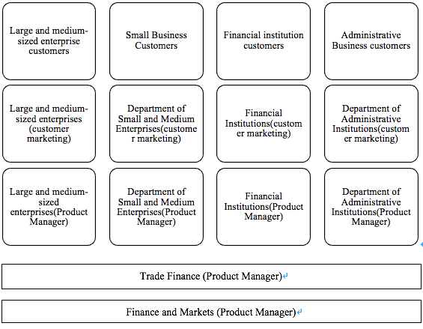
Figure 13 Customer-oriented service marketing organization structure

5Conclusion
Recently, the development of Internet finance has changed the behavior of customer financial consumption, resulting in a great threat to the business performance of ICBC.
In order to tackle the threat, ICBC carried out the reform of the service marketing strategy. Through the analysis of the changing environment, this paper draws the necessity of changes in product, price, channel, promotion, personnel, physical display and process 7 from the perspective of 7PS service marketing combination theory. Then, this paper summarizes the key points of change in 7 aspects: enrich product system, enhance service value, increase channel reform, carry out multimedia promotion, optimize personnel team, enhance network image display, and optimize process services. Finally, this paper focuses on its analysis from Multi-head to Customer-oriented organizational structure and design Changes.

References
Akroush, M. N. (2011) 'The 7Ps Classification of the Services Marketing Mix Revisited: An Empirical Assessment of their Generalisability, Applicability and Effect on Performance Evidence from Jordan’s Services Organisations', Jordan Journal of Business Administration, 153(3141), pp. 1-32.
Bell, S. J., Auh, S. and Smalley, K. (2005) 'Customer relationship dynamics: service quality and customer loyalty in the context of varying levels of customer expertise and switching costs', Journal of the Academy of Marketing Science, 33(2), pp. 169-183.
Booms, B. H. and Bitner, M. J. (1982) 'Marketing services by managing the environment', Cornell Hotel and Restaurant Administration Quarterly, 23(1), pp. 35-40.
Borowitzka, M., Larkum, A. and Nockolds, C. (1974) 'A scanning electron microscope study of the structure and organization of the calcium carbonate deposits of algae', Phycologia, 13(3), pp. 195-203.
Bowen, D. E. and Lawler III, E. E. (2006) 'The empowerment of service workers: What, why, how, and when', Managing innovation and change, 33, pp. 155-69.
'China Internet Network Information Center'.
Dengyin, Z. (2015) 'The cornerstone of improving bank organization effectiveness: customer-oriented organizational structure design - state-owned bank provincial branch organization structure optimization case', financial words and deeds: Journal of Hangzhou Financial Institute, (5), pp 47-50.
Dev, S. M. (2000) 'Economic Liberalisation and Employment in South Asia: II', Economic and Political Weekly, pp. 135-146.
Fang, D. and Qing, Z. (2014) 'Analysis of tangible strategies for service marketing of state-owned commercial banks', People's Forum, (A12), pp. 101-103.
Feizhou, W. (2018) 'Recommendations for Banking Channel Construction Management', Contemporary County Economy, (2), pp. 66-68.
Gan, S. Q., McBride, O. W., Idler, W. W., Markova, N. and Steinert, P. M. (1990) 'Organization, structure, and polymorphisms of the human profilaggrin gene', Biochemistry, 29(40), pp. 9432-9440.
Gill, R. (2002) 'Change management--or change leadership?', Journal of change management, 3(4), pp. 307-318.
Grönroos, C. (1982) 'An applied service marketing theory', European journal of marketing, 16(7), pp. 30-41.
Gronroos, C. (1988) 'Service quality: The six criteria of good perceived service', Review of business, 9(3), pp. 10.
Hart, A. E. and Rosenberger III, P. J. (2004) 'The effect of corporate image in the formation of customer loyalty: An Australian replication', Australasian Marketing Journal (AMJ), 12(3), pp. 88-96.
Heskett, J. L. (1986) Managing in the service economy. Harvard Business Press.
Huiqun, G. and Chao, H. (2008) 'Research on Quality Improvement of Financial Services Based on Gap Model', Statistics and Decision, 2008(16), pp. 155-157.
Industrial and Commercial Bank of China official website. Available at: http://www.icbc.com.cn/icbc/.
Jiajun, Y. (2018) 'Research on the Risk Management of Online Banking Operation of China's Commercial Banks under the Background of the Internet', Modernization of Shopping Malls, (1), pp. 136-137.
Jiefang, W. (2009) 'Study on Strategic Innovation of State-Owned Commercial Banks from the Perspective of Service Marketing', Market Forum, 2009(6), pp. 46-48.
Jindong, L. (2013) A Bank Private Banking Service Marketing Research Based on 7PS Theory. Nanchang University.
Jing, J. (2016) Bank3. 0 era China commercial bank channel optimization strategy research. Southeast University.
Juan, L. (2017) 'Transformation and Innovation of Retail Marketing Services for Internet Finance and Commercial Banks', Reform and Strategy, 33(6), pp. 88-90.
Liang, J. and Peihua, Y. (2009) 'Research on Business Network Transformation of Commercial Banks', Financial Aspects, (1), pp. 43-46.
Liang, Z. (2014) Research on the Strategy of ICBC's Response to Internet Finance Challenge. Xiamen University.
Liwen, L. (2004) Service Operations Management. Tsinghua University Press Co., Ltd.
Liyun, C. (2017) 'Industrial and Commercial Bank of China XY Branch Transformation Network Marketing Strategy Research', Guangxi University, pp. 1-z.
Lovelock, C. and Wright, L. (2001) Principles of Service Marketing and Management.
Lusch, R. F. and Vargo, S. L. (2014) The service-dominant logic of marketing: Dialog, debate, and directions. Routledge.
Nohria, N. (1991) Note on organization structure. Harvard College.
Parasuraman, A., Zeithaml, V. A. and Berry, L. L. (1985) 'A conceptual model of service quality and its implications for future research', Journal of marketing, 49(4), pp. 41-50.
Pierce, J. L. and Delbecq, A. L. (1977) 'Organization structure, individual attitudes and innovation', Academy of management review, 2(1), pp. 27-37.
Ping, Z. (2016) 'On how to optimize the labor combination of outlets to further promote the second transformation', Modern Finance, (10), pp. 48-49.
Pugh, D. S., Hickson, D. J., Hinings, C. R. and Turner, C. (1968) 'Dimensions of organization structure', Administrative science quarterly, pp. 65-105.
Regan, W. J. (1963) 'The service revolution', Journal of marketing, 27(3), pp. 57-62.
Schneider, B. and Chung, B. 1993. Service Management: Strategy and Leadership in Service Business. JSTOR.
Shostack, G. L. (1987) 'Service positioning through structural change', Journal of marketing, 51(1), pp. 34-43.
Todnem By, R. (2005) 'Organisational change management: A critical review', Journal of change management, 5(4), pp. 369-380.
Wei, L. (2010) 'ICBC A Banking Service Marketing Status and Existing Problems', Modernization of Shopping Malls, (2010 1), pp. 59-60.
Wilson, A., Zeithaml, V., Bitner, M. J. and Gremler, D. (2016) Services marketing: Integrating customer focus across the firm.
Xianhe, Z. and Jiebin, L. (2005) Reengineering the organizational structure and process of China's commercial banks.
Ye, N. (2004) Bank Reengineering: Theory and Practice. China Financial Publishing House.
Yi, Z. (2018) 'Analyzing the Brand Construction Strategy of Commercial Banks with New Media', Modern Finance, (1), pp. 29-31.
Yixi, C. (2013) 'The concept of Internet finance, current status and development proposals', Financial Development Review, (12), pp. 126-131.
Yongliang, Z. (2004) 'Investigation on Organizational Structure Innovation of China's Commercial Banks', Southern Finance, (9), pp. 25-26.
Zeithaml, V. A., Bitner, M. J., Gremler, D. D. and Pandit, A. (2006) 'Services marketing: Integrating customer focus across the firm'.
Zhicheng, L. (2000) 'Customer-centered, building a market-oriented modern commercial banking operating mechanism', Journal of Wuhan Agricultural College, Agricultural Bank of China, (2), pp. 8-15.

