

EMPL4012 b | Do the dangers of online shopping impact on the amount of people visiting the High Street?
Joan Larbi
1606026
Mushfiqur Rahman

Do the dangers of online shopping impact on the amount of people visiting the High Street?
The aim of this piece is to look at whether issues with online shopping safety impact on the number of people making trips to the High Street.
The common consensus is that online shopping is a growing trend. The below graph from e-marketer in a 2016 article shows past and present figures as well as future projections.
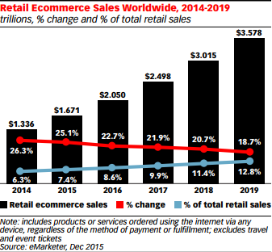

Fig1 – Showing past, present and future e-commerce projections
Online shopping however is not for everyone and there are still masses of people who visit the stores in person to buy goods. Retail Touch Points is an online publishing network that looks at the retail market from the point of view of retail executives suggests that 94% of retail is still done by foot and in stores (https://www.retailtouchpoints.com/resources/type/infographics/retail-vs-e-commerce-trends-a-match-made-in-heaven) as shown by the info graphic below.
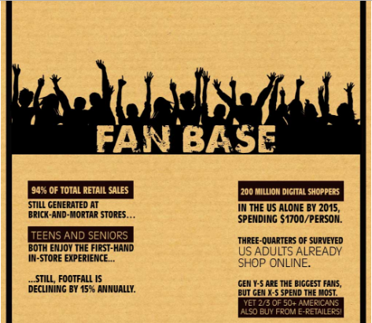
Fig 2 – Infographic showing trends in retail
The infographic still suggests although this is the case retail footfall is falling year on year.
During an informal conversation between some friends and I the idea that the internet was a place that was unsafe to shop on. As a result many of my friends decided to visit the retail outlets in person to do shopping especially when it came to buying presents or things that were able to be tried on before buying.
To investigate I created a questionnaire to share among friends in my age group which is 50 – 60 years of age. My friends in this age group and me often have problems with online shopping experiences. In my personal experience it is not always easy to navigate or find exactly what it is I am looking for.
My other reservation is using my payment details online. I have issue with identity theft and feel that the internet is not quite the safest place. At least in a store in can be sure of where you have used your card and where the fraud or identity theft may have happened.
While having another discussion with friends about this it seemed that the consensus amongst us was that we all had some experience of card fraud online. Perhaps this was a common fear among our age and was the reason that went shopping on the high street instead of using online. The exception was that some of us used online shopping for things like Food shopping from Sainsbury’s or Marks and Spencer’s.

Methodology
I created a questionnaire with a few questions to find out how often my friends shopped and what their experience of shopping was like and also whether they preferred the online or the High Street Experience.
The questionnaire can be found here: https://docs.google.com/forms/d/e/1FAIpQLSfEvga8sG45e7dEnvcGa9jzrGA-d3gvRUnif-IzTyZZfl3wfA/viewform?usp=sf_link
It was made intentionally short in order to get straight to the point with no questions about age as the age range within the sample group was already predetermined by selecting particular sections of my friendship group that occupied the 50-65 year age group.
With Cyber Monday looming the subject of online shopping is high on the agenda. This period of the year leading up to Christmas is the busiest part of the year according to the article posted by The Global Cyber alliance. The Global Cyber Alliance are an organisation that work internationally to make the internet a safer place and reduce risk. The organisation ran an article on a PR and News website discussing recent statistics obtained from a survey of 611 UK consumers who shopped online. 36% had no idea of what constituted a safe site to perform online retail activities on. Further to this 45% have stopped before fulfilment of a purchase and 24% have a fear of being subject to fraud while shopping online.
The article resonated with the informal conversations I found within my friendship group and also had some similarities with the findings of my survey. http://www.prnewswire.co.uk/news-releases/cyber-monday-alert-36-of-united-kingdom-consumers-cannot-determine-safety-of-online-shopping-sites-new-659009483.html.
Concerning my primary data collection, I can present the findings as below. The findings were as I expected in terms of the consensus towards online safety. However the findings regarding the split between those who preferred online to those who preferred to shop in person did come as a surprise.
Results
In Fig 4. Regarding online safety, the data split at first glance almost looks like an even divide of opinion as to whether shoppers feel safe or not. 28 percent of participants said they feel safe online with 32 percent of participants saying that they did not feel safe. However if You factor in those that do not shop online for whatever reason as well as those that feel relatively safe then there builds a different picture. What could be drawn from this combination of the sample group is a section of people who actually do feel safe online outweighing those that do NOT feel safe online.
The unknown section of the sample group; unknown meaning the reasoning behind not using online has not been stated, may hold an answer as to how to convert more people to using online based on safety.
In Fig 5 the graph shows those who have an understanding of how to keep safe online. Understanding of the online environment and the unknown may also be a factor in how and why the population group make choices as to whether to make purchases online. In Fig 6 - The Pie chart potentially represents the amount of people that visit the high street as opposed to shopping online. This may also represent a section that do not feel safe online in Fig 4.
Another surprise was finding a section of the population that do not care about online safety. This was something that did not come up in the informal conversations that we were having as a group.
Further investigation will be made in future surveys to gain deeper understanding of this area.

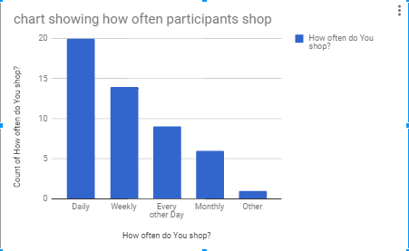
Fig 3 – Frequency of shopping per participant

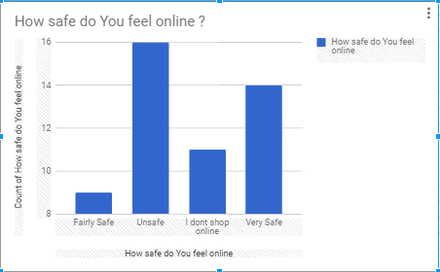
Fig 4 – How safe do you feel online

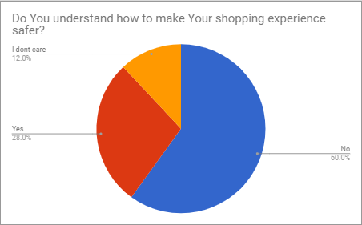
Fig 5 – Do You understand how to make Your shopping experience safer

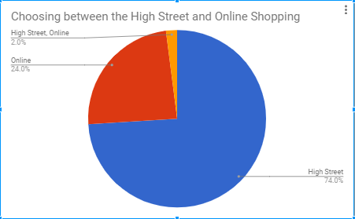
Fig 6 – High Street or Online?

Analysis
What is the relevance of this data?
In regards to business online is most definitely becoming a larger area of interest year on year as shown in fig 1. When applying the knowledge gained from this survey and further reading from the articles listed in this report it is necessary to create user friendly web platforms that are easy to use from the point of view of the shopper.
This means that the experience on all platforms has to be clean, people often use the internet on their phones and tablets as well as on the laptop or desktop machine. ALSO using the social media experience to inspire confidence could be an aspect of company communication that drives people towards online.

What Wisdom can be gleaned and applied from this survey?
In the age group surveyed we find a propensity to visiting retail outlets in person. So perhaps placing online portals in retail spaces with staff members that can give short training courses in how to use online or having staff that give taster experiences would be a great idea. In the retail space technology like NFC is now being used to communicate with shoppers in a short target range.
An aspect going forward may be to complete the survey again and look into how many of the users are accessing the net via smart phones. With this information and data the retail space can look at how to interact with shoppers that are non-online. By encouraging them to use online while in store habits could be formed that may then encourage shoppers to use online while at home.
Reward based activities that award discounts or benefits for online shopping may also funnel those in my age group towards the online experience.
What was understood by this data?
Among the 50 – 65 age group a significant amount or people still prefer this retail environment as opposed to the online environment. We still don’t understand the exact reasons why however as the main topic looked at in the title was safety we can deduct from the data set that safety online has impacted the answers given. So within this particular data set there is an impact on the high street. The data certainly shows a correlation between this population group visiting the high street and the use of online. Still another survey can be done to find reasoning behind visits to retail bricks and mortar.
Conclusion
Moving forward I would inform those that might use this data set to look at this population group as a target group. As in particular areas that are more heavily weighted in with a population of older shoppers there may be an opportunity to build a shopping experience that offers more security in the minds of a group that have potentially a lot more time on their hands. More time at leisure may be more time spent online and potentially more time shopping online.
The survey did have some limitations in that it would have been more descriptive if open-ended answers were given. This would have needed the use of qualitative questions that allowed free answers and more personalised accounts as within the informal focus groups. These types of information gathering exercises often provide anecdotes that numbers cannot as the comments expressed may characterise a whole cross section of the population group.
While online shopping is a growing trend, it may be growing faster in particular age groups as opposed to others. It is important to look at both sides of this story, as particular sections of society may be adverse or more inclined to using online points of sale. Similarly, there may be particular goods that lend themselves to being frequently purchased online. The subject could be broken down further into granular areas based on geography. Being closer to bricks and mortar could be a reason for the results found in this survey. As within most realms accessibility, necessity and convenience will be common factor for decision making especially in the areas of human needs and wants.

Bibliography
https://www.globalcyberalliance.org/about.html accessed 24/11/17

http://www.prnewswire.co.uk/news-releases/cyber-monday-alert-36-of-united-kingdom-consumers-cannot-determine-safety-of-online-shopping-sites-new-659009483.html accessed 24/11/17

https://www.retailtouchpoints.com/resources/type/infographics/retail-vs-e-commerce-trends-a-match-made-in-heaven accessed 24/11/17

https://www.emarketer.com/public_media/docs/eMarketer_eTailWest2016_Worldwide_ECommerce_Report.pdf
Accessed 23/11/17

