Community Engagement
Student Name: Mihaela Roxana Prostire
Student ID:2313602
Contents
Introduction 3
Element 1: Community Outreach 3
Objective 3
Demographic Analysis 3
Elements 2: Stakeholder Mapping 5
Stakeholder Analysis 5
Communication Strategy 5
Impact Evaluation 6
Element 3: Community Engagement Plan 7
Element 4: Practical Discussion 10
Practical Discussion 10
Conclusion 13
References 14

Introduction
Community engagement is a vital component in fostering social cohesion which is why it is an addressing the unique challenges faced by local communities. This portfolio focuses on Basildon UK and explores various aspects of community engagement within this locality. The portfolio will be divided in to four major parts so that each important part can be properly covered. These parts are community outreach, stakeholder mapping, the development of a community engagement plan, and a practical discussion based on the findings from these activities. It is being expected that by covering these four categories, it will be possible to overcome the challenges at hand. Basildon is known for its diverse population and they are known as a mix of long-term residents and newer communities (Visit Essex, 2024). The town has a rich history and is part of the Thames Gateway development area, which has seen significant regeneration and growth in recent years (Visit Essex, 2024). This is the reason why the town has been chosen for this study. However, these growths have induced various challenges such as economic disparity, social integration, and the need for improved community services within the community at the Basildon. The purpose of this portfolio is to actively engage with the Basildon community, understand its dynamics, and develop strategies to address some of the challenges faced by its residents. By engaging with stakeholders and creating a comprehensive community engagement plan, this portfolio aims to contribute to the ongoing efforts to build a more inclusive and supportive community environment in Basildon.

Element 1: Community Outreach

Objective
The objective of this community outreach activity was to engage directly with stakeholders within the Basildon community. The goal was to understand the demographics, social dynamics, and challenges that are being faced by the local residents of the Basildon. The outreach program was basically focused on a specific neighborhood within Basildon which was selected based on a few key criteria such as diversity and presence of various community groups.

Demographic Analysis
The population of Basildon has been found to be 115,964 and among these population, a demographic composition can be found that includes mix of different age groups, ethnic backgrounds, and socioeconomic statuses (Citypopulation.de, 2021). By studying the segmentation of the Basildon, it has been found that 61% of their population falls within the age 18 to 64 years, so most of their population belongs to the young generation (Citypopulation.de, 2021). The ratio of female and male has been studied, and found that the percentage of female and male at Basildon is almost equal. The percentage of female present at Basildon is 48.4%, and the percentage of male present at Basildon is 51.6% (Citypopulation.de, 2021). Also, in terms of ethnic group, most of the people at Basildon has been found to be white as they comprise of 84.9% of the population (Citypopulation.de, 2021). However, there are presence of various other ethnic groups within the Basildon such as Asian, Black, Arab, Mixed/Multiple, and others. In terms of country of birth, most of the people belonged to UK as the UK people comprises of 85.1% of the total population of Basildon (Citypopulation.de, 2021). Apart from that, people from EU, Europe (other), Middle East & Asia, Africa, and other country can be found at Basildon (Citypopulation.de, 2021).
In terms of socioeconomic landscape of Basildon, the factors can be found to be varied. The people that are residing in Basildon and are 16 years or above mostly have jobs (Ons.gov.uk, 2021). Based on census, it can be found that 58.5% of these people are employed at the Basildon excluding full time worked (Ons.gov.uk, 2021). However, similar data was found back in 2011 as well so Basildon has not been able to improve as much from this perspective within a decade (Ons.gov.uk, 2021).

Elements 2: Stakeholder Mapping

Stakeholder Analysis
Local Government: The Basildon Borough Council plays a crucial role in shaping local policies, providing services, and funding community initiatives. This is the reason why the local government are a primary stakeholder in any community engagement activities (Murphy, 2012). With the power that they have and the resources that they have available, the decisions that they can take have a huge impact on the population.
Community Organizations: These include local charities, youth groups, and cultural associations. There can be a number of community organisations found at the Basildon which can be identified as these community organisation (Murphy, 2012). Organizations such as the Basildon Borough Youth Hub and the Flex Youth and Community Group are key players in fostering social inclusion and addressing community needs.
Businesses: Local businesses, particularly those involved in retail and manufacturing, have a vested interest in the community’s economic stability. IF the economic stability of the people within the community is not present, then they will not be as interested to buy from the businesses (Wilson, 2019). This is the reason why the local businesses can be identified as stakeholders, and even the price that they set for their products can impact the decisions of the community (Wilson, 2019). Collaboration with these businesses can lead to job creation and support for local initiatives.
Residents: The residents of Basildon are the most directly impacted by community engagement activities (Wilson, 2019). All the decisions are made with the aim to be able to ensure the betterment of the people. Their needs, concerns, and aspirations must be at the forefront of any engagement plan.
Educational Institutions: Schools and colleges in Basildon, such as the Basildon Academies, are important stakeholders in youth engagement and education-focused initiatives (Murphy, 2012).

Communication Strategy
Effective communication with stakeholders requires a tailored approach that considers the unique needs and preferences of each group:
- Local Government: Regular meetings and formal proposals can be used to communicate with the Basildon Borough Council. If regular meetings can be held effectively, then it will be possible to be able to create a proper communication channel and ensure that the local government is being able to address the needs that arise (Wilson, 2019). Clear, evidence-based presentations will be crucial in gaining their support for community initiatives.
- Community Organizations: Direct, informal communication methods such as email, social media, and face-to-face meetings are effective in engaging with community groups. In terms of community organisations, formal communication may create difficulty because the people may not have as much time and interest to attend these formal meetings (Waterton and Watson, 2013). Collaboration on events and projects can also strengthen these relationships.
- Businesses: Networking events, business forums, and partnership opportunities can be used to engage local businesses. If the businesses can utilize the community then the reputation of these businesses will increase (Waterton and Watson, 2013). Highlighting the benefits of community involvement for business sustainability can encourage their participation.
- Residents: Outreach to residents can be achieved through community events, door-to-door engagement, and social media campaigns. It’s important to provide multiple platforms for residents to voice their concerns and contribute ideas (Waterton and Watson, 2013).
- Educational Institutions: Engaging schools and colleges through workshops, educational programs, and student-led initiatives can foster long-term community involvement.

Impact Evaluation
In terms of stakeholders, the impact evaluation is a major part as it will be the evaluation criteria to ensure if the desired development is being achieved. It can be helpful to set specific and clear goals so that works can be done to ensure progress of the development strategy that will be implemented. Also, the evaluation will need to be run on a regular basis so that the progress can be effectively tracked.
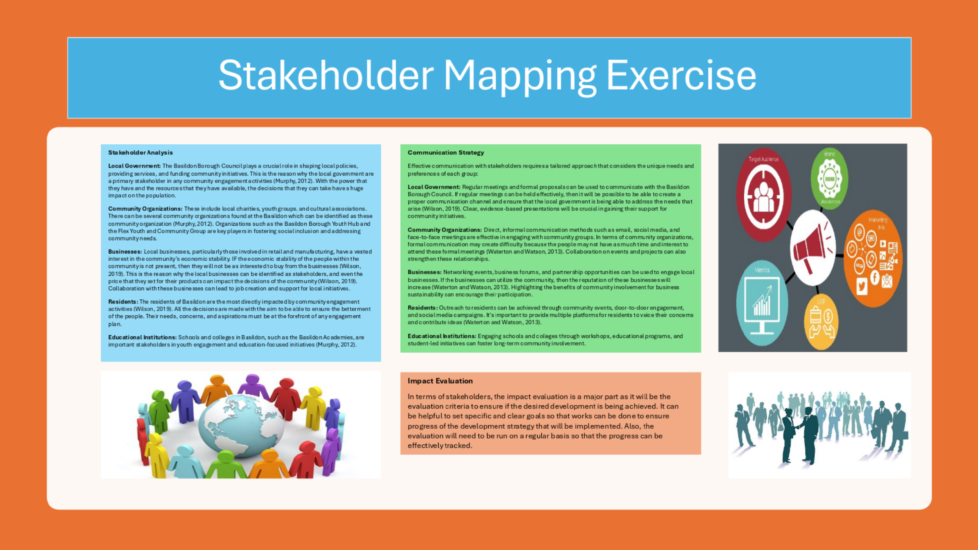
Figure: Infographic poster

Element 3: Community Engagement Plan
The three goals that have been set to ensure developing community engagement in the Basildon. The goals have been set as SMART because it will ensure that the goals can be achieved and will be impactful for Basildon. The first goal that has been set is related to the cross cultural initiatives. It has been found that launching a series of cultural exchange events in Basildon will be helpful to improve the engagement of the local people. It is relevant to the topic and has set a specific time as it shows that the target moth is April 2025. With the help of SMART goals, it can be stated that the goal of achieving SMART objectives will be possible.
The second program is focused on expanding economic support program which will be essential. For that, financial literacy workshops have been designed which will be implemented throughout the Basildon so that the people can participate in it and provide necessary support to ensure economic empowerment for disadvantaged residents (McReynolds and Shields, 2015). A specific timeframe has also been implemented for this which will ensure that the workshop ends within the year November 2025.
The third program is focused on engaging youth in the decision making process which will be done by establishing a youth council that will represent the diverse backgrounds. It is relevant with the goal and will be done by June 2025. It can be expected that by completing this objective, it will be possible to overcome the challenges that the Basildon is currently facing.

Element 4: Practical Discussion

Practical Discussion
Stakeholders play a crucial role in community engagement initiatives. In Basildon, the key stakeholders involved include:
- Local Government (Basildon Borough Council):
  - Provides policy support, funding, and resources.
  - Sets regulations and guidelines for community activities (Dolgon et al., 2017).
- Community Organizations and Non-Profits:
  - Engage directly with residents, offering programs and services that meet specific needs (Sachs and Clark, 2016).
  - Act as intermediaries between the community and larger institutions.
- Local Businesses:
  - Provide sponsorship and job opportunities.
  - Offer expertise and resources for community development projects (Dolgon et al., 2017).
- Educational Institutions (Schools, Colleges):
  - Engage youth in educational and extracurricular activities.
  - Foster a culture of learning and inclusivity within the community (Sachs and Clark, 2016).
- Residents:
  - Serve as both beneficiaries and active participants in community engagement initiatives (Dolgon et al., 2017).
  - Offer insights into local needs and challenges.
- Healthcare Providers:
  - Address the health and well-being of the community.
  - Offer programs focused on health education and preventive care.
4.2 Benefits of Actively Engaging with Stakeholders
Actively engaging with stakeholders in community projects brings numerous benefits:
- Enhanced Trust and Cooperation:
  - Building relationships with stakeholders fosters trust, making it easier to implement community initiatives. The trust will be very important as it will be necessary to implement all the goals and strategies that has been formed.
  - Cooperative efforts result in more effective problem-solving and resource sharing.
- Informed Decision-Making:
  - Stakeholders provide valuable insights that help shape more informed, relevant community strategies. All the insights will need to be collected and documents, so that these can be used to make informed decision making.
  - Engagement ensures that decisions reflect the diverse needs and perspectives of the community (Dolgon et al., 2017).
- Increased Community Participation:
  - Active engagement encourages residents and other stakeholders to participate more fully in community activities.
  - Increased participation leads to greater community ownership of projects, ensuring their long-term sustainability. The stakeholders will need to be motivated on a regular basis so that they get interested to attend these community participations and ensure the implementation of the plans.
- Better Resource Allocation:
  - Collaboration with stakeholders helps identify the best use of available resources.
  - Ensures that funding, manpower, and other resources are directed towards areas of greatest need.
- Stronger Social Networks:
  - Stakeholder engagement strengthens social ties within the community.
  - Promotes solidarity and collective action among different community groups. As most of the people of the community is youth and are present on the social network, so it will be necessary to ensure stronger social network presence regardingthe social community.
5.2 Personal Experiences
Throughout the engagement process, I encountered various challenges and learning opportunities. One of the key experiences was making plan for residents from different cultural backgrounds, which highlighted the importance of cultural competence in community work. As I studied these diverse community, I have been able to develop my planning skills, and got me understand that they are not as different. In some cases, I was worried if formal or informal meeting with such a diverse community is possible, and during then, various case studies have provided me with the confidence. Additionally, engaging with local businesses provided insight into the challenges they face and the potential for collaboration to address community issues. The issues that I have been able to identify beforehand were lacking the practical point
5.3 Techniques and Principles
Several community engagement techniques were employed, including:
- Surveys: To gather quantitative data on community needs.
- Focus Groups: To explore specific issues in-depth with smaller groups.
- Public Forums: To provide a platform for broader community input.
These techniques were guided by principles such as active listening, respect for cultural differences, and a commitment to inclusivity.
5.4 Recommendations
Based on the findings, the following recommendations are made:
- Increase Cross-Cultural Initiatives: More programs should be implemented to bring together different cultural groups in Basildon. The programs need to be educating as well as entertaining so that the people get interested towards these.
- Expand Economic Support Programs: Additional resources should be allocated to help residents facing financial difficulties.
- Engage Youth in Decision-Making: Creating more opportunities for young people to participate in community leadership roles will help address youth disengagement.

Conclusion
The community engagement activities in Basildon have provided valuable insights into the social, economic, and cultural dynamics of the town. Through outreach, stakeholder mapping, and the development of a community engagement plan, this portfolio has identified key challenges and proposed strategies to address them. The findings underscore the importance of fostering inclusivity, supporting economically disadvantaged residents, and engaging youth in community activities. By implementing the proposed strategies and continuing to build on the relationships established through this project, there is potential for significant positive impact on the Basildon community. Some issues may come up regarding the effectiveness of the plan and so on. These will need to be addressed from time to time so that the effectiveness can be ensured.

References
Citypopulation.de. (2021). Basildon (Essex, East of England, United Kingdom) - Population Statistics, Charts, Map, Location, Weather and Web Information. [online] Available at: https://www.citypopulation.de/en/uk/eastofengland/essex/E63004799__basildon/ [Accessed 10 Aug. 2024].
Dolgon, C., Mitchell, T.D. and Eatman, T.K. eds., 2017. The Cambridge handbook of service learning and community engagement. Cambridge University Press.
McReynolds, M. and Shields, E., 2015. Diving deep in community engagement: A model for professional development. Lulu. com.
‌Murphy, F.G. ed., 2012. Community engagement, organization, and development for public health practice. Springer Publishing Company.
‌Ons.gov.uk. (2021). How life has changed in Basildon: Census 2021. [online] Available at: https://www.ons.gov.uk/visualisations/censusareachanges/E07000066/ [Accessed 10 Aug. 2024].
Redding, S., Murphy, M. and Sheley, P. eds., 2011. Handbook on family and community engagement. IAP.
Sachs, J. and Clark, L. eds., 2016. Learning through community engagement: Vision and practice in higher education. Springer.
Visit Essex. (2024). Basildon - Town in Basildon, Basildon. [online] Available at: https://www.visitessex.com/towns-and-villages/basildon-p1266731 [Accessed 10 Aug. 2024].
Waterton, E. and Watson, S. eds., 2013. Heritage and community engagement: Collaboration or contestation?. Routledge.
Wilson, P., 2019. The heart of community engagement: Practitioner stories from across the globe. Routledge.

