Student Name: Farhan Sajid Rahman Student ID: 1802359

Programming in C++

Abstract
Throughout this project, programming tasks will be completed using C++. To be completed efficiently, the programs will first be planned through creating a list of problems and going over the logic with the use of a flowchart. Documentation of the development will then be done from following the problems listed, along with the flowchart. Once the development has completed, a series of tests will take place making sure the functionality was implemented correctly.

Contents
Programming in C++ 0
Abstract 0
1. Introduction 3
2. Creating Program 3
2.1 Higher or Lower Game: 3
2.1.2 List of problems 3
2.1.3 Development Stages - 4
2.1.4 Testing Program 0
3. Conclusion 0
4. Appendices 1
4.1 Appendix A – Flowchart of Higher or Lower game: 1
4.2 Appendix B – Solving Player One Problems: 2
4.2.1 How player one values are input 2
4.2.2 How the values being entered are stored: 2
4.2.3 How the values are checked whether they are in the range of 1 and 10: 3
4.2.4 How player ones’ value will be checked if it is not left empty 3
4.2.5 How number inputs are checked whether they are a valid number: 4
4.3 Appendix C – Solving Player Two problems: 5
4.3.1 How player twos’ guess will be input 5
4.3.2 How player twos’ guess will be stored 5
4.3.3 How player two will go onto the next guess 5
4.3.4 How player twos’ guess is checked if valid input 6
4.3.5 How to check if player two has went through all values entered by player one 6
4.3.6 How player ones’ values will be displayed to player two 7
4.3.7 How to check if player twos’ guess is correct or incorrect 7
4.4 Appendix D – Testing results: 0
Test 1 – Testing player one Empty input and letter inputs 0
Test 2 – Testing Player One number inputs less than 1 and greater than 10 0
Test 3 – Testing Player Two empty input and inputs not equal to ‘H’ or ‘L’ 1
Test 4 – Testing Player Two ‘H’ input when next value is greater than the value displaying 1
Test 5 – Testing Player Two ‘H’ input when next value is less than the value displaying 1
Test 6 – Testing Player Two ‘L’ input when next value is less than the value displaying 1
Test 7 – Testing Player Two ‘L’ input when next value is greater than the value displaying 2
Test 8 – Testing Player Two ‘H’ and ‘L’ input when next value is equal to the value displaying 2
Test 9 – Testing Player Two winning after guessing all values entered by player one 2
References 3

1. Introduction
From the programming tasks given, there will be the documentation of the creations. What will be done is an overview of the task and its description, then forming a plan of what problems there are and how the problems will be solved so that the development will have a structure to follow and not be gone in blindly, as this will be of assistance in knowing what is needed to be solved [1]. In addition, there will also be a section for testing to ensure there are not any errors found. Before beginning to create the program, it will be a good idea to first assemble a structure that can be followed to tackle the problems,

2. Creating Program
In this section, it will contain the process of creating the programs that have been assigned to work on.

2.1 Higher or Lower Game:
This is a two-player game where the first player will get to enter 7 numbers between 1 and 10, the second player will then get shown the first number and guess whether the next number is greater than or less than what is displaying, when correct it will then show the next number and repeat until all 7 numbers have been guessed. Player two must get all answers right to win, otherwise any answer that is wrong means player one wins and the game ends.

2.1.2 List of problems
From the description of the program above, a list of problems can be written down and then go onto creating a plan on how the program will function through the use of a flowchart. The lists below will begin from easiest to hardest of the problems to be solved.

Player one problems:
- How player one values will be input
- How player one values will be stored
- How player ones’ value will be checked if it is a number equal to 1 and 10
- How player ones’ value will be checked if it is not left empty
- How player ones’ value will be checked entered is not a letter

Player two problems:
- How player twos’ guess will be input
- How player twos’ guess will be stored
- How player two will go onto the next guess
- How player twos’ guess is checked if valid input
- How to check if player two has went through all values entered by player one
- How player ones’ values will be displayed to player two
- How to check if player twos’ guess is correct or incorrect
Flowchart created based on the problems - See Appendix A for Flow-Chart(CTRL+CLICK)

2.1.3 Development Stages -
The development stages will go through how the problems listed above are solved.

2.1.3.1 Player one problems:
How player one values will be input -
This problem can be simply solved by creating a function which returns a number from the input by the user, and in this case, it will return an integer as they will only be allowed to enter whole numbers. Creating it this way will stop the repeating of the code to get the number inputs from the player and also have the numbers that are input capable of being stored in a local integer variable.
See Appendix B 4.2.1 for screenshot of input function

How player one values will be stored
Player ones’ values can be stored simply with an array that holds up to 7 values and having a function that will assign its indexes. All that had to be done was to create a void function that returns nothing and requires an int array within its parameters when called. When called, this function then goes through a loop to ask the user to enter 7 values. The loop would then increment by 1 and get each index of the array assigned the value of the number entered by player one.
See Appendix B 4.2.2 for screenshot of how player one values will be stored

How player ones’ value will be checked if it is a number equal to 1 and 10
All that was required to do was to add an if statement within the loop of the function which assigns the values of the array, this was put after the input of the number entered by player 1. The if statement would check if it is greater than or equal to 1 and is less than or equal to ten, and if it is then it would continue on to the next value to be entered. If not, the game would send a message and restart to get the player to re-enter their values.
See Appendix B 4.2.3 for screenshot of checking the number

How player ones’ value will be checked if it is not left empty
To solve this problem, an if statement was to be added within the function that handles number input by player one. String variables hold a function called ‘empty()’, so before returning the number, an if statement can be used to first check if the string is not empty using the ‘!’ symbol, which is shown in Appendix B 4.2.4.
See Appendix B 4.2.4 for screenshot of how the input will be checked if it is not empty

How player ones’ value will be checked entered is not a letter
When it came to solve the last problem, a Boolean function was created to return true or false. This function goes through the ascii values of each character within the input given and will return false if it finds an ascii value not equal to the ascii values of a number. The ascii values of the numbers are 48-57, so a simple if statement check was made, if anything less than 48 or greater than 57, return false as it is not a number. If it comes out of the loop and does not return false, it will return true, meaning it is a number.
Once this function was made, an addition to the if statement of checking whether the input is not left empty, is to put in this function created and checking if it returns true before returning the number the player entered. See Appendix B 4.2.5 for screenshot of checking if valid number

2.1.3.2 Player two problems:

How player twos’ guess will be input
As player twos’ guess is either higher or lower, a Boolean function can be created to return true or false. This function will take their input and store it within a string, If the input is equal to the letter ‘H’, the function will return true, else if it is the letter ‘L’, the function will return false.
See Appendix 4.3.1 for screenshot of how player twos’ guess will be input

How player twos’ guess will be stored
Since the guess of player two will be handled within a Boolean function, this allows a local Boolean variable to be declared within the function which handles the game and be assigned the output of what the function returns.
See Appendix 4.3.2 for screenshot of how player twos’ guess will be stored

How player two will go onto the next guess
The use of a while loop does the job for going onto the next guess, simply done by first declaring an integer variable of what guess player two is on and assigning it 0 to begin with. Then, entering ‘while (playerTwoGuess < 7)’, would mean the process will be repeated until player two reaches guess 7. Whenever player two guesses correctly, the guess number must be incremented to loop again.
See Appendix 4.3.3 for screenshot of how player two will go onto the next guess

How player twos’ guess is checked if valid input
Alterations must be made on the input function for player twos’ guess. From solving player ones’ problems, I can use the same logic of checking if the input given is empty for player two, so this can be added onto the if statement when checking if they entered ‘H’ or ‘L’. However, if the input by player two was not valid, a way to repeat the code to get them to input valid answer must be considered, otherwise the program would not know what to do when ‘H’ or ‘L’ is not met. Again, a while loop is good for this as it will continue looping until a condition has been met.
See Appendix 4.3.4 for screenshot of how player twos’ guess is checked whether it’s valid input

How to check if player two has went through all values entered by player one
As an array begins at 0, that means 6 would be the last guess by player two, so an if statement added within the while loop checking if the player has reached guess 6 can be placed to determine when they have won the game.
See Appendix 4.3.5 for screenshot of how player twos’ guess will be input

How player ones’ values will be displayed to player two
Using the array with the stored values, the index of the value seeking to be retrieved can by done by putting a number within the square brackets, and since the amount of times player two guesses is equal to the amount of values that are entered by player one, within the while loop we can display the correct values entered by player one by using the integer of which guess player two is on as the index. Though since the first value will be shown with different text beside it, it will be done outside of the loop, and then the next values will have the same text beside it but will be shown when player two has guessed at least 1 time or more.
See Appendix 4.3.6 for screenshot of how player twos’ guess will be input

How to check if player twos’ guess is correct or incorrect
The use of if and else if statements can be used to check what player two guessed and whether the values entered by player one is greater than or less than the next value. The values are accessed from using the index of which guess player two is on. Depending on what player two guessed, if it is correct it will continue onto the next loop, when incorrect the program will exit.
See Appendix 4.3.7 for screenshot of how player twos’ guess is correct or incorrect

2.1.4 Testing Program
Below is a Table of tests of the higher or lower game.
Test Number & What is being tested | Input | Expected Result | Result | Pass or Fail? | Screenshot
1. Testing if game restarts on empty input and letter inputs from player one. | Pressing the enter key without anything typed and testing input with anything other than a number | For program to display error message and restart the game | As expected, the game restarts | Pass | See Screenshot of Test 1
2. Testing what happens when entering a value less than 1 and greater than 10 | First entering a value of -1 then trying -20  Next entering a value of 15 then 50 | For program to display error message and restart the game from the inputs given | As expected, the game restarts | Pass | See Screenshot of Test 2
3. Testing if Player Two gets asked to re-enter guess if input not equal to H or L and testing when it is left empty | Entering any key other than H or L  And Pressing enter without anything typed | For program to display error message asking to re-enter their guess | As expected, the program displays a message asking to re-enter guess | Pass | See Screenshot of Test 3
4. Testing entering ‘H’ when the next value is greater than the value being shown | Player one values as:  6, 9, 7, 8, 5, 4, 1  Player Two first guess:  H | For program to display correct, and move onto displaying the next number which is 9 | As expected, guessing higher when the next value is higher than the one displaying works. | Pass | See Screenshot of Test 4
5. Testing entering H when next value is less than value being shown | Player one values as:  9, 6, 7, 8, 5, 4, 1  Player Two first guess:  H | For program to display loser message and end. | As expected, the message displaying you have lost enters right before the program ends. | Pass | See Screenshot of Test 5
6. Testing entering ‘L’ when next value is less than the value being shown | Player one values as:  9, 6, 7, 8, 5, 4, 1  Player Two first guess:  L | For program to display correct, and move onto displaying the next number which is 6 | As expected, guessing lower when the next value is lower than the one displaying works. | Pass | See Screenshot of Test 6
7. Testing entering ‘L’ when next value is greater than value being shown | Player one values as:  6, 9, 7, 8, 5, 4, 1  Player Two first guess:  L | For program to display loser message and end. | As expected, the message displaying you have lost enters right before the program ends. | Pass | See Screenshot of Test 7
8. Testing entering ‘H’ and ‘L’ when next value is equal to the value being shown | Player one values as:  1, 1, 1, 6, 4, 7, 5  Player Two guesses:  H, L | For program to continue and display next value when the next numbers are equal to the number being displayed. | As expected, continues to next value. | Pass | See Screenshot of Test 8
9. Testing If program knows when player two has won | Player one values as:  6, 9, 7, 8, 5, 4, 1  Player Two Guesses:  H, L, H, L, L, L | For program to display the congratulation message and exit program. | As the expected result, the program displayed the congratulation message and the program ended right after. | Pass | See Screenshot of Test 9

3. Conclusion
To conclude the process of creating the Higher or Lower program, firstly going over its problems and planning beforehand allowed easy awareness of what should be worked on and taken into consideration during the development. Later going onto the testing allows a double check on whether the functionality of something was working as intended, if this was not to be done, then there would be a possibility that implications would occur when other people come to use the program.

4. Appendices

4.1 Appendix A – Flowchart of Higher or Lower game:
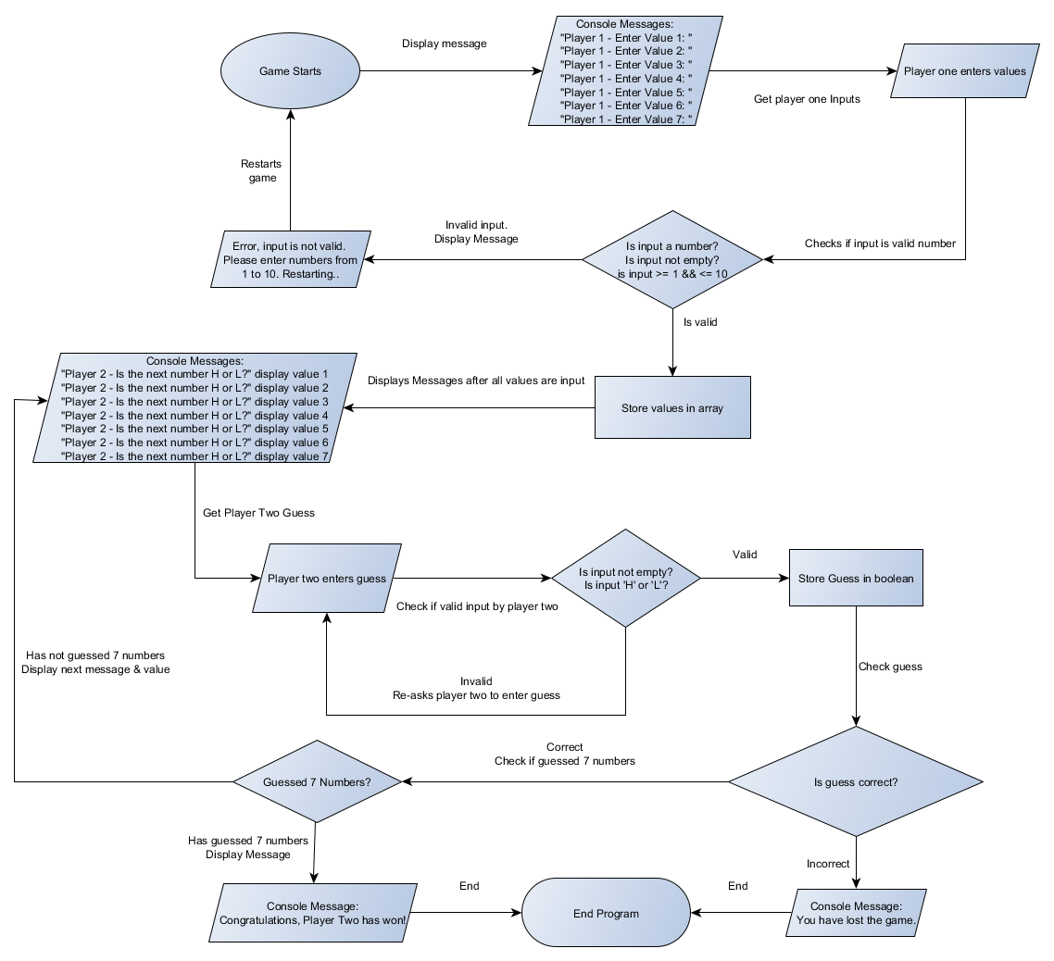
This is a flowchart created for the first programming task which is the Higher or lower game. This goes through the logic of the program that is going to be created.

4.2 Appendix B – Solving Player One Problems:
Screenshots of player one problems being solved below.
Go back to development stages

4.2.1 How player one values are input
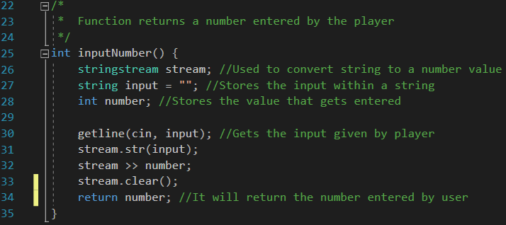

4.2.2 How the values being entered are stored:
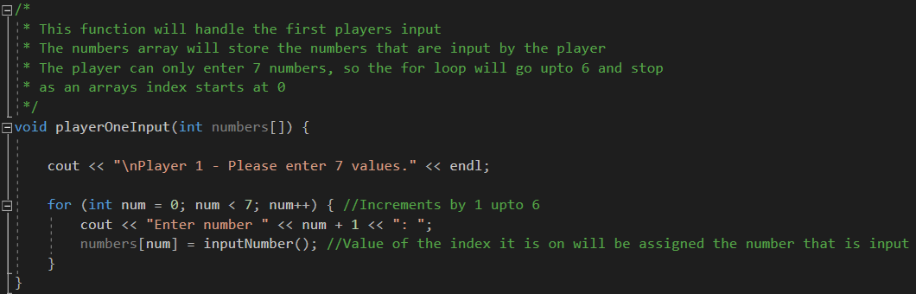
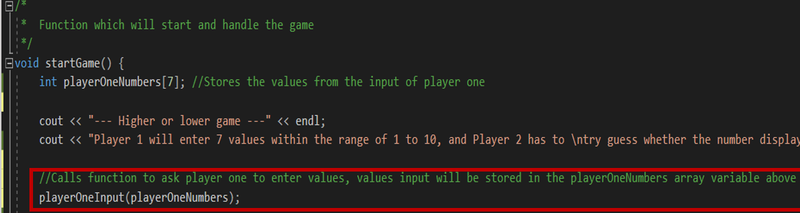

4.2.3 How the values are checked whether they are in the range of 1 and 10:
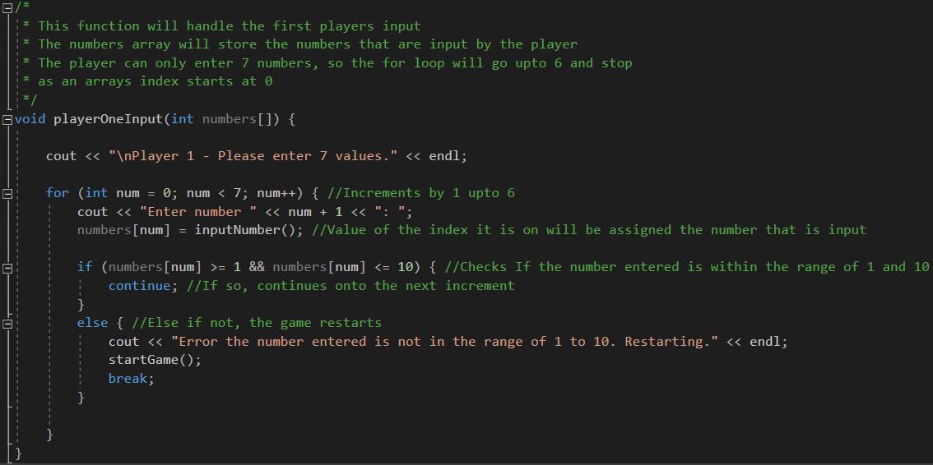

4.2.4 How player ones’ value will be checked if it is not left empty
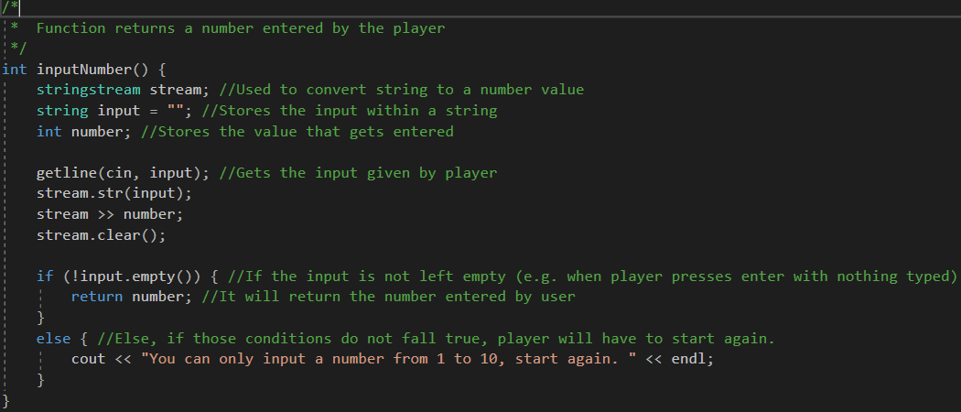

4.2.5 How number inputs are checked whether they are a valid number:
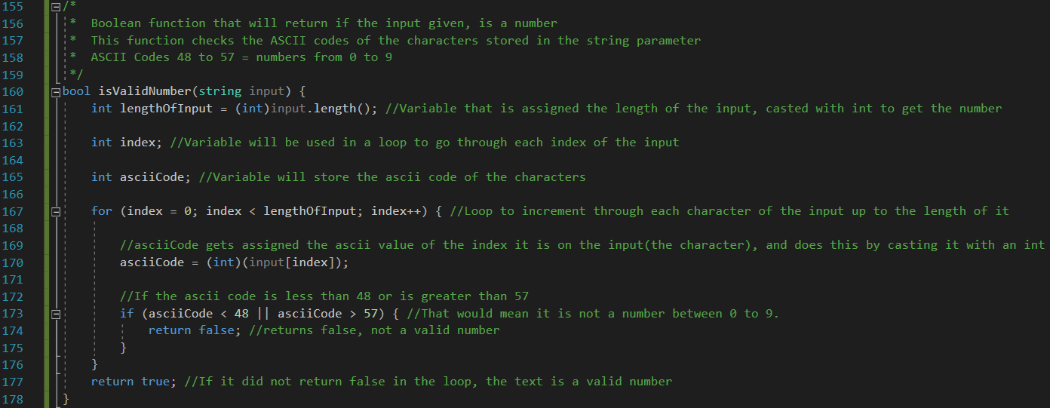
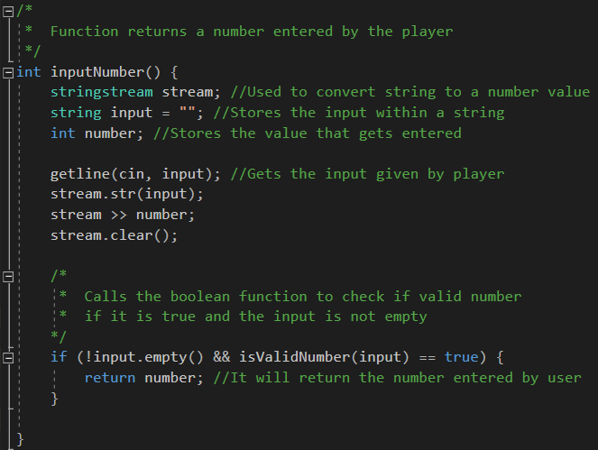

4.3 Appendix C – Solving Player Two problems:
Screenshots of player two problems being solved below.
Go back to development stages

4.3.1 How player twos’ guess will be input
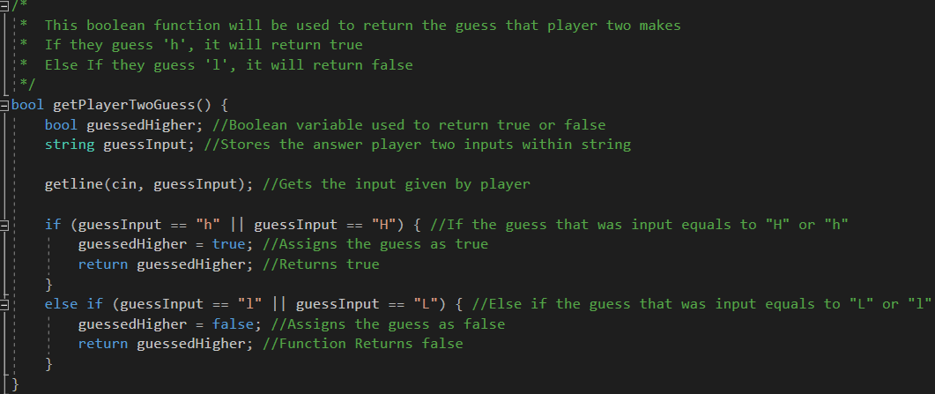

4.3.2 How player twos’ guess will be stored
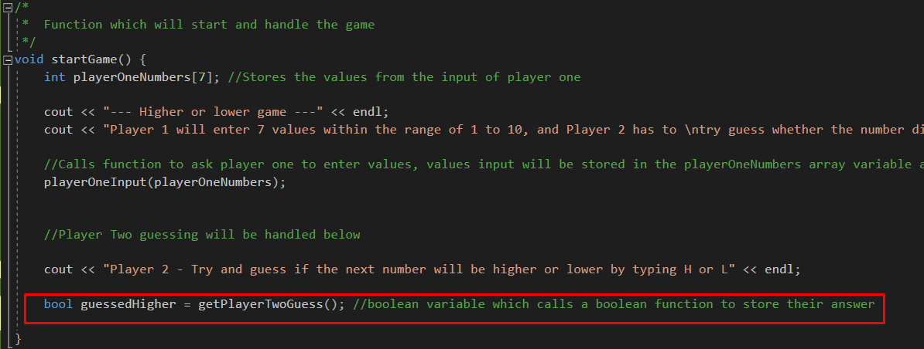

4.3.3 How player two will go onto the next guess
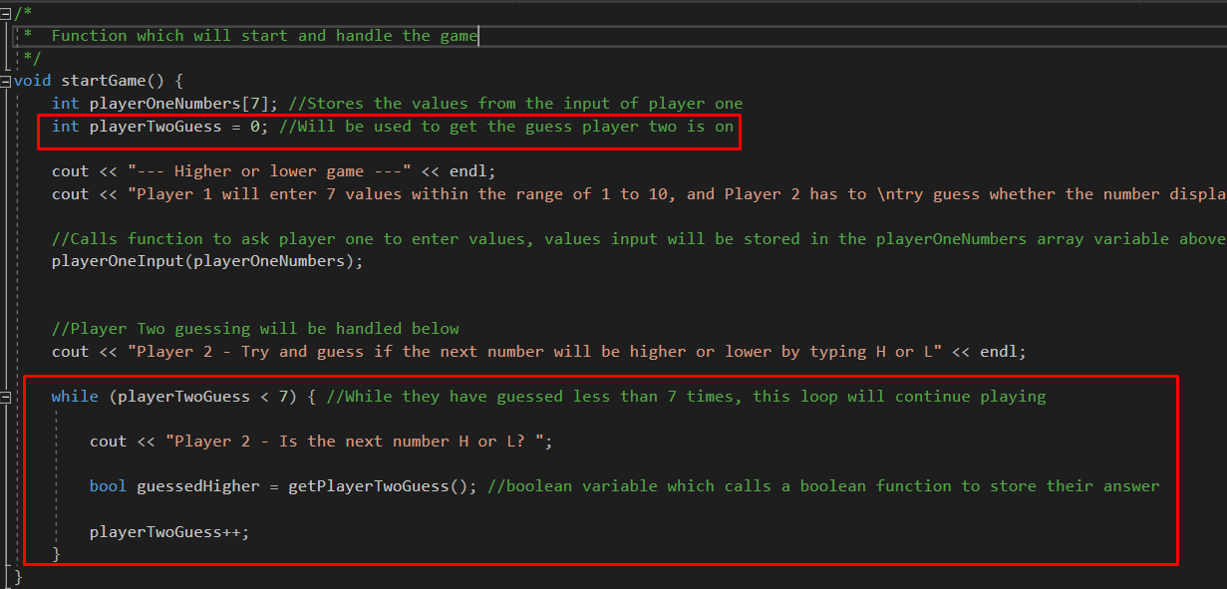

4.3.4 How player twos’ guess is checked if valid input
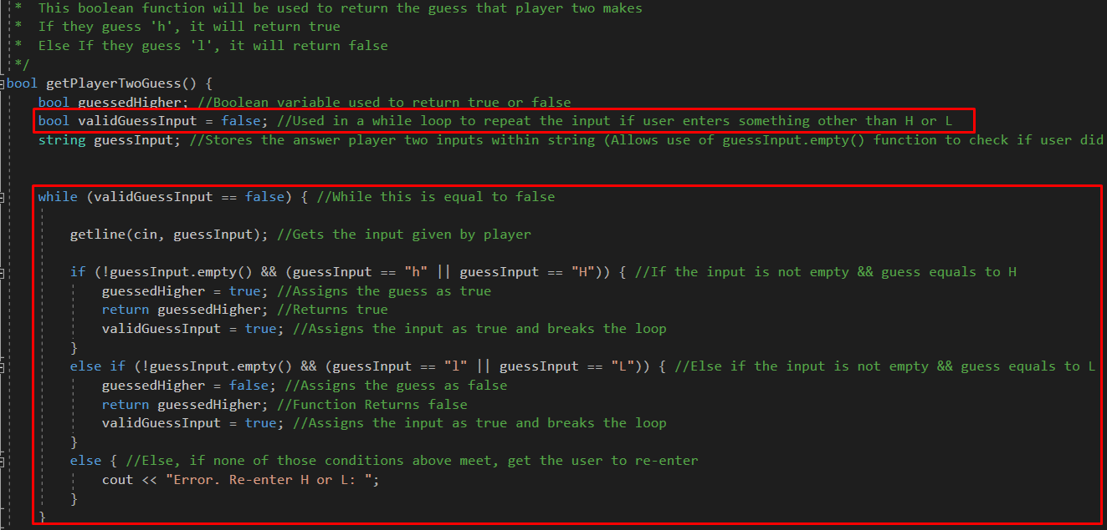

4.3.5 How to check if player two has went through all values entered by player one
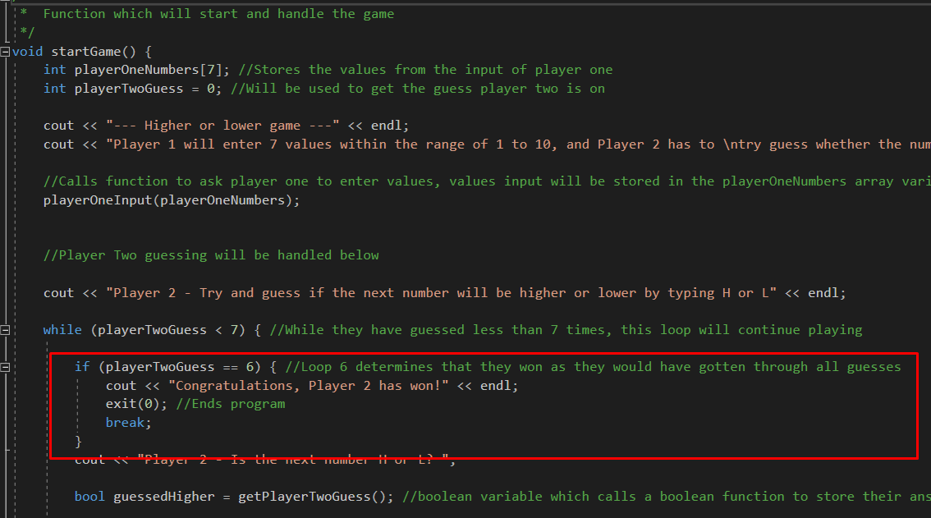

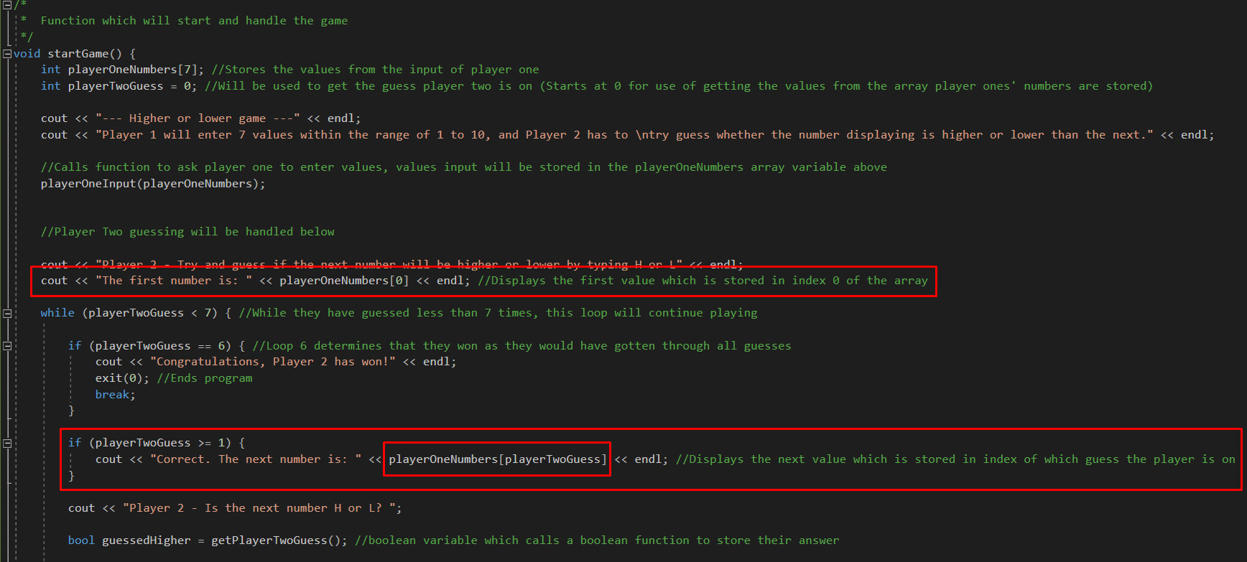
4.3.6 How player ones’ values will be displayed to player two

4.3.7 How to check if player twos’ guess is correct or incorrect
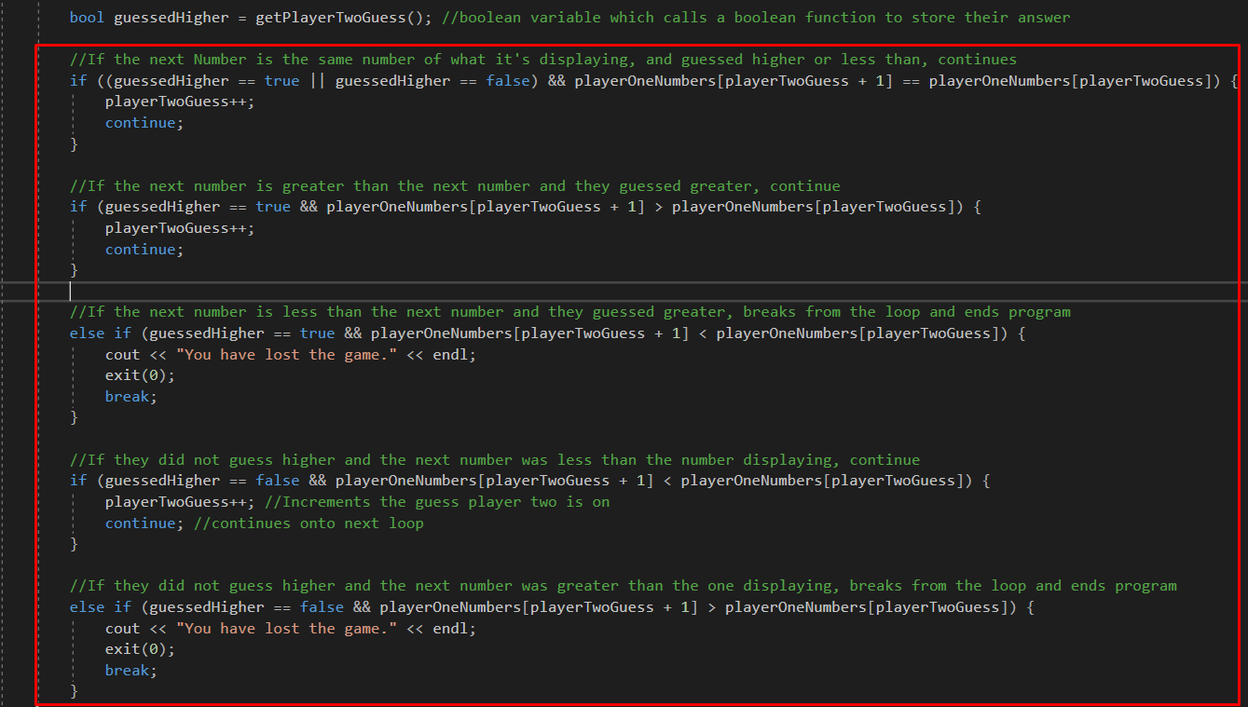

4.4 Appendix D – Testing results:
Below will be the screenshots of the tests completed in the Test table, the tests can be identified by the number and description of the test below.
Go back to Test table

Test 1 – Testing player one Empty input and letter inputs
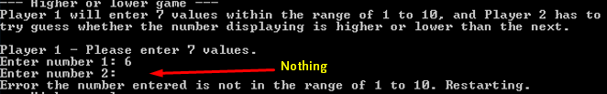
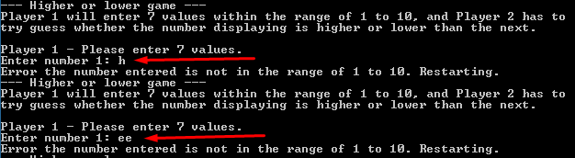

Test 2 – Testing Player One number inputs less than 1 and greater than 10
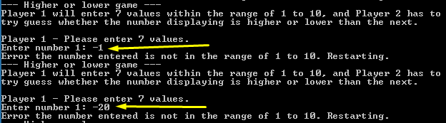
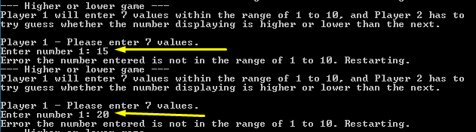

Test 3 – Testing Player Two empty input and inputs not equal to ‘H’ or ‘L’
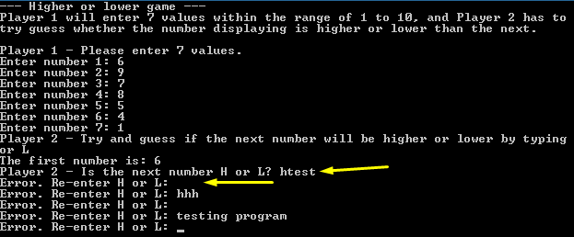

Test 4 – Testing Player Two ‘H’ input when next value is greater than the value displaying
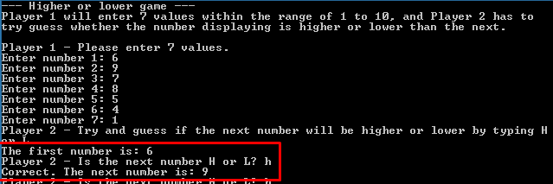

Test 5 – Testing Player Two ‘H’ input when next value is less than the value displaying
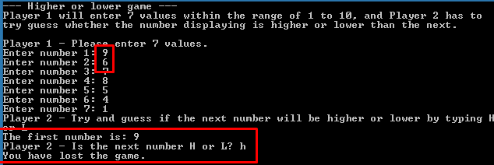

Test 6 – Testing Player Two ‘L’ input when next value is less than the value displaying
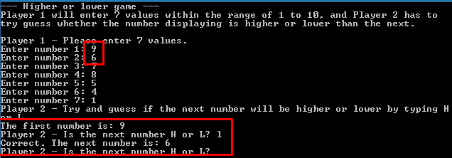

Test 7 – Testing Player Two ‘L’ input when next value is greater than the value displaying
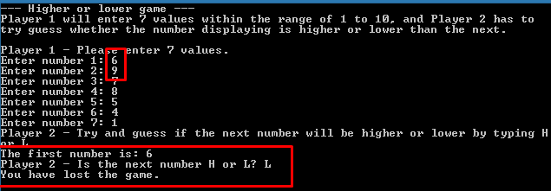

Test 8 – Testing Player Two ‘H’ and ‘L’ input when next value is equal to the value displaying
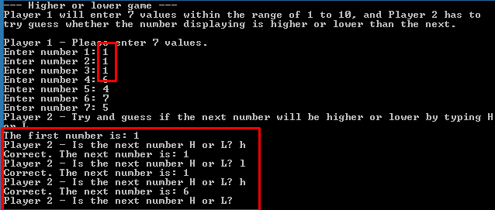

Test 9 – Testing Player Two winning after guessing all values entered by player one
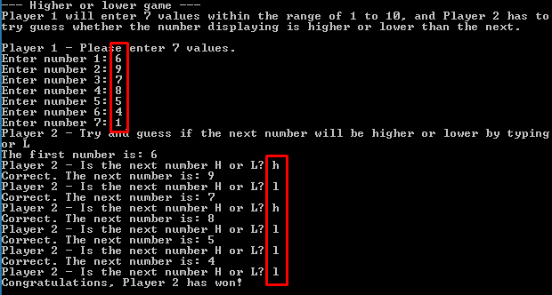

References

[1] | T. Star, “Principles of Good Software Design,” Intertech, 25 April 2018. [Online]. Available: https://www.intertech.com/Blog/principles-of-good-software-design/. [Accessed 5 April 2019].

