REPORT

My academic and employability skills

Student Name and Number: Oksana Klepailo 1912613
Moodle: Academic and employability skills BMSW4001
Lecture’s Name: Timothy Hopkins

01/05/2020
Table of Contents

Contents.......................................................................................................p. 2
Abstract .......................................................................................................p. 3
1. Introduction…………………………………………………………............... p. 4
2.The Methodology ……………………………………………………………. p. 5
3. Results or findings
3.1 Academic and Employability skills……………………………….……… p.5
3.2 Analyzing PDP and Eisenhower Matrix………………………………… p. 7
3.3 Short table of differences between Essay and Report………………... p.8
3.4 Reviewing of Paraphrasing, Summarizing and Referencing……….... p. 9
4. Case study
4.1 Skills are required hospitality industry…………………………………. p.10
5. Discussion and recommendation …………………………………………. p.11
6. Conclusion and Recommendations………………………………………... p.12
7. References…………………………………………………………………… p.13
8. Appendices…………………………………………………………………… p.15

Abstract
The main goal of this research is to analyze my own academic and employability skills, about their impact on my personality, find out the skills which I need to practice more to get better and competent, and how it can be improved for the future. To understand the case study which was drawn from the teaching Moodle. Ability to analyze the Personal Development Plan and the Eisenhower Matrix of time management. To define the importance of understanding the difference between writing a report and an essay. To look through the evidence drown into the report from the in classes exercise.

Introduction
Skills are the selection of knowledge, experience and capabilities needed to reach the aim. In worldwide exist different types of skills the most important is employability and academic skills, which is required by any kind of job. (Doyle, 2020)
To succeed any goal will need to have a complex of the skills. The skills have the ability to improve and with the right skills can get the desired result.
By reading this report the reader will understand what employability and academic skills are, their impact and how they can be improved through my own skills. Owing to certain methods will investigate the time management (Eisenhower Matrix) and Personal Development Plan to be able to reason the role which they are playing to get better our lives. Through in-class exercise will consider the importance of understanding paraphrasing, summarising and referencing skills. Reviewing the hospitality articles the reader can explore the skills which are necessary to have for work in that area.

2. The Methodology
The purpose of this research it to find out the value of academic and employability skills in our lives and which impact they might do. The research is based on the analysing and data collection include in-class exercises, reviewing in Moodle’s studying materials such as academic writing (referencing, summarising and paraphrasing), time management and employability skills and the research skills.
To analyse the data was used the Eisenhower Matrix of time management and Personal Development Plan to understand how to manage and improve the daily task to reach the success. As the method was utilized information drawn from the hospitality industry about the skills which are necessary to work in that professional area.

3.Result of findings
3.1 Academic and Employability skills
Employability skills are the set of skills that help to carry out the job to the best of all, employability depends on knowledge, skills, attitude and communications. How the person uses these skills and how to present them to employers.
Employability skills include:
- Communication and interpersonal skills – explanation in a clear way (written or spoken).
- Problem-solving skills – able to identify the problem and solve it.
- Self-motivated skills – to have new ideas.
- Working under pressure and to deadlines – to know how to work in a stressful situation and handle stress.
- Organizational skills – able to plan work in an order.
- Team working skills – be open mind to work with other people.
- Ability to learn and adapt – ability to learn new things.
- Negotiation skills - ability to communicate in the right way, to have advantages.
- Note-taking – ability to write down just necessary notes.
- Time management – able to manage your time, do not waste time.
- Transferable – skills that can be moved from different situations (STEMNET, Accessed: 23 April 2020)
Academic skills are so important as well as employability skills. Academic skills are complex abilities that give us knowledge, help to reach a good result in the studying process, at academic world and at work as well.
Exist the most common academic skills as:
- Writing – it is grammar knowledge and the ability to express the thoughts by words on paper.
- Note-taking – ability to write the most important piece of information in short form.
- Time management – allows us to organize and manage our time to be more productively.
- Research – it is the skill that teaches and helps to find the right information through plenty of resources. (Youniversitytv, 2017)
- Referencing – is an academic skill that allows the reader to find the resource and faith of information that was used in the report or essay. (Pears and Shields, 2019, p.1)
- Paraphrasing – the process to convert the information by own word to avoid the plagiarism.
- Summarising – helping to choose the important information from the text and write in a short way by expressing it with own words. (Yagelski, 2015, p.127, 128)

3.2 Analyzing PDP and Eisenhower Matrix
In the lectures I found out how to create and fill in correctly my Personal Development Plan as it is important to know in which side should move to achieve the plan and the goals. PDP is a plan which includes the personal plans, achievements and aims. It helps to own progress. Personal Development Plan has benefits such as: help to focus clear to the tasks, develop self-management skills, awareness of the need that might be improved, developing a positive approach and strategic thinking skills. (Cottrell, 2010 p.3)
The example below is a part of my personal development plan. The full PDP is attached below as Appendix 1.

 | Sort-Term Time Frame | Mild-Term Frame | Long-Term Frame
Section 1 -My Goals | At this time, I want to change my current job to become the hotel receptionist. | I want to finish my university and be graduated. | I would like to have a higher position at work, as a hotel manager.
Section 2 – Skills and Knowledges to be learned | I need to learn the OPERA PMS system, reservation system at the hotel. | I need to learn more about each subject in my classes to get the knowledge as much as I can. I need to improve my English writing and speaking. | I will get my education certificate. I need to improve my teamwork skills, need to be more confident, commercial awareness, need t have problem-solving ability, negotiation skills.
Section 3 – Next Steps | I must take a receptionist courses to learn everything about this type of job, including learning OPERA PMS to get training and knowledge. | I will visit my university classes, will focus on studying and will study at home as well. | After finished university I will get some experience, and as soon as I got a chance to develop my career.

(PDP table: Klepailo Oksana, 2020)

The Eisenhower Matrix is the tool of time management, this matrix helping to be more effective and teaching how to give more attention to necessary things than useless to save more time. This matrix shows us which are important things, which are urgent, and which are not urgent, and not important. (Expert Program Management, 2017)
To look at the PDP and Eisenhower Matrix can say that it is the perfect way to plan and organize the day, time and life. It helps to save precious time, to think about is most important in approaching a goal. My matrix of time management is attached below as Appendix 2.

3.3 Short table of differences between Essay and Report

The essay is an academic writing which covers a specific subject and demands to introduce own ideas, arguments, and evidence to disclose the topic of the essay. The essay has different types as the research essay, the reflective essay, and the exam essay. The essay structure consists of an introduction, body, conclusion, and references. (Roberts, 2017, p.1-5)
Report is science or academic writing that has a specific structure of writing, includes learning material, identified and analyze the issue, demands of providing findings, methods and investigations. Report structure has an abstract, table of contents, introduction, literature review, methods, findings, discussion, conclusion, recommendations, reference list, and appendices. (Bogg, 2012, p.2)

Differences between Essay and Report
Essay | Report
- Essay is academic writing as well but also can be used anywhere.  - Essay more analyse theory or model what is relevant to the topic.  - Essay has a different structure than report.  - In the essay does not use the methods. | - Report is required to be written in the academic world.  - Usually, the report includes the findings (case study, applying a theory to the work, class exercises).  - Report has a different structure than essay.  - Report uses the methods.

(Cottrell, 2003, p. 209)

3.4 Reviewing of Paraphrasing, Summarizing and Referencing
Summarising and Paraphrasing are essential skills that are using in academic writing. They help to write some text in a short way with keeping important information. Summarising and paraphrasing are so similar in understanding, but they are different in writing structure.
Paraphrasing giving meaning to the text from the source in another form. Paraphrase usually expresses the information by own words.
At (Appendix 3) that is below you can see an example of my paraphrasing skills.
Summarising help to convert the information from the text in the shorter form with its own writer’s words. It is using when need to choose the main idea of a text, to make an argument, or to express a point of view of certain text resource. (Yagelski, 2015, p.127, 128)
Referencing called the process of using other people’s work in your research. It helps the reader to find an easier way the material which was used and allows to verify the faith of arguments. (Pears and Shields, 2019, p.1)

4. Case study
4.1 Skills are required at the hospitality industry
Every employer wishes to have the professionals at their companies and before they will give a vacant place to candidate, they are required a couple of necessary skills they need to certain workplace.
According to Westone hotel & catering consultancy, can see which skills are needed to work at the hospitality area. The important skills are: delighting the customers, listening, organization and prioritization, to be awareness, patience. (West One Hospitality & Catering Recruitment, 2020) Full text available in Appendix 4 or using a link at the reference list.
Reviewing another article from Detail 2 Recruitment and there are required these types of skills: teamwork, multi-tasking, flexibility, attention to detail, knowledge, communication, time management, interpersonal skills, problem-solving, hazard awareness. (Detail 2 Recruitment, 2019) Look below Appendix 5.
The article “Leadership Skills in Hospitality Sector” is saying that leadership skills became more important in the organization success a well as communication skills.
Below in Appendix 6 given a detailed description of the leadership skills needed at the hospitality industry. (Sousa et al. 2019, p.105-117)

5. Discussion
As far as for me I can say that I have several academic and employability skills and they allow me to achieve my tasks, goals, and objectives. Employability skills that I have for now are communications, working under stress, organizational, ability to learn and adapt, note-taking, time management skills, team working skills. They are helping me at my job, they are making me stronger, independent, self-motivated person and look professional in the eyes of my employer. About my academic skills I have several of them such as writing, note – taking, listening, and some of them I just learned and got at my university lessons. The new skills that I gained are paraphrasing, summarizing, academic writing.
I also learned the writing report skills, I found out how to write a report and what is different between an essay and a report. I also understood how to write a reference correctly by using the Harvard referencing handbook, and these skills helped me in writing this report. But eventually I need to improve my writing, communication, creative thinking skills to succeed in my goal and to develop my career in the future. Time management skill I had before but according to my PDP it still could be developed more. From in classes exercise about paraphrasing skills I can see that I need to work out more on it.

6. Conclusion and Recommendations
The findings and the research methods that were pulled into the report are saying that skills are very important abilities in our life. Academic and employability skills give opportunities to reach the success. They help to get the job, to improve ourselves, through them we can learn, find out and open more new opportunities. Academic skills are giving knowledge about writing skills, referencing, paraphrasing and summarizing, helping to be competent in the academic world. And examples from PDP and Eisenhower matrix very useful in explaining how to manage our time properly. This report recommends my further development of writing skills, communication skills and searching for resources.

References
- Bogg, D. (2012) Report Writing. Berkshire: Open University Press.
- Cottrell, S. (2003) The study skills handbook. Basingstoke: Palgrave Macmillan.
- Cottrell, S. (2010) Skills for Success: Personal Development and Employability. 2nd edn. Basingstoke: Palgrave Macmillan.
- Detail 2 Recruitment (2019) Top 10 skills all hospitality employees have. Available at: https://www.detail2recruitment.com/news/article/293 (Accessed: 25 April, 2020).
- Doyle, A. (2020) ‘Skill Set Definition and Examples’. The balance careers. 28th January. Available at: https://www.thebalancecareers.com/what-is-a-skill-set-2062103 (Accessed: 24 April 2020).
- Exeter University. ‘Top 10 Employability Skills’. STEMNET. Available at:
https://www.exeter.ac.uk/ambassadors/HESTEM/resources/General/STEMNET%20Employability%20skills%20guide.pdf (Accessed: 23 April 2020).
- Expert Program Management (2017) The Eisenhower Matrix. Available at: https://expertprogrammanagement.com/2017/07/the-eisenhower-matrix/ (Accessed: 24 April 2020).
- Pears, R. and Shields, G. (2019) Cite them Right: The Essential Referencing Guide. 11th edn. London: Red Globe Press.
- Roberts Q, J. (2017) Essentials of Essay Writing: What Markers Look For. London: PALGRAVE.
- Sousa, M.J. et al. (2019) ‘Leadership Skills in Hospitality Sector’, Journal of Reviews on Global Economics, pp. 105-117. Available at: https://www.researchgate.net/publication/331099164_40_Leadership_Skills_in_Hospitality_Sector (Accessed: 30 April 2020).
- West One Hospitality & Catering Recruitment (2020) 5 Key Skills Required to Work Front of House. Available at: https://www.westonerecruit.co.uk/hospitality-careers/5-key-skills-required-to-work-front-of-house/ (Accessed: 25 April, 2020).
- Yagelski, R. P. (2015) The Essentials of Writing: Ten Core Concepts. Stamford: Cengage Learning.
- Youniversitytv (2017) 6 Academic Skills Every Successful Student Needs. Available at: https://www.youniversitytv.com/college-tips/6-academic-skills-every-successful-student-needs/ (Accessed: 26 April 2020).

Appendix 1
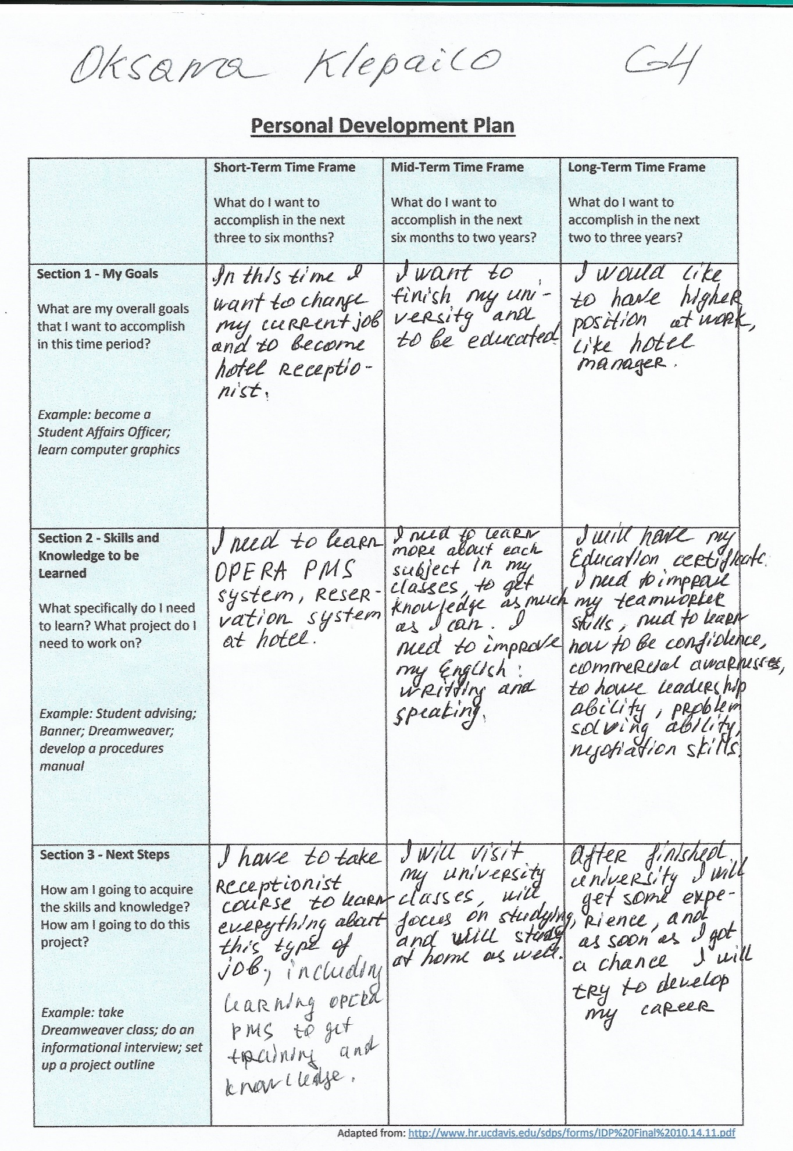

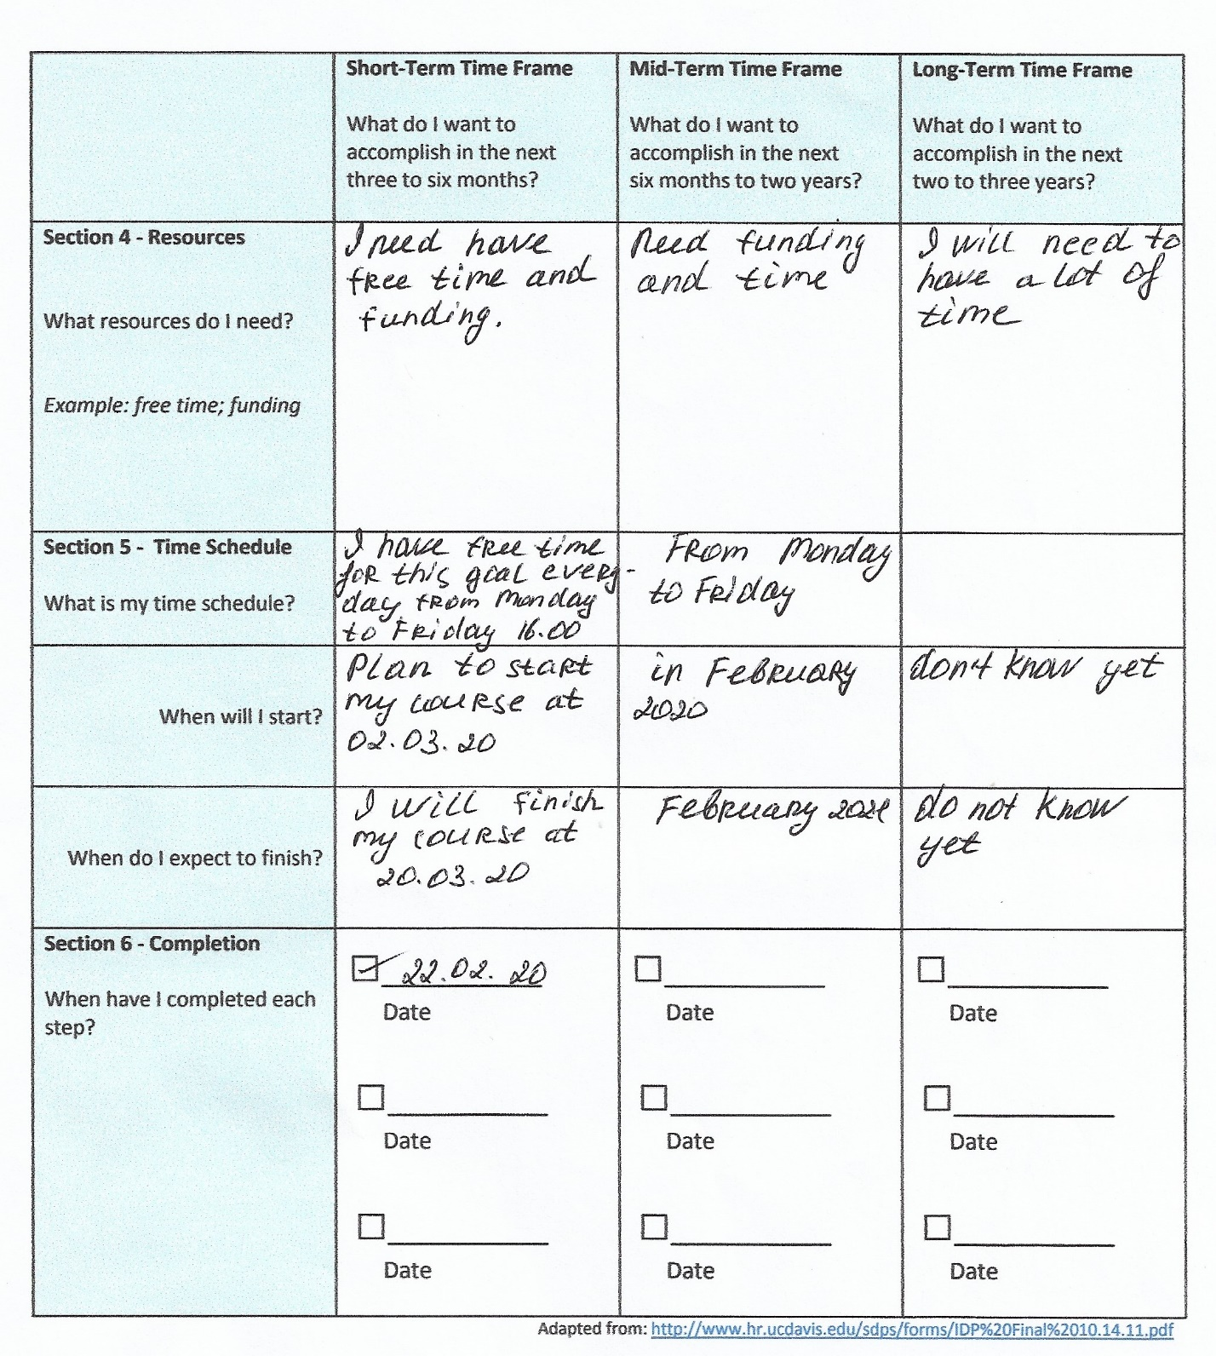
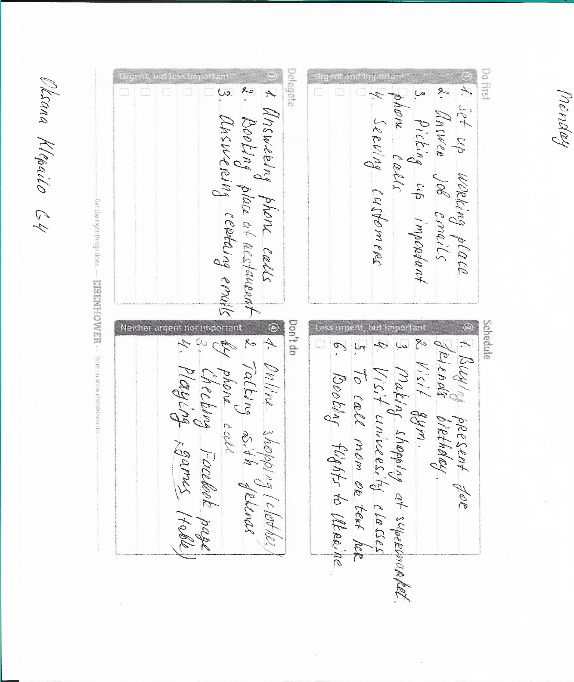
Appendix 2

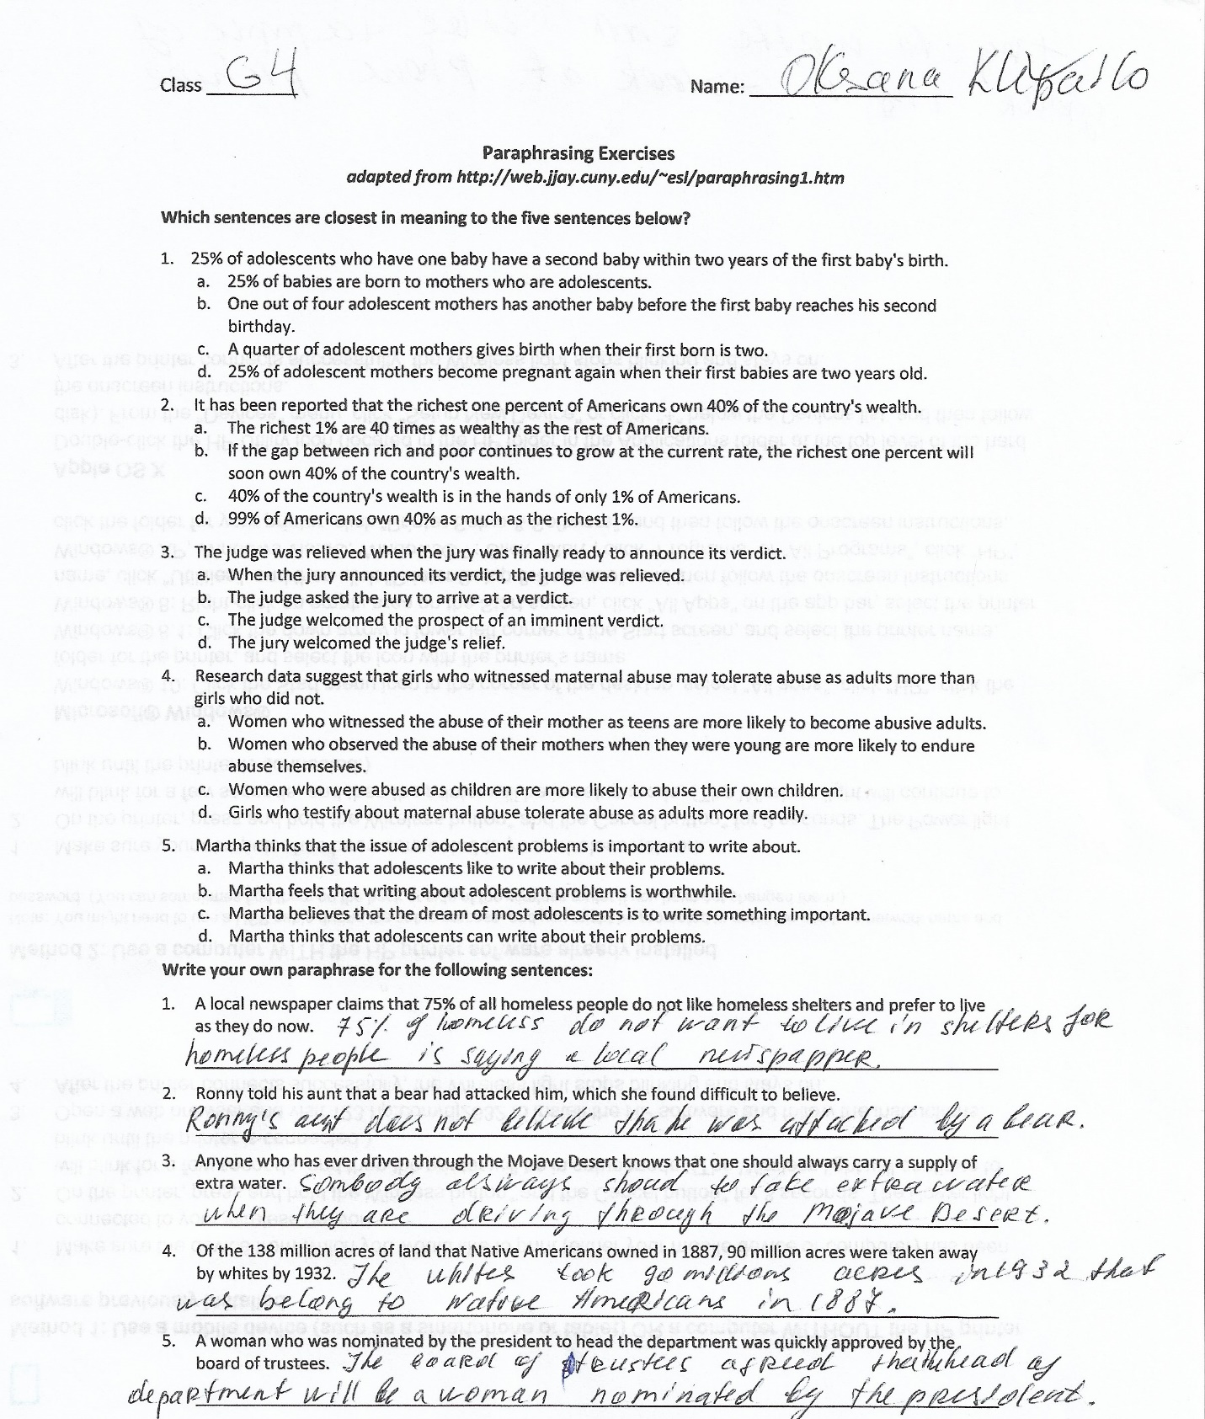
Appendix 3

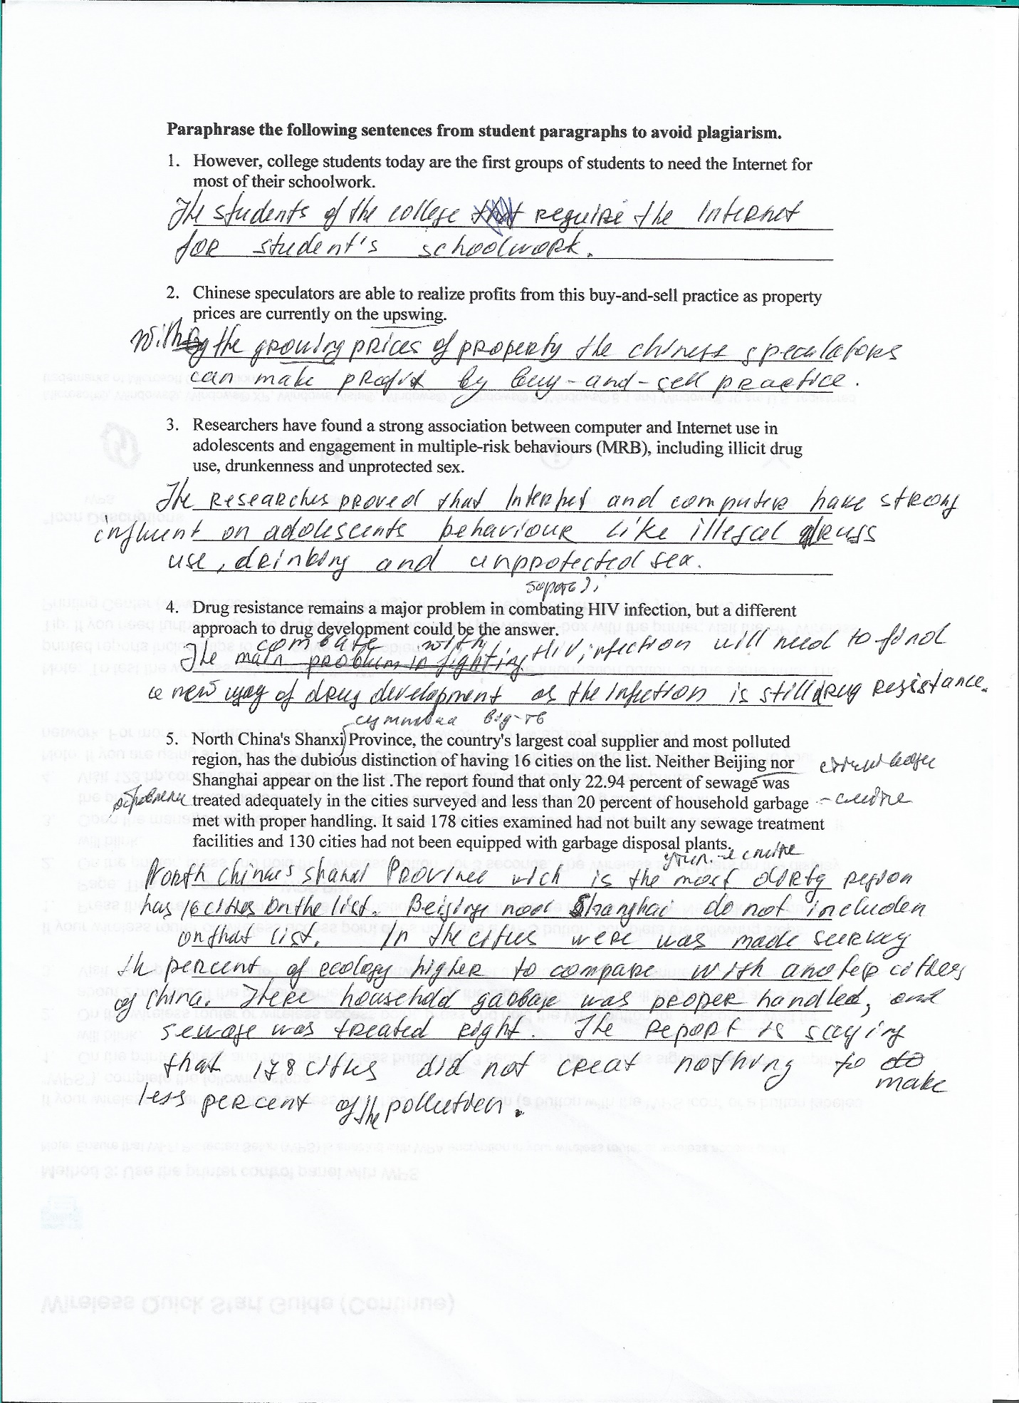
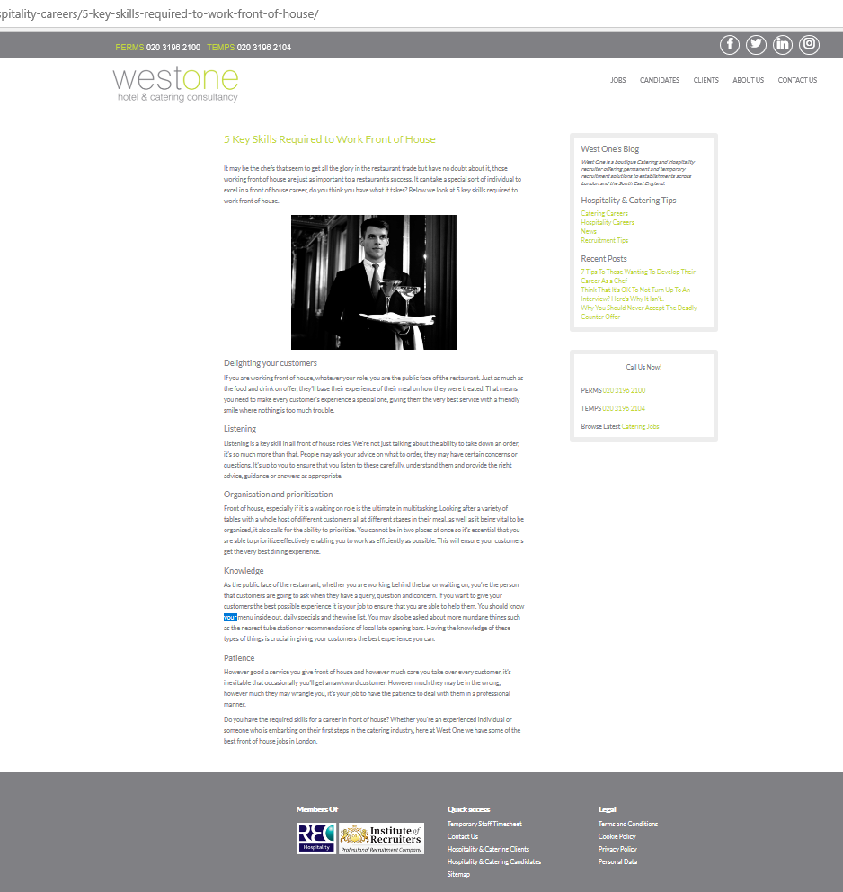
Appendix 4

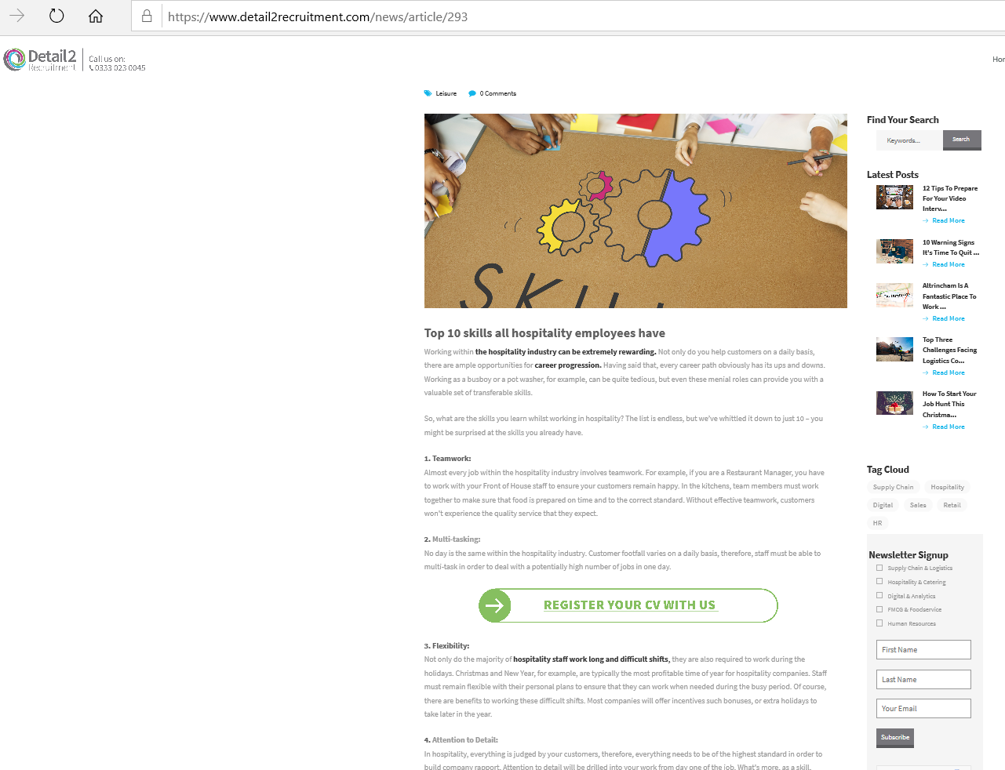
Appendix 5

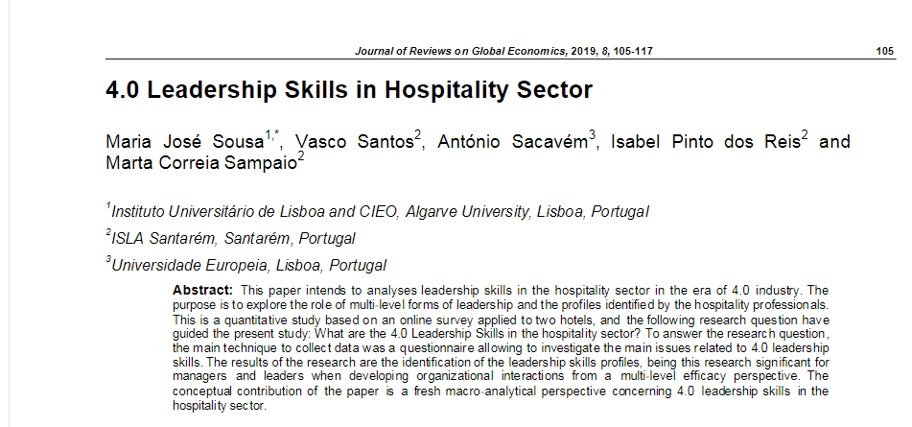
Appendix 6



