Marketing Fundamentals
Blogging to communicate-Apple

Name of the Student: Dragos Preoteasa
Name of the lecturer: Tushara Balendran

MARKETING STRATEGY AND MIX OF APPLE INC (iPhone)

Background /History of Apple Inc
Apple Inc is one of the American Multinational Technology Organization which is headquartered in Cupertino, California. The main task which is performed by Apple Inc is designing, developing along with selling the computer software, online services along with consumer electronics (Apple.com 2020).
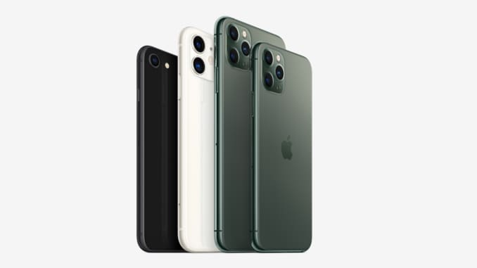
It is one of the five companies in the United States of America in the IT industry along with Google, Amazon, Microsoft as well as Facebook (Wu and Li 2018).
The company was incorporated in the year 1976 and they have their presence in 510 retail stores till the year 2020. The areas served by them are worldwide and number of employees working with Apple Inc till 2019 is around 137000.
Till the year 2020, there has been increase in level of revenues which is around US$274.515 billion and total equity is US$65.339 billion and the company is performing brilliantly against the different competitors.

The mission of Apple Inc is for bringing the best personal based computing products as well as supporting the different students, designers, consumers and businesspersons in over 140 countries in the entire world. The mission statement mainly considers changing kind of business landscape which mainly influences the various possibilities of what the company Apple Inc can be performing (Syapsan 2019).

PRODUCT
The respective marketing mix element mainly determines different outputs of business organization Apple Inc. In the respective case, the product mix of Apple Inc mainly includes the different products along with services which are mainly classified as, or mainly includes information technology (Stead and Hastings 2018). The company has been capable of expanding the product mix, creating the overall possibility of adding the non-IT based products in the 4P element. The major product lines of Apple Inc include:
- Mac
- iPhone
- Apple Watch
- Apple TV
- Cloud Services
- Accessories
- Digital content and software
These kinds of product lines of Apple Inc is mainly associated with the utilization of human resource along with business processes which are based on the product based divisions. iPhone mainly and mostly comes up with the new products every year that supersedes previous ones. Currently, it has come up with iPhone 12 pro which has preceded iPhone 11 and other trailing versions. ‘
In case of iPhone, lesser price of the older products mainly attracts various segments of different customers than newer ones, wherein the focus is provided on the technology specifications. The Apple iPhone mainly offers the unique level of operating system, running at the better level of speed than the other competitors such as Samsung (Pomering 2017).
The innovative kind of applications in Apple store is first kind of movers, copied them afterwards by different brands, in accordance with the Apple technologies and consumers both. Apple mainly hook for the different other products as well which makes the business perform brilliantly (Solimun and Fernandes 2018).
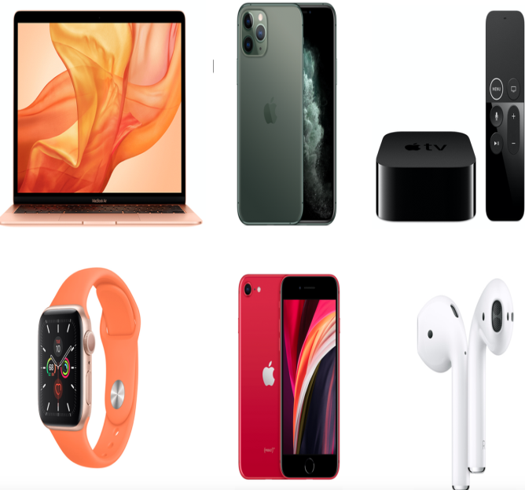

Apple Inc mainly operates in the digital content-based distribution industry and the product category is mainly based on the cloud-based technology. This mainly allow the different customers for storing as well as accessing the data along with the usage of the software as the service which includes iWork for iCloud (Ramani and Srinivasan 2019). The product lines in the 4P based element are mainly based on different outputs of product-based development growth strategy. This element of marketing mix mainly helps the company Apple in maintaining their growth in an accurate manner.
PRICE
The respective element of the marketing mix helps in setting the appropriate prices, price points along with analyzing the ranges of the prices for the different products which are developed by the company (Othman et al. 2019). In case of Apple Inc, there are majorly two kinds of pricing strategies which are being used and they are:
- Premium Pricing Strategy
- Price Skimming Strategy
The premium pricing-based strategy mainly involves the proper offering of the different kinds of products at the premium. In the respective theory, the premium is the amount which is mainly applied in the addition to typical along with common kind of price. In this aspect, the usage of premium pricing of Apple Inc sets the high level of prices for the different products. For instance- In the general terms, the iPhones are highly expensive in nature in comparison to Samsung and other major competitors which are serving in the same industry.
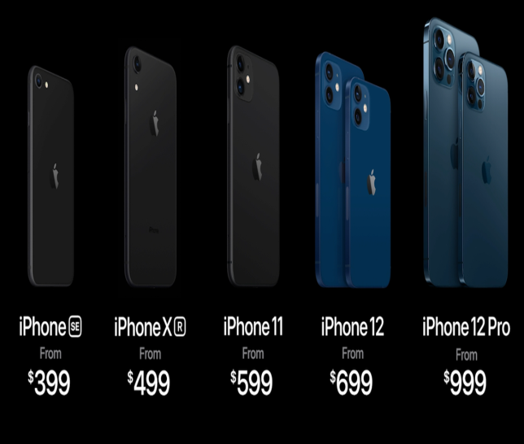
The premium pricing that is used by Apple helps them in maximizing the level of profit margins. Additionally, Apple Inc has been using the premium pricing in the combination with proper branding along with creative level of innovation (Ndofirepi, Farinloye and Mogaji 2020). Moreover, the price skimming strategy means when the brand wants to stand out effectively, therefore, in such scenario, the company will be capable of investing a lot in the research and development for mainly bringing X factor with every kind of new launch. Therefore, in such scenario, the research and development cost as well as the X factor mainly allows iPhone, for charging more as the part of the marketing mix kind of strategy and sustain (Abedi and Abedini 2017).
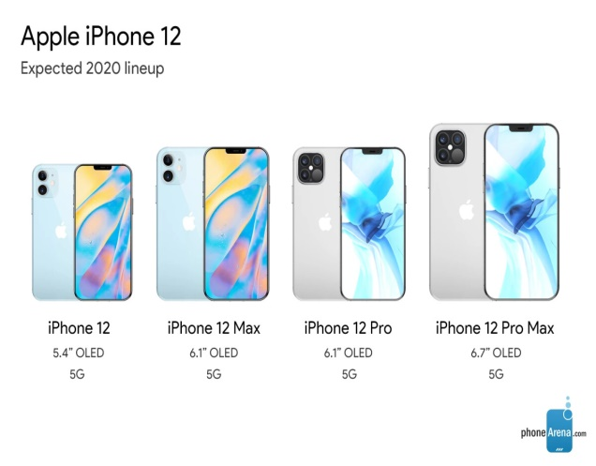
This kind of pricing is mainly and gladly accepted by the different target customers. Although, the different online stores mainly come up with discounted prices, as the market value of the different products mainly declines with the new kind of launches. Apple iPhone mainly follows the similar kind of policy based on pricing across the different markets; therefore, it follows cost effective kind of operation strategy, with the minimal level of cost spent mainly on the process of manufacturing. Apple stores always tries to focus on the providing of the experience to the different customers who makes them quite effective in enhancing their brand value and this makes them perform better against the different competitors. This provides the added value to everyone (Abril and Rodriguez-Cánovas 2016).
PLACE
iPhone has the strong level of distribution as well as place-based strategy as the part of their entire marketing mix. Some of the place and distribution centers are described in the following manner:
I-Stores- It is the first and foremost place wherein these are considered to be the people owned stores with the highly acceptable as well as knowledgeable service people. It will be giving them lot of time as well as effort for getting tech-based specifications across different customers (Andika and Susanti 2018). These kinds of stores are highly trained kind of salespeople, with their advances to offer, creating the great level of experience, which mainly enhances the customer’s experience for buying the different products such as iPhone. These kinds of exclusive show rooms receive the different products directly from the organization at the lesser prices.

Independent Stores- In different malls, there are few independent stores which have their shops and with the other phones, they place iPhones for sale. Buying from these kinds of stores is good, as these are the premium stores in themselves and they mainly purchase from the different distributors rather than the organization itself. These are considered to be the Brick-and-Mortar Model which allows the customers to come and analyze the products and check and then make the respective purchases. This will be capable of providing as well as creating the balance with many multiples and this enhances the business to a large extent (Blut, Teller and Floh 2018).
Online Stores- The different products of Apple Inc are mainly available, on different sites, like eBay, Amazon, or the others. There is the official website of Apple Inc which mainly provides the different customers and provides the service of fining nearest locator as well (Datta, Ailawadi and Van Heerde 2017). The customers can buy the different kinds of consumer-based electronics through the website of company. The major inclusion of the online distribution channels mainly helps Apple Inc in optimizing the international kind of reach in the market. This will be enhancing the business of iPhone and the other products which are sold by Apple Inc in an efficient and more appropriate manner.
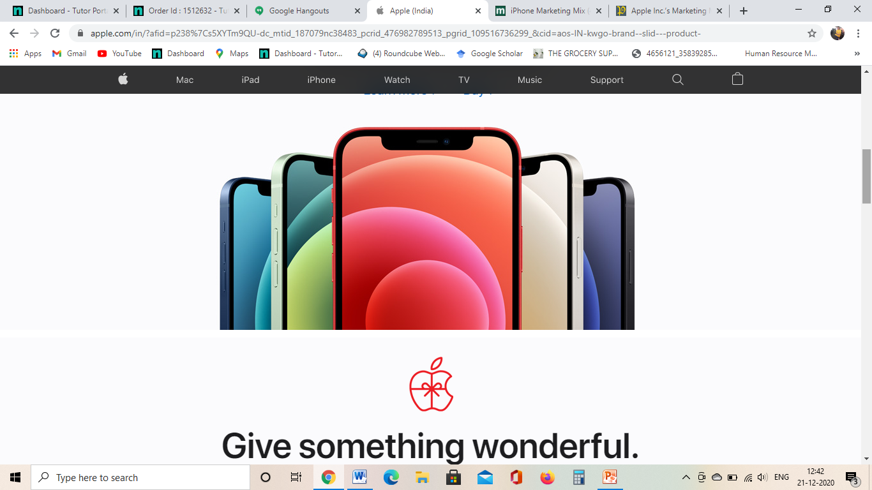
Second Hand Market and After Sales- There is a huge market which is already present for the second hand iPhone mobile sets along with showing the customers with high level of durability present in it. eBay is considered to be one of the largely online sites which mainly deal with the second-hand based segment. iPhone is also very well-known for the different after sales service aspect and this will be enhancing their growth largely in such scenario. iPhone mainly does not tie up with different corporates for many services (Išoraitė 2016).
PROMOTION
iPhone has been capable of mainly creating the unique position in the market which makes them quite unique and different against competitors. With the innumerous differentiating level of features, the new models of iPhone such as iPhone 12 or 12 Pro helped them in promoting the brand image in an accurate manner. The advertisements of the company Apple never compete with different kinds of competitors; however, it can show how the entire world is changing with each of the different models which have been developed by iPhone (Išoraitė 2016).
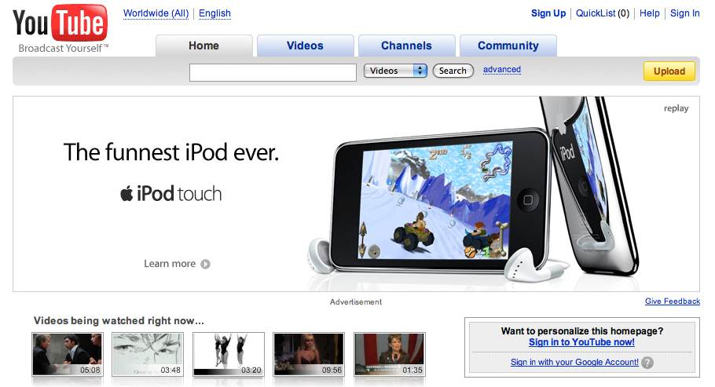
The company has different agreements with various websites which are prominent in nature. These help them in advertising the different products of Apple which are being introduced by them to the different groups of people. Additionally, Apple Inc also uses the personal selling in form of the Apple store employees who mainly tries to provide the product specific information in aim of convincing the different store visitors for making the appropriate purchase in an accurate manner. Some type of locations offers the different old models at the discounted prices. This enhances the progress of the company in an accurate manner and manages the business to perform as per the different norms which are appropriate for their sustainable growth in the competitive business scenario. The different launch-based events of Apple Inc are very dramatic. The newly based launched kind of wireless charging based features and the different technologies get the people in awe (Liu et al. 2017).
The social media platforms such as the YouTube or the Facebook are some platforms which are highly utilized by iPhone for talking regarding the uniqueness of the features, also utilized by the technology gurus for the specific kind of comparisons. The other biggest ones are secondhand sales offer and the other kind of knowledgeable sales kind of staffs and it makes the business perform in an accurate manner (Išoraitė 2016). Therefore, with the unique value proposition, iPhone will be setting the standard for the different product, and has no such close kind of competitor, the main reason being vast as well as loyal customer base. This helps to conclude that iPhone marketing mixes as well as profitability makes the business perform brilliantly (Lahtinen, Dietrich and Rundle-Thiele 2020).
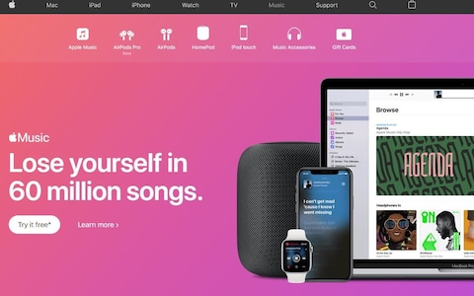
The organization is mainly involved in the different initiatives, such as ConnectED, that mainly aims for improving the formal education-based outcomes. It will be capable of promoting business and the products and these efforts make the progress in an accurate manner. The company can use such corporate social responsibility programs that will be enhancing the business and communication tactics. This will be capable of satisfying element of marketing mix, pertaining to the different business needs of the company and customers in an effective manner.
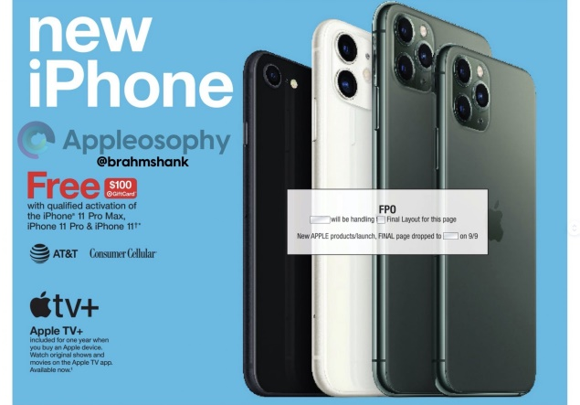
Apple also promotes the different products through the different commercials as well as print advertisements, which mainly focuses on how the different products which are sold by them are different and unique from the different competitors. The different commercial advertisements run when the products are firs launched as well as print advertisements will be running throughout the life of the products.
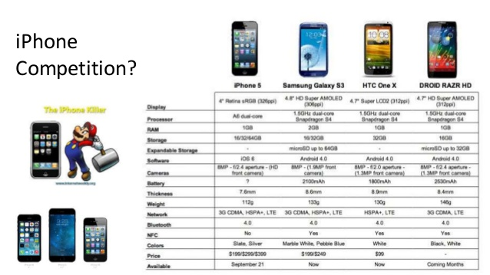
In addition, Apple Inc mainly utilizes the short-term techniques for persuading members of the different target customers. There are certain methods for the sales promotion are the money back guarantees, the lower purchase prices along with rebates. This will be enhancing the progress of the company in an accurate manner. This will be leading to the high level of progress and manage the progress of the company (Liu et al. 2017).
There has been usage of diversification aspect in case of Apple Inc wherein apart from iPhones, they can sell the different other gadgets and instruments. This makes them high diversified kind of business and enhances their business in an accurate manner and make the business perform brilliantly.

Reference List
Abril, C. and Rodriguez-Cánovas, B., 2016. Marketing mix effects on private labels brand equity. European Journal of Management and Business Economics, 25(3), pp.168-175.
Andika, A. and Susanti, F., 2018. Pengaruh Marketing Mix Terhadap Keputusan Pembelian Parfum di Azzwars Parfum Lubeg Padang.
Apple.com 2020 Apple Inc (Online) Retrieved from https://www.apple.com [Accessed on 21st December 2020]
Blut, M., Teller, C. and Floh, A., 2018. Testing retail marketing-mix effects on patronage: A meta-analysis. Journal of Retailing, 94(2), pp.113-135.
Datta, H., Ailawadi, K.L. and Van Heerde, H.J., 2017. How well does consumer-based brand equity align with sales-based brand equity and marketing-mix response? Journal of Marketing, 81(3), pp.1-20.
Išoraitė, M., 2016. Marketing mix theoretical aspects. International journal of research granthaalayah, 4(6), pp.25-37.
Lahtinen, V., Dietrich, T. and Rundle-Thiele, S., 2020. Long live the marketing mix. Testing the effectiveness of the commercial marketing mix in a social marketing context. Journal of Social Marketing.
Liu, Y., Li, K.J., Chen, H. and Balachander, S., 2017. The effects of products’ aesthetic design on demand and marketing-mix effectiveness: The role of segment prototypicality and brand consistency. Journal of Marketing, 81(1), pp.83-102.
Ndofirepi, E., Farinloye, T. and Mogaji, E., 2020. Marketing mix in a heterogenous higher education market: A case of Africa.
Othman, B., Harun, A., Rashid, W., Nazeer, S., Kassim, A. and Kadhim, K., 2019. The influences of service marketing mix on customer loyalty towards Umrah travel agents: Evidence from Malaysia. Management Science Letters, 9(6), pp.865-876.
Pomering, A., 2017. Marketing for sustainability: Extending the conceptualisation of the marketing mix to drive value for individuals and society at large. Australasian Marketing Journal (AMJ), 25(2), pp.157-165.
Ramani, N. and Srinivasan, R., 2019. Effects of liberalization on incumbent firms’ Marketing-Mix responses and performance: evidence from a quasi-experiment. Journal of Marketing, 83(5), pp.97-114.
Solimun, S. and Fernandes, A.A.R., 2018. The mediation effect of customer satisfaction in the relationship between service quality, service orientation, and marketing mix strategy to customer loyalty. Journal of Management Development.
Stead, M. and Hastings, G., 2018. Advertising in the social marketing mix: getting the balance right. In Social Marketing (pp. 29-43). Psychology Press.
Syapsan, S., 2019. The effect of service quality, innovation towards competitive advantages and sustainable economic growth: Marketing mix strategy as mediating variable. Benchmarking: An International Journal, 26(4), pp.1336-1356.
Wu, Y.L. and Li, E.Y., 2018. Marketing mix, customer value, and customer loyalty in social commerce. Internet Research.

