

HOTEL PLACEMENT – MANAGING FOOD AND BEVERAGE OPERATIONS

LEVEL 6

Student Name: Alexandra Felicia Ivanovici
Student ID: 2027274
Table of Contents
Introduction 3
Discussion 3
Section 1: Reflection on Experience and Personal Development using Gibb’s Model 3
Section 2: Critical evaluation of work-based skills and technical knowledge in the F&B department of New Steine Hotel 5
Section 3: Reflection on Organisational Issues 5
Conclusion and Action Plan 6
Reference 7

Introduction
The Food and Beverage (F&B) operations in hospitality include different services like restaurants, banquet services, bars, and in-room orders (Restaurantonline, 2024). I have been placed as a supervisor at the New Steine Hotel. It is a 4-star French retro and boutique hotel from Hip Brighton, UK. They provide rooms, restaurants, and events for leisure and weekend travellers (New Steine Hotel, 2024).
The learning objectives for the placement within the F&B departments of the new Steine Hotel, Brighton are:
- To incorporate my learning, theories and experience in the F&B department of New Steine Hotel.
- To gather a comprehensive understanding of daily operations and service protocols
- To perform the role of supervisor at New Steine Hotel
- To meet the needs of customers regarding their food and beverage choice
- To improve time-management and leadership skills with effective guest interactions

Discussion

Section 1: Reflection on Experience and Personal Development using Gibb’s Model
Gibbs's reflective model was established in 1988 by Graham Gibbs and cyclically identified experiences via 6 stages (Adeani et al. 2020).
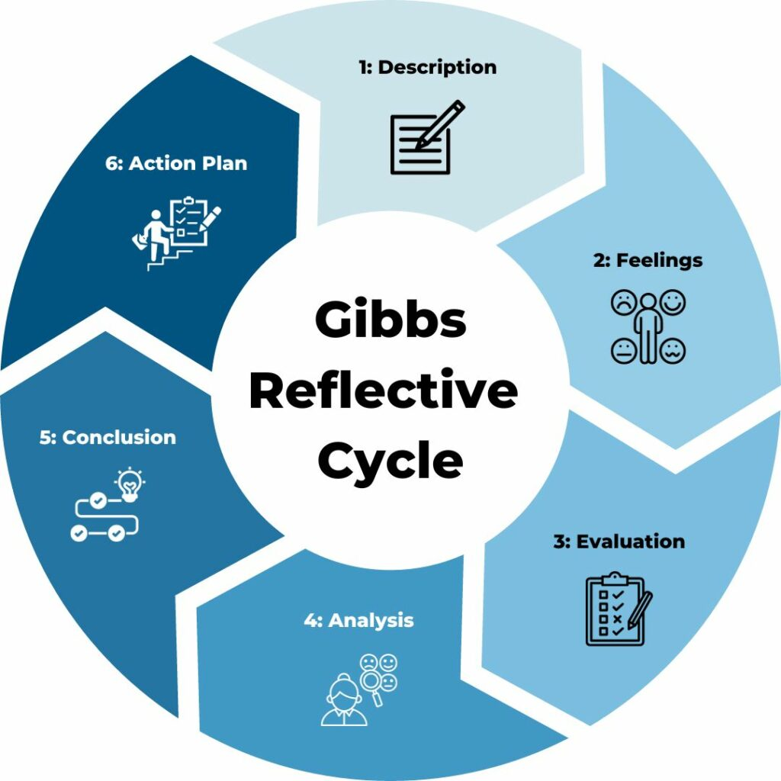
Figure 1: Gibbs reflective cycle
(Source: Adeani et al. 2020)
Introduction
Here, I will use Gibb’s Reflective Model [Refer to Figure 1] to reflect on my experience as an F&B supervisor at the New Steine Hotel. Each stage of this model has a unique contribution to an individual’s professional and personal growth throughout their journey (Tourky et al. 2020). During my undergraduate course in food and beverage management, I was introduced to basic customer service operations and organisational behaviour theoretically. However, my profession helps me to identify practical knowledge. After completing my undergraduate, I joined the F&B segment of New Steine Hotel, UK as a supervisor. During my academic life, I have learnt different theories and management ideas which help me to solve the critical situation in my professional life.
Description
In order to get an understanding of the complex dynamics involved in delivering outstanding client service is the part of F&B industry (Aslan, 2021). I observed and held a managerial position in the food and beverage division throughout the time I worked at New Steine Hotel, Brighton. Managing employees during busy serving hours, liaising along with managing the cooking area, and swiftly addressing guest problems were among my duties. As I was responsible for the operational management of the F&B department, I had to coordinate with dining services by kitchen staff and ensure a seamless experience for the visitors in the bar and restaurant lounge. I have understood the operational challenges and mitigation of those with effective communication measures.
Feelings
I was both thrilled and nervous about the position. Although I was excited about the chance to supervise, I was additionally aware of my responsibilities, especially concerning client happiness and high standards of hotel service. As I became used to the fast-paced atmosphere and gained faith in leading the team, my anxiety decreased. Every time visitors left compliments, confirming our efforts, I felt an overwhelming sense of success. However, the stress of hectic times made it quite clear that it is important to improve delegating and time organisational skills (Wood et al. 2024). In order to remove my anxieties, I reach out towards my colleagues for encouragement and advice and outline my objectives before my shift. By establishing this I have created a collaborative environment for better decision-making.
Evaluation
I gathered valuable experiences as a supervisor at New Steine Hotel, Brighton. This experience helped me to boost my communication skills as I have to communicate with guests and my other teammates in both Spanish and English. I came to understand that communication tone is an important factor in the F&B department. I instruct clearly for any changes which affects directly to the satisfaction of our clients. As I possessed some technical knowledge regarding F&B service protocols it helped me to improve the service and menu. In contrast, I also ran across issues regarding staff processes, especially during moments of high service demand. For example, there were communications breaches when I had an unexpected spike in visitors, which resulted in poor service and irate patrons. This situation made me understand the importance of effective communication and staff management in the New Steine Hotel.
Analysis
My role was to oversee the regular operations at bars and restaurants of New Steine Hotel. Being a highly motivated and conscientious person, I can liaise between the F&B crew and the higher management while ensuring the guests receive effective and smooth services. For example, at Christmas, we had a lot of customers and used my communication skills. I was able to stop the fight by leading and composing empathetically with guests and kitchen staff to prevent food delays. I have faced different operational challenges and I have used the SERVQUAL Model to enhance our service quality. This model helps to identify the service quality by analysing the reliability, tangibleness, responsiveness and assurance for meeting the consumer's expectation (Tourky et al. 2020). I started gathering regular feedback via Google Surveys and direct conversations with customers. I believe, Concepts like Consumer service diversity could emphasise the impact of meeting diverse consumer needs can boost brand loyalty and satisfaction.
Conclusion
I have gathered work-based skills like teamwork, communication as well and quick-decision decision-making for maintaining the hotel services. I saw areas that needed improvement, particularly in job allocation under tension, even though I was able to enhance my vocational comprehension and communication with guests. If I were to get back this position, I would concentrate on carefully assigning duties to prevent service outages and promote a more cooperative team dynamic.
Action Plan
In future, I would like to list my tasks according to their priority to manage my time-management skills.

Section 2: Critical evaluation of work-based skills and technical knowledge in the F&B department of New Steine Hotel
Within the hospitality sector, solid interaction plays an essential role (Köbnick et al. 2020). It strengthens bonds between staff and consumers as well as inside the company (Douglas et al. 2020). It encourages diversity since both employees and clients receive customised treatment, attention, and communication tailored to their requirements (Astawa and Ardiasa, 2022). For example, even seemingly insignificant things including verifying an order or giving a friendly welcome, had an immense effect on the overall satisfaction of visitors throughout my tenure as a supervisor. This led to favourable ratings consequently and return business (Agustina and Setiawan, 2020). In addition, I will develop an inclusive menu for customers while collaborating with chefs and understanding vegan dietary trends. Gaining this ability has highlighted how crucial it is to uphold high norms because every encounter has the potential to influence the image of the division. In contrast, the F&B team can do tasks more quickly and effectively with time management abilities, which decreases lost time and boosts output (Cousins and Weekes, 2020). For example, my team at New Steine Hotel may do additional tasks in fewer hours by setting priorities, eliminating interruptions, and assigning responsibility to others. This could lead to a surge in profits and sales in both restaurants and bars (Cousins and Weekes, 2020).
I have worked for 3 years as a supervisor in The Steine Hotel, Brighton which offered a wealth of professional development and opportunities in the F&B industry. I have a passion for working as a manager and the F&B industry is among the highest-paid segments across the UK hospitality sector. Initially, I was a bit nervous as well as excited since it was my first job in the F&B segment which demands problem-solving skills and time management. I lacked time management skills but being a conscientious person, I can be stable in critical situations. For this reason, I would like to ensure a smooth communication channel among staff and managers for daily briefings and debriefing after the shift period.

Section 3: Reflection on Organisational Issues
During my placement, I faced several organisational issues in the F&B segment of the New Steine Hotel. In October 2021, a group of vegan clients visited our organisation, but the New Steine Hotel did not have vegan products like soy milk, lentils or Tofu but meat and normal cow milk. This has posed a serial challenge for our organisation to serve the vegan customers of our hotel. It has a serious impact on the organisational image of the New Steine Hotel.
In order to uphold the New Steine Hotel's standing in relation to the moral handling of meat and meat-based product issues, I have to take serious steps to please the vegan guests. Consequently, the hotel needs to develop meatless substitutes to maintain its supply chain network and retail operations (Neeson and Billington, 2022). Since veganism is the new normal condition of current society, being a supervisor of the F&B department of the New Steine Hotel, I have to take care of that.

Conclusion and Action Plan
In conclusion, I can surely indicate that this reflective essay has helped me to get an idea about my own strengths and weaknesses. I have grown the experience of meeting the needs of the clients based upon the practical implications and complementing the client needs aligning with hotel profitability. I frequently had to solve unforeseen circumstances, such as unanticipated visitor waves, while making sure that customer service standards were maintained.
In future, I will focus more on team motivation and solving my work before the deadline during peak hours. I will improve my interpersonal skills for guest handling and their complaints to ensure a positive experience.

Reference
Adeani, I.S., Febriani, R.B. and Syafryadin, S., 2020. Using GIBBS’reflective cycle in making reflections of literary analysis. Indonesian EFL Journal, 6(2), pp.139-148.
Agustina, L. and Setiawan, R., 2020. Fostering a natural atmosphere; improving students' communication skills in a business meeting. Journal of Languages and Language Teaching, 8(3), pp.307-314.
Aslan, A., 2021. Problem-based learning in live online classes: Learning achievement, problem-solving skill, communication skill, and interaction. Computers & Education, 171, p.104237.
Astawa, I.G. and Ardiasa, I.K., 2022. Enhancing English-speaking skills for food and beverage services for tourism students through collaborative learning. Jurnal Kajian dan Terapan Pariwisata, 2(2), pp.26-36.
Cousins, J. and Weekes, S., 2020. Food and beverage service. Hachette UK.
Douglas, N., Knai, C., Petticrew, M., Eastmure, E., Durand, M.A. and Mays, N., 2020. How the food, beverage and alcohol industries presented the Public Health Responsibility Deal in UK print and online media reports. In Media Analysis and Public Health (pp. 5-16). Routledge.
Köbnick, P., Velu, C. and McFarlane, D., 2020. Preparing for Industry 4.0: Digital business model innovation in the food and beverage industry. International Journal of Mechatronics and Manufacturing Systems, 13(1), pp.59-89.
Neeson, R. and Billington, L., 2022. Entrepreneurship learning through a collaborative approach to student practical placement/internship. Journal of the International Council for Small Business, 3(1), pp.68-78.
New Steine Hotel, 2024. New Steine Hotel | 4 Star Hotel in Brighton City Centre. Available at: https://newsteinehotel.com/ [Accessed on: 26 October 2024].
Restaurantonline, 2024. Restaurant. Available at: https://www.restaurantonline.co.uk/ [Accessed on: 26 October 2024].
Tourky, M., Alwi, S.F.S., Kitchen, P., Melewar, T.C. and Shaalan, A., 2020. New conceptualization and measurement of corporate identity: Evidence from UK food and beverage industry. Journal of Business Research, 109, pp.595-606.
Wood, J.M., Wiesner, R., Morrison, R.R., Factor, A. and McKeown, T., 2024. Organisational behaviour: Core concepts and applications. John Wiley & Sons.

