

Student Name: Md Anisul Islam
ID: 2229222

Assignment on: Computer Systems Fundamentals

Assignment Title:

“Computer System Component Specification”

TASK 1: CASE STUDY
According to given scenario and subject to an elderly user, we would like to give you the preferred specifications for a budget efficient and low cost desktop computer which will fulfil the requirements of an elderly user.

BUILDING A DESKTOP COMPUTER FOR AN ELDERLY USER:

- CPU AND MOTHERBOARD: COST APPROXIMATELY £180-£200

My choice of preference:
CPU: Intel Core i3 13th Generation 12M Cache 4 core 3.40 GHz to up to 4.50GHz
Or
AMD Ryzen 3 3200 6 core 3.5Ghz to 4.4 GHz Frequency
Motherboard: ASUS PRIME H610-A WIFI D4
The speed at which your system runs programs, loads pages, and downloads files depends in part on the processor. Most computers have processors from a 3, 5, 7, or 9 series. The higher the series number, the better your processor's performance.

Reason for Choice:
This specification aims to provide a cost-effective solution for basic computing needs with a focus on simplicity and usability.

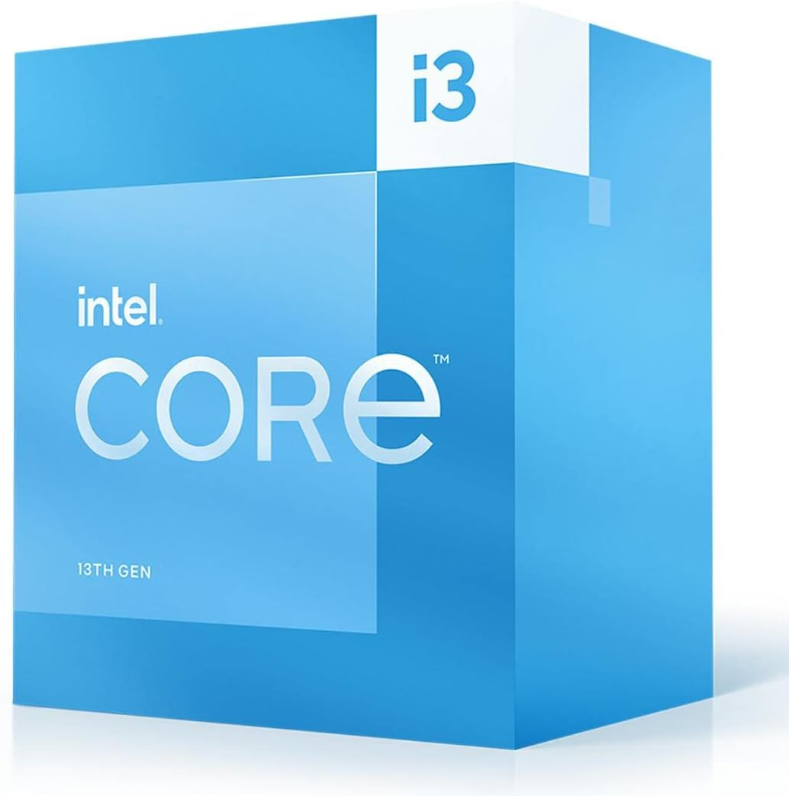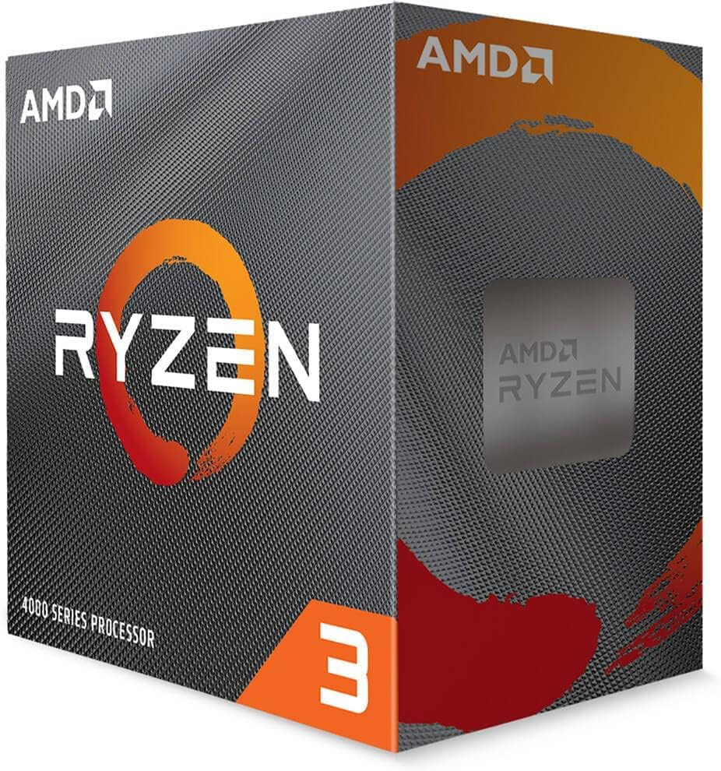

Picture: Processor from different manufacturer
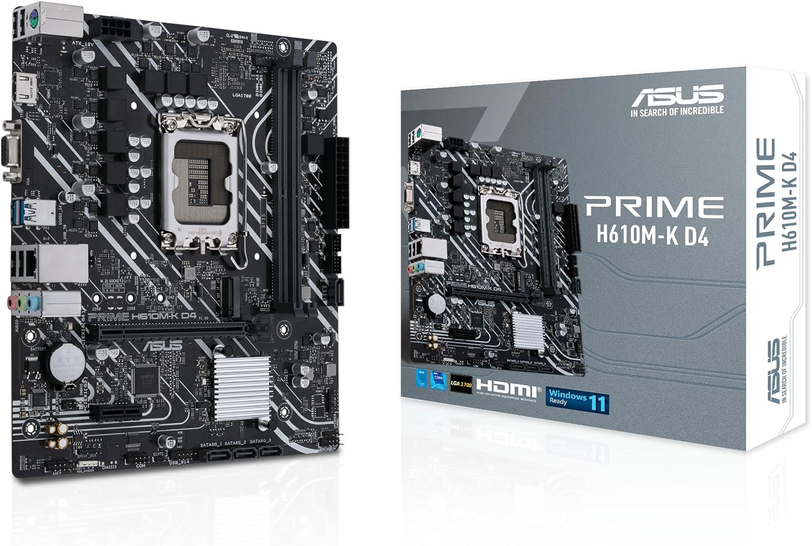
Picture: Motherboard: ASUS PRIME H610-A WIFI D4

We would like to go for intel core i3 13th generation which compatible with prepared motherboard. This is a mid-range processor supported by CPU, which is adequate for the described tasks. As well as it will be offering a good balance between performance and cost.
These processors provide sufficient power for
- Word processing.
- Internet browsing
- Skype video calls or google meet
- Email communication i.e.: Yahoo, Gmail, outlook
- Printing Facilities etc.
Processor's performance is impacted by bandwidth, clock speed, number of cores, available cache memory, and other factors.

- RAM: READ ACCESS MEMORY Cost Approximately £ 30-40
Definition:
Random Access Memory known as RAM is computers short term memory, which hold temporary data and helps to access quickly whatever computer doing currently. The More RAM a system has the system will provide the faster performance for editing documents, browsing internet, running applications. The RAM capacity is reflected by GB gigabyte.
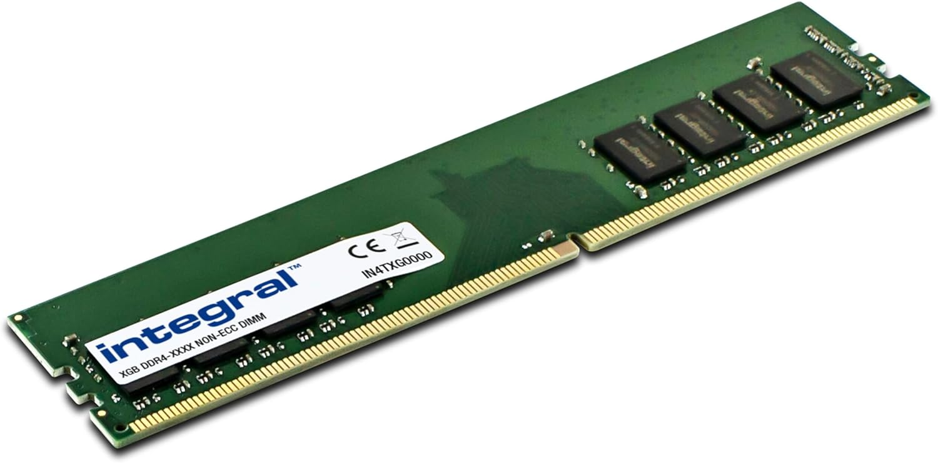
Picture: My Choice of preference: 8GB DDR4 RAM

Reason for Choice:

8GB is a suitable amount for the described tasks such as word processing, internet browsing, email communications, skype call etc. That will ensure smooth multitasking and responsiveness without unnecessary excess for this user's needs.

C. HDD: NON-VOLATILE STORAGE: Cost Approximately £40

Definition:
The storage drive or Hard drive (HDD) on a computer is the place where files like documents, photos, music, and videos are permanently stored. Having more storage capacity enables a computer to hold a greater amount of information. Storage is typically measured in gigabytes (GB) or terabytes (TB).
1 Terabyte = 1024 Gigabyte
1 Gigabyte = 1024 Megabyte
Choice of preference: 256GB SSD Drive

Reason for Choice:
An SSD (Solid State Drive) provides fast boot times and application loading. A 256GB capacity is sufficient for the described use case but consider a larger capacity if budget allows.
We have to remember primary boot device during installation, to store the Operating system (OS) software to run the computer systems. Some computer system allows dual or additional drive to allow more storage options. When we choose the HDD we need to make sure SSD class and PCIe specification.
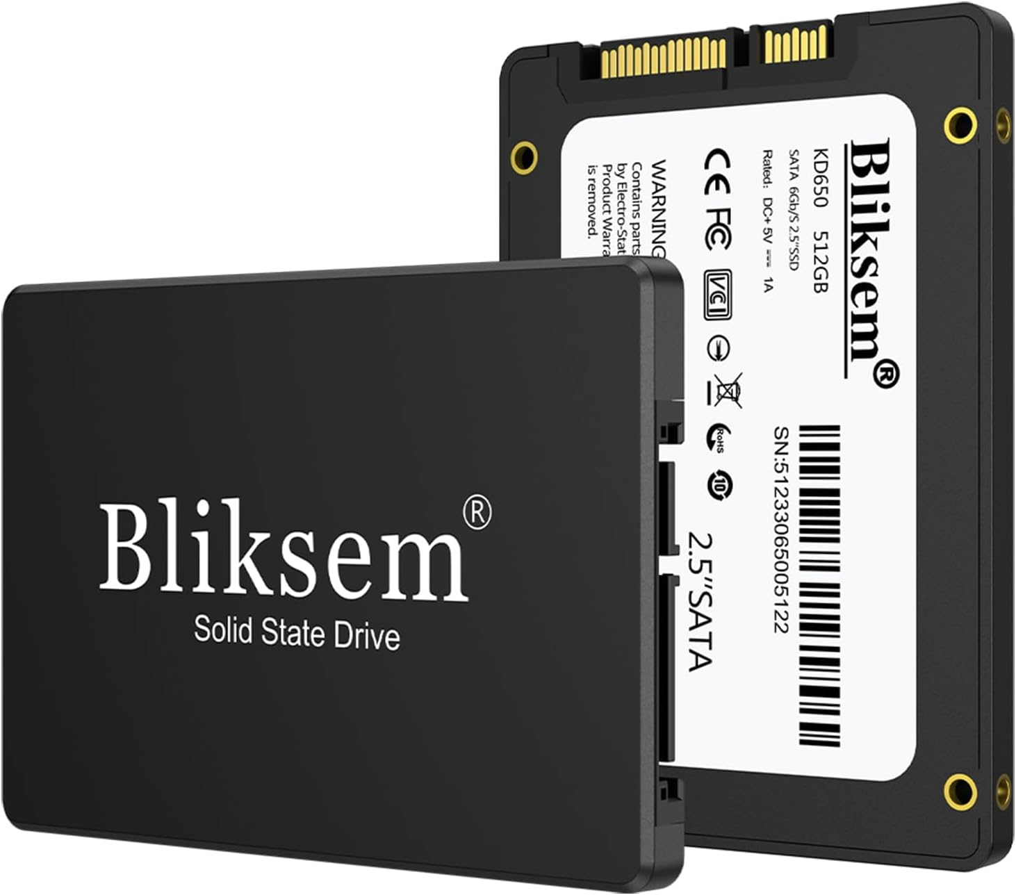
Picture: 256GB SSD HDD Storage

D) INPUT-OUTPUT FEATURES: Output Ports Cost Approximately £ 30
Input Device: Full-size wireless keyboard
Output: Display port, HDMI and VGA ports for monitor connectivity, USB ports for Pen drive or removable device/peripherals and printer
Reason for Choice:
A full-size wireless keyboard is preferable for comfortable typing and wire free connection will provide more flexibility.
HDMI and VGA ports provide flexibility for connecting to different types of monitors. Sufficient USB ports for keyboard, mouse, and other peripherals.

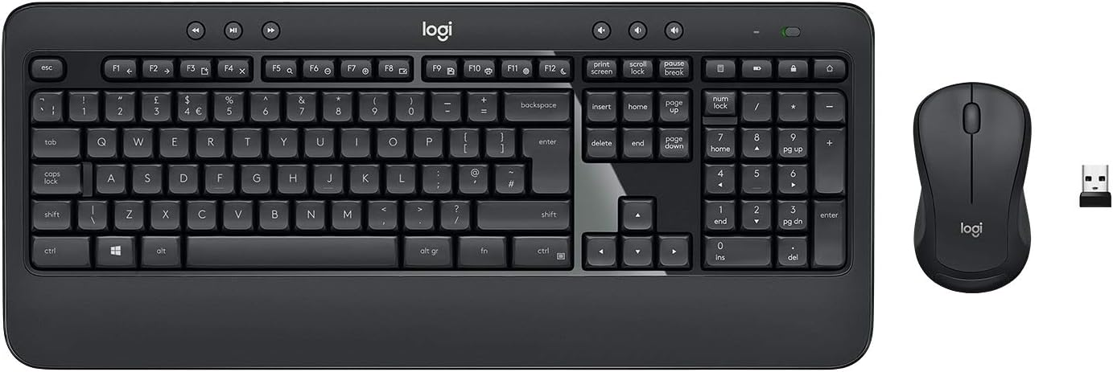

Picture: Wireless Keyboard and mice with Numeric key
E) GRAPHICS CARD:
Choice of Preference: Integrated graphics (e.g., Intel UHD Graphics)
Reason for Choice:

Integrated graphics cards share memory with processor. They use less power and create less heat and fan noise. For checking social media, email and other word processing work we can go integrated graphics. Since the user is not playing games, integrated graphics are sufficient for video playback and general desktop use. This also helps keep costs down.

F) CASE AND POWER SUPPLY: Cost Approximately £ 50
Choice of preference: Micro ATX case with a suitable power supply
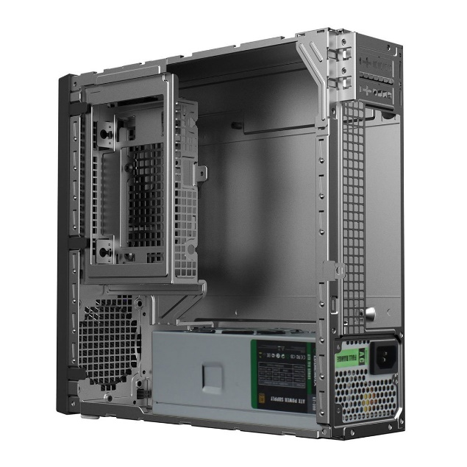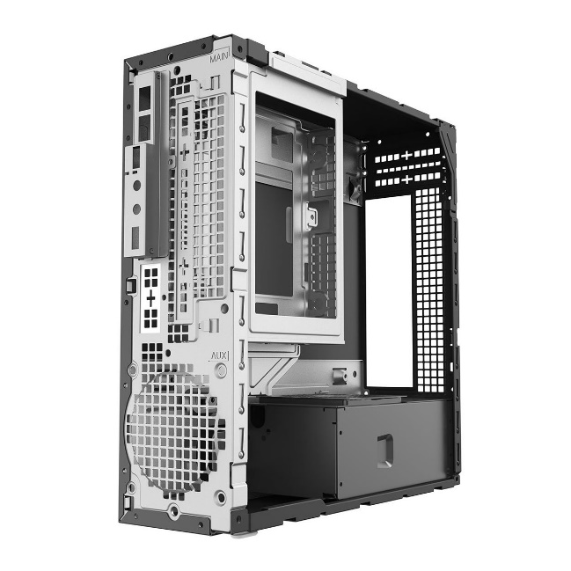
Picture: CIT MTX-008B Black Mini-ITX Desktop Case
Reason for Choice:
A smaller form factor (Micro ATX) is suitable for a compact desktop. Ensure the case has good ventilation and space for components. Choose a reliable power supply with enough wattage for the selected components.
G. LED MONITOR AND WEB CAMERA: Cost Approximately £100-£120
Choice: 21-inch or 24-inch LED monitor and web camera
Reason for choice:
A larger monitor size aids in better visibility, especially for an elderly user. LED technology provides good brightness and contrast for a pleasant viewing experience. A web camera enabling accessibility to user for skype Vedio call.
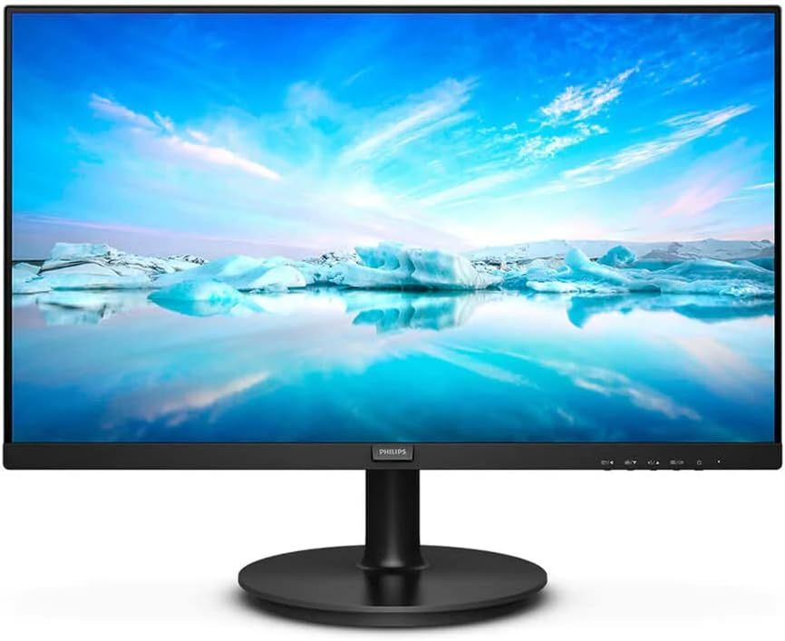
Picture: 24” LED Monitor
H. NETWORK CONNECTIVITY:
Choice of preference: Integrated Wi-Fi and Ethernet
Reason for choice:
Both Wi-Fi and Ethernet provide options for network connectivity. Wi-Fi is convenient for flexibility in placing the desktop, while Ethernet can be more reliable for internet-intensive tasks.
I. SOFTWARE: Cost Approximately £120
Operating System: Windows 11 Home
Reason for choice:
A user-friendly and widely used OS. Windows 11 Home edition provides all the necessary features for the described tasks. Such as
- Microsoft 365,
- Browsing the web
- Managing social Media
- Email Communication and
- Skype call
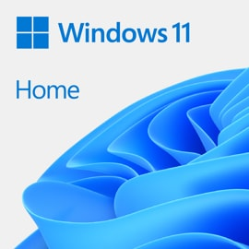
Picture: Microsoft Windows 11 Home
J. ANTIVIRUS: WINDOWS DEFENDER (BUILT-IN) AND MacAfee (ADDITIONAL)
Reason for Choice:
Windows Defender is effective and built-in. MacAfee adds an extra layer of protection against malware, however it will add an additional subscription fee yearly.

SHOPPING LIST: THIS IS AN APPROXIMATE PRICE MAY VARY

Component | Choice | Price | Price
CPU | Intel Core i3 / AMD Ryzen 3 | £100 | £120
Motherboard | Compatible with chosen CPU | £80 | £80
RAM | 8GB DDR4 | £30 | £30
Storage | 256GB SSD | £40 | £40
Case with Power Supply | Micro ATX Case with PSU | £40 | £40
Monitor | 21/24-inch LED Monitor | £80 | £120
Keyboard | Full-size Keyboard | £20 | £20
Wi-Fi Card | Integrated or separate card | £20 | £20
Windows 11 Home | Operating System | £120 | £120
Microsoft office 365 | Microsoft office subscription | £60 year | £60/Year
Antivirus Software | Wind Defender/MacAfee (Premium) | £0 | £30/year
Total |  | £530 | £680

Task 2: My Personal Computer
I have a Desktop Computer which is Dell OptiPlex XE2 small form factor, Core i5 processor, 8GB of RAM and 256SSD hard drive, with HP 27” Monitor (Model 27fw with Audio). It comes with logic tech wireless keyboard and mouse, a printer, a label printer, Wi-Fi adapter for Wireless connectivity. I use a web camera to attending Vedio call via google meet, Microsoft team etc. I normally use my computer for different purposes, like study and work. However, I use sometime surfing internet and social media. Preparing assignments and presentations and online product listing is the main use of my computer.

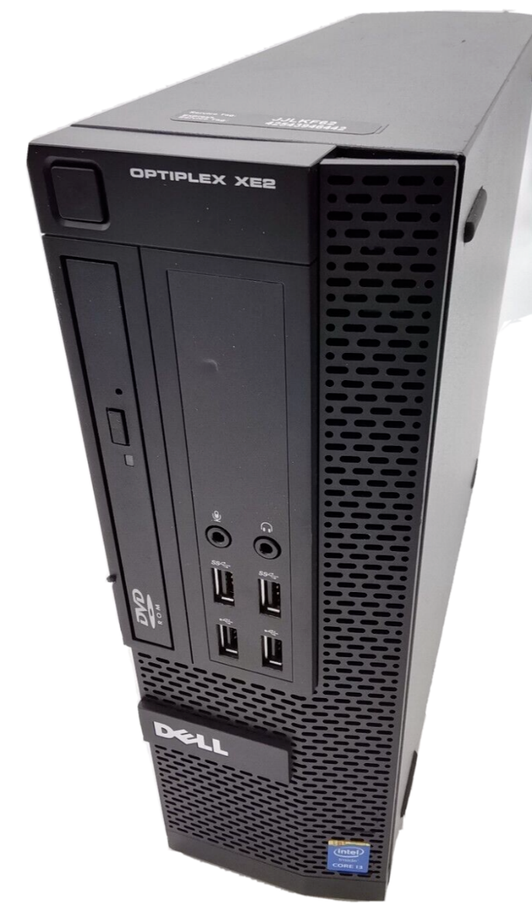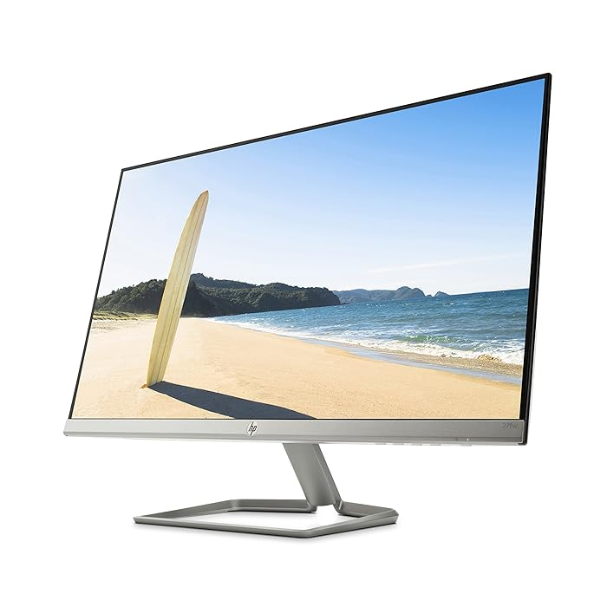
Picture: My personal desktop Dell OptiPlex XE2 and HP 27” Monitor

CPU: Central Processing Unit
Definition:
The CPU speed at which can make a computer system runs programs, loads pages, and downloads files depends in part on the processor. Most computers have processors from a 3, 5, 7, or 9 series. The higher the series number, the better your processor's performance. My Computer have intel Core i5-4570S 4th generation with speed 2.90 GHz. Processor's helps computer to perform better and impacted by bandwidth, clock speed, number of cores, available cache memory, and other factors.

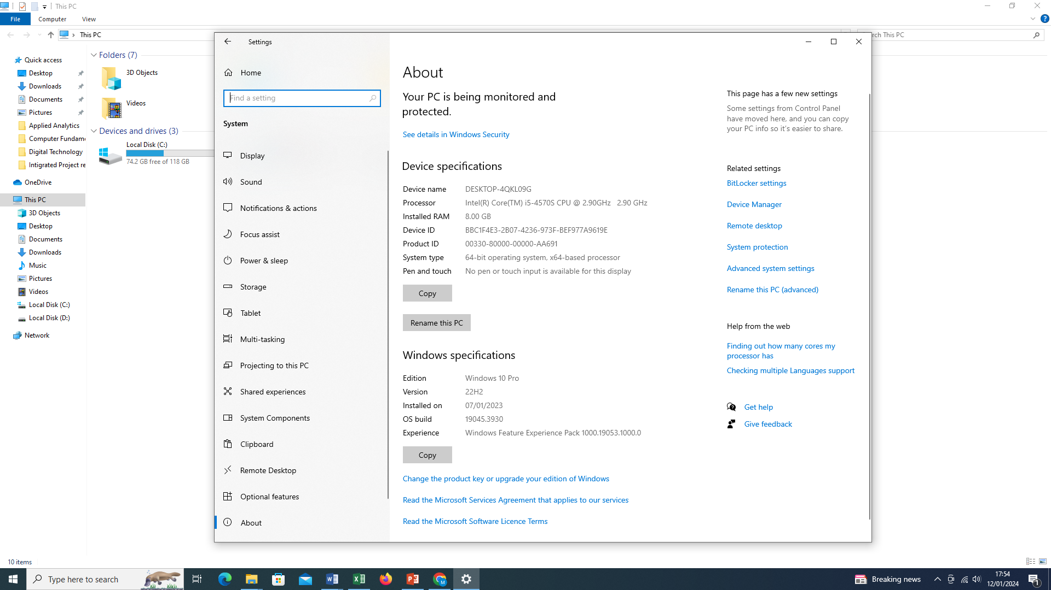

Picture: My personal Computer Processor intel core i5 4th generation

RAM: Read Access Memory
Definition:
Random Access Memory known as RAM is computers short term memory, which hold temporary data and helps to access quickly whatever computer doing currently. The More RAM a system has the system will provide the faster performance for editing documents, browsing internet, running applications. The RAM capacity is reflected by GB gigabyte.
FEATURE | SPECIFICATION
Memory type and Capacity | DDR3 / 8GB
Memory speed | 1600MHz

Picture: My Personal computer 8GB DDR3 RAM

HDD: Storage: 128GB SSD

Definition:
The storage drive or Hard drive (HDD) on a computer is the place where files like documents, photos, music, and videos are permanently stored. Having more storage capacity enables a computer to hold a greater amount of information. Storage is typically measured in gigabytes (GB) or terabytes (TB).
1 Terabyte = 1024 Gigabyte
1 Gigabyte = 1024 Megabyte
My computer has 128GB capacity with NTFS file system and SATA LITEON CV8-CE128-11.
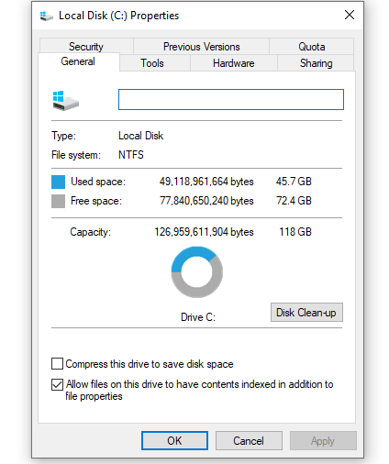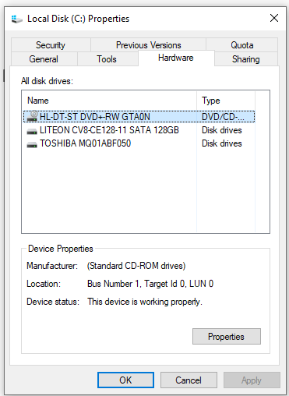
INPUT-OUTPUT FEATURES:
Input Device: Full-size wireless keyboard
Output: Display port, HDMI and VGA ports for monitor connectivity, USB ports for Pen drive or removable device/peripherals and printer. I have a label printer to print the label for product and HP printer for Normal printing.

Picture: Wireless Keyboard and mice with Numeric key
GRAPHICS CARD:
There are two types of graphics cards: Integrated Graphics Card and discrete graphics cards, this is use to display images on the computer screen. More powerful graphics cards can render high-resolutions image faster. My Computer monitor have Built in HD graphics 4600 with resolution 1920x 1080 and refreshment rate of 60.000 Hz. A higher rate of refresh rate provides smoother motion; however, it uses more power.
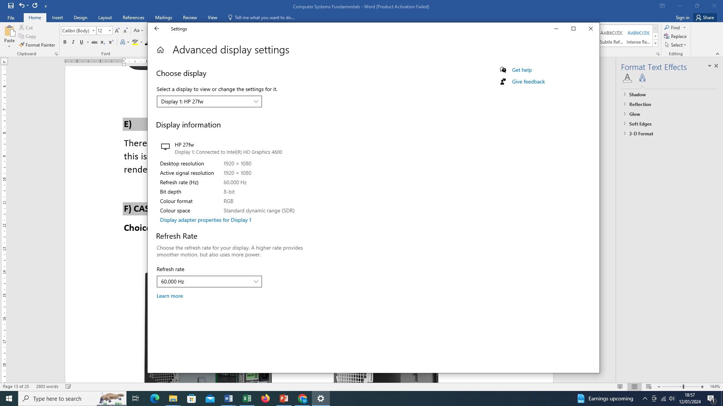
FEATURE | SPECIFICATION
Integrated | Intel HD Graphics 4600 i5 Intel 8 Series Express chipset CPU-GPU Combo
Discrete | PCI Express x16 graphics adapter

LED MONITOR AND WEB CAMERA:
My monitor is 27-inch LED monitor HP and web camera which have got multiple port including HDMI, Display Port, Power port, VGA port and audio 2.5mm port.
Picture: 27” LED Monitor
FEATURE |  | SPECIFICATION
Audio:
 | Front panel | one headphone connector and one microphone connector
 | Back panel | one line-out connector and one line-in/microphone connector

NETWORK CONNECTIVITY:
For Wi-Fi connectivity I have to use a Wi-Fi adapter.
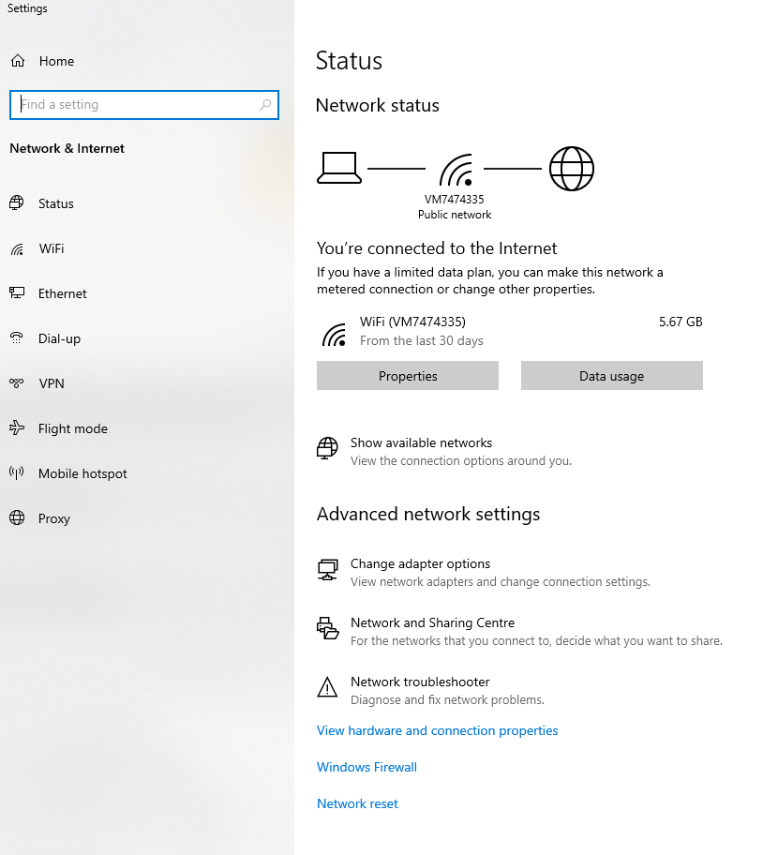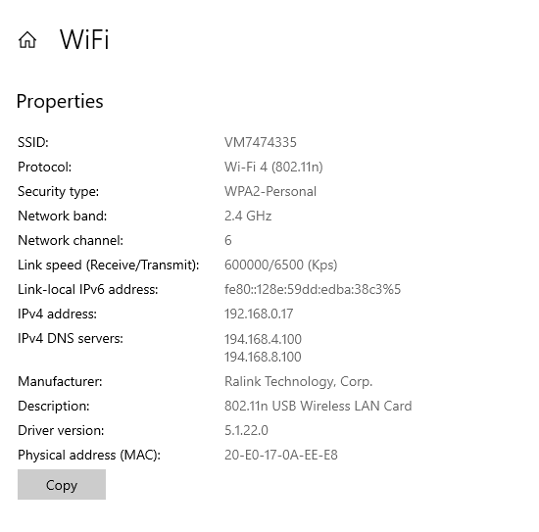
We use virgin for wireless internet connection, for wifi the computer use SSID VM747335 and use 802.11n Protocol.
FEATURE | SPECIFICATION
Integrated Ethernet | Intel 1217LM Ethernet capable of 10/100/1000 Mb/s communication

Software:
Operating System: Windows 11 Home
A user-friendly and widely used OS. Windows 10 pro edition with 22H2 version, last installed on 07th January 2023, provides all the necessary features are given bellow,
- Microsoft office 2016, Adobe
- Browsing the web: Google Chrome, Firefox
- Managing social Media: Facebook, Instagram, YouTube etc.
- Email Communication: Gmail and yahoo
- Google meet, Microsoft Teams, Skype call
- EBay Listing and Facebook market place Listing
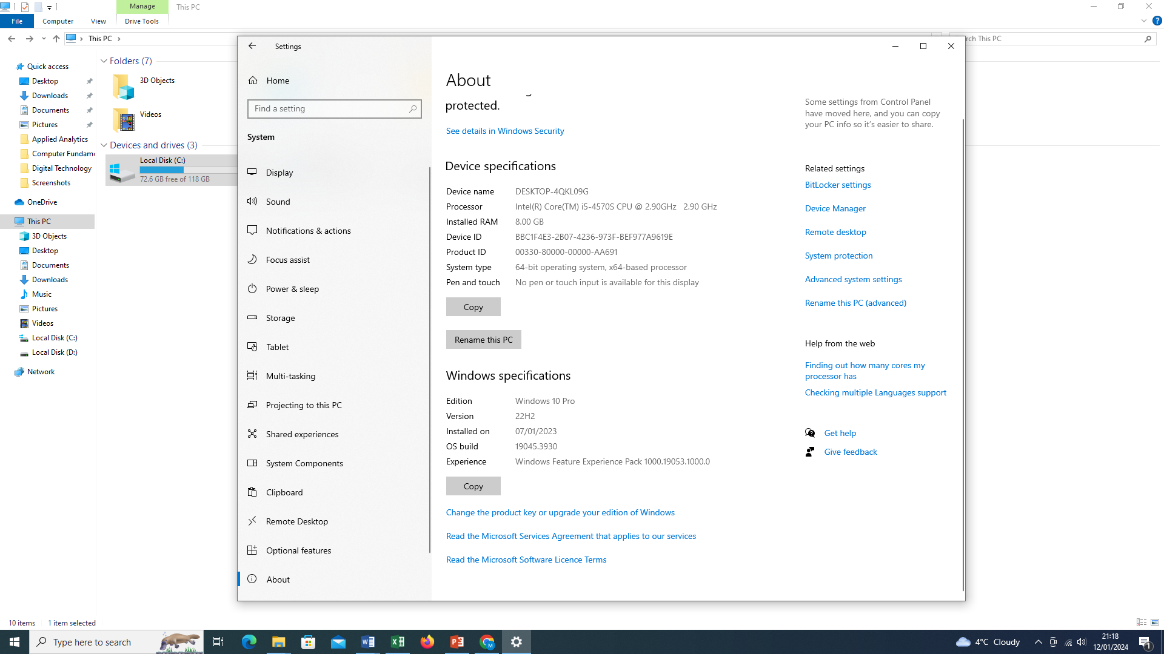

ANTIVIRUS: WINDOWS DEFENDER (BUILT-IN)
I Normally use Windows Defender which is very effective and cost free. However, it is important to stay up to date with windows update. Therefore, my computer says “no current threats”.

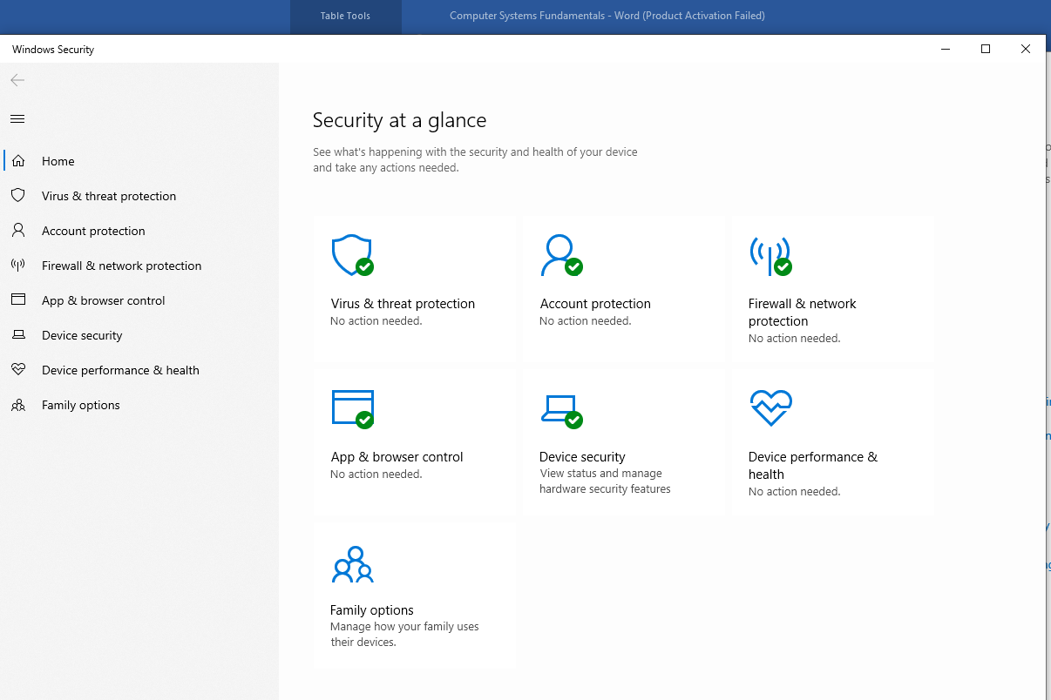

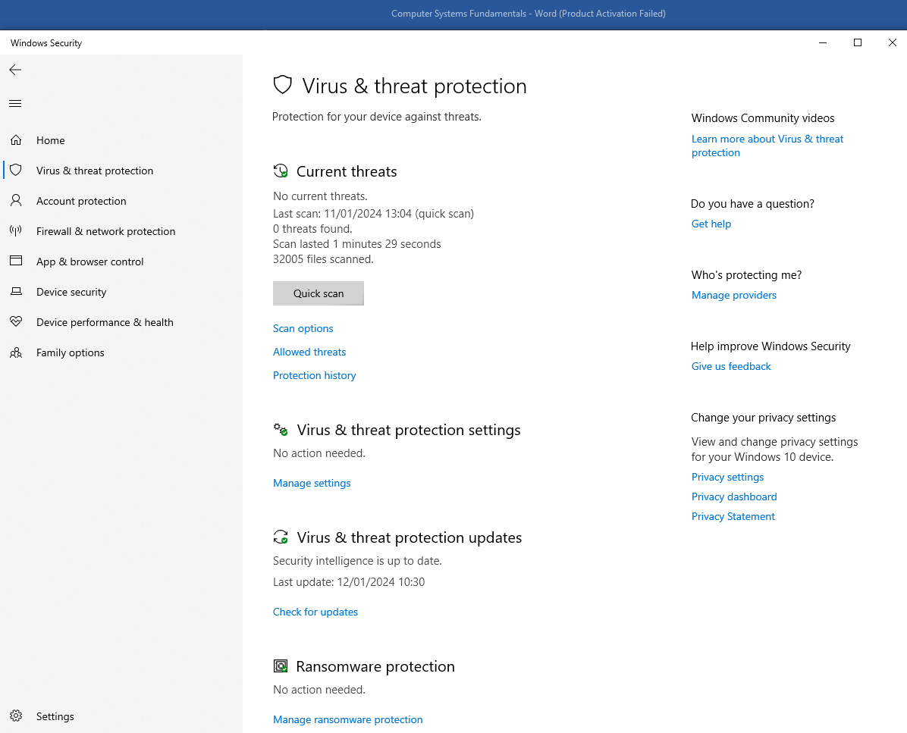

Virus & threat protection giving me message as “no action needed” and security intelligence is up to date.
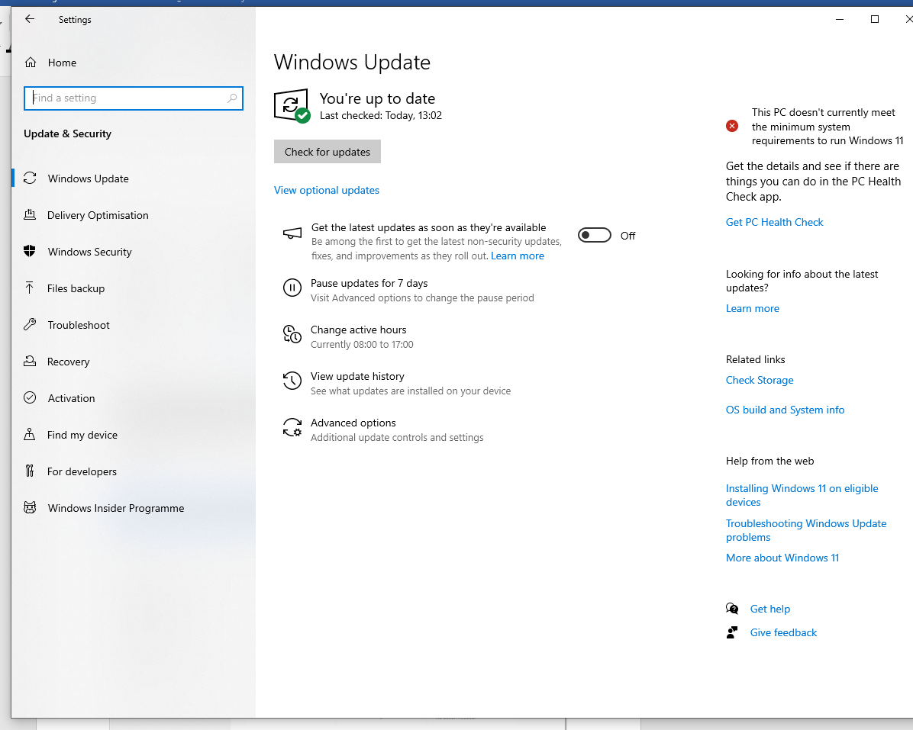

Windows update is very important to protect the computer from virus and malware. Windows updates makes computer more secure, efficient, and adaptable to new stuff. Getting regular updates keeps computer safe from online dangers, makes sure it works smoothly, and adds new features to make us happy. It's important to keep Windows updated for a safe and good computer experience.

OTHER FEATURES OF MY COMPUTER:
FEATURE | SPECIFICATION
System chipset | Intel 8 Series Express chipset
DMA channels | two 8237 DMA controllers with seven independently programmable channels
Interrupt levels | Integrated I/O APIC capability with 24 interrupts
BIOS chip (NVRAM) | 12 MB
Bus type | PCIe gen2, gen3 (x16), USB 2.0, and USB 3.0
Bus speed | PCI Express:  - x1-slot each direction speed – 500 MB/s  - x16-slot each direction speed – 16 GB/s
Network adapter | one RJ45 connector
Serial | one 9-pin connector, 16550 C compatible
Parallel (optional) | one 25-pin connector
USB 2.0 | Front Panel: two
 | Back Panel: four
USB 3.0 | Front Panel: two
 | Back Panel: two
Video | - 15-pin VGA connector  - two 20-pin Display port connectors

POWER | WATTAGE | MAXIMUM HEAT DISSIPATION | VOLTAGE
Small Form Factor | 315 W | 1075.00 BTU/hr | 100 VAC to 240 VAC, 50 Hz to 60 Hz, 4.4 A
Coin-cell battery | 3 V CR2032 lithium coin cell

Temperature range:
 | Operating | 5 °C to 35 °C (41 °F to 95 °F)
 |  | 5 °C to 45 °C (41 °F to 113 °F) (limited to 65W or lower processor. No discrete graphics card.)
 | Storage | –40 °C to 65 °C (–40 °F to 149 °F)
List of References:
[1]
https://uk.crucial.com/articles/about-memory/is-my-ram-compatible-with-my-
motherboard
[2] https://ark.intel.com/content/www/us/en/ark.html
[3] https://www.amd.com/en/processors/ryzen
[4] https://www.dell.com/en-uk/shop/desktop-computers/sc/desktops
[5] https://www.hp.com/gb-en/shop/list.aspx?sel=prn
[6] www.amazon.co.uk

