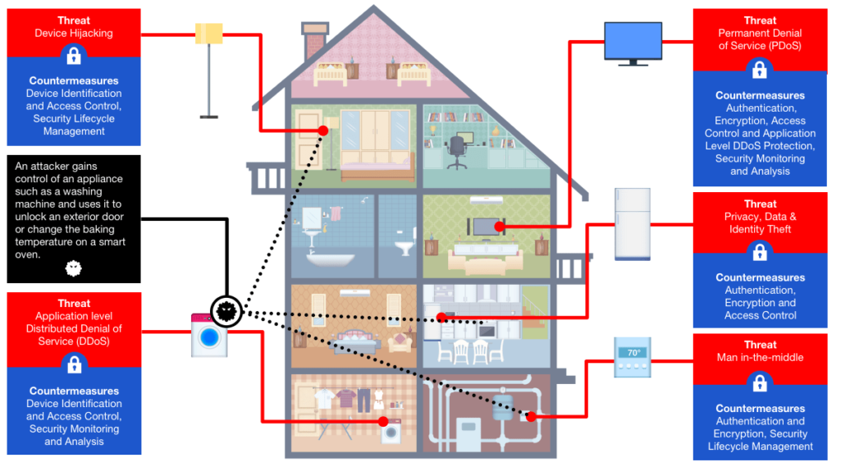

Assignment Title: Design and Implementation of Smart Home
Module : Smart and Connected Devices I
Module Code: ACDA5005
Student Name: Michelle Chalmers
Student Number: 1809316

Abstract
With Smart Home technology becoming increasingly commonplace are we keeping our homes adequately protected against attackers? This report considers the current available technology and the security solutions deployed by manufacturers and consumers.
The verdict is worrying, with the technology moving much faster than the security solutions and an enormous percentage of Smart Homes being left vulnerable to attack.
Contents
Abstract 1
Introduction 2
1. The Good and the Bad 2
1.1 The Positives 2
1.2 Not so Positive 2
2. Security Issues 3
2.1 The Mirai Botnet DDos Attack 4
2.2 What is a Botnet? 4
2.3 Why Mirai Targeted IoT devices 4
2.4 Major IoT Security Fails in 2019 4
2.5 What Improvements Have There Been Since Mirai? 5
3. Main Options for Domestic IoT 7
3.1 Amazon Alexa 7
3.1.1 Security Concerns 7
3.2 Google Nest 7
3.2.1 Security Concerns 7
3.3 Apple HomeKit 8
3.3.1 Security Concerns 8
3.4 Other Hubs 8
4. Alternative Options 8
Resources 9
References 9

Introduction
There is no set definition of a Smart Home. At it’s most basic it is the automation of a home function, such as turning a light on, via the internet. At the grander end of the scale there are solar powered homes that use home automation, also known as smart home technology, to control the temperature, lighting, coffee making, home security, vacuuming, laundry, and even cut the lawn. These items are the ‘things’ in our Internet.
Imagine driving home and your home detecting your proximity and preparing the house for you. The garage door will open, external and internal lights come on if it’s dark, your favorite music will start playing, and as you approach the front door it will unlock for you.

1. The Good and the Bad
It sounds wonderful – a home that lights your way as you walk through it, warms the house as you drive home, acts as a security system, even mows the lawn. But is it really that easy and is it beneficial?

1.1 The Positives
In theory anything that has a plug can be made smart. Dumb items such as fans, lamps, games consoles etc. can all be made available by timer or controlled remotely.
There are hundreds of ‘things’ you can use in your Smart Home:
Thermostats, door locks, blinds, speakers, coffee makers, bins, motion sensors, temperature sensors, moisture sensors and lighting options such as smart switches and smart bulbs.
You can use a programmable button to set a bedtime routine – press it to run a routine to check everyone is home (presence sensor on key fob or phone), close the garage, lock doors, lower the heating thermostat, turn lights off, turn on door sensors in children’s rooms to be alerted if they get up during the night.

1.2 Not so Positive
There are no standards for the hubs, the things, or the apps. You cannot buy a smart device and assume it will work in your system.
How many of the things are expensive solutions to problems that do not actually exist? We can all appreciate the value of a vacuum or lawn mower that does your chores for you, but does a smart washer really know the best wash cycle or is it a gimmick? Does anyone need a bin that opens on voice command? Is switching your coffee machine on manually really such hard work? For anyone with health or mobility issues that affect movement or dexterity then these solutions may be life changing, but for the rest of us it’s more a choice in how far you want to go with it for what will sometimes be limited gains.
Power, or sudden lack of it, will return your Smart Home to the dark ages. Whilst many of the things such as sensors and locks are battery powered, the whole system relies on the internet as the processing is done in the cloud. Lose your internet, or power to the hub, and your home is dumb again. For the most part that’s an annoying inconvenience – having to remember to turn lights on yourself, or change the thermostat manually. But if you have been relying on smart door locks you may not carry keys anymore and can find yourself locked in or out.

2. Security Issues
In the rush to adopt exciting new technologies security is not getting the attention it requires. The security needs to be considered at a device level as well as a network level. In 2019 Avast collected information from more than 16 million Smart Home networks globally and found that almost 41% contained at least 1 vulnerable device. A hacker only needs to access that device in order to access your Smart Home, and potentially your network.
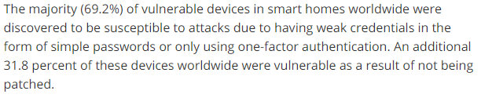 [1]
There are already well known cases of hackers accessing baby monitors and webcams. They may even be able to access conversations you have had with a smart assistant that records interactions. There may be passwords or sensitive information stored.
It is absolutely critical that consumers ensure device software updates and patches are up to date, as this is a major weak point. Very few devices are capable of having the updates pushed to them automatically.
[2]

2.1 The Mirai Botnet DDos Attack
12th October 2016 the Mirai botnet successfully ran a major DDos (Denial of Service) attack in the US. It brought down most of the East Coast internet in what was initially assumed to be an aggressive movement against the US. In fact it was an overly successful botnet that’s initial intention had been less ambitious, but was overwhelmingly successful due to its ability to make use of insecure IoT devices.

2.2 What is a Botnet?
PCs become infected via a virus/trojan etc. and serve as a slave to a controller, known as a bot herder. The herder instructs these slaves in DDos attacks – where a system, internet, network etc will be flooded by traffic from the bot network, blocking all other traffic and denying normal service.

2.3 Why Mirai Targeted IoT devices
As we have become better at keeping our PCs and smart phones protected from virus’, the criminals have sought out the path of least resistance.
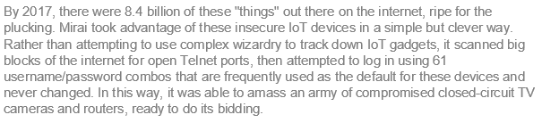 [3]
It was that easy. And given that we already know from Avast’s testing in 2019 that about 40% of devices are vulnerable, the potential for criminals to abuse lax security is enormous.
It is essential to note that the Mirai botnet source code was released into the wild and is available to anyone who wants to have a go at hacking IoT devices. If you aren’t protected, someone somewhere may well find your device.

2.4 Major IoT Security Fails in 2019
Hickory Hardware smart deadbolt confirmed as vulnerable to attack.
12 popular devices from major US outlets all found to lack basic security.
Hotel in-room robots used to spy on guests.
Amazon Ring doorbell allows attackers to watch families, and leaves wi-fi password visible.
Silex malware used to brick (kill) 4,000 IoT devices.
LeapPad educational tablet used to track the device and message children.
M2 children’s smartwatch used to track and call children.

2.5 What Improvements Have There Been Since Mirai?
The answer is a disappointing and concerning…very little, if anything.
In recent years attacks have been launched via thermostats, printers, baby monitors, door locks, doorbells, a doll, and a team testing smart vehicle security even managed to infiltrate and halt a car whilst it was being driven. A casino was hacked using it’s one weak point – an aquarium thermometer. This list is by no means complete as it seems almost every device has been used at some point.
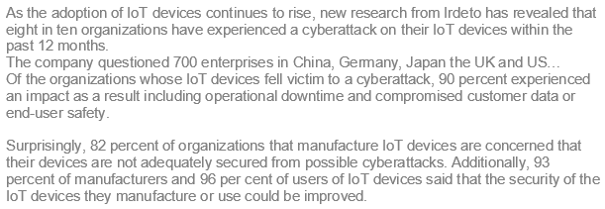
[4]
Consumers trust that the manufacturers have security covered. The constant push of products from the major household players such as Google Nest/Home and Amazon’s Alexa have normalised having smart technology in the home. But many of the products are not secure off the shelf. Unless the consumer understands their responsibility and takes the time to set up security and regularly update and patch devices, they are vulnerable.
Manufacturers do not seem to be stepping up and forcing security onto consumers. Given how naïve the consumers have proven to be maybe manufacturers need to accept that responsibility?

3. Main Options for Domestic IoT
In the UK the main hub system (language) options are Zigbee, Zwave, Apple, Philips Hue (for lighting), and Google Nest. Amazon’s Alexa and Philips Hue use Zigbee, Google Nest and Apple stand alone.
If you want your home devices to communicate as a group you need to create a mesh network - one or more hubs that control the devices. The devices become elements of the network and daisy chain together to pass information. That means a device in one room that is triggered when it’s dark can use information from a light sensor elsewhere in the network.

3.1 Amazon Alexa
Larger Alexa devices incorporate Zigbee and can be used with other Zigbee friendly devices, including Philips Hue. As a major player in the market they have developed relationships with manufacturers to provide a huge range of Alexa compatible devices.

3.1.1 Security Concerns
Alexa processes everything in the cloud. Everything you ask her, or she overhears or catches on camera, is saved. It can be accessed by Amazon staff, who we are told use the recordings to analyse how well Alexa is handling queries. You can order Alexa to delete the recordings, but it’s a manual process. Ring, the security camera owned by Amazon, records everything it sees.
The company is known for handing over user data to law enforcement without a fight.

3.2 Google Nest
The Nest is it’s own system, using it’s own hubs to create a wi-fi mesh network. It does not use Zigbee or Zwave so is unable to interact direct with things like Philips Hue – an additional hub is required to act as a bridge between them.

3.2.1 Security Concerns
Google is storing recordings, but it appears to be easier to control the settings and auto-delete them than with Alexa.
In early 2019 it was revealed that the Nest Secure Home security system has a built in microphone. It was not listed in the product specification and there was no indication as to its purpose. Google claimed it was a specification oversight, but it’s secret status left many people uneasy.

3.3 Apple HomeKit
Apple are bringing up the rear at the moment, mainly due to Apple’s initial requirements around an authentication chip. That policy has been eased and manufacturers other than Apple are starting to create suitable devices.
It can be used with Siri, or without. If you don’t want a hub you don’t need to have it, just use your iPhone or iPad as a remote control for the devices. If you want to create automated sequences, or control your home from elsewhere, there are options of hardware and software you can choose from.

3.3.1 Security Concerns
Apple have a stringent attitude to data security and do not share your data without your agreement. However, Siri does record what she hears and those recordings are used for quality control.

[5]

3.4 Other Hubs
There are many other brands of hubs available such as Wink, Hubitat and SmartThings. Hubs and devices need to be controlled by apps, which is where Alexa and Google (smart assistants) become popular options as they offer voice control as well as app control.

4. Alternative Options
You don’t have to use a hub. Some devices can be controlled by Bluetooth or Wi-Fi with an app, such as light bulbs and switches, but this solution will have more limited options.
The up side of keeping the solution in house (literally) is that you are not using the internet or allowing your data to be stored or used by a 3rd party, and do not have devices open to attack via the internet. This offers particularly good security if you decide to use Bluetooth devices rather than wi-fi.
There is a Bluetooth hub called Cassia that allows you to control all your Bluetooth devices from one app. Cassia also offers future potential as it is being developed as a mesh technology.

Resources
Avast detect security issues in 2019
Crazy IoT Hacks
Industry Must Tackle Security
Can you Trust Alexa?
Apple’s Smart Home
How to keep it Secure
UK Gov Plans
Beware of Alexa
Resilience

References
[1] | A. Spadafora, "Techradar," 27 02 2019. [Online]. Available: https://www.techradar.com/uk/news/smart-homes-at-greater-security-risk-than-ever#:~:text=The%20majority%20(69.2%25)%20of,result%20of%20not%20being%20patched.. [Accessed 12 07 2020].
[2] | J. Carson, "thycotic.com," 27 04 2017. [Online]. Available: https://thycotic.com/company/blog/2017/04/27/top-takeaways-from-symantecs-internet-security-threat-report-2017/. [Accessed 12 07 2020].
[3] | J. Fruhlinger, "csoonline.com," 09 03 2018. [Online]. Available: https://www.csoonline.com/article/3258748/the-mirai-botnet-explained-how-teen-scammers-and-cctv-cameras-almost-brought-down-the-internet.html. [Accessed 13 07 2020].
[4] | A. Spadafora, "techradar.com," 31 05 2019. [Online]. Available: https://www.techradar.com/uk/news/iot-attacks-are-the-new-normal. [Accessed 14 07 2020].
[5] | A. Hern, "theguardian.com," 26 07 2019. [Online]. Available: https://www.theguardian.com/technology/2019/jul/26/apple-contractors-regularly-hear-confidential-details-on-siri-recordings. [Accessed 17 07 2020].

