Generating a program for a specified embedded requirement in C.
  - ACDA4013
  - Course: BEng Electrical & Electronic Engineering
Module: Embedded C
Joe Williams 2413881
23/06/2026

Table of Contents
1. Introduction 3
2. Background Research 4
2.1 Automotive cooling systems 4
2.2 Embedded systems in automotive applications 5
2.3 PIC16F877A Microcontroller 6
2.4 LCD Displays 6
3. System design 7
3.1 Hardware Design 7
3.2 Input and Output Allocation 8
4. System Operation 9
5. Pseudocode 10
6. Screen dumps 11
7. Details of testing 15
8. Conclusion 16
9. References 17
10. Appendix 18

Introduction
The aim of this project is to design and simulate an Automotive Cooling System Status Simulator using a PIC16F877A microcontroller programmed in CCS C. The system replicates the basic operating sequence of an automotive engine cooling system by monitoring a series of simulated inputs representing engine start, coolant status and fan activation. The microcontroller processes these inputs and controls a range of outputs including LEDs, an LCD display and a DC motor [1].
Automotive cooling systems play a vital role in maintaining engine operating temperatures and preventing overheating [2]. Modern vehicles rely on electronic control systems to monitor coolant conditions and activate cooling fans when required [2]. Embedded microcontrollers are commonly used for this purpose due to their ability to process sensor inputs and control outputs in real time [3].
The simulator has been developed within the Proteus design environment, allowing the complete system to be tested and evaluated without the need for physical hardware [4]. The system follows a predefined sequence of operations where each stage can only occur after the successful completion of the previous stage. This approach reflects the logic used in real automotive control systems, where safety, reliability and correct operating procedures are essential.
Several outputs are incorporated to provide feedback during operation. LEDs indicate system status at different stages of the sequence, while a 16×2 LCD module displays real-time operating messages. A DC motor is used to represent the radiator cooling fan found within a typical automotive cooling system.
This report presents the background research associated with automotive cooling systems and embedded control technology, describes the circuit design and software implementation, explains the program logic used to control the system, and evaluates the simulation results obtained from testing. Finally, conclusions and recommendations for future improvements are provided.

Background Research

Automotive cooling systems
An automotive cooling system maintains the engine within its optimum operating temperature range. During combustion, significant heat is generated and must be removed to prevent overheating and component damage [2].
Most modern vehicles use a liquid cooling system consisting of coolant, a water pump, radiator, thermostat and cooling fan. Coolant absorbs heat from the engine and transfers it to the radiator where it is dissipated into the surrounding air.
Temperature sensors monitor operating conditions and provide information to an Electronic Control Unit (ECU), which controls the cooling fan when additional cooling is required. The system simulated in this project represents a simplified version of this process using push-button inputs and a PIC16F877A microcontroller [5].

Embedded systems in automotive applications
An embedded system is a dedicated computer-based control system designed to perform a specific function. In automotive applications, embedded systems are used for engine management, braking systems, climate control and vehicle diagnostics.
Microcontrollers receive information from sensors, process the data and control outputs such as motors, relays and indicators. Reliability is important within automotive systems, therefore sequential control logic is often used to ensure actions occur only when predefined conditions have been met [6].
This project demonstrates these principles through a sequential control process where engine start, coolant confirmation and fan activation must occur in the correct order before shutdown can occur.

PIC16F877A Microcontroller
The PIC16F877A is an 8-bit microcontroller manufactured by Microchip Technology. It is widely used in educational and industrial applications due to its low cost, simple architecture and extensive input/output capabilities.
The device contains 33 programmable input/output pins, onboard memory, timers, serial communication peripherals and interrupt functionality. These features make it suitable for a wide range of embedded control applications. The large number of available I/O pins makes the device particularly suitable for interfacing with multiple inputs and outputs within a single control system [1].
In this project, the PIC16F877A acts as the central controller. It monitors the status of the push-button inputs and controls the LEDs, LCD display and DC motor. The microcontroller processes all decision-making operations and ensures that each stage of the cooling system sequence is completed correctly before advancing to the next stage.

LCD Displays
Liquid Crystal Displays (LCDs) are commonly used in embedded systems to provide visual feedback to users. A 16×2 LCD module can display two rows of sixteen characters, making it suitable for presenting system status information.
The LCD used in this project operates in 4-bit mode, reducing the number of microcontroller pins required while maintaining full display functionality. Throughout system operation, the LCD provides messages such as "System Ready", "Engine Started", "Coolant OK", and "Shutdown Done" [7].

System design

3.1 Hardware Design
The Automotive Cooling System Status Simulator was designed around a PIC16F877A microcontroller, which acts as the central controller for the entire system. The circuit was developed and tested using the Proteus simulation environment, allowing both the hardware and software to be verified without the need for physical components.
Three push-button switches were used as system inputs. These inputs simulate the engine start signal, coolant sensor confirmation and cooling fan activation request. Each switch is connected to Port B of the microcontroller and incorporates a 10kΩ pull-down resistor to ensure stable logic levels when the switch is not pressed.
The output devices consist of three LEDs, a 16×2 LCD display and a DC motor. The LEDs provide visual indication of the current operating stage of the system, while the LCD display provides real-time status messages throughout operation. The DC motor is used to represent the radiator cooling fan found in a typical automotive cooling system.
A 20MHz crystal oscillator and two 22pF capacitors are connected to the oscillator pins of the PIC16F877A to provide a stable clock source for program execution. A 10kΩ pull-up resistor is connected to the MCLR pin to ensure reliable system startup and prevent unintended resets.
The microcontroller continuously monitors the state of the input switches and controls the outputs according to the programmed operating sequence. This arrangement enables the system to simulate the basic operation of an automotive cooling system while demonstrating the principles of embedded control.

3.2 Input and Output Allocation
Table 1: Table 1 shows the allocation of all input and output devices connected to the PIC16F877A microcontroller. The table identifies the microcontroller pin assignments and describes the function of each component within the Automotive Cooling System Status
Component | PIC Pin | Function
SW1 | RB0 | Engine Start Input
SW2 | RB1 | Coolant Sensor Input
SW3 | RB2 | Fan Activation Input
LED1 | RC0 | Engine Started Indicator
LED2 | RC1 | Coolant Status Indicator
LED3 | RC2 | Alert Indicator
DC Motor | RC3 | Cooling Fan Simulation
LCD RS | RD0 | LCD Control Signal
LCD Enable | RD1 | LCD Enable Signal
LCD D4-D7 | RD4-RD7 | LCD Data Lines

The LCD is configured in 4-bit mode to reduce the number of microcontroller pins required while maintaining full display functionality. This allows status information to be displayed efficiently throughout system operation.

System Operation
The system operates using a predefined sequential control process. When power is applied, the PIC16F877A initialises the input and output ports and displays the message "System Ready" on the LCD. At this stage all outputs remain inactive while the system waits for user input.
The first stage of operation requires the Engine Start switch (SW1) to be pressed. Once activated, LED1 illuminates and the LCD updates to display "Engine Started". This indicates that the engine startup stage has been successfully completed.
The system then waits for coolant confirmation through SW2. When the switch is pressed, LED2 illuminates and the LCD displays "Coolant OK". This simulates the microcontroller receiving confirmation that coolant conditions are suitable for normal operation.
Following coolant confirmation, the system waits for the Fan Activate switch (SW3). When pressed, the DC motor connected to RC3 is activated to represent the operation of the radiator cooling fan. The LCD displays "Fan Activated" to indicate that the cooling process is operating correctly.
After a predetermined delay period, LED3 flashes three times to indicate the system is entering the shutdown sequence. The motor is then switched off and the LCD displays "Shutdown Done". The system then returns to its initial state ready to begin the operating sequence again.
This sequential control approach ensures that each stage can only occur after the previous stage has been completed successfully, reflecting the safety and reliability requirements commonly found within embedded automotive control systems.

Pseudocode
BEGIN
Initialise PIC ports
Initialise LCD
Display "System Ready"
Wait until SW1 is pressed
Turn ON LED1
Display "Engine Started"
Wait until SW2 is pressed
Turn ON LED2
Display "Coolant OK"
Wait until SW3 is pressed
Turn ON DC Motor
Display "Fan Activated"
Wait 3 seconds
Flash LED3 three times
Turn OFF DC Motor
Display "Shutdown Done"
END

The pseudocode provides a simplified representation of the program logic used within the Automotive Cooling System Status Simulator. The sequence ensures that each stage of operation is completed before the next stage can begin, reflecting the structured control approach commonly used in embedded automotive systems.

Screen dumps

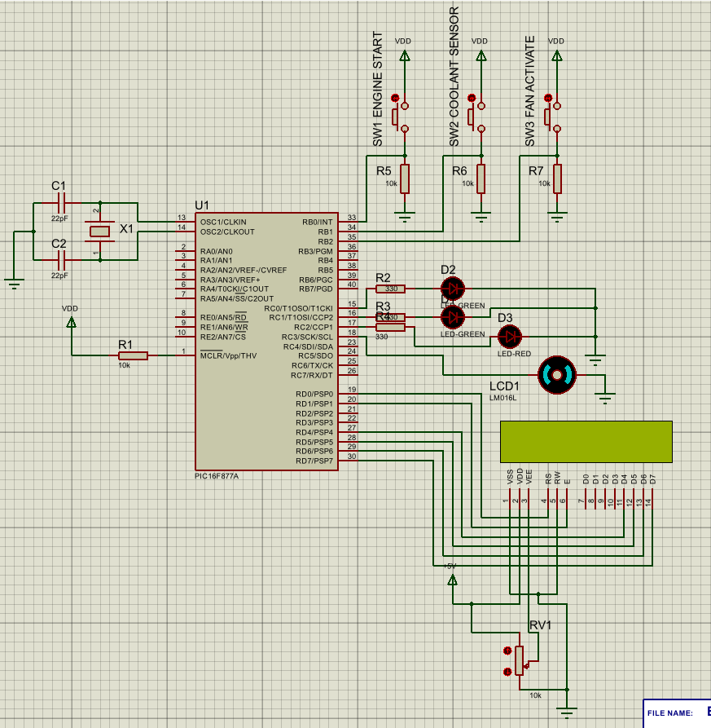
The following screenshots demonstrate the completed Proteus simulation and show the Automotive Cooling System Status Simulator operating through each stage of the control sequence.
Figure 1: Complete Proteus schematic showing the PIC16F877A microcontroller, input switches, LEDs, LCD display and DC motor.
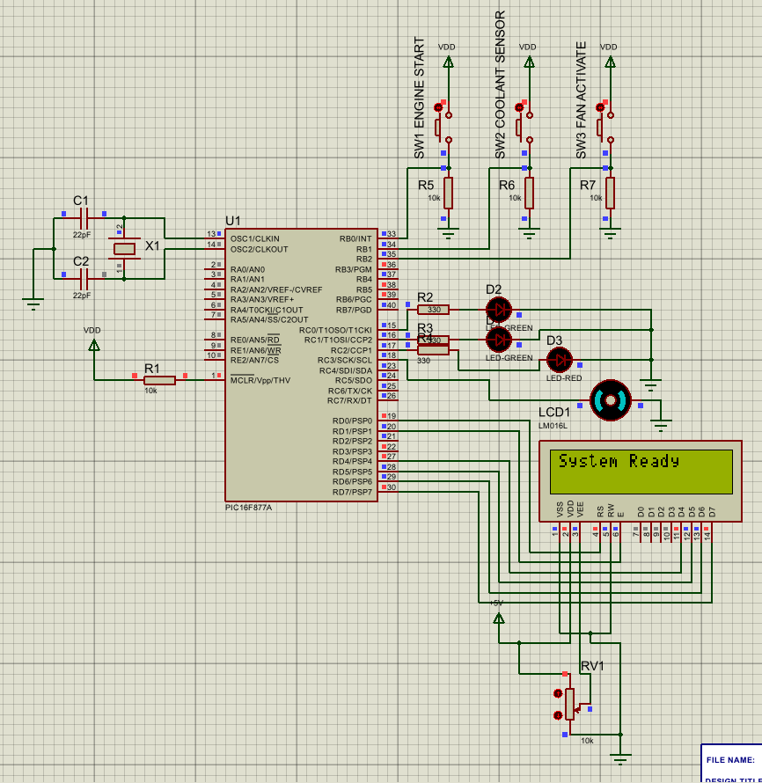
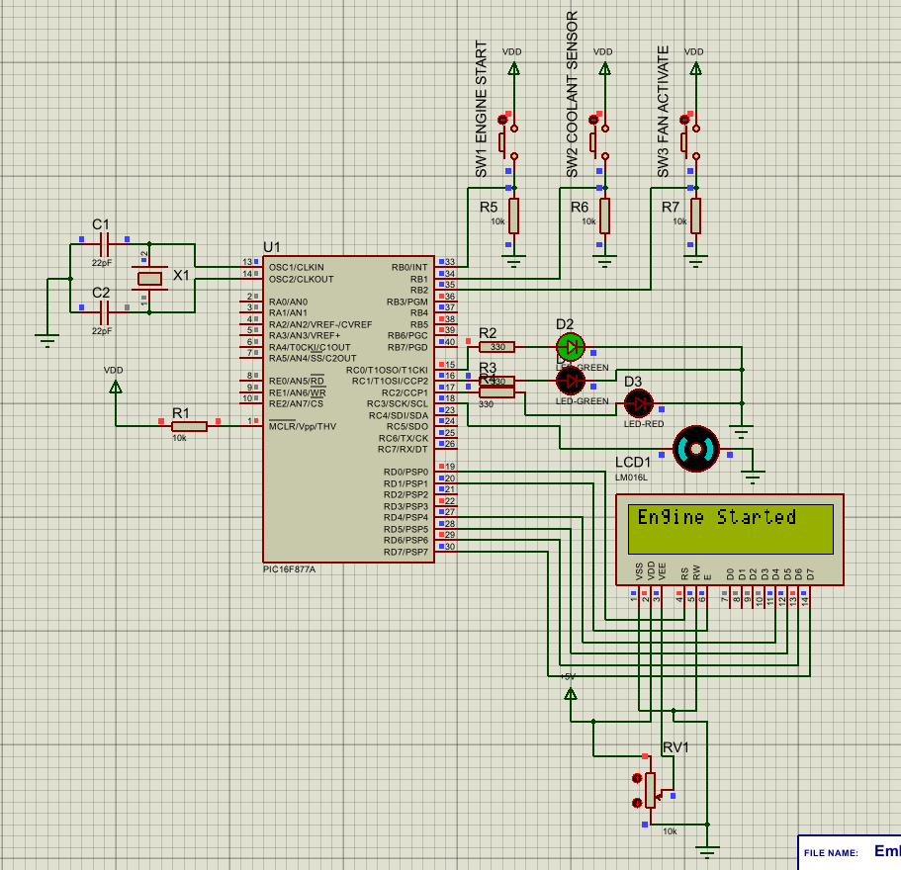
Figure 3: Engine start stage showing LED1 activated and the LCD displaying "Engine Started" after SW1 is pressed.
Figure 2: Initial system state showing the LCD displaying "System Ready" with all outputs inactive.
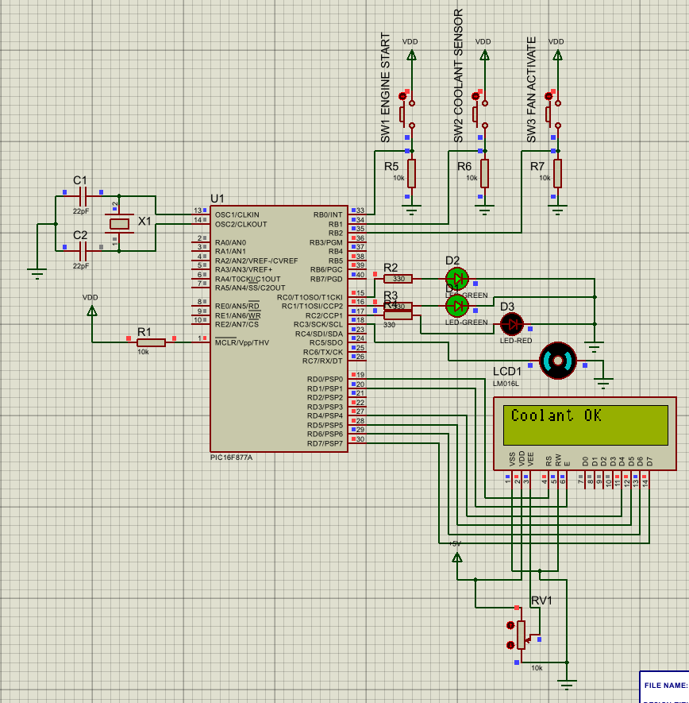
Figure 4: Coolant confirmation stage showing LED2 activated and the LCD displaying "Coolant OK" after SW2 is pressed.

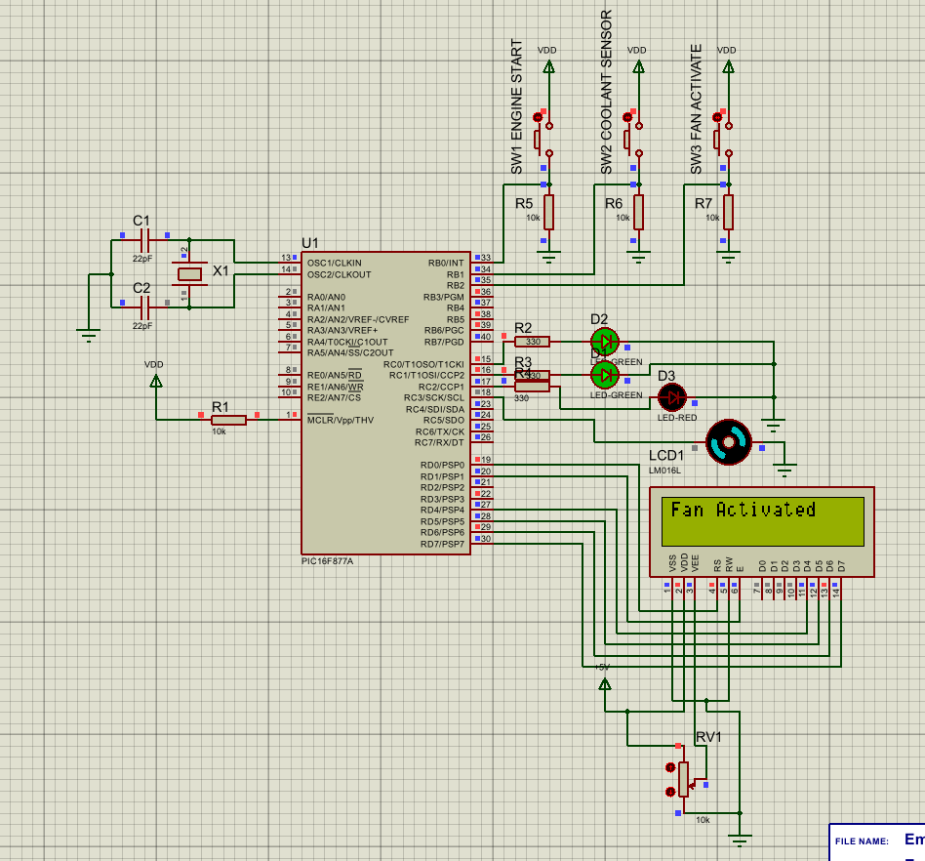
Figure 5: Fan activation stage showing the DC motor operating and the LCD displaying "Fan Activated" after SW3 is pressed.
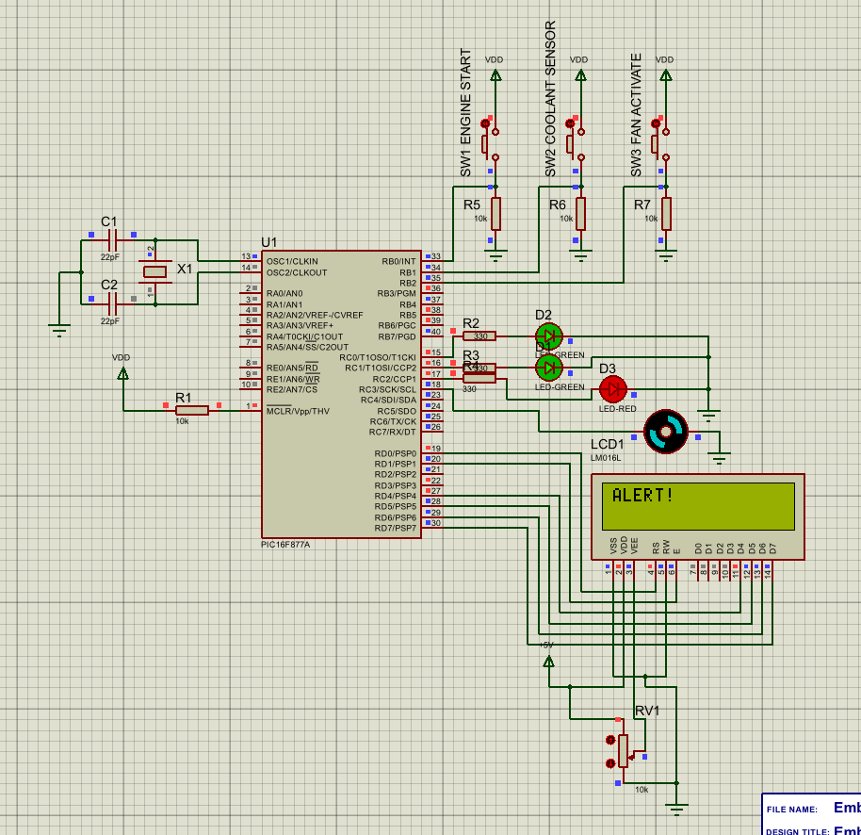
Figure 6: Alert stage showing LED3 flashing and the LCD displaying "ALERT!" before system shutdown.
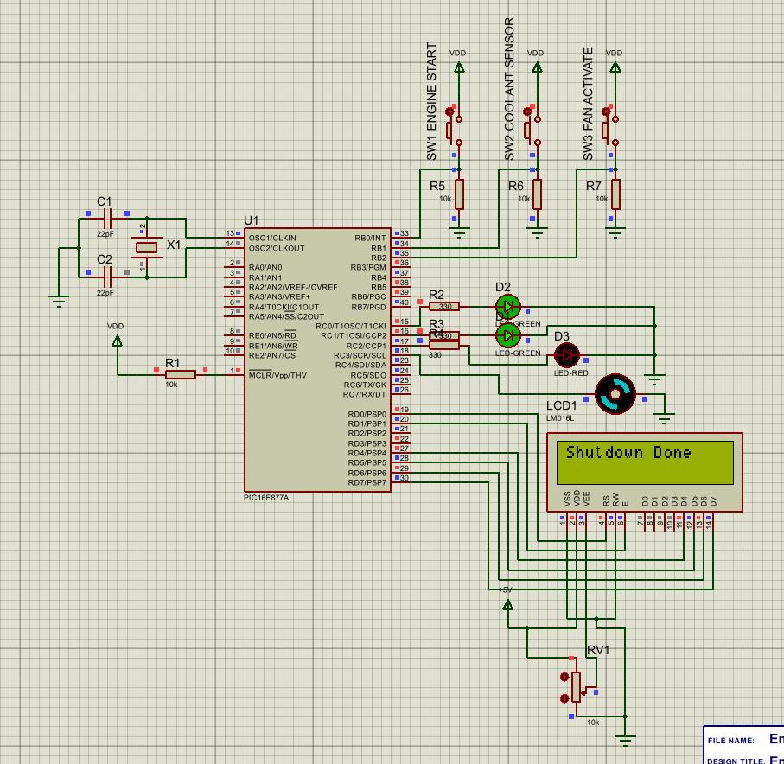
Figure 7: Shutdown stage showing the LCD displaying "Shutdown Done" after the alert sequence has completed.

Details of testing

Testing was carried out within the Proteus simulation environment to verify that the circuit and program operated correctly. The system was tested in stages to confirm that each input and output functioned as expected before the complete operating sequence was tested.

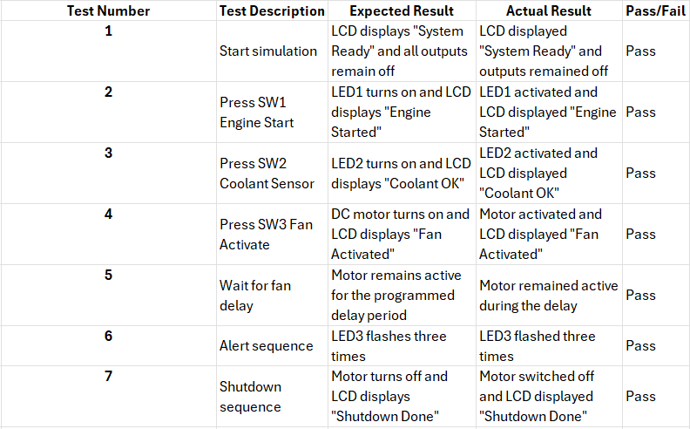
Table 2: The results show that the system operated as intended. Each stage of the sequence occurred only after the required input had been received, demonstrating that the programmed control logic was functioning correctly.

Conclusion

The aim of this project was to design and simulate an Automotive Cooling System Status Simulator using a PIC16F877A microcontroller programmed in CCS C. This aim was achieved through the development of a Proteus simulation containing push-button inputs, LED status indicators, a 16×2 LCD display and a DC motor representing the cooling fan.
The completed system successfully followed the required operating sequence. The simulation began in a ready state, then progressed through engine start, coolant confirmation, fan activation, alert indication and shutdown. The LCD provided clear text feedback throughout the sequence, while the LEDs and DC motor gave visual confirmation of the system status.
Testing confirmed that the input switches, LEDs, LCD display and motor operated correctly within the Proteus environment. The use of a sequential control structure ensured that each stage could only occur after the previous stage had been completed, improving the reliability and predictability of the system.
Overall, the project demonstrated the use of embedded C programming to control hardware outputs based on input conditions. It also provided practical experience in microcontroller programming, circuit simulation, LCD interfacing and system testing. Future improvements could include the use of an analogue temperature sensor, automatic fan speed control using PWM and additional fault detection features to make the simulation more representative of a real automotive cooling system.

References

[1] | M. T. Inc., PIC16F87XA Data Sheet: 28/40/44-Pin Enhanced Flash Microcontrollers, Chandler, Arizona, USA: Microchip Technology Inc., 2013.
[2] | Motorsport, “Car Cooling Systems: How Do They Work? & What Do They do?,” Demon Tweeks, 19 04 2023. [Online]. Available: https://blog.demon-tweeks.com/motorsport/how-your-cars-cooling-system-works/. [Accessed 09 07 2026].
[3] | TimesTech, “The Backbone of Vehicle Electronics: Exploring the Role of Automotive Microcontrollers in Modern Cars,” TimesTech, 23 04 2026. [Online]. Available: https://timestech.in/the-backbone-of-vehicle-electronics-exploring-the-role-of-automotive-microcontrollers-in-modern-cars/. [Accessed 09 07 2026].
[4] | Labcentre, “Proteus,” [Online]. Available: https://www.labcenter.com/pcb/?gad_source=1&gad_campaignid=671444043&gclid=Cj0KCQjwjb3SBhDgARIsAMKiWzjfESO8LGYaQsmAsRXGMaUPJeuXKfM9NfqE3rmEVE4AYOdBT5myaw4aAhWlEALw_wcB. [Accessed 09 07 2026].
[5] | T. Denton, Automobile Electrical and Electronic Systems, London: Routledge, 2017.
[6] | R. B. GmbH, Bosch Automotive Handbook, Hoboken, New Jersey, USA: Wiley, 2018.
[7] | H. Ltd., HD44780U (LCD-II) Dot Matrix Liquid Crystal Display Controller/Driver Datasheet, Tokyo, Japan: Hitachi Ltd., 1998.

Appendix

Appendix A: CCS C Source Code
#include <16F877A.h>

#fuses HS,NOWDT,NOPROTECT,NOLVP
#use delay(clock=20000000)

// LCD pin setup
#define LCD_RS_PIN PIN_D0
#define LCD_ENABLE_PIN PIN_D1
#define LCD_DATA4_PIN PIN_D4
#define LCD_DATA5_PIN PIN_D5
#define LCD_DATA6_PIN PIN_D6
#define LCD_DATA7_PIN PIN_D7

#include <lcd.c>

// Inputs
#define SW1 PIN_B0
#define SW2 PIN_B1
#define SW3 PIN_B2

// Outputs
#define LED1 PIN_C0
#define LED2 PIN_C1
#define LED3 PIN_C2
#define MOTOR PIN_C3

void main()
{
set_tris_b(0b00000111); // RB0, RB1, RB2 as inputs
set_tris_c(0x00); // PORTC as outputs
set_tris_d(0x00); // PORTD as outputs

output_c(0x00);

delay_ms(500);
lcd_init();
delay_ms(500);

while(TRUE)
{
output_low(LED1);
output_low(LED2);
output_low(LED3);
output_low(MOTOR);

lcd_putc('\f');
printf(lcd_putc, "System Ready");

while(!input(SW1));
delay_ms(200);

output_high(LED1);
lcd_putc('\f');
printf(lcd_putc, "Engine Started");

while(!input(SW2));
delay_ms(200);

output_high(LED2);
lcd_putc('\f');
printf(lcd_putc, "Coolant OK");

while(!input(SW3));
delay_ms(200);

output_high(MOTOR);
lcd_putc('\f');
printf(lcd_putc, "Fan Activated");
delay_ms(3000);

output_low(MOTOR);

lcd_putc('\f');
printf(lcd_putc, "ALERT!");

for(int i = 0; i < 3; i++)
{
output_high(LED3);
delay_ms(100);
output_low(LED3);
delay_ms(100);
}

lcd_putc('\f');
printf(lcd_putc, "Shutdown Done");

delay_ms(2000);
}
}

