
Programme: Master of Business Administration
Module: Marketing Management
Assessment component 1: Marketing Environment Analysis
Module code: LCMB7024

Study on HSBC (Pioneers) and Barclays Bank (Followers)


Lecturer: Laila Maazouz
Student Name : Abhishekkumar Vinubhai Pethani
Student ID : 2525424
Word Count: 2663
Table of Contents
Task 1: Marketing Environmental Analysis for Pioneers and Followers 4
1.1. Overview of the context 4
1.2. Macro Environment in Strategic Marketing 4
1.2.1. PESTEL Analysis 4
1.3. Factor 1: Economical aspects for HSBC and Barclays 6
1.4. Factor 2: Technological Factor aspects for HSBC and Barclays 6
1.5. Impact Assessment 7
1.5.1. Opportunities based on assessing the economic and technological aspects 7
1.5.2. Threats based on assessing the economic and technological aspects 7
1.6. Analysis 8
Task 2: Analysis aligned with assessing marketing environmental analysis for pioneers and followers 10
2.1. Strategic Response in Context 10
2.2. HSBC’s Strategic Responses 10
2.2.1. Leveraging Global Scale and Economic Connectivity 10
2.2.2. Implementation 10
2.2.3. Application of the Ansoff Matrix 10
2.2.4. Porter’s Genetic Strategy: 12
2.3. Barclays’ Strategic Responses 13
2.3.1. Operational Efficiency and Domestic Focus 13
2.3.2. Ansoff Matrix Application: 13
2.3.3. Porter's Generic Strategy 14
2.3.4. Comparative Evaluation 14
2.4. Sustaining Competitive Advantage 15
Reference List 16

Task 1: Marketing Environmental Analysis for Pioneers and Followers

1.1. Overview of the context
The marketing environment influences regulatory changes with technological advancements for any financial institution. Besides customer-centric and technology driven process, the banking institutions are often changing demographic needs with instant financial services. Barclays and HSBC have their presence in over 45 countries with over 95000 employees. Over 75% of the revenue comes from the UK retail sector. Barclays PLC have their net income of £8.193 billion in the year 2024-2025. The bank established its presence in the year 1936 in London, the UK (Bakhsh et al., 2025). It is the only and first banking industry that developed a cash vending machine in the year 1967. On the other hand, HSBC makes its presence in 59 different countries across Asia, Europe, North America and many more. Its revenue crossed over US$25 billion in the financial year 2024-2025 (Gaviyau and Godi, 2025). The Hong Kong and Shanghai Banking Corporation is preparing to purchase the UK-based Birmingham and Midland Bank very soon.

1.2. Macro Environment in Strategic Marketing
Micromarketing concepts are widely accepted by multinational bodies to adapt to the threatening situations by creating opportunities. The PESTEL analysis model is widely evaluated to maximise business opportunities. Several strategies are accepted by the different multinational industries (Grijalvo and García-Wang, 2023). Nevertheless, strategic marketing analyses these marketing factors for their consumer preferences and eliminates risk areas. Both economic and technological factors are considered the most important to analyse the threat and create global opportunities.

1.2.1. PESTEL Analysis
Political factors: For the HSBC bank, political turmoil is the issue for economic instability. Inflation with government actions and polices drives the extra issues for the economic platform for the bank (Hortega et al., 2025). On the other hand, for Barclays the trade disputes and other fiscal policy initiatives by the local government are now challenging for funding and grant opportunities
Economic factors: The inflation of the country with high interest rates on loan amounts is now a factor of economic aspects of HSBC. GDP of the mother country has been considerably taken for sustain in economic crisis (Jameaba, 2025). The foreign exchange liquidity crisis and rising credit risk amidst deterioration of asset quality are the major issues of Barclays.
Social factor: Changing customer experience and expectations often does not meet the criteria of the bank. People face issues with exchange rates and fees reduced purchasing power of Barclays ' customers.
Technological factor: Changes in the expectations, habits, and interactions of customers of HSBC bank are leading to greater digitalisation and adoption of digital platforms and processes (Jameaba, 2025). The rapid growth of AI cannot always be applied to maintain the workflow of Barclays.
Environmental Factor: Climate change impact with carbon footprints affects the Sustainable Financing efforts by HSBC Bank (Kovacevic et al., 2024). Barclay’s drives the greater expectation from multilateral and bilateral lenders for lending decisions, which sometimes do not, comes in considerations.
Legal factors: HSBC's foreign regulatory restrictions affect the outflows of money within the organisation (Kulsume, et al., 2025). On the other hand, Barclays faces the extension of debt affects the corporate and individuals. Restrictions in the import category sometimes get stuck.
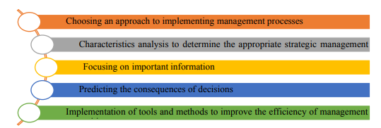
Figure 1: Factors Influencing Banks Performance Externally
(Source: Pavlov, 2025)
Based on the above analysis the context of the following discussions will look forward towards examining as well as analysing the economic factors as well as technological aspects for both the core Bank i.e. HSBC Plc Holding and follower Bank Barclays Plc.

1.3. Factor 1: Economical aspects for HSBC and Barclays
As opined by Jameaba, (2025), the HSBC bank is striving for economic growth both in the rising and inflation period. Interest rates of the said bank change for the marketing strategy. Pointing out the consumer growth, the bank provides a steady rate of interest during the fluctuations period also. In the year 2024-2025, the bank allows up to 7.5% rate of interest for any consumer loan (Kovacevic, Radenkovic and Nikolic, 2024). Compared to other financial institutions, the business spending patterns are far more modified in the HSBC bank.
Besides, Barclays allows consumers to enter the macro concepts where the global GDP growth is to be targeted. The GDP growth target is 4.83-5.63% for 2026-2027. Barclays considers building the awareness and understanding of each other’s markets within the UK and Europe nations (Kulsume, Saha and Sumi, 2025). According to Pavlov (2025), Barclays explores that they are willing to pay an average of 12% premium for UK goods. Hence, the latest report provides recommendations to strengthen trade and investment between India and the UK, deepening and broadening our close ties, and driving growth in economies.

1.4. Factor 2: Technological Factor aspects for HSBC and Barclays
Apart from economic vision, the HSBC bank allows to diversify the business by implementing AI and automation (Rodes Revueltas, 2025). Though the technology must be cost-oriented and it costs up to $400U.S., it comes with digital podiums with newly developed software from the platform ORACLE. Barclays is empowering to discover and engage its customers in different and the best possible ways (Odwaro, et al., 2022). The sustained innovations and transformation innovations. Technology or business model evolving a balanced portfolio of high-rated innovations

1.5. Impact Assessment

1.5.1. Opportunities based on assessing the economic and technological aspects
These transformations and strategies create opportunities and threats for the HSBC banking institution across the globe (Pham et al., 2024). They have already introduced career paths in different types of wealth management, international trade and digital banking. Opportunities come across the globe with modern innovations and global service centres (Pluskota et al., 2026). Dealing with high rated net worth individuals in trade finance, the support and offerings have a significant global market.
Opportunities are different for different organisations. Barclays focus on the investment patterns and partnership opportunities (Rodes Revueltas, 2025). The strategy includes the specialised role in developing business dealing with automated software's which will enable the non-disruptive technology with the transformation of banking needs.

1.5.2. Threats based on assessing the economic and technological aspects
HSBC faces a lesser amount of growth in local distributors as the competitors pay a higher margin to local distributors. Involving such a technology bank provides less credit availability to the investor, which previously impacted profitability (Zrybnieva et al., 2025). It brings some unethical behaviour amongst banks and financial institutions. The major theta of Barclays is intense digital competition. Digital banking provides a marketing threat. It allows the Regulatory and Compliance Risks, which can lead to high inflation, which allows increased in loan defaults.

1.6. Analysis
Both economic and technological aspects are considered from the HSBC and Barclays points of view. Investments in different segment has certain percentage uplifts the standard but affect the total credit portfolio. As opined by Pluskota, et al., (2026), the liquidity coverage has decreased by 123% in the previous year. The bank is navigating the changing landscape to maintain profitability and operational efficiency by diversifying its sources beyond interest income. Barclays not only depends on the global explore but mainly focuses on the partnerships and intensely diversified business categories (Pham et al., 2024). Opportunities in local distributor rates and enhancing liquidity management practices make the bank minimise the risk management process
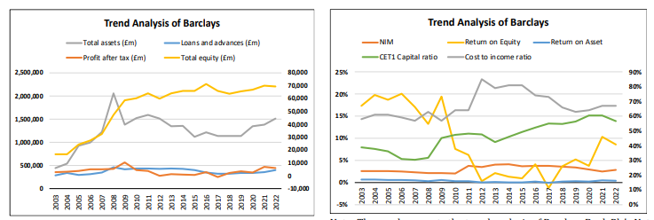
Figure 2: Market Trend Analysis of Barclays Bank
(Source: Kulsume, Saha and Sumi, 2025)
Technological analysis is driving the efficiency for AI implementation for better banking efficiency, collaboration and reducing optimal cost. This support rapid deployment of new services for Barclays.
Huge global investments with streamline operations evolve the needs of the HSBC customers. Diversified non-interest income is one of the major aspects to be a key revenue driver for HSBC By 2028. Compensation costs and high technology spending may slightly pressure efficiency ratios (Pluskota et al., 2026). As results banks may continue their growth through capital dividends and share repurchases.
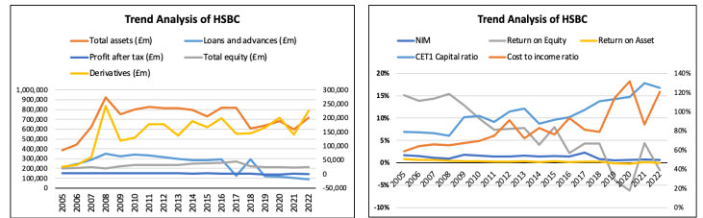
Figure 3: Market Trend Analysis of HSBC Bank
(Source: Kulsume, Saha and Sumi, 2025)
Besides all opportunities and threats, there are several other factors that affect the business growth as a whole. In the economic aspects, the HSBC bank regulates the economic cycle by providing adequate technology in its hands. And on the other side, Barclays is taking advantage of exploring the global concepts of collaboration by improving ai technology and strategies for transformation to macro-level marketing.

Task 2: Analysis aligned with assessing marketing environmental analysis for pioneers and followers

2.1. Strategic Response in Context
Aligned as per the above analysis, both the selected organisations in the report, HSBC and Barclays, faced major macro environmental changes that comprised economic fluctuations across global as well as domestic markets and fast-moving technological transformation over the entire banking platform, which found tailored their strategic responsive towards maintaining competitive advantages.

2.2. HSBC’s Strategic Responses

2.2.1. Leveraging Global Scale and Economic Connectivity
Strategic Focus: The strategic focus for HSBC Holdings Plc is to continue to streamline as well as focus on core, high-growth business, mainly measured within the context of wealth, commercial banking and Asia Markets, aiming towards divesting from non-core markets across the globe (Pham et al., 2024). The scope for the selected banking giant is to explore as well as evaluate the growth opportunities mainly across the emerging markets of the globe through diversifying the context of the proceedings aligned towards accomplishing the long-term set of strategic goals and objectives (Pavlov, 2025).

2.2.2. Implementation
According to Odwaro, et al (2022), simplified organisational structure will require accelerating the execution process along with focusing on the core business operations that are found to be successfully aligned with the highest growth opportunities across several kinds of geographical locations, such as the UK, Hong Kong, Wealth and Premier Banking. Along with the same point in time, sales of non-core units, for example, in Singapore insurance manufacturing, will allow towards relocating capital in a more effective manner.

2.2.3. Application of the Ansoff Matrix
Market Development: The market development process was found to be continuous in the ways in which the selected banking institution focused towards creating an ongoing business expansion process across key regions through leveraging global connectivity in order to attract internationally mobile clients (Kulsume, Saha and Sumi, 2025). For example, the expansion and development process will mainly target the emerging nations of the globe, such as the BRICS nations, that have shown as well as maintained a huge potentiality measured in terms of economic aspects. Nevertheless, the scope found open over both existing and new markets for HSBC.
Diversification: The diversification will begin with the withdrawal from the border regions where the profitability aspects are found to be limited in certain ways (Kovacevic, Radenkovic and Nikolic, 2024). Therefore, the management of the selected financial institution must focus towards structuring or adding efforts on fast-growth economic corridors such as India and China.
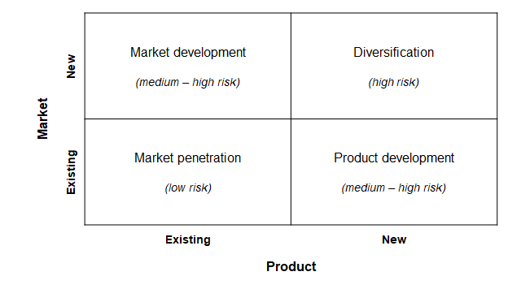
Figure 4: Ansoff Matrix Framework
(Source: Self-Created)
Assessment: The above-mentioned strategy supports growth through specifying the ongoing as well as current strategies through creating and determining the right point of execution aligned with market focus and diversification (Jameaba, 2025). For example, mitigating economic threats by reallocating resources towards creating aspects with overlapping markets, HSBC will maintain a defined competitive edge.
Digital and Innovation-Led Transformation
Strategic Focus: HSBC, under the mentioned circumstances, will have the options as well as the potentiality towards significantly invest in digital innovation such as AI, embedded banking solutions, tokenised transactions, and global merchant platforms.
Implementation:
According to Hortega et al., (2025), focusing on creating the right implementation process will evolve the ongoing proceedings, where the effectiveness of platform innovation, such as Omni Collect and blockchain-enabled cross-border services, along with digital asset platforms such as tokenised deposits and digital bonds, will create as one of the considerable amount of impact. On the other hand, digital application enhancements through specifying personalised AI banking tools will open up new opportunities towards strengthen customer engagement strategies in the best possible manner.

2.2.4. Porter’s Genetic Strategy:
Differentiation Focus: Out of the various quarters of the selected theory, the suitable quarter will be the differentiation quarter or aspects where the mentioned financial institution successfully positioned itself through advanced digital services that are highly emphasised over global connectivity and cross-border capability (Hasan, Hoque and Le, 2023). The context found appealing towards assessing the multinational customers over domestic banking rivals.
Assessment: HSBC’s with its differentiation strategy will ensure as well as specify the ongoing attributers aligned with the digital services that will create the required emphasis on global connectivity and cross border capability found appealing across multinational customer over domestic banking rivals considering the fact of the raising level in competition (Grijalvo and García-Wang, 2023). Along with the same point in time, the differentiation strategy will secure the necessary competitive edge through offering that competitors cannot replicate at the same scale, thereby enhancing both customer retention and revenue potential.

2.3. Barclays’ Strategic Responses

2.3.1. Operational Efficiency and Domestic Focus
Strategic Focus: The strategic focus aligned with specifying the business aspects of Barclays, found in executing a disciplined transformation plan through creating and specifying operational efficiency, along with assessing risk-weighted asset rebalancing toward higher-return UK businesses, and shareholder returns.
Implementation
The implementation process will begin by creating and specifying RWA for higher return businesses, as well as enhancing Net Interest Income (NII) stability. Alongside specifically addressing cost discipline in order to improve cost to income ratio, as well as retention of the shareholders' trust, measured at the highest potential level.

2.3.2. Ansoff Matrix Application:
Market Penetration: The application of the selected theoretical framework will look forward through creating as well as determine the right point of execution aligned with assessing the current market positioning for Barclays (Gaviyau and Godi, 2025). Barclays is intensifying towards penetrating in existing markets through enhancing both product and service delivery within the UK financial ecosystem, as well as deepening existing client relationships, measured at the highest potential level (Hortega, et al., 2025).
Assessment: Barclays, with its consolidation in its domestic market, strongly explored and redefined its business mix, where Barclays' business strategy will clearly emphasise the efficiency level, as well as fostering sustained profitability within established markets aligned with its followers' profile.
Digital Innovation and FinTech Integration
Strategic Focus: The strategic focus for Barclays successfully reinforced the company's digital transformation, as well as partnerships with fintech and cutting-edge technology and solutions.
Implementation
The implementation process continued over the ways that required towards ensuring the process, as well as required updates to mobile and AI-driven banking features through enhancing and fostering the customer experience, over real-time analytics, and third-party integrations (Bakhsh et al., 2025). Finally, specifying the ongoing attributes will look forward through focusing on digital financial infrastructure and blockchain for institutional clients (Grijalvo and García-Wang, 2023).

2.3.3. Porter's Generic Strategy
Differentiation: The application through creating the right point execution will align with assessing the implementation of Porter's Generic Strategic where creating differentiation through innovation will be specified as one of the key as well as considerable impact (Gaviyau and Godi, 2025). For example, Barclays will focus on creating digital experience excellence aligned with increasing customer loyalty over its domestic market and differentiating its strategies from competitors, including its rival banks.
Assessment: Barclays, under the ways, may not rival HSBC's global technological scale, considering the fact that its technological-driven differentiation strategy within the key segments bolsters its core competitive edge over its core operating markets, as well as allowing offset threats from fintech disruption.

2.3.4. Comparative Evaluation
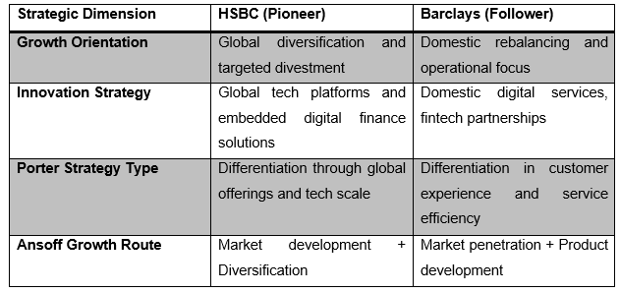

2.4. Sustaining Competitive Advantage
Ensuring the right sustainability aspects will look forward through assessing the ongoing attributes of global advantages, allowing HSBC to capture cross-border demand and diversify economic risks (Hasan, Hoque and Le, 2023). On the other hand, the brand must focus towards accelerating investment in next-gen digital services through supporting differentiated customer value at scale.
Coming within the context of Barclays Plc, focusing on operational and financial discipline will allow the mentioned company towards protecting profitability against economic volatility. On the other hand, specifying the targeting insights will explore digital innovation aiming towards strengthening domestic brand positioning as well as enhancing customer loyalty measured at the highest potential level.

Reference List
Bakhsh, M. S., Sharif, M. A., Nematizadeh, S., andHaranaki, M. K. (2025). Identification and Explanation of the Relationship between Credit Risk Management Constructs and Strategic Knowledge Management Approach in the Banking Industry. Agricultural Marketing and Commercialization, 9(1).https://oiccpress.com/amc/article/view/8549/18758
Gaviyau, W., and Godi, J. (2025). Banking sector transformation: Disruptions, challenges and opportunities. FinTech, 4(3), 48.https://www.mdpi.com/2674-1032/4/3/48
Grijalvo, M., and García-Wang, C. (2023). Sustainable business model for climate finance. Key drivers for the commercial banking sector. Journal of Business Research, 155, 113446. https://www.sciencedirect.com/science/article/pii/S0148296322009110
Hasan, M., Hoque, A., and Le, T. (2023)Big data-driven banking operations: Opportunities, challenges, and data security perspectives. FinTech, 2(3), 484-509.https://www.mdpi.com/2674-1032/2/3/28
Hortega, A., Menezes, D., Serra, F. A. R., Ebrahimpour, M., and Kramer, B. (2025). Revisiting the Intellectual Legacy of H. Igor Ansoff: A Critical Analysis of His Contributions and Their Impact on the Evolution of Strategic Management. Strategic Change.https://onlinelibrary.wiley.com/doi/epdf/10.1002/jsc.70027
Jameaba, M. S. (2025). Blockchain Technology, Artificial Intelligence and Financial Stability: Opportunities and Challenges for Financial Institutions. Artificial Intelligence and Financial Stability: Opportunities and Challenges for Financial Institutions (December 27, 2025).https://papers.ssrn.com/sol3/papers.cfm?abstract_id=5973614
Kovacevic, A., Radenkovic, S. D., and Nikolic, D. (2024). Artificial intelligence and cybersecurity in banking sector: opportunities and risks. arXiv preprint arXiv:2412.04495..https://arxiv.org/abs/2412.04495
Kulsume, U., Saha, S., and Sumi, N. A. (2025).Interest rate fluctuations and financial performance and stability of banks: evidence from the United Kingdom’s big four (Barclays, HSBC, Lloyds, and NatWest). Journal of Ekonomi, 7(2), 141-153.https://dergipark.org.tr/en/download/article-file/5028540
Odwaro, N. C., Abongo, B., and Mise, J. K. (2022). Moderating Effect of Dynamic Capabilities on the Relationship Between Porter’s Generic Strategies and Performance of Commercial Banks. European Journal of Business and Management Research, 7(4), 217-224. https://eu-opensci.org/index.php/ejbmr/article/view/51465/7534
Pavlov, K. (2025). Economic advantages of strategic development of a banking institution in conditions of competition. Economic journal of Lesya Ukrainka Volyn National University., (41).https://evnuir.vnu.edu.ua/bitstream/123456789/29370/1/25.pdf
Pham, H. N., Thai, N. T., Heffernan, T. W., and Reynolds, N. (2024). Environmental policies and the promotion of pro-environmental consumer behavior: A systematic literature review. Journal of Macromarketing, 44(1), 30-58.. https://journals.sagepub.com/doi/epub/10.1177/02761467231201507
Pluskota, P., Słupińska, K., Wawrzyniak, A., andWąsikowska, B. (2026).The Application of Artificial Intelligence (AI) in the Implementation of ESG-Oriented Sustainable Development Strategies in the Banking Sector: A Case Study. Sustainability, 18(2), 732.https://www.mdpi.com/2071-1050/18/2/732
Rodes Revueltas, B. (2025). Investment Banking Industry Analysis in Singapore: Growth, Performance and Sustainability.https://www.theseus.fi/bitstream/handle/10024/887942/Rodes%20Revueltas_Borja.pdf?sequence=2andisAllowed=y
Zrybnieva, I., Burdyak, O., Venherova, O., Nosachenko, O., andSerhiienko, O. (2025).Sustainable Marketing within the Environmental Responsibility Context: Research and Communication Strategies for Businesses Growth. https://elar.tsatu.edu.ua/server/api/core/bitstreams/7e325a9f-c425-4a80-94d7-80a812d62db9/content

