Swansea Civic Centre Building



Introduction Page 2
History Page 2
Embodied Carbon Page 8
British Standards Page 8
Recommendations Page 9
References Page 13

Introduction

This report is looking at the Swansea Civic Centre which is currently a multi-use structure used for both office space as well as public facing services along with a public library. This space is currently not being utilised efficiently due to the decommissioning of space along with services being moved to new areas. This allows a unique time to look at how this space could be redesign to meet both modern standards along with meeting up to date uses of the building.

I have set out some of the issues with the building along with recommendations of how this could be carried out differently if the building was to be constructed today, this does not discuss any issues that would arise with the demolition of the building as this would be vast due to the age and size of the structure.

This building has changed uses a few times over its life cycle and is no longer been used to the full potential due to its large size and older fashion designs. It has become less economically viable using the structure to house large office space due to its thermal inefficiency along with hybrid working styles being adopted meaning that fewer people are in office at the same time therefore the large office space provided by the building are no longer required. The decommissioning of spaces is to try and reduce energy costs of the building unfortunately this is not the best use of space as now there are large parts of the being maintained externally to remain watertight to only sit empty. This building therefore in a redesign can not only be brought up to modern standards to help improve thermal efficiency as well as ensuring that the building is reduced in size to be made more appropriate for the staff that it is required to home.

History

The Swansea Civic Centre was constructed in two phases from 1979-1984. The initial use for the building was for the Main Offices for West Glamorgan County Council. Designed by the County Architects Department with J. Webb as County Architect and CW Quick as the job architect. The structure is a concrete framed structure spanning five stories faced with white flint aggregate panels, with council chambers jutting out towards the entrance.

After local government re-organisation in 1996, which abolished West Glamorgan County Council, ownership of the building was transferred to Swansea Council. Swansea Central Library moved into the complex in 2008 as part of a redevelopment scheme. The library made nearly 566,000 book loans during the year ended March 2009, making it the busiest library in Wales and the tenth busiest library in the UK. (sourced from Swansea Civic Centre, Wales – The Twentieth Century Society (c20society.org.uk) )

Due to the building constructed 1979-84 there was asbestos used in insulating the building, even though this was considered a suitable insulation at the time this how now been made illegal for use in construction due to the hazards that were discovered in years to come this is no longer allowed to be used due to the risks to the health of those working with material such as Asbestosis.

Since Covid there has been a move towards hybrid work therefor there is less space required to home the staff that are working within the building there has been sections of the building now being decommissioned; in these areas heating has now been turned down or even off to reduce costs to the building. This means in the past 4 years there has been a reduction to energy costs however this is not due to efficiency but rather the use of the building being drastically reduced.

With this space no longer looking to run in the same medium as the initial design I believed this was an ideal building to look at how this can be redesigned to facilitate the needs of the modern office space. With this reduced requirements for office space there is the ability to reduce the size of the building while bringing the infrastructure up to a more modern standard for the thermal envelope.

Below shows some photos of the current Swansea Civic Centre building, the design and shape of the building; including interior photos showing how and where materials have been used around the building. This highlights the way that the materials have been used which is now considered outdated or less carbon efficient compared to modern methods. The brutalist concrete design is very apparent in other structures from this period such as Plymouth Civic Centre, Birmingham Central Library and Cumbernauld Town Centre. (Further examples included from BBC news Article. When concrete buildings drive people mad - BBC News)
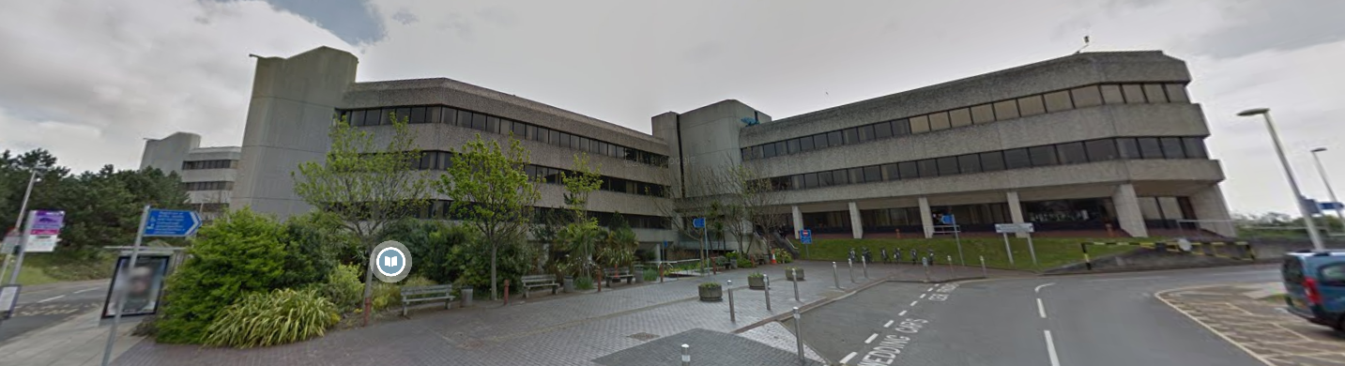
Photo Taken from Google Maps

Large Concrete panel cladding.
Large Spanning windows to allow light into deep building. However this over glazing can lead to temperature control issues.
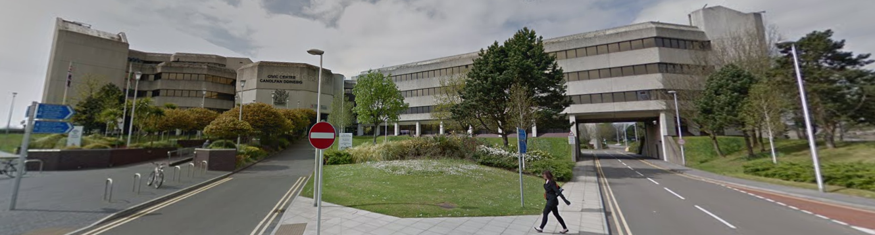
Photo Taken from Google Maps

Sections jutting out from the main block, the overhanging sections reduce the efficiency as framing materials are required for the overhanging sections which cannot be insulated as well as straight walling as well as potential cold spot bridging.
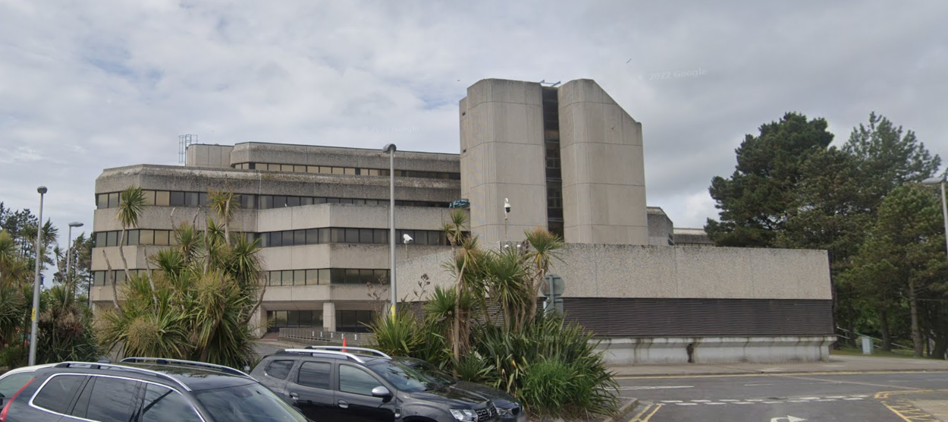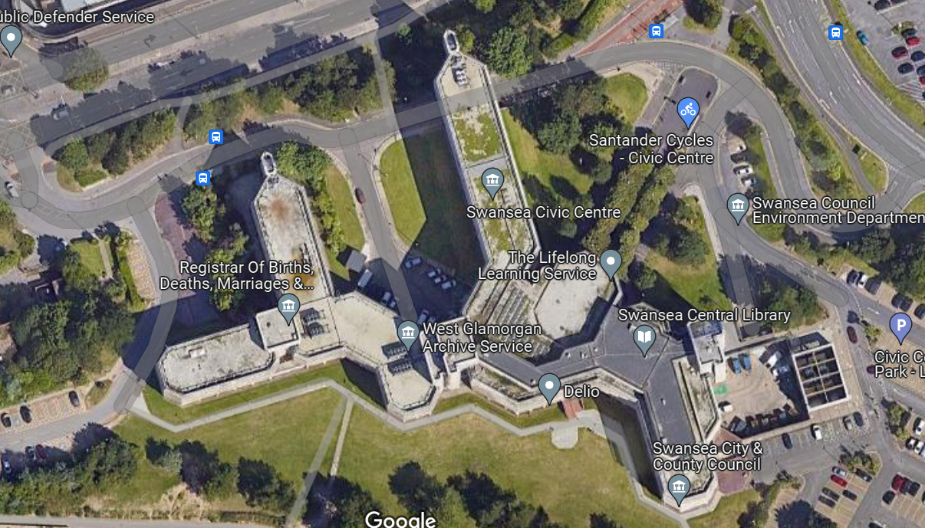
Photo Taken from Google Maps

- The large concrete sections will contain large amounts of embodied carbon.
- The building has been constructed from non-renewable resources.
- Due to this its construction methods are considered less environmentally friendly as todays modern construction methods.
Photo Taken from Google Maps

South
Flat roofing material used.
Sections have now been decommissioned which means there are large areas which are going to be holding cold air without the correct insulation installed between the commissioned and decommissioned areas.

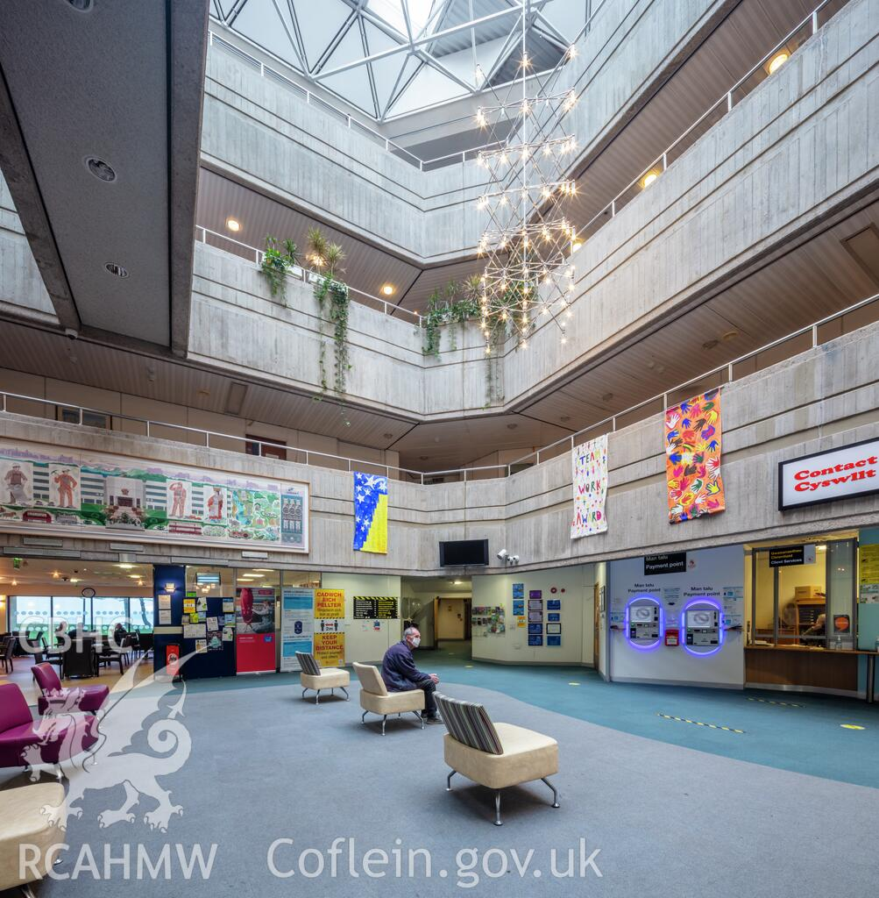
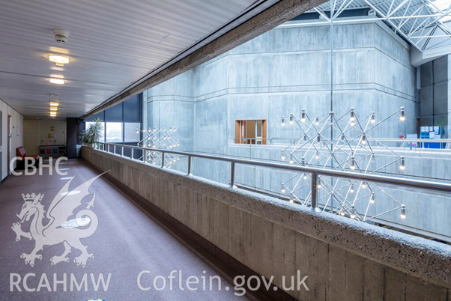
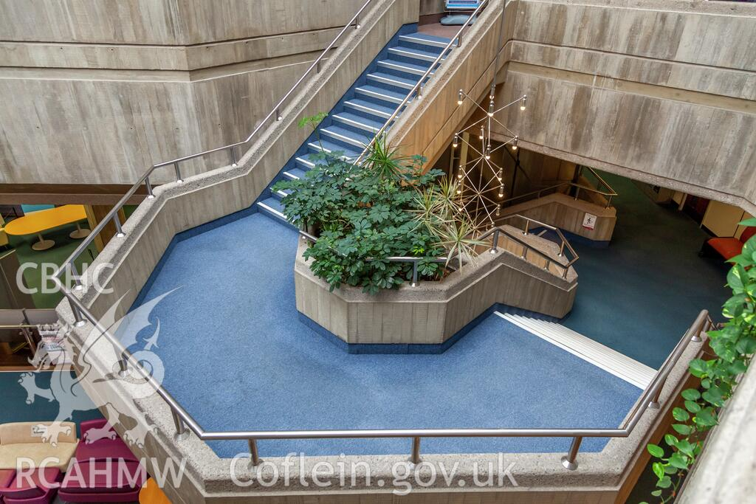
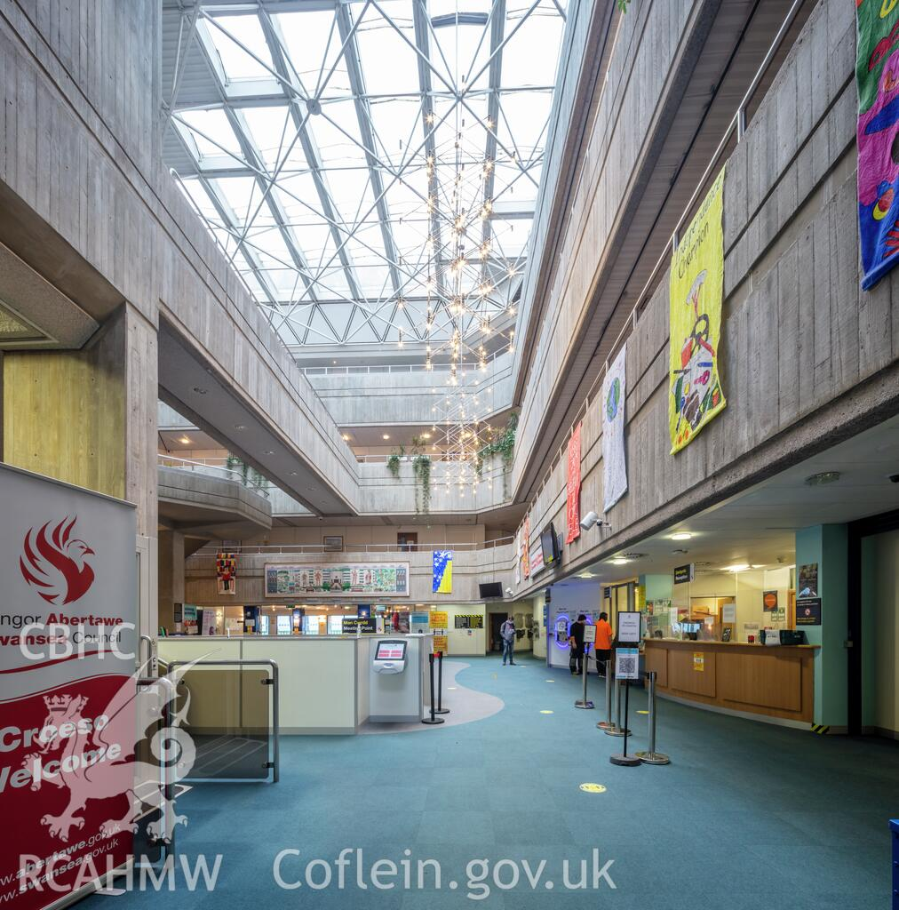
Interior Photos Taken from Coflein.gov.uk
Embodied Carbon

Embodied Carbon is the CO2 that is needed to produce and transport materials to site, this can be used to understand the amount of emissions that is caused to construct the building. These figures can be used to understand the Greenhouse contribution that is caused by the construction of the building. This figure that has been used can potentially be a higher figure that is involved in the construction period of the building may not be the worst of outcomes, as if the materials being used are run over a much longer life cycle then these materials of the lifetime of the building may mean that the overall CO2 output of the building could be lower in the long term.

Swansea Civic Centre is a concrete framed structure with an aggregate coated concrete cladding. Due to the age of the building the insulation would be an Asbestos Insulation, therefore this is highly toxic, the inner skin of the structure is a block and plaster finish. With some areas still using concrete cladding. As the building is highly exposed from to the weather coming from the south west across the bay without any protection from surrounding structures, it is likely a hard wearing material would be more suitable over the long term opposed to a material which will deteriorate due to weathering.

British Standards

In line with the up to date British Standards the new building will need to be built up to date with modern British Standards, all sanitary installations to be kept in line with BS 6465 (last updated in 2020). This would mean that the systems would be both kept in line with modern regulations but also ensuring that the building has been kept inclusive for both public and commercial use.

Another British Standard that will be complied with is the BS 9251 (Last updated in June 2021) which is for commercial sprinkler systems, these will be designed and integrated to the most up to date specification at the time of design to ensure the suitable safety systems are in place for fire safety, this would mean compliance to achieve a sophisticated systems that can ensure the safety of all who operate within the building. This is to include a plan that is involved within; design, installation, testing and maintenance of the system.

Thirdly, BS EN 12464-1:2021 is to be used which is the standard for suitable lighting in an indoor workplace. This will be complied with to ensure that the appropriate measure have been taken to meet the requirements of visual requirements for within the workplace to meet a comfortable standard for the workforce using the location. All visual work should be considered including Display equipment from monitors etc.

All doors will be compliant with BS 8214 fire doors to ensure that the risk of fire spread is reduced through doors. This will be tested and certified in line with BS 476 Part 22. This is to ensure that any risk of fire spread is brought in line with the approved standard of the BSI.

Recommendations

The first recommendation I would have is to protect the existing trees while planting more trees surround the building to help create a natural sound barrier from the road as well as a natural wind break from the see air, this will help create a more comfortable area to enter and exit from the building. Secondly, I would recommend a hard wearing material that will handle the heavy weathering that is being received from the coast. This hard weathering material I would suggest is a concrete cladding system similar to the system currently installed with a more modern finish, this is due to the 40 years span that has already been situated the concrete cladding is still holding up strong which shows this material is good for withstanding the coastal pressures.
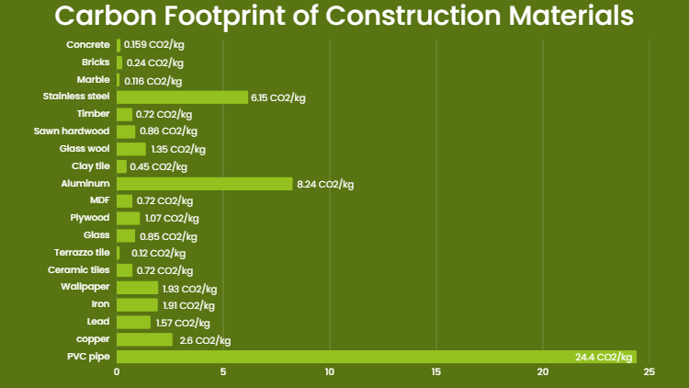
Table Extracted from 8billiontrees.com

There is a lower CO2/kg with concrete opposed to Timber however a timber cladding does not need to be as large and heavy rather per metres squared of the façade. However, I would anticipate the life span of the material to last much longer with reduced maintenance required. Treated timber on façade would require to be retreated to ensure that the material can maximise how long it can last as a cladding material. Alternatively, with concrete cladding panels on a steel frame, would allow for an expansive building structure to benefit from the expansive internal structure using timber stud walling with plasterboard walls to separate areas. This would also make the internal areas more future proof with the ability to move internal walls to suit any future modifications should the purpose of the building change further.

Due to the usage of the building being changed from the original plan if building this structure again the original building would not need to be the same size and potentially not the same shape. The reduction of overhanging section and strut out sections of the building will help reduce the surface of the building will mean that the building has a reduction in thermal loss. The concentration of design to reduce this surface area will mean that the structure can be targeted a more efficient insulation design.
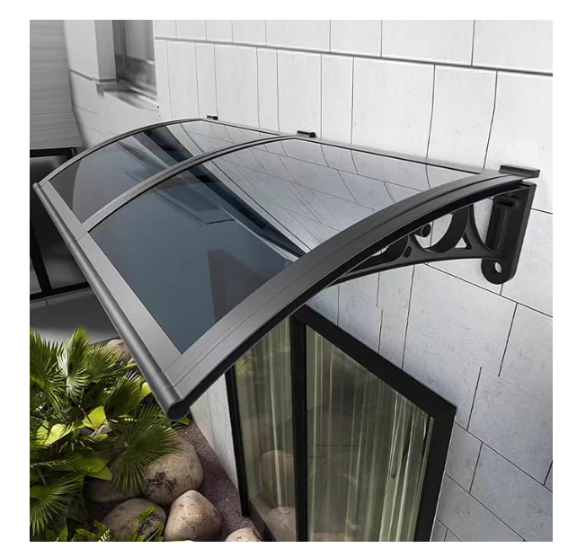
Example Photo Taken from Amazon.co.uk

The new structure constructed can be designed to take advantage of uninterrupted light from the south due to the building being built on the coast which can be used to create natural lighting and heating of the building structure. Using windows the light can use canopies over the windows to maximise the winter sun without overheating from the summer sun. Benefitting from the natural sun for thermal heating can help to reduce energy bills in both summer and winter months, as the ability to block the high heat of the summer from coming into the windows will help to keep builds at a more comfortable temperatures in the summer months while the lower winter sun being able to shine into the building will help to heat the building in the colder months of the year.

Due to the building no longer needing to be the same size due to the decommissioning the building can be a much smaller foot print, making use of the outside space. The new structure can use sustainable materials for building, in keeping with the local surroundings. The use of timber can be much more eco-friendly rather than expansive concrete used, I would propose Steel framed structure with an external cladding using a low carbon wood fibre insulation (example below). This would be installed into timber stud walls meaning there is reduction of material needed to construct these internal walls in comparison to concrete block walling with the ability to stud the inner skin and insulate with a natural material. Additionally this alternative insulation won’t cause harm to the people working with the materials as well as being sustainable. The inside skin of the walls can be a plaster board finish which will be a suitable low impact material.
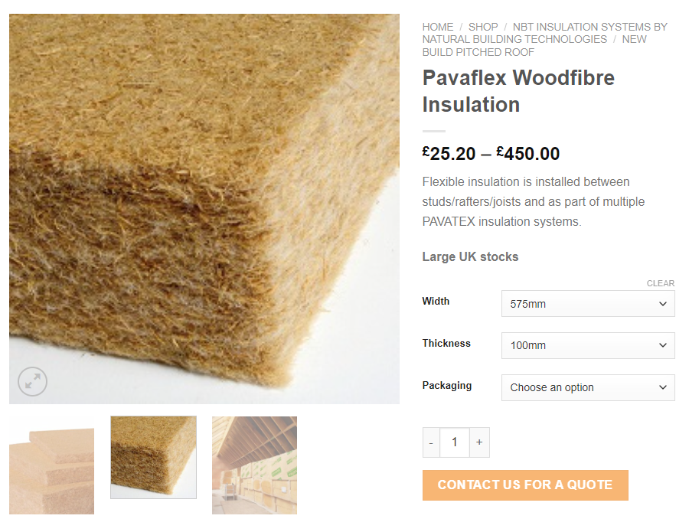
Example Photo Taken from Unitylime.co.uk

The building is currently in a period of transition as the public library that is expanded across the ground floor is in the process of moving to a new location in the city centre while other services have been relocated over to the Guild Hall. Due to this there is not a specific use that has been established for the building at this time, it is possible that the building may change use therefore my recommendation for this building if it was building constructed today is to ensure that is carried out in a way that is diverse allowing the building to evolve as with many public buildings its usage will evolve over time as is required for the needs for the Councils requirements for the building. The building currently both public facing as well as office space, therefore ensuring that the ground floor meets the accessible nature of a customer focused location, with a warmer interior being fitted out with locally sourced renewal materials such as timber fixtures where ever possible; including reception areas.

The windows that are currently used are expansive of the structure which is beneficial for letting in large amounts of natural light however has the potential of over glazing the structure, I would recommend the use of modern triple glazing introduced to improve the thermal envelope of the building with modern aluminium windows, this will benefit from the use of less heat loss through the building along with modern aluminium frames being used. The use of these frames means that non recycled materials can be avoided, the material frames can be produced off site manufacturing with the ability to installation being reduced time on site.

When the internal fabric is improved it would be important to introduce a suitable mechanical ventilation system, with the ability to create a much better seal on buildings internal air quality can become poor, due to the large number of occupants within office space it is important to consider the benefits of ventilation systems which can ensure that air is suitably circulated while also filtered. Filtering the outside air ensures that the internal space remains comfortable by removed external toxins from things such as the vehicles that pass on the main road alongside the building, while also filtering out things such as pollen which can affect people’s allergies such as hay fever being common. This mechanical ventilation can help to reduce workplace sickness from things such as colds and airborne sickness being passed around the office, the use of the system can brick down workplace absences with illness.

To minimise the cost of energy with rising energy prices it could be seen beneficial to make use of the roof space for renewable energy consumption through things such as solar, as the area benefits from no large buildings trees shading the building. The use of solar panels and storage can be used in accompaniment of a large span ground source heat pump system, as the system is beneficial of being between three or four times more efficient than a standard gas boiler while the draw back being that energy is lost with the electric required from power station to the building itself. The benefit of planning this at an early stage would mean that a suitable storage bank along with solar system can be introduced to maximise the efficient of both systems. This working in tandem allows for both bills being reduced while also reducing reliance on energy suppliers in peak times, this would mean that should there be an issue with the grid losing power there would be a period of self-reliance available minimalizing the risk of losing information due to energy outages.

When constructed the new building a suitable canteen area is to be included to ensure that there is suitable resources available to food and drink for office staff whilst also allowing public to access any food or drink while on site for the customer facing sections operating within the new structure. This will need to be on the ground floor to allow access for the public with the office staff on the floors above having the ability to come down to access as required.

Reference List (As it appears within the above report)

Swansea Civic Centre, Wales – The Twentieth Century Society (c20society.org.uk)

When concrete buildings drive people mad - BBC News

County Hall; Civic Centre, Swansea | Coflein

Carbon Footprint of Building Materials (Green Building Calculator) (8billiontrees.com)

Grey Modern Polycarbonate Cover,Window Awning Front Door Canopy,Patio Porch Awning,Sun Shetter,Outdoor Window Rain Shelter Cover,UV Rain Snow Protection Garden Awning (60x170cm/24"x67") : Amazon.co.uk: DIY & Tools

PAVAFLEX Woodfibre Insulation Slabs - Unity Lime

