

LEVEL 7 – ASSESSMENT
MARKETING ENVIRONMENT ANALYSIS
BHP’s Transition Towards a Lower-Carbon Business Model

MASTER OF BUSINESS ADMINISTRATION
Marketing Management | LCMB7024
Module: | Marketing Management
Module Code: | LCMB7024
Lecturers: | Laila Maazouz, London  Taonga Kaonga Sobere-Snithers, Birmingham
Student Name: | Mayur Jivabhai Sundavadra
Student Id: | 2538588
Word Count: | 2,695 words excluding Title Page, Table of contents, Tables and References.
Submission Date: | Friday, 26 June 2026

Table of Contents

“Introduction: 3
1. Task 1 – Marketing Environment Analysis: 4
1.1. BHP’s Market Context and PESTLE Position 4
1.2. Natural Environment Actor and Physical Risk: 7
1.3. Political-Regulatory Actor and Market Access: 8
1.4. Competitive and Strategic Synthesis: 8
2. Task 2 – Strategic Growth and Competitive Positioning: 11
2.1. Ansoff Product Development Strategy: 12
2.2. Selective Market Development: 14
2.3. Porter’s Broad Differentiation Strategy: 14
2.4. Implementation, Metrics and Risk Control: 16
3. Task 3: Critical Reflection on AI Usage: 18
3.1. Tool Disclosure and Contribution Boundary: 18
3.2. Verification, Hallucinations and Corrections: 18
3.3. Ethical and Professional Reflection: 19
Conclusion: 19
References: 21
AI Use Acknowledgement: 25"

Introduction:
The decarbonisation of metals and mining has moved from corporate responsibility to a central marketing challenge because customers, regulators, investors and communities increasingly judge product performance and verified environmental impact (Busch et al., 2024; Verma and Diwan, 2025). As steel generated about 4.1 billion tonnes of carbon dioxide equivalent in 2024, representing 7 to 8% of global anthropogenic emissions, while each tonne averaged 2.18 tonnes of emissions across its value chain (World Steel Association, 2025).
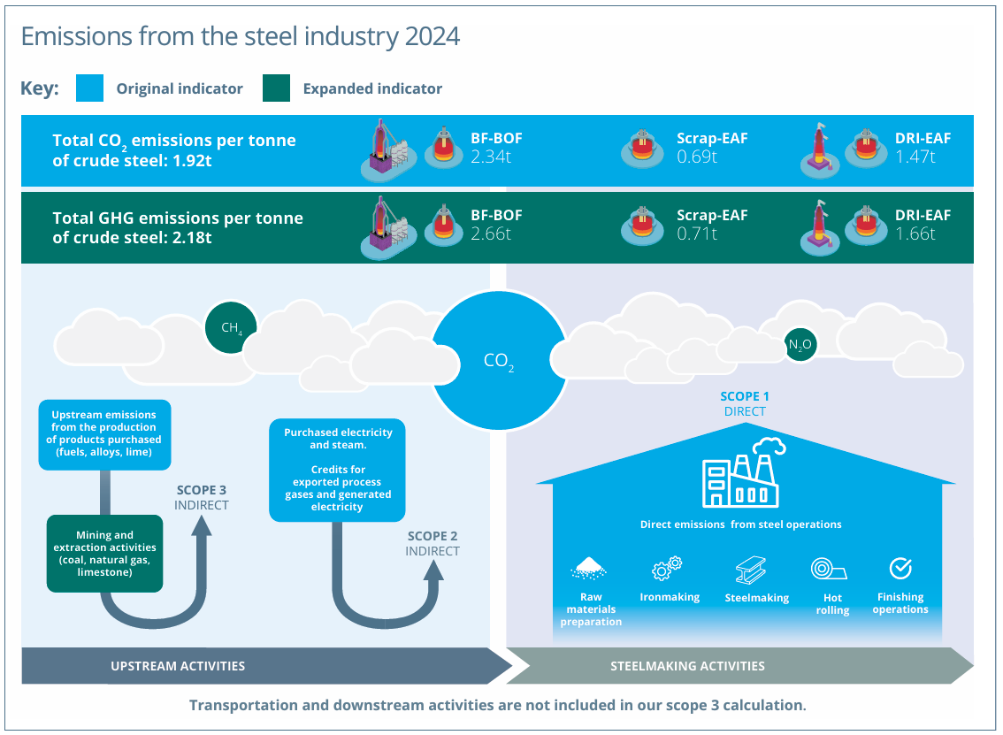Figure 1: Emissions from the steel industry 2024 (World Steel Association, 2025)
Against this background, BHP must market essential iron ore and copper without overstating progress in a technically uncertain transition. Therefore, this report critically evaluates the natural and political-regulatory actors shaping BHP’s lower-carbon offer through PESTLE, Porter’s Five Forces and SWOT analysis in Task 1. Building on these findings, Task 2 recommends an Ansoff product-development strategy supported by Porter’s broad differentiation strategy, customer co-innovation and verifiable product-level carbon data. Finally, Task 3 critically reflects on the use of generative artificial intelligence to structure the research, test arguments and improve presentation while maintaining human judgement, independent source verification, academic integrity and professional accountability.

Task 1 – Marketing Environment Analysis:
BHP is analysed as a business-to-business marketer whose proposition depends on reliable supply, technical quality, cost and legitimacy. External actors influence which products customers prefer, which environmental claims stakeholders trust and which projects receive permission to operate as Kotler et al. (2024) distinguish macroenvironmental forces from market actors, while Porter (1980) explains how industry structure shapes profitability. The following assessment prioritises the natural and political-regulatory environments, then synthesises their implications through PESTLE, Five Forces and SWOT (Kotler et al., 2024; Porter, 1980). In addition, environmental performance is treated as both a constraint and a potential differentiator, without assuming that sustainability automatically produces commodity price premiums (Busch et al., 2024; Verma and Diwan, 2025).

  - BHP’s Market Context and PESTLE Position:
BHP enters the transition from a position of scale, yet its portfolio creates conflicting marketing signals. In FY2025 it produced 2.02 million tonnes of copper, 28% above FY2022, alongside 257 million tonnes of attributable Western Australia Iron Ore output and revenue of US$51.3 billion (BHP, 2025a). Copper supports electrification, while iron ore supplies a steel sector with high downstream emissions. Additionally, BHP reported 8.7 million tonnes of operational Scope 1 and 2 emissions, 36% below its adjusted FY2020 baseline, but Scope 3 emissions remained 378.2 million tonnes (BHP, 2025a).
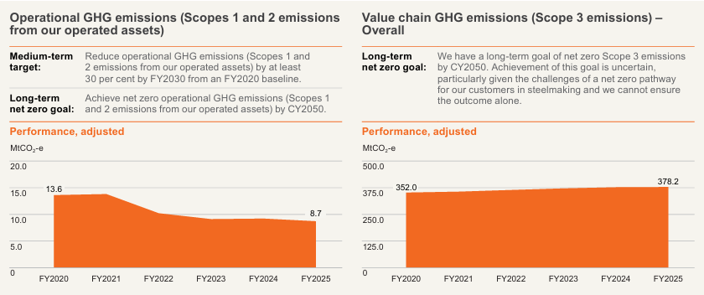Figure 2: Operational GHG emissions (Scopes 1 and 2 emissions from our operated assets) and Value chain GHG emissions (Scope 3 emissions) (BHP, 2025a)

Moreover, part of the reduction reflected the suspension of Western Australia Nickel rather than process redesign. Its FY2030 operational target is at least 30% below FY2020, although value-chain progress depends on customers and technologies beyond BHP’s control (BHP, 2024). PESTLE therefore reveals economic and technological opportunity alongside social, legal and environmental exposure. Thus, marketing must communicate measurable progress without equating transition-mineral exposure with decarbonisation because trust depends on clear evidence boundaries (Delmas and Burbano, 2011).

Table 1. PESTLE analysis of BHP’s lower-carbon marketing environment
PESTLE Factor | Current evidence | Marketing implication
Political | Australia’s Safeguard baselines generally decline by 4.9% annually to 2030. Government support is also helping advance NeoSmelt (DCCEEW, 2026; BHP, 2025c). | Policy shapes the economics and credibility of transition investments, while government relations should be integrated with customer-value planning (Kotler et al., 2024; Porter, 1985).
Economic | FY2025 revenue was US$51.3 billion and copper production reached 2.02 million tonnes. The IEA projects a possible 30% copper supply shortfall by 2035 (BHP, 2025a; IEA, 2025). | Copper growth is attractive, but capital allocation must reflect long lead times, commodity cycles and responsible-production expectations (Busch et al., 2024; Teece, 2007).
Social | Communities, investors and industrial customers increasingly expect credible environmental evidence and fair local outcomes (Kotler et al., 2024). | Trust depends on site-level transparency, meaningful stakeholder engagement and claims that distinguish targets from achieved outcomes (Delmas and Burbano, 2011; Zervoudi, Moschos and Christopoulos, 2025)..
Technological | China Baowu’s commercial-scale direct-reduction trial and NeoSmelt test pathways that could use Pilbara ores in lower-emissions steelmaking (BHP, 2025b; BHP, 2025c). | BHP should market its co-development capability rather than claim that one guaranteed technological solution exists.
Legal | Australian climate reporting began in 2025 and EU CBAM entered its definitive phase in 2026 (Australian Treasury, 2026; European Commission, 2026). | Auditable product information and consistent lifecycle boundaries are becoming market-access capabilities (Zhang and Seuring, 2024).
Environmental | Operational emissions were 8.7 MtCO2-e, Scope 3 emissions were 378.2 MtCO2-e, freshwater withdrawal was 162,740 megalitres and nearly 7.9 million hectares were managed (BHP, 2025a). | Carbon, water, biodiversity and resilience must be managed together because a narrow emissions claim can obscure material nature impacts (IPCC, 2023).

Natural Environment Actor and Physical Risk:
The natural environment is BHP’s most consequential external actor because climate, water and biodiversity conditions alter continuity, community acceptance and customer perceptions. BHP withdrew 162,740 megalitres of freshwater in FY2025, 46% more than FY2024, although the increase largely reflected rainfall and runoff management at BMA, while 31,830 megalitres came from water-stressed areas (BHP, 2025a). In addition, it managed almost 7.9 million hectares, with about 149,700 hectares disturbed and 23,800 rehabilitated (BHP, 2025a). Aggregate improvement can therefore conceal site-level scarcity or ecological damage.
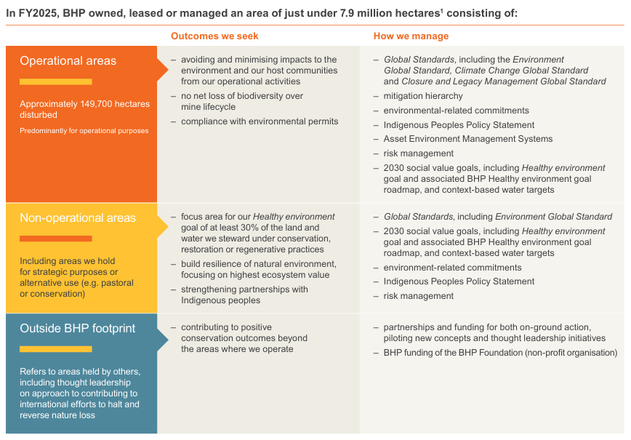Figure 3: In FY2025, BHP owned, leased or managed an area of just under 7.9 million hectares (BHP, 2025a)
Moreover, heat, floods, cyclones and sea-level rise can disrupt mines, ports and rail systems, while the IPCC (2023) expects hazards to escalate under higher warming pathways. Furthermore, environmental resilience consequently becomes part of supply assurance (IPCC, 2023). But various claims should include absolute emissions, water context, land disturbance and restoration, and not just a carbon metric (Delmas and Burbano, 2011). Meanwhile, Hart (1995) offers an alternative natural resource-based perspective that pollution prevention and stewardship can create capabilities, but polluter value comes when practices are measurable at the site and aligned with customer outcomes.

Political-Regulatory Actor and Market Access:
The political-regulatory environment changes the expectations for the environment into costs, into disclosure requirements and conditions for market-access. The Safeguard Mechanism for Australia currently brings down the covered-facility baselines by 4.9% each year until 2030, keeping net emissions within facility limits (DCCEEW, 2026). Similarly, mandatory climate-related financial reporting started on 1 January 2025 and will roll out gradually, adding more pressure to transition plans, to understand scope exposures and assumptions (Australian Treasury, 2026). The EU’s Carbon Border Adjustment Mechanism (CBAM) has been in a decisive phase since 1 January 2026, impacting on carbon-intensive imports, such as iron and steel (European Commission, 2026). In addition, the primary product being covered is not raw iron ore itself, but BHP is indirectly impacted by them because its steel customers require lower sources of embedded emissions and information that was auditable throughout their supplier chain. The regulation thus increases the demand for product level carbon data and produces compliance friction due to the lack of consistency with methods. In addition, government support for NeoSmelt demonstrates that policy can help fast-track the demonstration. Thus, BHP must view regulators as market-shaping actors, as changes in regulators' policy affect the purchasing criteria, and as a means of rewarding verified innovation, resulting in higher risks for unsupported claims.

Competitive and Strategic Synthesis:
Porter’s Five Forces indicates that the transition raises rivalry and buyer power rather than automatically improving margins (Porter, 1980).
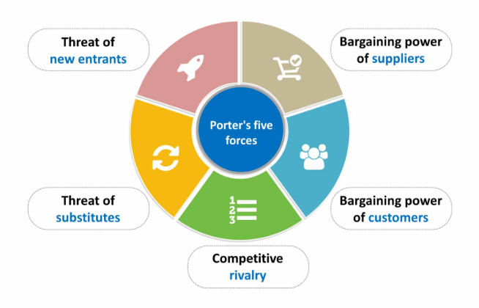Figure 4: Porter Five Forces Analysis (Porter, 1980)

BHP in particular has a high level of competition as Vale has the capability to supply green briquettes which are up to 10% lower in emissions, while Fortescue is developing the green iron production ramp up (Vale, 2024; Fortescue, 2024). Furthermore, large steelmakers have a lot of buying power as they can mix ores, examine lifecycle information and jointly conduct trials (Porter, 1980). Likewise, supplier power is still somewhat limited when renewable electricity, hydrogen, specialized equipment, and assurance knowledge are limited (Porter, 1980). In addition, the substitution pressure is medium, because of an increasing use of alternate feeds to electric arc furnaces, with material efficiency, that cuts down the normal primary iron demand (Porter, 1980). Finally, the barriers to entry in mining are not negligible due to the capital needed, geology, and approvals, yet technology companies have the ability to help create value without owning mines (Porter, 1980).

Table 2. Porter’s Five Forces Analysis
Force | Assessment and evidence | Strategic meaning
Competitive rivalry | High. Vale’s green briquette and Fortescue’s green iron programme increase innovation-based rivalry (Vale, 2024; Fortescue, 2024). | BHP must differentiate through verified performance, scale and customer-trial knowledge (Porter, 1980; Porter, 1985).
Buyer power | High. Major steelmakers can blend ores, compare suppliers and demand data or collaborative trials (Porter, 1980). | Value must be demonstrated through lower transition risk, technical fit and dependable volume (Porter, 1985).
Supplier power | Moderate. Renewable power, hydrogen, specialist equipment, assurance and digital expertise may be constrained (Porter, 1980). | Partnerships and long-term procurement can reduce bottlenecks (Adner, 2017).
Threat of substitutes | Moderate. Scrap-based electric arc furnace production, material efficiency and alternative feedstocks can reduce primary iron demand (Porter, 1980). | BHP should support ore compatibility with several pathways and grow copper exposure (BHP, 2025a; BHP, 2025b).
Threat of new entrants | Low in mining because capital, geology, infrastructure and approvals are substantial, but technology entrants can capture value (Porter, 1980). | BHP should build ecosystem partnerships and retain control of customer data and product qualification (Adner, 2017; Zhang and Seuring, 2024).

The SWOT is mixed, however, as BHP has scale and low-cost assets, has a history of customer relationships, and is seeing copper production growth, it is also exposed to high Scope 3 exposure and ore quality constraints (BHP, 2025a). Furthermore, opportunities lie in verified feedstocks and transition minerals, whereas threats include rival innovation, climate disruption, carbon rules and greenwashing scepticism (IEA, 2025; IPCC, 2023; Zervoudi, Moschos and Christopoulos, 2025).

Table 3. SWOT analysis of BHP’s transition position
Category | Critical factors
Strengths | Large-scale, low-cost operations, integrated logistics, 2.02 million tonnes of copper output, established steelmaker relationships, a strong balance sheet and commercial-scale trial experience (BHP, 2025a; BHP, 2025b).
Weaknesses | Scope 3 emissions of 378.2 MtCO2-e, exposure to conventional steelmaking, ore-quality constraints for some direct-reduction routes, long investment cycles and reported operational reductions partly influenced by asset suspension (BHP, 2025a; BHP, 2024).
Opportunities | A potential 2035 copper supply gap, lower-carbon feedstocks, digital product records, customer co-innovation, assured lifecycle data and nature-positive operating practices (IEA, 2025; BHP, 2025b; Zhang and Seuring, 2024).
Threats | Physical climate hazards, water and biodiversity conflict, tightening carbon rules, strong buyer power, rival products, technology uncertainty and greenwashing scepticism (IPCC, 2023; DCCEEW, 2026; Zervoudi, Moschos and Christopoulos, 2025).

Task 2 – Strategic Growth and Competitive Positioning:
The environmental analysis provides a firm basis for a targeted growth policy and not for a policy of unselective diversification. Ansoff (1957) matrix is used to differentiate between market penetration, market development, product development and diversification through novelty of product and market. BHP's most promising strategy for managing risk is product development for its existing steel and industrial customers, with target market diversification limited to jurisdictions where carbon policy and green procurement are moving forward. In addition, the Porter’s (1985) framework then indicates broad differentiation built on verified environmental performance, technical collaboration and dependable scale. This approach preserves commodity cost discipline while creating additional customer value through reduced transition risk, stronger data and compatibility with emerging production technologies.

Ansoff Product Development Strategy:
Product development should centre on a BHP Verified Low-Carbon Materials proposition rather than a vague green label, thereby applying a product-development approach to strengthen the value offered to existing customers (Ansoff, 1957; Verma and Diwan, 2025). Accordingly, the offer would combine qualified Pilbara ore blends for direct reduced iron and electric smelting routes, lower-emissions logistics, assured product-emissions data and technical support for customers changing furnaces (BHP, 2025b; Zhang and Seuring, 2024).
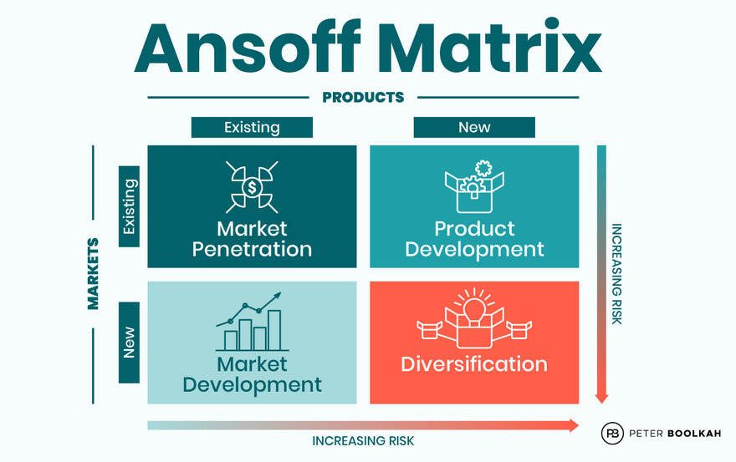Figure 5: The Ansoff Growth Matrix Framework (Ansoff, 1957)
Moreover, this approach builds on demonstrated learning because, in 2024, China Baowu completed a commercial-scale trial using pelletised BHP Pilbara fines in a one-million-tonne-per-year hydrogen-based direct-reduction shaft furnace, with 70% hydrogen in the reducing gas (BHP, 2025b). Similarly, NeoSmelt is developing a 30,000 to 40,000 tonne annual pilot to test Pilbara ores through direct reduction and electric smelting, with commissioning targeted for the second half of 2028, subject to approvals (BHP, 2025c). Consequently, these initiatives should become a repeatable product-development platform with defined specifications, lifecycle boundaries and qualification stages. Nevertheless, Ansoff risk remains substantial because the technological pathways are unsettled and, therefore, BHP should use staged investment and customer commitments before scaling rather than assume that one route will dominate (Ansoff, 1957; Nurdiawati et al., 2025).

Table 4. Ansoff Matrix options for BHP
Growth option | Application | Evaluation
Market penetration | Increase sales of existing iron ore and copper to established customers (BHP, 2025a). | Lower strategic novelty, but limited differentiation and possible conflict with emissions constraints (Ansoff, 1957; BHP, 2025a).
Market development | Target carbon-regulated steel markets and electrification supply chains with existing products and stronger data (European Commission, 2026; IEA, 2025). | A useful supporting route where customers value traceability, but market access alone does not resolve product compatibility (Zhang and Seuring, 2024; BHP, 2025b).
Product development | Develop qualified lower-carbon ore blends, assured product-carbon records, technical services and lower-emissions logistics for existing customers (BHP, 2025b; BHP, 2025c). | Recommended as the primary route because it converts trial learning and relationships into customer value while controlling diversification risk (BHP, 2025b; BHP, 2025c; Nurdiawati et al., 2025).
Diversification | Move substantially downstream into green iron or steel production (Ansoff, 1957). | Potentially transformative, but capital intensive, outside BHP’s strongest capabilities and exposed to technological and execution uncertainty (Nurdiawati et al., 2025).

Selective Market Development:
The selective market development should target steel customers and regions where regulation, renewable energy and green procurement create value for transition attributes (European Commission, 2026). Hence, BHP should target steel plants in the EU, Japan, South Korea and China that experiment with direct reduction, electric smelting, carbon capture and hydrogen technologies, with a few exceptions as ore and infrastructure demands vary (BHP, 2025b). For this reason, BHP should categorize customers on a pathway basis, by carbon-cost enablement etc., and then bundle different solutions, and not the one standard solution. Furthermore, this is also true in the case of copper, like in other applications, electrification brings growth without, however, being criticized. However, due to lower quality, higher costs, and fewer discoveries, the IEA (2025) expects that copper mine supply may become about 30% below the level needed in 2035. This means that BHP's copper production aligns with projects that aim to establish a pathway into the grid, renewable and digital infrastructure supply chains, provided that these secure impacts with respect to water, nature and community performance (BHP, 2025a). Finally, the emphasis should be on collaboration as it minimizes uncertainty and enhances demand visibility.

Porter’s Broad Differentiation Strategy:
For BHP's lower carbon offering, broad differentiation has more defensibility than cost leadership, as per Porter's Generic Strategies (Porter 1985). However, buyers remain price sensitive, so BHP cannot rely on a green premium. Rather, differentiation should reduce the costs for customers to move to different types of products by providing volumes, ore-blending, verified emissions data, regulatory readiness and regulatory learning (Verma and Diwan, 2025). Moreover, Barney (1991) argues sustained advantage depends on valuable, rare and difficult-to-imitate resources, while Khanra et al. (2022) view green innovation as strategic. BHP has a scale that is repeatable, but a combination that is harder to copy, with geological knowledge, integrated logistics, steelmaker relationships and trial data and assurance systems. As a result, BHP must be attentive to evidence-motivated changes to their routes, partnerships and product configurations, as outlined by Teece (2007) through his dynamic capabilities theory. Hence, BHP's exact, conditional brand promise should include a string of verifications against known baselines, and spell out their dependence on Scope 3, while concurrently preventing the impression that their copper sales or pilots define their low carbon portfolio.

Table 5. Porter’s Generic Strategies and recommended positioning
Generic strategy | Suitability for BHP | Decision
Cost leadership | BHP’s low-cost assets remain essential, but cost alone will not address customers’ carbon exposure or trust (BHP, 2025a). | Retain as the operational foundation rather than the sole lower-carbon positioning (Porter, 1985; Busch et al., 2024).
Broad differentiation | Verified emissions data, technical co-development, reliable scale and transition-compatible products can reduce customer risk (BHP, 2025b; Zhang and Seuring, 2024). | Recommended. Differentiate broadly while preserving commodity-cost discipline (Verma and Diwan, 2025).
Focus strategy | A narrow focus on a small green-steel niche could create learning but restrict scale and expose BHP to one pathway (BHP, 2025c; Teece, 2007). | Use targeted pilots within a broader differentiated portfolio rather than as the corporate strategy (Ansoff, 1957; Porter, 1985).

Implementation, Metrics and Risk Control:
The roadmap for implementation is to be within 2026-2030 with a stage gate system which will hold accountable the marketing, technology, operations and sustainability teams. First, BHP should establish lifecycle rules and assured digital product records for iron ore and copper products (Zhang and Seuring, 2024). Second, broaden customer trials on range of ore blends and furnace configurations, with the addition of artificial intelligence for ore-body modelling, optimisation of ore blends, predictive furnace maintenance and validation (UNESCO, 2023). Third, contracts should tie volume commitments and emission and performance targets. Fourth, communications should reveal successes and failures of trials, absolute operational emissions, assumptions of water-stress exposure and of biodiversity outcomes, and customer-use assumptions (BHP, 2025a). Thus, indicators should include tonnes sold with validated carbon data, emissions intensity of products, blends to direct reduction, customer development agreements, progress for Scope 1 and 2 emissions, and hectares of restored land and stressed areas of water withdrawals. Furthermore, concepts of location-specific evaluation and AI help foster transparency and oversight (TNFD, 2023; UNESCO, 2023). Lastly, governance should contain a claim approval process, independent assurance and an executive incentive, matching marketing evidence with operations.

Table 6. Proposed 2026–2030 implementation roadmap
Period | Priority action | Key performance indicator | Principal risk control
2026 | Set common lifecycle boundaries and create assured digital product records for priority iron ore and copper (Zhang and Seuring, 2024). | Share of priority products with independently assured carbon data (Australian Treasury, 2026). | External assurance and formal marketing-claim approval (Australian Treasury, 2026).
2026–2027 | Segment steel customers by technology pathway, regulation, furnace cycle and data needs (Kotler et al., 2024). | Number of jointly agreed transition roadmaps and multi-year development agreements (Kotler et al., 2024). | Avoid one-size-fits-all claims and document customer assumptions (Busch et al., 2024).
2027–2028 | Expand direct-reduction and electric-smelting trials across ore blends and operating conditions (BHP, 2025b; BHP, 2025c). | Qualified blends, trial yield, product quality and measured emissions improvement (BHP, 2025b; Nurdiawati et al., 2025). | Stage gates, technical peer review and publication of material limitations (Nurdiawati et al., 2025).
2028–2029 | Launch verified commercial bundles combining material, data, logistics and technical support (Verma and Diwan, 2025). | Tonnes sold with verified attributes, retention rate and customer compliance-cost reduction (Verma and Diwan, 2025). | No guaranteed-premium assumption and contract value linked to evidenced benefits (Busch et al., 2024).
2029–2030 | Scale successful offers and integrate water, nature and operational-carbon metrics (BHP, 2025a). | Scope 1 and 2 progress, stressed-area water withdrawal, restored hectares and revenue from verified offers (BHP, 2025a). | TNFD-aligned location analysis, board oversight and executive accountability (TNFD, 2023).

Task 3: Critical Reflection on AI Usage:

Tool Disclosure and Contribution Boundary:
I have utilized ChatGPT as a generative AI assistant for planning and drafting. Also, I have provided a formal acknowledgment of the use of generative AI with this submission. I asked it to provide me with report structures, search terms, connect to PESTLE, Five Forces, SWOT, Ansoff and Porter and areas where there is the need for up-to-date evidence. I also used it to try out the coherence of paragraphs and also to minimize repetition. I didn't rely on its output as a source of information though. I selected BHP, decided that the natural and political-regulatory environments were the principal actors, chose product development and broad differentiation, and determined the final argument. This boundary is important in order to preserve what generative AI can do to improve efficiency without undermining learning, and to inhibit the use of generative AI as a disguised author or a surrogate for judgement (Bittle and El-Gayar, 2025). My role was, therefore, to evaluate the evidence, reconcile the conflicting indicators and make the strategic recommendation.

Verification, Hallucinations and Corrections:
I verified every material AI-assisted claim through source triangulation rather than accepting fluent wording as proof. Operational data was verified against the BHP FY2025 Annual Report as well as against dated partnership announcements, market forecasts against the IEA and regulatory statements against the Australian Government and the European Commission sources. I made comparisons of units, reporting periods, organisational boundaries and definitions. This revealed significant possibilities for possible hallucination. For example, an initial summary could have indicated a 36% “structural” operational emissions reduction, whereas the annual report gives the attributed share to asset suspension. Another draft suggested that CBAM would directly price raw iron ore, and I revised the analysis to only consider its indirect impact through iron and steel customers. Also, I have denied assurances based on green premiums—evidence wasn't strong enough. UNESCO (2023) suggests a more human presence with clear and transparent assessment of generative AI, which my verification log did by noting every claim or evidence and any corrections or final usage steps.

Ethical and Professional Reflection:
Ethically, I believe AI enhanced speed and our test of relation between proof of the environment and marketing, but with its additions of bias, falsified specificity, weak provenance and over-confidence. These risks are very real when it comes to sustainability accounting, as slick marketing can embellish greenwashing. Delmas and Burbano (2011) have demonstrated how organisational, market and regulatory influences can foster misleading communication and Zervoudi, Moschos and Christopoulos (2025) highlight the harm to trust. I thus resolved to make transparency a work ethic. I also disclosed the tool, which I did not enter into any confidential information, without losing my judgment and expectation in selecting sources, and, further, that recommendation was based on evidence not rhetorical style. Further, I rewrite the analysis writing in my own academic style and retained the uncertainty where technologies or forecasts were not settled. Overall, my main learning is that responsible AI use is not demonstrated by merely naming the tool. It demands evidence that can be traced back to a source, careful editing, effective demarcation of authors and eagerness to cut desirable and defensible statements.

Conclusion:
In conclusion, this report critically finds that BHP’s lower-carbon transition is shaped most powerfully by the natural environment and a demanding political-regulatory environment. Environmental credibility is a precondition to supply assurance and stakeholder legitimacy (DCCEEW, 2026; European Commission, 2026) as climate hazards, water stress and biodiversity impacts become increasingly pressuring, whilst the European Union's CBAM and climate disclosure, and Australia's Safeguard Mechanism are changing the expectations of customers. In addition, the PESTLE, Five Forces and SWOT analysis also indicate that lack of rivalry and buyer power also check easy green premiums. Thus, the recommended growth approach is Ansoff product development with some market development and some broad differentiation by Porterian approach. More specifically, BHP would need to leverage qualified lower carbon ore solutions, copper growth, customer co-innovation and independently vetted product information, rather than blanket sustainability claims. Finally, responsible AI proved helpful in providing structure and challenge, but ultimately verification of sources and responsible human judgment had to be determinative to the integrity of the report.

References:
Adner, R. (2017). Ecosystem as structure: An actionable construct for strategy. Journal of Management, 43(1), pp. 39–58. doi: https://doi.org/10.1177/0149206316678451.
Ansoff, H.I. (1957). Strategies for diversification. Harvard Business Review, 35(5), pp. 113–124.
Australian Treasury (2026). Climate-related financial reporting and guidance. [online] Australian Government. Available at: https://treasury.gov.au/policy-topics/banking-and-finance/sustainable-finance/climate-financial-reporting-guidance.
Barney, J. (1991). Firm resources and sustained competitive advantage. Journal of Management, 17(1), pp. 99–120. doi: https://doi.org/10.1177/014920639101700108.
BHP (2024). Climate Transition Action Plan 2024. [online] BHP. Available at: https://www.bhp.com/-/media/documents/investors/annual-reports/2024/240827_bhpclimatetransitionactionplan2024.pdf.
BHP (2025a). Annual Report 2025. [online] BHP. Available at: https://www.bhp.com/-/media/documents/investors/annual-reports/2025/250819_bhpannualreport2025.pdf.
BHP (2025b). BHP and China Baowu celebrated successful commercial-scale DRI trials using BHP’s Pilbara iron ores. [online] BHP. Available at: https://www.bhp.com/news/articles/2025/05/bhp-and-china-baowu-celebrated-successful-commercial-scale-dri-trials-using-bhps-pilbara-iron-ores.
BHP (2025c). NeoSmelt welcomes Federal Government support and signs two new participants. [online] BHP. Available at: https://www.bhp.com/news/media-centre/releases/2025/06/neosmelt-welcomes-federal-government-support-and-signs-two-new-participants.
Bittle, K. and El-Gayar, O. (2025). Generative AI and academic integrity in higher education: A systematic review and research agenda. Information, 16(4), 296. doi: https://doi.org/10.3390/info16040296.
Busch, T., Barnett, M.L., Burritt, R.L., Cashore, B.W., Freeman, R.E., Henriques, I., Husted, B.W., Panwar, R., Pinkse, J., Schaltegger, S. and York, J. (2024). Moving beyond ‘the’ business case: How to make corporate sustainability work. Business Strategy and the Environment, 33(2), pp. 776–787. doi: https://doi.org/10.1002/bse.3514.
Delmas, M.A. and Burbano, V.C. (2011). The drivers of greenwashing. California Management Review, 54(1), pp. 64–87. doi: https://doi.org/10.1525/cmr.2011.54.1.64.
Department of Climate Change, Energy, the Environment and Water [DCCEEW] (2026). Safeguard Mechanism. [online] Australian Government. Available at: https://www.dcceew.gov.au/climate-change/emissions-reporting/national-greenhouse-energy-reporting-scheme/safeguard-mechanism.
European Commission (2026). CBAM successfully entered into force on 1 January 2026. [online] European Commission. Available at: https://taxation-customs.ec.europa.eu/news/cbam-successfully-entered-force-1-january-2026-2026-01-14_en.
Fortescue (2024). Fortescue starts works on Green Metal Project. [online] Fortescue. Available at: https://www.fortescue.com/articles/fortescue-starts-works-on-green-metal-project.
Hart, S.L. (1995). A natural-resource-based view of the firm. Academy of Management Review, 20(4), pp. 986–1014. doi: https://doi.org/10.5465/amr.1995.9512280033.
International Energy Agency [IEA] (2025). Global Critical Minerals Outlook 2025. [online] IEA. Available at: https://www.iea.org/reports/global-critical-minerals-outlook-2025.
Intergovernmental Panel on Climate Change [IPCC] (2023). Climate Change 2023: Synthesis Report. [online] IPCC. Available at: https://www.ipcc.ch/report/ar6/syr/. doi: https://doi.org/10.59327/IPCC/AR6-9789291691647.
Khanra, S., Kaur, P., Joseph, R.P., Malik, A. and Dhir, A. (2022). A resource-based view of green innovation as a strategic firm resource: Present status and future directions. Business Strategy and the Environment, 31(4), pp. 1395–1413. doi: https://doi.org/10.1002/bse.2961.
Kotler, P., Armstrong, G., Harris, L.C. and He, H. (2024). Principles of marketing. 19th edn. Harlow: Pearson.
Nurdiawati, A., Tahir, F., Zaini, I.N. and Al-Ghamdi, S.G. (2025). Prospective environmental and economic assessment of green steel production in the Middle East. Resources, Conservation and Recycling, 219, 108277. doi: https://doi.org/10.1016/j.resconrec.2025.108277.
Porter, M.E. (1980). Competitive strategy: Techniques for analyzing industries and competitors. New York: Free Press.
Porter, M.E. (1985). Competitive advantage: Creating and sustaining superior performance. New York: Free Press.
Taskforce on Nature-related Financial Disclosures [TNFD] (2023). Recommendations of the Taskforce on Nature-related Financial Disclosures. [online] TNFD. Available at: https://tnfd.global/wp-content/uploads/2023/08/Recommendations_of_the_Taskforce_on_Nature-related_Financial_Disclosures_September_2023.pdf.
Teece, D.J. (2007). Explicating dynamic capabilities: The nature and micro foundations of sustainable enterprise performance. Strategic Management Journal, 28(13), pp. 1319–1350. doi: https://doi.org/10.1002/smj.640.
United Nations Educational, Scientific and Cultural Organization [UNESCO] (2023). Guidance for generative AI in education and research. [online] UNESCO. Available at: https://www.unesco.org/en/articles/guidance-generative-ai-education-and-research.
Vale (2024). Integrated Report 2024. [online] Vale. Available at: https://vale.com/documents/44618/430705/Integrated%2BReport%2BVale%2B2024.pdf.
Verma, S. and Diwan, H. (2025). Marketing innovation for sustainability: Review, trends, and way forward. Business Ethics, the Environment & Responsibility, 34(3), pp. 912–935. doi: https://doi.org/10.1111/beer.12686
World Steel Association (2025). Climate change and the production of iron and steel. [online] World Steel Association. Available at: https://worldsteel.org/climate-action/climate-change-and-the-production-of-iron-and-steel/.
Zervoudi, E.K., Moschos, N. and Christopoulos, A.G. (2025). From the corporate social responsibility and environmental, social and governance criteria to the greenwashing phenomenon: A comprehensive literature review about the causes, consequences and solutions of the phenomenon with specific case studies. Sustainability, 17(5), 2222. doi: https://doi.org/10.3390/su17052222.
Zhang, A. and Seuring, S. (2024). Digital product passport for sustainable and circular supply chain management: A structured review of use cases. International Journal of Logistics Research and Applications, 27(12), pp. 2513–2540. doi: https://doi.org/10.1080/13675567.2024.2374256.

AI Use Acknowledgement:
I acknowledge using ChatGPT to support initial structuring, search-term generation, framework comparison, wording review and coherence checking. All statistics, claims and references were independently checked against the original sources. The selection of BHP, critical evaluation, strategic recommendations, reflection and final wording remain my responsibility. No confidential or personal data were entered.

