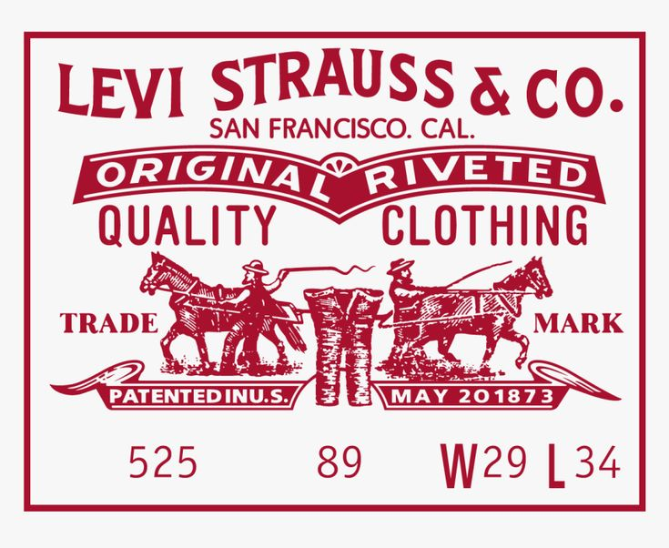

Student name: Sagar Rajodiya

Student ID: 2241171

Program: MBA- Masters of Business Administration

Module: Marketing Management

Module code: LCMB7001

Lecturer name: Tushara Balendran

Assignment: 2

Date: 1st September 2023

Contents

- Introduction 3
- PESTLE analysis of Levi’s 3
- Porters 5 forces model 6
- SWOT analysis of Levi’s 9
  - Advantages and disadvantages of SWOT analysis 12
- Segmentation, targeting, and positioning 13
  - Segmentation 13
  - Targeting 15
  - Positioning 15
- Marketing mix 4Ps 16
  - Product 16
  - Price 17
  - Place 18
  - Promotion 18
- Recommendation of future strategies 19
- Conclusion 20

- Introduction:-
This assignment includes a PESTLE analysis of Levi’s brand, porters 5 forces model, SWOT analysis, advantages and disadvantages of SWOT analysis, Segmentation targeting and positioning of Levi’s, marketing mix 4Ps of Levi’s, and the mention of new marketing strategies for Levi’s that should adopt in the near future for success.
- PESTLE analysis of Levi’s
A pestle analysis shows the company in a very micro way and its stand for Political, Economic, Social, Technological, and Legal, and Environmental factors.
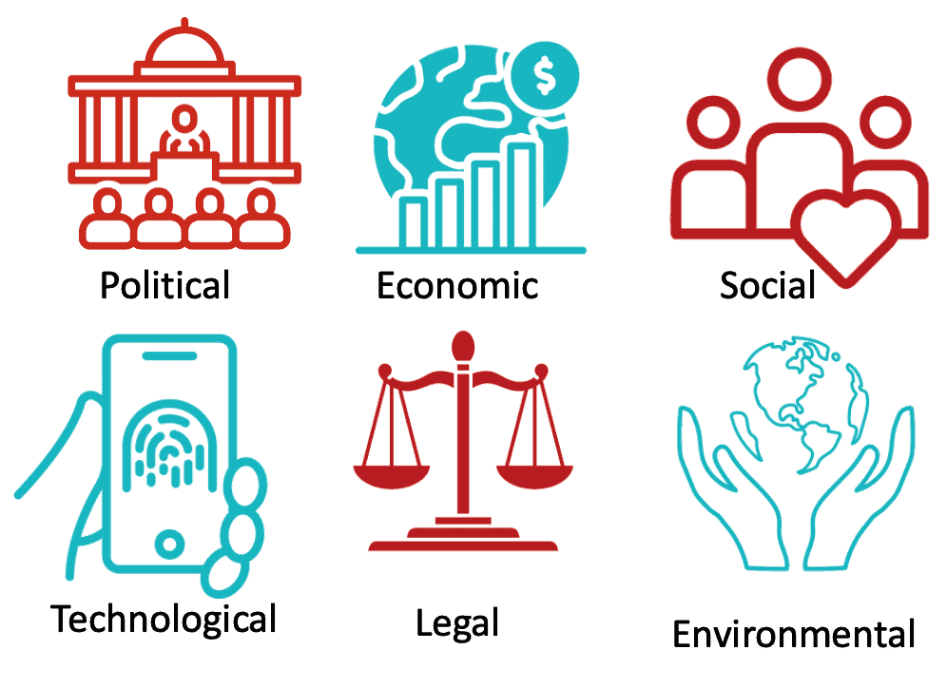
[Source: https://businessanalystmentor.com/pestle-analysis/]

- Political Factor

- Attacks by Terrorists are a Risk
We think that within the post-9/11 environment, businesses like Levi Strauss must learn to live with the plausibility of a psychological militant ambush. Taking up protections and other supporting measures to reduce the harms brought on by fear-monger assaults is the coherent course of activity. (Unfavorable)
- Trade Agreements & Other Treaties
The country features a strong track record of upholding its agreements with a few remote accomplices. There's steadiness within the run the show of law and directions since the governments of each party have tolerated by the understandings made by prior organizations. (Favourable)

- Economic Factor

- Inflation rate
The request for Levi Strauss products may be affected by the swelling rate. Levi Strauss may ought to raise costs more regularly to keep up with swelling on the off chance that expansion rates rise, which might result in lower levels of brand devotion and ongoing cost-control endeavors. Cost-based estimating may not be the finest course of activity in a few circumstances. (Unfavorable)
- Gini Index ranking
The Gini Record and the degree of imbalance are amazing pointers to a society's peace and advancement. Struggle and wrongdoing are more likely to happen in social orders where there are extraordinarily rich differences. Both briefly and forever, it may result in vulnerability and a decrease in utilization. (Favorable and unfavorable)

- social factor

- The nature of the social contract between society and government
Levi Strauss must comprehend the nature of the social compact between society and the government sometime recently entering a showcase. For occurrence, since the UK wellbeing framework is nationalized and everything is administered by contracts at the national level, it has been exceedingly troublesome for US organizations to connect the UK wellbeing segment. (Favorable)
- Demographic trend
One of the foremost imperative factors in foreseeing request for an economy is the statistic drift. For occurrence, as the populace of the USA and EU ages, there will be more prominent request for merchandise focused on fundamentally at this advertise. Some time recently making unused items, Levi Strauss should take statistic patterns into consideration and join characteristics that target this advertise. Less mechanically progressed things will be essential as the populace ages. (Unfavorable)

- Technological factor

- The incorporation of technology into societal and commercial processes
Uber looked for to enter China some time recently smartphones were broadly utilized there, which is why it fizzled. The commerce demonstrate of Levi Strauss ought to be coordinates with society's standards, framework, and other components. (Unfavourable)

- Mobile payments and fintech services are accepted.
Versatile installments are one of the areas in which the US slacks behind China. Evaluating the foremost popular mobile installment choices within the nearby economy can offer assistance to Levi Strauss in deciding its commerce arrangement. (Favorable)
- Legal Factor

- Length of Court Procedures
Indeed in case a country has the finest laws, they won't cruel anything in case they can't be connected expeditiously. Given the potential legitimate issues Levi Strauss may experience, the company ought to do an in-depth investigation to decide how long it regularly takes to resolve a case within the country. (Favourable and unfavorable)
- Laws governing employment
What are the country's business controls, and are they consistent with the Levi Strauss commerce show? For occasion, Uber's business framework does not follow to French law and is having issues there. (Favorable and unfavorable)

- Environmental factor

- Environmental agencies' influence and effectiveness
In arrange to secure benchmarks, natural measures authorization organizations play a vital part. In any case, these organizations habitually utilize strategy slowing down as a bribery request strategy in creating countries. Levi Strauss has to be mindful that such practices exist in a given country. (Unfavorable)
- The effects of climate change
How the supply chain and commerce demonstrate of Levi Strauss will be influenced by climate alter. For occasion, on the off chance that the supply chain is inflexible, it may deliver bottlenecks in case supplies from one locale of the world are postponed due to an unexpected alter within the climate. (Unfavorable)
https://embapro.com/frontpage/pestelcase/11093-levi-strauss,

- Porters 5 forces model

The concept itself was put out by Michael Porter in 1980 in his well-known book, "Competitive Strategy." It contends that there are five factors at play in each given market, and your ability to compete in that market depends on how strong these forces are. It is seen as a universal paradigm that can be used by both small-town greengrocers and global corporations like Microsoft.
https://www.interaction-design.org/literature/article/porter-s-5-forces-model-design-in-context-understand-the-market?psafe_param=1&gclid=Cj0KCQjwuNemBhCBARIsADp74QTvsc72bzYKBEpJ1qZ8hBDHXIJd4NHAqVg5MMi9Vk-ltQPmc3KrJ1YaAjBJEALw_wcB,

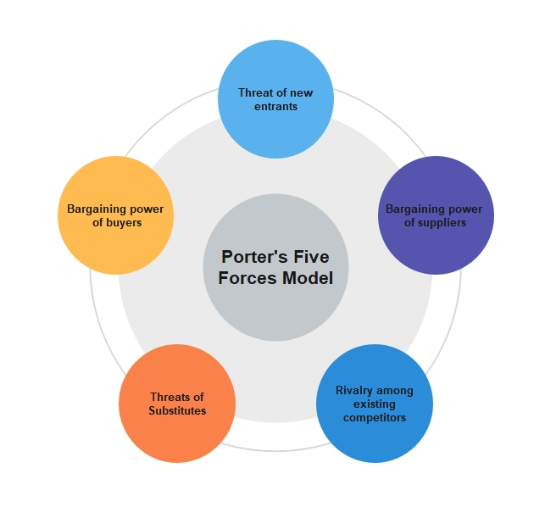
[Source: https://www.edrawmind.com/article/porters-five-forces-analysis-definition-and-examples.html]

There are 5 components included in porters 5 Forces model.
- Threat of New Entrants

Threat of Substitutes

Bargaining Power of Customers

Bargaining Power of Suppliers

Competitive Rivalry

- Threat of New Entrants

American firm Levi Strauss is an ace in denim pants. Moreover, they donate shoes, coats, eyewear, shirts, and more. Their yearly compensation outperforms $5 billion USD. The exhibit will persistently be troublesome for unused members since of set-up competitors like Levi Strauss. These businesses can at any time advantage from economies of scale that cutting-edge businesses are unfit for planning. Setting up the era workplaces and impelling the commerce requires a noteworthy cash wander. The potential section of unused competitors, able to disturb the advertise, is conceivable and can be seen as solid weight in the denim industry so the danger of modern participants is high.

Threat of Substitutes

Dress are one illustration of a Levi Strauss item that cannot be substituted. In this manner, the danger postured by modern choices may be nearly totally reduced. The showcase offers a wide assortment of clothing and adornments. Whereas there are numerous competitors with things within the lower-income divisions that donate not too bad quality, it nourishes the premium area of the showcase. Hence, by taking absent individuals who are price-conscious and endeavor to secure cheap things, these items constitute a threat to Levi's. There are a ton of brands with for all intents and purposes indistinguishable item portfolios that are essentially estimated. Levi Strauss faces noteworthy concerns from these substitute things since the industry's item contrast is so awesome. Nowadays customers use trousers and leggings, considered substitute products so the threat of substitutes is medium.

Bargaining Power of Customers

Inside the clothing industry, there are a portion of suppliers as well as a portion of clients. Clients have a allocate of choices since clothing and additional items are an unavoidable parcel of life. Dress are available at all taken a toll centers. Clients have a little bit of wheeling and dealing control. Brands like Levi's are inside the premium parcel and are not affected by client bargains. They have the brand esteem that steadfast clients persistently see. In any case, many price-sensitive clients might go for the cheapest thing regardless which brand it is. This increments the customers' bargaining control. Companies contribute a portion of cash in their advancement which may affect the behavior of their clients. Thus, clients can diminish their haggling control through key exhibiting strategies. For the foremost portion, clients are not outstandingly incredible at in turn around integration. As there are no such tremendous choices or recognized brands in comparison to Levi's buyers have less bartering control in this circumstance.

Bargaining Power of Suppliers

There are a few suppliers within the showcase who serve companies like Levi's. These merchants frequently offer the crude fixings required to deliver clothing. The merchandise need standardization and separation. The greatly unstable nature of the design division diminishes suppliers' haggling use. Also, all providers will need to be associated with brands like Levi's since they have positive notorieties. This reduces the suppliers' capacity to arrange. Due to the brands' advantage within the talks, the providers will have small impact on the costs. In any case, a few providers serve numerous brands and consequently have influence over the segment as a entirety. A few of the sellers may combine going ahead. At first glance, namely due to the rise in the price of cotton, we could have assumed that suppliers had considerable negotiating leverage and could exert significant pressure on the sector. However, if we examine more closely, we can see that the suppliers are spread today, which makes them weaker than they were previously.

Competitive Rivalry

In show disdain toward of the truth that there are various individuals inside the clothing and embellishment exhibit, because it were a unassuming bunch of them straightforwardly compete with Levi's. Most rivals of Levi's consolidate Tommy Hilfiger, Lee, and Wrangler. These brands all target the market's high-end categories. They utilize comparable quality measures and cost plans. They will because it were be able to seem a qualification through their displaying and ask approximately endeavors. Be that as it may, given how rapidly unused thoughts may be replicated and how quickly fashion trends can alter, the mole commerce could be a whimsical one. The market itself incorporates an exceptionally constrained potential for advancement due to immersion. As a result, there's furious competition among the members for positions within the showcase. For this force in the clothing industry, the competitive rivalry is low because it is not easy to make premium clothes in this competitive era.

https://www.mbaskool.com/five-forces-analysis/companies/18349-levi-strauss.html,

SWOT analysis of Levi’s brand

Strengths | Weaknesses | Opportunities | Threats
Strong Global Presence | Forged Products | Low Labour Cost | Product Replacement
Strong Supply Chain | Dependence on Contract Manufacturers | Online Retail Platforms | Adaptive Trends
Brand Name | Dependence on Few Wholesale Customers | Casual and Western Wear Trends

Skilled Workforce

- Strengths of LEVIS

Strong Global Presence

With a colossal riches of retail stores that cover differing geological bundles, Levis has overseen to set up a solid around-the-world closeness. The Levis brand has 327 retail stores in Asia, 356 stores in Europe, 71 interior the Joined together Kingdom, and a whopping 359 in America. Other than, the Levis brand cover 110 nations around the world. This unending closeness has, in turn, made a refinement to create a solid picture of the company over the globe.

Strong Supply Chain
Levis brand spread out 60 fabricating units within the USA and another 25 Fabricating units spread out in other nations. One of the fabricating units is based in swan valley, Northampton, England. In addition, Levis contains a framework input to reach its clients, which uses different conveyance stages. Such as Levis have claimed retail stores additionally offers their item on the web through their claim site.

Brand Name
Levis is not only the oldest brand in clothing but it’s already successful in the global world. It is very easy to recall this brand name in upcoming future.

Skilled Workforce
One of the biggest strengths of Levis brand is its skied labor workforce. It is only possible to provide proper training to their employee and invest money for that.
- Weaknesses of LEVIS

Forged Products
One of the biggest weaknesses of Levis brand is forged products. There are so many small clothing brands that copied Levi's products and make low-quality products as well as sold at cheap prices. It also impact on Levi's sale and brand image so it’s one of the biggest weakness of Levi's brand.

Dependence on Contract Manufacturers
Another shortcoming of the Levis brand is its over-dependent on contract supervisors for its fundamental crude materials as well as items. This may well be influenced the well-established supply chain of the brand.

Dependence on Few Wholesale Customers
Levi's brand intensely depends on a few discount clients for most of its income. In reality, as of 2020, Levi's discount office created $2.5 billion, and as it were $1.7 billion in deals were produced from coordinate to client. So, in the event that steadfast wholesalers may take off the brand it's specifically impact on company's deals and benefits.

- Opportunities of LEVIS

Low Labour Cost

Same as other brands Levis can moreover build up fabricating units in other nations that offer moo costs of labor. Such nations incorporate the like of India, Pakistan, Nepal, and so on. By utilizing this strategy company not as it were diminish labor taken a toll but moreover makes a difference to extend the company's benefit.

Online Retail Platforms

With the extended development of online retail stages, especially amid covid circumstance Levis brand contributed more in online retail stages to extend their deals. The brand can too utilize huge information analytics to pull in and keep up solid connections with its customers.

Casual and Western Wear Trends

As continuously clients hop on the casual and western wear brief fever, the show off for Levi's things is making at a quick pace. In development, such plans permit the brand to consolidate to its offerings and maybe in truth look at unused wage streams.
- Threats of LEVIS

- Product Replacement
Given the exponential development within the number of options available to shoppers, where a few brands are giving more of the same, ordinarily at cheaper rates, brand devotion may be a thing of the past for most consumers. If Levi's needs to preserve its showcase share, it must recognize this reality and make an exertion to set its things separated from competing products.
- Adaptive Trends
Trends in the fashion sector are possibly the most unstable when compared to other industries since they have to keep up with customers' constant need for something new. To stay current and, much more so, to dominate the market, businesses must continuously invest in resources. Likewise, Levis needs to bear this in mind.

https://pestleanalysis.com/levis-swot-analysis/#LEVIS_SWOT_Analysis_Final_Thoughts,

  - Advantages and disadvantages of SWOT analysis:-

- Advantages

- Brand awareness
Branding could be a significant perspective of the company. Brand recognition, according to the online lexicon, may be a marketing idea that illustrates consumers' mindfulness of a brand's nearness. By opening a establishment, you will capitalize on an existing, well-known brand. A across the nation establishment counseling and showcasing company helps franchisers in creating their brand and making a difference them offer to potential franchisees (Bohi, 2010).
- Reduced Failure Risks
The lesser chance of disappointment is pivotal for business visionaries when they enter a advertise. Disappointment rates for entering a unused advertise versus an built up showcase contrast essentially. The Office of Commerce insights too illustrate, by Cavaliere and Swerdlow, that franchisor-franchisee disappointment.
- Easy to Find Financial Support
Given that diversifying is recognized to have a moo disappointment rate, banks and other comparable organizations make it simple for franchisees to get back and financing. Banks will favor subsidizing an built up company over a start-up.

- Disadvantages

- Dependency
Reliance, in which the franchisee possesses a firm but the franchisor works autonomously, is another issue. "Franchisors get cash from franchisees, a few of which deciphers into benefits from the diversifying action itself, additionally by implication get extension capital which is at the sole risk of the franchisees," claim Cavaliere and Swerdlow (1988, p. 13). Since franchisees need to turn their ventures into benefits and franchisors need to share in those benefits, franchisors need to take after their franchisees.
- Strict Regulations
Another issue is that franchisees have their businesses but they are still subject to the franchisor's limitations. Franchisees are required to stand by a comprehensive list of directions that the franchisor gives to them. Franchisees must give the same administrations.

- High Price
Costs related with acquiring an establishment incorporate start-up costs, utilities, lease, diversifying expenses, staff, and charges. Beginning and continuous charges make up these costs.
- Segmentation, Targeting, and positioning of Levi’s

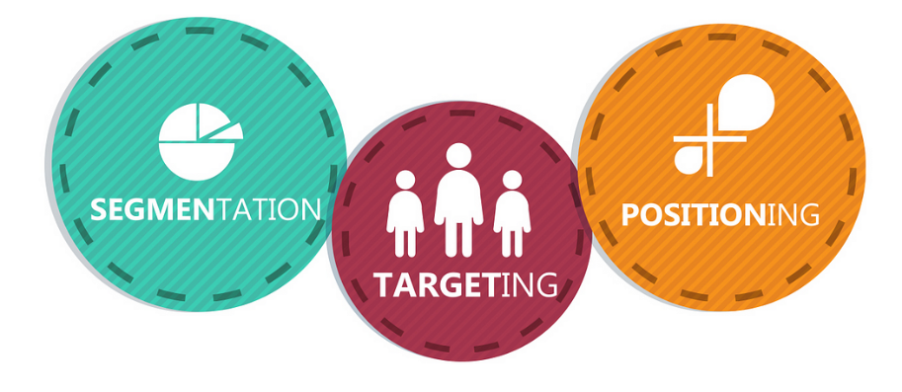
[Source: https://medium.com/@r.b.srikanth/stp-marketing-232fc86dd531]

  - Segmentation:-
5.1.1 Demographic segmentation
The showcase is portioned into bunches agreeing to components counting age, sexual orientation, wage, occupation, instruction, religion, race, era, nationality, and social lesson within the demographic division prepare. The foremost common premise for separating shopper bunches is based on statistic components. (Kotler, Phillips, 2003).

Gender:
Levis offers a wide extend of things for men and ladies, from the foremost basic (Jeans, Shorts) to the foremost elegant (T-shirts, Shirts). Ladies, in specific, have extra alternatives with Levis Bend ID. To meet client request, Levi's too offers an assortment of extras.
Income:
Levi's centres on those with tall livelihoods who can bear the brands. The firm, in any case, doesn't ignore middle-class shoppers, so it gives a cost run of S$30 to S$600 that essentially covers client request.
Age:
Some a long time back, the Levi Strauss Company separated its clientele into age bunches. Grown-ups, youngsters, kids, and babies are all included in Levi's age extend. Due to the measure of this extend, there are less conceivable clients. Particularly when they are youthful clients. For occurrence, the firm offers a wide range of items for kids, just like the 501 Unique Jean, the 569 Free Fit Jean, and the 514 Thin Straight Pants.
Occupation:
Levi's isolates the occupation division into sections for understudies, experts, businesswomen, and administrators.
    - Geographic segmentation:-
“Geographic segmentation calls for dividing the market into different geographic units such as nations, states, regions, countries, cities, or neighborhoods. The company can operate in one or a few geographic areas, or operate in all but pay attention to local variations.” (Philip Kotler, 2003).

- Levi’s Americas:

- Levi’s Europe:

UK

Finland

France

Hungary and other countries.

- Levi’s Asia Pacific:
The Asia Pacific Division of Levi Strauss & Co. was established in 1995 and has its base camp there. With workplaces in Australia, Hong Kong, India, Indonesia, Japan, Korea, Malaysia, Modern Zealand, Pakistan, the Philippines, South Africa, Taiwan, and Vietnam, the organization has more than 4,500 representatives.
https://www.ukessays.com/essays/marketing/a-market-analysis-for-levi-strauss-and-co-marketing-essay.php,

  - Targeting:-

- Differentiated marketing:
By developing goods for several market categories, Levi's differentiates its target market. For instance, they cater to various age groups and genders by providing jeans for men, women, and kids. Additionally, they come in a variety of fits including slender, slim, and relaxed to accommodate different body shapes and tastes (Levi's website: levi.com).

- Undifferentiated Targeting:
In the past, Levi's focused on a larger mass market and used a more undifferentiated strategy. No of the customer's age or gender, their timeless denim jeans were designed to appeal to a wide spectrum of people, highlighting how jeans are a timeless piece of clothing.

- Concentrated Targeting:
Levi's has occasionally used collaborations or specialized collections to further its focused targeting strategy. To cater to a particular niche within their broader market, they could, for example, release limited-edition lines in collaboration with well-known designers, personalities, or brands (such as Levi's x Justin Timberlake collection).
https://levi.com,

5.3 Positioning:-
- Legacy & Authenticity: By highlighting its extensive history and legacy as the creator of riveted jeans, Levi's portrays itself as a pioneer in the denim industry. A sense of sincerity and trust in the company is fostered by this posture.

- Levi's markets itself as a maker of timeless and adaptable denim clothing, appealing to a wide spectrum of customers looking for timeless designs that defy trends.

- Modern and Trendy: The company also markets itself as a cutting-edge, fashion-forward denim label, always launching cutting-edge styles and partnerships to appeal to contemporary customers.

- Emotional Connection: By linking its denim with individual freedom, self-expression, and adventure, Levi's appeals to consumers' emotions and appeals to their aspirations.
https://thebrandhopper.com/2023/07/27/marketing-strategies-marketing-mix-and-stp-of-levis/#google_vignette,

- Marketing Mix
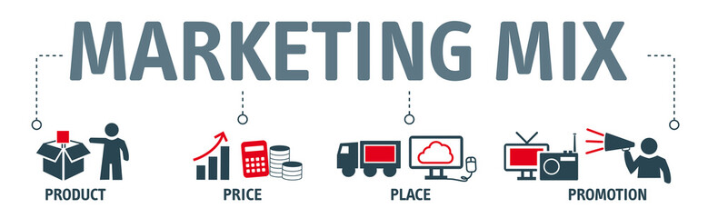
[Source: https://stock.adobe.com/uk/search?k=4p]

  - Product
In contrast to its rivals, Levi's jeans are distinguished by their distinctive style, dual seam durability, and five convenient pockets. Although the firm provides a variety of colors options, including khaki, black, grey, and green, its timeless blue jeans are the most well-liked item in its product line.

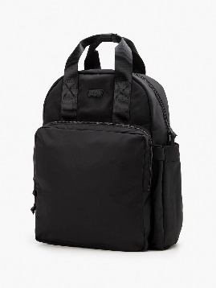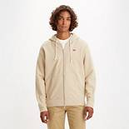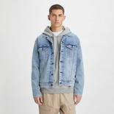
BAG JEANS SWEATSHIRTS SHERPAS
[Source: https://www.levi.com/GB/en_GB/]
Branding strategies
Things from Levi's are of incredible quality and are unfathomably comfortable. As a result, the exchange increases in value colossal publicize affirmation and a sizable, immovable client base.

They never shop wherever else since Levi's has such bewildering items and organizations to offer. Its denim pants are cutting edge, enough expansive for keeping the basic things, and have two layers for strength.

Blue denim pants are the first well-known Levi's thing, but over the past few a long time, other things have additionally begun to choose up reputation.

In expansion to being known for its denim pants, Levi's offers a wide assortment of products, such as skirts, pants, clothing, shirts, dresses, jumpsuits, belts, and embellishments.

Assist divisions of its denim pants incorporate Decrease, Thin, Boot cut, Thin, Flare, Loose, Mothers, and Big and tall. The foremost particular highlight is that it joins a three-digit number to its pants.
https://startuptalky.com/levis-marketing-strategy/#Levi's_Product_Marketing_Strategy

Price

Customers are constantly looking for high-quality products at the most affordable costs, thus every business needs to set the proper pricing for a product. Levis applies a policy of differential pricing to its goods in several nations. Each product's selling price fluctuates depending on regional expenses as well as political and social variables that impact the area.

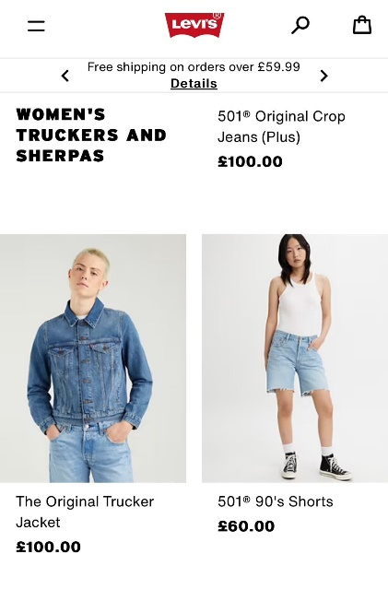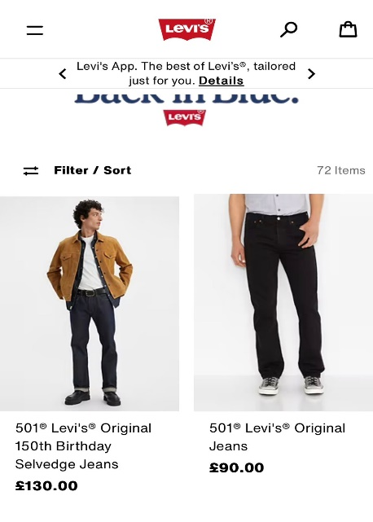

[Source: https://www.levi.com/GB/en_GB/]

Place

Three geographical divisions of the Levis Corporation make up its worldwide structure: Levi-Strauss America, Levi-Strauss Africa, Middle East and Europe, and Levi-Strauss Asia-Pacific. Initially based in San Francisco, the business has subsequently grown to include operations in Australia, China, India, Japan, Singapore, and Sri Lanka.

To ensure quick and effective delivery, specialized warehouses were built in every nation where Levi's has stores. To keep ahead of its rivals in this cutthroat industry, the corporation expanded its sales channels and updated all of its distribution hubs. Today, a variety of retail stores and shopping centres sell Levi's pants.

Promotion

For its marketing initiatives, Levi's uses a variety of media platforms, including television, newspapers, and magazines. The business also makes use of social media websites to broaden its audience. Levi's has run several advertising campaigns and even has a theme song.

In their "Be Yourself" campaign, which received high accolades, Levi's emphasized originality and distinctiveness while marketing to young people. In order to market itself and chart its development over the previous 150 years, the brand has also organized open exhibits around Europe. Additionally, as part of their marketing initiatives, Levi's has launched eco-friendly items like their waterless "smart jacket."
[Available at: https://writohub.com/marketing-mix-of-levis/, last accessed on 11th August 23.]

Recommendations

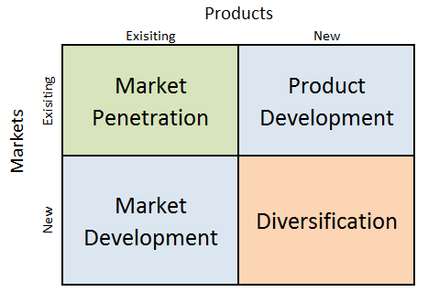

(Source: https://research-methodology.net/apple-ansoff-matrix-2/)

Product development

In product development, Levi’s launched new child and baby clothing in the existing market in which they already achieve success. For example, Levi’s launch new baby t-shirts, jeans, shirts, bags, and shoes.

Moreover, it’s also targeting old-age customers to launch new products for its old-age customer. For example, Levi’s will launch new fashion jeans, t-shirts, and caps for old-age customers.

Diversification

In the diversification, Levi’s brand launched a new product in the market related to the clothing industry. For example, Levi’s launch new perfumes in the market or launched various types of curtains, bed sheets, and other cloth-related products.

Conclusion

This marketing, assignment includes a brief introduction, Levi’s pestle analysis, Porters 5 forces model, SWOT analysis, advantages and disadvantages of SWOT analysis, Segmentation, Targeting and positioning of Levi’s brand, marketing mix 4Ps of Levi’s, and new future marketing strategies which should adopt Levi’s brand.

References:

https://businessanalystmentor.com/pestle-analysis/
https://levi.com,
https://medium.com/@r.b.srikanth/stp-marketing-232fc86dd531

https://research-methodology.net/apple-ansoff-matrix-2/]
https://stock.adobe.com/uk/search?k=4p
https://www.edrawmind.com/article/porters-five-forces-analysis-definition-and-examples.html
https://www.levi.com/GB/en_GB/
International Design Foundation (2018) Porter’s 5 Forces Model - Design in Context, Understand the Market. Available at: https://www.interaction-design.org/literature/article/porter-s-5-forces-model-design-in-context-understand-the-market (Accessed: July 18, 2023).
M, Abdul. (2023). Levis SWOT Analysis: Strong Brand Loyalty for the Blue Jeans Company
Available at: https://pestleanalysis.com/levis-swot-analysis/#LEVIS_SWOT_Analysis_Final_Thoughts, (Accessed: July 24, 2023).
M, Leslie. Organizational Development. Available at: https://embapro.com/frontpage/pestelcase/11093-levi-strauss (Accessed: July 15, 2023).
MBA School Team. Levi Strauss Porter Five Forces Analysis. Available at: https://www.mbaskool.com/five-forces-analysis/companies/18349-levi-strauss.html (Accessed: July 21, 2023).
N, Shelke. (2023) The Secrets behind the Marketing Mix of Levi’s. Available at: https://writohub.com/marketing-mix-of-levis/ (Accessed: July 28, 2023).
S, Pratyusha. (2022) Innovating Marketing Strategy of Levis Strauss & Co. Available at: https://startuptalky.com/levis-marketing-strategy/#Levi's_Product_Marketing_Strategy (Accessed: July 29, 2023).
Team TBH (2023) Marketing Strategies, Marketing Mix, and STP of Levi’s. Available at: https://thebrandhopper.com/2023/07/27/marketing-strategies-marketing-mix-and-stp-of-levis/#google_vignette, (Accessed: July 27, 2023).
UKEssays. November 2018. Marketing Analysis of Levi Strauss And Co Marketing Essay. [Online]. Available from: https://www.ukessays.com/essays/marketing/marketing-analysis-of-levi-strauss-and-co-marketing-essay.php?vref=1 [Accessed 25 July 2023].

