Computer Architecture and Operating Systems

Written By
James Taylor

Computer Networks and Cybersecurity BS-Hons

0152272@student.uwtsd.ac.uk

Revision 0.0

Submission Date

07/04/2023

Contents
Introduction 4
Fundamental characteristics of standard operating systems 5
Various operating system types 6
System Components of the Linux Operating System 6
Analysis Overview of Linux System Architecture 7
PowerShell CLI Commands 8
Linux OS CLI commands 13
Windows Batch OS Scripts 20
Linux Script 27
Conclusion 29

Figure 1:The operating system’s job 5
Figure 2: System / Hardware Overview 6
Figure 3:Linux system's architecture 7
Figure 4:https://www.pdq.com/blog/powershell-guide-get-ciminstance-and-get-wmiobject/ 11
Figure 5:https://www.commandline.ninja/get-aduser-syntax-and-examples/ 12
Figure 6: Sudo update 13
Figure 7:Sudo ls cmd 13
Figure 8: Sudo cmd Pwd 14
Figure 9: sudo cmd - man mkdir 15
Figure 10: Linux Version of Task Manager Via CLI 16
Figure 11:Neofetch 17
Figure 12: alias Command 18
Figure 13: uname-a 19
Figure 14:batch script with several commands 24
Figure 15:System Memory & Network Info 24
Figure 16:Google dns 8 Times 24
Figure 17:Goto C Drive 25
Figure 18:List Directory contents 25
Figure 19::cd Test Folder 25
Figure 20:echo 26
Figure 21: Pause Function 26
Figure 22:NDG Linux Unhatched certificate 28

Introduction

Operating systems and computer architecture are critical components of modern computing. This task delves into the inner workings of computer systems, including the hardware and software that controls and operates them. We'll look at the key concepts and principles in these areas, as well as how they affect overall system performance and functionality.

Fundamental characteristics of standard operating systems

An operating system acts as a communication interface (bridge) between the user and computer hardware. The goal of an operating system is to provide a platform for a user to execute programmes in a convenient and efficient manner.

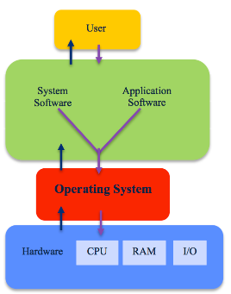
Figure 1:The operating system’s job

The software for the system and the application illustrated in the following screenshot is utilized by the user. There are interfaces between both the operating system, the system, and the application software. Operating System and Hardware interact. All of these interfaces support two-way data transmission and reception.

Various operating system types

Operating systems are generally pre-installed on any computer you obtain. Although many people use the operating system that came with their computer, but it is possible to either upgrade or change the default operating system to meet your specific requirements. Different operating systems will differ significantly. They may vary in appearance, use various terminology for common functions, and organise programmes in different ways. Below illustrates common functions and Sub functions of Linux.

System Components of the Linux Operating System

The Linux operating system consists of the following components:
- Kernel: The core component of the Linux kernel that functions as a link between hardware and software.
- System libraries: A combination of library functions designed to assist with tasks like memory management, I/O, and networking.
- Shell: A command-line interface (CLI) that allows users to execute commands and automate tasks.
- System Utilities: Programs called system utilities are in charge of carrying out specific, high-level duties.

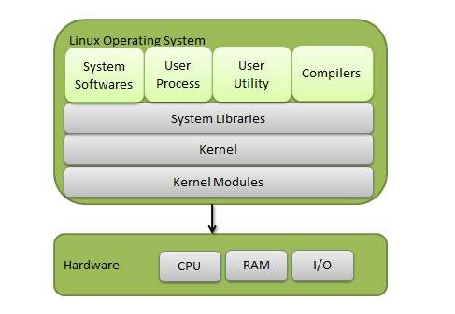
Figure 2: System / Hardware Overview

Architecture

An illustration of a Linux system's architecture.
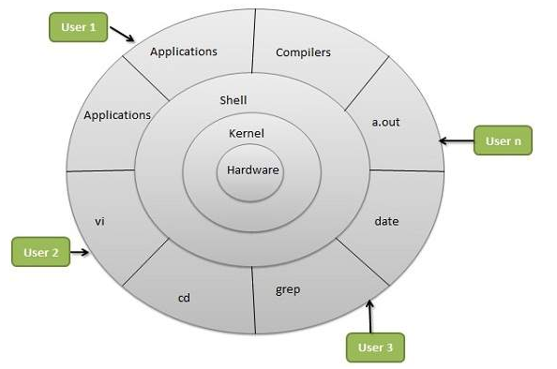
Figure 3:Linux system's architecture

Analysis Overview of Linux System Architecture

The kernel, the operating system's central component, controls all the major functions of the LINUX operating system. The various modules that constitute this operating system communicate directly with the underlying hardware. By using the kernel's abstraction, this system can conceal software applications or low-level hardware characteristics. The various Kernel varieties are as follows:

- Monolithic Kernel
- Microkernels
- Exo Kernels
- Hybrid Kernels

PowerShell CLI Commands

Most PowerShell cmdlets are written using C# and include instructions for performing functions that return.NET objects. There are over 200 cmdlets in PowerShell. These commands can be typed in either uppercase letters or lowercase letters because the Windows PowerShell command prompt does not distinguish between the two.
“ Get-ChildItem -Path C:\ -Recurse -File | Sort-Object -Property Length -Descending | Select-Object -First 10 ” Will list top 10 files on your C: disc, including all subdirectories, will be listed by this command. The Get-ChildItem cmdlet is used to iteratively list all files and directories, and the Sort-Object cmdlet is used to order them according to file size. Lastly, it restricts the display to the ten largest files using the Select-Object cmdlet. However, it’s thrown an error due to Windows defender picking it up as a threat so this will need to be disabled in order to complete.
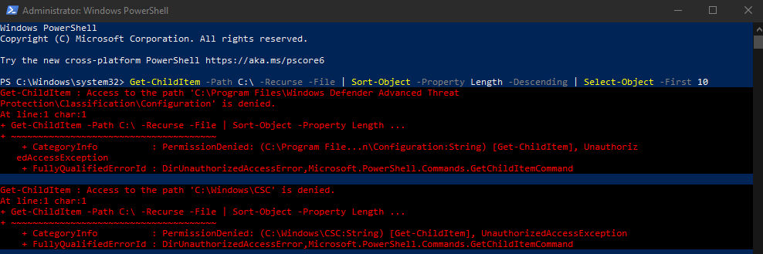

All PowerShell cmdlets and functions containing the word "Service" in their names are listed when Get-Command is used with the *-Service option. The result is provided below:
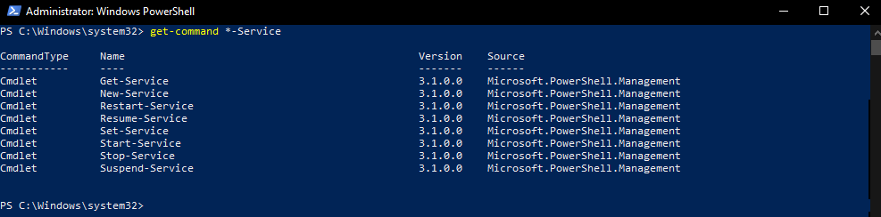
This demonstrates the availability of several PowerShell cmdlets for managing services, such as Get-Service, New-Service, Restart-Service, Stop-Service, and others.

The “ Get-Process “ cmdlet in PowerShell is like task-Manager “GUI” which shows you all of the process that are currently running however in command – line. If you wanted to restart a service from this cmd line you would type Restart-Service -Battle.net
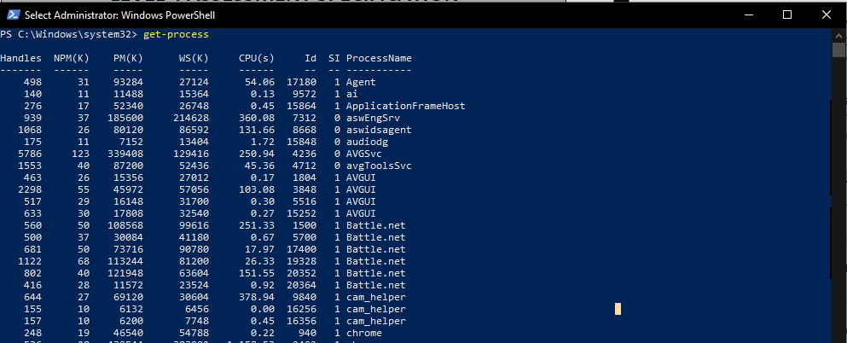

“ Get-Event -LogName Application -Newest 20 “ This Powershell Cmd pulls the number of the most recent 20 entries, however you can change the number to any range you wish and also rather than application you can change to “System” or “Security” the -Newest list the most entries to retrieve.
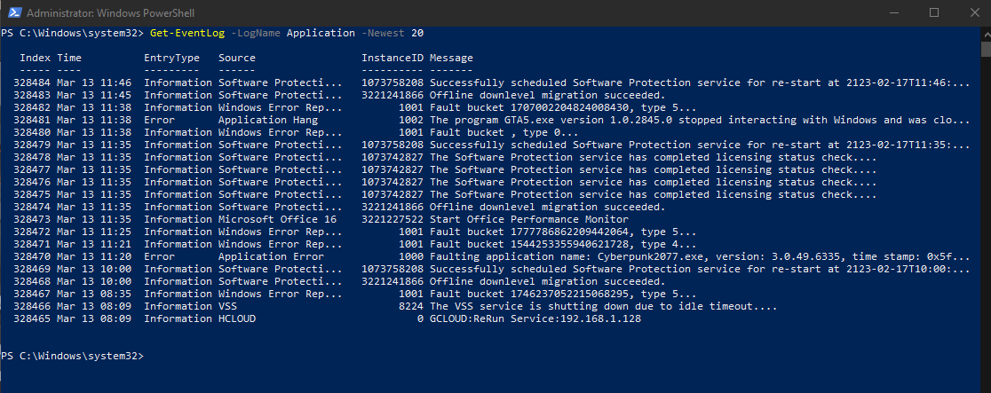

“PS C:\Windows\system32> Set-ExecutionPolicy Unrestricted”
By setting the current user's execution policy to Unrestricted, this command enables scripts to execute without restrictions. To set the execution policy for each user on the machine, use the -Scope argument.
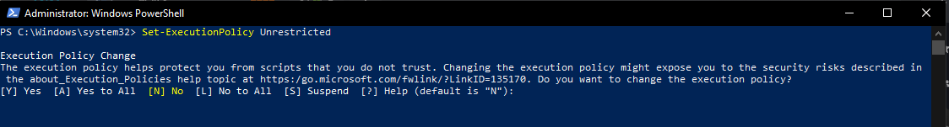

“ Test-NetConnection “
Used to evaluate various network ports and protocols in order to identify network connectivity problems and find solutions.
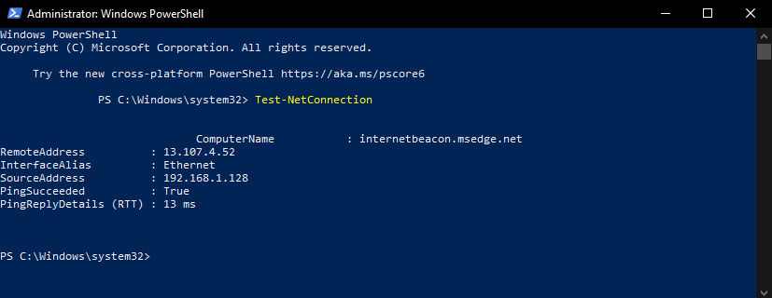

“ ConvertTo-Json “
PowerShell's ConvertTo-Json cmdlet lets you convert PowerShell objects or arrays to JSON (JavaScript Object Notation) format. Humans can read and write JSON easily, and robots can understand and generate it quickly as well. JSON is a lightweight data interchange format.
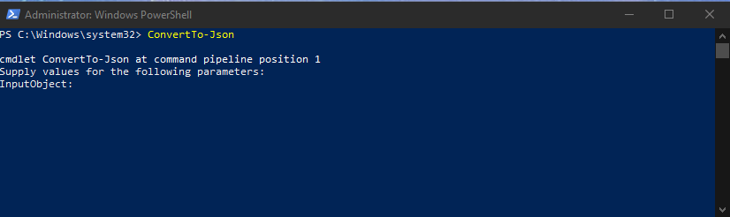

The PowerShell cmdlet “Get-WmiObject” can be used to retrieve information from Windows Management Instrumentation. (WMI). [1]
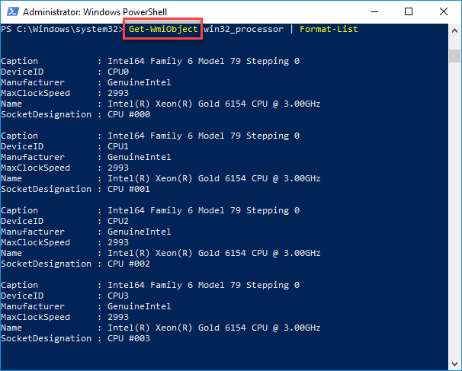
Figure 4:https://www.pdq.com/blog/powershell-guide-get-ciminstance-and-get-wmiobject/

The PowerShell command Get-ADUser bgoodman -prop * | select *password*, *Logon* will return the Active Directory user account with the username "bgoodman". [2]

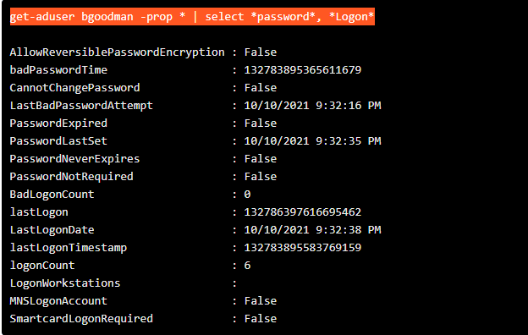
Figure 5:https://www.commandline.ninja/get-aduser-syntax-and-examples/

To verify the last logged in user in PowerShell, use the Get-LocalUser cmdlet in conjunction with the Select-Object cmdlet to filter the results.
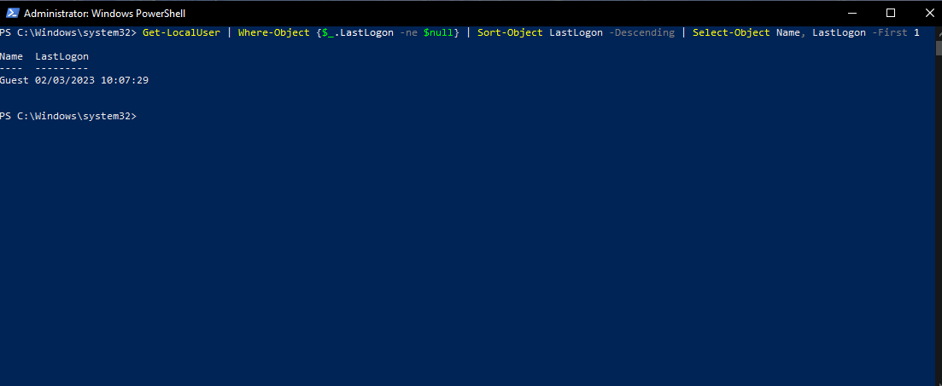

Linux OS CLI commands

A Bash command is sudo. To run commands with administrator or superuser capabilities, it is used in the Bash shell. Below is a list of the ten most used sudo / bash commands. [3]
“ Sudo apt-get update “ The package list is updated by this command. To complete this action, the sudo prefix causes the command to be run as the superuser, also known as root.
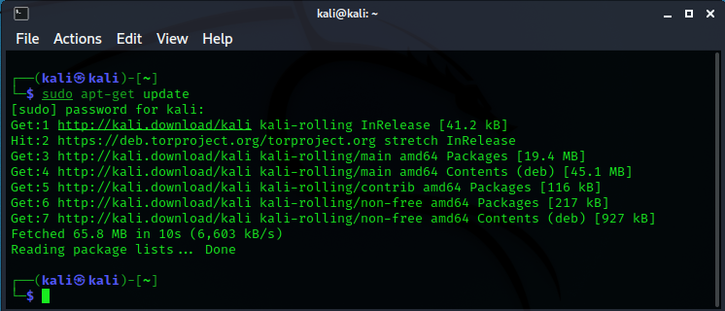
Figure 6: Sudo update

The first command that every Linux user most likely entered into their terminal was “ls”. It enables you to list the contents of any directory, including files and other nested directories (by default, the current directory) then using the cmd ls routerspolit shown below it list the contents of said given file.
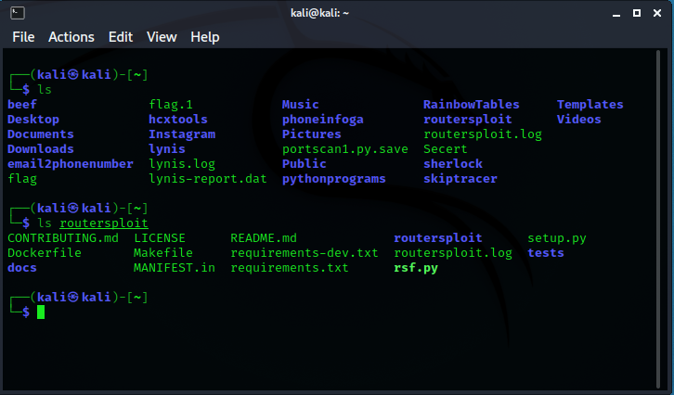
Figure 7:Sudo ls cmd

The "print working directory" (pwd) command displays the absolute path of the directory you're presently in.
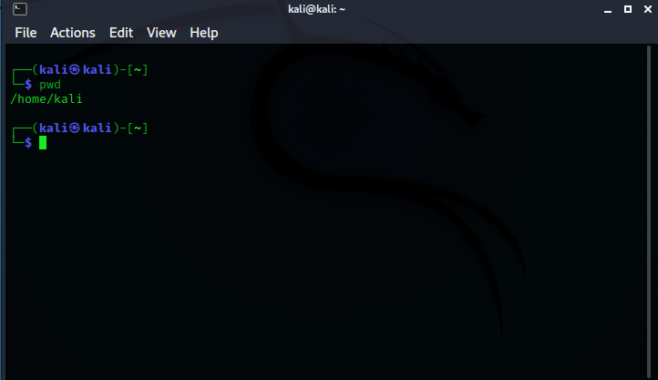
Figure 8: Sudo cmd Pwd

“Man” displays the documentation for any other command. So, if you wanted to see the manual page for “mkdir” you would type msn mkdir as shown below. [4]

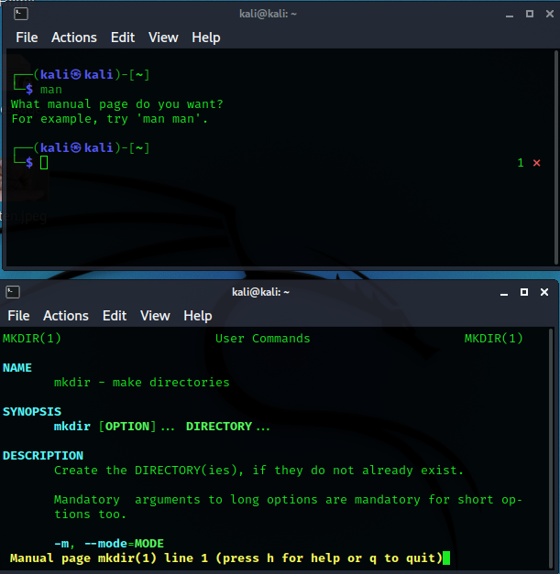
Figure 9: sudo cmd - man mkdir

“Htop” Is a command-line tool that enables interactive real-time monitoring of server activity or other important system resources. htop is a more recent programme than top command and offers a number of enhancements. [4]
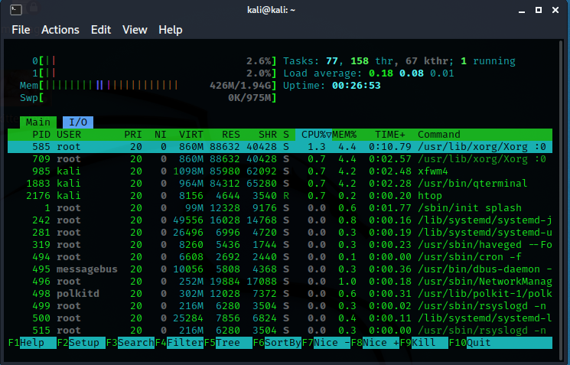
Figure 10: Linux Version of Task Manager Via CLI

“Neofetch” is a command-line interface (CLI) programme that shows details about your system, including the hardware, hardware version, and kernel, shell, and version information, along with an ASCII logo for your Liux distribution
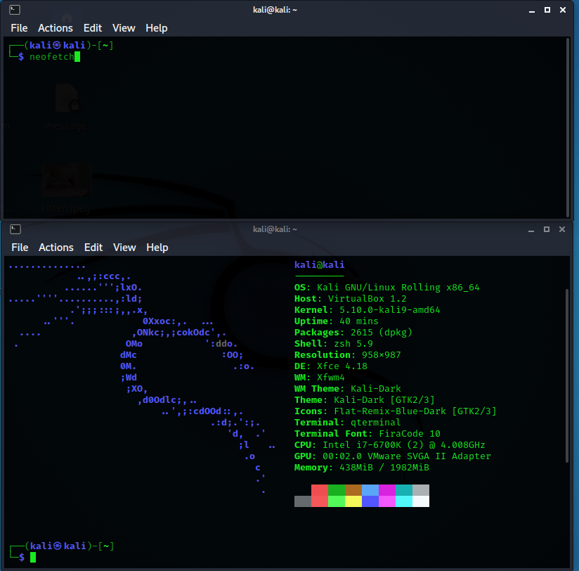
Figure 11:Neofetch

“Alias” You can create temporary aliases in your shell session using the alias command. You can tell your shell to replace a term with a set of instructions by giving it an alias. [5]
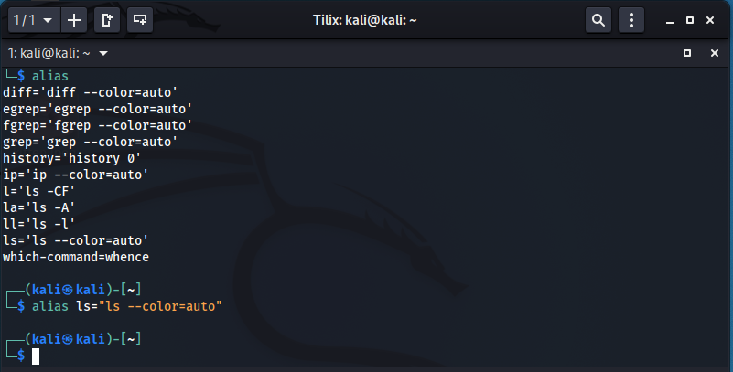
Figure 12: alias Command
“Cat” The cat (short for "concatenate") command is one of the most commonly used commands in Linux/Unix-like operating systems. We can use the cat command to create single or multiple files, check the content of a file, concatenate files, and redirect output to a file or the terminal. [6]
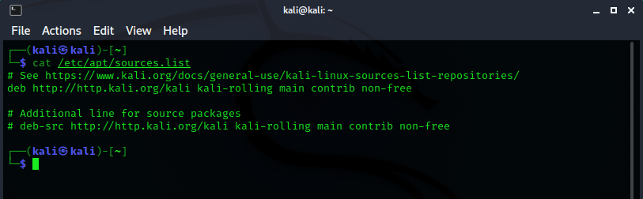

“uname -a” The "uname" tool can be used to display details about your Linux system. Most of the system information is displayed via the "uname -a" command.
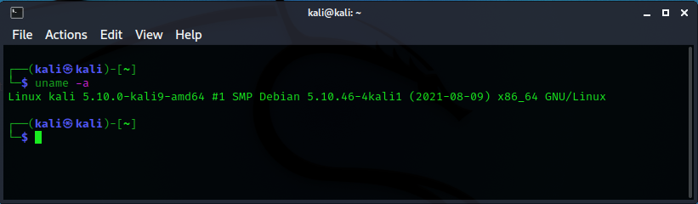
Figure 13: uname-a

To see how much disc space is remaining in each of your system's partitions, use the df command. By running df on the command line, you may display the used/available space in% and KBs for each mounted partition. Use the command to see it in megabytes “ df-m “. [7]
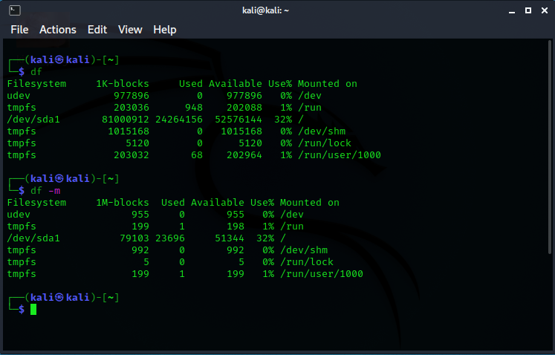

Windows Batch OS Scripts

This batch file will list all of the printers that are set up on your computer when you execute it. A list of printer names is retrieved using the wmic printer get name command, and each name is iterated over and displayed using a for loop.
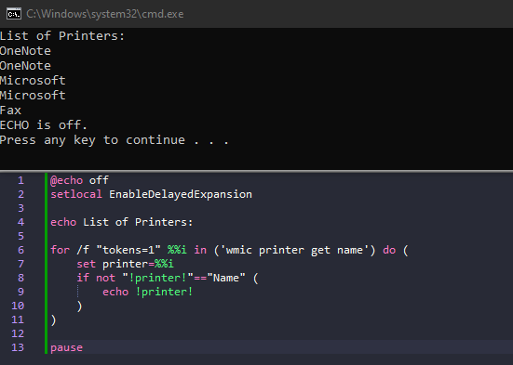

This script provides network information as well as specific network packet details. Ipconfig /all simplifies network data viewing, while ping and tracert provide information on individual packets.
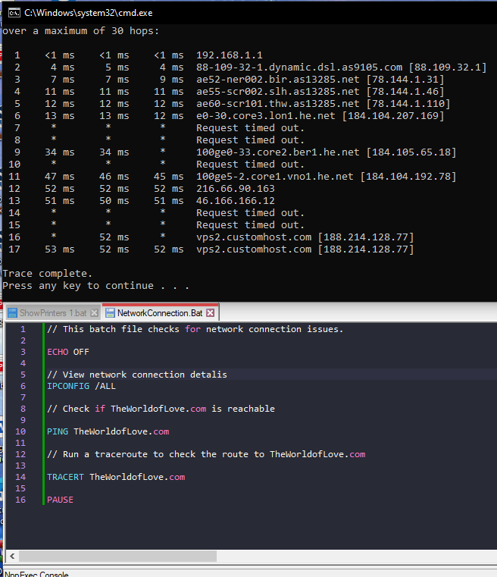

The "/dn" switch instructs the PrintUIEntry function to remove a printer connection, while the "/n" switch provides the “printername” to remove.
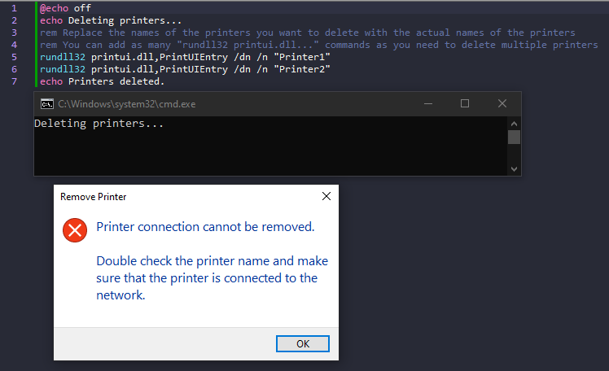

The script begins the "top" loop, which uses the %random% command to generate and show 40 random numbers. The "goto top" command causes an infinite loop by going back to the "top" label.
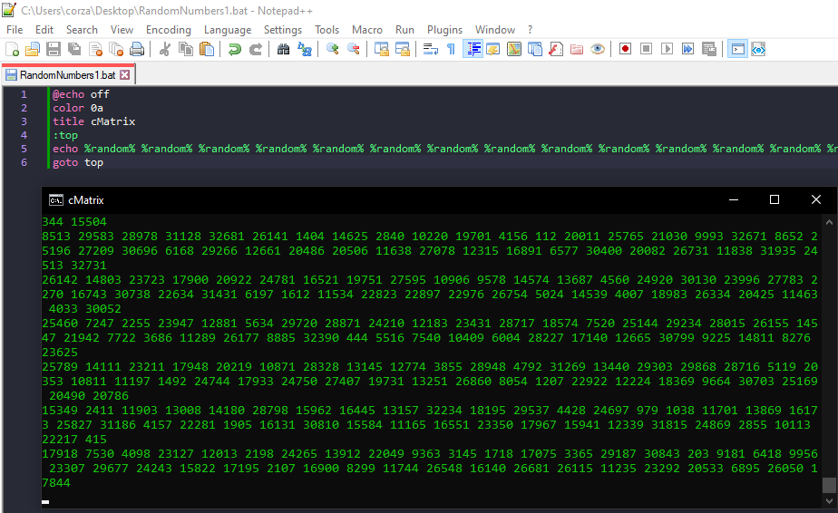

The script comprises many commands for doing various activities such as checking system memory, network information, connectivity, exploring directories, creating, and removing directories, copying and deleting files, and so on.
Here's a rundown of what each command does:
- The echo command is used to print a message to the console.
- The total physical memory available in the system is displayed using the command wmic computersystem get totalphysicalmemory.
- Ipconfig /all displays all of the network information
- In order to test the network, ping 8.8.8.8 -n 8 sends 8 ICMP packets to the Google DNS server.
- C: redirects the current directory to the C drive's root directory.
- The command cd navigates to the current drive's root directory.
- dir/w/p displays the current directory in a paginated wide format.
- The command md test folder creates a new directory with the name "test folder".
- In a wide format, dir/w displays the current directory's contents.
- cd test folder switches to the newly created "test folder" directory.
- Copying the file "test2.bat" from the root of the C drive to the current directory is accomplished with the command copy c:test2.bat.
- Disk use information for the directory "test folder" is shown with the command DiskUsage /h C:test folder.
- All files in the "test folder" directory are deleted with the command del c:test folder*.* /q without a confirmation question.
- To show that the files have been deleted, run dir c:test folder to display the directory's contents.
- The operation "rd test folder" deletes the test folder directory.
- In order to demonstrate that the directory has been deleted, dir displays the contents of the current directory.
- To stop the script from closing we use the “ Pause “ function.

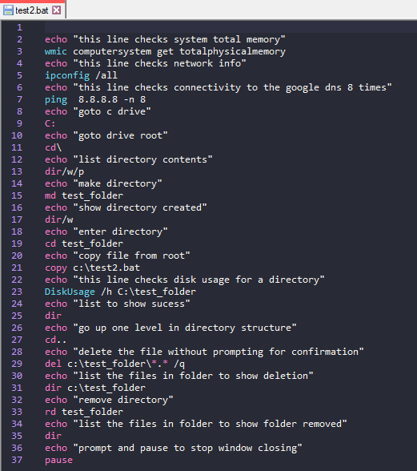

Figure 14:batch script with several commands

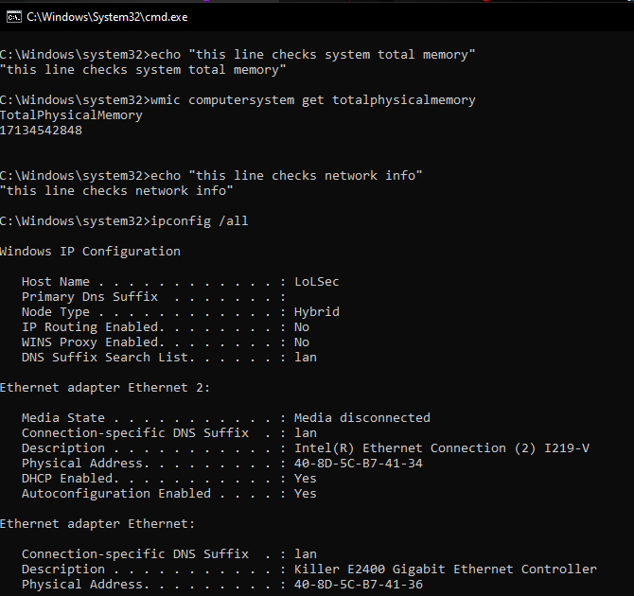
Figure 15:System Memory & Network Info

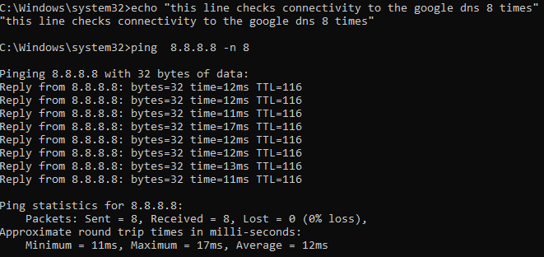
Figure 16:Google dns 8 Times

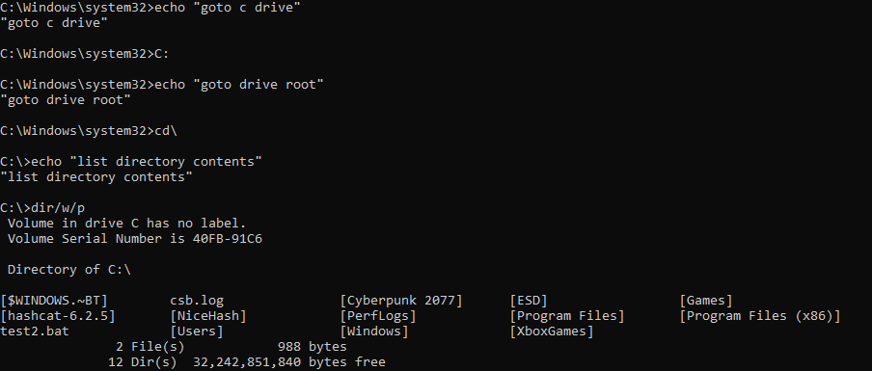
Figure 17:Goto C Drive

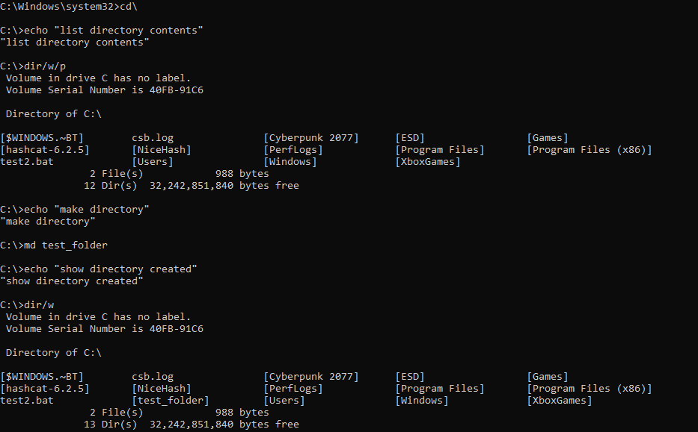
Figure 18:List Directory contents

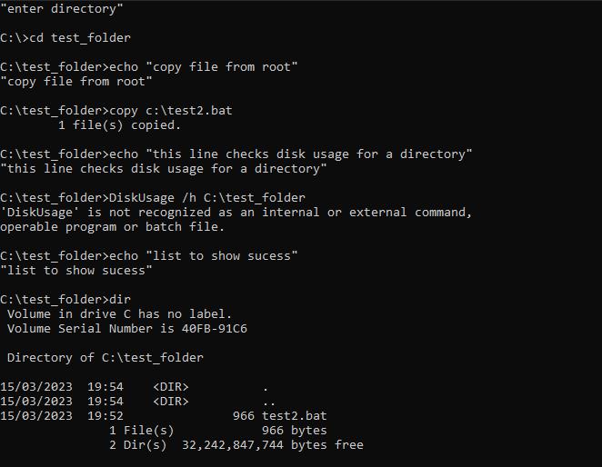
Figure 19::cd Test Folder

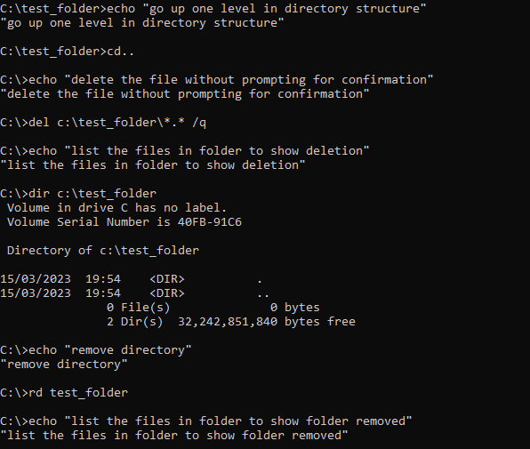
Figure 20:echo

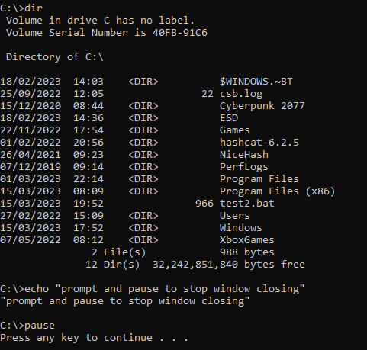
Figure 21: Pause Function

Linux Script

This bash script generates passwords based on the user's specified length and level of complexity. It generates random data with the /dev/urandom device and filters out unwanted characters with the tr command. The character set used for password generation is defined by the complexity level, with "low" using only alphanumeric characters, "medium" using alphanumeric and punctuation characters, and "high" combining alphanumeric, punctuation, and printable characters (except space). The head command restricts the output to the user-specified length. A newline is used to format the generated password before it is printed to the terminal.

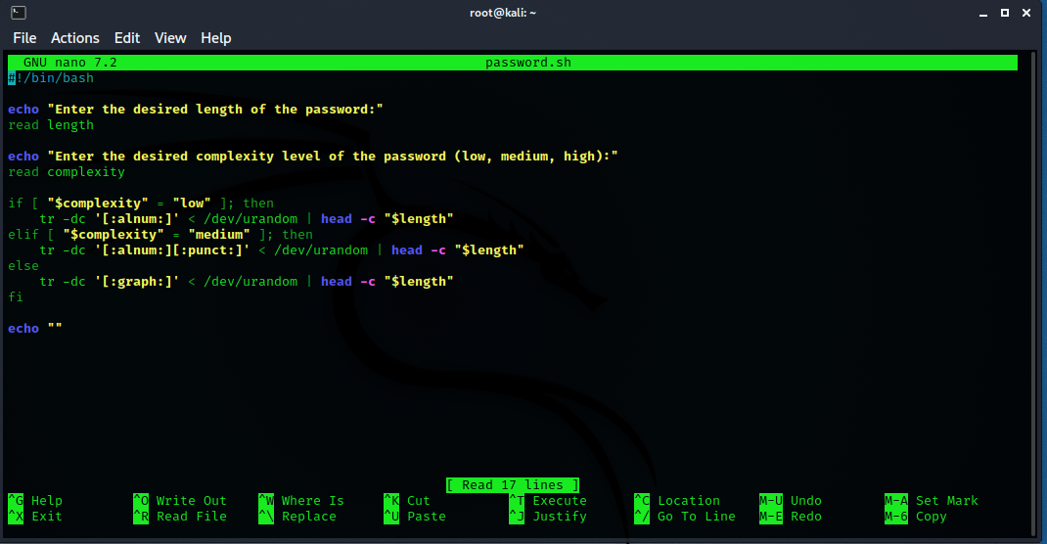

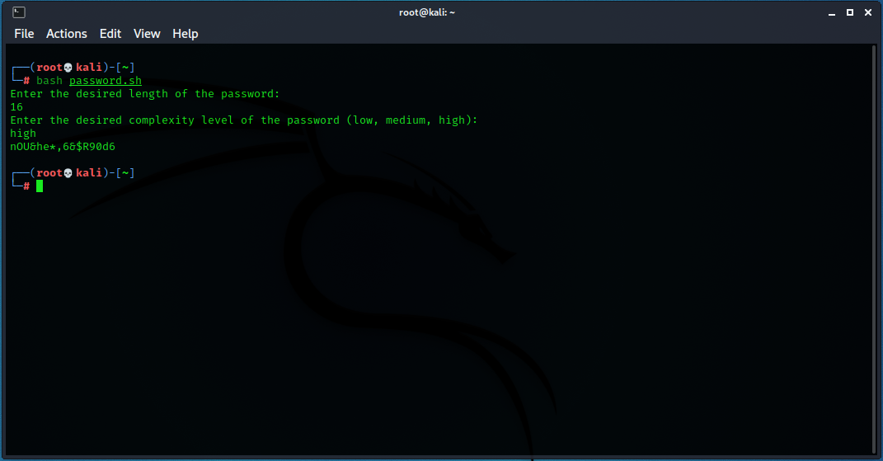

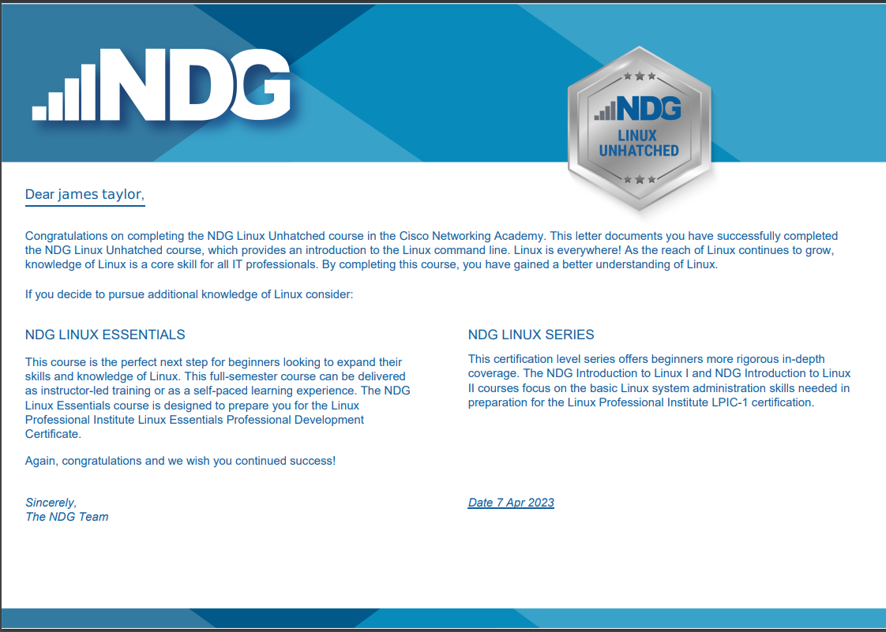
Figure 22:NDG Linux Unhatched certificate

Conclusion

The information presented in this assignment emphasises the significant role that operating system software plays in modern computer environments as well as the numerous benefits that they give to both system administrators and average users. As technology advances, operating system software will definitely continue to advance, delivering even more cutting-edge features and usefulness. To choose the operating system software that best meets their needs and expectations, users must stay current on the most recent modifications.

References
[1] Anonymous (). PowerShell guide to Get-CimInstance & Get-WmiObject | PDQ. Available: https://www.pdq.com/blog/powershell-guide-get-ciminstance-and-get-wmiobject/.
[2] Anonymous (-05-14T13:47:17.000Z). Get-ADUser - Cmdlet Syntax and Examples. Available: https://www.commandline.ninja/get-aduser-syntax-and-examples/.
[3] Anonymous (-05-02T19:30:12.000Z). sudo apt-get update vs upgrade – What is the Difference?. Available: https://www.freecodecamp.org/news/sudo-apt-get-update-vs-upgrade-what-is-the-difference/.
[4] Anonymous (-10-06T12:14:20+00:00). The 40 Most-Used Linux Commands You Should Know. Available: https://kinsta.com/blog/linux-commands/.
[5] G. Ornbo. (). Linux and Unix alias command tutorial with examples. Available: https://shapeshed.com/unix-alias/.
[6] Anonymous (-08-16T05:54:17+00:00). 13 Basic Cat Command Examples in Linux Terminal. Available: https://www.tecmint.com/13-basic-cat-command-examples-in-linux/.
[7] A. Naushad. (-03-21 02:37:42). Basic Linux Commands for Beginners | Linux. Available: https://maker.pro/linux/tutorial/basic-linux-commands-for-beginners.

