ASSESMENT 2 DIGITAL SKILLS
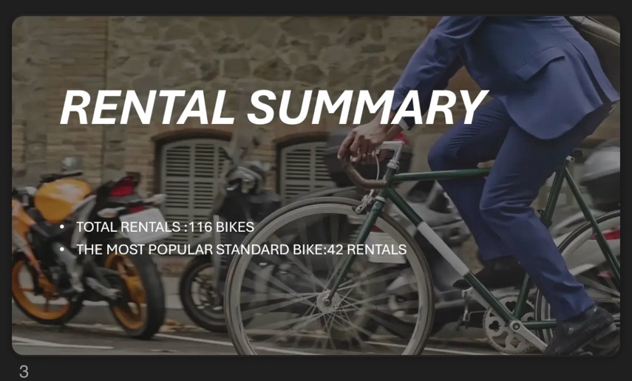
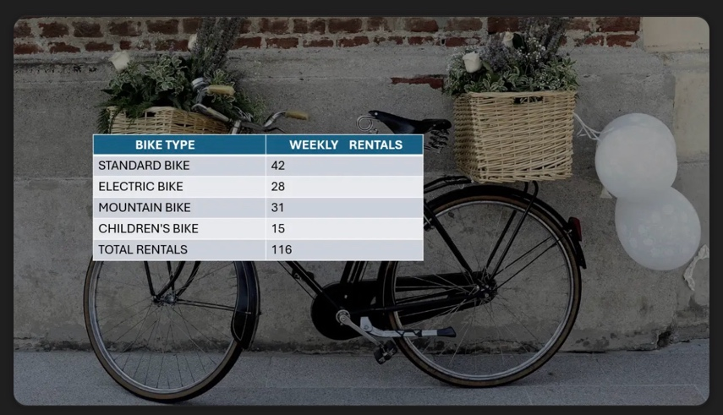


1.WHY I CHOSE MY TOOL
Because it’s good for creating, editing, formatting, and sharing professional, academic, and personal text documents.
2. WHAT INFORMATION I USED
I use the total sales, the unit price and how many bicycle it’s sold.
3.HOW I CREATED MY ARTEFACT
I put all the information in world and then I calculated the total sales, after that I see the result with the best bike seller.
4.WHAT CHANGES I MADE
I add a page with design
I change the type write and color
I made the letters bigger
I add a column with all information
5.FEEDBACK I USED
I use my own feedback to have a different design big letters different type write and color.
6.FINAL EXPLANATION
The owner of the bicycle company can see wich bike make more money.

