BSM5002
Developing Relationships
And
Workplace Achievement

Jaly Begum
1704778
13.12.2018

Introduction
In any business whether it is retail, food chain or an office jobs, big or small. There are different varieties of development vehicles that are implanted in an organisation. This is to ensure a better working environment, sales to exceed, excellent understanding of the organisation and its product. The more vehicles that are available for the employees the better it is for the organisation.
In task one my aim is to research on the vehicles and theories of Motivation, training and feedback and understand the meaning of these vehicles.
In task two I will compare two organisations Tesco and British Gas, see the kind of vehicles and theory’s each organisation are using and see whether they are working and benefitting for the companies.

Task 1
Motivation
According to ‘Critical thinking’, Tom Chatfield 2018, Motivation is an internal and external factor. It stimulates an individual’s energy and their desire of needs to continually stay committed and interested to a job, or a job role. For motivation some of the following strategies have been put into workplace in many different organisations like Tesco, Sainsbury and British Gas.



There are many different motivational levels some people perform and behave better than other. As suggested by Melvin Blumberg journal of manufacturing systems 1982 and also Charles O Pringle. The employee has to have the opportunity to perform from Organisation.
Motivation comes when an individual is enjoying their job, the position they are in, they feel needed by the employer, when the individual gets recognised for the good work and dedication they have invested in the job. In any industry it is important to understand what motivates the individual, because this makes it easier for the organisation to make decisions, encourage development, and give training and the correct tools for the job which leads to a successful development of a high performing individual.
As an organisation it is also important to set clear, achievable goals for individuals or teams, it can be demoralizing to work on a project that seems like it will never end. Visible progress not only feels good, it is also a clear indicator that the work is making a difference. Setting clear and achievable goals provides a real boost of motivation each time it is conquered. As an individual understanding the purpose behind the work and seeing how it fits into the larger picture, it can boost motivation in the workplace by ensuring the individuals or a team’s understand the dedication helped the company to grow in multiple effects.

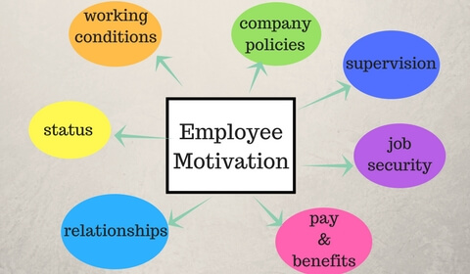

Training
Training is a process an individual puts themselves through a learning method that is needed in a particular job or a job role. As described in the Kolb’s model theory by David Kolb. It is a hand on method for teaching the skills, knowledge a person or employee needed to perform the specific job at a workplace. The benefits of training can improve multi skilling, flexibility, enhanced performance and efficiency, better awareness of health and safety and everyone gets the benefits of training, the organisation, the employees and customers. There are two main types of training and they are:
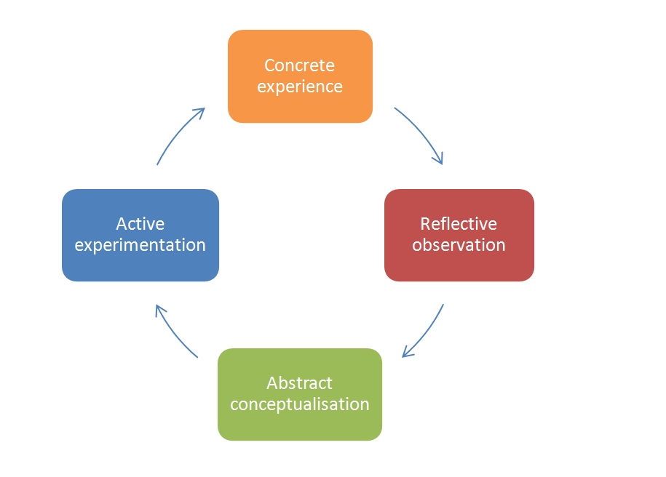
- Formal training: formal training can be done as participating in a structured activity either as the speaker or delegate. The formal training is quick to learn, convenient, cheaper and it is an easy way of sharing knowledge in a formal setting, which everyone can understand and sometimes relate to. Many companies use this method as it is on the job training, where the employee is working at the same time learning and they can keep an eye on what kind of training they are giving out either its working or not. Many companies from the fashion industry and the food industry use these methods.
- Informal training: informal training can be done outside of the organisation. It can be convenient because the individual can learn, read, research about the job role and the organisation they have joined also take in information that it is relevant for them.
This method can also be inconvenient for the organisation and the individual as the employee might not understand the process of how the organisation works, this also can be time consuming, costly and the learning method might not be transferred.
An organisation is only as good as the people who work for it; if the correct training is not given the process of the work will not run smoothly or correctly. The employee will not have the correct knowledge, skills, attitudes and they will behave in an incorrect manner in the job role. In any industry the fashion, food and professional office environment they all require some kind of trainings which will help the organisation and the employee survive and prosper in the long term.

Feedback
This is giving and receiving feedback at a workplace, it is a very powerful tool that informs employees about their performance and behaviour within the organisation. Feedback should be used in all aspects of jobs from peers to peers, from employees to managers and from managers to employee it’s a way of finding out how the organisation is running by the workforce and what can be done to improve performances from individuals as well as teams. From the web site ‘contactzilla’ 10.12.18 Abraham Maslow believed that Feedback can also improves motivation if employees receive positive feedback about their work; they will feel appreciated and know their work is being valued. Below is a feedback model that can be linked to the Kolb’s learning model.

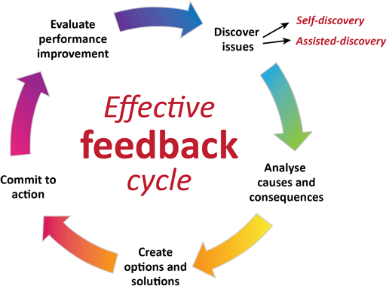

As mentioned in the web site: business.com it is important to have a positive workplace interaction for the success of the organisation as every team member plays a role in ensuring the smooth and success of the business. Sometime a team member can be lacking in confidence or competence, appositive feedback can boost their morale and enable team to learn better, interact more confidently and become more productive.
Feedback is not always about commendation as written by Edward Thorndike his Feedback theory there are situations where a manager needs to challenge behaviour or an outcome to let an individual know the area they need to improve on. The effective way to do that is to make the individual or a team to feel respected, safe and still valued to the organisation. Feedback must be tailored to the person or the team making them feel valued and letting them know why, and how they need to improve and grow within the company. Companies in all organisations uses this theory’s to make a success of their companies.

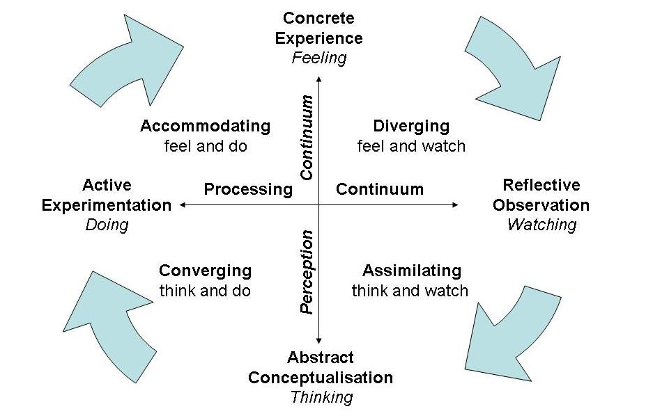

Reflection also falls into the category of feedback according to the American philosopher and educationalist John Dewey is considered to be a significant figure in progressive learning education. In the book ‘Study skills for business and management students’ (2010), An individual needs to see its reflection to be able to have a good feedback meeting with a superior. Reflecting helps to understand the actions that have been taken or if something that happened, if it had a positive or negative impact on the situation. It helps to draw out a conclusion whether to it will be helpful in the future.

Task 2
There are many different types of development vechicles an organisation can use to improve the company and make it more effective for both parties the employees and the employers.
A big Company like Tesco which is the third largest grocery retailer with outlets across USA, Asia and Europe. It began in 1919 by a man called Jack Cohen. As UK holds the most number of stores around 2,200, a large vartery of products from grocery to house hold products and they also sell Tesco Insurance, electrical goods,phone contracts.
At todays date Tesco holds around 280,000 staff across its 2,200 stores and to serve the market it needs to ensure the staff are on hand are well trained to run the stores and sell its product.
There are many different roles the employees hold for example:
- Customer service assisstant
- Department managers
- Warehouse staff
- Office based staff which includes Fianance,purshasing, personnal and marketing.
- Logistics staff
Tesco reguarly evaluates their staff to ensure that the skills, taining, knowledge are upto date and standard to sell their product. They do this by yearly reviews, career discussions. According to the ‘Tesco business studies’ website (10.12.18) Tesco believes in internal Promotion as the transition runs smoother and less training is needed because the employees knowledge about the company how it runs what is expected from the role.
Tesco belives in Motivateing its employees by increasing their knowledge, skills and job satisfaction through training,it offers on the job training where a higher member of staff shadows the person on training and shows how its done. A manager may also choose to coach and mentor the individual if it is going into a higher job role. Tesco also offers off the job training which is provided for team- building, organisation, planning skills this involev attending seminers and professional training organisations. It also offers development and providing relveant and timely reward and recogintion . Pay is considered a primary motivator. Other factors include appreciation of hard work, opportunity for advancement for example train for a higher job role within the company.
Flexible rota where you can choose from day and night shift also if you want to do full time or part-time hours. It offers of Holidays 4- 12 weeks unpaid and stills gurantes a job back also a long term career break.
Pension schemes to save for after an empolyee retirements.
Travel allowances if an employee is travelling to another store to cover shifts
Christmas bonus, staff and friends and family discount which can be used by a member of family on any goods. As mentioned in the business case studies for tesco 10.12.18.
Tesco uses the Frederick Taylor motivational theory, how ever tesco goes far and beyond Taylors theory and gives more than just simple pay increases. It supports the varied lifestyles of individual employees through relevant and targeted benefits. Every year tesco invites its staff to take part in a staff satisfaction survey called Viewpoint which gives them the opportunity to express their views on almost every aspect of their jobs. This helps the company to improve working conditions if needed and hold on to the postive feedbacks.
Tesco also uses Elton Mayo theory ( tesco training 10.12.18). his theory is being implemented throughout the company. Communication is an extemely important factor in motivating and training the employees. They do this by one to one discussions to find out how an individual is doing at its job role whether there is anything can be done to make their trainigng better or easier. News letters to keep everyone updated with what is happening within the companies also job opperotunities in different departments and stores. Apraisals to determine the staffs attitudebtowardsbtheir role and whether they need imprOving in any aspect of the role and to determinr their future goal.
Daily staff meetings to update staff what is happening for the dayand give out value awards.
Health and hygiene are a very important factor for tesco as they deal with freashly made food,and a lot of saff which work for them. For this they also implement the Frederick Herzberg theory. It is important for the staff to feel safe and secured at the work place and for the customers to see a freah clean enviornment that they are shopping in
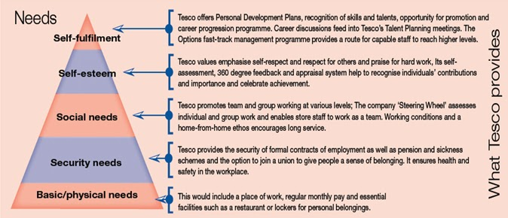

British Gas is the current best recognised energy provider, it is owned by the Centrica multinational group. The Centrica group was formed in 1997 and consist of eight separate energy-related businesses. It supplies gas, electric drain and pipe work maintenance. It also deals with installation of boilers, central heating and other appliances. It provides a maintenance and break down covers for electrical goods.
As the energy markets are very much in demand, customers are always looking out for the best and cheapest energy deals. Along with the deals the customer also looks for a very good customer service represented who can provide up to date and correct information about the energy supplies. To provide this excellent service a very intense and accurate training is provided.
For British gas just training on technical skills and knowledge is not the only goal it is also very important to be trained on people skills as the employee will have direct contact with the customers on a daily basis at the customers home or business premises.
One of the models and theories British gas tend to use is Wieck & Sutcliffe 1988 this is a more mental theory where an individual continually evaluates the environment and creates a new situation and environment. It involves more planning and thinking ahead of a task.
Providing energy is on the rise, so when British gas are looking for staff they look for someone who wants to grow within the company as it takes around three to five years to become a qualified gas engineer (British gas training 10.12.18). The company believes in motivating the staff from the office grounds where they should be energy conscious not wasting gas, leaving lights on or even leaving their equipment’s and phones on charge for longer than it requires, the employers are already energy conscious this helps to share the same vision and goals with the employees who share the values.
British gas motivates their staff by providing financial and non- financial benefits where one gets free training huge discounts on boilers for friends and family. A very good pay, pension scheme and opportunity to be a shareholder in the company and also a high standard training. British gas has a training Academy named as’ British Gas Academy training service’ 10.12.18, which was established in 2002. It has its academy in various locations in the UK like Leeds, Leicester, Dartford and wales. The training is very important for the company as the technology, rules and regulations are always changing so the training never stops it also makes detailed forecast of its demands for engineering personnel for one year ahead. This allows them to have enough staff on hand ready and well trained to go and interact with the customers and provide them with the service needed.

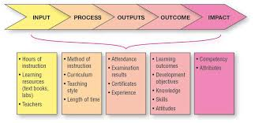
British gas has also applied the Victor Vrooms theory in the organisation to build and maintain the expectations of their employees for example to be successful; they need to know the capacity of the expectations and the different methods of creating certain expectations of the employees. It is very important for the managers to use the theory of motivation to show the best performers in their work.

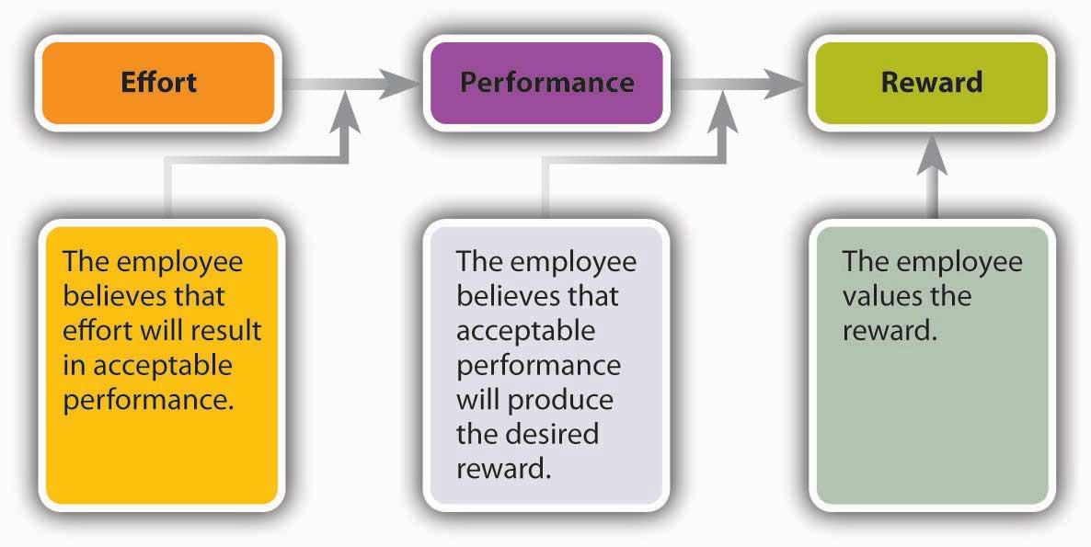

For British gas it is very important to have feedback from the employees as the company believes in keeping the entire workforce engaged and active, take in their advice and suggestion to make the working environment better for the staff and customers. This will lead to employees stay longer with the company and reach their full potential and increase productivity which helps to create a successful business.(feedback on creating a great place to work at Centrica 26.03.15) Feedback showed high satisfaction in serval important areas including safety and employee relationships with their direct line managers.
It is also very important to have feedback from the customers; many customers are contract customers that have service agreement with the company and also there are customers that call for one-off assistance if they have a specific problem that needs dealing with. With the feedback from both types of customers the company can work on the timing to reach a customer, customer service skills and knowledge of the products, and how well the job was done.
British gas has also applied the Victor Vrooms theory in the organisation to build and maintain the expectations of their employees for example to be successful; they need to know the capacity of the expectations and the different methods of creating certain expectations of them
According to the book ‘how to lead ‘ 2005 it is important for a employee to stay positive , influence customers and other members of staff when they are on the job as it sets examples, brings rewards and satisfaction to the job.

Conclusion
Tesco and British gas are two completely different companies from each other. Tesco sells grocery and everyday house hold stuff whereas British gas sells energy. Both companies rely on retaining existing customers and acquiring new ones. For both organisations when it comes to motivation, training and feedback it seems to be the number one priority for both organisations as it is very important to put staff training on top of their agenda and to make customers service training a top priority . It is important for both companies to have the staff trained to a high standard to sell their product and do it well so the customers come back to them. According to the book ‘Top performance leadership’ (2014) it is important for all members of staff to establish the importance of what, why, when. This will help them to understand the company, its motive the customers and how the product should be distributed.

Task 3
Development plan for retail Assistant Manager
Objectives | Measures | Priority | Support & Development |  | Review Dates | Other comments
Objectives | Measures | Priority | Internal | External | Review Dates | Other comments
Training on managing the shop floor | Shadowing the store manager | High | internal |  | 2 weeks
Improve time management | Use technology more efficiently and effectively | High |  | External  Head office training required | 3 weeks | Manager to review instore
Motivating the team | Hold meetings and trainings instore every week | Medium | internal |  | 4 weeks | Store manager to give feedback after every meetings and trainings
Management training | Observing board meetings at the flagship store | Medium |  | external | 4 weeks | Travel to a flagship store and monitor how the management training is done there
Customer service training | Read the company booklets and observe the store manager when dealing with customers | High | internal |  | 1 weeks | Store manager to observe when dealing with the customers and then give feed back
Communicating effectively with the store manager and head office | Shadowing the manager | Medium | internal |  | 4 weeks | Store manager to shadow the trainee when communicating is active with the store and head office

Bibliography
https://www.thetimes100.co.uk 10.12.18
https://www.britishgastrainingAcademy.co.uk 10.12.18
https://www.Weick&sutciffe.org 10.12.18
https://wwwcentricafeedback.co.uk 26.03.15
Critical Thinking, Ford. T, 2018, London, sage publications
Blumberg, Alber.A journal of Manufacturing Systems 1982 journal
Study skills for business and management students, Ramsay.P, Maier.P, Price. G, 2010, Great Britain, Dorchester, Henry lieng ltd
How to lead, Owen. J, 2005, Great Britain, Ashford
Top Performance leadership, Jones. G, 2014, UK, London
https://www.Britishgastraining.co.uk 10.12.18
https://businesscasestudies.co.uk 10.12.18
https://contactzilla5psychologicaltheories.com 10.12.18
BA in Leadership and Management, Maund.A, 2018, London, Sage publication

