Name: Olugnenga Davis-Amosu
Student number:2211024
E-portfolio report
Learning in the Digital Era – BMPL4007/BMPS4009

Table of Contents

Task 1 – Written summary 2
Task 2 – Mind map 3
Task 3 – Presentation 4
Task 4 – Reflection 5
Reference list 6

Task 1 – Written summary
Preparing for higher education
Getting to university is arguably a significant achievement for majority of individuals because it paves the way for professional development, and it offers new approaches to excel in life. To excel however, one needs to effectively prepare themselves adequately to develop the right mindset to studying. This will go a long way towards improving performance and offer the individual the right mindset needed to understand what is being taught. One of the key steps to prepare oneself to higher education is creating the perfect study environment (Grunschel, Patrzek, Klingsieck, & Fries, 2018). Having the right environment will reduce distractions that limit the effectiveness of learning and will also ensure one is surrounded by positive thinking. This will ensure individuals absorb majority of what they are taught.
The biggest challenge to the preparation process is procrastination. Delaying embarking on the tasks one wants to execute will lead to time wastage and reduce the overall productivity of any individual. It is therefore important to ensure that one takes the necessary steps to reduce time wastage and improve productivity. Saman (2017) argues that in higher education, procrastination is the biggest hindrance to attainment of results because majority of students fail to achieve their goals and objectives. There mental health is affected by the lack of mental preparedness which results in delayed efforts in completion of tasks (Saman, 2017). Sharing a similar opinion, Bäulke & Dresel (2021) argue that there is widespread procrastination in the education sector with majority of students showing reduced productivity due to time wastage (Bäulke & Dresel, 2021).
Using a timetable to plan oneself is one of the ways to reduce on procrastination and to improve the overall effectiveness of time management. This will go a long way towards fostering productivity of learners. Further, offering the learners an opportunity to effectively manage their time and improve their planning skills (Eerde, 2003).

Task 2 – Mind map
Mind Map
The image below illustrates the mind map to becoming a digital learner.
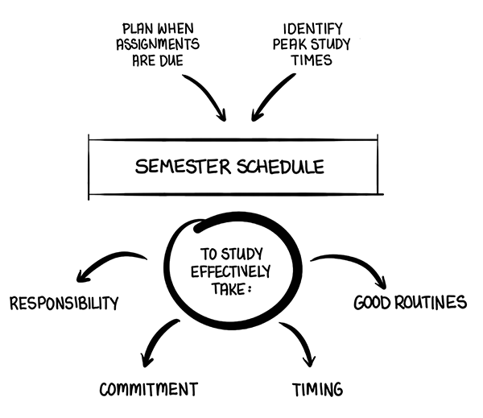
- Planning assignment submission
The first step to becoming a digital learner is planning assignments in time to reduce lateness. Failure to remit assignments on time is one of the main reasons why majority of people fail to get good grades. They are fined for late delivery whereas others do not deliver the assignments at all. Ensuring that there is timely submission of assignments will ensure that there are no penalties incurred for late submission and maximum points are awarded.
- Identification of peak study times
Finding the right time to study will be integral towards increasing the effectiveness of a learner. This will not only ensure that the learner is able to deliver results effectively but also ensure that one optimizes their overall productivity. Regan, et al., (2019) have underscored the need to plan how to learn because it will improve the ability of the learner to manage their time and achieve the intended objective on time (Regan, Hopson, Gisondi, & Branzetti, 2019).
- Effective study guidelines
A learner needs to ensure that they plan themselves and organize their schedules properly to improve their overall ability to deliver timely results. The first step towards effective management is taking responsibility of one’s actions. Students have different responsibilities and ensuring that one executes all the activities that have been assigned to them will be integral towards increasing their overall productivity. Suyidno, et al., (2019) has evaluated the importance of increasing the responsibility of students towards improving responsibility and creativity in the learning process. Therefore, allowing learners to plan their responsibility will not only allow for increased effectiveness in the learning process but it will also offer different approaches towards fostering creativity (Suyidno, et al., 2019).
Commitment to the teachings and guidelines of the tutors will be essential towards increasing the overall efficiency of the learning process. Not only will the learners offer increased ability to grasp the teachings but also they will develop continued dedication to their work (Cavanagh, et al., 2018). Dedication to the work that one does will ensure that learners do not miss out on the work they are engaged in and they can effectively meet the different tasks that they are seek to undertake. Learners equally need to invest in proper timing and developing a routine. This will help them to manage themselves and their time towards their studies.

Task 3 – Presentation
Please follow this link to view my presentation:
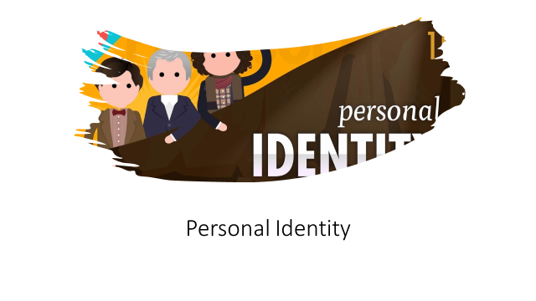
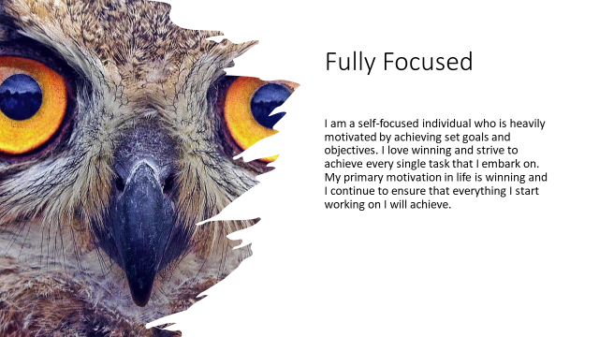


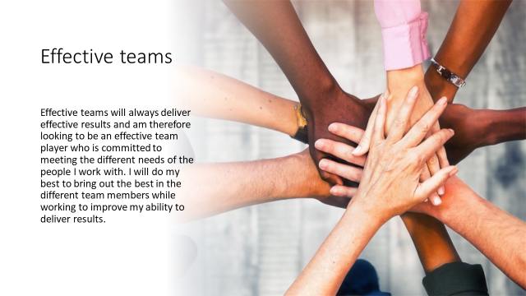

Task 4 – Reflection
Reflection
Going to university is both challenging and interesting task because it offers the learner the opportunity to experience new opportunities and challenges. Starting university is an opportunity to interact with the different course teachings and meet new people. This will open up my perspective to learning and allow me to experience some of the different experiences that are present in the workplace. Further, taking part in the learning will also ensure that I am well prepared to meet the different challenges that come with working in a formal environment and offer me first-hand experience to prepare myself for what I will meet in the work space. This will be integral towards my personal development, and it will allow me the chance to diversify my talents.
The resources that I will meet in the institution will allow me to adequately study the literature I will be exposed to and effectively improve my learning capabilities. This will be integral towards improving my learning capabilities and further ensure that I am able to perform assigned tasks with ease. The first assignment that I will embark on will be relatively easy because I will have the knowledge necessary to execute the assignment and deliver against instructions. I have been practicing on how to write papers with the different referencing styles and this will allow me to easily adjust to the different demands from teachers. I believe I am prepared to handle the different challenges that I will encounter, and I will be better prepared to excel in the different tasks that I will embark on. I am confident I will become an effective learner who can meet the different tasks that I will be tasked with.

Reference list
References
Bäulke, L., & Dresel, M. (2021). A Multivariate Two-Level Analysis of Higher-Education Course Characteristics Relating to Academic Procrastination. Augsburg: University of Augsburg, Germany.
Cavanagh, A., Chen, X., Bathgate, M., Frederick, J., Hanauer, D., & Graham, M. (2018). Trust, growth mindset, and student commitment to active learning in a college science course. CBE—Life Sciences Education, 17(1), ar10.
Eerde, W. (2003). Procrastination at work and time management training. The Journal of psychology, 137(5), 421-434.
Grunschel, C., Patrzek, J., Klingsieck, K., & Fries, S. (2018). I’ll stop procrastinating now!” Fostering specific processes of self-regulated learning to reduce academic procrastination. Journal of Prevention & Intervention in the Community, 46(2), 143-157.
Regan, L., Hopson, L., Gisondi, M., & Branzetti, J. (2019). Learning to learn: A qualitative study to uncover strategies used by Master Adaptive Learners in the planning of learning. Medical teacher, 41(11), 1252-1262.
Saman, A. (2017). Proceedings of the 2nd International Conference on Education, Science, and Technology (ICEST 2017). International Conference on Education, Science, and Technology. 149, pp. 181-183. ICEST.
Suyidno, S., Susilowati, E., Arifuddin, M., Misbah, M., Sunarti, T., & Dwikoranto, D. (2019). Increasing students’ responsibility and scientific creativity through creative responsibility based learning. Banjarmasin: Lambung Mangkurat University.

