
Applied Leadership and Management in the Workplace
Module Assignment Submission
Student Name: | Kelly Watkins
Student Number: | 2324163
Module No: | BMSK4015
Module Title: | Academic and Research Skills

Statement of Confirmation of Authenticity
By the act of making this submission, the student declares that this is the work of the student named above. The work has not, in whole or in part, been knowingly presented elsewhere for assessment, or where assessment has been built on a previous assessment, this has been identified. Where materials have been used from other sources it has been properly acknowledged. If this statement is untrue, the student acknowledges that an assessment offence has been committed.
Attention is drawn to the plagiarism and unfair practice policies of both the University and of ILM.

Managing remotely
Contents page.

- Introduction to Managing remotely Impacts and Benefits..........................page 3

- Management Perspectives........................................................................page 4
-Impacts
-Benefits
- How Management overcome concerns

- Employee Perspectives..............................................................................page 6
-Impacts
-Benefits
- How Employee overcome concerns

- Company Perspectives..............................................................................page 8

- Overall conclusion.....................................................................................page 8

- Reflection..................................................................................................page 9
-Overall own thoughts

- References................................................................................................page 10

- Appendix...................................................................................................page 12

Managing Remotely Impacts and Benefits

Introduction
Managing remotely became a major factor for businesses worldwide during a global life- threatening pandemic (covid-19) from 2019, that led the government in March 2020, to the harrowing decision to carry out a “lockdown”, to curb the deadly virus, by suggesting for businesses to allow working remotely at home, or “hybrid” (a flexible model of work that included working few days in office and working few days in home) this was put in place to protect management and their staff during this horrific time (Kramer & Kramer, 2020). Although remote working was in some ways retrospectively in place by choice prior to the pandemic for some companies, it proved unconventional for some and for most, an impossible task, with some companies hit with loss of staff, loss financially or even worse, closure (Farooq & Sultana, 2021). For some businesses managing remotely and working from home/hybrid was not an option despite the impacts or benefits it will cause (Baker, 2020).
Management also had to consider providing immediate intense training to their staff to work from home, and of course provide supplies and IT equipment to suit everyone, to carry out their everyday role at home to their best standard, due to the unforeseen circumstances. This of course, without the worry of how management can manage their staff remotely to meet the needs of the business, but also respecting and appreciating their staff concerns to such immediate adaptability and the major concern it acquired on both sides.
With such sudden adaptations required overnight to management and staff during this time, came a mixture overall of health and emotional impacts. According to one researcher of the Journal of Occupational Health Psychology, their study showed the sudden adaptions caused major psychological effects to both parties due to the pressure of the transition of home and work in one environment, amongst other issues and responsibilities that came with it (Sonnentag et al., 2021).
This assignment will investigate the devastating impacts on remote working for both parties and for others, how remote working is beneficial to them. With so many mixed reviews and points of view on this subject from many Authors and Journalists it is difficult to understand, unless of course from one's experience, as Management and Employee. Many researchers believe that managing remotely posed a positive effect on Managers and their Companies (Barrero et al 2021). Whilst many other researchers may argue differently (Chang et al., 2021) due to many reasons, this report will look more into further on, from both parties and how they overcome them.

Management Perspectives
When working and managing remotely became necessary during the pandemic (covid19), managements in most Businesses/Companies had no, or little choice but to put their full trust and willingness into staff to be able to assign them to working from home/hybrid (Kaushik & Guleria, 2020). Management had no idea of how it would affect themselves not just financially but emotionally, mentally, and physically.
In this area, it will cover the Impacts and Benefits through the Management perspective, to run their business successfully without failure, within the company's expectations and ensuring their staff are being pro-active, productive, and of course coping with the sudden change from all aspects during the transition. Also, how Managing remotely issues occurred and the best they could do to overcome the issues, considering the tricky situation at the time.

Managing Remotely Benefits- (Management Perspective)
For some Management roles within the office or assuming for some it was beneficial to work from home/hybrid. Not just for the obvious conveniences that suited most during this turbulent period, such as home comfort, childcare or flexibility. It also however came with, no “busy” office environment distractions such as during meetings, from the phones ringing to employees/colleagues talking/shouting/entering offices, which was ideal in most cases as this meant management could be more productive and complete more deadlines with none or little distractions (Ipsen et al., 2021). It also means no concerns with commuting (if from home) or being late for work/meetings due to little traffic if in office. Management also found that their employees were less likely to ring in sick or unable to work due to childcare, as working from home helped in such situations if / when arise. Another great benefit was that management found employees were also keen to carry out overtime when working from home, as no rush to attend to their personal responsibilities outside of the work environment. It also saves Company's financially as offices/departments are not in little use. These savings could be considered on other economic resources required for the firms as an option.
With such phenomenal, progressed latest technology with the use of Laptops, iPads, Tablets, Mobile phones and other devices, managing remotely means that Management and their employees/business partners could keep up to date and check staff welfare by E-mails, Business meetings via Facetime (Zoom/Teams) and other means of communication without being in the same room and keeping that safe distance to protect one another, at scheduled times/days agreed by all parties.
However, as fantastic, and smooth sailing as the above benefits from working from home/hybrid working may seem. It came with unfortunate impacts and difficulties for Management. So, what are the impacts? And how did it affect Managers, Managing remotely.

Managing Remotely Impacts- (Management Perspective)
Whilst managing remotely seemed perfectly “bliss” and worked out incredibly well for some Managers, for others, the actual reality of managing remotely, was an extremely stressful and challenging time, that resulted in drastic impacts not just on their wellbeing but the whole fear of losing the control of their staff and business by working from a distance and trying to keep up the smooth running of the business/company to maintain structure and reputation to prevent all aspects of loss at the same time.
Let us start with the “Busy office environment,” a busy office environment is a positive, of course, it means there is continuity, structure, communication, social wellbeing, productiveness, support from peers and so forth. However, by suddenly overnight taking most or all of this away from this type of environment with immediate unforeseen circumstances, on a manager's perspective, it can take a horrible turn of events. With no or minimal social interactions with staff, it can impact the structure of the daily working environment. It means that liaising with staff is not as simple as just approaching them and keeping up to date or communicating in ways of face to face to be pro-active and productive or just discussing general social topics. It means solely an entire world of technology to run the structure of an office environment to manage staff remotely. As great as modern technology can be to interact with others, it can also come with significant issues making it impossible for managers to ensure staff are being productive and maintaining their highest standard and getting full support during the working hours. Another negative factor was due to the poor internet connections in particular areas. Also, home life distractions with children being home, thus resulting in major delays and added pressure on the workload. Plus, the delegation, urgencies, and support from management to staff and staff to other colleagues it proves much more difficult to maintain that continuous expected high standard.
Taking for granted the social interaction aspect of Managing solely in a full capacity office environment to little or none, Plus, the worries and endless stress Management endured to maintain the business/staff afloat relying on mainly technology, Overtime, progressed to Management suffering with an incline to their mental health causing great concern to themselves and the Company.
With all impacts in consideration came to most, unfortunate devastating loss to most Managers and their Companies, from bigger companies to smaller ones and those that are self-employed. This of course also impacted the employees. Resulting in the fear, managements predicted coming true, for their staff and the company. (This area of company loss will be covered in more detail, further on in the assignment).

How Management overcome concerns
Considering the impacts and benefits, Management need to find the right balance between both, by noting the learning curves from the impacts made, and working more towards the benefits together with their employees and work harder to maintain the trust, communication, support and providing further flexibility with all things considered to working towards preventing further loss from all aspects and making it easier on both parties to be positive and continue to work and build the businesses together.

Employee Perspectives
The assignment so far has investigated the Managements perspectives but what about their employees. Let us now investigate the situation through the Employees perspectives, when it came to their managers, managing remotely. Also of course, covering the Impacts and Benefits relating to them. With families affected by the turbulence it caused with their daily routine of life, of seeing their children to school and commuting to work. Now dealing with having to home school their children due to the global lockdown, and suddenly having to proceed to remote/hybrid working (Budhrani et al., 2021). Just like Management, it fortunately worked for some, for others it became chaos and caused family conflicts. So, how did Employees meet management, to overcome the obstacles to meet the business needs, whilst balancing family life during this time and how can they combine both for a better outcome.

Managing remotely Impacts- Employee Perspective.
When Government suggested to companies to place Employees on a remote or hybrid working schedule pending on the requirements of the workplace, Employees became worried and concerned on how it would impact their lives with juggling both families and work life outside of the “norm,” that was consistent with going about with daily life and routines. For example, working families with children found that working remotely from home caused major distractions and time management, becoming impossible to concentrate on the workload and the pressure of meeting the needs of the business. Thus, with minimum support/interaction needed from other peers and management throughout the working day became unbearable for some. Although there were suggested protocols put in place from management in means of communication and support, for some employees they found it not enough and exceedingly difficult to maintain the days and times suggested by management to meet, due to unexpected turn of events with mixing with home life. Even with the suggestion of hybrid working some employees had to liaise within their family “bubble” if any, to help with childcare due to the school closures.
Employees also found that even with the technology in place, technology is only functional with great internet access. For many employees it depended on what areas they lived, and how great the internet access was within these areas. This alone was a major struggle, as with very bare internet access it affected employee's abilities to continue to carry out their duties as best they could, also affecting the communication between the employee and management.
For some employees, the impacts some faced, resulted in being furloughed, meaning temporarily being off work, with bare minimum pay from government, or in some cases job loss, especially for those that companies that did not require such options of remote/hybrid working.
Although working remotely helped towards saving costs from commuting to and from work it became an impact in an increase on home energy bills. Working remotely required constant use of electricity from use of required devices and during the colder days at home the use of gas to help warm up the work/home environment was needed. Financially this was a struggle for a lot of employees especially if the business was not able to reimburse such costs to help.
With all impacts considered, just like management it affected employee's mental health to decline causing further added concerns to themselves, their families and reflecting on the role at the workplace (Somasundram et al., 2022).

Managing Remotely Benefits- Employees Perspective.
Another side of the Employees perspective is that of the benefits and how it worked in some cases. Employees that had no children or older children, working remotely or hybrid was great. They could get more workload completed in a timely manner, from the comfort of their home and no distractions from the workplace and was more flexible with the suggestion of hybrid to keep the social aspect with their peers. Meetings via team/zoom was met at the times/days specified and overtime was more available than those with busy households with younger children. Those with children that were sick, or lack of childcare for those more fortunate in some ways, did not need to take a day from work as working from home meant their work commitments could still be carried out and overtime was an option once the children were settled (Aczel et al., 2021).
Employees that were fortunate enough to gain the benefits rather than the impacts found working from home with home life and work life mixed, easier, less stressful, and enjoyable with spending more time with their families by finding the balance of both.

How Employees overcome the concerns with Management.
Clearly by looking at both the Impacts and the Benefits from the Employees perspectives, there are more Impacts than benefits. To tackle and overcome the issues Management need to put more in place a considerable amount of a support network for those employees struggling to carry out their responsibilities to meet the needs of the workload due to a chaotic homelife, by listening to their concerns and suggesting more flexibility in every aspect required from the employee to help reduce the pressure and stress caused by the sudden adaptions. By suggesting this, it will help the balance of work and home life. Also reducing the decline in mental health in employees.

Company Perspective
For some Companies it gained more financially, as stated within the Introduction to this assignment, with little or no use to the workplace meant savings with energy usages and other means of little use of the building (Licite-Kurbe & Leonovica, 2021). With such savings this could be of use, within other departments of the company to better the business during this time. Also, in cases where Management and Employees are able to place more time into their workload by remote working the Companies are highly gaining in areas and meeting specific deadlines and requirements that helps boost the overall business.
However, it also became a negative effect and caused companies to fall into financial loss, or lapse, resulting in significant drop in job losses. As for some firms this was not controlled in a delicate manner, by management and their employees from all accounts to protect and maintain the company, needs and requirements were not specifically met or addressed correctly.

Overall Conclusion
Considering all aspects of Managing remotely from the Managers perspectives, employee's perspectives, and the Company as a whole. Some may still argue that managing remotely does not work and some still argue that it does.
Overall, by addressing and combining all issues from all areas of the impacts and benefits of managing remotely, this clearly shows from research and evidence gathered on both sides of arguments from the Managment's perspective and Employees perspectives. That, if possible, by overlapping the impacts with the benefits to create a steady work/life balance this may make it easier for managers to manage remotely, Hopefully by doing this, it can be effective enough, to maintain the smooth running of the company with the Managers alongside their employees, to uphold its business without significant loss, or concerns that can arise from remote/hybrid working. Also to ensure the steadiness of balance and prevent incline of mental health it can cause to do this both Management and Employees need to be more pro-active and productive in becoming much more flexible with sufficient support, trust, and continual communication and provide easy access to resources when needed. As managing remotely is not a one-way act as a business, it can be seen as respect and being appreciated from both sides to make it work effectively and sufficiently.

Reflection
From carrying out this assignment on Managing Remotely Impacts and Benefits, I have reflected using a reflective model (Boud et. Al., 1985), (See Appendix A) to understand what lessons I can learn with respect to working remotely as an employee and a manager.

Following the current research, I carried out on “Managing Remotely Impacts and Benefits”, I have come to realise from the research, how significant the situation is managing remotely, affected Management, staff and companies. Especially as it was more of a sudden adaption due to the global pandemic.
From this, Management along with the company, need to take all concerns into account from employees, to support and work together to move forward, to prevent most of the impacts from occurring, for a better overall outcome.
From being in this situation as an employee, I, myself, encountered many impacts and found the support network more stressful than beneficial. Due to the experience, if I were in a Management position I would most certainly take all employees/staff situations into consideration to make sure any obstacles they endure can be overcome by being supportive and put suggestions and options of flexibility in place that may help them carry out their role to the best they can, so that they can meet the needs of the company in such a difficult situation with very few concerns. Also offer further support for their wellbeing during this time.

References:

Aczel, B., Kovacs, M., van der Lippe, T., & Szaszi, B. (2021). Researchers working from home: Benefits and challenges. PLOS ONE, 16(3), 1–13. https://doi.org/10.1371/journal.pone.0249127
Baker, M. G. (2020). Who cannot work from home? Characterizing occupations facing increased risk during the COVID-19 pandemic using 2018 BLS data. American Journal of Public Health. https://doi.org/10.1101/2020.03.21.20031336
Barrero, J. M., Bloom, N., & Davis, S. (2021). Why Working from Home Will Stick. National Bureau of Economic Research, 5. https://doi.org/10.3386/w28731
Budhrani, K., Martin, F., Malabanan, O., & Espiritu, J. L. (2021). How Did Parents Balance It All? Work-From-Home Parents’ Engagement in Academic and Support Roles During Remote Learning. Journal of Online Learning Research, 7(2), 153–184. https://www.learntechlib.org/primary/p/218909
Farooq, R., & Sultana, A. (2021). The potential impact of the COVID-19 pandemic on work from home and employee productivity. Measuring Business Excellence, 26(3), 308–325. https://doi.org/10.1108/mbe-12-2020-0173
Ipsen, C., van Veldhoven, M., Kirchner, K., & Hansen, J. P. (2021). Six Key Advantages and Disadvantages of Working from Home in Europe during COVID-19. International Journal of Environmental Research and Public Health, 18(4), 1–17. ncbi. https://www.mdpi.com/1660-4601/18/4/1826
Kaushik, M., & Guleria, N. (2020). The Impact of Pandemic COVID -19 in Workplace. European Journal of Business and Management, 12(15), 1–10. https://doi.org/10.7176/ejbm/12-15-02
Kramer, A., & Kramer, K. Z. (2020). The potential impact of the Covid-19 pandemic on occupational status, work from home, and occupational mobility. Journal of Vocational Behavior, 119(1), 103442. https://doi.org/10.1016/j.jvb.2020.103442
Licite-Kurbe, L., & Leonovica, R. (2021). Economic Benefits of Remote Work from the Employer Perspective. 22nd International Scientific Conference. “Economic Science for Rural Development 2021” No 55 Sustainable Bioeconomy, Integrated and Sustainable Regional Development, Rural Development and Entrepreneurship, Circular Economy: Climate Change, Environmental Aspect, Cooperation, Supply Chains, Efficiency of Production Process and Competitive of Companies, New Dimensions in the Development of Society, 55. https://doi.org/10.22616/esrd.2021.55.034
Somasundram, K. G., Hackney, A., Yung, M., Du, B., Oakman, J., Nowrouzi-Kia, B., & Yazdani, A. (2022). Mental and physical health and well-being of canadian employees who were working from home during the COVID-19 pandemic. BMC Public Health, 22(1). https://doi.org/10.1186/s12889-022-14349-5
Sonnentag, S., Cheng, B. H., & Parker, S. L. (2021). Recovery from Work: Advancing the Field Toward the Future. Annual Review of Organizational Psychology and Organizational Behavior, 9(1). https://doi.org/10.1146/annurev-orgpsych-012420-091355

Appendix A. Model of Reflection
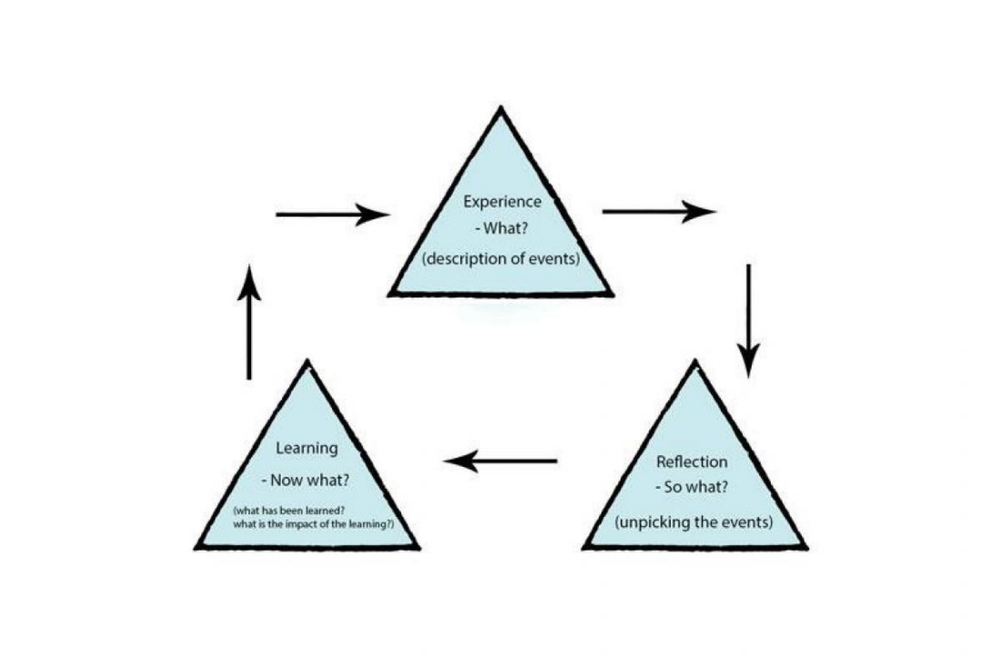
Boud et. Al. (1985)

