1. Executive summary
Summary of the entire document

2. Introduction
2.1 Report purpose
2.2 Background of the company

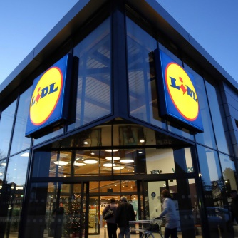
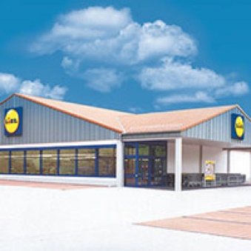
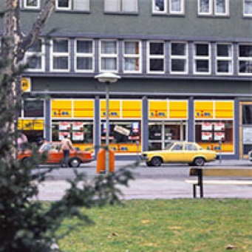
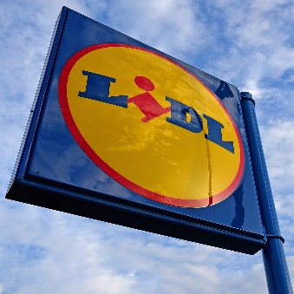
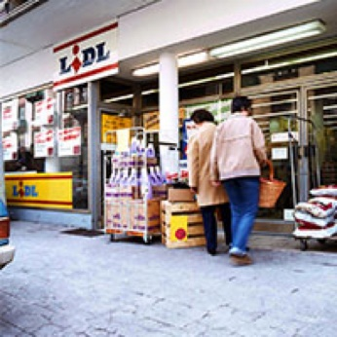
- 1970s
First Lidl store opens in Germany 1973, employing three people and stocking around 500 product lines. By 1979, Lidl open 6 more, taking total to 30 stores.
- 1980s
Lidl opens 300 stores across Germany. On average each store employing seven people and stocking around 900 product lines.
- 1990s
Lidl begins opening stores outside Germany, starting in France, and in 1994 Lidl open first UK store.
- 2000s
Lidl firmly establish themselves as leading retailers in the UK.
- 2017
Lidl opens in the U.S.

到2019年，利德尔公司在世界各地开办的连锁店分布图
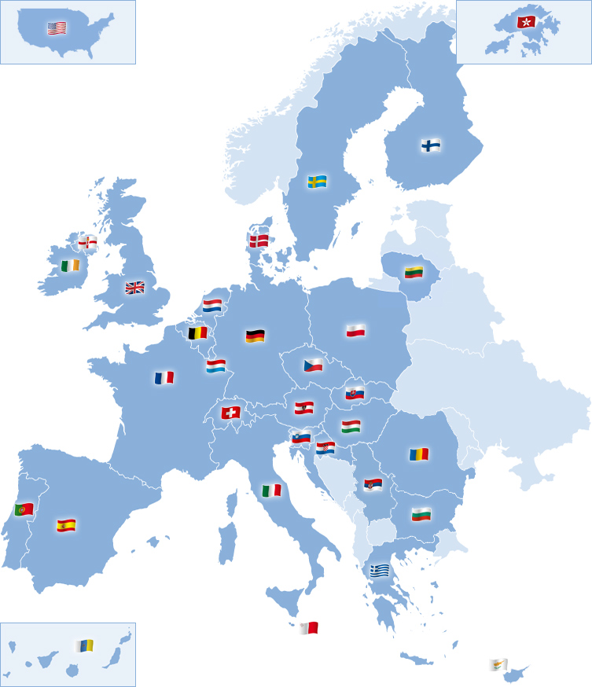

2.3 全球零售行业市场规模与竞争格局分析
美国零售行业杂志《STORES》(STORES Magazine)联合德勤日前发布2019年度全球零售商力量报告（Global Powers of Retailing 2019），榜单采用企业公布的2017年度公开数据(截至2018年6月的公司财政年度)。沃尔玛高居榜首，其他的零售商有，好市多、克罗格，施瓦斯集团等巨头。前十强中只有亚马逊一家电商企业。下面是2017.-2019年近三年来的著名零售商零售额统计图。

Stores magazine and Deloitte recently released the global powers of retailing 2019. The list uses the 2017 public data published by enterprises (the company's fiscal year as of June 2018). Wal Mart tops the list, with other retailers including Costco, Kroger and Schwarzenegger. Amazon is the only e-commerce company in the top ten. Below is the retail sales statistics of famous retailers in the past three years from 2017 to 2019.

从统计图中可以看出，沃尔玛以绝对的优势占据行业的首位，其他的几家零售商规模相当，彼此之间是强有力的竞争对手，企业要想在竞争中取得优势，运用正确的战略管理显得尤为重要。

It can be seen from the statistical chart that Wal-Mart takes the first place in the industry with absolute advantage, and several other retailers have the same scale, and they are strong competitors with each other. It is particularly important for enterprises to use correct strategic management if they want to gain advantage in the competition.

Definitions:
Strategy
Business level strategy
Competitive advantage
Porter’s generic strategies
Cost leadership
Differentiation
Focus

2.4 企业战略的要素

What is Strategy?

Strategy is the direction and scope of an organization over the long term, which achieves advantage in a changing environment through its configuration of resources and competences with the aim of fulfilling stakeholder expectations (Johnson et. Al. 2011).

Business level strategy

(How to develop in an industry) Is the company's secondary strategy, also known as competitive strategy. The business unit strategy is to compete effectively in their respective areas of business in response to the changing external environment.

Competitive advantage

In order to gain the advantage of market competition, enterprises in the formulation of strategy, according to the correct thinking method, a series of strategic management, so as to obtain the advantage of market competition.

2.5 Porter’s generic strategies

一、成本领先战略

2.5.1 Cost leadership

企业通过如改进设计性、优化供应链、降低人工费用、生产自动化等方法降低成本，使企业成本全面低于竞争对手的成本，从而获得竞争优势。
典型案例：
利德尔公司，首先是将重心放在软件研发上，将硬件生产全部外包，降低了建立工厂生产的成本。
Enterprises reduce costs by improving design, optimizing supply chain, reducing labor costs, production automation and other methods, so that the cost of enterprises is lower than the cost of competitors, so as to gain competitive advantage.
Typical cases:
Liddell company, first of all, focuses on software research and development, outsourcing all hardware production, reducing the cost of establishing factory production.

二、差异化战略

2.5.2 Differentiation

差异化战略的优势就是其独特性，这种战略的核心，就是使自身产品与众不同，为客户提供某种有独特性价值的产品或服务，如：产品差异化、服务差异化、形象差异化等，与竞争对手有明显的区别。差异性主要可以通过产品的性能、外观、服务等方面来体现。实现这种差异化战略的重要手段，就是研发和服务。
The advantage of differentiation strategy is its uniqueness. The core of this strategy is to make its own products different and provide customers with some products or services with unique value, such as product differentiation, service differentiation and image differentiation, which are obviously different from competitors. The difference can be mainly reflected by the product performance, appearance, service and other aspects. The important means to realize this differentiation strategy is R &amp; D and service.

利德尔公司采取的就是差异化战略，它十分注重研发，使得它的产品几乎在各个方面，比如在性能、设计、使用感受上都与其他电子产品有着较明显的差异。
Liddell company adopts the differentiation strategy. It attaches great importance to research and development, making its products have obvious differences with other electronic products in almost all aspects, such as performance, design and use experience.

三、聚焦战略

2.5.3 Focus

所谓聚焦战略，就是瞄准某个特定的细分市场，比如特定的地区或者特定的客户群体。利德尔公司，它并没有盲目地进入大众市场，而是开发高端小众市场，市场竞争没那么激烈，而且利润较高。在这里要说明一点，选择了聚焦战略后，你也可以同时选择建立差异化或低成本中的一种优势，这样你就能很好的占据市场了。

The so-called focus strategy is to target a specific market segment, such as a specific region or a specific customer group. Liddell company, instead of blindly entering the mass market, develops the high-end niche market. The market competition is not so fierce, and the profit is high. Here's a point to illustrate. After choosing the focus strategy, you can also choose to establish one of the advantages of differentiation or low cost at the same time, so that you can occupy the market well.

3. How does Lidl implement their strategy？ (3 examples) Main body

3.1 Lidl 对于产品的选择，它都是用自己的质量标准在全世界寻找供应商，标准合格即贴上自己的牌子。集中大批量采购，只要确定一种产品，一般只要一种型号，通常一批订货量都不低于5万件。（这使得采购、谈判、仓储和物流的成本都远远低于其它追求品种多样化的零售商。这也是其今年爆炸性增长的武器。）

3.1 Lidl's choice of products is to use its own quality standards to find suppliers all over the world. If the standards are qualified, it will stick its own brand. Centralized large-scale procurement, as long as a product is determined, generally as long as a model, usually a batch of orders are not less than 50000 pieces. (This makes the cost of procurement, negotiation, warehousing and logistics far lower than that of other retailers pursuing variety diversification. This is also the weapon of its explosive growth this year.)

3.2

3.3 Lidl是德国的连锁超市，特点是价格低廉。而这家零售业巨头在去年先后进军中国市场之后，摇身一变成了轻奢电商，价格不再亲民。
（德国之声中文网）由于中国的消费市场潜力巨大，德国零售业巨头Lidl（历德）在大约一年前进军中国市场，开设了网店，但是它的经营战略发生了转变。到了中国市场改走"轻奢"路线，主打的目标群体是具有一定经济实力，追求生活品质，愿意为了优质安全的食品和日用品而掏腰包的中国城市中产阶层。

3.3 Lidl is a chain supermarket in Germany, characterized by low price. After entering the Chinese market last year, the retail giant has transformed itself into a luxury e-commerce business and its price is no longer close to the people.
(voice of Germany Chinese website) due to the huge potential of China's consumer market, Lidl, a German retail giant, entered the Chinese market about a year ago and opened an online store, but its business strategy has changed. The main target group is the urban middle class in China who has certain economic strength, pursues quality of life and is willing to pay for high-quality and safe food and daily necessities.

4. Advantages and disadvantages of Lidl’s strategy

Advantages (3) + disadvantages (3)

5. Conclusion

6. Recommendation

7. References

