
Master of Business Administration
International Business pathway


Contemporary employability skills
Assessment 1: Individual report. Weight: 50%

Module name: Contemporary Employability Skills
Module code: LCMB7023
Lecturer name: Hoang Nguyen

Student name: Sanketkumar
Student ID: 2538532

Word count: 2660
Submission date:

AI use acknowledgement
I confirm that no artificial intelligence (AI) tools were used in the preparation, research, writing, or editing of this assignment. All ideas, analysis, and written content are my own work and have been completed independently in accordance with academic integrity requirements.

Table of Contents

TASK A: Socialisation, Identity & Business Activism 3
Traditional Onboarding versus Strategic Organisational Socialisation 3
Structured Socialisation Framework for Helios Urban Mobility 4
Mechanisms to Cultivate Organisational Identification, Ethical Professionalism, and the Business Activist Mindset 6
TASK B: Job Design 7
Rethinking Job Design for Strategic Renewal 7
Applying the Job Characteristics Model 8
Integrating Job Crafting Theory into Everyday Work 9
Developing a Skills-Based Architecture and Internal Talent Marketplace 10
Stimulating Intrinsic Motivation and Supporting Continuous Innovation 11
TASK C: Reflective report 12
Using AI as a Decision-Support Tool While Preserving Critical Human Judgement 12
Personal capability development plan 13
Reference List 15

TASK A: Socialisation, Identity & Business Activism

Traditional Onboarding versus Strategic Organisational Socialisation
Mostly, onboarding is an administrative orientation, compliance and job initiation process. New employees usually are provided with details on organisational policies, employment paperwork, workplace procedures, and fundamental operations in the first few days. This can help with legal compliance and help staff to get going but may not account for more advanced psychological and social dynamics that need to be engaged in order to build commitment, organisational identity and engagement (Stone et al., 2024). This suggests that technical skills can be learned without an understanding of the value of the organisation, the priorities and expectations of the team. At Helios Urban Mobility (HUM) – an innovative company that relies on multidisciplinary working between London, Berlin and Singapore, a traditional induction process is not enough since staff members need to be quickly integrated into a vibrant and knowledge sharing environment.
But strategic organisational socialisation is a broader approach as it takes a longer-term orientation event rather than a single event to view the process of employee's socialisation. The organisational socialisation theory presented by Van Maanen and Schein reveals that structured and institutionalised socialisation techniques greatly mitigate uncertainty and speed up the adjustment process for employees (Stewart and Brown, 2019). A traditional onboarding has a limitation as it comes to the concept of Psychological Contract. Then there are the expectations that the employees have when they enter into a company for their growth, management support, recognition, fairness and learning experience. These “soft” expectations are not addressed in the standard induction, and could jeopardise the Psychological Contract. These events may result in lower morale, staff loyalty, confidence in management, and/or the best young people leaving the organization in hopes of making a difference in their careers and developing, building and investing in themselves (Searle and Rice, 2025). These expectations are met by strategic organisational socialisation, which involves creating open communication, setting clear expectations, having structured career dialogues and providing consistent managerial support throughout the employee's relationship. This will make the employee feel a sense of responsibility towards the organisation and hence increase his or her engagement and reduce turnover.

Structured Socialisation Framework for Helios Urban Mobility
There should be three phases of a structured socialisation process: prior to you boarding, the first 90 days and the first year. By using a staged approach it is possible to build up the competence, confidence and commitment of employees over time and in a continuous manner, enabling them to learn as they go along. The pre-boarding stage should start right after the acceptance of employment (Chowdhury et al., 2022). New staff members should be greeted and introduced to HUM's Mission, strategic goals, sustainability goals and organisational values and future work colleagues and to digital organisational learning resources. Prior to the onset of a new employee's tenure in an organization, it is important to find a mentor for them to work with as well as a cultural ambassador (Birtch, Cai and Chiang, 2024). Structured learning during the first 90 days should be a blend of the formal and practical aspects of work. Technology training and project on-the-job training related to the employee's project, cross functional project teams, innovation workshops and regular on-the-job training with line managers for all employees. The emphasis of the first year of development should be on building capacity and commitment of the organisation.
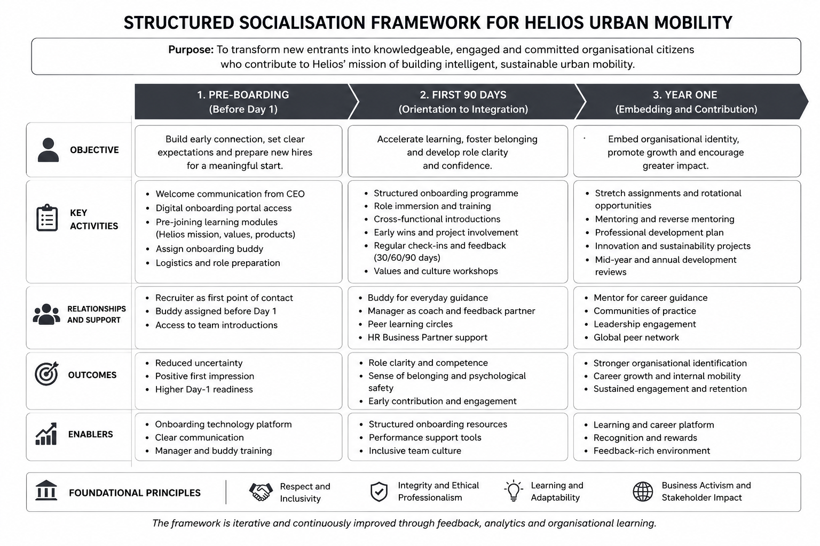
Figure 1: Structured Socialisation Framework
(Source: self-developed)
Career development plan should align the employee's career development plan with the needs of the organisation. Opportunity to participate in leadership development, innovation labs, reverse mentoring and international projects with colleagues from London, Berlin and Singapore. Career conversations should take place at least quarterly to review professional development, wellbeing, contribution to the organisation and to discuss opportunities for the future (McDonald and Hite, 2023). A structured approach is suitable for HUM, since it is geared towards changing the socialisation from HR to strategic activity. The ongoing development will minimize uncertainty, improve organisation learning, speed up the productivity growth, help retain highly skilled graduates in a fast changing technological environment.

Mechanisms to Cultivate Organisational Identification, Ethical Professionalism, and the Business Activist Mindset
Creating a strong organisational identity should encompass a frame of feeling successful when the organisation is successful and vice versa for employees. The organisational vision of which HUM is a part, needs to be clearly communicated and focused on the strengthening of the urban sustainability, mobility and quality of life. It is important to continually champion organisational values through story, communication and celebrating the employee contribution (Marchington et al., 2025). Staff should have the sense of belonging when working towards organisational outcomes including through cross functional working, employee innovation forums and as part of decision making.
Rather than being a compliance measure, ethical professionalism should be a part of employee development. Realistic scenarios with artificial intelligence, data privacy, sustainability, environmental responsibility and the accountability of stakeholders should be part of ethical decision making workshops (Ulrich et al., 2017). Ethical leadership should be seen in the way leaders act in their work, the openness and transparency of government and uniformity of organization's action. Ethical conduct, collaboration, inclusion and responsible innovation performance measures are measures of performance that should be included in performance management systems.
Workers need to move beyond the rationalities of efficient operation to one that creates value for other actors to build an orientation to business activism. Ulrich's HR Business Partner journey is important to bear in mind as a reminder of the value of building employees who can influence on business transformation and organisational strategy as a business partner (Boxall et al., 2007). HUM employees, from top to bottom, are encouraged to consider how they can improve HUM's sustainability, how they can increase HUM's ability to meet customer needs, how they can increase HUM's ability to build community partnerships and how they can increase HUM's ability to be innovative in their work. Stakeholder capitalism is more than just metrics of shareholder value; it's about generating sustainable economic, environmental and social results (Shahrokhi et al., 2022). Therefore HUM should try to encourage employees to participate in mobility programmes in the community, in innovations in the environment and with local governments or educational institutes. Performance indicators should not only be financial, but also need to be related to the outputs of the innovation, sustainability, stakeholder management and organisational citizenship.
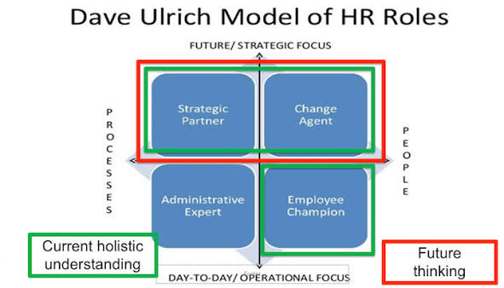
Figure 2: Ulrich's model of HR Roles
(Source: thepeoplespace.com, 2023)

TASK B: Job Design

Rethinking Job Design for Strategic Renewal
Helios Urban Mobility (HUM) exists in an extremely dynamic environment defined by artificial intelligence, smart infrastructure, sustainable mobility and constant technological advances. Therefore, the traditional “job design” practices that emphasize job roles, job scope and decision making will not do the trick in organizations with the need to be more agile and to engage employees (Henderson and Sowa, 2022). Greater autonomy for employees, upskilling and flexibility in career path required due to reduced engagement of employees, high graduate attrition of high potential employees and longer ramp up time for employees. Therefore, the Job Characteristics Model (JCM), Job Crafting Theory and a skills-based design and architecture that features an internal talent marketplace is a novel job design technique that should be adopted (Oh, Han and Han, 2024).

Applying the Job Characteristics Model
Hackman and Oldham's Job Characteristics Model is a complete model to redesign jobs to motivate and improve employee job performances. The model involves a cause-and-effect relationship between the five key job dimensions – skill variety, task identity, task significance, autonomy, feedback – and the psychological job conditions of the person, which in turn influences the person's motivation, satisfaction and organizational commitment (Oh, Han and Han, 2024). In HUM, expand skills variety by designing jobs that require collaboration among different disciplines, evaluating customer needs for sustainability, and engaging in technical aspects (Armstrong, 2021). For example, software engineers should also be involved in projects on innovation in cooperation with transport planners and environmental specialists, and software engineering in user centred design sessions and presentations to the clients. The responsibility for innovation cycles should include all parts of the cycle, not just problem solving, from problem identification through to problem solving, testing and implementation. The importance of task significance cannot be overlooked because these technologies, which are developed by HUM, will improve the mobility, environment and public infrastructure of cities (Rui and Othengrafen, 2023). Flexibility in project management, decision making and performance management and be goal oriented. Staff to be empowered to plan their work, prioritise and suggest innovative ideas within agreed strategic goals. Autonomy paves the way for creativity, and quicker adaptation of the organisation to new technology opportunities. Lastly, give ongoing feedback, rather than an annual appraisal.
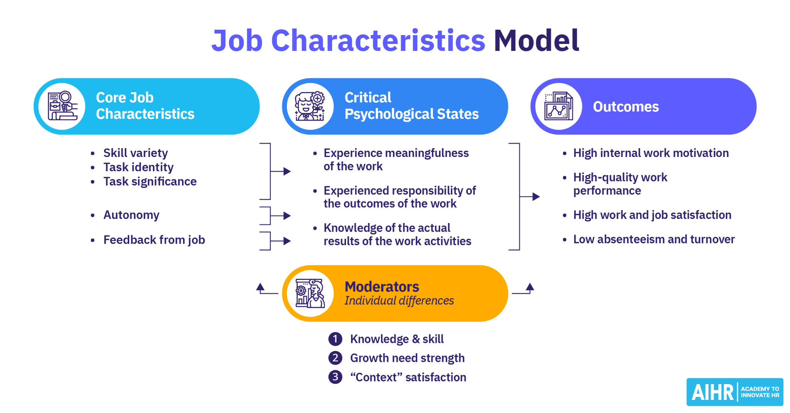
Figure 3: Job Characteristics Model
(Source: Lucas, 2024)

Integrating Job Crafting Theory into Everyday Work
This is Job Crafting Theory, which means that the formal job design gives the structure of the organisation, and the employees are active players, who continuously mold their experiences on the job. HUM should remind workers that a job description can change over time, and that perhaps some changes need to be made to their job to incorporate their strengths, interests and career goals (Hewett and Meier‐Barthold, 2026). It should be provided to the employees to carry out innovation projects, sustainability projects or international projects, in addition to their job scope. There is a need for relational crafting to be encouraged using collaborative networks which link employees across departments and international offices. Staff should be given the opportunity to develop strong professional relationships with colleagues across a range of disciplines in the engineering, AI, customer success, sustainability and strategic planning departments (Rui and Othengrafen, 2023).This broader perspective will help to reinforce organisational purpose and in turn, organisation commitment and engagement.
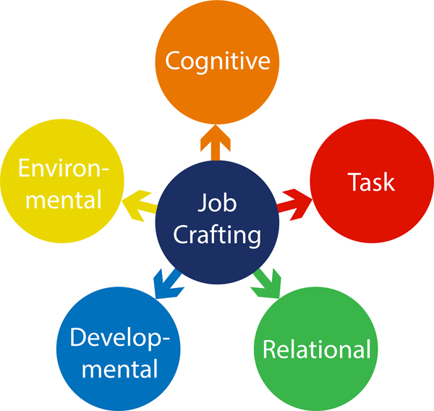
Figure 4: Job Crafting Theory
(Source: delphis.org.uk, 2020)

Developing a Skills-Based Architecture and Internal Talent Marketplace
Organisational structures are often rigid and consistent based on job roles of employees, which is difficult to move people around and difficult to utilise new skills and abilities. While the skills-based architecture is job-centric, the skills-based approach is skills recognition, discovery and utilization-centric, with regard to the various needs within the organization (Denuzzo, 2024). HUM should develop and adopt a structure of Digital Skills that will clearly define Digital Skills for an Organisation through the linkage of the 5 pillars of Digital Skills (technical, behavioural, leadership, sustainability and innovation). When recruiting employees to participate in various short-term projects, innovation challenges, inter-country assignments, mentoring or cross-functional projects and partnerships to support this architecture, an internal talent marketplace can be used. AI can identify the skills of its workers, their professional goals and learning goals and match them to internal opportunities, thereby maximizing the use of talent and its development (Babashahi et al., 2024). The London-based artificial intelligence specialist, for instance, could be offered to relocate to Berlin where he or she can contribute to an IT project related to sustainability analytics, while the Singapore-based transport systems engineer could be offered to work remotely from the London office on a project on smart infrastructure.

Stimulating Intrinsic Motivation and Supporting Continuous Innovation
The proposed solution reflects the design of the job in line with intrinsic motivation aspects that meet the needs of the employees, namely competence, autonomy, relatedness and purpose. The ongoing learning for staff in their roles, cross-disciplinary initiatives, and a diversity of organisational challenges make staff more capable. The more skills a member of staff acquires the more confident they are of these, and they can be given more and more difficult skills as they move up the career ladder (Denuzzo, 2024). Autonomy is achieved by decentralising decision making, being flexible in job participation and having opportunities to design parts of a job which are significant to the employee. The greater the control over the way the work is carried out, the less hierarchical approvals and more initiative, experimentation and accountability are needed. Relatedness is created through collaborative project teams, mentoring, international assignments and employees in internal talent marketplaces with various departments and locations. Interpersonal relationship enhances knowledge sharing, organises identification and group problem solving.
Purpose has a set of repeated linkages with overall work of HUM, which enable sustainable urban mobility improvement and value generation for governments, communities and society (Babashahi et al., 2024). The greater the number of employees that recognise the social contribution, the more likely they are to be committed to the organisation, to show discretionary effort, and to be long-term employees. Staff members are encouraged to be innovative, to work inter-branch and to develop skills in two areas at once and to foster a culture of innovation. It's possible to find innovative solutions in multidisciplinary teams and that internal employee markets can be a source of learning and new ideas - employee may be facing new challenges in the company.

TASK C: Reflective report

Using AI as a Decision-Support Tool While Preserving Critical Human Judgement
Using AI to aid in Decision Support, whilst never neglecting the importance of human judgement. With its ability to analyse vast amounts of data and gain insights from it, AI systems can enhance the quality and timeliness of HR decision making, resulting in a more empowered workforce. AI can analyse large amounts of data, better understand the patterns in the workforce and provide insights based on that data, which can improve the quality and timeliness of HR decisions and ultimately lead to a more empowered workforce (Ayanponle, Okatta and Ajiga, 2022). As an HR I will leverage AI as a decision-making aid as opposed to a decision-maker. AI can help to analyse employee engagement data, predict who may be at risk of leaving the business, pinpoint skills gaps, and suggest appropriate learning opportunities, for instance. The abilities can be useful for boosting efficiency, or for making strategy decisions. However, when it comes to AI systems, I do know that there's a potential for bias in the data, or even if there is no data, or flaws in the algorithm. So, I'm going to spend some time critically evaluating the suggestions that AI can make, keeping in mind the organizational context, morality, employee well-being and legal requirements when deciding (Nishant, Schneckenberg and Ravishankar, 2024). But, where complex situations exist in the workplace, with cultural, emotional, diversity and individual nuances, human judgment is still very important and can't be captured by algorithm. I will also try to understand by asking questions that differ from organisational values and/or professional ethics, and know the operation of the AI systems for recommendations. I am able to successfully integrate critical and reflective thinking, stakeholder engagement and professional experience with AI-driven insights to inform fair, informed and balanced HR decisions. This will ensure that technology complements and doesn't supplant human knowledge, fostering responsible leadership and trust, accountability and ethics in the growing digital workplace.

Personal capability development plan
Development Area | Development Activities | Expected Employability Outcome
Data Literacy | I will strengthen my ability to analyse and interpret HR data by completing professional courses in HR analytics, Power BI, Excel, and basic data visualisation. | Improved capability to make data-driven HR decisions, interpret workforce trends, and provide strategic recommendations that contribute to organisational performance and business sustainability.
AI Augmentation in HR | I will develop practical knowledge of AI-powered HR technologies, including recruitment analytics, workforce planning, predictive analytics, and generative AI applications. | Enhanced ability to combine technological innovation with human judgement, enabling responsible AI adoption that improves efficiency, employee experience, and strategic HR decision-making.
Strategic Influencing Skills | I will improve communication, negotiation, stakeholder management, and presentation skills through leadership workshops, collaborative projects, networking opportunities, and reflective practice. | Greater confidence in influencing senior leaders, facilitating organisational change, building collaborative relationships, and supporting strategic business objectives through effective communication and leadership.
Global Mobility Awareness | I will broaden my understanding of international HRM by studying cross-cultural management, global employment practices, international labour regulations, and diversity management. | Stronger capability to manage culturally diverse workforces, support international talent mobility, and contribute effectively to global organisations operating across multiple countries and business environments.

Reference List
Armstrong, M., (2021). Armstrong's Handbook of Learning and Development: A Guide to the Theory and Practice of L&D. Kogan Page Publishers. https://books.google.com/books?hl=en&lr=&id=MXRJEAAAQBAJ&oi=fnd&pg=PP1&dq=Armstrong,+M.+(2021).+Armstrong%E2%80%99s+Handbook+of+Human+Resource+Management+Practice+(15th+Ed.).+Kogan+Page.&ots=j4co40GM0e&sig=ZvHJbHM9In5276NPDOJY7A2TTvU
Ayanponle, L., Okatta, C.G. and Ajiga, D., (2022). AI-powered HR analytics: Transforming workforce optimization and decision-making. International Journal of Science and Research Archive, 5(2), pp.338-346. https://www.researchgate.net/profile/Daniel-Ajiga/publication/387074554_AI-powered_HR_analytics_Transforming_workforce_optimization_and_decision-making/links/679ac89a96e7fb48b9a8b4d3/AI-powered-HR-analytics-Transforming-workforce-optimization-and-decision-making.pdf
Babashahi, L., Barbosa, C.E., Lima, Y., Lyra, A., Salazar, H., Argôlo, M., Almeida, M.A.D. and Souza, J.M.D., (2024). AI in the workplace: A systematic review of skill transformation in the industry. Administrative Sciences, 14(6), p.127. https://www.mdpi.com/2076-3387/14/6/127
Birtch, T.A., Cai, Z. and Chiang, F.F., (2024). Effects of formal mentoring support on newcomer–protégé affective organizational commitment: A self‐concept‐based perspective. Human Resource Management, 63(2), pp.225-242. https://repository.ceibs.cn/files/47763271/Human_Resource_Management_-_2023_-_Birtch_-_Effects_of_formal_mentoring_support_on_newcomer_prot_g_affective.pdf
Boxall, P.F., Purcell, J. and Wright, P.M. eds., (2007). The Oxford handbook of human resource management. Oxford Handbooks Online. https://books.google.com/books?hl=en&lr=&id=-_Ab7aS7-NUC&oi=fnd&pg=PR5&dq=Boxall,+P.,+Purcell,+J.,+%26amp%3B+Wright,+P.+(2022).+The+Oxford+Handbook+of+Human+Resource+Management.+Oxford+University+Press.&ots=HoWY_KKPKJ&sig=wEfmmGnEH0yZjzsSAFpb2IRKFhM
Chowdhury, S., Budhwar, P., Dey, P.K., Joel-Edgar, S. and Abadie, A., (2022). AI-employee collaboration and business performance: Integrating knowledge-based view, socio-technical systems and organisational socialisation framework. Journal of business research, 144, pp.31-49. https://nul.repository.guildhe.ac.uk/id/eprint/1138/1/1-s2.0-S0148296322000819-main.pdf
delphis.org.uk (2020) Delphis Learning. Available at: https://delphis.org.uk/peak-performance/job-crafting-for-managers/ (Accessed: 14 July 2026).
Denuzzo, W., (2024). What's in Store Among Skills-Based Strategies: Internal talent marketplaces are evolving into a valuable architecture for talent mobility and development within organizations. TD Magazine, 78(3), pp.44-50. https://go.gale.com/ps/i.do?id=GALE%7CA786741838&sid=googleScholar&v=2.1&it=r&linkaccess=abs&issn=23740663&p=AONE&sw=w
Henderson, A.C. and Sowa, J.E., (2022). Job design and motivation: crafting the work of the public sector. In Research handbook on motivation in public administration (pp. 234-248). Edward Elgar Publishing. https://www.elgaronline.com/abstract/edcoll/9781789906790/9781789906790.00023.xml
Hewett, R. and Meier‐Barthold, M., (2026). Embracing complexity in HRM research: A call for system and process perspectives. Human Resource Management. https://onlinelibrary.wiley.com/doi/pdf/10.1002/hrm.70060
Lucas, S. (2024) Job Characteristics Model: A Practical Guide, AIHR. Available at: https://www.aihr.com/blog/job-characteristics-model/ (Accessed: 14 July 2026).
Marchington, M., Wilkinson, A., Donnelly, R. and Kynighou, A., (2025). Human resource management at work: The definitive guide. Kogan Page Publishers. https://books.google.com/books?hl=en&lr=&id=nctJEQAAQBAJ&oi=fnd&pg=PP1&dq=Marchington,+M.+%26amp%3B+Wilkinson,+A.+(2020).+Human+Resource+Management+at+Work+(7th+Ed.).+CIPD.&ots=hkfSM4tPXV&sig=FZuQkkUqi6SG3SIGErqGRfOhgQU
McDonald, K.S. and Hite, L.M., (2023). Career development: A human resource development perspective. Routledge. https://api.taylorfrancis.com/content/books/mono/download?identifierName=doi&identifierValue=10.4324/9781003246381&type=googlepdf
Nishant, R., Schneckenberg, D. and Ravishankar, M.N., (2024). The formal rationality of artificial intelligence-based algorithms and the problem of bias. Journal of Information Technology, 39(1), pp.19-40. https://journals.sagepub.com/doi/pdf/10.1177/02683962231176842
Oh, J., Han, S.J. and Han, S.H., (2024). Linking a growth mindset, job crafting and in-role performance via meaningfulness at work: a moderated mediation model. Journal of Workplace Learning, 36(5), pp.364-381. https://www.emerald.com/jwl/article/36/5/364/1213114
Rui, J. and Othengrafen, F., (2023). Examining the role of innovative streets in enhancing urban mobility and livability for sustainable urban transition: A review. Sustainability, 15(7), p.5709. https://www.mdpi.com/2071-1050/15/7/5709
Searle, R.H. and Rice, C., (2025). Trust, and high control: an exploratory study of Counterproductive Work Behaviour in a high security organization. European Journal of Work and Organizational Psychology, 34(3), pp.392-402. https://www.tandfonline.com/doi/pdf/10.1080/1359432X.2024.2344870
Shahrokhi, M., Parhizgari, A.M., Hashemijoo, M., Okafor, C.E., Nishikawa, Y. and Dastan, A., (2022). Corporate governance and stakeholder capitalism. Managerial Finance, 48(8), pp.1123-1136. https://www.researchgate.net/profile/Manuchehr-Shahrokhi/publication/358935200_Corporate_governance_and_stakeholder_capitalism/links/624d3dd0b0cee02d69542cfe/Corporate-governance-and-stakeholder-capitalism.pdf?origin=journalDetail&_tp=eyJwYWdlIjoiam91cm5hbERldGFpbCJ9
Stewart, G.L. and Brown, K.G., (2019). Human resource management. John Wiley & Sons. http://www.ir.harambeeuniversity.edu.et/bitstream/handle/123456789/1637/Human%20Resource%20Management%2C%20Second%20Edition%20%28%20PDFDrive.com%20%29.pdf?sequence=1&isAllowed=y
Stone, R.J., Cox, A., Gavin, M. and Carpini, J., (2024). Human resource management. John Wiley & Sons. https://books.google.com/books?hl=en&lr=&id=JS_TEAAAQBAJ&oi=fnd&pg=PR12&dq=Stone,+R.J.,+Cox,+A.,+%26amp%3B+Gavin,+M.+(2020).+Human+Resource+Management.+John+Wiley+%26amp%3B+Sons.&ots=rKTsgmLdNw&sig=MnALvMlYIlXcOQi4fFC67m9kgQk
thepeoplespace.com (2023) Five shortfalls of the HR business partner model | The People Space. Available at: https://www.thepeoplespace.com/insights/ideas/five-shortfalls-hr-business-partner-model (Accessed: 14 July 2026).
Ulrich, D., Kryscynski, D., Brockbank, W. and Ulrich, M., (2017). Victory through organization: Why the war for talent is failing your company and what you can do about it. New York: McGraw-Hill. https://scholar.valpo.edu/cgi/viewcontent.cgi?referer=&httpsredir=1&article=1212&context=jvbl

