Digital Forensics Analysis – ACCA7031
Student Name: Thomas Ellis Bennett
Student Number: 2003893
Lecturer: Dr Nitheesh Kaliyamurthy
Submission Date: 12th January 2024



Task 1

Introduction
Digital forensics is a specific field under the forensic science umbrella. This form of forensics focuses on the collection, preservation, examination, and presentation of digital evidence found on electronic devices. Technology is becoming increasingly intertwined with our lives so the need for the ability to analyse digital footprints is crucial for various sectors.
Understanding the intricacies of digital trails is important in a world where digital transactions, communications, and storage are a key part of our day to day lives. Whether it's for criminal investigations or cyber breach analyses, digital forensics plays a pivotal role in delivering justice, ensuring security, and upholding accountability in our interconnected world.

Current state of the field
Digital forensics is the application of computer science in an investigation process through the examination of digital evidence [1]. The digital forensics process is made up of four key areas. Collection involves gathering the digital evidence from a variety of sources [2] Preservation is the process of maintaining the integrity of the collected data in a secure manner. Examination is a detailed analysis of the collected evidence to uncover relevant information. Presentation involves summarising, interpreting, and presenting any findings in a clear and concise format often in a legal setting[3].
The use of digital forensics has increasingly been used in legal proceedings as it provides an admissible form of evidence which can be used in court. This evidence can range from digital footprints, documents, photographs and just about any form of data found on a device that can prove or disprove a legal claim [4]. To ensure the integrity of the data holds up in court it is important to maintain a chain of custody. The chain of custody is essentially a way of tracking the evidence from its initial collection until the point of presentation in court, this is usually done through a method of signing documentation when evidence is passed from person to person. It is extremely important for the forensics experts to adhere to legal standards and regulations set in place by law when conducting the forensics process[5].

Intersection of Digital Forensics and Cybersecurity
The focus of digital forensics is to identify, preserve, analyse, and present digital evidence after an incident has occurred. This can be achieved through employing standardised methodologies to ensure the admissibility of evidence in legal proceedings. Digital forensics typically addresses legal aspects, looking at the reason as to ‘who’, ‘how’, and ‘why’ behind a cyber incident [6]. Cybersecurity, on the other hand, is the initial protection of systems, networks, and data from cyber threats. This method of protection utilises risk management, threat prevention, and maintaining the ‘C.I.A’ triad (Confidentiality, Integrity, and Availability) of information. Data protection strategies are incorporated such as firewalls, anti-virus programs, encryption, and employee training [6]. Although both fields have their differences, they complement each other well. By implementing the preventative cybersecurity measures risks of breaches are reduced. Digital forensics provides insights post-breach to enhance future security. The use of computer forensics aids in understanding types of attacks and previous vulnerabilities that have been exploited, allowing cybersecurity specialists to enhance their security measures [7]. Real world examples demonstrate how forensic analysis can reveal new malware signatures or attack patterns. Preventative measures to these attacks are then incorporated into cybers security defences. This relationship is evolving with technological advancements, necessitating continuous adaptation in both fields to combat sophisticated cyber threats.

Emerging Trends
Emerging trends are significantly transforming the landscape of digital forensics, driven by rapid societal shifts and technological advancements. Digital forensic methodologies are evolving to meet new challenges and opportunities. One notable area of growth is in mobile app forensics, from the widespread use of smartphones globally. This field focuses on the extraction and analysis of critical data from mobile applications, catering to the growing demand for specialized forensic capabilities in an increasingly mobile oriented world. Vital evidence such as chat logs, geolocation data, and call records can be recovered and analysed, offering insights in various investigations [8].
Cloud forensics is an emerging trend within the digital forensics landscape. As highlighted in the EC-council's whitepaper on current trends and challenges in cloud forensics, this field confronts unique challenges. These include the dynamic allocation of resources, the utilisation of virtualisation, and the distributed nature of data storage in cloud environments. Traditional digital forensics methods are less effective in these conditions, due to their design for more static and centralised data sources. This means there is a pressing need for advancements and adaptations in forensic techniques to ensure their effectiveness in analysing cloud-based systems.
The key points show the need for employing novel tools for investigating incidents in cloud-based environments and preserving relevant evidence. The dynamic nature of cloud computing means data is susceptible to being rapidly lost or overwritten, highlighting the crucial role of advanced cloud-based preservation techniques. The whitepaper also draws attention to the trends of containerisation and serverless computing. These developments will likely introduce new challenges for forensic investigators in the future[9].
Advancements in Artificial Intelligence (AI) and Machine Learning (ML) are significantly elevating the field of cyber forensic investigations. The capacity for AI to sift through extensive data sets enables the rapid detection of threats and streamlines the investigation process. This includes the examination of network traffic from multiple sources to track the source of cyberattacks. Machine Learning utilises algorithms to independently evolve from data input, this slowly enhances its functionality without being explicitly programmed. Within cyber forensics, ML's role is critical in sorting and analysing digital data. It's instrumental in detecting potential cyberattack patterns in network traffic and in the automated analysis of malware[10]. A comprehensive study, which assessed 608 primary studies until December 2021, emphasised the significance of ML in digital forensics. Particularly it noted MLs contribution to the precision of evidence gathering and evaluation. Despite its proven efficiency, ML has certain challenges including the requirement for extensive training and large data sets[11].

Key Challenges
In digital forensics practitioners face several key challenges. Encryption, legal and jurisdictional issues stand out as particularly significant. Encryption presents a major obstacle in the field of digital forensics. The core challenge involves the retrieval and examination of encrypted data within investigative contexts. Professionals in digital forensics are often involved in scenarios with encrypted files, hard drives, or communication logs, which can be pivotal to unravelling evidence relating to criminal investigations. The process of accessing this encrypted information while preserving its integrity to be admissible in court is intricate and demands careful handling. The article titled "The growing impact of full disk encryption on digital forensics" explores how encryption significantly impedes digital forensic investigations. Full disk encryption (FDE) which is commonly used for data privacy, poses a major hurdle for forensic professionals. It encrypts the entire data on a storage device requiring specific credentials to access it. This situation creates a barrier for forensic experts as vital evidence in legal cases can potentially become unreachable, even with sophisticated forensic technology[12].
Another prevalent challenge in digital forensics is posed by cross-border investigations and data access. The publication "SoK: cross-border criminal investigations and digital evidence" from Oxford Academic examines the complex legal issues encountered in international digital investigations. It focuses on the challenges law enforcement faces when accessing digital evidence across different legal territories. The study emphasizes the tension between national sovereignty and the need for global collaboration in solving crimes. It draws attention to the obstacles posed by diverse legal frameworks and privacy laws, which can lessen the effectiveness of digital evidence. The changing nature of technology and data storage further complicates this scenario. It presents a continuously shifting and demanding environment for both legal experts and investigators. This article serves as an insightful guide to the legal issues and suggested approaches in the field of cross-border digital forensic investigations[13].

National and International Job Markets
There is a rising need for digital forensic specialists, both domestically and globally, due to the growing prevalence of cybercrimes and the crucial importance of digital evidence in criminal court cases. According to projections by the US Bureau of Labor Statistics, the job market for digital forensic science is expected to expand by 16% from 2020 to 2030, a rate that is double the average for all professions. This increase is linked to the growing reliance on digital devices, with digital components now being involved in over 90% of criminal activities[14]. They are essential in data recovery, digital event reconstruction, and pinpointing weaknesses in digital systems. Their duties also involve working alongside law enforcement and compliance groups. Due to the complexities of this profession it generally requires 5-6 years to become a computer forensic analyst, including earning an appropriate bachelor's degree and acquiring relevant work experience in the cyber-digital arena. The salaries for digital forensics analysts show a broad range, from $59,000 to $132,000, influenced by factors such as educational background, certifications, work experience, skills, and geographical location[15].

Task 2

Introduction
In digital forensics, the success and speed of investigations heavily depend on the tools that investigators use. These tools are ever-changing, adapting to the constantly shifting digital environment. They vary in functionalities from simple data retrieval to complex analysis of digital evidence. This review examines the present capabilities and features of digital forensic tools. It also offers a comparative analysis of both open-source and proprietary forensic tools, underlining their individual advantages and drawbacks. The focus of this discussion is on practical application, with insights from tools used in academic settings, backed by scholarly literature and industry reports.

Current state of Digital Forensics Tools
The digital forensics landscape is characterized by its large selection of advanced tools designed to meet the challenges of modern investigations. Tools are used in many scenarios like data recover, mobile forensics, network analysis, and cloud data acquisitions. This reflects the variety of digital forensic data sources and the need for an array of different tools for different situations. There are many advancements in the tools being used such as AI and machine learning for data analysis and enhanced encryption-breaking capabilities for more complex investigations. The continuously evolving field emphasises the need for powerful tools that can be adapted to tackle complex forensic scenarios.

Open-source tools
Open-source digital forensics tools are publicly accessible tools. This means that experts around the world can contribute towards them to improve their features and functionality. This allows for a more collaborative nature, resulting in rapid updates to a wide variety of tools. Open-source tools cater to a wide variety of digital forensics scenarios such as data recovery, analysis, and reporting.

Autopsy/Sleuth Kit
The autopsy/sleuth kit is now well-known within the field of digital forensics. Significantly increasing the accessibility of the command-line-driven Sleuth Kit. Autopsy offers a graphical user interface. The modular design of the suite makes it possible to add plugins for additional functionality. The program is regularly updated by its community to guarantee that it stays compatible with newly developed file systems and technologies. It has established itself as an essential tool in many law enforcement investigations because of its strong and trustworthy analytic capabilities [16].

Wireshark
Wireshark is utilised for analysis of network protocols and is considered one of the essential tools for network forensics. Its deep inspection capabilities and wide variation of protocol support sets it out as a favourite for forensic investigators. There is a need for a technical understanding of network protocols when using this tool but when used correctly it proves to be a powerful addition to an investigator’s arsenal. As an open-source tool there is a lot of community support behind Wireshark, there are frequent updates and an extensive library of plugins available. These are some of the reasons that Wireshark proves to be pivotal in the analysis of network related incidents in corporate and legal scenarios[17], [18].

Volatility
Volatility is an opensource framework used for memory forensics. Its primary use is for the analysis of volatile data (RAM). Like Wireshark this tool also requires a steep learning curve and extensive knowledge in its niche field. This is due to the tool being command-line based resulting in it taking some time to learn, however it proves to be an extremely powerful tool in the right hands. Like the other open source tools the community behind Volatility are active, meaning that the tool receives regular updates to adapt to new artifacts and memory structures. Volatility has proven itself to be an effective tool in understanding the characteristics of malware and system intrusions [19].
Each of these open-source tools reflect the commitment of the communities behind them in creating powerful solutions for forensic investigators. Their continued development and real-world application in notable cases show the significance and reliability of open-source tools in the forensic domain.

Commercial Forensics tools
Companies create proprietary commercial forensic tools for digital investigation and cybersecurity. They are highly regarded for their advanced features, reliability, and dedicated customer support. These tools are often used in legal, corporate, and law enforcement environments, offering specialised functionalities that adhere to professional standards.

Encase
Encase is a commercial tool know for its comprehensive data investigation capabilities. Encase is widely respected in the digital forensics’ community, due to its robust features in acquiring and analysing digital data from a variety of sources. One of the main reasons digital investigators turn to encase is because of its reliability due to its long history of court validations. The customer support is highly rated, and the tools receives regular updates to stay up to date. Encase showcases advanced data recovery techniques that are not found in open-source tools[20], [21].

FTK (Forensics Toolkit)
FTK is another commercial forensics tool which is recognised for its processing speed and ability to handle large quantities of data at one time. Some of FTK’s features include decryption, password recovery, data visualisation, just to name a few of its extensive list of functions. Like Encase customer support is another strong attribute to FTK with extensive training and certification available. FTK can be integrated with a plethora of AccessData (the company behind FTK) tools making it a great choice for comprehensive investigations[22].

Cellebrite UFED
Cellebrite’s UFED is acknowledged for its superior capabilities in mobile forensics. Specifically in extracting, decoding, and analysing data from various mobile devices. It is valued for its consistent updates and support for new devices. This is crucial for modern investigative needs. The tool is distinctive for its ability to access locked and encrypted devices, surpassing many open-source alternatives. Like the previously discussed commercial tools, Cellebrite has a robust customer support. It offers comprehensive training and benefits from a vast global community. These features make UFED a vital asset for understanding complex digital evidence, particularly in tackling encrypted or inaccessible devices[23].
The commercial tools discussed offer specialised features that will often be used in high stakes forensic investigation environments. The use of commercial tools comes with the reliability and dedicated customer support making them valuable assets in the industry.

Comparison of Open-source vs Commercial tools
The open-source tools that we have just investigated are often community driven tools that offer a wide range of adaptability. These feature rich tools offer a variety of functionality for digital investigations. These tools often necessitate technical expertise for effective use. However, unlike their commercial counterparts, they lack the accompanying customer support and training opportunities that facilitate easier usage and understanding. The commercial tools such as encase, FTK and UFED are all known for their advanced features and customer support which is not as present in the open-source tools. It is important to remember that both sets of tools are important, and the best forensics investigators will utilise all types of tools to have a more comprehensive investigation.

Task 3 – HDD digital forensics

Introduction
Task 3 involved simulating a digital forensics investigation as a part of a team each with our own unique roles and responsibilities. The task consisted of two major tasks the first being to create a realistic crime scenario by embedding evidence within a hard drive. The second task was to receive a hard drive from another team, this hard drive contained the scenario that they had created which we would investigate as a team with no prior knowledge of its contents.

Team Formation
Teams were selected at random from a mix of peers from our digital forensics class. This method ensured that a mix of skills and perspectives were brought into each team. I was appointed as the team leader, my role was to ensure that the team worked together, used effective communication methods and the project was guided in the right direction to meet our objectives.
The team consisted of:
Ellis Bennet, Connor Wilson, Lara Costa, Dawid Trachim, Rohan Chavan, John Hughes

HDD Preparation

HDD collection
The HDD was provided as a part of the course materials. A preliminary check was carried out on the HDD to ensure that it was free from preexisting data and compatible with the forensics tools we were going to use.

Creating the Crime Scenario
Our team brainstormed several ideas and finally decided with corporate espionage and went with the following scenario:
“An online dating company called Red Hot Passion has received veiled threats that confidential information such as (Payment information, Names, Address, Job positions, Photographs) stored in database documentation as well other communications via text messages emails, videos could be leaked by unknown source.
This information is more so sensitive due to the nature of website that provides a platform for married members to engage in infidelity. This is an invasion on the user’s privacy who trusted that website would confidentially retain their information. A lot of the users of the website are work in high positions of importance such as at working fortune 500 companies and working in high-end managerial positions who could be under pressure of firing if this information was leaked as well as effecting their security of their marriages.
It is believed that serval employee/employees of administration staff could have potentially had access to this sensitive information that have left the company within a recent period. These employees could have potentially been disgruntled and could have had reasons to want to take revenge against the company due to previous payment disputes.
We ask that during your investigation you provide data integrity to ensure that the culprits can be made liable for breach of the companies’ data policies and potential cyber terrorism against the company. The integrity of the data is important as this information may need to be used in a trial in the future.”

Tools used for preparation.
Tools Utilised: The preparation involved tools such as Oracle VirtualBox, Kali Linux VM, MD5 Hash generator, VeraCrypt file encryption, and FTK Imager.

Risk Assessment
Chain of Custody | From point of receival of HDD to handover to team B, a chain of custody was maintained to prove proper handling, transfer and storage was met
Hardware Risks | Condition of HDD was assessed upon receiving the device, to ensure it was functional, compatible, and fit for purpose
Data Privacy and Compliance | To Ensure that any data used complies with privacy laws and regulations, we ensured that no personally identifiable information was present on the disk. We also ensured that financial data was fictional and not in breach of laws
Data Integrity | To assess risk related to data loss or corruption, we tested its accessibility and ensured the data was retrievable. All data on drive was also backed up
Ethical Integrity | Ethical standards were always adhered to, ensuring data and device were appropriate and acceptable
Incident Response Plan | Incident response plan consisting of backing up data, ensuring device functionality

HDD Preparation steps
Accessing and formatting the HDD: The team first accessed the hard disk, ensuring it was clear of pre-existing data. It was reformatted from its original exFAT file system to NTFS to enable partitioning of the 256GB space. This stage was conducted on a SOAC computer.
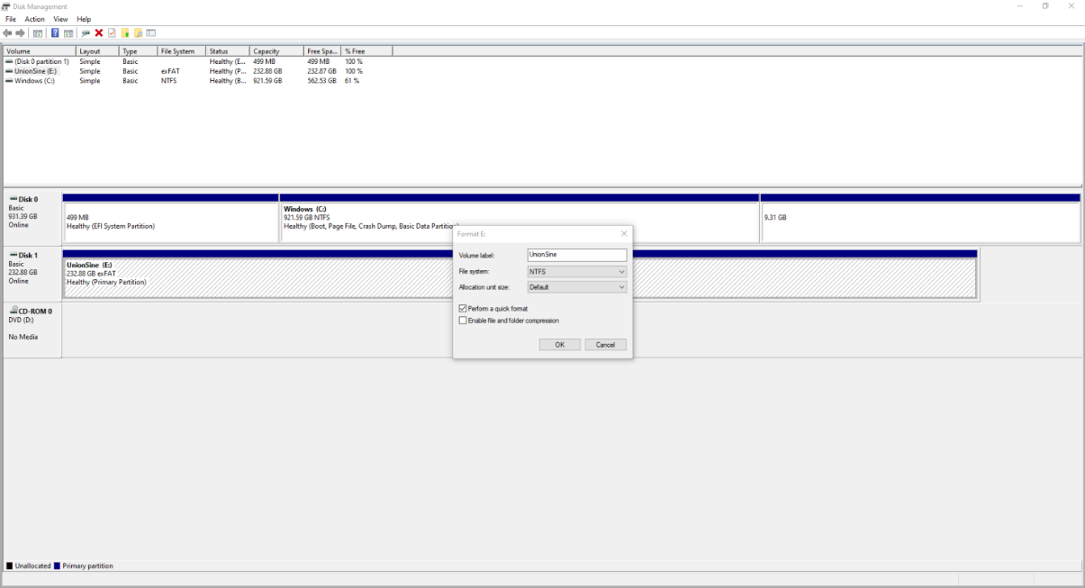

Partitioning and Data Addition: Six partitions were created in total. One of the partitions was set to "hidden". A fabricated spreadsheet was also created containing fake customer details.
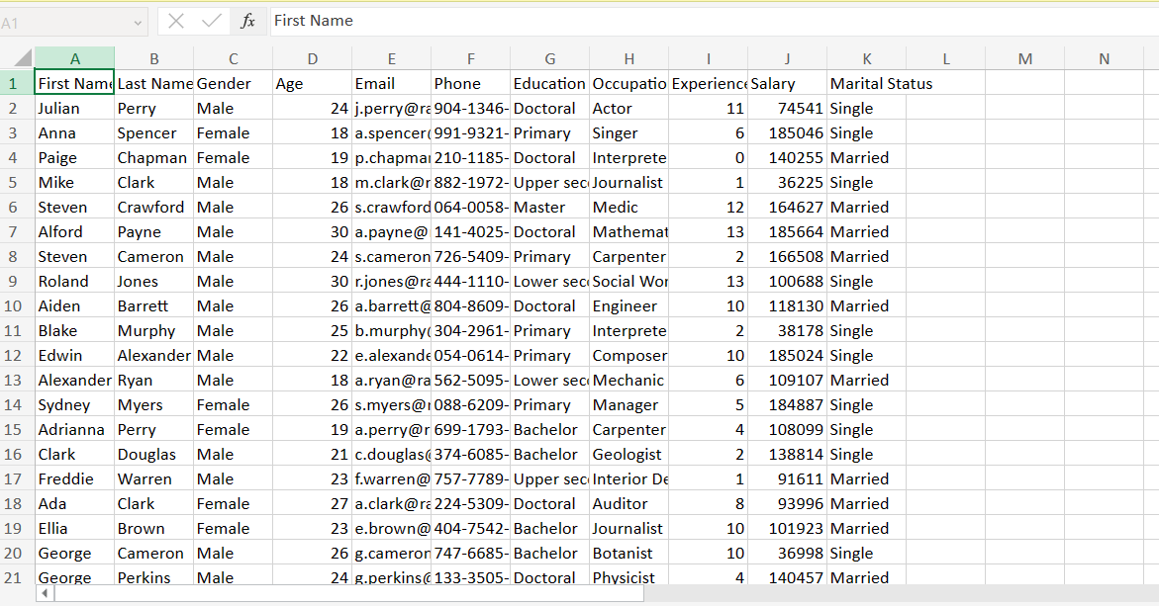
Another spreadsheet was created that contained payment details for customers. Both fabricated documents were placed on drive ‘I’ that was set to hidden.
Password Protection and MD5 Hashing: The partition with the spreadsheet was password-protected with a specific passphrase, which was then hashed using MD5 for added security.
Password = ‘nitheesh123hseehtin’
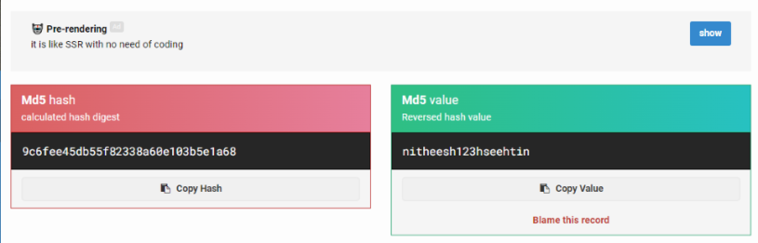
Steganography Implementation: Steganography was implemented to increase the complexity of the crime. This was done through hiding JPEG images of bank statements within MP4 files using the ‘copy/b’ command hiding the data.
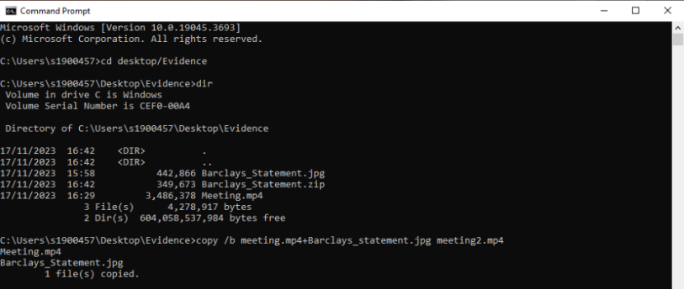

Data Encryption with VeraCrypt: The collected data was then encrypted using VeraCrypt. This would ensure the information remain secure and that the data would need to be decrypted to access it.
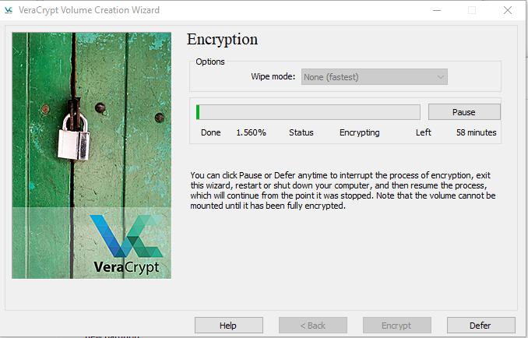
Creating and Adding 'Fake Malware' Batch Files:
I developed several batch files simulating 'fake malware'. One batch file was programmed to swap left and right mouse clicks, creating a confusing user experience. Another batch file continuously displayed vague hints about the password, designed to be uncloseable unless the PC was shut down. The final batch file was created to display a message saying, “MALWARE DOWNLOADING” and crash the PC upon execution. These files were tested in a Windows VM to ensure they would cause no real harm to other teams’ computers. The purpose of these batch files was to act as a distraction taking away attention from the hidden data.
Finalization for Handover: After thorough preparation and testing, the HDD was deemed ready and handed over to Team B for analysis.

Analysis of Team C’s HDD
Group Video - https://youtu.be/Dfrjao54ZTY

Introduction of analysis
To conduct this analysis correctly it was important to adhere to proper digital forensics methods for ensuring the integrity and reliability of data and findings. The analysis of the HDD that Team C provided employed a suite of forensics tools that were discovered and analysed in task 2.
Tools used: SOAC PCs, Games Lab PC’s, Autopsy, FTK Imager, Oracle VirtualBox, Kali Virtual machine.

Team C scenario overview:
The scenario presented by Team C involved a hacker compromising a victim's home wireless network to conduct financial fraud. The hacker used phishing techniques to gain access to the victim's credit card details and then committed financial fraud. This scenario not only tested our technical skills but also our understanding of common cybercrime tactics, including network intrusion, phishing, and privilege escalation.

In the following sections, we will detail our approach to analysing this complex scenario, from the initial imaging of the HDD to the final interpretation of the data. Our goal was to methodically uncover how the hacker executed this crime and identify evidence that could potentially lead to the recovery of the victim from this scandal.

Chain of custody:
UWTSD Police Department
EVIDENCE CHAIN OF CUSTODY TRACKING FORM

Case Number: 01
Offense: Cyber-attacks (phishing email, reverse shell payload)
Submitting Officer: (Name/ID#) Digital forensics group A / 01
Victim: N/A
Suspect: N/A
Date/Time Seized: 6/11/2023
Location of Seizure: University IQ building

Description of Evidence
Item # | Quantity | Description of Item (Model, Serial #, Condition, Marks, Scratches)
01 | 01 | 1 TB– External Hard Drive

Chain of Custody
Item # | Date/Time | Released by  (Signature & ID#) | Received by  (Signature & ID#) | Comments/Location
01 | 6/11/2023 | Digital forensic investigation team B | Digital forensic investigation team A – Ellis, Rohan, John, Dawid, Connor | Exchange of hard drives
01 | 13/11/2023 | Digital forensic investigation team A- Connor | Digital forensic investigation team A – Ellis, Rohan, John, Dawid, Connor | First official session of the investigation- FTK image was collected – evidence item was
01 | 14/11/2023 | Digital forensic investigation team A- Connor | Digital forensic investigation team A – Ellis, Rohan, John, Dawid, Connor | Majority of data found was corrupted. One encrypted file needed to decrypted using a python and pip code.
01 | 16/11/2023 | Digital forensic investigation team A- Connor | Digital forensic investigation team A – Ellis, Rohan, John, Dawid, Connor | pieces of data were uncovered
01 | 17/11/2023 | Digital forensic investigation team A- Connor | Digital forensic investigation team A – Ellis, Rohan, John, Dawid, Connor | decryption of data was attempted
01 | 20/11/2023 | Digital forensic investigation team A- Connor | Digital forensic investigation team A – Ellis, Rohan, John, Dawid, Connor | decryption of data was attempted – continued
01 | 22/11/2023 | Digital forensic investigation team A- Connor | Digital forensic investigation team A – Ellis, Rohan, John, Dawid, Connor | Found data was recorded
01 | 23/11/2023 | Digital forensic investigation team A- Connor | Digital forensic investigation team A – Ellis, Rohan, John, Dawid, Connor | Investigation continued
01 | 27/11/2023 | Digital forensic investigation team A- Connor | Digital forensic investigation team A – Ellis, Rohan, John, Dawid, Connor | A table was drawn of found data
01 | 28/11/2023 | Digital forensic investigation team A- Connor | Digital forensic investigation team A – Ellis, Rohan, John, Dawid, Connor | Work was finalized
Final Disposal Authority
Authorization for Disposal
Item(s) #: 01 external hard drive on this document pertaining to (suspect): N/A
is(are) no longer needed as evidence and is/are authorized for disposal by (check appropriate disposal method)
☐ Return to Owner ☐ Auction/Destroy/Divert
Name & ID# of Authorizing Officer: Digital forensic investigation group A Date: 10/01/2024

Release to Lawful Owner
Item(s) #: 01 on this document was/were released by Evidence Custodian digital forensic investigation team A
Name Lara Costa
Address: University of Wales Trinity Saint David Kings Road, Swansea, West Glamorgan, SA1 8EW
Under penalty of law, I certify that I am the lawful owner of the above item(s).
Copy of Government-issued photo identification is attached. ☐ Yes ☐ No
This Evidence Chain-of-Custody form is to be retained as a permanent record by the UWTSD Police Department.

APD_Form_#PE003_v.1 (12/2012) Page 2 of 2 pages (See front)

Risk Assessment:
Data Integrity | Use write-blocking tools to prevent data corruption. Use hash values to confirm data integrity
Hardware Damage | Use safe storage in Faraday case. Adopt correct handling procedures
Software Risks | Access data in isolated environment using VM’s
Confidentiality Breach | Avoid accessing unnecessary data
Legal Compliance | Legal requirements are complied with by receiving permission to access data
Chain of Custody | From point of receival from Team C, chain of custody was maintained to prove proper handling, transfer, and storage, as well as non-repudiation.
Technical Competence | Ensure all team members understand their roles and responsibilities
Technical Challenges | Analyse the file system and format. Be prepared for encrypted data
Incident Response | Store disk image backups to prevent data loss. Analyse file types to identify relevant data, avoiding sensitive and unnecessary information

HDD analysis Steps
Chain of Custody and Initial HDD Access: The process started with the creation and the beginning of the documentation of the chain of custody. The HDD was accessed using a Kali Linux Virtual machine where we attempted to take a disk image of the HDD. The 1TB size of the HDD proved to be so much for the SOAC lab to handle meaning we had to find an alternative solution.
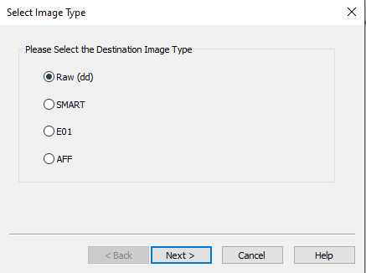
Alternative Location and disk imaging: To overcome the issue of the SOAC PC’s not having enough storage we moved our operation to the game’s lab. These PCs were more capable and allowed us to use Forensics Toolkit Imager (FTK) to create a disk image of the HDD. Physical drive and Raw (dd) image were selected when creating an image, to create an exact copy of the HDD.
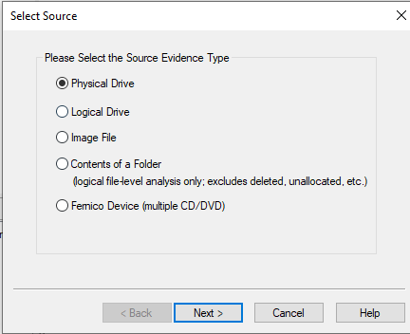

Corrupted Data: After creating the image, we attempted to mount the disk image. This proved to not be possible for us an upon further inspection it was determined that the data was unreadable and corrupted. In terms of forensics operations in a real-world scenario this would be the end of the operation as nothing further could be done, however we decided as a team to contact team C to aid in re preparing the hard drive as the steps to come after creating the disk image are crucial to learning and understanding the digital forensics process. The likely cause of the corruption was team C’s use of reverse shell malware likely leading to altered and damaged file structures. Team C Re formatted and re prepared the hard drive and we began the process again.
Second Imaging Attempt with FTK Imager and Autopsy: The second imaging process followed the same steps as the initial disk imaging process. Both the MD5 and SHA1 computed hash values and report hash were compared to ensure the integrity of the data.
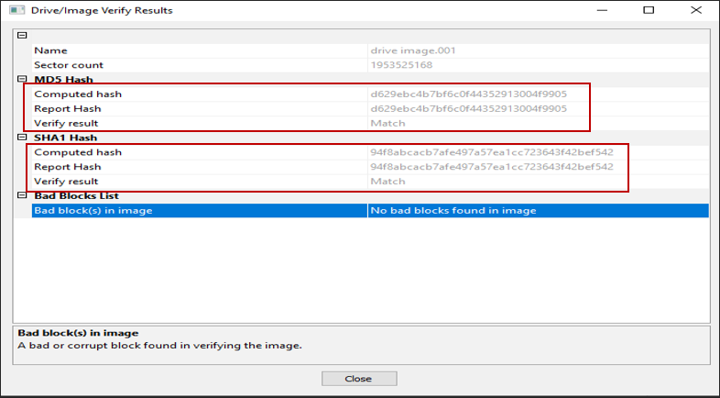
Decrypting Encrypted Files: After the imaging process further analysis led to the discovery of encrypted files. These files were encrypted through the use Kali Linux tools were imported onto a Kali Linux VM. Necessary Python and PIP tools were installed for the decryption process.
Evidence Extraction and Analysis: Various file types, including PNG, JPEG, text files, Python script files, and. Zone. Identifier files were extracted and analysed for evidence.
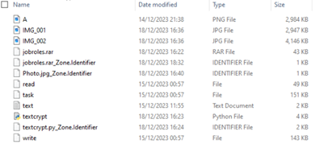
Further Analysis with Binwalk: Further analysis of the files it was determined that steganography was used by the other team to hide additional files within an image. 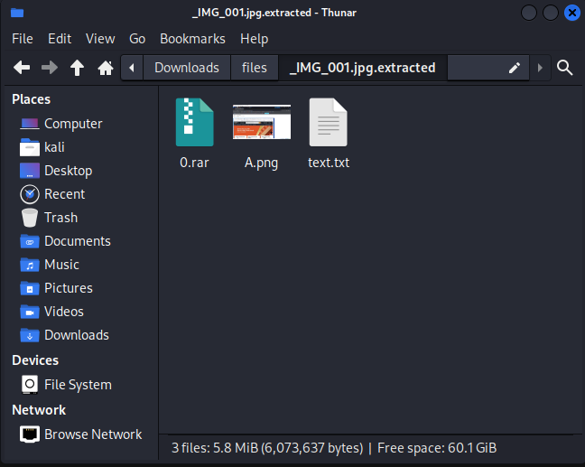
Binwalk: The binwalk tool was then used to uncover any embedded code in the files. This resulted in encrypted code being found.
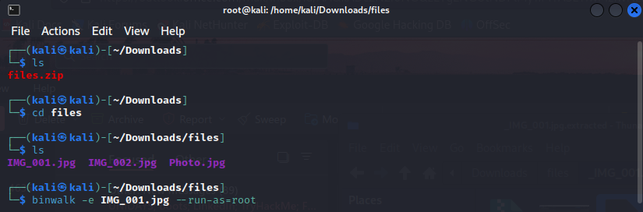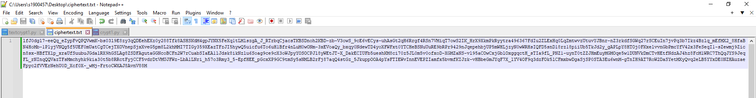
Decryption of Embedded Code: The embedded code found in the Binwalk scan was decrypted using a Python script, leading to the discovery of a PGP private key.
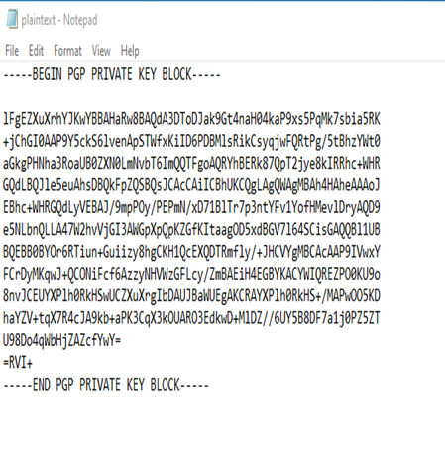
Decryption of Additional Files: The PGP private key was used to decrypt a “ciphertext.txt” file into plain text using a Python script.
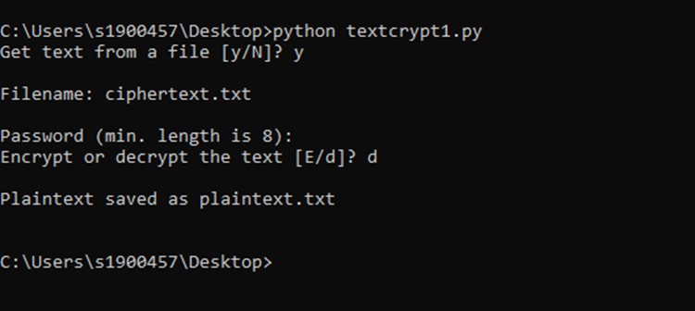
Final Discovery: The analysis conducted resulted in the team discovering an image of a hacker having remote access to a user's account, which tied back to the simulated crime scenario.

Team contributions to the task:

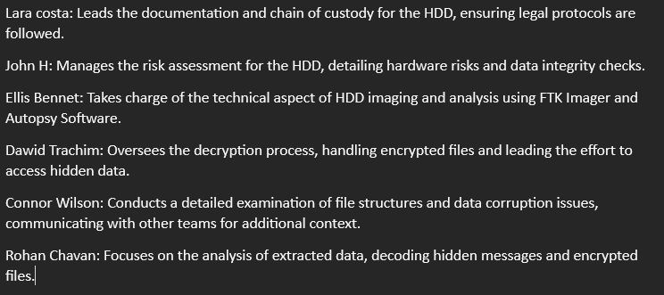

Individual Contribution to the task:
As the Team leader for the task my responsibility was to oversee the whole task and point the team in the right direction. Additionally, my key responsibility was to oversee the HDD imaging and analysis through FTK imager and Autopsy. I focused on ensuring the HDD was imaged correctly and effectively.

Task 4
For task for we delve into a digital forensics’ investigation based on a factitious scenario created for the same groups that were chosen in task 3. The investigation focuses on allegations surrounding an employee of a company, who is suspected of disclosing confidential information to competitors. This suspicion arises from a pattern of behaviours that deviates from standard professional conduct and contractual obligations. Specifically, the individual in question has taken multiple trips abroad to locations of known competitors and has availed unrecorded leave without prior notification to the management, as mandated by their employment contract. These actions not only breach company policy but also raise serious concerns about the security of sensitive corporate information. Our aim was to investigate the employee’s mobile device to uncover any data that may incriminate them.

Risk assessment
User Privacy and Data Protection | Handle personal data with care. Analyse only necessary data
Hardware Damage | Use safe storage in Faraday case. Adopt correct handling process
Data Corruption | Use correct process with Cellebrite tools. Use reliable tools to verify integrity of extracted data. Safeguard extracted data
Legal and Ethical Considerations | Ensure investigation methods maintain correct processes that are acceptable in court. Use data only relevant to case
Technical Challenges | Analyse the file system and format. Be prepared for encryption
Documentation and Reporting | Maintain detailed documentation of the investigation process, findings and methodologies used
Incident Response | Store image backups of extracted data. Analyse file types to avoid unnecessary data

Chain Of Custody

UWTSD Police
Digital Forensics Department

EVIDENCE CHAIN OF CUSTODY TRACKING FORM

Case Number:02 Offense: Selling Intellectual Property of Company to
Competitors and uninformed national and International Trips
Submitting Officer: (Name/ID#) Team A
Victim: Confidential Suspect: Undisclosed
Date/Time Seized: Device1: 27/11/2023 & Device2: 11/12/2023.
Location of Seizure: 205 IQ Swansea

 |  | Description of Evidence
Item # | Quantity | Description of Item (Model, Serial #, Condition, Marks, Scratches)
1 | 1 | Huawei POT-LX1 P Smart, usual wear and tear, no major scratches, or damages
2 | 1 | Ulefone Note 14, usual wear and tear, no major scratches, or damages

 |  | Chain of Custody
Item # | Date/Time | Released by  (Name) | Received by (Name) | Comments/Location
1 | 27/11/2023 | Niteesh | John | Phone was collected. 205, UWTSD, IQ Swansea
1 | 01/12/2023 | John | Connnor | phone was kept in Connor’s accommodation.  205, UWTSD, IQ Swansea
1 | 04/12/2023 | Connor | Ellis | Today we attempted to guess the password.  The phone was transported to the university and was brought to room  205  205, UWTSD, IQ Swansea
1 | 04/12/2023 | Ellis | Nitheesh | Phone was given to Niteesh to check the passcode.  205, UWTSD, IQ Swansea
1 | 04/12/2023 | Nitheesh | Rohan | The phone was connected to the Cellebrite kit and reset. When the phone was reset, it remained in a bootloop and was unable to be unlocked.  However the software said the phone
is not supported. The device was also subjected to an attempted eRecovery
to no success, the device remained in bootloop.
205, UWTSD, IQ Swansea
1 | 04/12/2023 | Rohan | Ellis | The device was reset due to the malfunction and no data was able to  be recovered. There was also no sim  card available so there would haven’t not been much data to recover. All  data that was able to be recovered was all bloatware.  205, UWTSD, IQ Swansea
1 | 08/12/2023 | Ellis | Niteesh | The phone was handed back as we were not able to recover the relevant  data due to limitation of the device.  205, UWTSD, IQ Swansea

Page 1 of 2 pages (See back)
EVIDENCE CHAIN-OF-CUSTODY TRACKING FORM
(Continued)

 |  | Chain of Custody
Item # | Date/Time | Released by (Name) | Received by (Name) | Comments/Location
2 | 11/12/2023 | Team B | John and Connor | An extraction process was started and  accomplished.  205, UWTSD, IQ Swansea
2 | 15/12/2023 | John and Connor | Rohan, Connor,  Ellis, Lara | Data was uncovered using  Cellebrite. This showed prove of travel to India,  Dubai, Poland and UK London.  205, UWTSD, IQ Swansea
2 | 20/12/2023 | Rohan, Connor, Ellis, Lara | Rohan, Connor,  Ellis, John, Lara and Dawid | Images, Videos and Audios were retrieved and analyzed.  205, UWTSD, IQ Swansea
2 | 21/12/2023 | Rohan, Connor, Ellis, | Team B | Mobile was
 |  | Lara and Dawid |  | handed to team B  for their  investigation.  205, UWTSD, IQ Swansea

Final Disposal Authority
Authorization for Disposal

Item(1) #: Huawei POT-LX1 P Smart on this document pertaining to (suspect):N/A is(are) no longer needed as evidence and is/are authorized for disposal by (check appropriate disposal method)
☐ Return to Owner (Nitheesh) ☐ Auction/Destroy/Divert
Name & ID# of Authorizing Officer: INVESTIGATION Team A Signature: Team A Date:08/12/2023

Authorization for Disposal

Item(2) #: Ulefone Note 14 on this document pertaining to (suspect):N/A
is(are) no longer needed as evidence and is/are authorized for disposal by (check appropriate disposal method)
☐ Return to Owner (Team B) ☐ Auction/Destroy/Divert
Name & ID# of Authorizing Officer: INVESTIGATION Team A Signature: Team A Date: 21/12/2023

This Evidence Chain-of-Custody form is to be retained as a permanent record by the UWTSD Police Department.

Page 2 of 2 pages (See front)

Mobile Forensics Analysis
Tools: SOAC Lab PC, Oracle VirtualBox, FTK, Autopsy, Cellebrite UFD kit, Kali Linux VM.
Initial Analysis of Huawei POT-LX1 P Smart: From the initial inspection of the device, we identified the model as a Huawei POT-LX1 P Smart Which will now be referred to as the ‘Huawei’. The device presented several issues the first being a faulty battery which would not charge above 2% and when powered on the device would remain in a boot loop. This prevented us from being able to conduct further analysis using Cellebrite. Due to the device being stuck in a boot loop Cellebrite was unable to extract data.
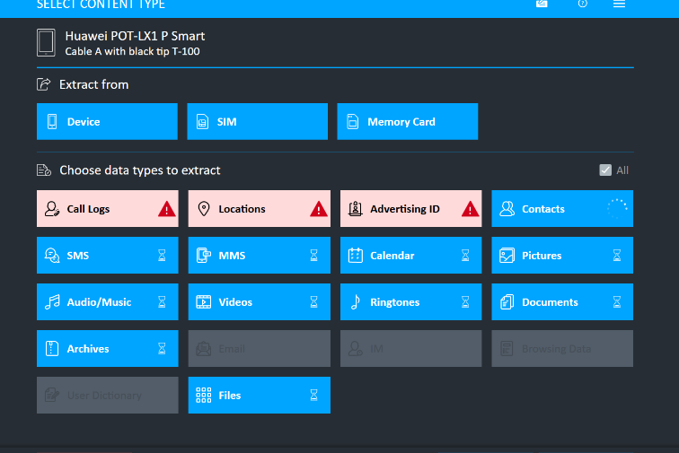
Factory Reset Decision and Consequences: Due to the device being unfunctional after several recovery attempts the team opted to factory reset the device through recovery mode. This stabilized the device but resulted in the loss of potential data making the device unusable for further forensic analysis. To complete the other aspects of a simulated forensics operation we requested another device which was approved. The device given to us was a Ulefone Note 14 which will be referred to as the ‘Ulefone’.

‘Ulefone’ Analysis
Ulefone Inspection: The Ulefone Note 14, secured by a PIN, was in good physical condition and operational, making it suitable for forensic analysis. I was able to decipher the four-digit pin from hints given to us based on dates and number selection.

Data Extraction and Analysis Using Cellebrite: The data extraction processed involved connecting the Ulefone to the Cellebrite UFED. A comprehensive extraction was performed to retrieve data such ass: Files, application data, user data.
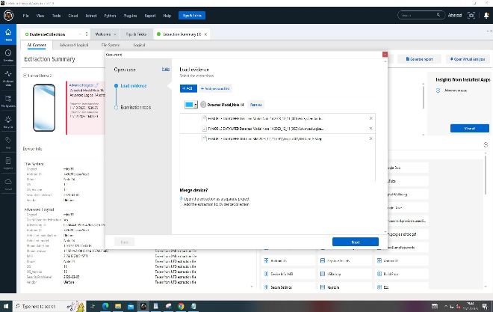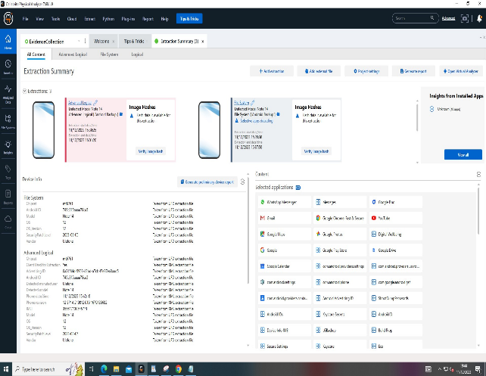
Key Findings: From the analysis there was several interesting findings, the first was images which contained geolocation meta data. This meta data allowed us to map the travel patterns of the users with some of the locations being those of competitors of the organisation.
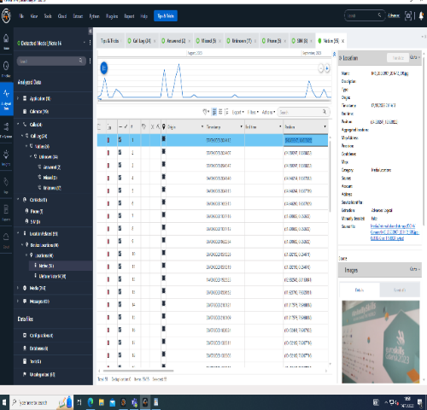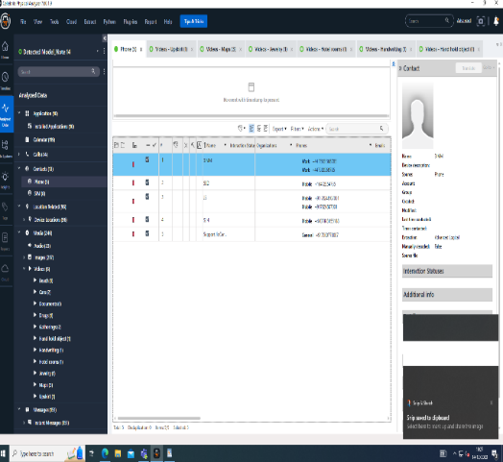

The geolocation meta above was used to create a map of the suspects travel patterns:
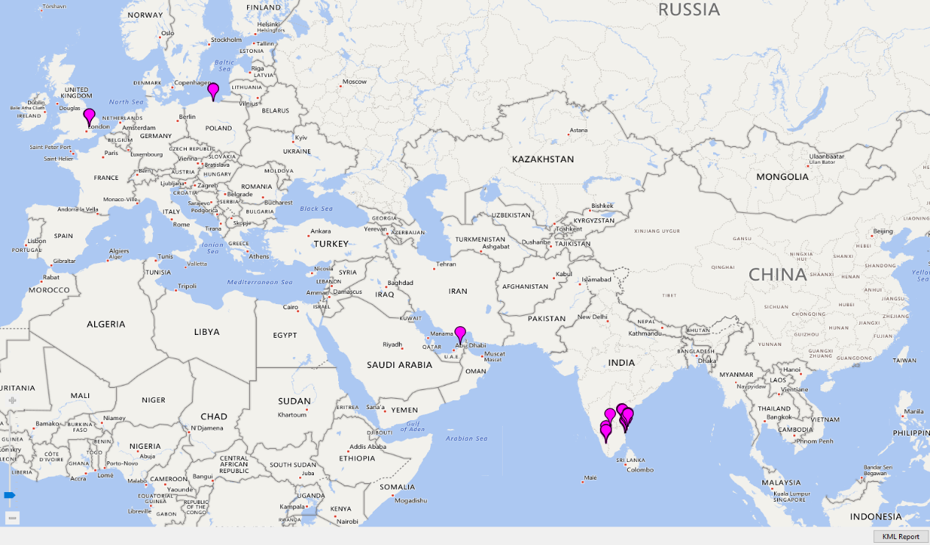
Financial Evidence Recovered: A significant discovery was a photograph in the WhatsApp Images directory showing a credit card, potentially tied to the financial aspect of the investigation. This was not determined to have any direct link with the investigation. The details have been hidden in the image.
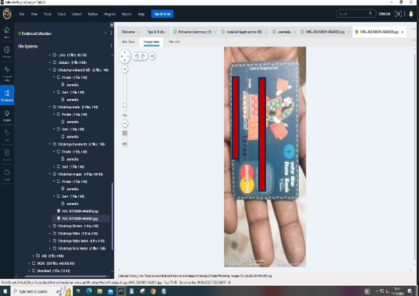
Audio File Recovery: A series of .WAV audio files were recovered. These were catalogued based on their timestamps. The following is the description of what was uncovered in the audio files:
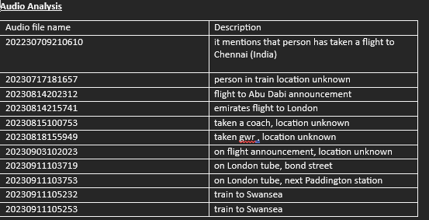
These audio files may indicate the suspect being at competitor location branches due to some of the locations matching.

Team contribution for task
Dawid Trachim: Takes responsibility for the initial receipt and documentation of the mobile device.
Lara Costa: Performs the risk assessment on the mobile phone, checking hardware functionality and compliance.
John Hughes: Analyses application data, focusing on any anomalies or evidence of data exfiltration.
Ellis Bennett: Specializes in the extraction process using tools like Cellebrite and analysing the extracted data.
Connor Wilson: Reviews call logs, messages, and contacts, looking for suspicious patterns or contacts.
Rohan Chavan: Maps geolocation data from images, reviewed audio logs and other metadata to build a timeline of the suspect's movements.

Individual contribution
As the team leader for task 4 my role was to steer the team in the right direction for the mobile investigation. My specific process in the completion of the task was the extraction process of the data. I used the specialist Cellebrite UFED kit to retrieve and examine data from the mobile device. Additionally, I assisted in the analysis of the extracted interpreting the data sets provided to help draw connections to the crime scenario provided.

Conclusion
In conclusion, this report has offered a glimpse into the field of Digital Forensics. It commenced with research into digital forensics, analysing academic papers and pertinent sources, initially focusing on the current state of the field and its intersection with cybersecurity. This led to discussions on emerging trends, challenges, and the national and international job market in digital forensics.
Subsequently, the report delved into the key tools utilised in digital forensics, analysing both open-source and commercial tools and comparing their differences. It concluded that both types of tools are vital for a comprehensive solution in digital forensics.
Tasks 3 and 4 involved the analysis of a hard drive and a mobile device. The research in the initial phase was crucial for these tasks, providing fundamental knowledge about the processes and tools required for digital forensics investigations. Challenges were encountered during these investigations, such as corruption and broken devices. Although the methods used for swapping out the mobile device and re-collecting data for the hard drive would not be feasible in real-world scenarios, they were implemented to provide the team with a complete experience of the digital investigation process.
The project should be considered a success. The objectives to research, analyse, and investigate digital cybersecurity incidents and perform digital forensics assessments were achieved, resulting in a significant acquisition of knowledge about the current field and its processes.

References
[1] NIST, “digital forensics,” Computer Security Resource Cener CSRC. Accessed: Oct. 31, 2023. [Online]. Available: https://csrc.nist.gov/glossary/term/digital_forensics#:~:text=In%20its%20strictest%20connotation%2C%20the,2015%20from%20DoDD%205505.13E
[2] A. Dimitriadis, N. Ivezic, B. Kulvatunyou, and I. Mavridis, “D4I - Digital forensics framework for reviewing and investigating cyber attacks.,” Array (New York, N.Y.), vol. 5, 2020, doi: 10.1016/j.array.2019.100015.
[3] S. Mohammmed and R. Sridevi, “A Survey on Digital Forensics Phases, Tools and Challenges,” 2020, pp. 237–248. doi: 10.1007/978-981-15-1480-7_20.
[4] D. B. Garrie Law, F. J. David Morrissy Zeichner Ellman, K. Llp, D. B. Garrie, and J. David Morrissy, “Issue 2 Article 5 Spring 2014 Digital Forensic Evidence in the Courtroom: Understanding Content and Quality, 12 Nw,” 2014. [Online]. Available: https://scholarlycommons.law.northwestern.edu/njtip/vol12/iss2/5
[5] N. Zahadat, “Digital Forensics, A Need for Credentials and Standards,” The Journal of Digital Forensics, Security and Law, 2019, doi: 10.15394/jdfsl.2019.1560.
[6] M. I. Alghamdi, “Digital Forensics in Cyber Security—Recent Trends, Threats, and Opportunities,” in Cybersecurity Threats with New Perspectives, IntechOpen, 2021. doi: 10.5772/intechopen.94452.
[7] M. I. Alghamdi, “Digital forensics in cyber security-recent trends, threats, and opportunities,” vol. 8, no. 3, pp. 1321–1330, 2020.
[8] M. Chernyshev, S. Zeadally, Z. Baig, and A. Woodward, “DIGITAL FORENSICS, PART 1.” [Online]. Available: www.computer.org/security
[9] Sunil Kumar, “Cloud Forensics Today: An Overview of Challenges and Trends,” ECCouncil. Accessed: Dec. 08, 2023. [Online]. Available: https://www.eccouncil.org/cybersecurity-exchange/whitepaper/cloud-forensics-today-challenges-trends/
[10] B. Fakiha, “Enhancing Cyber Forensics with AI and Machine Learning: A Study on Automated Threat Analysis and Classification,” International Journal of Safety and Security Engineering, vol. 13, no. 4, pp. 701–707, 2023, doi: 10.18280/ijsse.130412.
[11] T. Nayerifard, H. Amintoosi, A. G. Bafghi, and A. Dehghantanha, “Machine Learning in Digital Forensics: A Systematic Literature Review,” Jun. 2023.
[12] E. Casey, G. Fellows, M. Geiger, and G. Stellatos, “The growing impact of full disk encryption on digital forensics,” Digit Investig, vol. 8, no. 2, pp. 129–134, Nov. 2011, doi: 10.1016/j.diin.2011.09.005.
[13] F. Casino, C. Pina, P. López-Aguilar, E. Batista, A. Solanas, and C. Patsakis, “SoK: cross-border criminal investigations and digital evidence,” J Cybersecur, vol. 8, no. 1, Jan. 2022, doi: 10.1093/cybsec/tyac014.
[14] Peri Storey, “The growing need for digital forensic investigators,” opentext. Accessed: Dec. 12, 2023. [Online]. Available: https://blogs.opentext.com/the-growing-need-for-digital-forensic-investigators/
[15] INFOSEC, “Digital forensics analyst careers,” infosecinstitute.com. Accessed: Dec. 12, 2023. [Online]. Available: https://resources.infosecinstitute.com/overview/digital-forensics-careers/
[16] Autopsy, “Autopsy,” N/A. Accessed: Dec. 30, 2023. [Online]. Available: https://www.autopsy.com/
[17] V. Ndatinya, Z. Xiao, V. R. Manepalli, K. Meng, and Y. Xiao, “Network forensics analysis using Wireshark,” International Journal of Security and Networks, vol. 10, no. 2, p. 91, Jan. 2015, doi: 10.1504/IJSN.2015.070421.
[18] wireshark, “wireshark,” N/A. Accessed: Dec. 11, 2023. [Online]. Available: https://www.wireshark.org/
[19] Volatility Foundation, “Volatility Foundation,” N/A. Accessed: Dec. 15, 2023. [Online]. Available: https://www.volatilityfoundation.org/
[20] opentext, “OpenText EnCase Forensic,” n/a. Accessed: Dec. 17, 2023. [Online]. Available: https://www.opentext.com/products/encase-forensic
[21] N. P. Bhosale, “Evidence Recovery using EnCase and FTK in Forensic Computing Investigation,” International Journal of Scientific Research in Computer Science and Engineering, vol. 9, no. 4, pp. 8–13, Aug. 2021, doi: 10.26438/ijsrcse/v9i4.813.
[22] exterro, “FTK® Forensic Toolkit,” n/a. Accessed: Dec. 30, 2023. [Online]. Available: https://www.exterro.com/forensic-toolkit
[23] Cellebrite, “Cellebrite UFED,” n/a. Accessed: Dec. 30, 2023. [Online]. Available: https://cellebrite.com/en/ufed/

