Galina Kaeva
2019393
BMSW4004
Charles Oham
Problem Solving and Decision making
Problem Solving and Decision Making Ass1

Table of Contents
Introduction 2
PART 1 3
The impact of a complex problem on the overall performance of organizations 3
Causal investigative analysis of a complex problem based on research 4
PESTEL analysis of the macro-environmental factors contributing to a complex problem 6
Analyse the problem and alternative solutions to solve the problem 8
Demonstration of the plan for implementation of the selected decision and evaluation of the results 9
PART 2 10
Defining a complex problem in the workplace, including its scope and impact 10
Analyse information on the identified problem, to help inform the decision-making process 11
Propose a range of alternative solutions to the problem 11
Decision-making technique to evaluate a range of solutions 12
Plan for implementing the solution 14
Communicating the plan to the stakeholders 16
Evaluate appropriate monitoring and review techniques to ensure successful implementation of the decision 16
Conclusion 17
References 18

Introduction

Everything that happens in this world has its problems, because there is no system in this world that is 100% effective. However, people are willing to deal with any kind of problem by going through various steps that help identify the problem. Problem solving is an important process or action to find a solution to a problem, in which a problem is identified and appropriate alternative solutions are chosen to solve the problem, after which the solution is applied. Decision making is a process in which a choice is made by gathering information and evaluating the alternative decision. There are several steps that organizations go through to reach a solution to a problem. After defining the problem, the problem is analyzed, alternative decisions are made, different decision-making techniques are applied, a decision-making plan is developed, this plan is communicated to stakeholders and the monitoring and review techniques are evaluated. All these steps guarantee success in the implementation and solution of the problem. This approach increases the chances of organizations to choose the most satisfactory alternative possible. For the successful management of an organization, management also uses various techniques to solve problems in the management of its employees. As a manager-consultant, a report was prepared on solving a complex problem in organizations in the UK. This report identified various problems with dissatisfied employees, and subsequently proposed techniques to address these problems that would help companies become more competitive and improve their efficiency. The report is in two parts, the first part identifies a complex problem on the overall performance of organizations, after which the problem is analyzed. PESTEL analysis of the factors of the macro environment is applied and the alternative solutions to the complex problem are evaluated. The report selected the most appropriate solutions among these alternatives. A demonstration of the applied solution was made by the organizations and an assessment of the result was made. The second part of the report identifies an issue that concerns employee dissatisfaction in the workplace. In the process of finding a solution, the problem is analyzed, after which an alternative solution to this problem is indicated. Decision-making techniques have been used to identify the most appropriate option. Finally, a plan was prepared and the techniques were evaluated to ensure success in implementing the decision. The report concludes with a conclusion summarizing the overall finding of the study.

PART 1

The impact of a complex problem on the overall performance of organizations

Solving problems is not an easy task and to a large extent the lack of attention on the part of the manager and management can lead to loss of interest and leaving the job on the part of employees. This is a complex problem in the workplace that needs to be defined and has its scope and impact. For an organization to be effective, concerns are needed on both the internal and external environment. Internal and external factors affect the profitability of organizations, revenues and expenditures, and employee retention. SWOT analysis helps organizations create a plan to promote resource efficiency. On the other hand, SWOT analysis helps companies scan their strengths and weaknesses, and analyze external threats (Lindholm, 2021).

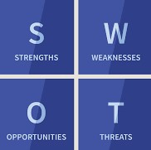
Figure 1. SWOT analysis
Source: https://www.investopedia.com/

Organizations need to understand their strengths and weaknesses within the organization to address the complex issue. The strengths are the financial situation and the value of human capital, and the weaknesses are identified through financial analysis and employee retention. Organizations must also assess the external factors that affect performance. These are opportunities (factors that lead to profit) and threats (competition, residence, customers).
It is important to analyze the problem, which helps in making alternative solutions to the problem. SWOT analysis helps organizations prepare for change and encourages organizations to plan for what may happen in the future (Lindholm ed. al.,2012).

Causal investigative analysis of a complex problem based on research

The interest of every company is to achieve better efficiency in a short period of time in order to gain a competitive advantage. However, the consequences of dissatisfied employees affect companies and organizations. This leads to a lack of motivation, interest, low productivity, absences and frustrations for employees. There are various reasons why employees may be dissatisfied with their work. This affects companies and organizations as it leads to a loss of efficiency. The reasons why employees are dissatisfied with their work are many and varied. Below are six problems with dissatisfied employees ( Meister and Willyerd, 2010).

Reasons of job dissatisfaction
Underpayment
No career growth
Little or no rest time
Inappropriate boss
Company culture
Work / life balance

Table 1. Reasons of job dissatisfaction
Source: Created by the Author

* Underpayment - The financial factor is of great importance for every worker. The feeling of being underpaid affects the atmosphere of the team and leads to a loss of motivation and enthusiasm. Often the dissatisfied worker realizes that he is underpaid by researching what others get for the same work in the same field.
* No career growth - When the employee has no incentive to grow in the workplace within the company, then the motivation decreases. Usually, the employee loses his confidence in career development and loses the desire to work effectively.
* Little or no rest time - Lack of free time leads to lower productivity of employees and risk of reduced work efficiency, as employees do not have time for healthy rest. Additional responsibilities directly affect their motivation, which is why employees begin to look for other opportunities.
* Inappropriate boss - Every employee needs attention from his manager. Employees need a manager to praise them for a job well done. The lack of such a manager kills motivation. Feedback between an employee and a manager is also very important. In addition, messages from the e-mail chief led to a lack of face-to-face communication, which is also a problem for the employee. On the other hand, high-pitched conversations, reproaches, and chaotic decision-making by the manager do not inspire the team at all.
* Company culture - Workplace relationships must be built on moral values. A healthy and supportive culture motivates employees and makes them creative. Lack of corporate culture leads to low productivity. In addition, employees do not feel listened to and engaged in their work. The level of company culture shows how mature the organization itself is and how it is developing. For example, if the culture is weak, people are not aware of the values ​​and cells of the organization. This affects the social commitment, competitiveness and activity of a company. Company culture often influences employee enthusiasm (Edmonds, 2014).
* Work / life balance – Lack of balance between personal and professional lifestyles can create many problems. Maintaining a balance between balance and life is important because it affects employee retention. Often the imbalance between them leads to low productivity and creativity of employees, as the time employees spend at work shortens the time he spends with his family. This challenge often leads to leaving work and looking for new opportunities for professional development of employees. Employee retention can be achieved through proposals for flexible working hours, telecommuting, promotion practices, subsidized childcare (Greer, 2003). The key to problem solving is in understanding the purpose of the problem and also identifying the different paths that management takes to solve the problem (Richards, 2015). On the one hand, the focus on employees' skills and training must be continuously improved, and on the other hand, motivating employees makes them more effective and competent. Nowadays, companies are committed to career development programs to retain employees, which encourage the development of the needs of the organization in parallel with the needs of employees. In addition to selecting the talent they need, organizations need to provide training and development opportunities for employees to help people achieve their career goals. While meeting the needs of the company (Lindholm et al., 2012). Company culture is also very important, because people are consistent with the values ​​and goals of the organization, and if the culture in the organization is strong, it will lead to high productivity and loyalty of employees. In addition, the values ​​of an organization set the standard for how employees will behave towards customers (Lindholm et al., 2012). Employee engagement ensures a healthy workplace. Company leaders need to promote commitment, as committed employees have the potential to influence the achievement of the company's overall goals. The committed culture of the companies is characterized by encouragement and support of the employees by evaluating their efforts in the work.

PESTEL analysis of the macro-environmental factors contributing to a complex problem

PESTEL analysis is a tool used to identify key drivers of changing the strategic business environment and assists in strategic decision making. With the help of the PESTEL analysis you can assess the current environment and react more effectively to changes. PESTEL includes political, economic, social, technological, environmental and legal factors.

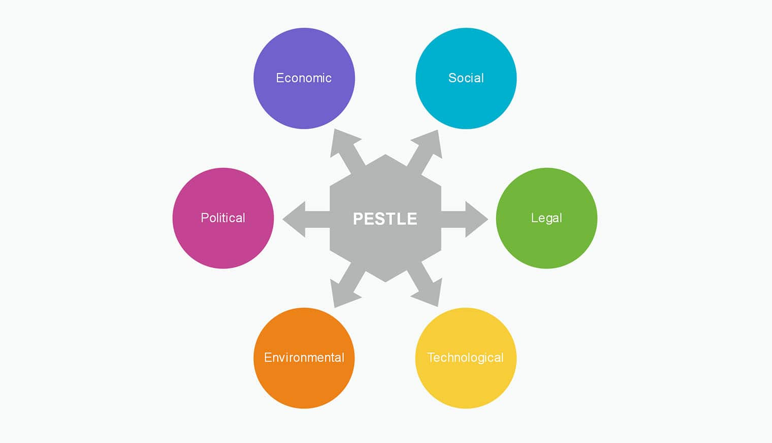
Figure 2. PESTEL analysis
Source: https://mychartguide.com/

Political factors can affect the functioning of Human Resources by starting to recruit talent. Most employees feel replaceable, as many organizations use recruitment as their primary growth strategy. The companies offer talent-based management. This in turn leads to a change in pay, which leads to dissatisfaction with some employees.
Economic factors are caused by the impact of globalization, which leads to a new way of hiring. For example, most companies offer new accommodation by hiring foreign workers because it is cheaper for them. But on the other hand, hiring foreigners makes it difficult to train these new employees. In addition, tracking these remote workers is becoming more difficult, which puts a strain on human resources staff in terms of how workers' communication and information are managed.
Social factors affect the rights of employees, as depending on the location of the employee. In this case, when companies hire employees from different parts of the world, employees' expectations regarding pay, training and communication are different. Human resources must ensure that the company does not violate the rights of employees in parallel with compliance with all regulations of the company by employees.
Technology affects human resources in terms of communication. Thanks to technology, communication in the workplace becomes easier. Recruiting talent is also easier since finding new employees through websites and social media can only take a few minutes. Despite this facilitation, employees may feel that their security is compromised, as methods of analysing data to collect information about employees can make employees busy.
Legal factors are related to confidentiality. This is a legal responsibility for human resources and ethically important. For this reason, if the legal responsibility is violated, the human resources staff may be fired. Proper inspection of employees is very important to prevent legal consequences.
Environmental factors are related to reducing pollution and reducing the use of paper. Thanks to the Internet and digital technologies, most documents are processed digitally. On the other hand, working with talent from all over the world leads to less driving, which means less carbon emissions in the air, as any employee can work from home.
All factors pose challenges and opportunities to both organizations and employees. Modernizations such as technology and communication rely on the development of human resources and staff skills. Human resource management and training are crucial for the modernization of the company (Muiswinkel, 2013). The search for new talent often burdens human resources workers with the requirement to be more creative to achieve their goals. PESTEL will continue to change human resources and it is important to keep an eye on all external factors.

Analyse the problem and alternative solutions to solve the problem

Analyzing the problem is a stage at which it is necessary to assess whether the problem requires an immediate solution or a simple study. It is necessary to clarify the causes of the problem, gather information about this problem and diagnose the problem. Analyzing the problem is a stage at which it is necessary to assess whether the problem requires an immediate solution or a simple study. It is necessary to clarify the causes of the problem, gather information about this problem and diagnose the problem. In this case, the analysis of PESTEL factors found some alternatives for organizations (Sproull, 2018).
1. The human resources department must focus on motivating employees and improving employee performance. Motivation is a complex task, but it is the 'engine of change'. Some useful ways to motivate employees are supportive leadership, flexibility, communication, team building.
2. Training and development of employees' skills. This can be achieved through various training courses, internal and external training, cooperation, and special training for new recruits.
3. Work and mobility. This is an alternative that increases the possibility of flexible working conditions. Frequent telecommuting and work from home is an important factor in staff retention. Mobility has several advantages, such as: motivation, flexibility of staff, a better understanding of the goals and problems of the company (Muiswinkel, 2013).
4. Change management. This means creating an environment that supports change and innovation.

Demonstration of the plan for implementation of the selected decision and evaluation of the results

Planning gives the company a shared vision that helps everyone work together. Planning helps organizations prepare for possible change. In addition, this strategy encourages organizations to plan for what may happen in the future (Lindholm et al., 2012). An organization can evaluate its plan, change, or eliminate activities that do not give the desired result. In this case, the consequences of employee dissatisfaction in the company can be offset by alternative solutions to be implemented to ensure success in implementing the decision.
Demonstration in the implementation plan:
1. Workers should be encouraged to find new, more efficient ways to work. Leaders need to encourage employee engagement by promoting an environment that attracts and retains people. In this case, the committed culture of employees is characterized by the encouragement and support of employees, appreciating the hard work.
2. To enable employees to use their skills in the workplace. Focusing on the skills and training of employees is in the interest of every company in achieving greater efficiency in terms of competitive advantage. The more competent the employees, the more efficient they will be.
3. To increase the possibility of flexible working conditions. Mobility has several advantages, such as: motivation, flexibility of staff, better understanding of the goals and problems of the organization. This is an important factor in attracting and retaining employees.
4. Managers and management must keep employees informed of changes in work procedures. In this case, the organization must create a centre that supports change and innovation.
5. Pay attention to the suggestions of workers for improvements and efficiency of organizations.

PART 2

Defining a complex problem in the workplace, including its scope and impact

Solving problems is not an easy task and to a large extent the lack of attention on the part of the manager can lead to loss of interest and leaving the job on the part of employees. This is a complex problem in the workplace that needs to be defined and has its scope and impact. It is important to analyse the problem, which helps in making alternative solutions to the problem (Adair, 2010). The various decision-making techniques are used to identify the most appropriate option. The development of a plan for the implementation of the decision and the evaluation of the monitoring techniques guarantees the success of the implementation of the decision. There are various reasons why employees may be dissatisfied with their work. This affects companies and organizations, as it leads to lack of motivation, low productivity, absence, and interest. One of the problems of dissatisfied employees is the lack of career development.
Lack of career development
Careers are difficult to plan due to the conditions of the business environment. People need to be flexible enough to stop working, and sometimes they just change jobs to achieve their career goals. When the employee has no incentive to grow in the workplace in the company, then the motivation decreases. Usually, the employee loses confidence in career development and loses his desire to work effectively. To ensure the success of employees' career development, it is not enough for them to work for one company for a long time. Nowadays, companies are committed to career development programs to retain employees and encourage their development in parallel with the needs of the organization. Organizations and managers have an important role to play in career development, planning and management. To selecting the talent they need, organizations need to provide opportunities for training, education, and employee development. This helps people realize their career goals while meeting the needs of the company. Career problems must be managed responsibly. Lack of career development leads to reduced employee motivation, resentment and feelings of worthlessness, which in turn reduces productivity. The reason for lack of career development may be a lack of necessary skills and competencies of employees. Too often, a change in the external environment can lead organizations to recruit talent, which reflects on workers.

Analyse information on the identified problem, to help inform the decision-making process

Human resources should be seen as an investment perspective, as employees are seen as valuable investments. Therefore, an incentive is needed to provide training opportunities for the company to be competitive. To be competitive, organizations are required to have highly qualified and experienced workers. Second, human resource management must play a significant role in the strategic management of organizations. In this case, investing in employee training and development is important for companies because on the one hand companies are competitive and on the other hand it facilitates the career development of employees.
One of the easiest and fastest ways to increase the level of innovation in an organization is to develop the skills of its members to generate alternatives as part of solving the problem (Higgins, 1994). Focusing on employee training and development is an important strategy for organizations as skills are constantly improving. The more competent the employees, the more efficient they are at work. Therefore, companies are focusing on improving employee skills. In addition, motivating employees and managing conflict through methods also leads organizations to efficiency. This helps people realize their career goals while meeting the company's needs.

Propose a range of alternative solutions to the problem

The key to problem solving is in understanding the purpose of the problem and also defining the different paths that management takes to solve problems (Richards, 2015). The management and training of human resources is crucial for the modernization of companies. One of the easiest and fastest ways to increase the level of innovation in an organization is to develop its members and develop the ability to generate alternatives as part of solving the problem. In this case, the lack of career development requires organizations to do the following alternative solutions:
1. Investing in training and development programs. Employee development and training programs are needed for organizations, as this allows employee retention, profitability and cost reduction. In addition to selecting the talent they need, organizations need to provide training and development opportunities for employees to help people achieve their career goals.
2. Organizations need to be more flexible and adaptable to strategic needs. Strategic planning helps organizations prepare for change, and encourages organizations to plan for what may happen in the future. Strategic planning provides organizations with a shared vision that helps everyone work together.
3. Improvement and retention practices - In order to retain their employees, organizations need to implement good retention practices and programs in which organizations invest.
4. Managing activities that provide recognition and appreciation in the absence of promotions, job enrichment, tasks and side transfers that provide opportunities for growth.
5. Workers should be encouraged to find new, more efficient ways to work. In addition, workplace rotation is useful.

Decision-making technique to evaluate a range of solutions

Different decision-making techniques can lead to unique benefits for specific decisions. One of the best ways for organizations to become more creative is to use techniques such as: analyzing the environment, recognizing the problem, generating alternatives, choosing between alternatives, and implementing solutions and controls (Higgins, 1994).

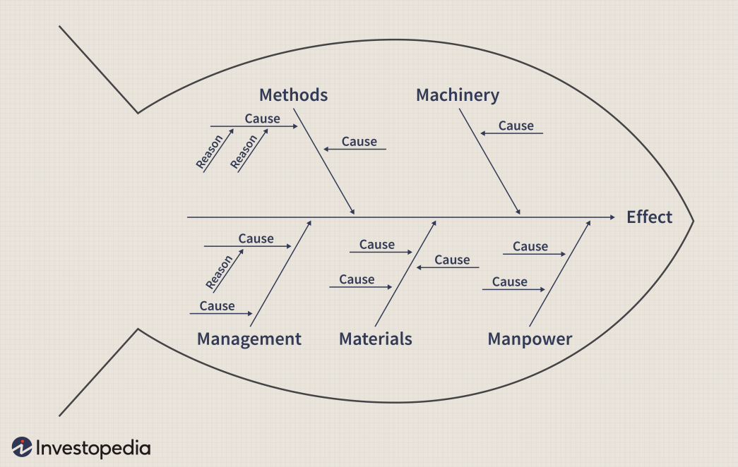
Figure 3. Ishikawa Diagrams
Source: https://www.investopedia.com/terms/i/ishikawa-diagram.asp

The Ishikawa diagram, called the herringbone diagram, was developed by Kaoru Ishikawa in the 1960s and shows the causes of certain events, and is used in the production and development of products. The diagram outlines the various steps in a process and is used to demonstrate control and quality problems. The chart is used to determine which resources are needed at certain times. In addition, the chart is used to show the causal factors that affect organizations. In other words, a causal diagram shows the reasons for a particular event. The purpose of the herringbone chart is to allow the leaders of the organizations to determine which issues need to be addressed. In this case, the diagram is useful in deciding the problem of the dissatisfied employees. The causes of the problem and why they occur are discussed. The different branches show causal relationships.
With the mail in this chart, organizations can easily identify problems. In this case, the identified problem is the lack of training and development of employees. The reasons for this are insufficient investment in training programs, lack of strategic planning. The effect of untrained workforce leads to deteriorating business results. The herringbone chart helps to identify solutions to the problem, in which case companies need to focus on developing new training ideas and developing career development programs.

Plan for implementing the solution

Organizations need the best implementation plan when making a strategic decision that allows guidance in the strategic decision. Implementation includes the implementation of improvements, which include work planning, task planning, time planning, people and resources. Here are some steps you can take to begin the process of preparation for mediation (ROTHWELL and KAZANAS, 2003).
Step 1 | Desired result | The main objective of step 1 is to identify and communicate what will happen and when it will happen, to ensure that all participants have a common understanding of how improvements in recruitment and training programs will be implemented. and employee development. It is important that the results are predictable. The skills used by both employees and management enable the organization to become more efficient.
Step 2 | Choose a manager | At this stage, the organization must select someone who will be responsible for planning and implementation. For this purpose, the organization will choose a person with good communication skills to communicate with colleagues and managers. It is also a good approach to finding and looking for innovative ways to solve the problem of dissatisfied employees.
Step 3 | Schedule for implementation | The schedule includes the beginning, middle and end. The organization must be confident that planning decisions will lead to rapid implementation. In this case, the company must use planning strategies for effective management.
Step 4 | Delegation of tasks | Each member of the team must be informed of additional tasks, if any. This provides motivation and clear expected results among employees.
Step 5 | Budget | The useful budget of the implementation plan should make all elements easy to measure. In this case, the organization must work with worksheets, which will help identify possible costs.
Step 6 | Risk assessment | The organization must understand the dangers and factors that affect the effectiveness of the company. This is important for the implementation plan. Risk assessment should be a team commitment, as it is important to gather all points of view to identify the risk.

Table 2. Development of a plan for the implementation of solutions
Source: Created by the Author

Communicating the plan to the stakeholders

Stakeholders are the people who will be affected by the project or who can influence it. These are managers, leaders, internal departments, customers and suppliers within the organization. The aim is for stakeholders to support and facilitate the action plan. The herringbone technique is expected to lead to feedback through which the opinion of each employee can be assessed. In addition, possible meetings when communicating the stakeholder plan for the Ishikawa Diagram are not ruled out. On the other hand, stakeholders are able to prevent the implementation of change, as they are also affected by it. The reasons for this can be: costs, organizational changes, new technologies, competing projects. This is the reason for developing a strategy and action plan to overcome resistance in order to minimize the negative consequences.

Evaluate appropriate monitoring and review techniques to ensure successful implementation of the decision

To ensure a successful implementation solution, organizations need to focus on conducting weekly and daily meetings with management staff to ensure success in implementing the herringbone chart. the plan will help to detail and evaluate the performance of the presentation. At these meetings, the project team is expected to identify objectives in implementing employee training and development programs within the organization. The Ishikawa Diagram techniques will improve the organization's business performance by analyzing the plan and communicating it to management, which involves providing training and development opportunities for employees in the workplace.

Conclusion

The report focused on identifying a complex problem on the overall performance of organizations, after which this problem was analyzed. PESTEL analysis was applied and alternative solutions to a complex problem were evaluated, choosing the most appropriate solutions among these alternatives. A demonstration of the implemented decision was made by the organizations and an assessment of the result was made. The report also identifies a problem (lack of career development) that affects employee dissatisfaction in the workplace. In the process of finding a solution, the problem was analyzed, and then an alternative solution to this problem was identified. Decision-making techniques were used to identify the most appropriate option. Finally, a plan was drawn up and the techniques were evaluated to ensure success in implementing the decision. In conclusion, this report aimed to examine both the problem-solving process and the decision-making process, which are crucial for leaders and managers of business organizations in the UK. Identifying various problems with disgruntled employees and the applied techniques to deal with these problems help companies to become more competitive and improve their efficiency.

References

- Adair, J. (2010) Decision Making and Problem Solving Strategies. 2nd edn. United Kingdom: Kogan Page
- Edmonds, S. (2014) The culture engine. New Jersey: John Wiley & Sons
- Greer, C. (2003) Strategic Human Resource Management. 2nd edn. United States: Pearson Custom Publishing
- Higgins, J. (1994) 101 Creative Problem Solving Techniques: The Handbook of New Ideas for Business. United States: New Management Publishing Company
- Lindholm, C. (2021) SWOT Analysis of City Council Leadership Roles and Functions. Available at: https://www.linkedin.com/pulse/swot-analysis-city-council-leadership-roles-functions-craig (Accessed 15 November 2021)
- Meister, J. and Willyerd, K. (2010) The 2020 workplace: how innovative companies attract, develop, and keep tomorrow’s employees today. 1st edn. United Kingdom: HarperCollins
- Muiswinkel, J. (2013) Human Resources: Management and Training. [no publisher]
- Richards, T. (2015) Problem Solving: Best Strategies to Decision Making, Critical Thinking and Positive Thinking. United States: CreateSpace Independent Publishing Platform
- Rothwell, W. and Kazanas, H. (2003) Planning & Managing Human Resources. 2nd edn. Massachusetts: Human Resource Development Press
- Sproull, B. (2018) The Problem – Solving, Problem – Prevention, and Decision – Making Guide. New York : Taylor & Francis

