UWTSD

ACDC 5009: Analysis of Electromagnetic wave propagation
Alun Morris

Contents
Abstract: 3
Introduction: 3
1 Rectangular Waveguide: 3
1.1 Method: 3
1.2 Results: 5
1.3 Discussion: 7
1.4 Conclusion: 8
2 Halfwave Dipole Antenna: 8
2.1 Method: 8
2.2 Results: 10
2.3 Discussion: 10
2.4 Conclusion: 10
References: 11
Appendices: 12
Appendix A: Other Waveguide results 12
Appendix B: Antenna incorrect Operating Frequency (3 GHz) 14

Academic integrity declaration
I declare that:
- the assignment submitted has been written by me alone.
- the assignment submitted has not been previously submitted to this university or any other.
- that all content, including primary and/or secondary data, is true to the best of my knowledge.
- that all quotations and references have been duly acknowledged according to the requirements of academic research.
I understand that to knowingly submit work in violation of the above statement will be considered by examiners as academic misconduct.

Abstract:
This report looks at designing a rectangular waveguide and a half wave dipole antenna using arbitrary dimensions derived from a unique student ID. By using this design method, it was possible to conclude that rectangular waveguides require very specific dimensions to function correctly. For half wave dipole antenna, the conclusion is made that when specifying the operating frequency of the antenna it is important to include the phenomenon of fringing fields into the design of the length of the antenna.

Introduction:
Using modelling software, this report will be examining the wave propagation of a rectangular waveguide with walls made of a Perfect Electrical Conductor (PEC) where the dimensions of the waveguide have been defined by the individual student numbers of the classroom. Next, the wave propagation of the PEC walled waveguide after it has been filled with Teflon whose Relative permeability is 1 and relative permittivity is 2.1 shall be examined.
Section 2 will use the same student ID from the waveguide experiment to determine the desired wavelength (𝜆) that will be radiated by a dipole antenna. The results will be generating using a model of a dipole antenna with a radius of 1mm and made from a PEC material. The excitation shall be applied through a lumped port with a port impedance of 50 Ohms (Ω). The model will be placed in a rectangular radiating surface.

1 Rectangular Waveguide:

Method:
Using the High Frequency Structured Simulation project in ANSYS electronics software. A model of a rectangular waveguide where the width of the waveguide (a)mm is the first two numbers of student ID 2314593 and the height (b)mm is the 3rd and 4th number divided by 2, with a length of 50mm along the z-axis.
- = 23mm
- = 7mm
The walls of the rectangular waveguide were set to Perfect Electrical Conductor (PEC), and the inside material was filled with a vacuum. Two ports were assigned to the waveguide with 3 modes each and a port impedance of 50 Ohms.
The driven solution for the analysis used a solution frequency that is close to the theoretical cut off frequency of the waveguide for the dimensions stated above. Number of passes was set to 60 as that should provide the necessary level of detail for the analysis.
To calculate the theoretical cutoff frequency, the following formula was used.
$$f_{c}=\frac{c}{2}\sqrt{{\left(\frac{m}{a}\right)}^{2}+{\left(\frac{n}{b}\right)}^{2}}$$
Equation 1: Cut-off frequency in a rectangular wave guide (vacuum)
The values for m and n were derived from the “port field display” option in the ANSYS software. Figure 1 shows one half wavelength across the x-axis of the waveguide and nothing across the y-axis. Therefore, m = 1 and n = 0 for mode 1 giving a theoretical cutoff frequency of around 5.5 GHz.
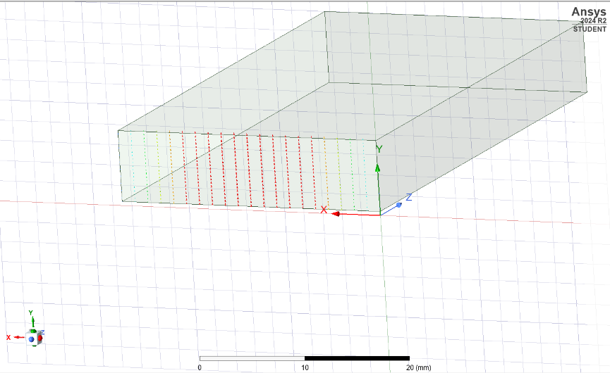
Figure 1 dominant mode
To ensure a broad range of frequency are covered by the analysis tool an interpolating sweep with a linear count distribution between 2 GHz and 30 GHz was selected. This should allow a high enough frequency sweep distribution to avoid any results getting cut out of the simulation.
Once the simulation had finished images of the E field and H field magnitude and Vectors were generated for use in the results and discussion sections.
The method above was then repeated for a rectangular waveguide of the same dimensions with the vacuum replaced with Teflon. Equation 2 must be used to calculate the cut off frequency because it is no longer a vacuum therefore μ the permeability of the medium and ε permittivity of the medium must be included in the calculation. For Teflon ε = 2.1 [1] and since Teflon is not magnetic μ = 1 [2].

$$f_{c}=\frac{C}{2\sqrt{εμ}}\sqrt{{\left(\frac{m}{a}\right)}^{2}+{\left(\frac{n}{b}\right)}^{2}}$$
Equation 2: Cut-off frequency in a rectangular wave guide.
Since the speed of light travelling through the material is going to be influenced by ε and μ they can be added into equation 1 to form equation 2 to calculate a cut off frequency of around 3.8 GHz for the Teflon filled rectangular waveguide in the simulation.

Results:
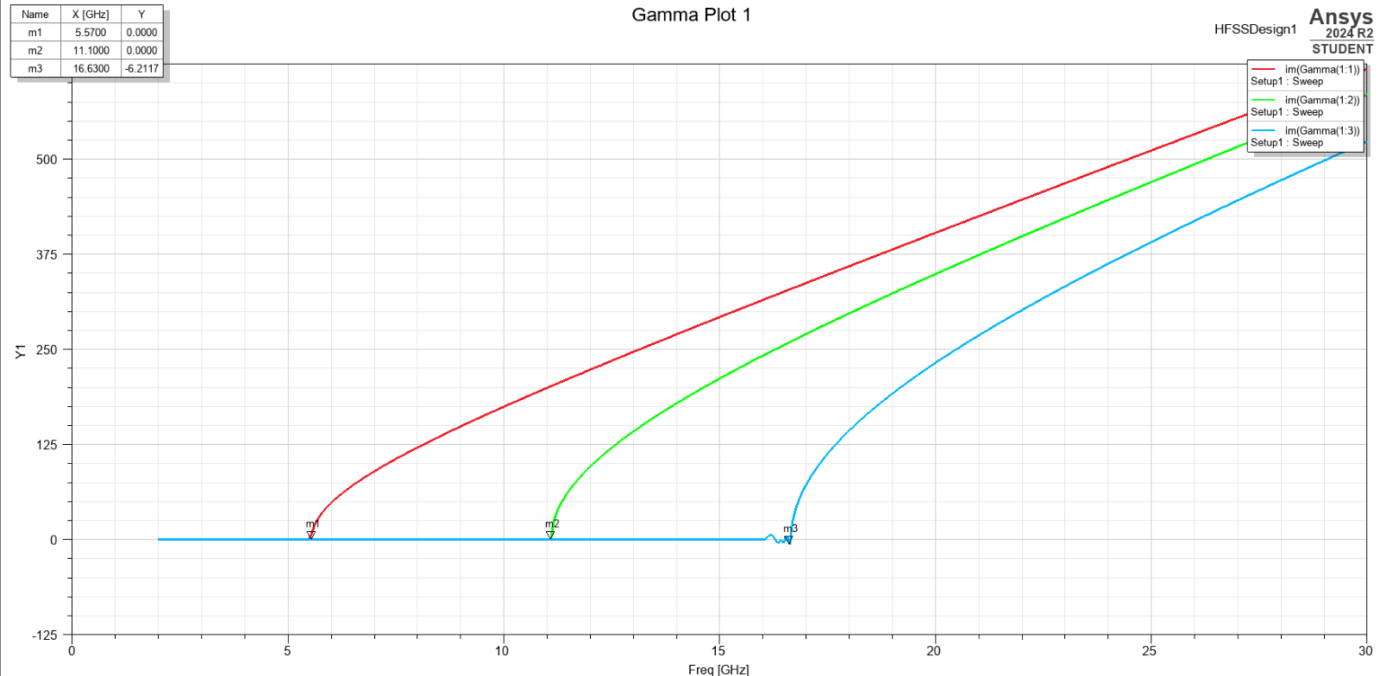
Figure 2: Simulated cut-off frequency vacuum
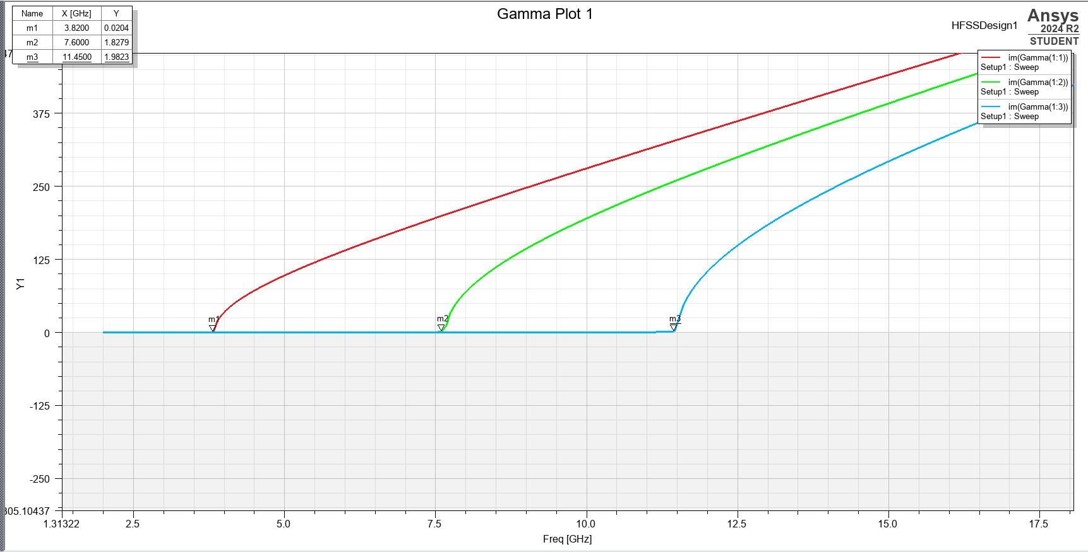
Figure 3: Simulated cut-off frequency Teflon

Figure 4: Port field display Port 1 modes
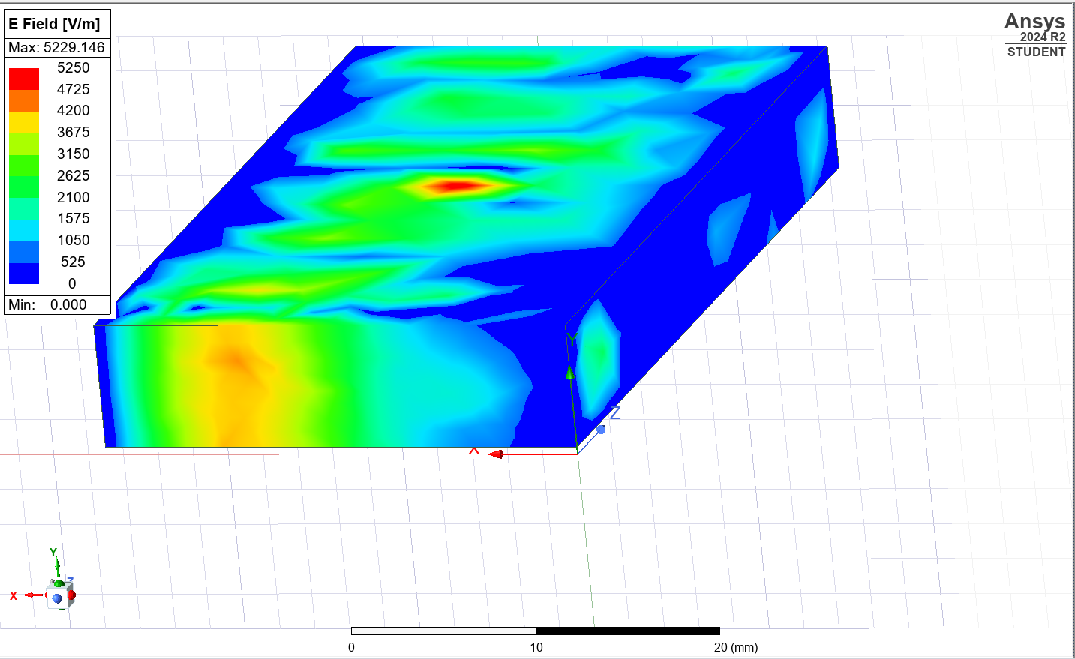
Figure 5: Source 1:1 Magnitude E field Vacuum
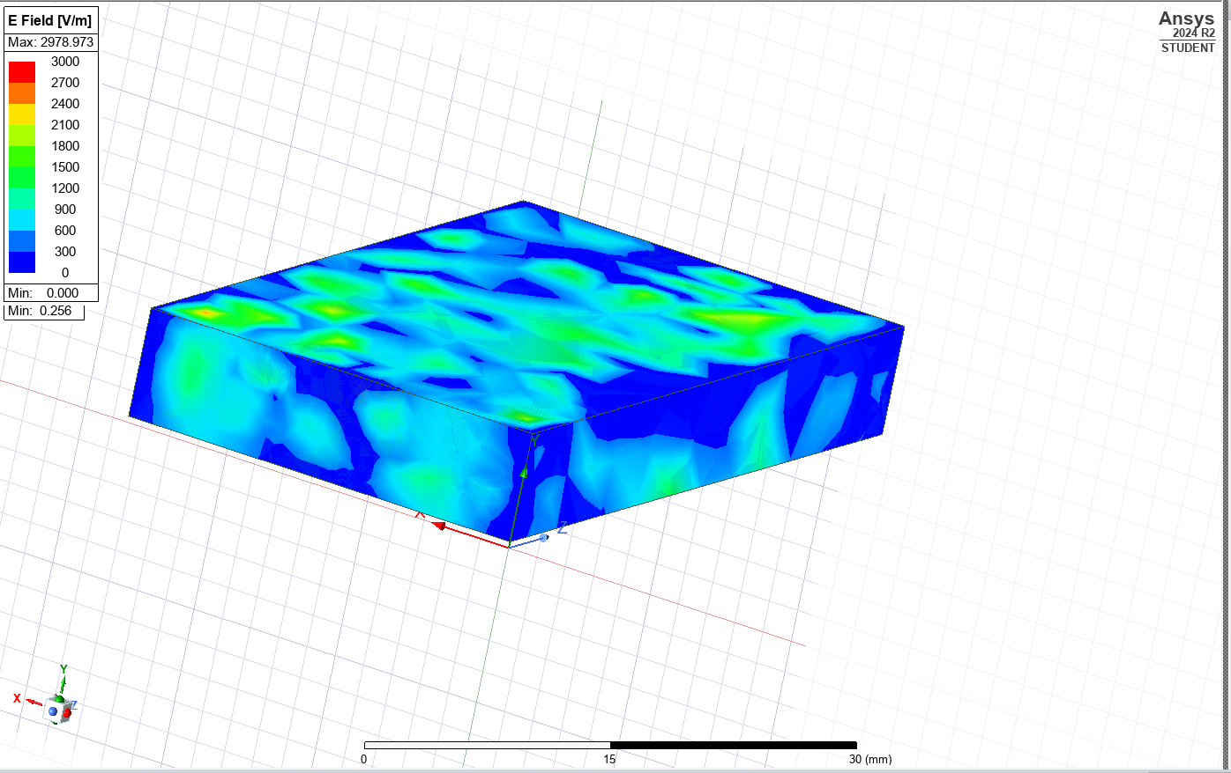
Figure 6: Source 1:1 Magnitude E field – Teflon
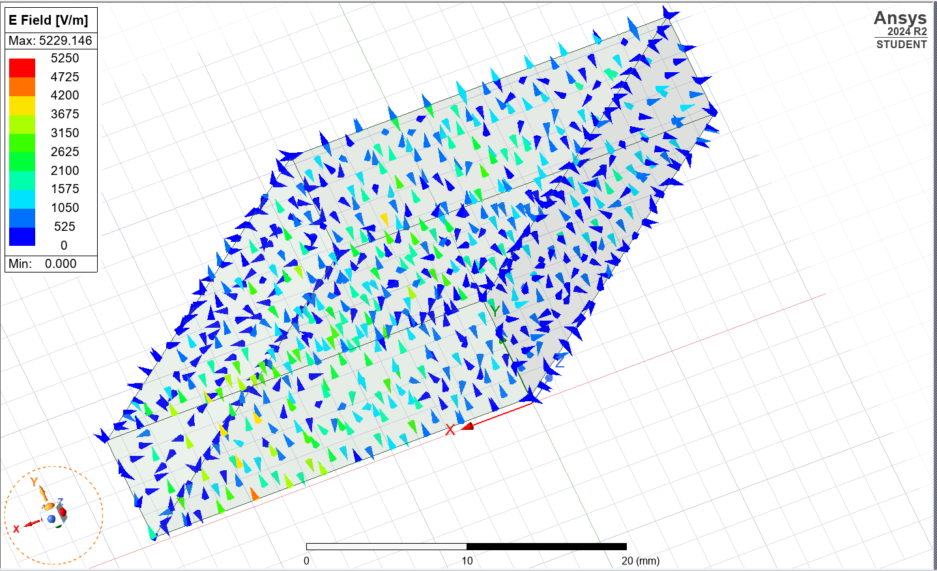
Figure 7: Source 1:1 Vector of Electric E field Vacuum
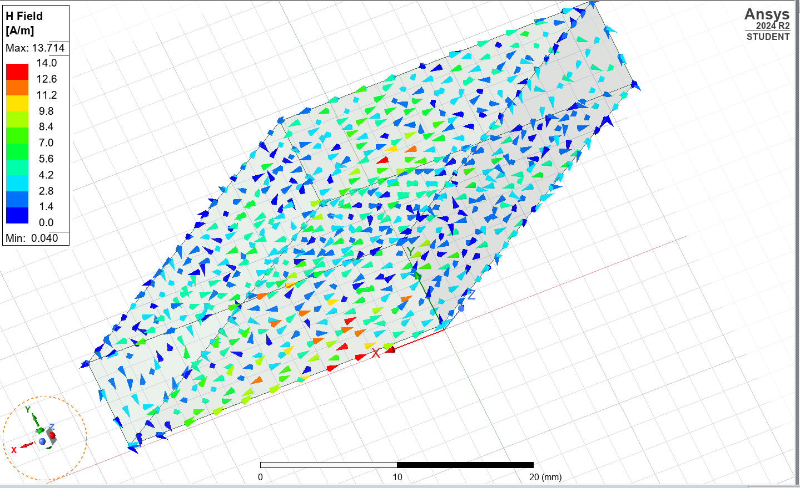
Figure 8: Source 1:1 Vector magnetic H field Vacuum

Discussion:
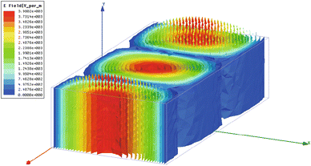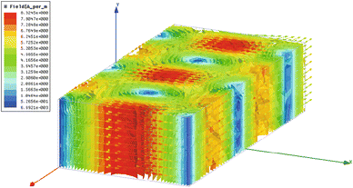
Figure 9: Correct E and H field magnitude and Vector [3].
The mode observable in figures 2 and 3 with the lowest cutoff frequency in both the vacuum and Teflon models is TE₁₀. This is the dominant mode the number after TE indicates the number of half wavelengths across the x-axis and y-axis. Figure 4 displays one half wavelength across the x axis and nothing across the y-axis therefore the mode is TE_{10.} The cut-off frequency for TE₁₀ Teflon is lower than the vacuum. This is because the relative permittivity (ε) of Teflon is greater than the vacuum and thus has a higher resistance to forming an electric field and slower propagation through the medium [6].
The expected behaviour of the electric and magnetic fields in a rectangular waveguide can be seen above in Figure 9. The highest magnitude of the electric field is in the middle of the waveguide as that’s where the peak power of the half wavelength is, and the vector of the electric fields are uniformly traveling up the y-axis. Maxwell’s equations state that the magnetic field will travel transverse to the electric field. In the right-hand image of Figure 9 above the vector of the magnetic field is travelling transverse to the electric field as expected. However, for the TE₁₀ mode images in the results section the peak magnitude of the electric field is off centre for the vacuum simulation and the Teflon image appears to have not formed a half wavelength at all. The vectors of the magnetic and electric fields for both the vacuum and Teflon are also not uniformly pointing across any axis.
Probable causes for the incorrect wave propagation and field vectors for the waveguide designed using the method in this report could be either:
- The ANSYS modelling process had an error in the process or selection of operating frequency suitable for a waveguide of such dimensions.
- The unconventional dimensions for a rectangular waveguide caused the unusual results.
[4 p.49 – 50] Discusses the importance of getting the dimensions of the rectangular waveguide correct for minimising loss of power when propagating over the dominant mode. This suggests that b) is the reason for the results of the waveguide model in this report not aligning with how the results of other similar waveguide models look. To ensure optimal performance of rectangular waveguides for the desired frequencies there are industry standard dimensions for both the x and y axis. By selecting the cut-off frequency for the dominant mode that is closest to 5.5 GHz a waveguide of the dimensions x= 25.9mm and y = 12.9 mm would yield better wave propagation.

1.4 Conclusion:
When designing a rectangular waveguide, it is important to select the dimensions that correspond to the operating frequency of the signal that is to be transmitted. Otherwise, the waveguide will not function correctly.

2 Halfwave Dipole Antenna:

2.1 Method:
Using the HFSS modelling in ANSYS a project was created with the solution type set to HFSS modal. The antenna specification is to radiate waves with a wavelength equal to the first 3 numbers of the student ID noted in the rectangular waveguide section. Therefore, the antenna length was calculated as 115.5 mm using equation 3 below.
$$L=\frac{λ}{2}$$
Equation 3: Length of Dipole
A 1mm radius cylinder with a length of 115.5 mm was created in ANSYS using the PEC material. A lumped port with an impedance of 50 Ohms was created at the middle point of the cylinder at 57.75 mm (1/4 $λ)$ along the z-axis for the excitation (Figure 10).
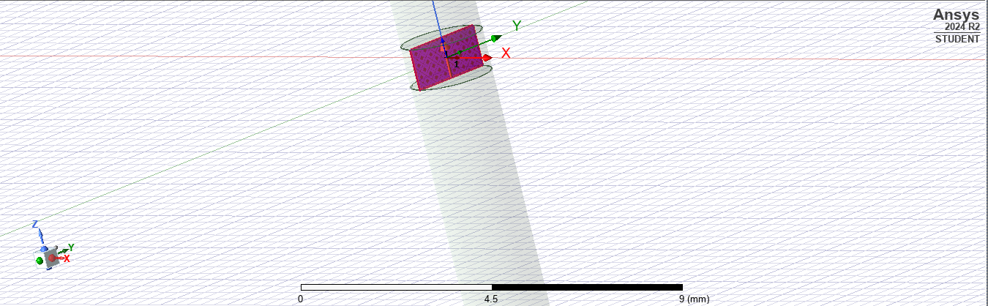
Figure 10: Lumped port
Next, an open region was created around with antenna with an operating frequency of 1GHz and the boundary set to Perfectly Matched Layers (PML) because this is the most suitable for free space termination.
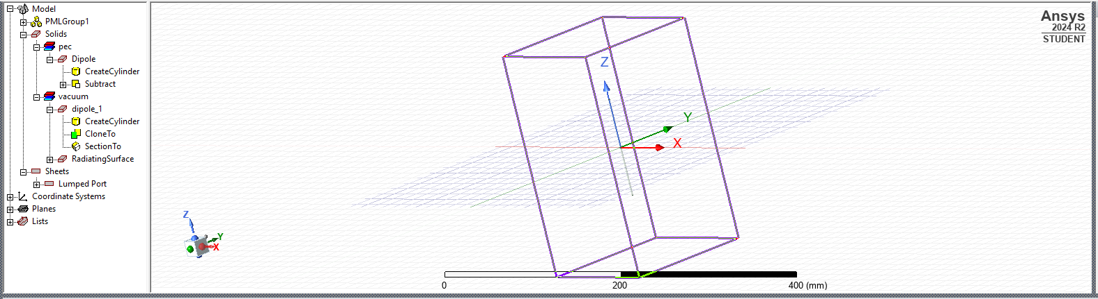
Figure 11: Antenna and Boundary Box
For the solution it is necessary to select a frequency that is close to the theoretical resonant frequency of the antenna which can be determined using the following equation:
$$f=\frac{C}{2L}$$
Equation 4: Half Wave Dipole resonant frequency (vacuum)
f = Resonant Frequency
C = Speed of Light
L = length of Antenna
For this antenna design f = 1.299 GHz therefore, the operating frequency for the driven solution was set to 1.3 GHz and the frequency sweep range for the analysis was set between 1 GHz to 7.5 GHz. If the operating frequency is not calculated accurately then the results may be different see Appendix B.
Once the ANSYS analysis had completed a plot with the following parameters was produced [ Terminal S (Scattering) parameter, S (1,1), dB] and a 3d polar plot to display the direction of the gain (radiation pattern) was also created.

2.2 Results:
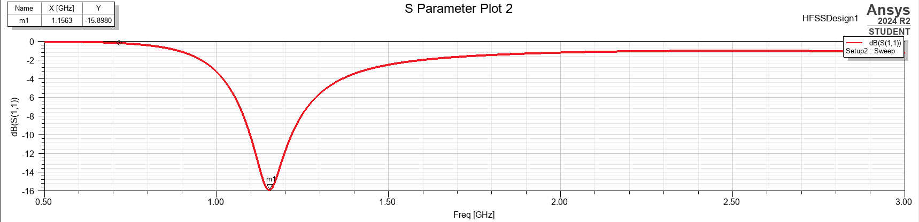
Figure 12: Scattering Parameter plot resonant frequency
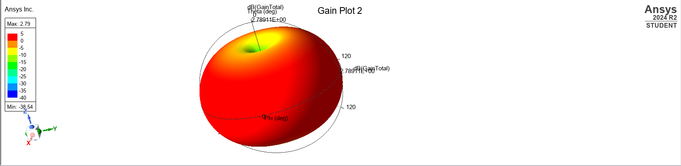
Figure 13: Half Wave Dipole Antenna Radiation Pattern

2.3 Discussion:
Figure 12 shows that the antenna is operating within a narrow bandwidth this is controlled by the radius of the antenna. Increasing the radius of the antenna pole would increase the bandwidth. A thin dipole like the one in the model is highly frequency sensitive so it would be advisable to design the antenna to closely match the design frequency. Looking at the results of the simulation the operating frequency of 1.156 GHz is lower than the design frequency of 1.299 GHz. The model not matching the design operating frequency is likely due to a phenomenon called fringing fields. Because there is nowhere for the current to flow at the ends of a dipole antenna there forms a large charge concentration at the ends until the cycle ends and the current flow the opposite direction. The high charge concentration leads to high density fields at the ends of the antenna these are the fringing fields. This causes the effective length of the dipole antenna to be somewhat longer than its physical length. Meaning that to achieve the target resonance frequency the antenna needs to be slightly shorter than the length calculated using equation 3 [7].
By looking at the shape of the 3d plot at figure 13 it can be observed that this antenna has an omnidirectional radiation pattern, easily identifiable by the donut shape. Omnidirectional antennas can radiate or receive signal in all directions within a specific plane. This is ideal for antennas that need to radiate or receive signal from multiple directions without having to re-orientate the antenna.

2.4 Conclusion:
When designing a dipole antenna to operate at a specific resonant frequency it is important to consider the fringing fields. When using software to design the antenna it is possible to match the length to the resonant frequency through trial and error. Failure to match correctly match the antenna length to the resonant frequency desired would result in the signal and antenna impedance not matching which could lead to reflections and loss.

References:
[1] Steven W. Ellingson “10.1: Permittivity of Some Common Materials,” Physics LibreTexts, Apr. 02, 2020. https://phys.libretexts.org/Bookshelves/Electricity_and_Magnetism/Electromagnetics_I_(Ellingson)/10%3A_Appendices/10.01%3A_Permittivity_of_Some_Common_Materials
[2] Steven W. Ellingson “11.2: Permeability of Some Common Materials,” Engineering LibreTexts, Apr. 02, 2020. https://eng.libretexts.org/Bookshelves/Electrical_Engineering/Electro-Optics/Book%3A_Electromagnetics_II_(Ellingson)/11%3A_Constitutive_Parameters_of_Some_Common_Materials/11.02%3A_Permeability_of_Some_Common_Materials
[3] T. ul Haq, M. F. Khan, and O. F. Siddiqui, “Design and implementation of waveguide bandpass filter using complementary metaresonator,” Applied Physics A, vol. 122, no. 1, Dec. 2015, doi: https://doi.org/10.1007/s00339-015-9533-1.
[4] C. E. Free and C. S. Aitchison, RF and microwave circuit design : theory and applications. Hoboken, Nj, Usa: Wiley, 2020.
[5] “Waveguide Sizes | Dimensions & Cutoff Frequency - everything RF,” Everythingrf.com, 2021. https://www.everythingrf.com/tech-resources/waveguides-sizes
[6] Mark Hughes “Antenna Basics: Radiation Patterns, Permittivity, Directivity, and Gain - Technical Articles,” www.allaboutcircuits.com. https://www.allaboutcircuits.com/technical-articles/antenna-basics-field-radiation-patterns-permittivity-directivity-gain/
‌ [7] Ruturaj Rao “Fringing Fields,” Iitb.ac.in, 2025. https://www.ee.iitb.ac.in/course/~vel/apps/Dipole1/Pages/Fringing_Fields.html (accessed Apr. 22, 2025).
‌

‌

‌

‌

‌

‌

Appendices:

Appendix A: Other Waveguide results
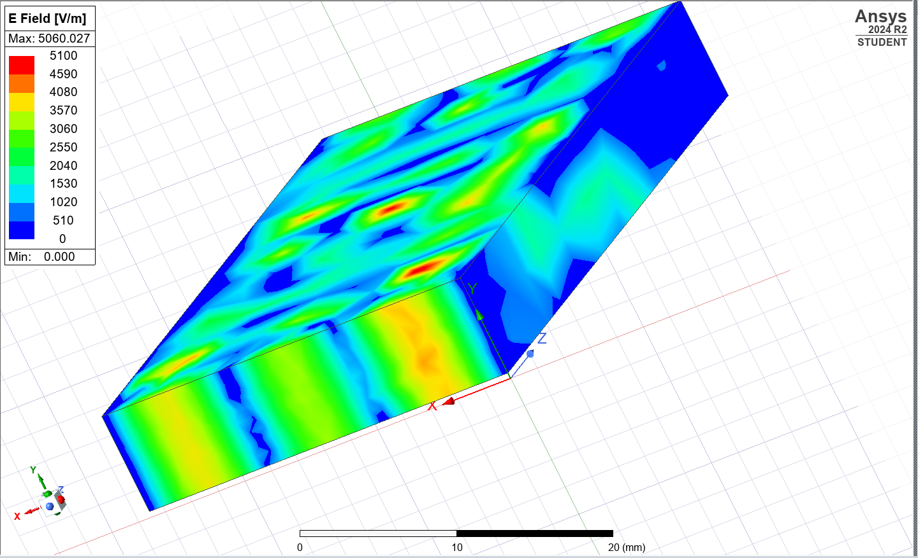
TE₃₀ Vacuum Electric Field Magnitude
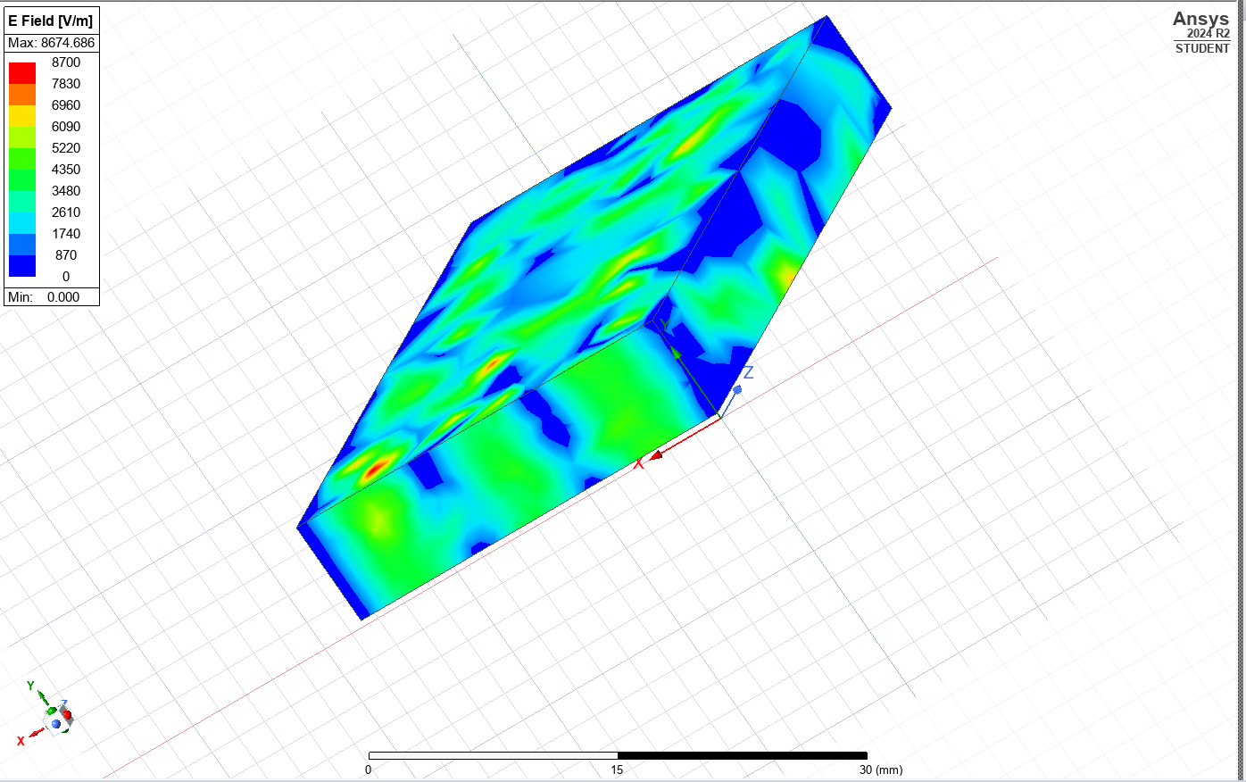
TE₃₀ Teflon Electric Field Magnitude
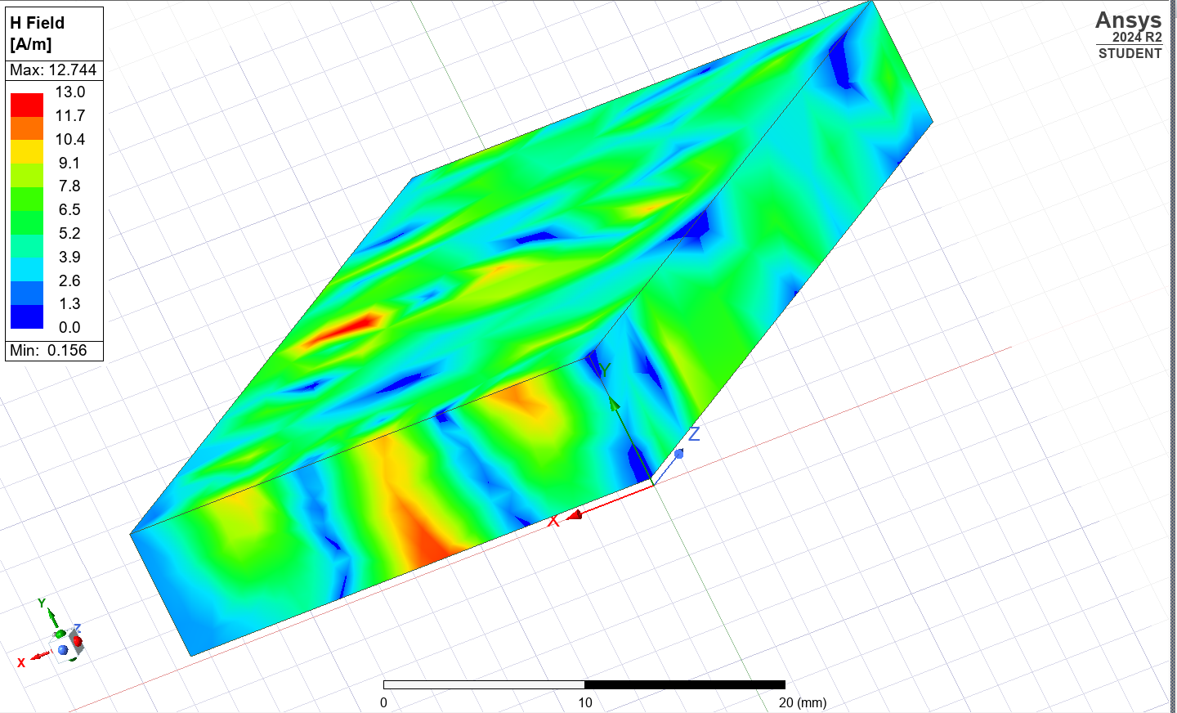
TE₃₀ H Field Magnitude Vacuum
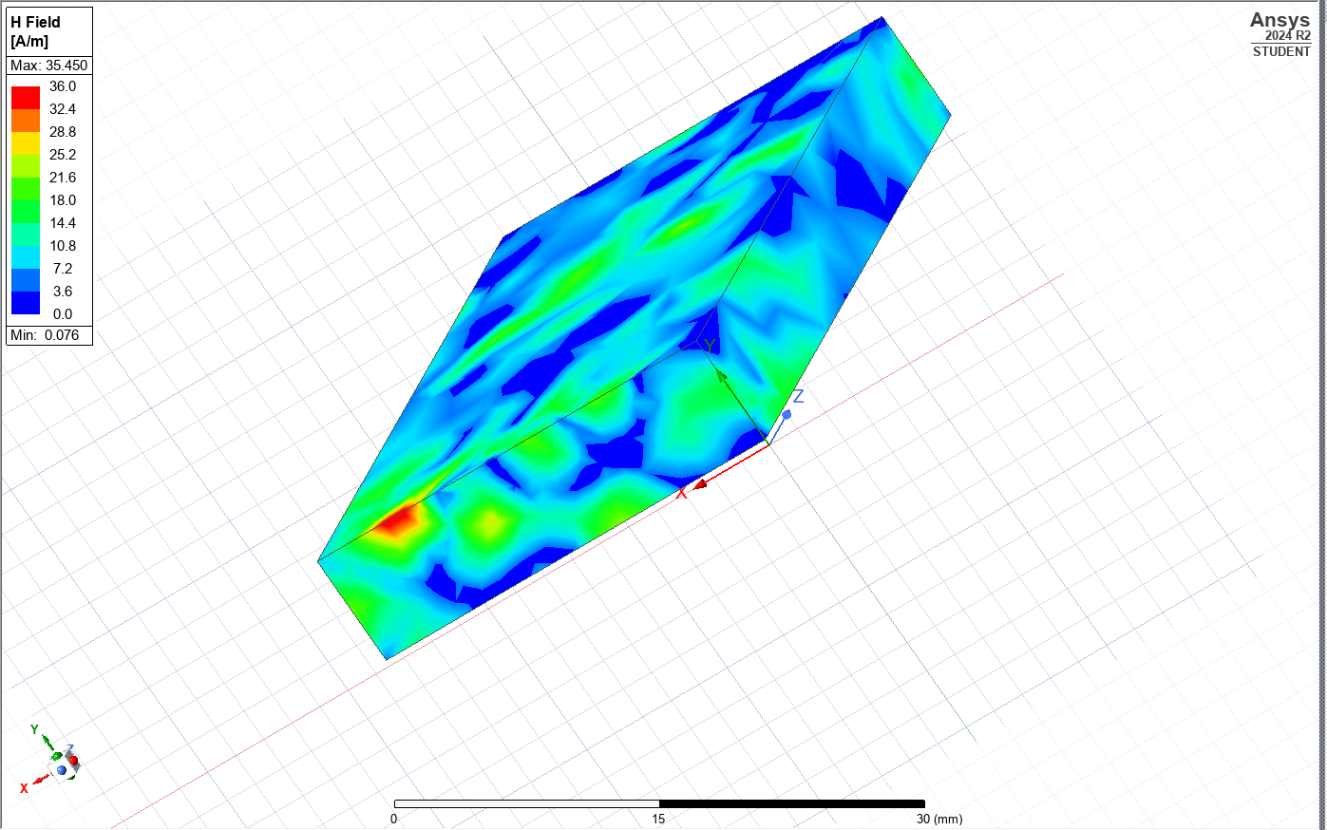
TE₃₀ H Field Magnitude Teflon

Appendix B: Antenna incorrect Operating Frequency (3 GHz)


