Module code & Title | BMIH6004 Managing Hotel Administration | Programme: | B.A. International Hotel Management
Lecturer: | Christopher Wilkin  Rodrigo Fernandes Aguilera | Internal Verifier: | Lola Villard
Student Name: | Masudur Chowdhury | Student ID: | 1911444
Module level | 6 | Word Count: | 1134

Table of Contents
Student Learning Log 3
The Development Record 3
The Attainment of Objectives: 3
Management Issue and Solution 5
References 7

Student Learning Log

The Development Record
In light of my position as a Hotel Assistant Manager at Hilton Hotel- East Midland Airport, I was afforded the chance to acquire invaluable expertise within the hotel sector whilst honing my proficiencies in the domains of self-regulation, task administration, fixing problems, interpersonal communication, and practical implementation of knowledge. Personal learning objectives must need focus on enhancing the capacity to function autonomously, efficiently manage task prioritisation, proficiently communicate with co-workers and customers, and competently apply academic knowledge to practical scenarios (Tesone, 2017). My learning objectives focused on enhancing my capacity to function autonomously, efficiently manage task prioritisation, proficiently communicate with co-workers and customers, and competently apply academic knowledge to practical scenarios. During my placement, the primary goals of the hotel were to uphold superior levels of customer satisfaction, enhance operational efficiency, and augment revenue (Pratap, 2017).

The Attainment of Objectives:
Throughout my placement, I made a concerted effort to attain the objectives delineated in my action plan and learning agreement. Regarding self-management and development, I continuously exhibited a noteworthy degree of professionalism and accountability by assuming ownership of the tasks and responsibilities and actively pursuing opportunities for personal growth and advancement. Furthermore, I consistently participated in introspection and solicited evaluations from my superiors and peers. Facilitating the recognition of shortcomings and the formulation of specific approaches to tackle them leads to a crucial outcome in success criteria (Tewari, 2009).
Regarding task management, I successfully prioritised my workload, ensuring the timely completion of urgent tasks and appropriate attention to longer-term projects. Furthermore, I exhibited a robust aptitude for handling conflicting priorities and promptly adjusting to dynamic situations.
Considering the initiative's implementation in workplace predicaments, I was proficient in utilising my ingenuity and analytical abilities to devise inventive resolutions for intricate issues. For example, I proposed an innovative strategy for handling customer complaints, which streamlined the entire procedure and significantly improved customer satisfaction ratings.
Regarding communication, I fostered robust connections with my peers and clients by proficiently and coherently conveying information through oral and written means. In addition, I proactively solicited feedback from peers and incorporated it into my communication practices, gradually enhancing my proficiency in this area.
Ultimately, concerning the practical implementation of knowledge, I could utilise my scholarly experience to recognise areas for enhancement and formulate solutions to workplace issues grounded in empirical evidence. The employment of critical expertise in revenue management to devise a novel pricing approach for hotels yields a noteworthy surge in revenue (Fallon and Rutherford, 2010).
Missed chances or lost opportunities: Although I take pride in the advancements achieved during my placement, there were several missed prospects that I could have capitalised on. One possible approach to enhance professional networking and industry knowledge could have been to proactively explore additional avenues for engaging with colleagues from diverse departments and attending relevant industry events. This strategy may have facilitated the expansion of the individual's professional network and provided a more comprehensive understanding of the industry (Vallen and Vallen, 2017). Furthermore, I contend that I could have assumed additional duties and encountered more demanding tasks throughout my placement. In retrospect, I regret not having demonstrated greater proactivity in actively pursuing novel avenues for personal growth and knowledge acquisition.

Management Issue and Solution
During My placement, I observed the matter of inadequate communication between the front desk and housekeeping personnel, leading to tardy room cleaning, which is a crucial management concern in the hospitality sector. The reason for this is that the satisfaction of guests is a crucial factor in determining the reputation and revenue of a hotel (Johnston et al., 2012). The expression of unfavourable feedback and grievances by patrons has the potential to result in a reduction in commercial activity and financial earnings (Casado, 2012). Consequently, it is crucial for hotels to promptly and effectively address such matters. To mitigate this concern, the implementation of a daily briefing session between the front desk and housekeeping personnel can prove to be efficacious (Flynn, 2017). The aforementioned approach aligns with the communication model, which underscores the significance of reciprocal communication and feedback. The implementation of a daily briefing session will facilitate the exchange of information between the front desk and housekeeping personnel, enabling them to effectively tackle any challenges that may have emerged(qaa.ac.uk). Implementation of this measure is expected to enhance communication and expedite the cleaning process, thereby ensuring the timely availability of occupancy rooms.
Apart from the routine update, the utilisation of technological tools such as a task management system can prove advantageous. Task management systems enable personnel to monitor their designated tasks and associated deadlines, mitigating the possibility of overlooked duties and postponed room sanitation (Wood, 2015). The aforementioned methodology aligns with the fundamental tenets of operations management, wherein the emphasis is laid on enhancing processes and optimising efficiency.
I recommended employing Maslow's Hierarchy of Needs framework to bolster the suggested remedies. As per Maslow's argument, survival needs are satisfied in this context, so now the focus must be on satisfying the higher needs.
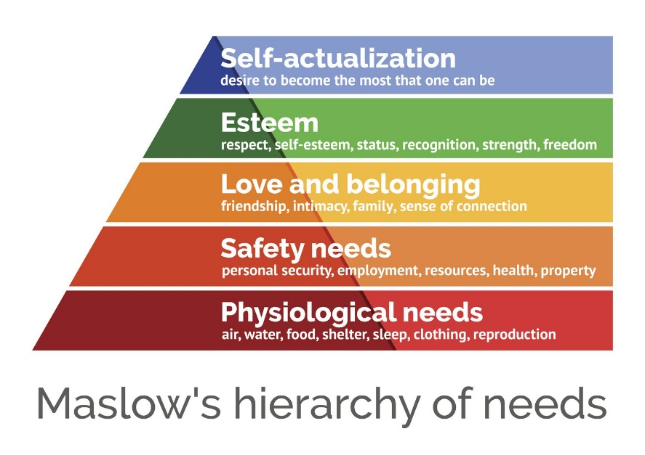
Figure 01: Maslow’s Hierarchy of Needs (Bojanic and Reid, 2016)
It becomes increasingly challenging to meet a higher-level hierarchy's requirements as the structure becomes more complex. The theory in question places significant emphasis on fulfilling fundamental needs, including safety and security (Lok, 2022). The hotel can enhance guests' experience and meet their fundamental requirements by guaranteeing that guest rooms are tidy and prepared for habitation, assisting hotel customers in experiencing a sense of security and fulfilling the physiological requirements of hotel guests (Hollander, 2022). This phenomenon possesses the capacity to lead to increased levels of customer satisfaction and consequent loyalty. Moreover, I also suggest employing Herzberg's Two-Factor Theory. The theory posits that the presence of hygiene factors, such as favourable working conditions, and motivators, such as job satisfaction, are crucial in establishing a conducive and constructive work milieu.
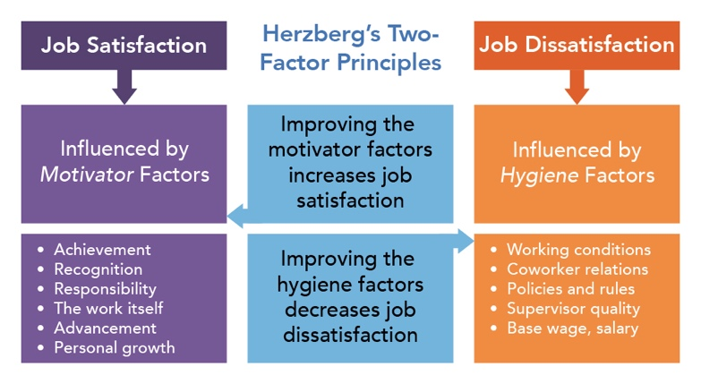
Figure 02: Hygiene factors in the hospitality industry (Cindy, 2014)
Through the implementation of measures aimed at enhancing room cleanliness and fostering effective communication among staff, Hilton Hotels can effectively tackle a hygiene-related concern and cultivate a more favourable work atmosphere for its personnel (Klyuchevskaya, 2021). The previously mentioned phenomenon possesses the capability to yield increased levels of motivation and satisfaction among staff, eventually leading to an improvement in the quality of service provided to customers.
In conclusion, I hope that this student learning log provides a glimpse into my time spent assisting as an assistant manager at Hilton Hotel, where I was able to reflect on the growth and development of my professional hospitality skills. The experiences and skills I gained throughout this time have set me up for great success as a hospitality professional. By remaining proactive in searching out independent learning opportunities, and new challenges and increasing my professional networks, I hope to continue building upon the abilities I acquired throughout my placement.

References
Bojanic, D. C. and Reid, R. D. (2016) Hospitality Marketing Management. 6th edn. Nashville, TN, USA: John Wiley & Sons. pp.93-107.
Casado, M. A. (2012) Housekeeping Management. 2nd edn. Nashville, TN, USA: John Wiley & Sons.
Fallon,M. & Rutherford,D. (2010) Hotel Management and Operations, Wiley, London
Flynn, S. (ed.) (2017) ASET good practice guide for work-based and placement learning in higher education: Toolkit for institutional use. Sheffield: Aset (1982).
Hertel, C. (2014). Motivational Job Satisfaction in the Caribbean Hospitality Industry: How Demographic Variables Influence Job Satisfaction. Germany: Anchor Academic Publishing. pp.16-60
Johnston, R., Clark, G. and Shulver, M. (2012) Service operations management: Improving service delivery. 4th edn. London: Pearson Education.
Klyuchevskaya, I. (2021) Personnel management of a hotel company. ru: INFRA-M Academic Publishing LLC.
Lok, J. (2022) Hotel Industry Management Strategy. Notion Press.
Pratap, A. (2017) Mission and vision of Hilton worldwide: An Analysis, AIM-BLOG. Available at: https://aim-blog.com/mission-and-vision-of-hilton-worldwide-an-analysis/ (Accessed: 10 June 2023).
Tesone, D. V. (2017) Principles of management for the hospitality industry. London, England: Routledge
Tewari, J. R. (2009) Hotel Front Office: Operations and Management. Oxford: OUP.
Vallen, G. K. and Vallen, J. J. (2017) Check-in check-out: Managing hotel operations. 10th edn. Upper Saddle River, NJ, USA: Pearson.
Wood, R. C. (2015) Hospitality Management: A Brief Introduction. Edited by R. C. Wood. Christchurch, New Zealand: Sage Publications.

