
Reflective report
Professional Career Development Skills

Shama Ghias
1914665
February 20, 2020
University of Wales Trinity Saint David

Table of Contents

Introduction 5
Findings 6
Conclusion (average of 10% of word count) 7
Refrences 9
Appendices 10
UPDATE TABLE FREQUENTLY – CHECK IT HAS BEEN UPDATED PRIOR TO SUBMISSION

Introduction – Entire report in 1st person

Professional career development skills are very important in all industries. They will enable the employee to become efficient, confident, up to date, have the ability to lead and influence others, to achieve career goals, and perhaps most importantly, to become a better employee.
My aim in completing this course is to become aware of my own strengths and weaknesses and develop/improve them in order to further my opportunities for employment by setting SMART goals.
I will use several techniques to achieve this, including SWOT analysis – it will help me uncover opportunities that I might not have otherwise identified and by understanding my weaknesses I will be able to manage and eliminate threats that could otherwise have prevented me from going forward.
I will do this by identifying different options for learning and development, exploring the different support mechanisms that are available to me, and preparing personal and professional development plans to ensure I succeed.
In order to do this, I must be self-aware.
“Self-awareness is our capacity to stand apart from ourselves and examine our thinking, our motives, our history, our scripts, our actions, and our habits and tendencies.” (Covey, 2015)

There are numerous tools that can assist me in reflecting and becoming more self-aware, such as the Myers Briggs Personality Test and other learning styles questionnaires. These will give me an indication of my personality type and help me to identify learning styles that would be most suitable for me.

Following on from exercises improving my self-awareness, I will move forward to self-assessment.

“Gathering as much information as possible from others is crucial for understanding how good we are at certain skills. The information needs to be accurate and so the more we gather, the more accurate our skills assessment becomes.” (Morgan, 2017)

I will consider Johari’s Window (Joseph Luft) and Kolb’s Learning Cycle (Kolb, 1984) to help assess my skills and abilities and identify areas for improvement.

Finally, I will set myself a Personal Development Plan in order to identify and address any shortcomings in employability skills.

Findings

In the past, I have quietly thought about my future and dreamt of becoming a qualified hairdresser, moving onto owning my own salon. However, this goal was only ever discussed with my husband and close friends. I never wrote it down or developed a plan in order to ensure success. Neither did I give conscious thought to how I could develop myself in order to achieve my goals.
I now realise the importance of consciously setting a goal/objective and will use the SMART tool to set out a goal. This clear and simple framework will enable me to bring structure and trackability to my objective – to help me visualise my goal and work out what I need to do to get there.
The SMART acronym was originally developed in November 1981 by George Doran:
'How do you write meaningful objectives?'- that is, frame a statement of results to be achieved, Managers are confused by all the verbal from seminars, books, magazines, consultants, and so on. Let me suggest therefore, that when it comes to writing effective objectives, corporate officers, managers, and supervisors just have to think of the acronym SMART. Ideally speaking, each corporate, department and section objective should be: (SMART). (Doran, 1981)

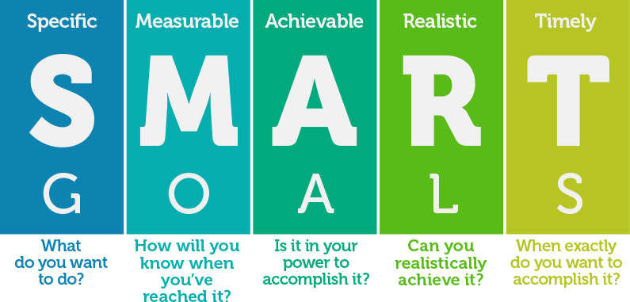

(Trinh, 2018)
I thought carefully about how I could achieve my goal of becoming a qualified hair dresser but recognised that I need to improve my conversational English (as well as obtain relevant qualifications and work experience), so I will include this as part of my SMART goal:

S(pecific) - Improve conversational English skills.
Complete hairdressing qualifications (NVQ).

M(easurable) - I will measure improvement in conversational English by
speaking with friends/teachers.
I will complete the pass the Level 1 NVQ course in Hairdressing
and Barbering.

A(chievable) - There are several courses available for conversational English and I can
complete the NVQ course at Gower College. I am capable of doing both
courses at the same time.

R(ealistic) - Both courses are within my reach and I have the skills and abilities to
complete both with the support of my friends and family.

T(imely) - Once I have completed this course, I aim to finish the NVQ and English
courses within 12 months. I will regularly monitor and reflect on my
progress.

Now that I have laid out my SMART goal, I need to reflect on my strengths and weaknesses. I have used the SWOT analysis model in order to explore these.
SWOT analysis is a type of diagram widely used in business and education used for exploring strengths, weaknesses, opportunities, and threats in a given situation. (Lucidchart, 2020)

SWOT analysis is a very simple and effective tool that can be used by any person, group or organisation/employer, not requiring any special knowledge or training. The model is credited to a management consultant by the name of Albert Humphrey who worked at the Stanford Research Institute in the USA.

My own SWOT analysis is shown below:

STRENGTHS  - Friendly personality  - Good communicator/listener  - Flexible  - Persistent | WEAKNESSES  - Conversational English  - Mental arithmetic  - Time management  - IT skills
OPPORTUNITIES  - Online and college courses  - Unpaid work placements  - Youngest child starting half day nursery | THREATS  - Family commitments  - Competition for work placements  - Competitors with better language skills and more experience

Now that I have laid out my SMART goal, I must think about how I will accomplish these, and consider what learning and development options are available to me.
I recognised the need to look deeper within myself in order identify my developmental needs. I am no longer a youngster in school or college with no commitments. I have a family and young children to look after, so I need to make efficient use of me time and I must consider how I learn best.
Lots of research has been done into how we learn and numerous theories have been written in an attempt to describe the learning process, one such model is Kolb’s Experiential Learning Cycle (Kolb, 1984). Kolb’s theories have often been referenced in self assessment and learning and development – in essence it is a cycle based on a person’s experience, reflection and thinking about what happened, thinking about why you did what you did and what made it successful (or not) and finally moving on to planning – how will I do things differently next time to make sure I succeed.

(Noronha, 2012)

In 1943 Abraham Maslow proposed a psychological theory in a paper “A Theory of Human Motivation” in Psychological Review and it has since been known as Maslow’s Hierarchy of Needs (Maslow, 1943).
It describes what motivates human behaviour and is important in the field of learning and development as the lower, more basic needs must be met before the higher ones can be achieved.
In my case, this is important as I have a family with young children and I understand that as a family unit, our basic needs must be met before I can seek to improve my skills and abilities and develop myself in order to find employment. I am fortunate that my basic needs are met but I recognise that I need to work on my self-confidence (particularly in conversational English) before I can actualize my dreams.

(Cherry, 2019)

Another simple tool for improving self-awareness is the Johari Window Model. This was developed by American psychologists Joseph Luft and Harry Ingham in the 1950’s while they were researching group dynamics at the University of California Los Angeles. It is particularly useful in understanding the importance of soft skills and group behaviour in the work place but equally in understanding who you are and how you deal with others.

The Johari Window

(Meier, 2009)

It is made up of four quadrants:
- Open self – what you know about yourself and others know about you
- Blind self – what others know about you, but you do not.
- Hidden self – what you know about yourself but others do not.
- Unknown self – what you don’t know about you and neither do others.

But what kind of learner am I? How do I best learn?
In order to assess this, I completed two learning style questionnaires.: The Big Five Personality Test (openpsychometrics.org, 2019) and the questionnaire by Peter Honey and Alan Mumford (please see attachments in Appendix 1).

Here are the results summary of The Big Five Personality Test:

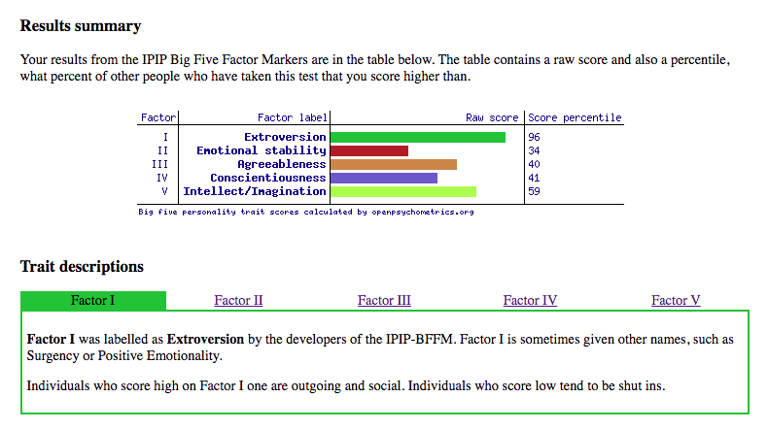

The results above would appear to indicate that I am an extrovert. I would tend to agree – I am sociable and talkative, I like to work in groups and look for opportunities to engage with other people. My preferred learning style suggest that I learn best through direct experience, by working in groups and with problem-based learning.
“Honey and Mumford (1992) identified that different people have innate learning preferences.” (Morgan, 2017). The results of my Honey and Mumford learning styles questionnaire show a broader choice of learning styles but I believe the results reflect that I am an activist/pragmatist who prefers learning through workshops, presentations, group discussions and case studies.
With the above in mind, I considered what kind of learning and development options were available to me. There are numerous further academic courses that I could take, but seeing as one of my main concerns was my speaking ability, I believe more practical English-speaking classes would suit me better. I have the support of my family, my husband (who’s English is perfect) and my children, who correct every mistake I make! This approach will tackle one of the most important employability skills which I believe I am lacking – COMMUNICATION.
I am also weak in IT skills and mental arithmetic and similarly, there are numerous online and college courses that I could complete. Given my learning preferences, I believe that attending classes and working in groups with likeminded students would be more suitable for me.
Now that I have a SMART goal, I have looked at my strengths and weaknesses using SWOT analysis and have considered my own learning style preferences, I am in a position to prepare a Personal Development Plan to address the above weaknesses.

PERSONAL DEVELOPMENT PLAN

Development Objective | Specific Actions | Blockers | Support required | How will I know when I have achieved the objective
Conversational English | Attend college courses.  Complete online courses, watch YouTube videos, television, listen to radio.  Practice speaking with friends. | Embarrassment.  Free time.  Family commitments. | College.  Family/friends.  Internet. | I can confidently hold a conversation with a stranger on any given topic.
IT Skills | Attend college courses.  Complete online courses.  Practice using MS Office applications with friends. | Free time.  Family commitments. | IT equipment (laptop at home, college intranet).  Tutor/mentor. | I can prepare an Excel based presentation without assistance.
Mental arithmetic | Attend maths classes.  Take regular tests. | Free time.  Family commitments. | Tutor/mentor. | I can perform basic mental arithmetic without using pen/paper or a calculator.

Change is always difficult. To change oneself, even more so. The advantages of having a Personal Development Plan are that seeing the plan in writing motivates me to take an interest in my self-development, allows me to become consciously aware of actions that I need to take, any hindrances to those actions and allows me to consider what support I will require.

Conclusion

Developing myself and improving my employability skills are important in order for me to successfully find a job and achieve personal satisfaction.
I began by thinking about what I wanted to achieve and set a SMART goal. I then went onto consider my own strengths and weaknesses and external threats and opportunities using a SWOT analysis.
Having thought about what I wanted to achieve and what I needed to do, I realise I will need to learn new skills or improve ones in which I am lacking. I need to learn!
But how do I learn best? I read about theories around learning and development, including Maslow’s Hierarchy of Needs, the Johari Window and Kolb’s Experiential Learning Cycle.
In order to assess what kind of learner I was, I took part in two learning styles questionnaires, one online (The Big Five Personality Test) and one on paper (Mumford and Honey learning styles questionnaire). These indicated that I was an extrovert and activist/pragmatist.
Taking these preferred learning styles into consideration, I developed a Personal Development Plan which took into account what learning options were available to me, which of these best suited me and what support I would require. I will regularly review my progress in order to ensure I am meeting my aims and objectives.

References

Cherry, K., 2019. VeryWellMind.com. [Online]
Available at: https://www.verywellmind.com/what-is-maslows-hierarchy-of-needs-4136760
[Accessed 17 February 2020].
Covey, S., 2015. The 7 Habits of Highly Effective People. s.l.:s.n.
Doran, G. T., 1981. There's a S.M.A.R.T. Way to Write Management's Goals and Objectives. Management Review, pp. Volume 70, Issue 11, 35-36.
Kolb, D. A., 1984. EXPERIENTIAL LEARNING: EXPERIENCE AS THE SOURCE OF LEARNING AND DEVELOPMENT. NEW YORK: PEARSON EDUCATION INC..
Lucidchart, 2020. [Online]
Available at: https://www.lucidchart.com/pages/what-is-swot-analysis
[Accessed 19 February 2020].
Lucidchart, 2020. http://www.lucidchart.com. [Online]
Available at: https://www.lucidchart.com/pages/what-is-swot-analysis
Maslow, A., 1943. A Theory of Human Motivation. Psychological Review, Volume 50, pp. 370-396.
Meier, J., 2009. Sources of Insight. [Online]
Available at: http://sourcesofinsight.com/know-and-share-yourself-enough/
[Accessed 17 February 2020].
Morgan, P., 2017. The Business Student's Guide to Study and Employability. s.l.:s.n.
Morgan, P., 2017. The Business Student's Guide to Study and Employability. s.l.:Sage.
Noronha, W., 2012. WWW.WINSTONNORONHA.COM. [Online]
Available at: http://www.winstonnoronha.com/2012/01/25/kolbs-cycle-of-learning/
[Accessed 19 February 2020].
openpsychometrics.org, 2019. [Online]
Available at: https://openpsychometrics.org/tests/IPIP-BFFM/
[Accessed 19 February 2020].
openpsychometrics.org, 2019. [Online]
Available at: https://openpsychometrics.org/tests/IPIP-BFFM/
[Accessed 17 February 2020].
Trinh, D. A., 2018. [Online]
Available at: https://www.fullfunctionrehab.com/smart-goals/
[Accessed 19 February 2020].

Appendices

Mumford and Honey learning styles questionnaire


