Module Name: International Meetings Management for the Hotel Industry
Module Code: BMIH6007
Student Name:Mariana Mironov
Student ID:2232725
Tutor name: Kathryn Flynn

Table of Contents
Introduction 3
Event Content and Context 4
Market factors 5
Target market 5
Demand 5
Supply 6
Competition 6
Marketing activities 6
Operational factors 7
Financial factors 9
Conclusion 10
References 11

Slide: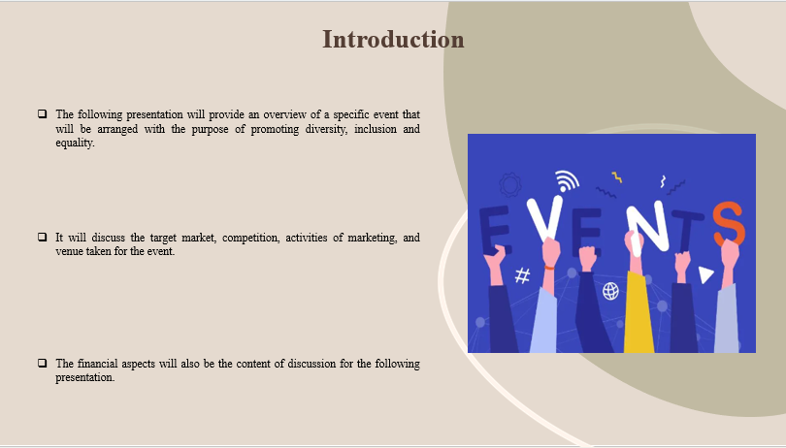
Note:

Introduction
The following presentation will provide an overview of a specific event that will be arranged with the purpose of promoting diversity, inclusion and equality. It will discuss the target market, competition, activities of marketing, and venue taken for the event. The financial aspects will also be the content of discussion for the following presentation. The financial aspects will include a predicted breakdown of the costs, resources for funding and predicted revenue to be generated from the event.

Slide: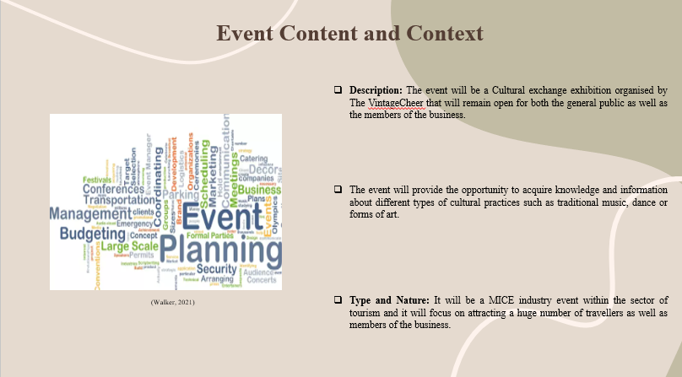
Note:

Event Content and Context
Description: The event will be a Cultural exchange exhibition organised by The VintageCheer that will remain open for both the general public as well as the members of the business. The event will provide the opportunity to acquire knowledge and information about different types of cultural practices such as traditional music, dance or forms of art. This type of initiative will be beneficial to ensure diversity, inclusion, and equality among the members of the team as well as for the general public. Therefore, the primary focus of the event will be to enhance inclusivity, diversity and equality among people and provide them enough opportunity to get engaged with different types of cultures and traditions. There are many travellers who have the desire to explore and know about different cultures and traditions and this type of event will play a significant role in fulfilling their desire (Walker, 2021).
Type and Nature: It will be a MICE industry event within the sector of tourism and it will focus on attracting a huge number of travellers as well as members of the business. Art pieces from different regions and countries will be showcased in this exhibition and a detailed description of them will also be provided along with them so that the engaging audiences can boost their knowledge (Bladen et al., 2022). Therefore, by nature, the event will be an encouraging approach to diversity, equality and inclusion and will play a significant role in enriching traveller’s experiences and expectations. Apart from acquiring knowledge and information, they will also get the opportunity to take part in different types of cultural and traditional dances and music and in this way, they will become able to respect different cultures and traditions.

Slide: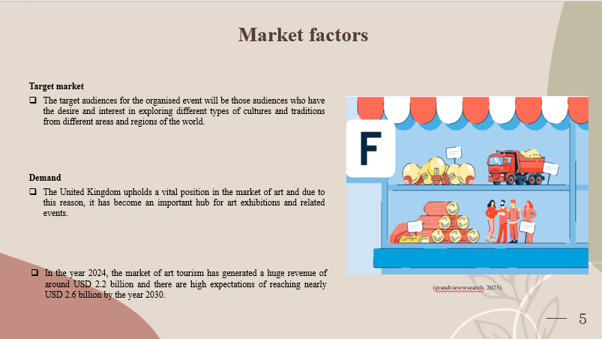
Note:

Market factors

Target market
The target audiences for the organised event will be those audiences who have the desire and interest in exploring different types of cultures and traditions from different areas and regions of the world. In this aspect, students, travellers, artists, training centres, local community groups, people from different cultural backgrounds and so on will be the target audiences for the event. The UK tourism market will be targetted here as the event will be organised in Bristol and people residing there or visiting the places can be targeted (Jeong and Kim, 2020). Audiences between the age group of 12 to 45 will be ideal for this event and based on this aspect the marketing activities will be aligned according to their preferences (Allen et al., 2022).

Demand
The United Kingdom upholds a vital position in the market of art and due to this reason, it has become an important hub for art exhibitions and related events. In the year 2024, the market of art tourism has generated a huge revenue of around USD 2.2 billion and there are high expectations of reaching nearly USD 2.6 billion by the year 2030. On the other hand, the UK market has the potential to grow at a CAGR of 3.4% during the time frame of 2025 to 2030 (grandviewresearch, 2025). Based on all the relevant data and information it can be said that this type of cultural event has demand and appreciation in the market of the United Kingdom and this aspect raises the chances of the exhibition getting success (Rogers and Wynn-Moylan, 2022).

Slide: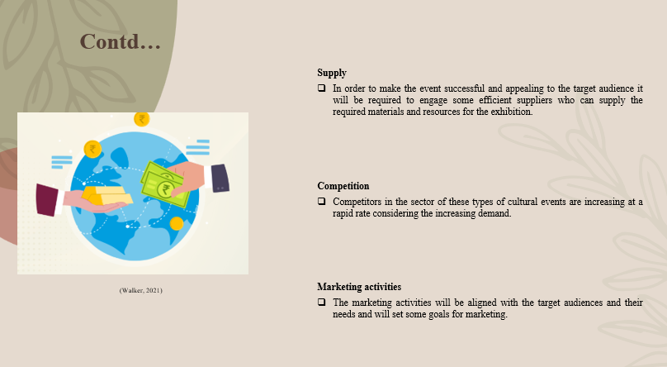
Note:

Supply
In order to make the event successful and appealing to the target audience it will be required to engage some efficient suppliers who can supply the required materials and resources for the exhibition. Therefore, the required suppliers for the event will include decorators, designers who will design the entire exhibition, and manufacturers who will prepare the items for the exhibition (Abson and Schofield, 2022). The event will call the local community people who can convey their knowledge regarding the local culture and can make the travellers participate in the cultural performances. Some renowned artists will also be invited to show their artworks to the audiences present there and enrich the experience of every member (Parent et al., 2020).

Competition
Competitors in the sector of these types of cultural events are increasing at a rapid rate considering the increasing demand. There are some event organisers within the United Kingdom that can become potential competitors for the cultural exhibition. Such competitors include Artbox London, Bristol City Council, Auto Italia and many more. The unique approaches and initiatives of the event may provide them with competitive advantages (Bowdin et al., 2023).

Marketing activities
The marketing activities will be aligned with the target audiences and their needs and will set some goals for marketing. To let a huge amount of audience regarding the cultural exchange exhibition, the business will use digital technologies and strategies of marketing. Social media platforms will be the ideal medium to reach a lot of potential audiences and they will include Facebook, Instagram, YouTube and many more. It will use content marketing also to provide informative content regarding the event to audiences (Pooch and Wall, 2024).

Slide: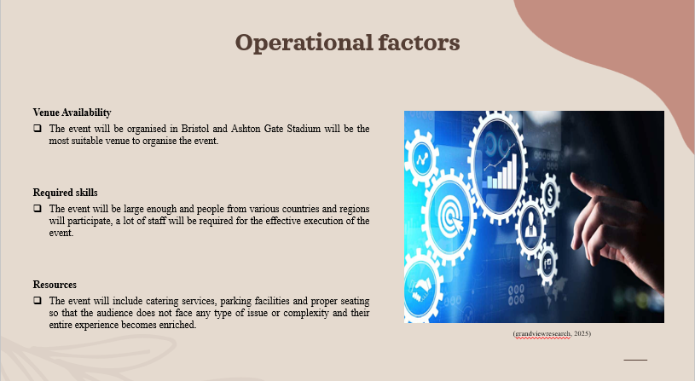
Note:

Operational factors
Venue Availability
The event will be organised in Bristol and Ashton Gate Stadium will be the most suitable venue to organise the event. This place has a wide range of function rooms and due to this reason, it will be the most suitable one for the exhibition. It is known for events and conferences and it will be required to be pre-booked so that it remains available on the date of the exhibition (ashtongatestadium, 2025). The date for the event will be on 28th March 2025 and based on the information regarding availability it can be said it will be available on the above-mentioned date.
Required skills
The event will be large enough and people from various countries and regions will participate, a lot of staff will be required for the effective execution of the event. Therefore, 20 to 22 staff are required for a variety of services such as catering, decoration, management and many more. Apart from this, the employees will be supposed to have some essential skills so that they can execute their tasks in a proper way. The skills and abilities will include effective time management skills, communication skills, critical thinking, problem-solving skills and so on (Bowdin et al., 2023). In addition to this, it will be important that they have some knowledge regarding the cultural aspects so that they can resolve the queries of people present there to an extent. The staff will be trained properly to accomplish the allotted responsibilities properly (Silva and Figueiredo, 2020).
Resources
The event will include catering services, parking facilities and proper seating so that the audience does not face any type of issue or complexity and their entire experience becomes enriched. The selected venue Ashton Gate Stadium offers parking and catering services and due to this reason, the complexities will be reduced in this aspect (Li et al., 2021).

Slide: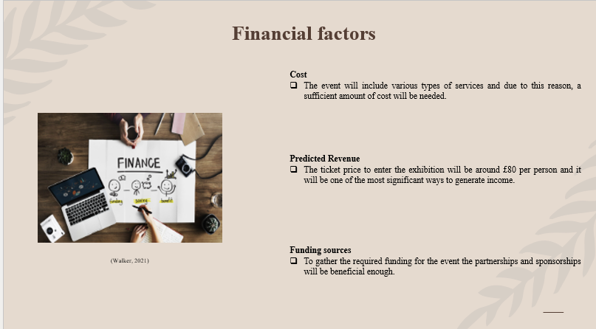
Note:

Financial factors
Cost
The event will include various types of services and due to this reason, a sufficient amount of cost will be needed. The capacity of the event will be 500 persons and the catering person around £2500 and within this cost, it will be required to fulfil audience expectations (Allen et al., 2022). Marketing activities will require £1000 and for staff, £800 will be allocated. Therefore, including the venue charges, maintenance and all the other aspects, the overall cost of the event will be nearly £6,000 and it will be the motive to recover this cost and generate more revenue (Pilbeam, 2023).
Predicted Revenue
The ticket price to enter the exhibition will be around £80 per person and it will be one of the most significant ways to generate income (Caliendo et al.,2021). Apart from this, other ways to generate revenue will income from the sales of art pieces and their commissions, sponsorships and partnerships, sales of merchandise and so on. Based on all the aspects the predicted revenue from the entire event can be around £10,000 and there is the potential to get a profit of £ 4000 and make the event successful enough (Banks, 2023).
Funding sources
To gather the required funding for the event the partnerships and sponsorships will be beneficial enough. Investors will also play a significant role in providing the funds that will be required apart from the partnerships and sponsorships (Harvey and Liu, 2021).

Slide: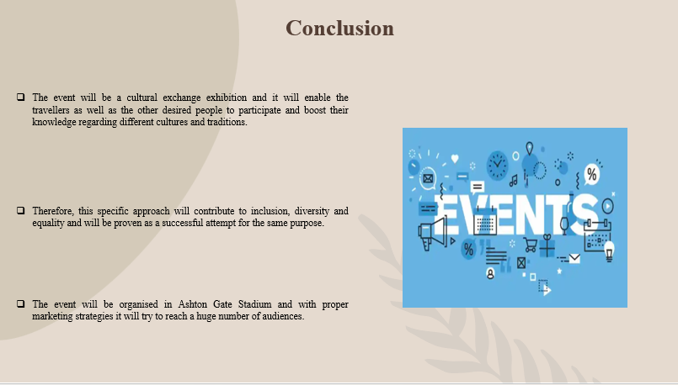
Note:

Conclusion
The event will be a cultural exchange exhibition and it will enable the travellers as well as the other desired people to participate and boost their knowledge regarding different cultures and traditions. Therefore, this specific approach will contribute to inclusion, diversity and equality and will be proven as a successful attempt for the same purpose. The event will be organised in Ashton Gate Stadium and with proper marketing strategies it will try to reach a huge number of audiences.
Slide: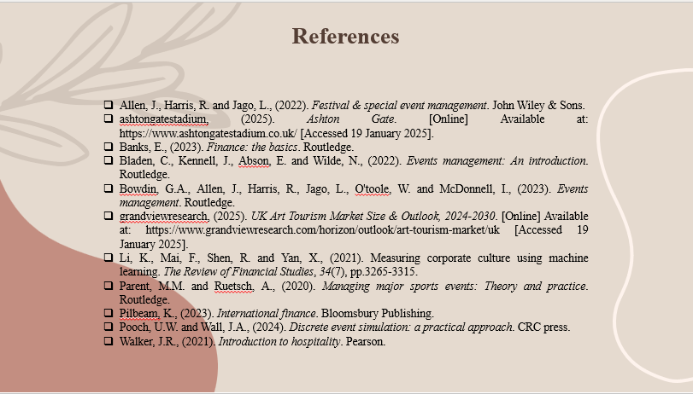

References
Abson, E. and Schofield, P., (2022). Exploring the antecedents of shared leadership in event organisations. Journal of Hospitality and Tourism Management, 52, pp.439-451.
Allen, J., Harris, R. and Jago, L., (2022). Festival & special event management. John Wiley & Sons.
ashtongatestadium, (2025). Ashton Gate. [Online] Available at: https://www.ashtongatestadium.co.uk/ [Accessed 19 January 2025].
Banks, E., (2023). Finance: the basics. Routledge.
Bladen, C., Kennell, J., Abson, E. and Wilde, N., (2022). Events management: An introduction. Routledge.
Bowdin, G.A., Allen, J., Harris, R., Jago, L., O'toole, W. and McDonnell, I., (2023). Events management. Routledge.
Caliendo, L., Opromolla, L.D., Parro, F. and Sforza, A., (2021). Goods and factor market integration: A quantitative assessment of the EU enlargement. Journal of Political Economy, 129(12), pp.3491-3545.
grandviewresearch, (2025). UK Art Tourism Market Size & Outlook, 2024-2030. [Online] Available at: https://www.grandviewresearch.com/horizon/outlook/art-tourism-market/uk [Accessed 19 January 2025].
Harvey, C.R. and Liu, Y., (2021). Lucky factors. Journal of Financial Economics, 141(2), pp.413-435.
Jeong, Y. and Kim, S., (2020). A study of event quality, destination image, perceived value, tourist satisfaction, and destination loyalty among sport tourists. Asia Pacific Journal of Marketing and Logistics, 32(4), pp.940-960.
Li, K., Mai, F., Shen, R. and Yan, X., (2021). Measuring corporate culture using machine learning. The Review of Financial Studies, 34(7), pp.3265-3315.
Parent, M.M. and Ruetsch, A., (2020). Managing major sports events: Theory and practice. Routledge.
Pilbeam, K., (2023). International finance. Bloomsbury Publishing.
Pooch, U.W. and Wall, J.A., (2024). Discrete event simulation: a practical approach. CRC press.
Rogers, T. and Wynn-Moylan, P., (2022). Conferences and conventions: A global industry. Routledge.
Silva, M.E. and Figueiredo, M.D., (2020). Practicing sustainability for responsible business in supply chains. Journal of Cleaner Production, 251, p.119621.
Walker, J.R., (2021). Introduction to hospitality. Pearson.

