Thomas Rhys Evans
Student No: 1810164
Network Operating Systems and Services (NOSS)
(ACCA5023)
Worksheet 3
Table Of Contents
Heading | Page Number
Part 1 – Practical Work | 1
Task 1: Understanding NTFS and Share Permissions | 1
NTFS | 1
Share Permissions | 6
Accessing the file share/server over the network | 9
Task 2: Utilising Group Policy Management Console to better facilitate network object management | 10
Configuring User Environment and Computer Environment Network Group Policy Objects | 10
Computer GPO | 18
Passwords | 20
Part 2 – Observational tasks | 22
a) Local permissions and fileshares | 22
i) NTFS permissions | 22
ii) Share Permissions | 22
iii) Differences between NTFS and share permissions | 23
iv) File permission best practices | 23
b) Group Policy Management | 23
i) Local Group Policy | 24
ii) Group policy via Active Directory | 24
iii) Group Policy Objects (GPO’s) | 24
iv) Group policy in an organisational environment | 24
c) Password principles | 28
i) Password length | 28
ii) Password complexity | 29
iii) Password age | 30
iv) Multi-factor authentication | 30

Part 1 – Practical work
Task 1: Understanding NTFS and Share Permissions
NTFS
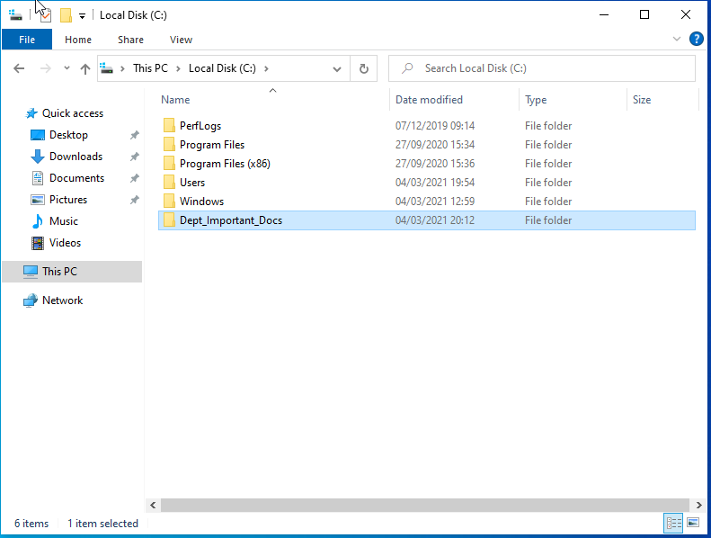
In order to apply permissions, a new folder is created called “Dept_Important_Docs”
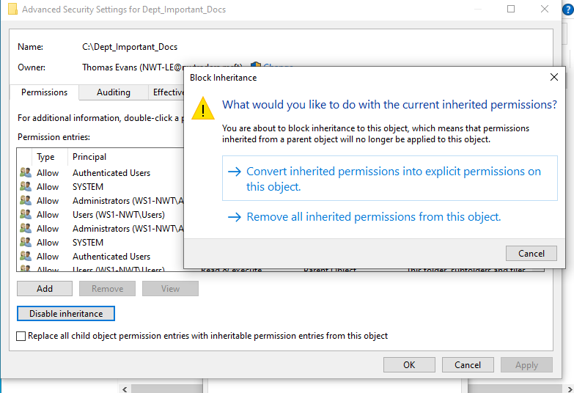
To change permissions, the inheritance of permissions must first be turned off
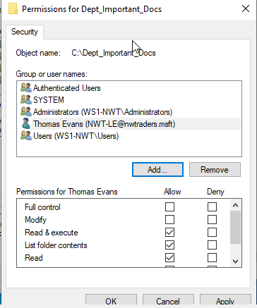
Access is then provided to the user
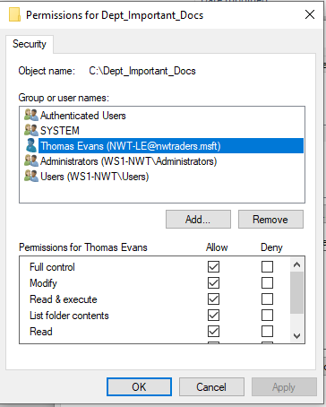
Before these permissions are amended to allow for full control
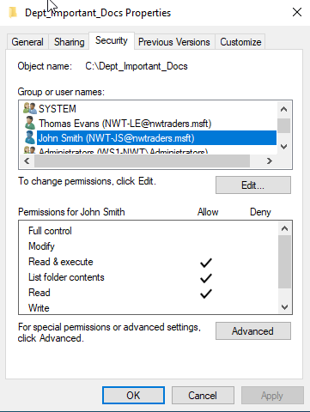
Another user is provided access, but the second user if only allow the above permissions
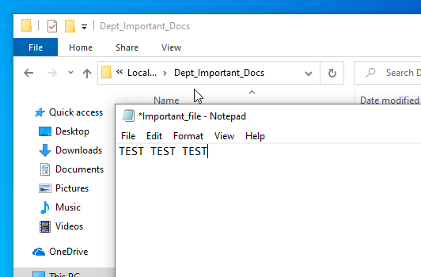
The user with full control can create a new file within the folder, and then insert text in to this file, as well as save the changes

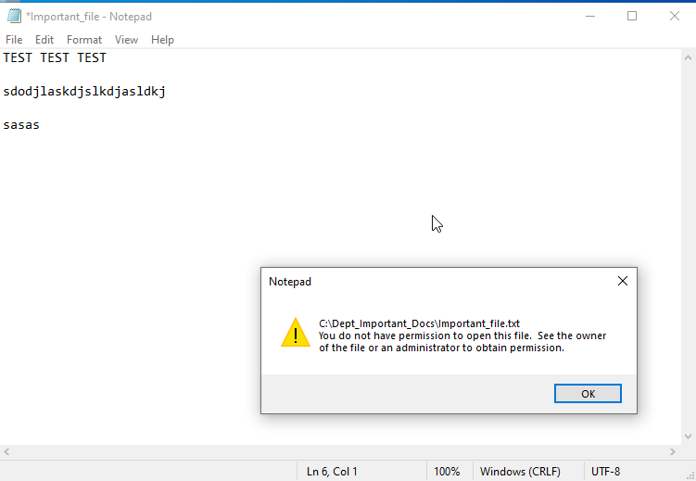
The user with read access can open the file, but is unable to make or save any changes to the file

Share permissions
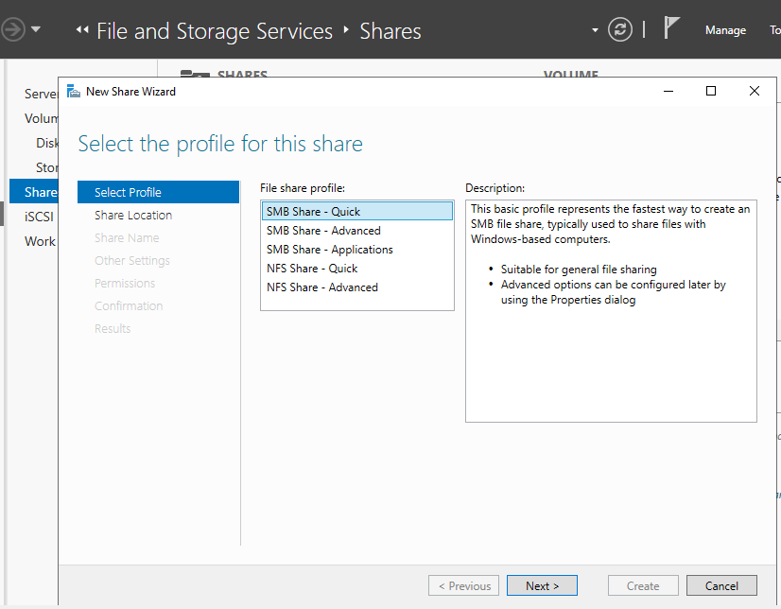
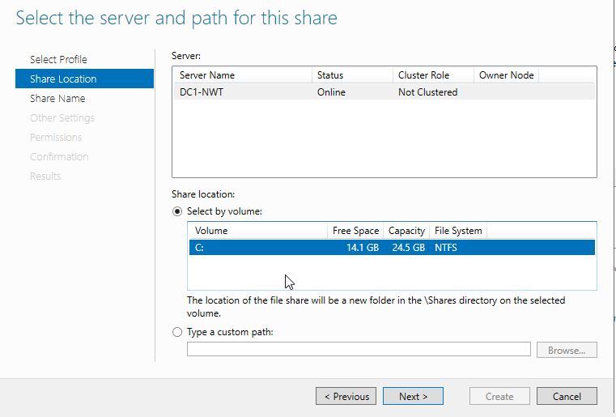
The domain controller is being used as the file server, so this is selected during set up
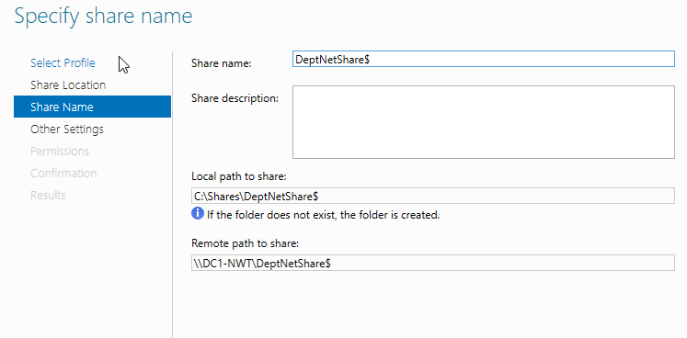
The share is named
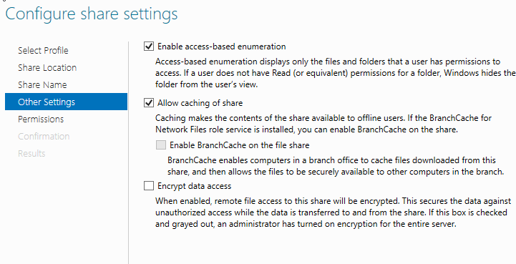
And the following options are selected
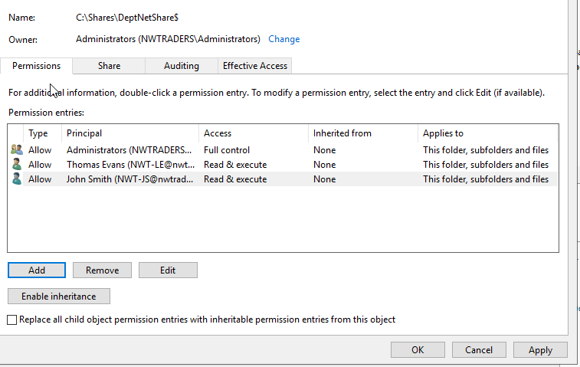
Here the users with access, and their levels of access, are selected and the share is created
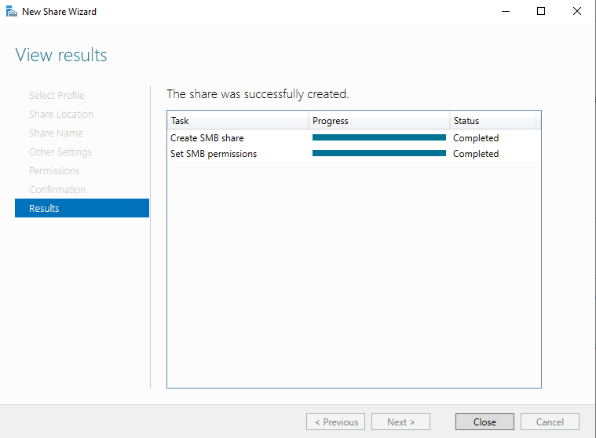

Accessing the file share/server over the network
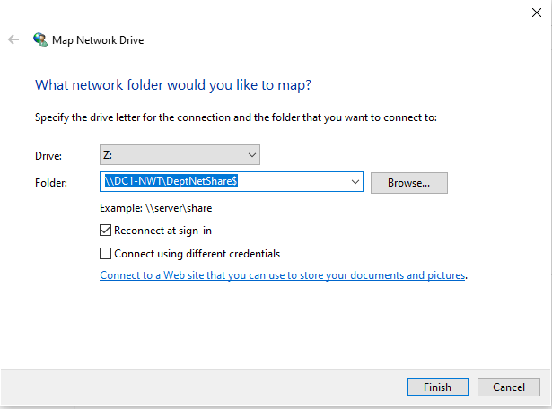
The newly created share is then mapped on the client device
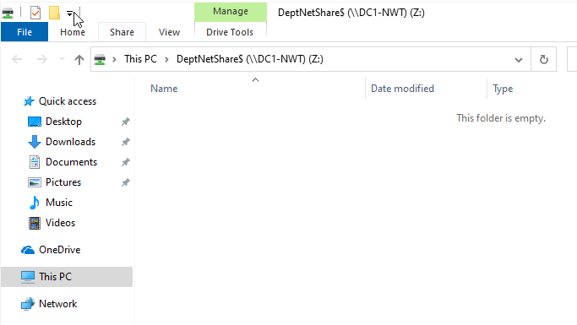

Task 2: Utilising Group Policy Management Console to better facilitate network object management
Configuring User Environment and Computer Environment Network Group Policy Objects
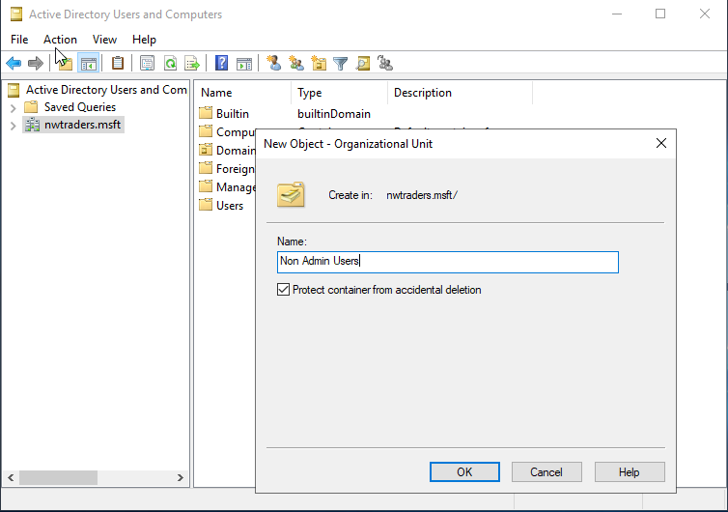
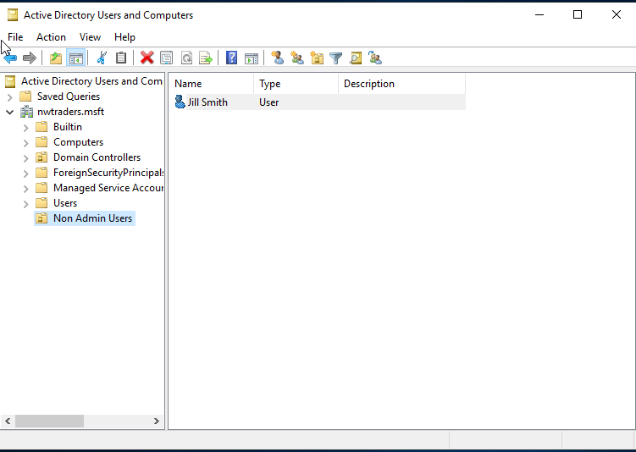
In order to begin restricting access via group policy, users must first be grouped in Active Directory in accordance with their access levels. The OU “non-admin” users allow non administrative staff to be categorised together. The OU is created and then a new non-admin user is created within the OU.
Within GPMC, the newly created OU then appears, allowing us to create GPO’s and link them to OU’s
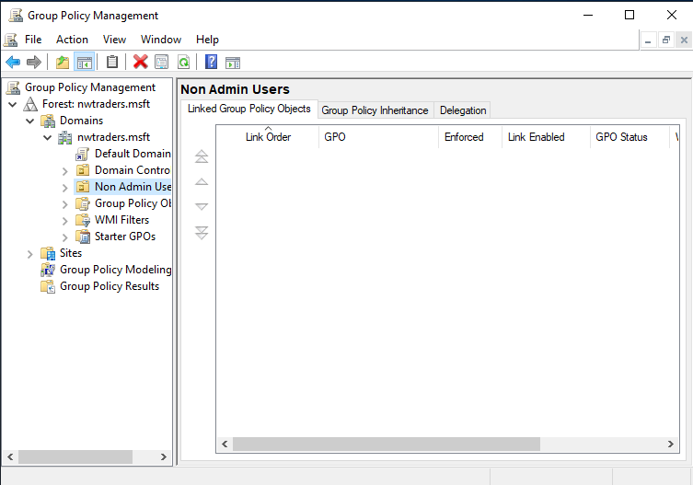
In this case, we are prohibiting access to the control panel for “Jill Smith”. The GPO is created, then linked to the “Non-admin users” OU
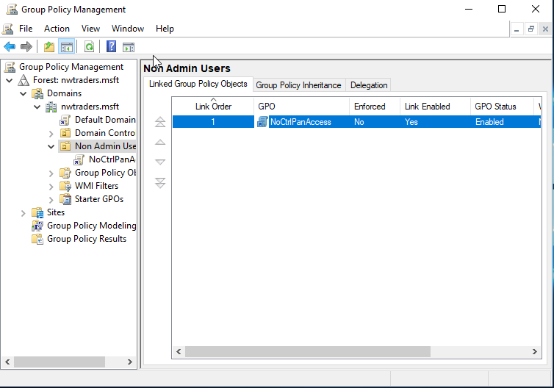

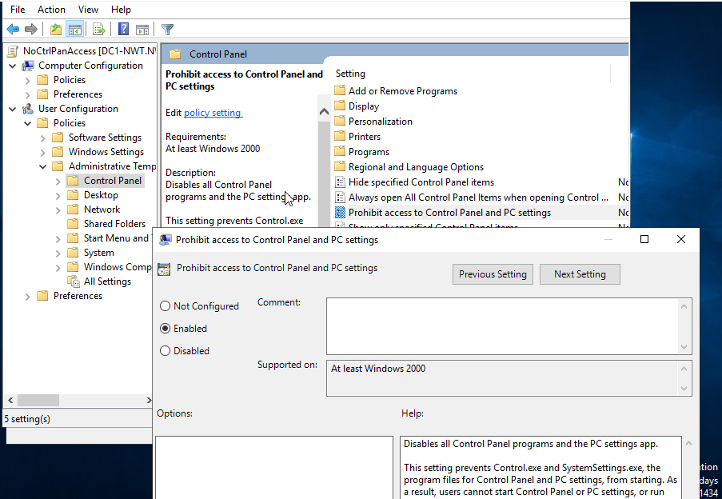

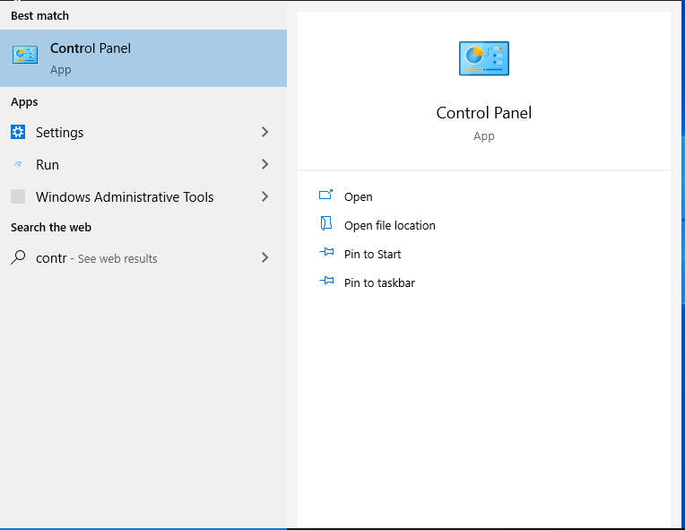
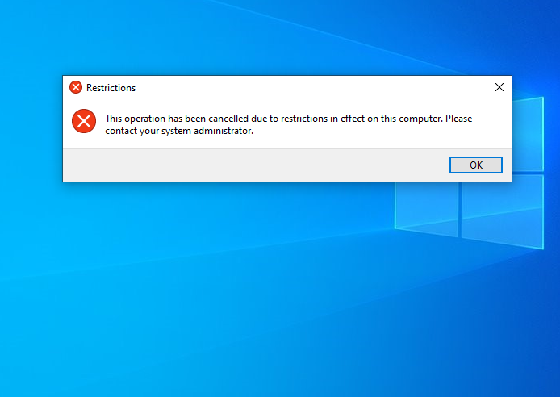
The same is then done to prohibit non administrative users access to the command prompt, following the same process
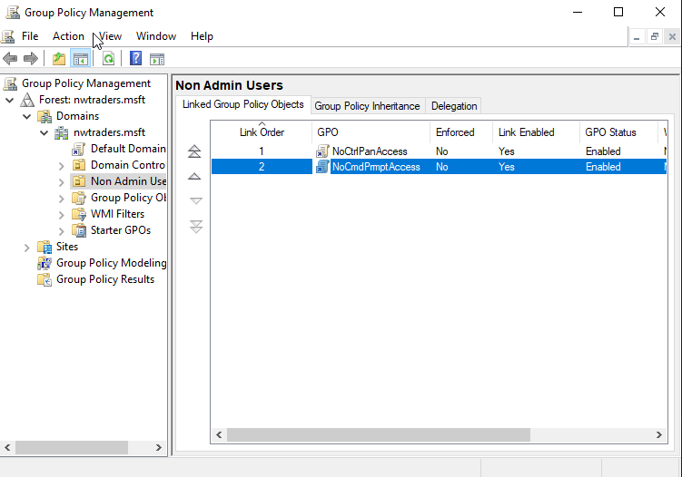
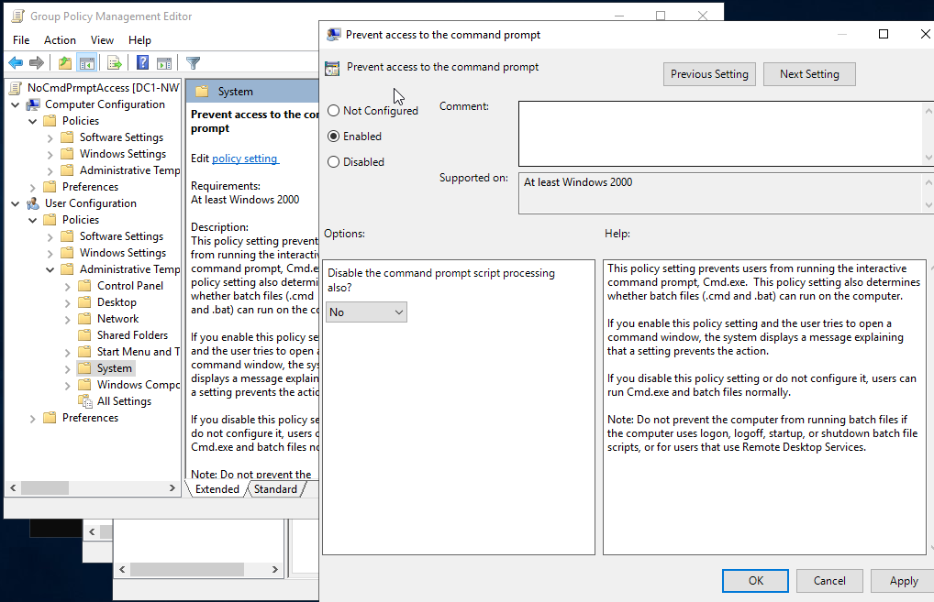
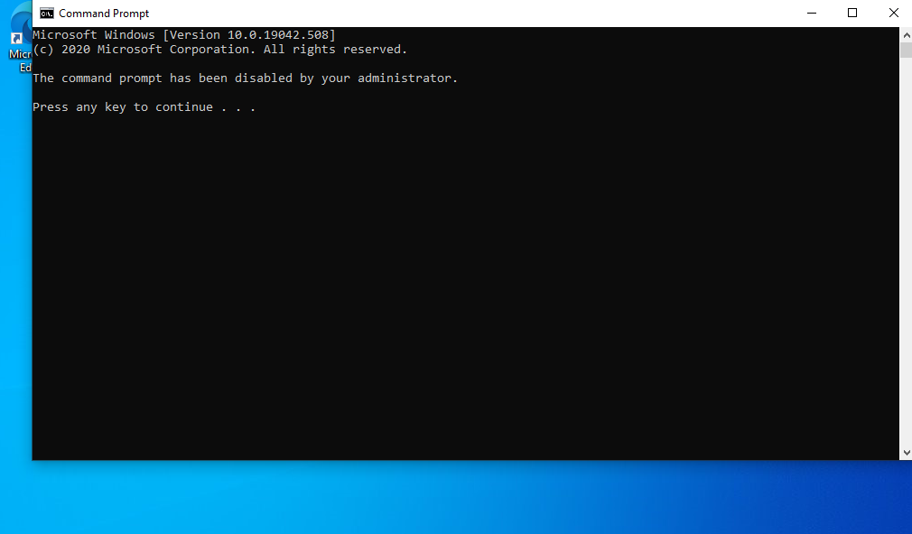
Then, removable drive access is prohibited
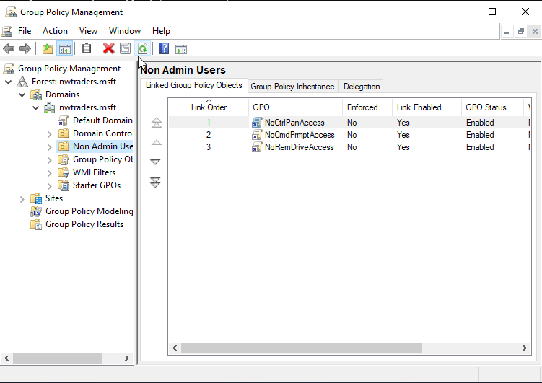
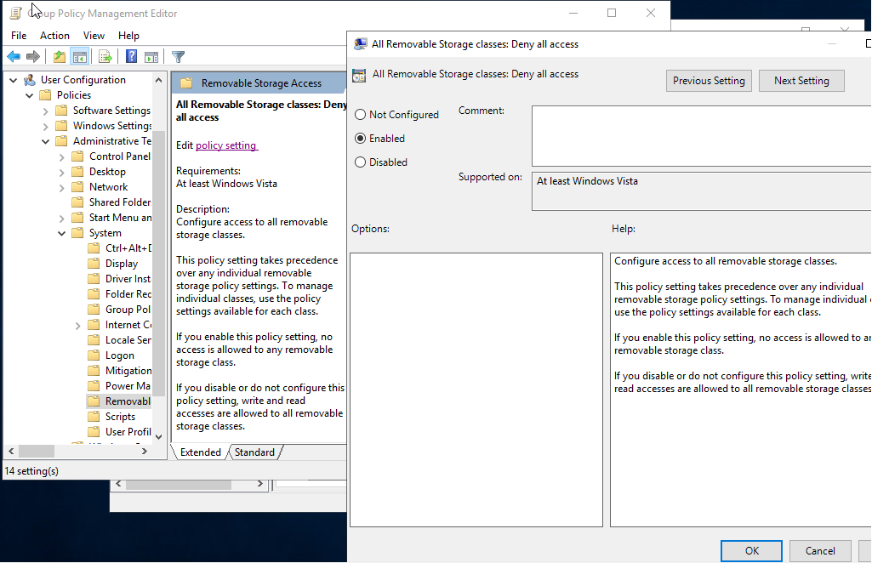
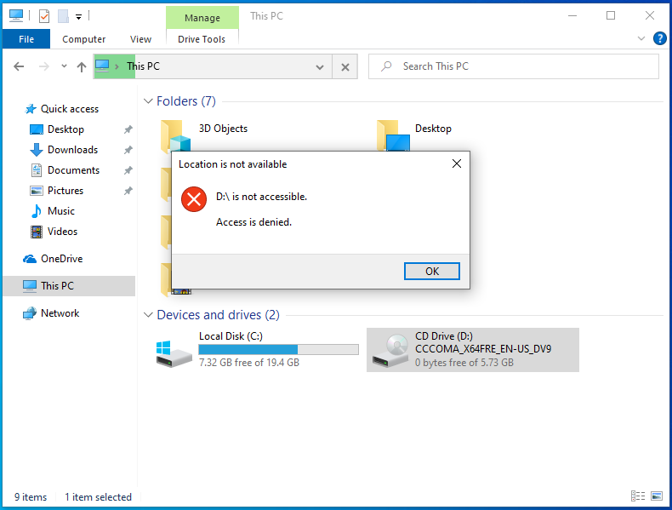

Computer GPO
Where a user OU was created for “Non-Admin” users, a new OU is created that will this time group together computers instead
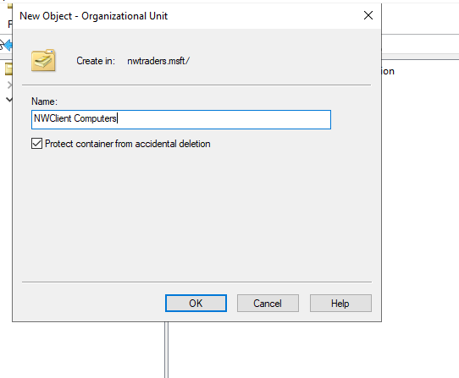
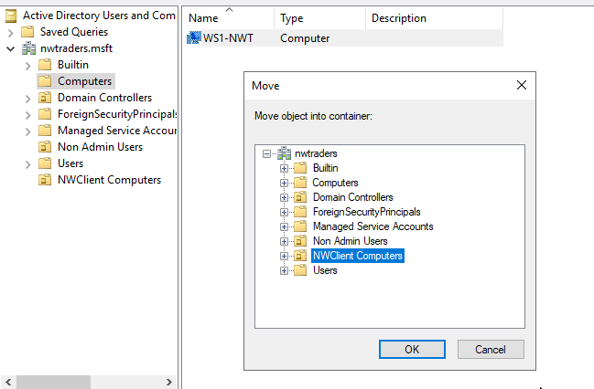
The PC “WS1-NWT” is moved into the newly created computers OU. GPO’s can now be created and assigned to the new OU. The following group policy prevents any user installing software on “WS1-NWT”
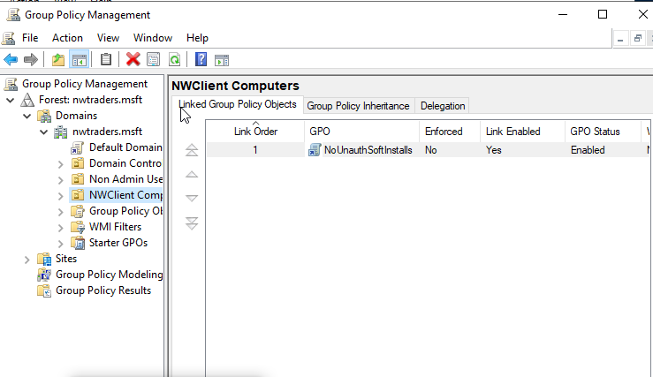
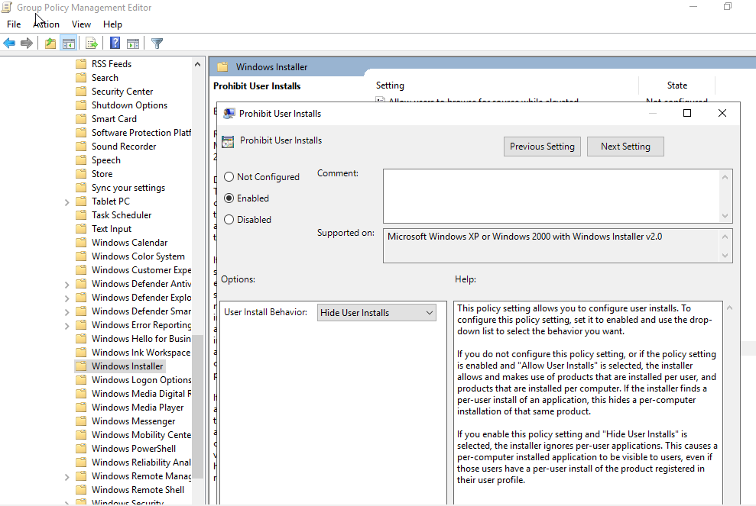
Passwords
The password requirements are then defined by group policy. Each separate option can be configured and enabled/disabled as needed. In order to adhere to password principle best practice, the following settings are selected
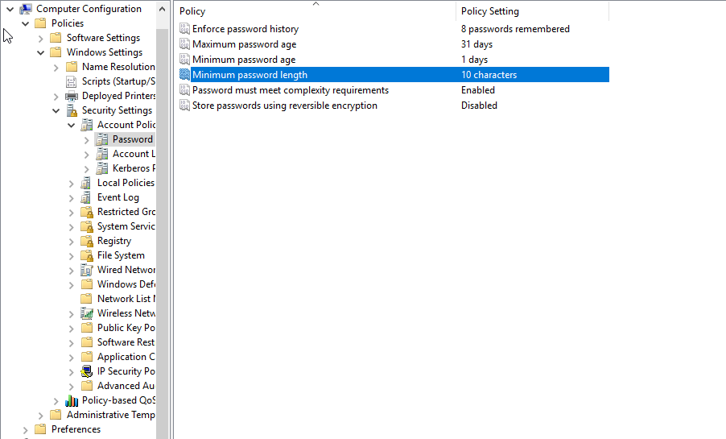
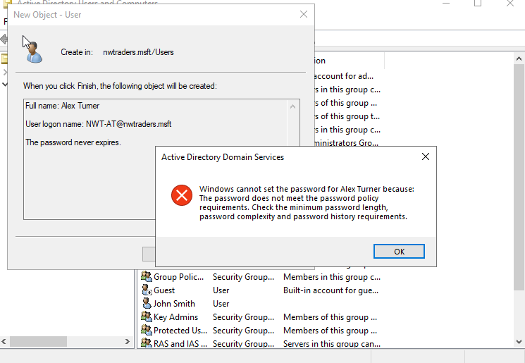
An example can be seen of what happens when a password that doesn’t meet one of the requirements is entered

Part 2 – Observational tasks
a) Local permissions and fileshares
There are a number of differences between permissions that are applied either locally, or to folders/files shared over a network. These differences allow for differences in level of access, as well as dictating when the particular resource can be accessed.
i) NTFS permissions
NTFS stands for “New technology file system” and is the latest file system used by the Windows NT operating system for storing and retrieving files [1] [2]. NTFS permissions are used to manage the levels of access to files and folders that are stored on an NTFS file system. The current version of NTFS stands at 3.1 and has been used in Windows operating systems at XP and above [3]. When implementing NTFS permissions, the level of control that can be dictated is much more granular than what can be achieved when simply sharing a folder across a network. NTFS permissions allow for the following levels of access:
- Full Control: Users can add, change, move, and delete files and directories. This also applies to any associated properties of the files or directories. Furthermore, users can change the permissions for the files and directories, which means they can give others full control or take permissions away.
- Modify: Users can still view and modify files and their properties, as well as add or delete files from a directory or add or delete properties from a file, but are unable to provide, or remove, full control from other users
- Read and Execute: Users can read files and run executable files including scripts. They cannot modify files and their properties.
- Read: Users can only read or view files, their properties, and directories.
- Write: Users are only able to write to a file or add files to a directory. [4]
With the current version of NTFS, there are a number of associated features which further enhance its use. These include:

- Self-healing NTFS- This provides self-healing feature which detects and repairs corruption on the NTFS volume or files
- ACL - With NTFS, administrator can now set permissions using access control lists (ACL) which determines who else can access or modify a specific file.
- File-Level Encryption
- Disk Quotas- Disk Quotas enable administrators to limit the disk space that a user may use..
- Reliable File System- NTFS File System automatically performs recovery operations, if system shuts down unexpectedly then the system checks for consistency by using transaction log and journal file.
- File Compression- Allows users to compress large files so that disk space will be used efficiently [3]
NTFS permissions are applicable to both local and network users and are based on the permissions given to a user at Windows logon [5]
ii) Share permissions
Share permissions are used to manage access to folders shared over a network. If a user is logged in locally, then share permissions do not apply. Whereas NTFS permissions allow for granular access levels, share permissions allow for 3 differing levels of access. These are:

- Read — Users can view file and subfolder names, read data in files, and run programs. By default, the “Everyone” group is assigned “Read” permissions.
- Change — Users can do everything allowed by the “Read” permission, as well as add files and subfolders, change data in files, and delete subfolders and files. This permission is not assigned by default.
- Full Control — Users can do everything allowed by the “Read” and “Change” permissions, and they can also change permissions for NTFS files and folders only. By default, the “Administrators” group is granted “Full Control” permissions [5]
It’s also useful to remember that where NTFS permissions allow for control over particular subfolders within a root folder, share permissions do not have this kind of granular control. Permissions are applied to all files and folders within the share.
iii) Differences between NTFS and share permissions
There are differences between the two, as mentioned above, and depending on the environment they are used in, both offer different advantages and disadvantages. Share permissions are easy to apply, but do not offer the level of control provided by NTFS permissions. Although, this added level of complexity can be harder to administrate and lead to the higher likelihood of mistakes when applying permissions. Share permissions can also be used to apply restrictions to FAT and FAT32 file systems, whereas NTFS can’t.
iv) File permission best practices
When creating and applying restrictions to files and folders, there are a number of best practices that administrators should endeavour to adhere to, both to minimise mistakes and to make administrating permissions simpler. These include:
- Assign permissions to groups, not users - By putting users into groups and then assigning permissions to the groups themselves, administrators can more easily keep track of who has access to what. When users’ roles change, they can be added to a different group and removed from groups they don’t need to have access to. This is simpler than having to remove users permissions directly from individual files and folders
- Ensure users only have access to files and folders they require. This means not giving users access to more than what they need to carry out their role. Adhering to the principle of ‘least privilege’ is a principle that should be followed across all sectors of IT. Ensuring everyone only has the basic privileges they need prevents security problems and vulnerabilities from arising. It is always better to be too restrictive and have to open resources up to users, than be too open and allow access to resources that are not needed
- “Be careful with the “Everyone” group. This group includes every user who has access to shared folders, including guest accounts. By denying or approving privileges to this group, you can cause major issues or create huge vulnerabilities” [4]
- Properly manage the “Administrators” group. “Users in the “Administrators” group would usually have Full Access permissions to all shared folders and the files in them. The number of administrator accounts within an organisation should always be kept to a minimum, as these permissions can have the possibility to cause catastrophic harm to an organisation if they fall into malicious hands or are misused in any way, either accidentally or intentionally.
b) Group Policy Management
The configuration settings and management of operating systems, computer settings and user settings in a Microsoft environment all come together to form “Group Policy” [6]. There are two separate ways to administer group policy. This can be done either locally on individual workstations, or managed and deployed centrally in an environment with Active Directory running.
i) Local Group Policy
Local group policy is best used when there is no active directory running in an environment. Local group policy only affects the individual machine the policy is on. As such, each machine must have its individual policy configured, and each machine must be done manually. For small environments, this may not be a big issue, but in large organisations with more than even a handful of machines, managing local group polices on each PC would become impossible.
ii) Group policy via Active Directory
The much more common approach to group policy within an organisational environment is to configure Group policy and deploy it across machines within in an Active Directory domain. To manage Group Policy, administrators use the “Group Policy Management Console (GPMC)”.
iii) Group Policy Objects (GPO’s)
Group policy objects are collections of group policy settings. These settings define how a system will behave for a particular user. Each GPO contains two nodes, with these being “User configuration” and “Computer configuration” [6]. The computer configuration part of a GPO applies to the device itself, no matter who logs in. The user configuration part of a GPO applies to the specific user as they log in, and these settings will “follow” the user around from machine to machine as they log in. Once GPO’s are created, these need to be applied to either sites, domains or OU’s in Active Directory. Depending on where the GPO is applied, the following will happen:
- Site level. This will affect all user accounts and computer accounts in that specific site, no matter which domain or OU a given account is in..
- Domain level. This affects all users and computers in the domain, across all OUs beneath it.
- OU level, This affects all users or computers in that OU and all sub OU’s [6]
GPO’s work on a hierarchical system. If, for instance, a GPO is applied at domain level and a conflicting GPO is applied on a particular OU further down the Active Directory structure, then the GPO further down takes precedence. This means administrators can create stricter, more restrictive rules at domain level and then allow individual users or groups in different OU’s varying levels of access.
iv) Group policy in an organisational environment
Group policy can carry out a wide variety of functions, from preventing users accessing resources, to simple tasks such as forcing specific desktop wallpapers. When used in an organisational environment, group policy can be used as one the most effective tools to enhance security. For example, group policy can be used to:
- Prohibit access to control panel:
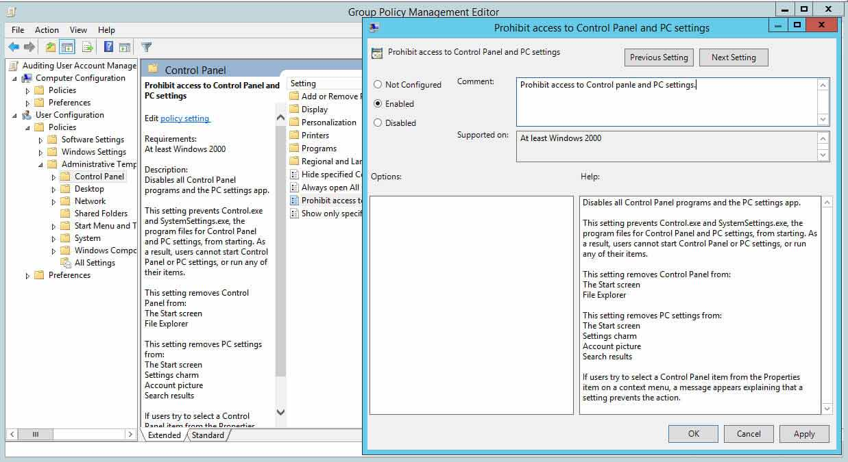
Figure 1 Prohibit access to control panel
- Prohibit access to command prompt
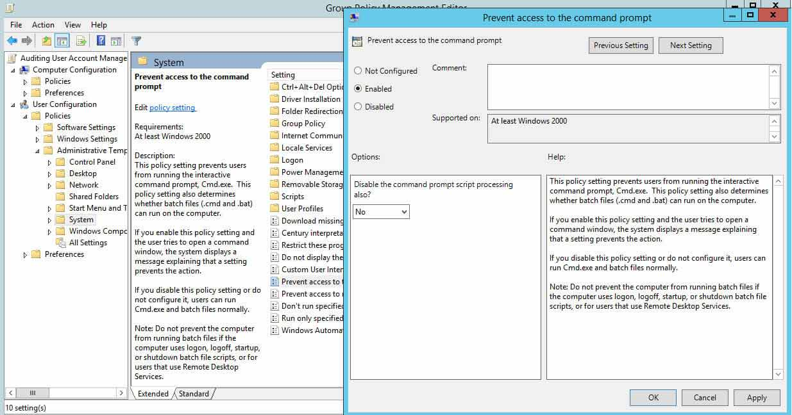
Figure 2 - Prohibit access to command prompt
- Prohibit access to removable media
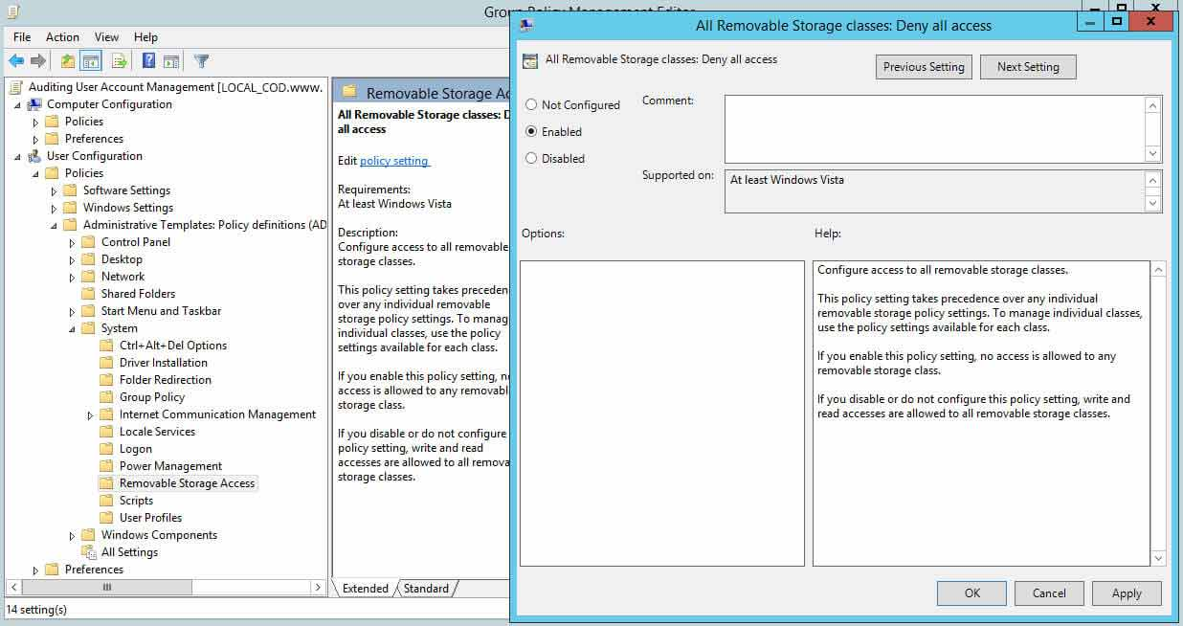
Figure 3 - Prevent access to removable media
- Prohibit software installs
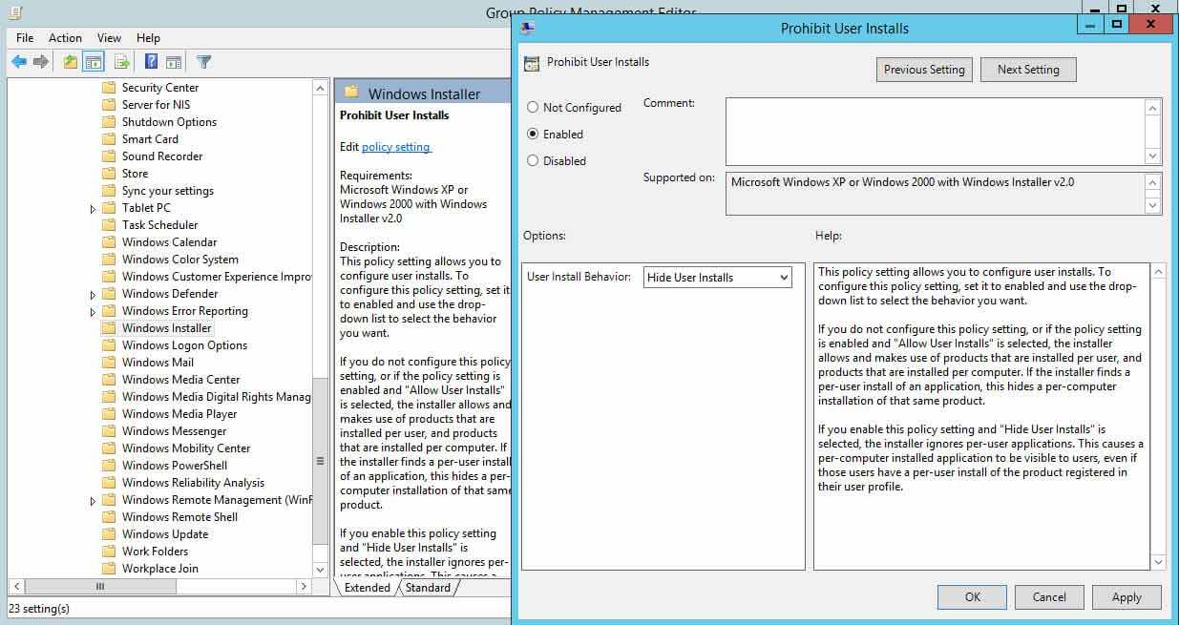
Figure 4 - Prevent software installations
- And, perhaps most widely used of all, enforce a variety of password standards such as increasing the minimum length, maximum password age and complexity requirements of passwords:
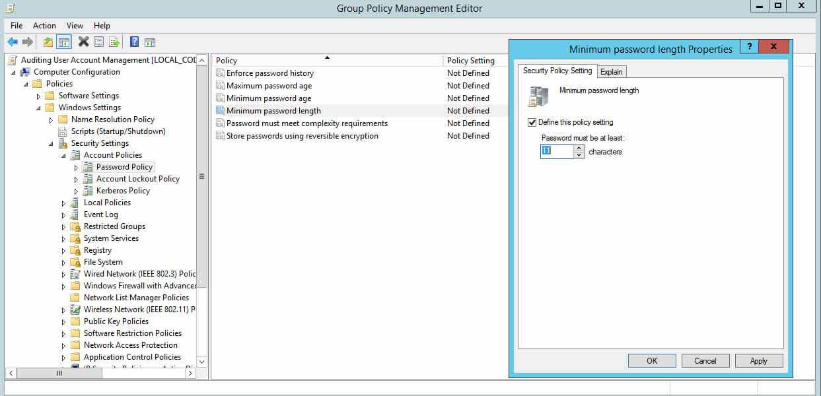
Figure 5 - Password length
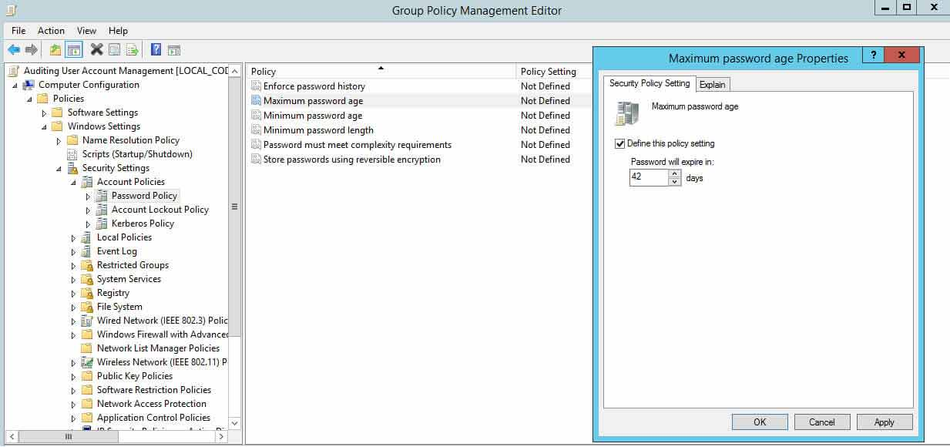
Figure 6 - Password age
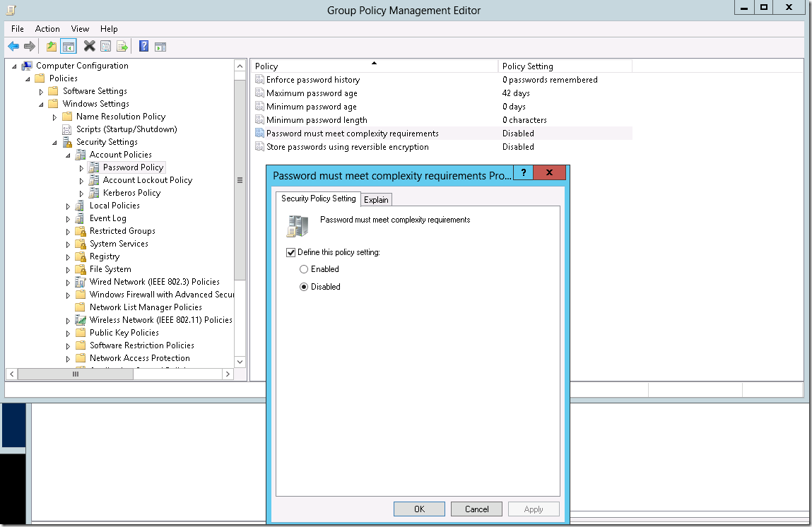
Figure 7 - Password complexity
c) Password principles
There are a number of different recommendations to consider when choosing what kind of policies and requirements are to be selected for a password policy. These recommendations have been relatively constant for a long period, but in recent times, these recommendations have been updated and in some places changed completely to complement advances in technology and advances in our understanding of human behaviour.
i) Password length
This is perhaps the most obvious requirement to consider when thinking about password strength. Microsoft recommend as best practice to select a minimum length password of at least 8 characters [7], with the highest minimum value being 14 characters. When considering brute force attacks, each additional character can have an exponential impact on the increasing of security, as can be seen below:
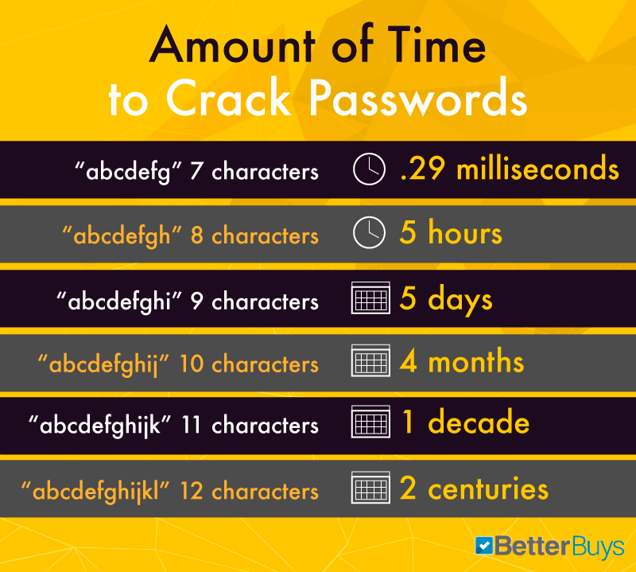
Figure 8 https://www.betterbuys.com/estimating-password-cracking-times/
The length of a password becomes irrelevant in the case of a dictionary attack if the password is commonly used, but from a purely brute force perspective, a 12 character password can be seen as secure. Many organisations will mandate a minimum length of at least 10 characters, as a compromise between increasing security standards but allowing users to select memorable passwords
ii) Password complexity
As mentioned above, the complexity of passwords also has a drastic effect on security. Forcing users to choose both alpha and numeric, as well as special characters and capital letters, can massively boost the difficulty of the password being cracked. For example, the password “Password” would be cracked by brute force in a fraction of a second. However, the password “P@ssw0rd” would take roughly 14 years [8]. Organisations will often mandate password that meet at least 3 of the above complexity requirements in order for the password to be accepted. It’s also possible to implement blocked password lists. Microsoft have created and maintain a list of banned passwords that include easily guessed and widely known passwords. It’s also possible to customise these lists further, with information such as:
- Brand names
- Product names
- Locations, such as company headquarters
- Company-specific internal terms
- Abbreviations that have specific company meaning [9]
iii) Password age
Historically, guidance on password age stated that passwords should be regularly changed, with users forced to change their passwords every 90, 60 or sometimes even 30 days. Whilst this is still the recommendation for administrator or privilege accounts, the guidance from organisations such as the National Cyber Security Centre states that forcing users to regularly change their passwords does more harm than good, because:
- The user is likely to choose new passwords that are only minor variations of the old
- Stolen passwords are generally exploited immediately
- Resetting the password gives you no information about whether a compromise has occurred
- An attacker with access to the account will probably also receive the request to reset the password
- If compromised via insecure storage, the attacker will be able to find the new password in the same place [10]
Instead, guidance suggests that password expiry is removed completely. In its place, the minimum length should be increased and users recommended to choose passphrases, consisting of 3 or 4 easy to remember random words, which will not expire. If a password is known, or suspected to be compromised however, then the password change should be forced.
iv) Multi-factor authentication
As well as implementing all of the above, the implementation of Multi-factor authentication should be the aim for all organisations. At a minimum, administrator accounts should be secured using multi-factor authentication, such as using authentication apps or SMS codes. This added layer of security means that even in the case of a password becoming compromised, access to the system should still be unachievable. The authorised user of the account will also be notified of a possible attempted breach of their password, prompting them to immediately change it and helping to avoid a security incident.

Bibliography

[1] | “NTFS Overview,” 30 9 2020. [Online]. Available: https://docs.microsoft.com/en-us/windows-server/storage/file-server/ntfs-overview. [Accessed 04 15 2021].
[2] | Varonis, “ntfs permissions,” 08 04 2021. [Online]. Available: https://www.varonis.com/blog/ntfs-permissions-vs-share/. [Accessed 15 04 2021].
[3] | “NTFS,” Windows Data Recovery - NTFS, [Online]. Available: https://www.windowsdatarecoverysoftware.com/ntfs/. [Accessed 15 04 2021].
[4] | D. Stuff, “DNS Stuff - NTFS,” 03 04 2020. [Online]. Available: https://www.dnsstuff.com/ntfs-vs-share-permissions. [Accessed 04 15 2021].
[5] | Netwrix, “differences-between-share-and-ntfs-permissions/,” Netwrix, 03 03 2020. [Online]. Available: https://blog.netwrix.com/2018/05/03/differences-between-share-and-ntfs-permissions/. [Accessed 15 04 2021].
[6] | Netwrix, “Group-Policy,” Netwrix, 11 03 2020. [Online]. Available: https://blog.netwrix.com/2017/02/17/group-policy/. [Accessed 15 04 2021].
[7] | M. -. minimum-password-length, “minimum-password-length,” [Online]. Available: https://docs.microsoft.com/en-us/windows/security/threat-protection/security-policy-settings/minimum-password-length. [Accessed 15 04 2021].
[8] | https://www.betterbuys.com/estimating-password-cracking-times/, “estimating-password-cracking-times/,” Betterbuys, [Online]. Available: https://www.betterbuys.com/estimating-password-cracking-times/. [Accessed 15 04 2021].
[9] | M. -. Azure, “tutorial-configure-custom-password-protection,” Microsoft, [Online]. Available: https://docs.microsoft.com/en-us/azure/active-directory/authentication/tutorial-configure-custom-password-protection. [Accessed 15 04 2021].
[10] | NCSC, “Updating your approach,” National cyber security centre, 11 2018. [Online]. Available: https://www.ncsc.gov.uk/collection/passwords/updating-your-approach. [Accessed 15 04 2021].

