University of Wales Trinty Saint Davids
Wales Institute of Science & Art



Title of Report: Energy in a flywheel
Module name (ACHA4007)
Student name: Finn O’Connor
Student number:2406000
Date (03/2025)
Contents
Contents
1. Introduction 3
2. experimental procedure 4
3. results 5
4. analysis 6
5. conclusion 7
6. evaluation …………………………………………………………………………………………….. 10
7. further work ………………………………………………………………………………………. 12
8. references………………………………………………………………………………………… 13

Introduction

The aims of this topic were focused on connecting research related to a flywheel in the lab. Key objectives included facilitating communication with others and gathering valuable information for the flywheel while ensuring a fair testing process. To achieve this, three tests were conducted for each flywheel to ensure a fair and accurate average. The goals involved using Excel to create a table, calculate results, and generate a graph. “What can fly wheels be used for? Fly wheels can be used in machines to act as an energy reservoir by storing and supplying energy when required.” (Ashika,2024, AQA A Level Physics Revision Notes 2017). Fly wheels can also stabilize engine speed, power smoothing in renewable energy systems, and mechanical clocks.

Experimental procedure

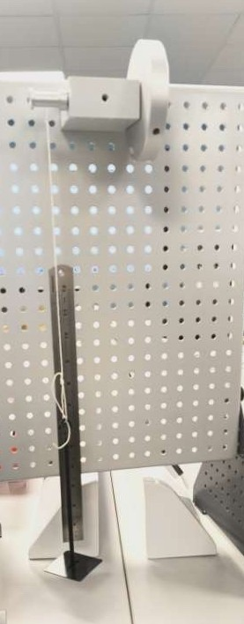
Firstly, the flywheel was constructed in the lab, as shown in the picture below. After that, tasks were assigned to each team member to conduct the experiment efficiently. One team member was responsible for winding up the flywheel and releasing it while counting down, stating “3, 2, 1, go” from a height of 0.28 m. Another team member was tasked with timing how long it took for the weights to drop to the bottom and hit the top. Meanwhile, a different team member recorded the height of the bounce from the bottom to the top. For example, the bounce height would be less than the initial height, which could be something like 0.234 m or 0.264 m. The researchers then conducted these experiments three times for each weight to find the average weight and time to fall, ensuring a fair test.

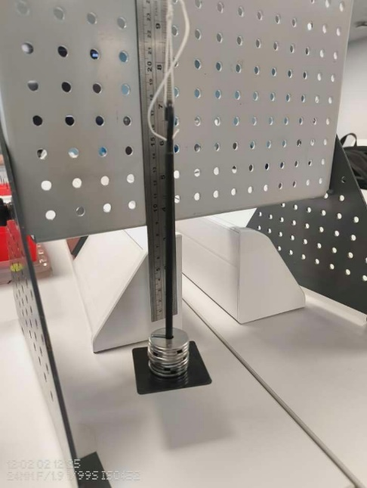
example of flywheel with weights on it being measured against the ruler.

Results
The team calculated the results by recording the fall and rise times, as well as the height from top to bottom, with different weights attached. They documented these results and then calculated the mean average, which was used to generate additional results in an Excel table. The results are shown below.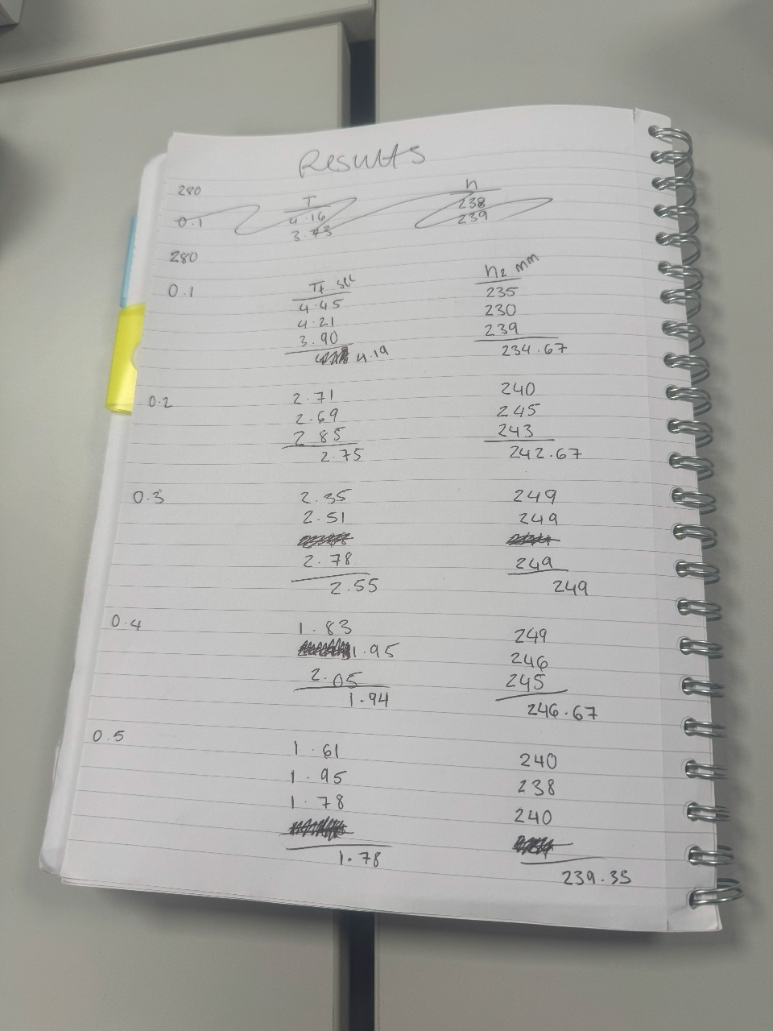

Analysis
From the data gathered the researchers crated a excel spread sheet to then gather more results
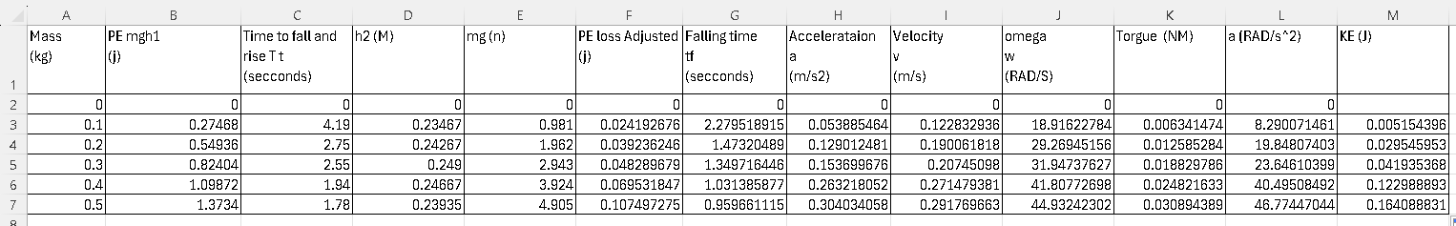

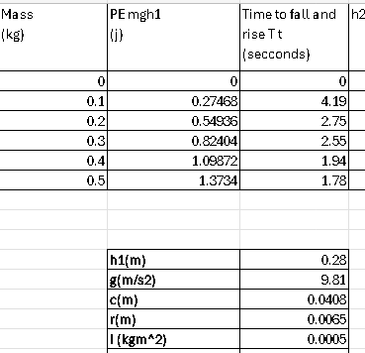How they calculated potential energy was that was that they multiplied the weight by the height (0.28) and multiplied gravity (9.81) as well how they calculated this in excel is using the formula =sumA3*$C$11*$C$12

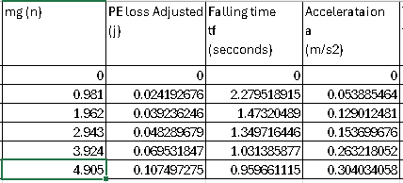
How they calculated mg was that they multiplied the mass by gravity using the formula =sum(A3*$C$12)
And calculating PE loss adjusted was that they multiplied Mass (0.1) by time to fall and rise (4.19) then multiply (new bracket) by the height (0.28) then minus that by the H2 (0.23467) then multiply (new bracket again) Height (0.28) divided (new bracket) by the height plus the H2 (0.23467) then close the 3 brackets and the formula should look like this =SUM(A3*$C$12*($C$11-D3)*($C$11/($C$11+D3)))

Calculating Falling time they start a bracket multiply the mass (new bracket) height (0.28) divided (new bracket) height (0.28) plus by H2 (0.23467) then close all the brackets and it will look like this =SUM(C3*($C$11/($C$11+D3))) using the $ to lock cells so that you can drag down the formulas so that it is easier

Acceleration was calculated by using I3 velocity (0.053885464) then divide that by G3 (falling time) (2.279518915) locking these as well, so it does it for all the rows. The formula will then look like this =SUM($I3/$G3)
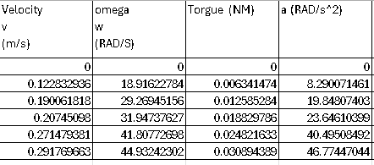
To calculate velocity, they divide the height (0.28) by falling time (2.27) where the sum looks like this =SUM($C$11/$G3)
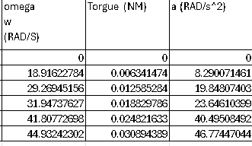
Calculating omega, the team used 2 multiplied by pi multiplied Velocity (0.122832936) divided by C (0.0408) this will then calculate omega ad the formula should look like this =SUM(2PI()$I3)/$C$13
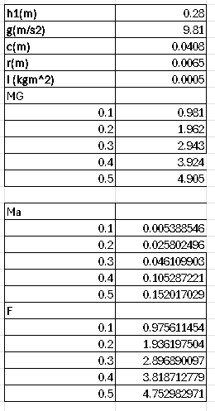
To calculate Torgue you need to find F to and to find F=mg-ma with Torgue is T=Fr So, to find mg the researchers multiplied each mass by gravity (9.81) and calculating ma its each of the mass multiplied by acceleration and then F=(mg-ma) as you can results for F below
So after calculating F you can then use the formula T=Fr so calculating that is as simple as using the results from F and multiplying them by r (0.0065) giving us the results of T (torque) with the formula looking like this =SUM($C30*$C$14)

=SUM($C17-$C24) for F

Calculating a (alpha) they used the formula A (alpha)= a/r so with this formula alpha was calculated by acceleration divided by R (0.0065) with the formula looking like this =SUM($H3/$C$14)

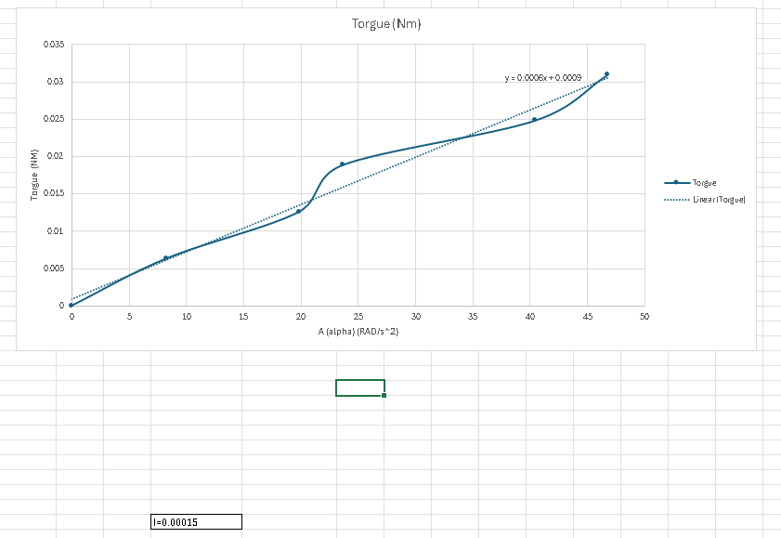
Above is an image of a graph that shows the moment of inertia (0.00015) how they found this is that they crated a graph from using Torgue and alpha to find the trend line equation which you can then calculate moment of inertia.
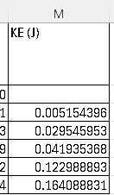
From calculating inertia, you are then able to do the KE (kinetic energy) by using the formula KE= ½*Iw^2(alpha) making the sum on excel look like this:
=SUM(1/2*$C$36*$L3^2)

Conclusion
In conclusion, the researchers systematically used calculations and Excel formulas to analyse potential energy, torque, velocity, and other physical properties involved in their experiment. By employing formulas such as =A3*$C$11*$C$12 for potential energy then they used more standard formulas for mass and gravity, and acceleration and then used those results to calculate more complex equations like torque and moment of inertia which was derived from the formulas to make a graph of torque and alpha values. With the use of excels formula functions, including cell locking which played key part with the “$” allowed a very efficient process to process large datasets and calculate critical values such as velocity, omega and kinetic energy. And from these results the graph was derived from torque and alpha helped calculate the moment of inertia and from then they where able to create the final kinetic energy formula of =sum(1/2*$C$36*$L3^2) which then provided a result for energy involved in the system.

Evaluation
During the experiment the team insured that it was conducted fairly by making sure that the conditions are the same for every test these being that the fly wheel was dropped from the same height and started falling at the same speed (0) , the team also insured that it was properly set up by checking lots of times and also using the same tools for each test, the team would also then repeat the same test 3 times to make sure there where no fluke results and then they where able to calculate a mean average by doing this as well the team was able to check for consistency and also being consistent with the way the team member would drop the flywheel as these factors would help reduce errors. With the chance to repeat the experiment, the team has decided that they would like to perform it in a wind-controlled space as this could come back with better and fair results as in the science lab. Perhaps there could have been a draft that could have affected some results, and by following these steps, the results will be more accurate and will reduce the unexpected errors.

Further work
If I had unlimited time and money, I would create a more accurate timing and dropping mechanism to achieve reliable results. When a human performs this task, it can be somewhat slow and may lead to inconsistent results. However, if a machine were to handle it, the process would be more accurate and produce fair results every time. I would still repeat the experiment three times to ensure fairness and calculate a mean average.

To accomplish this, I would install a button that, when pressed, drops the flywheel and starts the timer simultaneously. Additionally, I would create a windproof room to eliminate any interference from drafts or open windows, ensuring that external factors do not affect the results. The reason for these improvements is to reduce confusion among participants, allowing everyone to focus on observing the height to which the flywheel bounces back, ultimately leading to better results.

References

- Ashika (2024). 11.1.10 Flywheels in Machines | AQA A Level Physics Revision Notes 2017. [online] Save My Exams. Available at: https://www.savemyexams.com/a-level/physics/aqa/17/revision-notes/11-engineering-physics/11-1-rotational-dynamics/11-1-10-flywheels-in-machines/.

