

Student Name: Ahmed Rain

Student ID: 2535781

Module Name: Human Capital Management Assignment
Module code: LCMB7023

Designing a Human Capital Architecture for Strategic Renewal

Lecturer’s Name: Shahrukh Irfan

Work Count: 2640

TABLE OF CONTENTS
TASK A: Socialisation, Identity & Business Activism 3
1. Critically evaluate traditional onboarding versus strategic organisational socialisation 3
2. Structured Socialisation Framework for Helios 4
3. Proposing mechanisms 5
3.1 Organisational identification 5
3.2 Ethical professionalism 5
3.3 The “business activist” mindset 6
Task B: Job Design 6
1. Innovative Job Design Strategy for Enhancing Employee Motivation and Innovation at Helios Urban Mobility 6
2. Stimulating Intrinsic Motivation and Supporting Innovation Through Strategic Job Design 8
Task C: Reflective report 10
1. Uses of Artificial Intelligence as a Decision-Support Tool While Preserving Critical Human Judgement 10
2. Personal Capability Development Plan 11
References 13

TASK A: Socialisation, Identity & Business Activism

1. Critically evaluate traditional onboarding versus strategic organisational socialisation
According to Stone, Cox and Gavin (2020), traditional onboarding is a short-term orientation that includes administrative, compliance, and familiarisation with the role, ensuring that an employee learns about the role in the short term and the organisational policies and procedures. While this may be useful in the initial phase of the transition, it does not help to foster long-term commitment, organisational identity, or long-term alignment of behaviour to the new organisation – particularly one that is knowledge-intensive, such as Helios Urban Mobility (HUM). In contrast, Cappelli and Keller (2020) argued that strategic organisational socialisation highlights the integral and sustained manner in which the orientation and socialisation of the employees of an organisation become an integral part of the cultural values, networks and strategic agenda of the company, resulting in learning, an increase in engagement and reduction of turnover. Collective training, sequential pathways of learning, serial mentoring and investiture are all socialisation tactics by which newcomers are taught to learn the content of an organisation and gain confidence and connectedness.
Griep et al. (2023) described that as per Psychological Contract Theory, employees' hopes of support, development, equity and opportunities for their careers from the start become “Psychological Contracts” with their employers. Many companies have a standard onboarding process that only covers the transactional dimension, creating the risk of psychological contract violation, turnover and dissatisfaction. Cheng et al. (2022) claimed that strategic socialisation simultaneously raises expectations again through coaching, feedback and Development in Careers, fostering trust and employment. This is supported by Identity Construction Theory, which proposes that identities are actively constructed by employees as they socialise through interaction, experience and storytelling with other people within the organisation. New hires don't just learn how to do the job; over time, they internalise organisational values, and they feel as though they are helping to accomplish the organisation's long-term goals. But with HUM, it can be an issue because their reports – low engagement at the time of joining, a long 8+ month ramp-up programme, a high turnover of graduates might indicate poor integration. Strategic organisational socialisation, compared to onboarding, is more sustainable for HUM. HUM can be a combination of formal learning, psychological support, and identity development to produce dedicated organisational citizens, who are of value to stakeholders, innovation and organisational development.

2. Structured Socialisation Framework for Helios
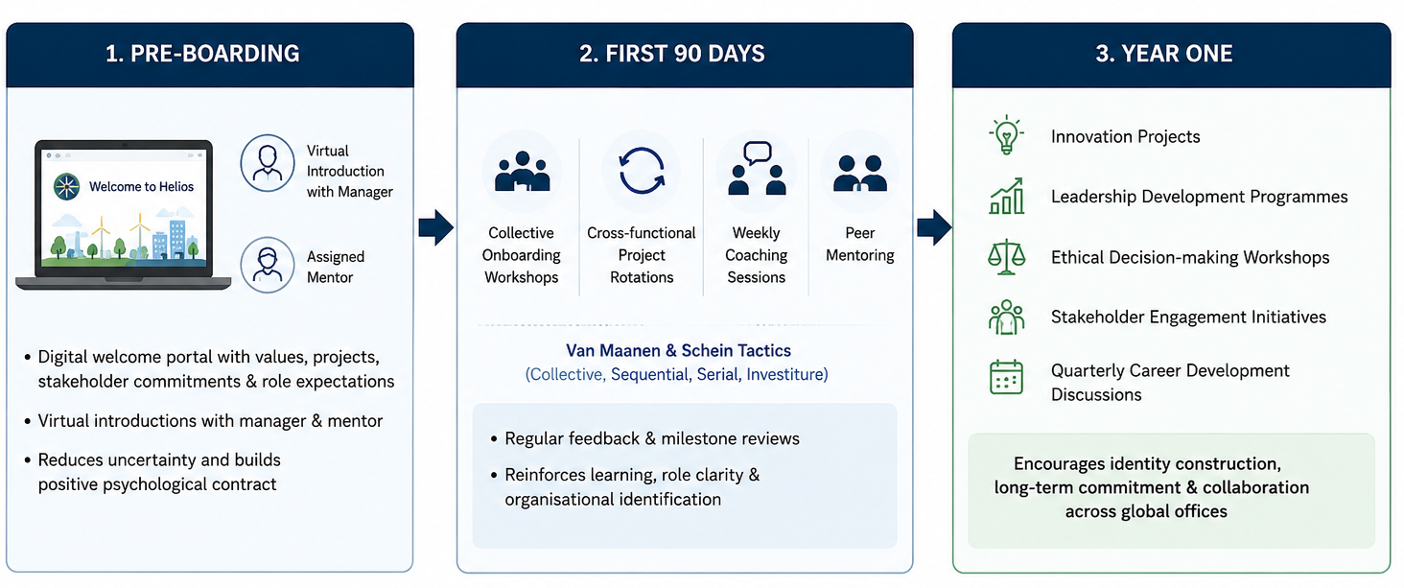
Figure 1: Structured Socialisation Framework
(Source: Self-Created)
Structured socialisation for Helios Urban Mobility (HUM), shown above, should not just be orientation, but should continue to help people learn, build identity and join their organisations. During the pre-boarding phase, new hires should be given a digital welcome package consisting of organisational values, AI/ML-related mobility projects, commitments of the different stakeholders, and expectations for the roles/virtual introductory lectures with the manager/assigned mentor. This decreases uncertainty and sets an optimistic psychological contract prior to starting work. For the first 90 days, HUM should establish collective, sequential, serial, and investiture onboarding strategies based on John Van Maanen and Edgar H. Schein's potentially counterintuitive approach. Kammeyer-Mueller, Rubenstein and Barnes (2024) illustrated that John Van Maanen and Edgar H. Schein's potentially counterintuitive approach is an effective organisational socialization sometimes challenges newcomers to encourage adaptation and commitment. Ashley, PHR and George (2025) proposed that in addition to providing learning to support feedback and milestone reviews, they should also help to create a sense of belonging to the organisation and role clarity. In year one, it is important for employees to engage in innovation projects, leadership development programmes, decision-making based on ethical values, and stakeholder participation in projects and quarterly discussions about career development. These experiences lead to ongoing identity construction, commitment to career, and connections among offices across Helios.

3. Proposing mechanisms

3.1 Organisational identification
For HUM to grow, employees must be identified with a common aim of sustainable urban mobility and stakeholder value. Practical mechanisms include purpose-driven town-halls, cross-functional innovation projects, mentoring programmes, international job shadowing and recognition programmes for those involved in the city impact projects, etc (Nieto-Rodriguez, 2026). The collaboration in the digital space can help employees across London, Berlin and Singapore to share knowledge and success stories, thus making a unified organisational identity even more powerful. According to Cappelli and Keller (2020), the identity construction theory demonstrates that a sense of belonging can only be established through ongoing communication and shared experiences in the organisation, organisational stories and does not have to be done through formal orientation. Gallup (2013) has reported that companies with high employee engagement can provide around 23% more profitability than companies with low engagement, making them understand the importance of building organisational identification. For HUM, these efforts could result in reduced graduate attrition, improved engagement and a shortened eight-month ramp-up period.

3.2 Ethical professionalism
A governance structure that includes ethical leadership, continuous education and accountability is required for embedding ethical professionalism. HUM should introduce mandatory AI ethics and data governance training, include ethics champions on project teams, develop confidential reporting platforms, and create metrics for ethics in performance appraisals. Consistently, Godwin Olaoye et al. (2024) stated that reviewing with staff the ethical issues that arise throughout AI-supported transport initiatives helps develop critical thinking. This practical approach promotes responsible innovation and makes sure that innovations are in line with legal, environmental and social requirements. The Edelman Trust Barometer and other studies have increasingly identified “safe” ratings and higher employee commitment as two drivers of ethical organisations. Thus, the professional behaviour of an individual in the workplace can increase trust in the organisation, accountability of its members and long-term organisational achievement.

3.3 The “business activist” mindset
HUM should foster the Business activist attitude by engaging employees beyond their working role to engage them in broader organisational and societal goals. In line with Evolving HR Business Partner by Dave Ulrich, employees need to be encouraged to challenge existing practices, product innovation, and influence strategic decision making through innovation forums, sustainability committees and employee-led improvement initiatives (Ulrich, 2017). Projects must be approachable from a Stakeholder capitalism approach, where projects are valued by balancing the aspects of customers, governments, employees, community and environment over the sole consideration of financial performance (Freeman, 2023). Participation in environmental impact programmes, public sector partnerships and strategic problem solving helps build the responsibility of employees, increase organisational resilience, and empower employees as proactive drivers of sustainable organisational renewal.

Task B: Job Design

1. Innovative Job Design Strategy for Enhancing Employee Motivation and Innovation at Helios Urban Mobility
Job Characteristics Model as the Foundation
In order to overcome problems with a lack of engagement, a long onboarding process, and graduate attrition rates at Helios Urban Mobility, an innovative job design should combine the Job Characteristics Model (JCM) by Hackman and Oldham, the Job crafting theory and a skills-based architecture that is backed up by an internal talent marketplace. The JCM suggests that these five factors of skill variety, task identity, task significance, autonomy and feedback increase meaningfulness, responsibility and knowledge of results, thus strengthening intrinsic motivation. As per Stone, Cox, and Gavin (2020), AI engineers and mobility analysts, as well as specialists on infrastructure, should engage in cross-functional projects to link software delivery with sustainability and mobility outcomes and boost the significance of the tasks and raise mobility specialists' identity. Similarly, Puspitasari, Ramadhani, and Rosyada (2023) indicated that information presented during the performance appraisal lecture, including greater autonomy by letting individuals make agile decisions and providing continuous performance feedback through the use of Behaviourally Anchored Rating Scales (BARS) and Management by Objectives (MBO), would be a way to ensure there is behavioural clarity while ensuring that individuals would be working towards Helios' strategic goal of mobility solutions. Developmental conversations and coaching would ensure accountability and minimise ambiguity in the growth of the organisation on a regular basis.
Job Crafting and Skills-Based Architecture
According to Stewart and Brown (2019), based on the JCM, Wrzesniewski and Dutton's job crafting theory enables employees to proactively adjust the task, relational and cognitive boundaries, which can engender person-job fit and organisational commitment. Recent engineering graduates would be able to personalise innovation projects, involve members of other engineering teams, analytics teams, and customer teams, and relate their work to meaningful sustainable urban transformation, helping to establish a strong sense of professional identity and minimising the risk of early career turnover. Helios can help ensure flexibility, for instance, in the way that roles are defined; roles can be replaced by a skills structure, and projects can then be allocated based on demonstrable skill competencies in Helios' internal talent marketplace. Ulrich (2017) indicated that employees would work in a rotational cycle where they constantly gained Technical, Analytical, and Leadership skills while working from a wide variety of jobs, mentoring, and focused learning programs. As per the views of Saikrishna (2025), this relates to the emphasis on career pathing, coaching, mentoring, job rotation and a continuing process of professional development, and the use of Kolb's experiential learning cycle, which helps develop capability through getting people to experience, reflect, conceptualise, and experiment in a given project. This architecture helps enhance the agility of the workforce as limited AI and digital infrastructure expertise is spread rapidly across strategic initiatives.
Strategic Value for Helios
Bratton and Gold (2017) stated that as opposed to traditional job design, which privileges only being efficient, with this integrated approach, role design is born from learning by doing and is ever flexible with the ever-changing priorities of the organisation. In-house talent mobility expands career prospects, helps save on external hiring expenses, and retains institutional knowledge. At the same time, Haines et al. (2025) indicated that customised approaches to development and skills recognition boost procedural justice in employees' minds, and this is an important part of the psychological contract between staff and their employers. As per the views of Md, Md Saiful, and Jannatul (2025), skill analytics can be AI-led to identify skill gaps and Learning opportunities, but ultimate judgment and decision can only be made by the manager to get an equitable deployment. Thus, Helios fosters the creation of a new ‘humane’ human resources architecture, in which meaningful work, employee autonomy, ongoing learning and strategic mobility all help to improve employee engagement in a smart mobility industry that is experiencing rapid change and accelerated evolution.

2. Stimulating Intrinsic Motivation and Supporting Innovation Through Strategic Job Design
Stimulating Intrinsic Motivation
The project's job design increases intrinsic motivation through meaningful, autonomous, and developmental work experiences, which focus on individual aspirations and correspond to Helios Urban mobility's strategies. Bratton and Gold (2017) indicated that Hackman and Oldham's Job Characteristics Model states that skill variety, task significance, autonomy, feedback and task identity lead to three psychological states that positively affect a person's internal motivation to work, satisfaction with the job and performance. Cross-functional innovation projects make it easier to provide employees with an understanding of the impact these innovations have on society and thus enhance meaningfulness and organisational commitment. At the same time, Demerouti (2026) implied that job crafting allows employees to rearrange, reconceptualise, and redefine elements such as the job tasks, relations and work perceptions to suit individual characteristics and career aspirations, leading to increased ownership and enhanced person-job fit. Skills are also a key element in creating an architecture that represents clear pathways to internal mobility, capability development, internal succession or even external promotions, supporting high individuals' motivation. As per the views of Chukwunweike and Aro (2024), in line with performance management, frequent (or even better, continuous) feedback, SMART goals, coaching and development of employees replace annual reviews – and turnover is delivered in an agile, growth-oriented way, emphasising that employees can quickly identify improvement areas while celebrating their successes. These ongoing developmental dialogues boost self-confidence, decrease ambiguity and support the psychological contract, which increases the engagement and retention of high potential graduates.
Supporting Sustainable Innovation
The built-in design also helps to foster an environment where innovation can continue, through collaboration, ongoing learning and adaptive capacity building. In the aspect of Pilbeam and Corbridge (2019), internal talent marketplaces make connecting individuals and departments easier, enabling them to share knowledge and expertise and engage in interdisciplinary problem-solving, key in dynamic technological settings, particularly for AI engineering, data analytics, and smart infrastructure projects. This is complemented by Kolb's learning cycle, which involves learning through experience, reflection, conceptualisation and action, and allows employees to always gain new skills in the context of imminent strategic issues. In addition, Bartram, Cavanagh, and Cooke (2026) emphasised the importance of employee voice, psychological safety, open communication and partnership-based employment relationships as a basis for innovation, as employees are more prone to share ideas when they believe in organisational procedures. Helios should thus establish a digital feedback system, innovation forums, town halls, and problem-solving events where its global workforce can engage in positive and constructive discussions. Maley et al. (2024) indicated that the modernity in the performance management concept also strengthens innovation through agile working, ongoing feedback and open performance management, goals should be linked to employee creativity, and procedures should be seen as just, compliant and free from injustice. While AI can be used to work out what skill gaps are currently or rapidly forming and suggest personalised learning pathways, managerial judgment is still important to take into account the relevance of contextual factors, reduce algorithmic bias and maintain ethical decision-making.

Task C: Reflective report

1. Uses of Artificial Intelligence as a Decision-Support Tool While Preserving Critical Human Judgement
As a human capital professional in the future, I will employ Artificial Intelligence (AI) to support evidence-based decision-making and retain the human element in my decision-making process. Cappelli and Keller (2020) indicated that AI can help predict staff turnover, identify trends, and suggest suitable actions by processing and analysing massive amounts of workforce information, hence enabling HR decision-making and action that is faster and more informed. But, I am aware that there are possibilities that AI programs might be biased, and they do not consider the feelings or values of employees, nor their ethical issues. Therefore, before making a decision and applying the outline, I will critically examine the outcomes of AI, taking into account any organisational values, ethics and man-to-man issues. To eliminate algorithmic bias will also try to gather inputs from an array of sources, particularly managers and employees, to confirm the AI recommendations. I can apply the characteristics of continual reflection, professional scepticism and data literacy to approach outputs created with machine tools with a questioning approach, relying not solely on the machine.

2. Personal Capability Development Plan
In order to improve my future prospects of employability as an HR individual, I will make use of a personal capability development plan that will be structured in the development of Technical skills, strategic skills and global skills (Figure2). Within the next 12-18 months, I will develop my data literacy skills to enable myself to use HR data tools such as Excel, Power BI and SPSS to interact with HR data and make evidence-based decisions. Similarly, I'll enhance my proficiency in AI in HR by mastering how to leverage generative AI for workforce planning, recruitment, performance analytics and talent management while exercising ethical considerations and strict adherence to data privacy laws. In order to develop strategic influencing as a skill, I will attend leadership workshops, share my findings and recommendations in academic projects and practice negotiating with and presenting to key stakeholders. I will also be getting more tech-savvy by increasing my understanding of International employment law, Cross-cultural management and international talent management and planning methods and by actively engaging in some international human resource webinars, as well as collaborating with a variety of teams (Swami and Atitkar, 2025). Finally, I will continue to develop my skills through ongoing certification courses, reflective learning experiences and industry participation to be open-minded to adapt to technological innovations and shifts in workforce requirements.
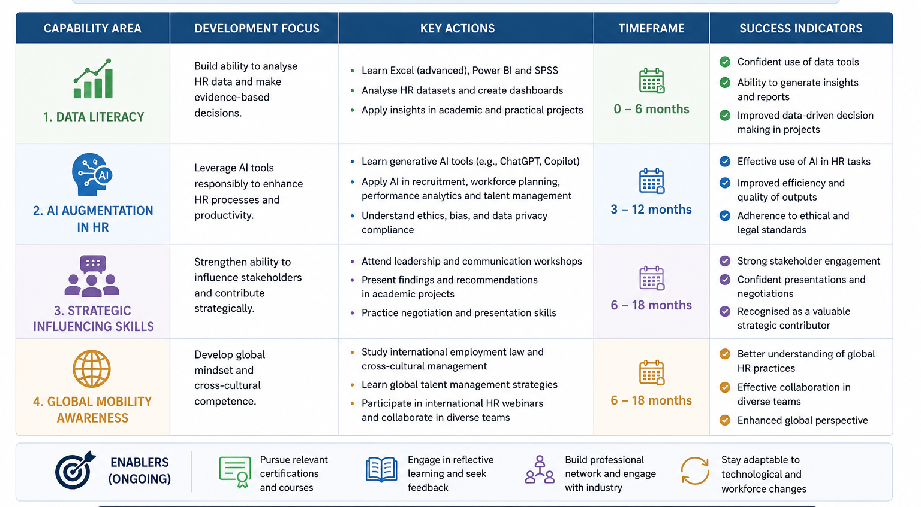
Figure 2: Personal Capability Development Plan
(Source: Self-Created)

References
Ashley, L., PHR, S. C., and George, N. (2025). Enhancing Onboarding for Staff Engagement and Belonging.
Bartram, T., Cavanagh, J. and Cooke, F.L. (2026). Bringing employment relations into collaborative human resource management research and practice: the role of social partnership and mutuality. Personnel Review, 55(1), pp.375-395. https://doi.org/10.1108/PR-06-2025-0605
Bratton, J. and Gold, J. (2017). Human Resource Management: Theory and Practice (6th Ed.). Palgrave Macmillan.
Cappelli, P. and Keller, J. (2020). Managing the Future of Work: The New HR Imperative. Harvard Business Review Press
Cheng, S. Q., Costantini, A., Zhou, H., and Wang, H. J. (2022). A self-enhancement perspective on organizational socialization: Newcomer core self-evaluations, job crafting, and the role of leaders’ developmental coaching. European Journal of Work and Organizational Psychology, 31(6), 908-921. https://doi.org/10.1080/1359432X.2022.2077724
Chukwunweike, J. and Aro, O.E. (2024). Implementing agile management practices in the era of digital transformation. World Journal of Advanced Research and Reviews, 24(1), pp.2223-2242. https://doi.org/10.30574/wjarr.2024.24.1.3253
Demerouti, E. (2026). Job crafting revisited: Current insights, emerging challenges, and future directions. Annual Review of Organizational Psychology and Organizational Behavior, 13. https://doi.org/10.1146/annurev-orgpsych-020924-064242
Freeman, R. E. (2023). Understanding stakeholder capitalism. In R. Edward Freeman’s Selected Works on Stakeholder Theory and Business Ethics (pp. 691-695). Cham: Springer International Publishing.
Gallup. (2013) The Benefits of Employee Engagement. [Online] Available at: http://gallup.com/workplace/236927/employee-engagement-drives-growth.aspx (Accessed on: 6 July 2026).
Godwin Olaoye, J. O., Flypaper, D., Oluwaseyi, J., and Brightwood, S. (2024). Ai-supported peer review: enhancing critical thinking and collaboration. https://www.researchgate.net/profile/Opeyemi-Adeojo-3/publication/384767823_Ai-supported_peer_review_enhancing_critical_thinking_and_collaboration/links/6706fd05dc91726ad3863e4b/Ai-supported-peer-review-enhancing-critical-thinking-and-collaboration.pdf
Griep, Y., Bankins, S., Kraak, J.M., Sherman, U. and Hansen, S.D., 2023. Sustainable psychological contracts: A pathway for addressing precarious employment. In Tackling precarious work (pp. 302-324). Routledge. https://www.taylorfrancis.com/chapters/edit/10.4324/9781003440444-16/sustainable-psychological-contracts-yannick-griep-sarah-bankins-johannes-kraak-ultan-sherman-samantha-hansen
Haines, S.L., Lee, K.C., Gable, K.N., Thigpen, J., Gibson, C.M., Morley, S., Crowl, A.N., Chahine, E.B., Hilaire, M.L., Komperda, K.E. and Szollosi, D. (2025). Exploration of psychosocial hazards: core values, justice and fairness, and social support to address workforce well-being. American Journal of Pharmaceutical Education, p.101460. https://doi.org/10.1016/j.ajpe.2025.101460
Kammeyer-Mueller, J. D., Rubenstein, A. L., and Barnes, T. S. (2024). The role of attitudes in work behavior. Annual Review of Organizational Psychology and Organizational Behavior, 11(1), 221-250. https://doi.org/10.1146/annurev-orgpsych-101022-101333
Maley, J.F., Dabić, M., Neher, A., Wuersch, L., Martin, L. and Kiessling, T. (2024). Performance management in a rapidly changing world: implications for talent management. Management decision, 62(10), pp.3085-3108. https://doi.org/10.1108/MD-07-2023-1162
Md, S., Md Saiful, I. and Jannatul, F. (2025). Harnessing ai adoption in the workforce a pathway to sustainable competitive advantage through intelligent decision-making and skill transformation. American Journal of Economics and Business Management, 8(3), pp.954-976. https://globalresearchnetwork.us/index.php/ajebm/article/view/3355
Nieto-Rodriguez, A. (2026). Powered by Projects: Leading Your Organization in the Transformation Age. Harvard Business Press.
Pilbeam, S. and Corbridge, M. (2019). People Resourcing and Talent Planning (6th Ed.). Pearson.
Puspitasari, N.B., Ramadhani, N.A. and Rosyada, Z.F. (2023). Preparation of employee performance assessment with a combination of management by objective and behaviorally anchor rating scale. World Journal of Advanced Engineering Technology and Sciences, 9(1), pp.296-306. https://doi.org/10.30574/wjaets.2023.9.1.0174
Saikrishna, M.B. (2025). Leveraging job rotation programs for experiential learning in organizations through the lens of Kolb’s experiential learning theory. Development and Learning in Organizations: An International Journal, 39(6), pp.24-27. https://doi.org/10.1108/DLO-09-2024-0272
Stewart, G.L. and Brown, K.G. (2019). Human Resource Management. John Wiley & Sons.
Stone, R.J., Cox, A. and Gavin, M. (2020). Human Resource Management. John Wiley & Sons.
Swami, A., and Atitkar, M. (2025). Addressing Cross-Cultural Challenges in Global Human Resource Management. International Journal of Innovative Research in Technology, 11(12), 3371-3375. https://www.researchgate.net/profile/Anil-Swami-5/publication/393332507_Addressing_Cross-Cultural_Challenges_in_Global_Human_Resource_Management/links/6865f1d7b991270ef301264c/Addressing-Cross-Cultural-Challenges-in-Global-Human-Resource-Management.pdf
Ulrich, D. (2017). Victory Through Organization: Why the War for Talent is Failing Your Company and What You Can Do About It. McGraw-Hill Education.

