

Right Care, Right Person from a Response Policing Perspective, an exploration of the impact Right Care Right Person has had on response policing within South Wales Police

Name: Colm Callaghan
Student number: 2134472
Degree title: BSc Professional Policing Practice
Word count: 6259

Acknowledgements
I would like to thank all the University of Wales Trinity Saint David staff who have made this study programme and dissertation possible, particularly my academic tutor and markers. I would also like to thank the survey respondents who took time out of their busy schedules to provide valuable insight into the topic.

- Declaration - This work has not previously been accepted in substance for any degree and is not being concurrently submitted in candidature for any degree. Signed: CC Date: 01/04/2025
- Statement 1 - This dissertation is being submitted in partial fulfilment of the requirements for the degree of BSc. Signed: CC Date: 01/04/2025
- Statement 2 - This dissertation is the result of my own independent work/investigation, except where otherwise stated. Other sources are acknowledged by footnotes giving explicit references. A bibliography is appended. Signed: CC Date: 01/04/2025
- Statement 3 - I hereby give consent for my dissertation, if accepted, to be available for photocopying and for interlibrary loan, and for the title and summary to be made available to outside organisations. Signed CC Date: 01/04/2025
- Statement 4 - I hereby give consent for my dissertation, if accepted, to be available on the university’s IT system to those who have consent to use the system. Signed: CC Date: 01/04/2025

Abstract
The role that police in England and Wales play in responding to mental health emergencies has changed with the development of a national partnership agreement between the Home Office, the Department of Health and Social Care, NHS England, the Association of Police Crime and Crime Commissioners and the National Police Chiefs’ Council. This agreement is called Right Care, Right Person (RCRP) and aims to ensure that those facing social or health emergencies are responded to by the right service and right people with adequate training. Prior to the introduction of RCRP, it had been suggested that police in England and Wales responding to mental ill health emergencies had become a barrier to their productivity when they were not the right service to respond. This dissertation aims to explore what impact RCRP has had on response policing in South Wales Police and, more specifically, gain insight from officers working in response policing as to whether the introduction of RCRP has alleviated pressure on their capacity to respond to and investigate crime as well as whether they feel the policy is being utilised correctly. Using surveys distributed to police officers working in response policing in South Wales Police, qualitative and quantitative data was produced, which was analysed using thematic analysis and statistical analysis. This process found that overall, officers found the introduction of RCRP beneficial and had alleviated some of the pressure and demand on response policing; however, there was not a conclusive finding concerning the correct utilisation of RCRP with concerns surrounding how incidents were screened and assessed prior to being passed to response and the ability of partner agencies to resource incidents.
Keywords: Right Care, Right Person, Response Policing, South Wales Police, Mental Ill Health, Police Productivity

Table of Contents

Chapter 1 Introduction 1
1.1 Aims and objectives 1
1.2 Structure 1

Chapter 2. Literature Review 3
2.1 Background 3
2.2 Services that deal with mental ill health 4
2.3 The role of police in mental health emergencies 5
2.4 Right Care Right Person (RCRP) 6
2.5 Conclusion 7

Chapter 3. Methodology 8
3.1 Research design 8
3.2 Data collection 9
3.3 Survey sample 9
3.4 Data analysis 9
3.5 Ethical considerations 10
3.6 Limitations 10

Chapter 4. Results 11
4.1 Descriptive statistics and cross-tabulations 12
4.2 Assessment 15
4.3 Deployment 16
4.4 Awareness 16
4.5 Conclusion 16

Chapter 5. Findings and Conclusion 18
5.1 Do officers in SWP feel that RCRP is being utilised correctly? 18
5.2 Has the introduction of RCRP alleviated pressure on response officers’ capacity and time to investigate crime effectively? 18
5.3 What impact has RCRP had on response policing in SWP? 19
5.4 Limitations 19
5.5 Future research 19
5.6 Conclusion 20

References 21
Appendix A 25

Chapter 1. Introduction
While it could be suggested that police will inevitably deal with people going through mental health crises as they are a public-facing body, in particular being first responders where there is an immediate threat to life, it has been stated that police involvement in mental health medical incidents is limiting their ability to respond to and disrupt and investigate crime (Home Office & Department of Health and Social Care, 2024). As a result, the role that police within England and Wales play in mental health crises has recently changed with the introduction of Right Care, Right Person (RCRP). RCRP is a national agreement designed to ensure that people experiencing health or social care issues and emergencies are responded to by the right service and people trained with the right skills to provide a service that meets their needs (Home Office, 2024). Due to RCRP’s recent introduction, little is known regarding the impact it has had on police. Therefore, this dissertation aims to conduct an exploratory study into RCRP’s impact; more specifically, the dissertation aims to explore RCRP from a response policing perspective and conduct an exploration into the impact RCRP has had on response policing within South Wales Police.

  - Aims and objectives
Through the dissertation’s research title and question, Right Care, Right Person from a Response Policing Perspective, an exploration of the impact Right Care Right Person has had on response policing within South Wales Police, the dissertation aims to understand the following:
- What impact has RCRP had on response policing in South Wales?
- Do officers in SWP feel that RCRP is being utilised correctly?
- Has the introduction of RCRP alleviated pressure on response officers’ capacity and time to investigate crime effectively?
By conducting this research, the dissertation aims to expand knowledge and understanding in relation to a new policy development within policing in England and Wales and add to the existing literature in the field of UK policing.

  - Structure
This dissertation contains five chapters. Following this chapter, which introduces the topic and sets out the aims and objectives of the dissertation, chapter 2 will contain a literature review. The literature review will delve into current and relevant literature regarding RCRP, including a more detailed background into how RCRP originated, and provide contextual knowledge regarding the roles that emergency services play in responding to mental health emergencies. Chapter 3 then outlines the methodological approach taken in this research, including the ethical considerations and limitations of the design. Chapter 4 will then outline the results of the research, and finally, chapter 5 will discuss the key findings and conclude the dissertation, as well as note how future research can build upon the results.

Chapter 2. Literature Review
In order to understand how RCRP has impacted response policing in South Wales Police, one must first understand the contextual issues that led to its inception. The following chapter explores and analyses themes and topics that emerge throughout the literature regarding RCRP and police responding to concern for welfare and mental ill health incidents. These themes include services that deal with mental ill health, the role of police in mental ill health emergencies and RCRP’s development. These topics will be discussed throughout the chapter in the form of relevant sub-headings before providing a conclusion.

2.1 Background
NHS England (2024) has provided some insight into the current demand for mental health services. Their recorded statistics show a growth in the number of people in contact with mental health services in England between 2016 and 2024, as shown below in Figure 1.

Figure 1. People in contact with mental health services (NHS England, 2024)

While these figures do not give an indication as to the reasons there has been an increase, nor does it account for population growth in the UK, which has increased from an estimated 65.6 million in 2016 to an estimated 69 million in 2024 (Office for National Statistics (ONS), 2024), they do show a growth in people contacting mental health services, suggesting an ever increasing demand for frontline services including both the NHS and police. A review conducted by the Mental Health Foundation (2016) found that approximately 17% of adults in the UK suffered from a mental health condition, with Marsden, et al. (2020) stating that one in four people in the UK that are having a mental health crisis access mental health services with involvement from the police.
It could, therefore, be argued that responding to mental ill health emergencies is intrinsically bound to the police’s duty in order to preserve life and improve the safety and well-being of the public, which is underpinned by the College of Policing’s Competency and Values framework (College of Policing, 2020). However, in 2021/2022, police in England and Wales recorded that they responded to over 600,000 mental health-related incidents, with an estimated 2.2 million hours spent dealing with mental ill health incidents each year (Home Office, 2024). It was reported that 45% of these involved no immediate threat to life, which suggested that police spent an estimated 1.6 million hours in the year 2021/2022 at mental ill health incidents that did not involve a criminal offence or an immediate threat to life (Home Office, 2024).

2.2 Services that deal with mental ill health
Before one can understand what RCRP is and how it was formed, it could be argued that a wider understanding of the services involved in mental ill health is needed. A review conducted by Odejimi, et al. (2020) identified several services that dealt with the immediate response to mental ill health crises within the first 24 hours. These services are described as Psychiatric Emergency Services (PES) and include public services such as Crisis Resolution and Home Treatment (CRHT), Police Officer Intervention, Psychiatric Assessment Units (PAU), as well as voluntary organisations (Odejimi, et al., 2020). CRHT teams are part of the NHS, and it has been argued that they play a fundamental role in tackling mental health crises by providing an alternative to in-patient care with community teams that can assess and provide support and treatment in a home-based setting (NHS Wales, 2024; Murphy, et al., 2015). Studies have suggested that the use of CRHT teams can reduce in-patient admissions (Johnson, et al., 2005; Lloyd-Evans, et al., 2020; Murphy, et al., 2015). However, it has been suggested that a lack of consistency in its implementation in some cases has led to challenges in its effectiveness (Wheeler et al., 2015).
Another pillar of the NHS’s strategy to treat and assess mental ill health is PAUs. PAUs have been developed to assess and triage people experiencing a mental health crisis and in need of immediate mental health care and are usually staffed by mental health nurses and supervised by a psychiatrist consultant (Odejimi, et al., 2020). Referrals to this service can come in the form of attending A&E, the ambulance service, speaking to a health care professional by calling 111, and through the patient’s local GP (NHS, 2023). There are also organisations outside of public services that can help people experiencing a mental health crisis, which include voluntary organisations such as the Samaritans and Shout (Odejimi, et al., 2020). Shout is a text-based service that allows people who are experiencing a mental health crisis to get support (Mental Health Innovations, 2024) and relevant safeguarding measures, such as referrals to other organisations, can be made if there are concerns for the person’s safety (Mental Health Innovations, 2024). The Samaritans also offer support to people, however, this can be utilised by talking to a trained volunteer on the phone (Samaritans, 2024). However, while these services provide support to those experiencing mental health crises, it could be argued that emergency services such as the police will inevitably be contacted if there is a risk of serious harm.

2.3 The role of police in mental health emergencies
It has been argued that there is a role for police involvement in mental health emergencies, such as when there is a substantial risk of serious harm to the person having a mental health crisis and/or others that may be harmed by that person or to investigate a crime that has occurred or is occurring (Department of Health and Concordat signatories, 2014; Marsden, et al., 2020; NHS, 2024). However, it has been suggested that there is an overreliance on police in responding to mental health emergencies and that this may be the result of deinstitutionalisation with an increase in the use of community-based care as well as austerity leading to underfunding in the NHS (Marsden, et al., 2020; Mclean & Marshall, 2010). Police involvement in mental health emergencies can sometimes lead to officers exercising powers under Section 136 of the Mental Health Act (1983), whereby they can detain and move a person to a place of safety such as a healthcare facility. Marsden, et al. (2020) state that officers spend an estimated ten hours with each person detained under this section, which suggests a considerable amount of time and resources are being diverted from investigating and preventing crime.
However, to truly understand the role of police in dealing with mental health crises, one must consider how much time is spent dealing with non-crime or public welfare incidents relating to mental ill health. A study conducted by Marsden, et al. (2020) utilised semi-structured interviews on 15 police officers from a police force in North-West England and used thematic analysis on data that was collated. The study concluded that police felt that they are overly relied upon in dealing with mental health emergencies and that further funding is needed in both preventative early help and intervention and community treatment, including better access to services and increased multi-agency approaches. However, it should be noted that Kane, et al. (2021) state that while incidents relating to mental health do consume police resources, it does not do so disproportionately. Kane, et al. (2021) conducted a study in which they analysed records from three forces and analysed data which covered a 24-hour period for all forces in England and Wales and concluded that 7.8% of incidents that warranted a police response involved mental health emergencies. While the study suggests that the time spent by police at mental health incidents is not disproportionate, it should be considered that a limitation of the study was the accuracy of data provided by police forces with 46% stating that their data was not very accurate (Kane, et al., 2021).
A theme that was prominent in the study by Marsden, et al. (2020) was that police felt that they were ill-equipped to deal with incidents relating to mental ill health and that further training concerning decision-making and incident management would be beneficial. A study conducted by Rodgers, et al. (2019) supports this finding with their paper concluding that mental health triage interventions where a partnership approach was utilised and involved support and advice from mental health professionals (MHPs) to police while they are dealing with incidents increased positive outcomes, with reductions in detentions, increased aftercare by mental ill health services, and an increase in the use of health care facilities. However, it should be noted that the partnership approaches that were studied varied, including in-person support, attendance from MHPs, and advice via telephone. It should also be noted that the findings produced consisted of input solely from police and researchers with no input from healthcare professionals (Rodgers, et al., 2019).
Marsden, et al. (2020) also found that officers felt that other services were hesitant to take ownership of mental health emergencies and that police have been left to address these shortcomings, with other agencies often misunderstanding police powers and remit (Marsden, et al., 2020). Furthermore, an independent report on police productivity conducted by the Home Office (2024) listed three barriers to police productivity. Firstly, the report from the Home Office (2024) lists police attending incidents involving mental ill health. The report suggested that public services with expertise in this area should be taking ownership, and police involvement should only be sought if the incident involves a crime or there is a real and immediate risk of serious harm or death to the individual or others (Home Office, 2024). The second barrier to productivity listed in the report was people reported missing from healthcare facilities (Home Office, 2024). The report states that approximately 25,000 people are reported missing each year, many of which should not have involved police. The report states that in the year 2020, 37 per cent of incidents should have been dealt with by the healthcare facility and not reported to police, suggesting that 9,250 were reported incorrectly (Home Office, 2024). The third barrier to police productivity listed in the report was time spent with people detained under section 136 of the Mental Health Act (1983), with officers spending an estimated 8,000 hours per year (Home Office, 2024).

2.4 Right Care Right Person (RCRP)
It has recently been argued that expectations on police to attend and involve themselves in mental health calls are limiting their ability to disrupt and investigate crime (Home Office & Department of Health and Social Care, 2024). As a result of this debate, a national partnership agreement which outlines a strategy to reduce police involvement in responding to mental health incidents was initiated, called Right Care, Right Person (RCRP), and initially pledged commitment from the Home Office, the Department of Health and Social Care, NHS England, the Association of Police Crime and Crime Commissioners and the National Police Chiefs’ Council to work towards this goal (Home Office & Department of Health and Social Care, 2024). In relation to the barriers to police productivity listed in 2.3, RCRP aims to address them by reducing the time spent with patients detained under Section 136 of the Mental Health Act (1983) to under one hour from when they arrive at a healthcare facility, triaging incidents with police only deploying to incidents where there is a crime or real immediate risk of serious injury or death, and the introduction of a framework to dealing with missing adults that sets out guidance prior to police involvement (Home Office & Department of Health and Social Care, 2024; Home Office, 2024).
The introduction of RCRP is being phased in by different police forces across England and Wales, and utilisation of the Crisis Care Concordat endeavours to ensure people receive the right care and support from the right services in the right setting (Home Office & Department of Health and Social Care, 2024). The Crisis Care Concordat, established in 2014, sets out four core principles: early intervention, urgent and emergency access to crisis care, recovery and prevention of future crises, and quality of treatment and care when in crisis (Department of Health and Concordat signatories, 2014). The Crisis Care Concordat is supported by the NHS Long Term Plan, which aims to increase funding for adult mental health services by £2.3 billion a year from 2023/2024, provide 24/7 access to crisis care and improve community and hospital-based services (Home Office & Department of Health and Social Care, 2024; NHS, 2019). These steps forward in the introduction of RCRP endeavour to create a holistic approach between emergency services where those in need of emergency care receive it from the right service (Home Office & Department of Health and Social Care, 2024) which could suggest an ever-evolving system seeking improvement in the care given to people experiencing crises.

2.5 Conclusion
The impact on police resources, in combination with an unintentional expansion in the role and responsibility of the police in dealing with health and welfare-related incidents have highlighted themselves as prominent impacts that led to the inception of RCRP. While other organisations, primarily the NHS, assess and treat mental ill health, the literature suggests that prior to RCRP, there was no clear definition of the roles that each service was responsible for. Furthermore, it has been suggested that factors such as austerity have led to the NHS becoming dependent upon the police providing a response to mental health emergencies, which in turn has become a barrier to productivity within the police. The review has suggested that the inception of RCRP seeks to solve these issues by setting clear definitions of roles between services and endeavours to create a more robust holistic approach where issues surrounding response can be streamlined by providing a universal framework.

Chapter 3. Methodology
This chapter will outline the methodological approach taken for this dissertation. The chapter includes the reasoning behind choosing this approach, including the benefits and limitations, as well as the ethical considerations when designing the research approach.

3.1 Research design
A combination of both a qualitative and quantitative non-experimental approach was considered the most effective method to answer this dissertation’s research objectives. This approach consisted primarily of a quantitative approach with the utilisation of a survey. The survey consisted of a set of structured questions that had multiple choice answers, which yielded quantitative data (Stoneman & Brunton-Smith, 2016). The quantitative data included the respondents’ length of service, age, role within response policing, and the Basic Command Unit (BCU) in which they worked, which allowed further categorisation of the data.
However, while quantitative data yields statistical insights (Stoneman & Brunton-Smith, 2016), it does not provide an in-depth descriptive picture of the topic from the perspective of respondents, nor does it provide meaning to the data without subjective interpretation from the researcher (Patton, 2015). Therefore, consideration was given to a qualitative approach, utilising semi-structured interviews, which would have yielded in depth data (Fielding & Thomas, 2016), which would have been beneficial due to the complexities of the research topic and its contentious nature (Home Office & Department of Health and Social Care, 2024; UK Parliament, 2023). However, due to the timeframe and scope of the project, it was deemed that this approach would not have been achievable; instead, a mixed methods approach was utilised (Patton, 2015). Many questions within the survey had an optional sub question where respondents could provide more details about their answers. This allowed for some qualitative data to be extracted from the surveys and provide further insight into the topic.
Consideration was also given to obtaining data regarding police deployments to mental health incidents pre and post implementation of RCRP from mental health liaison staff within SWP. A quantitative empirical study would then have been conducted utilising the data obtained from the survey to provide insight into any statistical correlations (Field, 2018). However, this data proved difficult to obtain for a multitude of reasons including no specific recording category for mental health incidents as they were recorded as public safety and welfare, as well as the data not being made available in the given time frame.

3.2 Data collection
The survey was created on Microsoft Forms, which allows the user to produce a web-based survey in which data can be collected from completed surveys (Microsoft, 2024). Once the survey was created, a link was produced that respondents could access if they had an internet connection. This link was then posted with a description of the research on the intranet for SWP as well as in an email sent to people who met the parameters for the sample group. The survey design was a one-off survey, meaning that it captured a snapshot of the time of the research topic (Calder, 1998). While a longitudinal survey could have been utilised during and after the implementation of RCRP in SWP, providing further insights into the topic, this would not have been achievable due to the timeframe of the research project.
The survey consisted of 13 core questions (Appendix A), which were predominantly closed questions with multiple-choice answers and took between 1 and 5 minutes to complete. However, many questions had sub questions for the respondents to add extra information if they wished to. This was made optional to allow for maximal participation from the sample group. Furthermore, in order to minimise frustration, the questions were added to the same page so that respondents could easily see and track their progress. Brace (2008) states that if respondents feel that they are making good progress near the start of the survey, they are more likely to finish it.

3.3 Survey sample
Sturgis (2016) states that the first stage of designing a survey is to define the demographic that the researcher plans to use for the sample group. Due to the nature of the topic, police officers currently employed in SWP and currently working in response policing were chosen due to the insight they were able to provide in answering the research question. The exact number of people who were requested to participate is unknown as it is not possible to review how many people had read or been aware of the post on the intranet, however, 27 participants completed the survey.

3.4 Data analysis
Primary data obtained from completed surveys were then extracted and descriptive statistics were produced using IBM SPSS in order to understand and visualise the research objectives (Field, 2018; IBM SPSS, 2024; Stoneman & Brunton-Smith, 2016). Furthermore, thematic analysis was conducted on qualitative data produced, which categorised emerging themes and concepts into a concept map to help visualise the data (Clarke & Braun, 2017).

3.5 Ethical considerations
A combination of non-consequentialist ethics, which suggests that one should follow a set of moral principles, and consequentialist ethics, which seeks to create the best overall moral outcome, were considered while planning and conducting this research (Portmore, 2020). The non-consequentialist approach took the form of following UWTSD ethical guidelines (University of Wales Trinity Saint David, 2022) and receiving ethical approval from the university. Furthermore, when considering consequentialism, confidentiality, anonymity, and informed consent were identified as important aspects of the research. For this reason, information regarding the project and its voluntary and anonymous nature was provided to participants prior to the completion of the survey (Appendix A). Regarding confidentiality, data was collected through the platform Microsoft Forms, which had a two-factor authentication process set up and was then stored on a secure password protected database with a multi factor authentication process. Once the data was analysed and included in this dissertation, it was deleted from the database.

3.6 Limitations
Contextualism is an epistemology which suggests that knowledge is dependent on the situation it is formed (Madill et al., 2000). This suggests the importance of understanding where data from the research project has been derived from and how it was formed, including awareness of the respondents’ subjectivity as well as the researcher’s positionality. Both the quantitative and qualitative data have been derived from a survey with a sample of police officers. From this context, it is important to note that the data will, therefore, inevitably be biased or at least subjective towards police operating in a response capacity. Furthermore, as stated, it is important to consider positionality, which refers to the researcher’s demographic background and how this can affect and bias the research (Madill et al., 2000; Millner, 2007). To overcome these biases, the researcher followed recommendations from Millner (2007), who states that one should research oneself in order to understand what unconscious bias one may hold towards the research topic. Through this self-reflection, the researcher has considered how they hold a similar position to the respondents and that they may already hold opinions about RCRP and its use, which could lead to confirmation bias, where certain pieces of data are highlighted over other pieces. However, through understanding this, the researcher has attempted to remain impartial and objective and remind themselves of this principle particularly through the analysis phase.

Chapter 4. Results
The following chapter outlines the results of the survey, which was completed by 27 officers from SWP. The data analysis approach used both thematic analysis and quantitative statistics to explore the research objectives:
- What impact has RCRP had on response policing in South Wales?
- Do officers feel that it is being utilised correctly?
- Has the introduction of RCRP alleviated pressure on response officers’ capacity and time to investigate crime effectively?
From the thematic analysis, the qualitative data was categorised into the following themes:
- Assessment
- Deployment
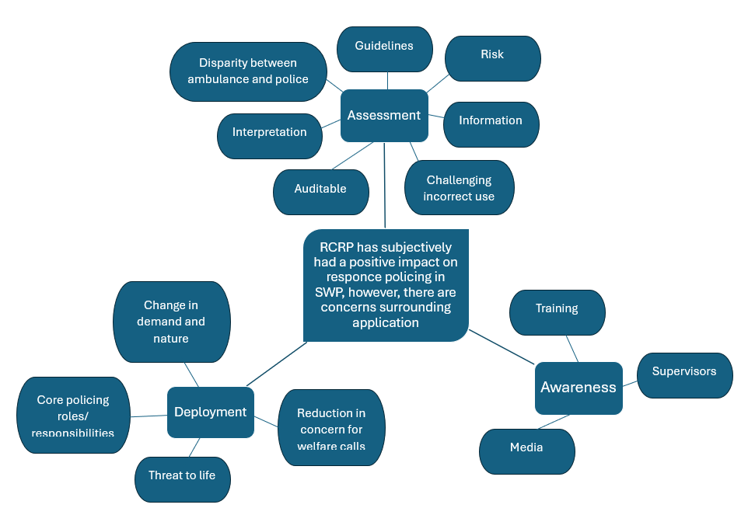
- Awareness
Figure 2. Thematic analysis portrayed on a spider diagram

For this chapter, data from the statistical analysis will be presented, and the three themes will then be discussed sequentially.

4.1. Descriptive statistics and cross-tabulations
A survey was completed by 27 officers working in response policing for SWP. The questionnaire contained 21 questions, which included 14 multiple-choice questions with the possibility of answering ‘yes’, ‘no’, ‘maybe’, and seven optional open-ended questions for respondents to provide further detail to their answers (see appendix A). However, of particular note is the respondents’ demographic, with 82% being constables and 81.5% working in Cardiff and the Vale, as shown in Table 1 below.

Table 1. Respondent demographics
Measure | Value | N | %
 | Constable | 23 | 85.2%
Rank | Sergeant | 1 | 3.7%
 | Inspector | 3 | 11.1%
 | 0-3 years | 14 | 51.9%
Length of service | 4-6 years | 4 | 14.8%
 | 7-9 years | 2 | 7.4%
 | 10+ years | 7 | 25.9%
 | 18-24 | 6 | 22.2%
Age | 25-30 | 12 | 44.4%
 | 35-44 | 6 | 22.2%
 | 45-54 | 3 | 11.1%
 | Cardiff and the Vale | 22 | 81.5%
BCU/location worked | Mid Glamorgan | 1 | 3.7%
 | Swansea, Neath, Port Talbot | 4 | 14.8%

Nevertheless, while this skews the data towards a particular rank and location, the survey still provided valuable insights into the impact of RCRP within SWP with a reasonable distribution of age and length of service.
Significantly, results showed that 88.9% of respondents thought that the introduction of RCRP was beneficial to response policing, as shown in Figure 3.
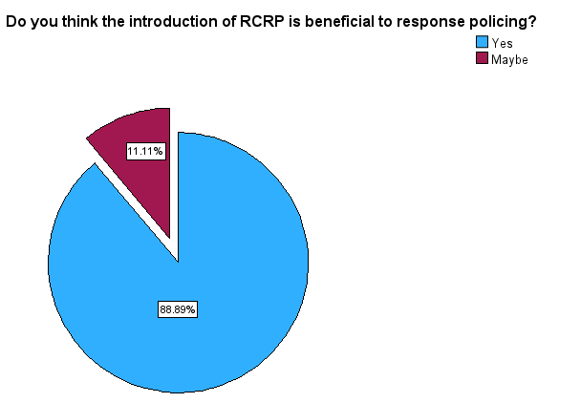

Figure 3. Pie chart showing results of Q.8 of the survey

However, 37% of respondents stated that they had concerns surrounding the implementation of RCRP, 48.1% stated that they did not have concerns, and a further 14.8% of respondents were unsure. A chi-squared test was conducted to explore the relationship between those who were concerned about the implementation of RCRP and the demographic categories set out in Table 1. Field (2018) states that to gain insight into associations between categorical variables a Pearson’s chi-squared test can be used, which produces a p-value of < 0.05 if it has a statistical significance. The chi-squared test showed that the p-values were .863 for length of service, and .365 for age which suggests that there is no significant correlation between the demographic categories and the rate of concern (Field, 2018). However, it is important to note that due to the small sample size, there were cells with significant proportions of the expected counts below 5, shown in Table 2., which reduces the accuracy of the test (Field, 2018). Due to this Fisher’s exact test was utilised also, which allows for a smaller sample size (Hess & Hess, 2017) which also concluded that there was no statistical significance amongst the demographic groups and concerns surrounding RCRP.
Table 2. Cross-tabulations: Concerns surrounding the implementation of RCRP*Length of service/Age


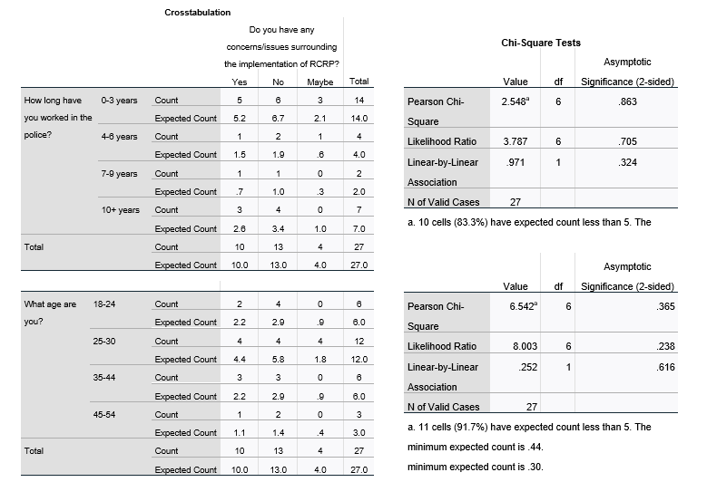

Furthermore, findings from the survey also show that 63% of respondents thought that RCRP had alleviated pressure/demand on their ability to investigate crime, and 55% of respondents stated that they noticed a difference in the type of safety and welfare calls that they were attending as shown below in figure 4.

Figure 4. Cluster bar chart showing perceived demand and type of calls post RCRP introduction
Of note within the findings were that 18.5% of respondents thought that RCRP was not being used correctly, and 29.6% were unsure whether it was being utilised correctly. No statistical significance was found between the demographic categories and the perceived correct utilisation of RCRP. However, the perceived concerns were outlined in the open-ended questions discussed in the following sub-sections.

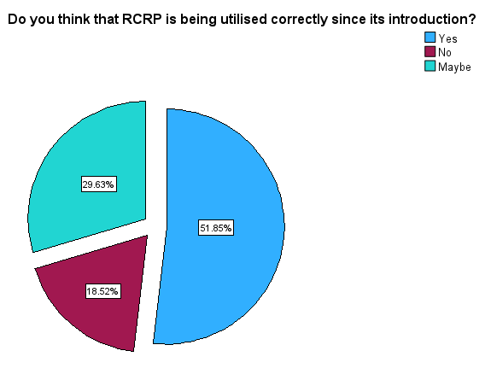
Figure 5. Pie chart showing results of Q.16 of the survey.

4.2 Assessment
Of the three themes that emerged from the qualitative data, the utilisation and assessment of what met the threshold for RCRP was of concern to officers. Officers felt that certain safety and welfare calls were not being managed and challenged correctly at source, with an officer stating:
“Call takers are still taking health calls and passing it on to us to challenge”.
Officers also raised concerns surrounding risk acceptance, with an officer stating that:
“Although policy will be in place stating that primacy for certain calls will lay with other agencies, the risk adverse nature of policing will overrule policy”.
However, other officers felt that with the initiative being in its infancy, overall call takers were doing a good job of assessing calls. Nevertheless, officers felt that improvements could be made with certain adaptions, allowing for stronger supervisory oversight and the ability to challenge and reallocate calls back to the correct agency.

4.3 Deployment
Deployment was another core theme that emerged from the textual data. Predominately, this involved concerns surrounding partner agencies, however, it also highlighted the positive aspects that have been perceived by officers, such as a reduction in health-related calls, allowing them more time to focus on core policing responsibilities. However, it should be noted that this was a contentious topic that split opinions amongst respondents. In regards to partner agencies, some officers felt that due to the inability of ambulance services to answer health calls, police were taking ownership of the calls against the principles of RCRP, with an officer stating:
“Often when it is accepted that RCRP would not be police in a particular incident, police are still asked to attend due to a shortage of paramedics/ambulances”.
However, it was noted by some respondents that there had been a significant drop in the amount of safety and welfare calls that they have attended since the introduction of RCRP, with officers stating that the majority of safety and welfare calls now involved an immediate threat to life. Furthermore, of particular note was that nearly all officers agreed that, in principle, RCRP benefitted response policing due to the reduction in demand and ability to focus on responding to and investigating crime, with an officer stating:
“The percentage of [safety/welfare] incidents not resourced is very high and equates to around 30 full-time police officers since [RCRPs] implementation, this will only increase as each phase is introduced”.

4.4 Awareness
The third and final theme that emerged from the data was awareness, with 100% of respondents being aware of what RCRP was. The majority of respondents stated that they learnt about RCRP through a mixture of training, emails, and notices on the intranet.

4.5 Conclusion
This chapter has presented and highlighted the key findings produced from the survey data. It has produced both qualitative and quantitative data. Significantly, it was found that 88.9% of respondents believed RCRP is beneficial, and 63% believed that it has alleviated pressure/demand on response policing. The chapter has also discussed the qualitative data produced, with awareness, assessment, and demand emerging from the thematic analysis conducted. This highlighted the concerns of respondents, such as the correct utilisation of RCRP by assessing and challenging initial calls at source and the ability of partner agencies to respond effectively, however, also highlighted the change to demand and the type of safety and welfare calls that were attended.

Chapter 5. Findings and Conclusion
The overall aim of this research project was to conduct an exploratory study into the impact that RCRP has had on response policing in SWP and, more specifically, answer the following questions:
- Do officers in SWP feel that RCRP is being utilised correctly?
- Has the introduction of RCRP alleviated pressure on response officers’ capacity and time to investigate crime effectively?
This chapter will endeavour to answer these questions by summarising the study’s key findings and referring back to the literature review to understand the contextual background of the topic.

5.1 Do officers in SWP feel that RCRP is being utilised correctly?
The literature review suggested that prior to the implementation of RCRP, there had been no clear definition of what roles different emergency services had in response to people experiencing mental health crises, and due to a number of factors, including austerity, the ability of the NHS to tackle the issue deteriorated leading to an expansion in the police’s responsibility (Marsden, et al., 2020). With the introduction of RCRP, police should only respond to mental health crises when it is related to crime, or there is a real immediate risk of serious injury or death (Home Office & Department of Health and Social Care, 2024).

When officers from SWP were asked whether they thought RCRP was being utilised correctly, 51.9% of survey respondents stated that they felt it was, 18.5% stated that they felt it was not, and 29.6% were unsure. The qualitative data provided some insight into understanding these responses, with officers raising concerns surrounding the assessment of incidents at source. Some officers felt that initial call takers were taking mental health calls without real immediate risk to life and passing it to them to challenge. Furthermore, officers expressed concerns surrounding the ability of other services, such as ambulances in certain incidents, to respond due to shortages in the services, which resulted in police being deployed. It was also noted that the issue of other services not responding is potentially exacerbated by risk tolerance levels within the police despite clear guidelines of roles following RCRPs introduction, with an officer expressing concerns that a risk-averse approach by police would eventually overrule policy.

5.2 Has the introduction of RCRP alleviated pressure on response officers’ capacity and time to investigate crime effectively?
The literature review suggested that other services became dependent on the police to deal with the initial response in mental health emergencies due to austerity within the NHS and lack of funding for mental health services in combination with the deinstitutionalisation of mental health and an increase in community-based care (Marsden, et al., 2020; Mclean & Marshall, 2010). The review suggested that this overreliance on police became a barrier to police productivity, with time spent responding to mental ill health calls, locating people who have absconded from healthcare facilities, and waiting with people detained under S136 of the Mental Health Act 1983, cited as the main issues (Home Office, 2024).
88.9% of survey respondents stated that they thought the introduction of RCRP was beneficial to response policing, with no respondents outright disagreeing, with the introduction in principle reducing the amount of safety and welfare calls officers need to respond to, however, as stated earlier, concerns persisted with the perceived effectiveness of assessment and issues surrounding deployment, such as partner agency resources. Furthermore, 63% of respondents stated that they felt that RCRP had alleviated pressure and demand, with a notable 55% of respondents stating that they had noticed a difference in the type of safety and welfare calls that they were attending.

5.3 What impact has RCRP had on response policing in SWP?
The findings of this study suggest that the introduction of RCRP has had a notable impact on response policing in SWP and that overall, officers feel that it is beneficial and that it has alleviated pressure and demand on response policing, however, survey responses were not as clear regarding the correct utilisation of RCRP. From examining the textual data, the main concerns around utilisation involved how calls were assessed and partner agencies’ ability to resource incidents. As stated in the methods chapter, this research is based on the subjective experiences of officers, and of note the survey respondents primarily worked in the region of Cardiff and the Vale, and therefore the findings cannot be applied universally. However, while the findings are not universal, they provide valuable insight into the experiences of those affected by the initiative, in particular at the early stages of implementation.

5.4 Limitations
While this dissertation is an exploratory study and seeks to understand the opinions of police officers within SWP, it does not provide an objective review of the impact of RCRP on SWP. The survey participants’ responses are inevitably based on subjective opinions routed in their personal experience, which does not account for the actual differentiation between the types and amount of public safety and welfare incidents officers have been responding to since the introduction of RCRP. Furthermore, due to the nature of RCRP, the actual effects it has on what incidents police are responding to may not be seen by response police due to the initial calls being closed at source by the Public Service Centre before being created as an incident for officers to attend.

5.5 Future research
Due to the demographic and sample size, the research topic would benefit from future research incorporating larger sample sizes across different force areas of England and Wales in order to gain a universal understanding of the impact of RCRP. Furthermore, this dissertation is a cross-sectional study, and further insights could be gained from conducting a longitudinal study to understand whether the experiences of officers change over time as RCRP becomes embedded in operational policies. Finally, as stated earlier, this dissertation aimed to understand the impact of RCRP on response officers in SWP and utilised a survey to gain insight into officers’ subjective experiences. Therefore, this research could be advanced by reviewing data held by SWP on safety, and welfare calls pre and post-RCRP to understand whether the actual reduction in police deployments to safety and welfare calls differs from the subjective experience of officers and provides a more objective understanding of the topic.

5.6 Conclusion
This dissertation has successfully addressed the aims and objectives of this research project. It has provided a snapshot into the impact that RCRP has had on response policing in South Wales Police by exploring the experiences of response police officers. This chapter has outlined how each of the questions has been answered by summarising the findings into subheadings containing the research questions. Furthermore, this chapter has highlighted the research limitations and, through doing so, has provided recommendations for future research into the topic.

References
Brace, I. (2008) Questionnaire design: how to plan, structure and write survey material for effective market research. 2nd edn. London: Kogan Page Ltd.
Calder, J. (1998) ‘Survey research methods’, Medical Education, 32, pp. 636-652.
Clarke, V. & Braun, V. (2017) ‘Thematic analysis’, The journal of positive psychology, 12(3), p. 297–298. Available at: https://doi.org/10.1080/17439760.2016.1262613.
College of Policing (2020) Competency and Values Framework for policing.
Available at: https://assets.college.police.uk/s3fs-public/2020-11/competency-and-values-framework-for-policing_4.11.16.pdf [Accessed 20 02 2023].
Department of Health and Concordat signatories (2014) Mental Health Crisis Care Concordat – Improving outcomes for people. Available at: https://assets.publishing.service.gov.uk/government/uploads/system/uploads/attachment_data/file/281242/36353_Mental_Health_Crisis_accessible.pdf [Accessed 24 09 2024].
Field, A. (2018) Discovering Statistics Using IBM SPSS Statistics. 5th edn. London: Sage
Fielding, N. & Thomas, H. (2016) ‘Qualitative Interviewing’, in: N. Gilbert and P. Stoneman, (eds.) Researching in Social Life. London: Sage, pp. 282-300.
Home Office (2024) Research and analysis - Right Care, Right Person.
Available at: https://www.gov.uk/government/publications/evaluating-the-implementation-of-right-care-right-person/right-care-right-person#executive-summary
[Accessed 30 03 2025].
Home Office (2024) Independant Report: Policing Productivity Review. Available at: https://www.gov.uk/government/publications/policing-productivity-review/policing-productivity-review-accessible [Accessed 22 08 2024].
Home Office & Department of Health and Social Care (2024) National Partnership Agreement: Right Care, Right Person (RCRP). Available at: https://www.gov.uk/government/publications/national-partnership-agreement-right-care-right-person/national-partnership-agreement-right-care-right-person-rcrp [Accessed 22 08 2024]
Hess, A. & Hess, J. (2017) ‘Understanding tests of the association of categorical variables: the Pearson chi‐square test and Fisher’s exact test’, Transfusion, 57(4), pp. 877-879.
IBM SPSS (2024) IBM SPSS software. Available at: https://www.ibm.com/spss
[Accessed 13 11 2024].
Johnson, S. et al. (2005) ‘Outcomes of crises before and after the introduction of a crisis resolution team’, British Journal of Psychiatry, 187(1), pp. pp, 68-75.
Kane, E., Cattell, J. & Wire, J. (2021) ‘Mental health-related police incidents: Results of a national census exercise in England and Wales’, Criminal behaviour and mental health, 31(4), pp. 262-274.
Lloyd-Evans, B. et al. (2020) ‘The CORE service improvement programme for mental health crisis resolution teams: results from a cluster-randomised trial’, The British Journal of Psychiatry, 216(6), p. pp. 314–322.
Madill, A. Jordan A., and Shirley, C. (2000) ‘Objectivity and reliability in qualitative analysis: Realist, contextualist and radical constructionist epistemologies. The British Journal of Psychology, 91(1), pp. 1-20.
Marsden, M., Nigam , J., Lemetyinen, H. & Edge, D. (2020) ‘Investigating police officers’ perceptions of their role in pathways to mental healthcare’, Health and Social Care in the Community., 28(3), p. 913–921.
Mclean, N. & Marshall, L. (2010) ‘A front line police perspective of mental health issues and services’, Criminal behaviour and mental health, 20(1), pp. 62-71.
McManus, S., Bebbington, P., Jenkins, R. & Brugha, T. (2016) Mental Health and Well-being in England: Adult Psychiatric Morbidity Survey 2014. Available at: https://assets.publishing.service.gov.uk/media/5a802e2fe5274a2e8ab4ea71/apms-2014-full-rpt.pdf
[Accessed 28 09 2024].
Mental Health Act (1983) Available at: https://www.legislation.gov.uk/ukpga/1983/20/section/136
[Accessed 24 09 2024].
Mental Health Foundation (2016) Fundamental facts about mental health. Available at: https://research-ebsco-com.ezproxy.uwtsd.ac.uk/c/onvpsy/viewer/pdf/7uw6i4nok5?route=details
[Accessed 28 09 2024].
Mental Health Innovations (2024) About Shout. Available at: https://giveusashout.org/about-us/about-shout/ [Accessed 28 10 2024].
Mental Health Innovations (2024) Safeguarding at Shout: information for children and young people.
Available at: https://giveusashout.org/about-us/safeguarding-children-and-young-people/
[Accessed 28 10 2024].
Microsoft (2024) Welcome to Microsoft Forms. Available at: https://support.microsoft.com/en-us/office/welcome-to-microsoft-forms-29cfe2e6-2f6e-4175-b88b-8fa82be33071
[Accessed 14 11 2024].
Millner H.R. (2007) ‘Race, Culture, and Researcher Positionality: Working Through Dangers Seen, Unseen, and Unforeseen’, Educational Researcher, 36(7), pp. 388-400.
Murphy, S.M. et al. (2015) ‘Crisis intervention for people with severe mental illnesses’, Cochrane database of systematic reviews, 2015(12), p. CD001087. Available at: https://doi.org/10.1002/14651858.CD001087.pub5.
NHS England (2024) Mental Health Services Monthly Statistics Dashboard. Available at: https://app.powerbi.com/view?r=eyJrIjoiOTdjYzFiYTUtZmEwMi00ZTA2LTkxOGUtMDZmMmZjMThiZGNhIiwidCI6IjM3YzM1NGIyLTg1YjAtNDdmNS1iMjIyLTA3YjQ4ZDc3NGVlMyJ9
[Accessed 22 08 2024].
NHS Wales (2024) Crisis Resolution and Home Treatment Teams (CRHT Teams). Available at: https://cavuhb.nhs.wales/our-services/mental-health/our-services1/crisis-resolution-and-home-treatment-teams-crht-teams/ [Accessed 27 10 2024].
NHS (2019) NHS Long Term Plan. Available at: https://www.longtermplan.nhs.uk/wp-content/uploads/2019/08/nhs-long-term-plan-version-1.2.pdf [Accessed 26 09 2024].
NHS (2023) Where to get urgent help for mental health. Available at: https://www.nhs.uk/nhs-services/mental-health-services/where-to-get-urgent-help-for-mental-health/ [Accessed 28 10 2024].
NHS (2024) Crisis and acute mental health services. Available at: https://www.england.nhs.uk/mental-health/adults/crisis-and-acute-care/ [Accessed 24 09 2024].
Odejimi, O., Bagchi, D. & Tadros, G. (2020) ‘Typology of psychiatric emergency services in the United Kingdom: a narrative literature review’, BMC Psychiatry, 20(1). Available at: https://doi.org/10.1186/s12888-020-02983-5.
Office for National Statistics (ONS) (2024) National population projections: 2021-based interim.
Available at: https://www.ons.gov.uk/peoplepopulationandcommunity/populationandmigration/populationprojections/bulletins/nationalpopulationprojections/2021basedinterim [Accessed 07 09 2024].
Patton, M. (2015) Qualitative research and evaluation methods. 4th edn. Los Angeles: Sage.
Portmore, D. (2020) The Oxford handbook of consequentialism. New York: Oxford University Press.
Rodgers, M. et al. (2019) ‘Police-related triage interventions for mental health-related incidents: a rapid evidence synthesis’, Health Services and Delivery Research, 7(20), p. DOI 10.3310/hsdr07200.
Samaritans, 2024. What we do. Available at: https://www.samaritans.org/about-samaritans/our-organisation/what-we-do/ [Accessed 28 10 2024].
Stoneman, P. & Brunton-Smith, I. (2016) ‘Quantitative Research’, in: N. Gilbert and P. Stoneman, (eds.) Researching Social Life. London: Sage, pp. 80-94.
Sturgis, P. (2016) ‘Designing and Collecting Survey Samples’, in: N. Gilbert and P. Stoneman, (eds.) Researching Social Life. London: Sage, pp. 226-238.
UK Parliament (2023) Urgent answers needed on funding for ‘Right Care, Right Person’ mental health strategy. Available at: https://committees.parliament.uk/committee/81/health-and-social-care-committee/news/198473/urgent-answers-needed-on-funding-for-right-care-right-person-mental-health-strategy/ [Accessed 11 13 2024].
University of Wales Trinity Saint David (2022) Research Ethics & Integrity.
Available at: https://www.uwtsd.ac.uk/research/research-integrity-and-ethics
[Accessed 14 11 2024].
Wheeler, C. et al. (2015) ‘Implementation of the Crisis Resolution Team model in adult mental health settings: a systematic review’, BMC Psychiatry, 15(74). Available at: https://doi.org/10.1186/s12888-015-0441-x.

Appendix A


