


Industry 4.0 Technology Deployment Report

Rikki Thomas – P151969
Introduction to Industry 4.0
Graham Howe
03/03/2020
MSc International Innovation Management MSc Industry 4.0 Advanced Manufacturing

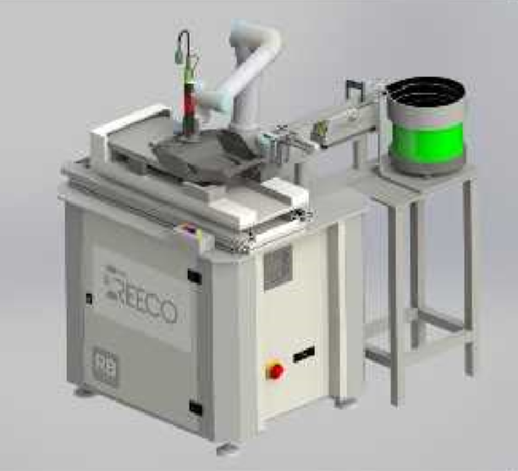

I Table of Contents

I Table of Contents 1
1.0 Introduction 2
2.0 Challenges Associated with introducing a Cobot 3
3.0 Introduction plan requirements 4
4.0 Potential costs and economic benefits 6
5.0 References 8

1.0 Introduction

Cyden Ltd designs and manufactures IPL (intense pulsed light) hair removal products for use within the home. The company has deep routed experience in IPL’s having produced Salon grade technologies for many years. Cyden was the first company in the UK to produce an IPL and now distributes to over 11 international markets. Its main headquarters is situated in Swansea, S.Wales and employs over 150 employees, split between its R&D department and production facility. At present, the production facility houses 3 assembly lines each producing and testing an individual model of IPL; however, each is very distinct in the way it is designed and the technology that it utilises.
The first line that was implemented, has all the technological architecture of a modern continuous production line, belt driven conveyors that transfer platens through the operations, combined with radio-frequency identification (RFID) tags that stores digital data that enable the tracking of the parts throughout the process. It has both manual assembly operations, programmable logic controller (PLC) controlled test and calibration machines and soldering robots. This line at present produces 9000 parts per week, which is set to increase to 15,000 and possibly further as the demand for such an innovative household item grows.
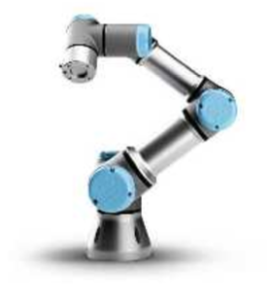
To accomplish such an increase in demand on a line that was only designed to produce 12,000 parts per week, will require some major improvements in Takt time of some operations but also a possible introduction of a collaborative robot (Cobot), figure 1. The Cobot would be an investment asset, that would need to show a return on investment (ROI) within 12-18 months, to be considered a feasible addition to the production line.
Figure 1: Universal collaborative Robot (Universal Robots, 2020)

2.0 Challenges Associated with introducing a Cobot

There are many challenges to introducing a Cobot within an existing production line, some obvious, such as space availability, the negative introduction of technology that will displace a person and ensuring a ROI is achievable to warrant its implementation. Space within Cyden is very limited, its production lines are very compact with minimal working area between operations, thus the cobot would need facilitate its operations in close proximity to humans. This, as suggested by (Calitz, Poisat, & Cullen, 2017) is the main function of a cobot, however it can limit the speed of its functionality and possibly negate its usefulness as part of a highly critical Takt time line? The writings of (Peterson, 2020) highlight the high percentage of cobot installations have additional safety controls, such as light curtains, that when activated cause the cobot to slow to a reduced movement rate, to ensure the wellbeing of its human counterparts that are working in close proximity. To ensure the cobots viability for such an operation, extensive trials will need to be carried out, to determine the optimum speed the cobot can effectively perform the operation, whilst adhering to the safety specifications of working in close proximity to humans and if this achieves the lines desired Takt time to deliver the increased demand.
Unfortunately, with some innovations centred around Industry 4.0 and autonomous production lines then human replacement is going to be a reality. The emphasis, as explained by (Lorenz, 2015) for managers and champions of such technological implementations, could be the upskilling and training of employees that will be required to service and maintain them or the software engineers that can integrate maintenance protocols within a virtual reality (VR) head piece so anyone could conduct the maintenance. As with the cobot, it will displace human workers, in this instance as many as three employees, however, extra maintenance may be required to ensure their continuous reliability, the VR option could be in the future. Furthermore, the ROI that is achievable, could be reinvested through new innovation projects that could create further job vacancies in the future, thus replenishing the lost jobs.
Some less obvious challenges to the introduction of a cobot could be, how to truly understand the actual performance of the cobot. The hype that surrounds new innovation as explained by (Rogers, 2019) can often create disillusion for potential users when the performance is far lower than anticipated or promised. Cobots are still relatively new and their robustness has yet to be tested for longevity and failure rates, thus creating scepticism with possible shareholders.
According to (Cleland & Ireland, 2001)a project can stall or fail if an organisation does not invest heavily in one person, a sponsor with sufficient authority to ensure it success. There should also be a; champion who is the problem solver, sales person and diplomat of the innovation; project manager who directs administration protocols: and the integrator who prioritises events through communication skills. Unfortunately, with small companies, such as Cyden, all of these rolls will be amalgamated into one role, and the sponsor is yet to be convinced by the innovation.
A major challenge for any company in selecting and introducing a new innovation, such as the cobot, is to ensure it is the correct technology for the process. The desired process that the cobot has been looked at is for screw assembly of four screws to secure a top plastic moulding to the bottom. There are other possibly more feasible options, such as screw delivery and electric torque tools that when assembled within a machine could facilitate the same operation and are a tried and tested operation.
All these challenges and considerations would form the basis of selecting the correct technological innovation and play a major part in the introduction plan.

3.0 Introduction plan requirements

Define the Objective
To introduce a cost-effective innovation delivering a ROI within 12 months, that runs at less than 21 second Takt time to ensure 15,000 units per week can be achieved, working at 85% yield.
Allocate Resources
Assigning effective roles within the implementation team and importantly the correct leader could ensure control over the process, coupled with all the relevant data, time management information and funding requirements can all help execute a successful introduction plan, delivering the project in on time and cost (Sanchez, Micaelli, Bonjour, & Monticolo, 2019).
Schedule Milestones
An action plan with attached Gantt chart is to be created to focus on incremental steps that lead to the end goal, basic elements will include:
- 20 weeks delivery of Cobot
- Schedule progression day visits to supplier including final sign off before delivery
- 2 weeks preparation of line for Cobot
- 3 weeks overtime to stockpile units to help with contingency time
- 1 week installation
- 1 week commission/training
- 1 week sign off
Define any Security and Privacy considerations
Ensure all privacy and security protocols are discussed and agreed upon between the customer, Cyden Limited and the supplier and that all relevant documentation and signatories are satisfied.
Documentation/software
Ensure all relevant documentation and software including, OEM electrical/pneumatic/layout/parts drawings, program backups, maintenance protocols, sign off check list and warranty paperwork are present and correct.
Define Metrics for Success
Both quantitative data; through extrapolation of the cobots throughput, overall equipment effectiveness (OEE) and mean time between failures (MTBF) which are key performance indicators (KPI) that should indicate the success of the Cobot introduction. Additionally, qualitative data such as a questionnaire, could add some correlation between the numerical data and the discernments of the personnel who have to work with it (Dragan, Zorica, & Milos, 2014).

4.0 Potential costs and economic benefits

Project Costings
Figure 2, shows the supplier itemised costings for the project totalling £55,400.00 (Glover, 2020). There are additional costings that will be associated with the project including:
- Line balancing other operations to accommodate the Cobot (weekend overtime rates for engineers/technicians)
- Production weekend overtime for manager, maintenance and operators for stockpiling
- Supplier progression visitation and sign off for delivery
- Additional electrical running costs of the cobot (utilities cost)
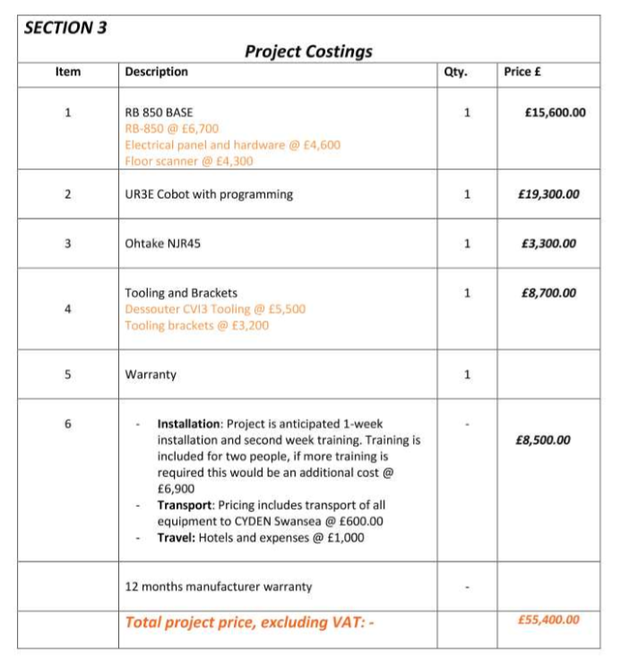
Figure 2: Project Costings (Glover, 2020)

Return on Investment (ROI)
The company’s directive on any new technological innovation is that it must deliver a ROI within 12 months. The Cobot will replace three operators, one per shift at a cost of £35,000 each, equalling £105,000 saving per year (Cyden, 2020). The cobot and associated costs are approximately £70,000, plus a 10 percent contingency would total £77,000. Thus, the ROI would be approximately £28,000 in the first 12 months and a feasible option for implementation.
Economic benefits
The introduction of the Cobot would require existing staff to be trained to maintain and recover over its lifetime, and possibly create the need for additional skilled workers. Furthermore, if the cobot delivers on its projected statistics it could help the lines productivity and throughput, thus satisfying customer demand and delivering more profit for the company. If the company secures additional work from its increasing reputation as a supplier that could create additional jobs, therefore creating an economic benefit. However, if the cobot’s success proves to be an excellent investment, the procurement of additional cobot’s could be harmful to the economy as jobs could be lost.

5.0 References

Calitz, A. P., Poisat, P., & Cullen, M. (2017). The future African workplace: The use of collaborative robots in manufacturing. SA Journal of Human Resource Management, 1-11.
Cleland, D. I., & Ireland, L. R. (2001). Project Management: Strategic Design and Implmentation. New York: McGraw-Hill Trade.
Cyden Ltd (2020) Finance department
Dragan, V., Zorica, T., & Milos, D. (2014). Towards an extended set of production line performance indicators. Total Quality Management & Business Excellence, Vol. 25 Issue 5/6, p618-634.
Glover, N. (2020, February 5). Offer Document from Reeco Automation Solutions. Cobot Screwfixing Application. Newtown, South Wales.
Lorenz, M. (2015, September 4). Industry 4.0:how intelligent machines will transform everything we know . Retrieved from youtube: https://www.youtube.com/watch?v=uBZmJOHIN8E
Peterson, D. (2020, February 29). Safety Requirements for Cobots. Retrieved from Control Automation: https://control.com/technical-articles/safety-requirements-for-collaborative-robots/
Rogers, D. (2019, Feb 19). Why hype technology is killing innovation. Retrieved from Medium: https://medium.com/@daverog/why-hype-technology-is-killing-innovation-84151c62a18b
Sanchez, F., Micaelli, J.-P., Bonjour, E., & Monticolo, D. (2019). A Step for Improving THE TRANSITION BETWEEN TRADITIONAL PROJECT MANAGEMENT TO AGILE PROJECT MANAGEMENT, Using a Project Management Maturity Model. Journal of Modern Project Management, Vol. 7 Issue 1, p102-119.
Universal robots. (2020). https://www.universal-robots.com/

