Sabrina Malek

Comparison of Ingress and Pokémon Go

Contents
1.0 Introduction 2
1.1 What is Ingress and Pokémon Go 2
1.1.1 Similarities of Ingress and Pokemon Go 2
1.1.2 Differences of Ingress and Pokemon Go. 2
2.0 Target user groups 4
2.1 Ingress 4
2.2 Pokemon Go 4
3.0 User Experience Ingredients in Ingress and Pokemon Go 5
3.1 Psychology 5
3.2 Usability 6
3.3 Design 8
3.4 Copywriting 10
4.0 Impact of Ingress and Pokémon Go 11
Reference 12

1.0 Introduction

What is Ingress and Pokémon Go

Niantic, a software development company, is known of developing two famous augmented reality games, Ingress and Pokémon Go. Ingress is a real world, location-based mobile game that was released on 2013. It uses the GPS to locate the user in the real world, letting the user to be able to see the location of portals. Ingress’ main goal is to capture portals. The portals are usually at real-life “point of interest” or significant places, such as historical buildings, monuments, or bridges. Pokémon Go is also an augmented reality game, where users need to go around searching for Pokemons using Poke Balls in real world. It was released on 2016 by Niantic, 3 years after the release of Ingress. Pokémon Go was trending worldwide when it first released, creating a huge wave with around 60 million players. It has reached 800 million downloads in May 2018 [1]. Ingress and Pokémon Go has several similarities and differences.

Similarities of Ingress and Pokémon Go

Ingress and Pokémon Go both uses GPS for augmented reality for users to be able to locate, capture, and battle in real world. Portals and Pokestops are located at interesting places, where users can collect resonators or Pokeballs. Both games require claiming a Gym or Portal for the user’s team. The two games share the same core play approach, but then carry quite a bit in theme and execution. Ingress has two factions battling for control of nodes and then linking them together to create control fields, while Pokémon Go lets its three player squads fight over control of nearby Pokémon gyms in the world.

Differences of Ingress and Pokémon Go.

Ingress | Pokémon Go
Players have to work in a large team, the Resistance and Enlightened since the beginning. | Players starts off as individual, eventually will be given a choice to pick their team.
Ingress has a more complicated interface. | Pokémon Go’s interface is simpler.
The goal of the game was not clear during the beginner’s level. | The tutorial given at the beginning of the game is sufficient. However, as the user begins to level up, the goal of the game becomes more complex.

2.0 Target user groups

2.1 Ingress

Ingress initially targets Android users, because it was first released on Android. However, 6 months later, they released the game for iOS. Young adults aged 21 to 30, teenagers mostly spend their time on gadgets, which makes them the target user group for Ingress [2]. Ingress’ interface is dark, clearly not targeting children as they are more prone towards bright colours.

2.2 Pokémon Go

Pokémon was popular in the 90s, creating a huge phenomenon among video game players. It was the second best-selling video game franchise with over 300 million copies sold [3]. They target children, teenagers, and young adults as their users. Children are more likely to be interested in playing Pokémon Go because of the bright and simple interface. The goal of the game is easy to be understood, and is not complex. The language used in the application is appropriate and suitable for kids. Pokemon-based storyline strongly encourages original Pokémon players to download the game. Therefore, original Pokémon players are one of the target user groups for Pokémon Go. Young adults now are the pioneer of the original Pokémon game as it was released when they were a child.

3.0 User Experience Ingredients in Ingress and Pokémon Go

3.1 Psychology

Both games encourage users to be active in the real world, where going out is required. Ingress requires players to walk around to find and hack portals and collect exotic matter while Pokémon Go requires players to move around to find and catch Pokemons and find PokeStops as well as Gyms. This can be dangerous if a user physically moves in his/her physical environment without being able to see his/her physical environment. There is a chance that the user may trip, or bump into a physical object (e.g., a rock or chair) [4]. Ingress and Pokémon Go offers various kinds of rewards, especially if they play the game every day. Pokémon Go has a 7-days streak that lets users get 3,500 stardust by catching a single Pokémon. Higher stardust is useful for higher levels to power up high level Pokémons. Both games make users feel satisfied and happy while getting rewarded. Daily usage of the games leads to daily rewards. Users are expected to walk in real life, and location is expected to be shared with the application. This will create a habit where players create a pattern of playing whenever they’re travelling. Being able to catch Pokémons everywhere they go by just throwing Pokeballs increases their motivation. Ingress has a chat feature, which allows players to interact with each other. However, Pokémon Go does not have the same feature, which makes it easier to avoid abuse and it will be safer children.

3.2 Usability

Ingress’ interface is simple but has a lot of features. Pokémon Go, on the other hand, has lesser features. Ingress’ interface makes it harder for users to accomplish a task without clicking a lot of times. A simple task in Pokémon Go does not require users to click more than 3 times. This difference between Ingress and Pokémon Go shows the changes made by Niantic to improve the usability of the game. For Ingress, it takes a lot of time to fully understand the game, while Pokémon Go takes lesser time to understand the game. The storyline of Pokémon Go is simpler, given that Pokémon was an established game back in 2000s. A significant number of players playing Pokémon Go has played Pokémon before [5]. Players tend to trespass while playing both games, which can be prevented by alerting users about it. Pokémon Go has recently updated their application with a warning about trespassing.
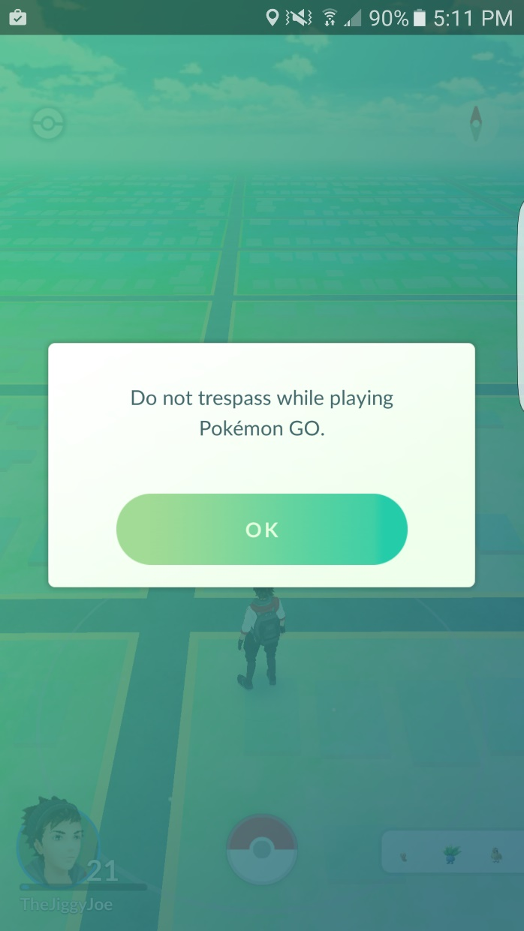
Figure 1.1: Trespassing warning in Pokémon Go
User mistakes can be prevented by providing more in-depth tutorial, especially for Ingress. Ingress provides less information for users to interact with while Pokémon Go’s interactions are clear and direct. Pokémon Go provides good tutorials in the beginning of the game, with instructions on how to catch Pokémon. Trials are given for beginners to practice their throw to catch Pokémon.

3.3 Design

The most noticeable difference between Ingress and Pokémon Go is their design. Ingress’ interface is dark and has a science fiction edge to it, while Pokémon Go has brighter colours, creating simpler interface that attracts younger audience. Pokémon Go’s map looks similar to basic map or navigation interfaces. Thus, it creates trust and interest among users. Ingress, on the other hand, has a more complicated map. The colour contradiction of black and neon makes the interface looks more complex. Powerful particle called Exotic Matter (XM) will appear on the map, creating neon particles on it. Usually, around 100 XMs will appear when users open the navigation. The figure below shows the difference between Ingress and Pokémon Go’s interfaces.

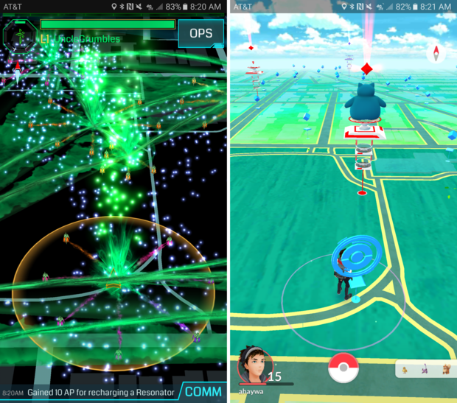
Figure 1.2: Ingress and Pokémon Go’s interfaces.
Ingress shows the user’s level and username at the top left corner of the application. Other information such as current points and XM Bar, which shows how much energy the user has left the game, are also situated around the same area. On the bottom right of the application, the users can find a feature called “COMM” where users can interact with each other in the chat box. These features are important; therefore, they must stand out in order to help users find what they want. In Ingress, the important features have different colour outline and shape. It helps to improve the usability of these features. Pokémon Go has less clickable features due to its simple interface. All clickable features are located at the bottom of the application. On the left, users can check their profile and their level.

3.4 Copywriting

Ingress provides a tutorial in beginner’s level. However, the information given is not sufficient to understand how the game works. The tutorial provided explains the plot of the game, and basic feature such as collecting XM. Other features such as the Inventory, Store, Agent, Intel and Missions are not explained in the beginner’s level. Ingress begins by dividing the users in different factions, the Enlightened or the Resistance. Without the instructions, the purpose and functions would be unclear. Pokémon is a well-known franchise, fans would be able to catch the story behind the game. However, if there are users who have never heard of Pokémon, they will also be able to comprehend the function of the application as there are pop up messages to guide users in the beginning of the game.

4.0 Impact of Ingress and Pokémon Go

Ingress was established in 2013, being the first augmented-reality mobile game developed. The mobile application has been downloaded more than 20 million times worldwide in 2018 [6]. Pokémon Go was launched in 2016, and has 147 million monthly active users as of 2018 [7]. Now, the game has grossed over $4 billion worldwide. Healthcare professionals have praised the games for encouraging physical activity and potentially increasing life expectancy, if long-term engagement can be sustained [8]. Emotional wellness benefits of playing Pokémon Go may follow the positive emotions and sense of achievement caused by playing while the physical benefits of playing may heighten one’s self-esteem. Through playing Ingress and Pokémon Go, the players in the same geographical areas are most likely to run into each other. This gives the places a chance to interact and build relationships. Social interaction is also rewarded within the game, as players can form teams and are able to coorperate.

References

- A. Dogtiev, "Pokémon GO Revenue and Usage Statistics (2017) - Business of Apps", Business of Apps, 2018. [Online]. Available: http://www.businessofapps.com/data/pokemon-go-statistics/. [Accessed: 04- Jan- 2019].
- B. Winegarner, "The 2015 Ingress demographic survey – Beth Winegarner – Medium", Medium, 2015. [Online]. Available: https://medium.com/@beth_winegarner/the-2015-ingress-demographic-survey-6e7181790069. [Accessed: 04- Jan- 2019].
- Nintendo Co., Ltd., 2018. [Online]. Available: https://www.nintendo.co.jp/ir/en/finance/software/3ds.html. [Accessed: 05- Jan- 2019].
- M. Ebling and R. Cáceres, "Gaming and Augmented Reality Come to Location-Based Services", IEEE Pervasive Computing, vol. 9, no. 1, pp. 5-6, 2010. Available: 10.1109/mprv.2010.5.
- A. Cunningham, "“Aren’t you a little too old for that?” Two decades of playing Pokémon", Ars Technica, 2019. [Online]. Available: https://arstechnica.com/gaming/2018/09/arent-you-a-little-too-old-for-that-14-years-of-playing-pokemon/. [Accessed: 16- Jan- 2019].
- "Welcome to Ingress Prime - Niantic", Niantic, 2019. [Online]. Available: https://www.nianticlabs.com/blog/ingress-prime/. [Accessed: 18- Jan- 2019].
- "Pokémon Go active player count highest since 2016 summer launch", Eurogamer.net, 2019. [Online]. Available: https://www.eurogamer.net/articles/2018-06-27-pokemon-go-player-count-at-highest-since-2016-summer-launch. [Accessed: 18- Jan- 2019]
- Althoff, T., While, R. W., and Horvitz, E. (2016). Influence of Pokémon Go on Physical Activity: Study and Implications. Journal of Medical Internet Research, 18(12), e315.

