Marketing plan written for
Holiday Inn
Student Name: Jozef Kotlar

Student ID number: 2207347

Marketing Essentials BMIH4005
Lecturer’s name: Chris Wilkin

Contents
Introduction 3
Situation Analysis 4
5 'C's 4
Company: SWOT analysis (Micro analysis) 4
Customers 4
Competitors 5
Collaborators 5
Climate: PESTLE (Macro analysis) 6
Objectives 6
Strategy 6
Tactics 7
Marketing mix 7
Action 8
Gantt chart of marketing activities 8
Control 9
Conclusion 9
References 10
Appendix 12

Introduction
Holiday Inn is a well-known international chain of hotels that offer comfortable and affordable accommodation to travellers. With its distinctive logo and signature green and white colours, Holiday Inn is one of the most recognizable hotel brands in the world. The company was founded in 1952 and has since grown to become one of the largest hotel chains in the world, with thousands of hotels in countries around the globe. The hotel business saw a drop in income during the COVID-19 epidemic and is currently working to get back to where it was financially before the outbreak. In this article, we develop a strategy for marketing the business to potential new clients in the hope that it would bring in more income and return it to pre-pandemic levels.

Situation Analysis

5 'C's

Company: SWOT analysis (Micro analysis)
A SWOT analysis of Holiday Inn would evaluate the hotel chain's Strengths, Weaknesses, Opportunities, and Threats.
Strengths:
Holiday Inn has a strong and established global brand, with hotels in many countries around the world. This provides the hotel with a competitive advantage in terms of recognition and customer loyalty (Rafahat, 2022).
Weaknesses:
Despite its reputation for affordability and quality, Holiday Inn does not have a strong presence in the luxury hotel market. This limits the hotel's ability to capture high-end customers.
Opportunities:
There is a growing demand for affordable and consistent quality hotels in many emerging markets. This presents an opportunity for Holiday Inn to expand its global presence and capture a larger share of the market.
Threats:
Holiday Inn faces intense competition from established hotel chains and emerging brands. To remain competitive, the hotel must continue to innovate and differentiate itself from its competitors (Bagrii, 2022).

Customers
Holiday Inn is a well-established hotel chain that caters to a wide range of customers. Its customer segmentation can be divided into several categories, including business travelers, families, and leisure travelers. For business travelers, the hotel offers convenient locations, high-speed internet, and meeting rooms to meet their needs. For families, the hotel provides child-friendly amenities such as family rooms and on-site recreation facilities. Leisure travelers can enjoy the hotel's restaurant, swimming pool, and proximity to popular tourist attractions (Yap and Alsowaidi, 2022).

Competitors
Porter's Five Forces model is a framework for analyzing the competitive environment of an industry. Here's a brief overview of how it applies to the Holiday Inn hotel chain:
Threat of new entrants: The hotel industry is highly competitive, with many established players, so the threat of new entrants is low.
Bargaining power of suppliers: Holiday Inn relies on suppliers for goods and services such as food, linens, and cleaning supplies, so their bargaining power is moderate (Gede, 2022).
Bargaining power of buyers: Customers have a wide range of hotel options, giving them strong bargaining power.
Threat of substitutes: The threat of substitutes is moderate, as there are many alternative forms of accommodation, such as Airbnb and other budget hotels.
Rivalry among existing competitors: The competition among existing hotel chains is intense, with many established players vying for market share Edo Sudarsana, 2021.

Collaborators
Holiday Inn has several B2B relationships that help the hotel chain run smoothly and efficiently. These relationships include partnerships with travel agencies and online travel booking platforms, as well as collaborations with corporate clients for meeting and event services. The hotel also has relationships with suppliers for goods and services such as food, linens, and cleaning supplies (Inn, 2021). These B2B relationships help the hotel to reach a wider customer base, increase efficiency, and provide a better overall experience for guests.

Climate: PESTLE (Macro analysis)
The PESTLE analysis is a framework for analyzing the macro environment of a business. Here's a brief overview of how it applies to Holiday Inn:
- Political: The hotel industry is impacted by government regulations and policies, such as tourism laws and visa requirements (Pathumporn et al., 2020).
- Economic: The state of the economy can affect consumer spending and the demand for travel.
- Sociocultural: Social and cultural factors such as changing attitudes towards travel and environmental consciousness can impact the hotel industry (George, 2021).
- Technological: The rapid advancement of technology has led to the development of new channels for booking and customer engagement.
- Legal: The hotel industry is subject to various laws and regulations, such as health and safety regulations.
- Environmental: Climate change and environmental concerns can impact the hotel industry, for example through changing weather patterns and increased focus on sustainability (George, 2021).

Objectives
Holiday Inn's 5% profit margin improvement is the SMART objective of the marketing strategy. Inasmuch as the organization has a sizable reputation among consumers, reaching the goal should be rather easy. This objective may be achieved via the use of proper advertising strategies. As a result, increasing Holiday Inn's net income by 5% is a worthwhile goal. Assuming average effort, this goal is reachable in 12 months (Rafahat, 2022).

Strategy
Holiday Inn's overall strategy is focused on providing affordable and comfortable accommodations to a wide range of customers. To achieve this, the hotel chain employs several key strategies, including:
- Brand differentiation: Holiday Inn differentiates itself from its competitors by emphasizing its affordability, comfort, and convenience.
- Expansion: The hotel is actively expanding its presence in new markets, both domestically and internationally, to reach a wider customer base (Stoyanova, 2021).
- Customer experience: Holiday Inn prioritizes the customer experience, offering a range of amenities and services designed to meet the needs of different types of travelers.
By implementing these strategies, Holiday Inn aims to continue providing affordable and comfortable accommodations, while differentiating itself from its competitors and expanding its reach.

Tactics

Marketing mix
The 4 Ps of marketing, also known as the marketing mix, are Product, Price, Place, and Promotion. Here's how these elements apply to the Holiday Inn hotel chain:
Product: The product offered by Holiday Inn is accommodation, which includes a range of room types, from standard rooms to family rooms and suites. The hotel also offers a range of additional services, such as meeting rooms, on-site dining, and recreation facilities, to enhance the customer experience (Windawaty, 2021).
Price: Holiday Inn's pricing strategy is focused on affordability and value for money. The hotel chain offers competitive rates to attract budget-conscious travelers, while also offering promotions and discounts to drive demand.
Place: Holiday Inn has a strong presence in several countries, with hotels located in major cities and tourist destinations. The hotel chain is actively expanding its presence, both domestically and internationally, to reach a wider customer base. The hotel's location and accessibility are key factors in attracting customers (Kurtuluş and KARAYALÇIN, 2020).
Promotion: Holiday Inn uses a variety of promotional channels to reach its target customers, including online advertising, email marketing, and social media. The hotel chain also collaborates with travel agencies and online travel booking platforms to reach a wider audience. In addition, the hotel uses loyalty programs and customer referral schemes to encourage repeat business (Kumar, 2021).
In conclusion, the 4 Ps of marketing are crucial to the success of the Holiday Inn hotel chain. By effectively balancing the elements of the marketing mix, the hotel is able to differentiate itself from its competitors and reach its target customers.

Action
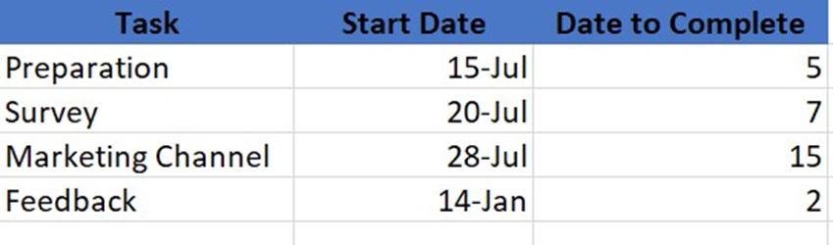
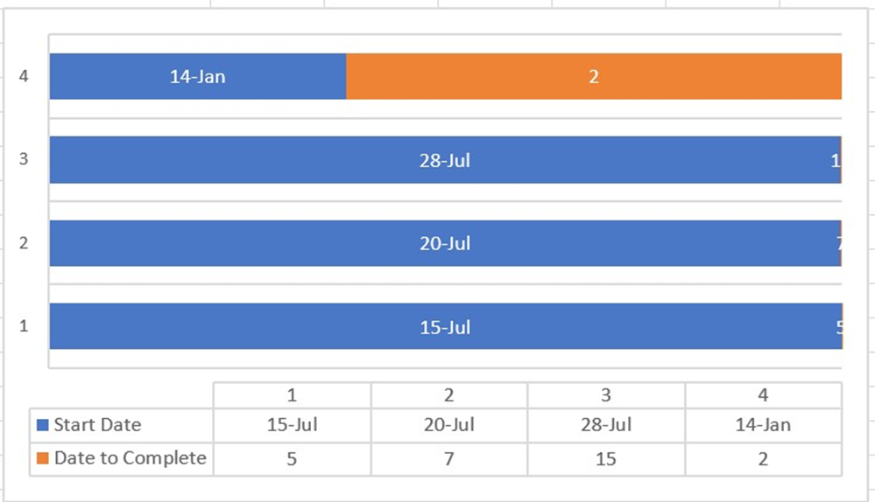

Gantt chart of marketing activities
Holiday Inn's marketing plan requires around 5 days of preparation time. We'll poll our ideal clientele by collecting responses from a variety of sources. Information from potential clients will be collected over the course of 7 days. A marketing strategy will be planned according to the information gathered. The whole process will take 15 days. After that, responses will be obtained. The feedback will be used to make any required adjustments (Paris, 2020).

Control
One way in which the Holiday Inn brand stands out from competitors is via its unique selling proposition (USP). Unlike its competitors, one product may use something called small-batch processing (Gede, 2022). If the company offers a service rather than a physical product, its unique selling proposition (USP) might be that it comes to the customer rather than vice versa. The phrase "unique selling proposition" (USP) is often used interchangeably with "USP."
How to measure
Customers are eager to return for more services; rivals are offering superior options; and both businesses are using similar strategies.

Conclusion
Many of the marketing plan's recommended techniques and methods require significant investment of time and money. Nonetheless, in the long term, they are anticipated to provide income. Holiday Inn should make a short-term investment to assure long-term success, development, and profitability, as well as the loyalty of current and prospective customers. To stay ahead of the competition, the firm must not only put into practice these strategies and techniques for marketing, but also perform frequent market research to learn about the existing and prospective industry trends.

References
Bagrii, K.L., 2022. SWOT Analysis as a Basis for Strategies Designed for the Management of Tourism Development in Ukraine. In Tourism and Rural Space. TARS Journal (pp. 21-36). Academia Română, Filiala Iași Institutul de Cercetări Economice și Sociale „Gheorghe Zane”.
Edo Sudarsana, K., 2021. THE FRONT OFFICE JOB DESCRIPTION AND REQUIREMENTS STAY IN HOLIDAY INN RESORT BARUNA BALI DURING PANDEMIC (Doctoral dissertation, Universitas Pendidikan Ganesha).
Gede, K.A.D., 2022. The Front Office Job Description and Requirement Stay in Holiday Inn Resort Baruna Bali During Covid-19 (Doctoral dissertation, Universitas Pendidikan Ganesha).
Gede, K.A.D., 2022. The Front Office Job Description and Requirement Stay in Holiday Inn Resort Baruna Bali During Covid-19 (Doctoral dissertation, Universitas Pendidikan Ganesha).
George, R., 2021. Tourism and Hospitality Marketing Planning. In Marketing Tourism and Hospitality: Concepts and Cases (pp. 149-182). Cham: Springer International Publishing.
George, R., 2021. Marketing tourism and hospitality: concepts and cases. Springer Nature.
Inn, H., 2021. 29 th Annual (Doctoral dissertation, Institute of Food and Agriculture MU Extension, University of Missouri).
Kumar, P., 2021. Digital Marketing in Hospitality and Tourism. University of South Florida M3 Center Publishing, 17(9781732127593), p.3.
Kurtuluş, K. and KARAYALÇIN, C., 2020. Vib: a marketing case study analysis. Journal of Business Innovation and Governance, 3(2), pp.155-160.
Paris, A., 2020. IE-DBA.
Pathumporn, J., Kotchare, T. and Esichaikul, R., 2020. Guidelines for development of tourism components to promote phuket as a destination for foreign gay tourists. PalArch's Journal of Archaeology of Egypt/Egyptology, 17(12), pp.1438-1453.
Rafahat, M., 2022. Service Strategy of Hotel Holiday Inn (Doctoral dissertation, Sonargaon University (SU)).
Rafahat, M., 2022. Service Strategy of Hotel Holiday Inn (Doctoral dissertation, Sonargaon University (SU)).
Stoyanova, V.S., 2021. Social Media Marketing plan for Holiday Inn Hotel (Doctoral dissertation, Saxion).
Windawaty, H., 2021. Pengaruh Promotion Mix Terhadap Pengambilan Keputusan Menginap di Hotel Holiday Inn Express Jakarta Thamrin. Hospitour: Journal of Hospitality & Tourism Innovation, 5(1), pp.56-67.
Yap, G., Saha, S. and Alsowaidi, S.S., 2022. The competitiveness of Qatari tourism: A comparative and SWOT analysis.

Appendix
Slide 1

Slide 2

Slide 3

Slide 4

Slide 5

Slide 6

Slide 7

Slide 8

Slide 9

