LABORATORY REPORT: RATE OF REACTION
ADVANCED CHEMISTRY, ACDA6020
Luke Malcolm (2030773)
2025
Contents
1. Aim 3
2. Hypothesis 3
3. Variables 3
4. Theory 3
4.1 Kinetics Overview 3
4.2 Reaction Orders and Rate 3
4.3 Iodine Clock 4
4.4 Relevance to Explosives 4
5. Observations 4
6. Calculations 4
6.1 Concentrations H₂O₂ (Series A) 4
6.2 Concentrations KI (Series B) 5
7. Results and Discussion 5
7.1 Results 5
7.2 Discussion 6
7.2.1 Rate Constant K 6
7.2.2 Order of Reaction 7
7.2.3 Rate Law 7
7.3 Additional Discussion Questions 7
7.3.1 Role of Ascorbic Acid 7
7.3.2 Effect of Temperature on Rate 7
7.3.3 Sources of Error 8
7.4 Comparison to Literature Values 9
8. Conclusion 9
9. Further Work 9
References 10
Annex A: Outlier Determination 11
Annex B: Chemicals and Equipment 13
Annex C: Procedure 14

Figure 1 - Series A Result 6
Figure 2 - Series B Result 6
Figure 3 - Series B Overall Result 11
Figure 4 - Series B1 - Outlier 11
Figure 5 - Series B2 - Outlier 12

1. Aim
The aim of this experiment is to determine the rate law for the formation of iodine in the reaction between hydrogen peroxide and iodine ions in an aqueous solution, using ascorbic acid as a reducing agent and starch as an indicator.
This reaction is commonly known as the “iodine clock” or “vitamin C clock”.

2. Hypothesis
At a given time after combining the solution and the hydrogen peroxide, the solution will exhibit a sudden chance of colour.
If the concentration of potassium iodide (KI) or hydrogen peroxide (H₂O₂) is increased, then the rate of the iodine clock reaction will increase, resulting in a shorter wait time for the blue-black colour to appear - because the reaction rate (in this case, production of iodine) is dependent on the concentration of reactants involved.

3. Variables
Independent: H₂O₂ concentration (series A), KI concentration (series B)
Dependent: Time taken for solution to change colour
Control: Volume of solution, concentration and quantities of ascorbic acid and starch

4. Theory

4.1 Kinetics Overview
Chemical kinetics is, at its core, the study of reaction rates [1]. It examines the change in the concentration of reactants and products over time and allows for the prediction of how a chemical system will behave. Theories covered by kinetics underpin the rest of the chemical world.

4.2 Reaction Orders and Rate
The reaction order is the relationship between concentration of reactants and the overall rate of the reaction. Rates can be zero, first, second, or fractional orders [2] [3] [4]:
Zero Order: the rate is independent of concentration of a particular reactant
First Order: when the concentration of a reactant doubles, so does the rate (linear)
Second Order: when the concentration of a reactant doubles, the rate quadruples (exponential)
Fractional Order: for complex reaction mechanisms that are neither first nor second order.
The slope of a graph showing Log[Reactant] against Log[1/t] gives the order [5]. If the slope is 1, the reaction is first order. If the slope is 2, the reaction is second order. If it is not an integer, then the reaction is fractional order.

4.3 Iodine Clock
The iodine clock is a common experiment used to demonstrate kinetics, as it occurs at an easily measured rate at typical room temperature ranges. The reaction takes place in three principal steps [6] [7]:
- Hydrogen peroxide (H₂O₂) oxidises iodide ions (I⁻) in potassium iodide (KI) to iodine (I₂)
- Ascorbic acid (vitamin C) reduces iodine back to iodide, delaying the appearance of iodine
- Once the ascorbic acid is depleted, iodine immediately accumulates and forms the blue-black starch complex

4.4 Relevance to Explosives
Chemical kinetics and kinetic modelling is extremely relevant to explosives. Energetics rely on fast exothermic reactions, but they must work reliably and safely in a variety of environments, temperature ranges, and conditions, for many years of service life. Small arms propellant and stabiliser is an excellent example of this. Autocatalytic degradation of nitrocellulose has led to at least eight major accidents since 1981 [8]. Kinetic modelling can accurately model stabiliser depletion rates under a variety of different conditions and allows safety cases to be produced comparatively quickly, and life to be extended if possible. This can have operational impact, if a batch of ammunition in theatre must be quarantined until it is re-lifed.
In addition, kinetic modelling has also been used for the examination of the following [8]:
- Propellant toxicity
  - Incredibly important for determining exposure limits for service personnel
- Solid rocket motor internal modelling
  - Fast and accurate modelling of rocket motors, allowing products to reach service faster and more cheaply
- Burn rate prediction for energetic materials
- Propellant formulation

5. Observations
Upon mixing the reactants, the solution initially remained colourless. After a short delay, a sudden colour change to blue-black occurred in each instance, indicating the formation of an iodine-starch complex. The time taken for this colour change varied depending on the concentration of the reactants. As the concentration of either potassium iodide (KI) or hydrogen peroxide (H₂O₂) increased, the time to colour change decreased, suggesting an increase in the rate of reaction.
The exact times taken for the colour change to occur are given in Table 1.

6. Calculations

6.1 Concentrations H₂O₂ (Series A)
Total solution volume: 25ml
H₂O₂ weight/volume = 3% (3g H₂O₂ per 100ml solution)
H₂O₂ molar mass: 34g/mol [9]
Moles = mass/molar mass
Moles (100ml) = 3/34 = 0.0882
Moles (1000l) = 0.0882x10 = 0.882
Mol/l = 0.88M
Concentration = (mol x volume) / total volume
Concentration (trial A1) = (0.88 x 0.001) / 0.025 = 0.0352M
This can be continued for trials A2-A4 using the correct volume for each trial. The calculated values are given in Table 1.

6.2 Concentrations KI (Series B)
Total solution volume: 25ml
KI concentration: 0.2M
Concentration = (mol x volume) / total volume
Concentration (trial B1) = (0.2 x 0.001) / 0.025 = 0.008M
This can be continued for trials B2-B4 using the correct volume for each trial. The calculated values are given in Table 1.

7. Results and Discussion

7.1 Results
The experiment was conducted per the procedure given in Annex C: Procedure. A completed results table is given in Table 1. Note that trial B1 is highlighted in yellow due to being identified as an erroneous outlier result. Further discussion is undertaken in Annex A: Outlier Determination.
Table 1 - Trial Results
Trial | [Reactant](mol/L) | Time (s) | 1/t | log[Reactant] | log(1/t)
A1 | 0.0352 | 110 | 0.009091 | -1.45346 | -2.04139
A2 | 0.0704 | 60 | 0.016667 | -1.15243 | -1.77815
A3 | 0.1056 | 53 | 0.018868 | -0.97634 | -1.72428
A4 | 0.1408 | 47 | 0.021277 | -0.8514 | -1.6721
B1 | 0.008 | 65 | 0.015385 | -2.09691 | -1.81291
B2 | 0.016 | 74 | 0.013514 | -1.79588 | -1.86923
B3 | 0.024 | 57 | 0.017544 | -1.61979 | -1.75587
B4 | 0.032 | 49 | 0.020408 | -1.49485 | -1.6902
Graphs were plotted for series A and B, showing Log [Reactant] against Log [1/t]. These graphs are shown in Figure 1 and Figure 2. A trendline was plotted on each graph, and the equation for the trendline (containing the Y-intercept) displayed on each graph. The equations and Y-intercepts for each are:
- Series A: Y = 0.6123x -1.1253
- Series B: Y = 0.598x -0.793
It should be noted that the outlier in series B was discounted from the trendline. If the outlier was included, the trendline would have a Y-intercept of -1.4261. Possible reasons for this outlier will be discussed in Annex A: Outlier Determination.

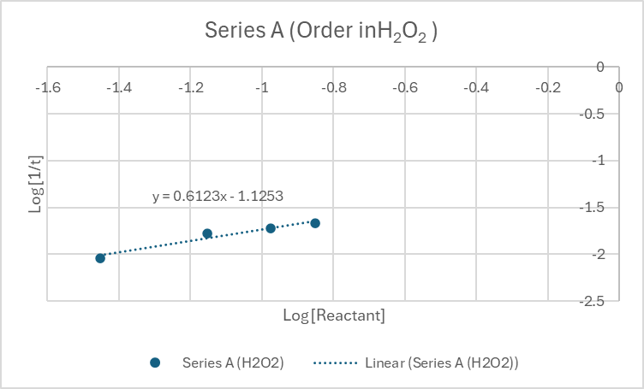
Figure 1 - Series A Result
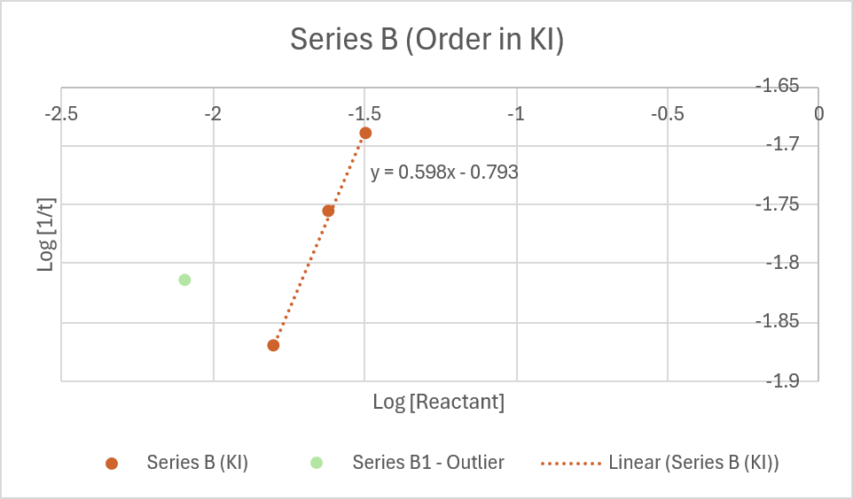
Figure 2 - Series B Result

7.2 Discussion

7.2.1 Rate Constant K
k can be calculated by rearranging the following equation:
Rate = k*(H₂O₂^{m})*(KI^{n})
K has been calculated for each individual reaction:
Table 2 - Calculated k Values
Trial | k
A1 | 0.656437
A2 | 0.787252
A3 | 0.695294
A4 | 0.657425
B1 | 1.09358
B2 | 0.634622
B3 | 0.647501
B4 | 0.633191
Average ^{exc. B1} | 0.673103

As shown in Table 2, the average k value is 0.673.

7.2.2 Order of Reaction
The slope of the line determines the individual order of each reactant (H₂O₂ and KI as m and n respectively). These can then be added to determine the overall order.
Series A: 0.6123
Series B: 0.598
Overall: 1.21
As the overall order is not an integer, this reaction is classified as a fractional order reaction.

7.2.3 Rate Law
The overall rate law for this experiment is given by [10]:
Rate = k*(H₂O₂^{m})*(KI^{n})
Rate (mol dm⁻³ s⁻¹) = 0.673*( H₂O₂^{0.6123})*(KI^{0.598})

7.3 Additional Discussion Questions

7.3.1 Role of Ascorbic Acid
Ascorbc acid (vitamin C) acts as a reducing agent. The reaction between the hydrogen peroxide and potassium iodide creates iodine. The vitamin C reduces the iodine back to iodide. Once the vitamin C supply is consumed, the molecular iodine level rises – which is seen as a colour change in the presence of starch [11].

7.3.2 Effect of Temperature on Rate
At a higher temperature, the rate will increase. Temperature is, in effect, a measure of the average kinetic energy of particles in a substance – higher temperature equals higher energy. The frequency and the energy of collisions between particles in a substance therefore increases with temperature. More energetic and more frequent collisions results in a faster reaction rate. The Arrhenius equation relates temperature to the rate constant k [12].

7.3.3 Sources of Error
This experiment contained many possible sources of error. Possible sources of error are listed below, along with any mitigations undertaken at the time of the experiment if applicable:
- Human reaction time (identifying colour switch)
  - Same individual timing for each experiment
- Initial stirring rate
  - Same individual stirring for the same amount of time for each experiment
- Variations in solution component volume
  - Same individual measured the same parts of the solution each time, using the same equipment
- Contamination
  - All glassware rinsed between experiments, by the same individual, using deionised water and dried using fresh blue roll each time
- Incorrect order of operations
  - One set of repeats had to be conducted when solutions started to turn blue before the KI had been added, due to the incorrect chemical being added at the wrong stage in the process
  - Time pressure
    - It is possible that the erroneous result identified in Annex A: Outlier Determination was due to equipment contamination or an incorrect order of operations, stemming from a desire to finish the session on time.
- No repeats conducted
- No room temperature logs taken

Many improvements could have been made with respect to the equipment used during this experiment:
Weighing Equipment: was not of particularly high grade, nor was there any indication the equipment was calibrated. If solutions are to be measured by weight, lab-grade scaled should be used that are either themselves calibrated, or checked against a calibrated reference source prior to the experiment
Pipette Fillers: as these are examined “by eye”, the amount varies from person to person. Electronic pipette fillers can be used instead, which offer more repeatable performance
Stirring: this was conducted by hand. Instead, an automated system can be used – again, offering improved repeatability.
Colour Change: instead of relying on the human eye and reaction time, devices that use photodiodes to measure a colour change are available. These produce instantaneous and reliable results.
Glassware Rinsing: fresh glassware should be used each time, and be set aside for proper cleaning afterwards.

7.4 Comparison to Literature Values
Literature values for this reaction state that this reaction is typically first order with respect to both hydrogen peroxide and iodine [6] [13]. The result ascertained by this experiment is that the reaction is fractional order. This is a considerable difference from literature values. It is possible that one or more of the factors listed in 7.3.3 Sources of Error is responsible for this difference. Principally, no repeats were conducted. It is believed this, combined with the rushed finish due to time pressure, is likely to be the cause of this difference.

8. Conclusion
The iodine clock reaction investigated in this experiment demonstrates a clear and measurable relationship between reactant concentration and reaction rate. By using ascorbic acid, hydrogen peroxide (H₂O₂) and potassium iodide (KI) and starch, the reaction proceeds via a redox mechanism where iodide ions are oxidized to iodine, which subsequently forms a blue-black starch complex when the ascorbic acid is fully depleted.
Experimental data showed that the reaction was fractional order with respect to both hydrogen peroxide and iodine. This differs heavily from literature values, and consequently, further work is required.

9. Further Work
Further work should be focused around repeating this experiment multiple times, with less time pressure, and using the equipment identified in 7.3.3 Sources of Error. Averages should be taken from these repeats to determine the rate law exactly.

References

[1] | T. Brown and E. S. B. LeMay, Chemistry: The Central Science, Pearson, 2009.
[2] | LibreTexts Chemistry, “Reaction Order,” [Online].
[3] | LibreTexts Chemistry, “First-Order Reactions,” [Online].
[4] | LibreTextx Chemistry, “Second-Order Reactions,” [Online].
[5] | Princeton University, “Reaction Order,” [Online]. Available: https://www.princeton.edu/~rpl/Labs/spring/ic_order.html.
[6] | LibreTexts Chemistry, “The Iodine Clock Reaction”.
[7] | R. Sheposh, “EBSCO Knowledge Advantage - Iodine clock reaction,” [Online]. Available: https://www.ebsco.com/research-starters/chemistry/iodine-clock-reaction.
[8] | R. Mazumdar, “A Case for Chemical Kinetics in Explosives Ordnance Engineering,” in PARARI Australian Explosive Ordnance Safety Symposium, 2024.
[9] | National Library of Medicine, “Compound Summary - Hydrogen Peroxide,” [Online]. Available: https://pubchem.ncbi.nlm.nih.gov/compound/Hydrogen-peroxide.
[10] | LibreTexts Chemistry, “12.4: Rate Laws,” [Online]. Available: https://chem.libretexts.org/Bookshelves/General_Chemistry/Chemistry_1e_%28OpenSTAX%29/12%3A_Kinetics/12.04%3A_Rate_Laws.
[11] | R. Kerr, W. M. Thompson and D. J. Smith, “Mathematical modelling of the vitamin C clock reaction,” Royal Society Open Science, vol. 6, 2019.
[12] | Thompson Rivers University, Principles of Chemistry, Pressbooks.
[13] | S. Hird, “Iodine Clock Reaction (AQA A Level Chemistry): Revision Note,” 11 2024. [Online]. Available: https://www.savemyexams.com/a-level/chemistry/aqa/17/revision-notes/8-advanced-practical-skills/8-1-physical-chemistry-practicals/8-1-5-iodine-clock-reaction/.

Annex A: Outlier Determination
When examining the result, an outlier was identified in series B. The graph is shown in Figure 3.
Given that the expected result is a straight line, one of the lowest two points is the outlier. Trend lines were plotted for each (shown in Figure 4 and Figure 5), and a correlation coefficient (R²) ascertained for each. The closer this number is to 1, the closer the observed values are to the line of best fit (predictor) values.
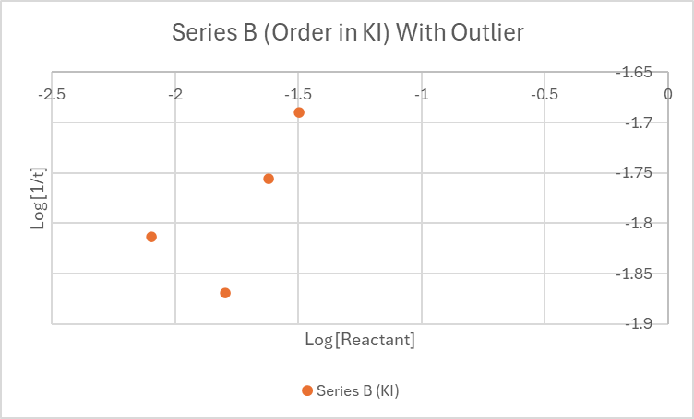
Figure 3 - Series B Overall Result
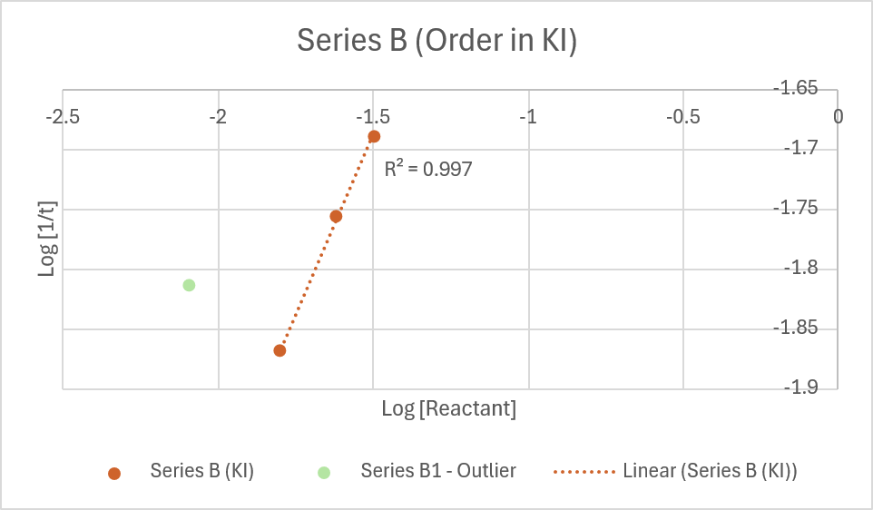
Figure 4 - Series B1 - Outlier

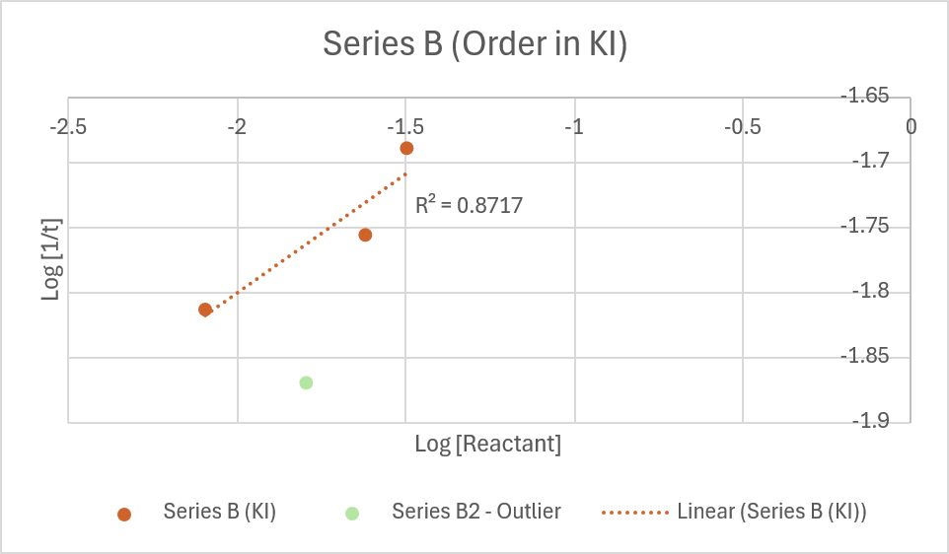
Figure 5 - Series B2 - Outlier
As can be seen from Figure 4 and Figure 5, the R² value for the trendline when series B1 is taken as an outlier is 0.997, whereas if B2 is taken as an outlier, the R² value is 0.872 – a less good fit. Consequently, for analysis throughout this document, B2 has been treated as the outlier value and excluded from the calculations.

Annex B: Chemicals and Equipment
- 0.20 M KI solution
- 0.10 M H₂O₂ solution
- 0.010 M Vitamin C solution
- 1 % starch indicator
- Distilled water
- 25 mL measuring cylinders, pipettes or syringes
- Beakers or cups (A and B)
- Stopwatch
- PPE: lab coat, goggles, gloves

Annex C: Procedure
Cup A: KI + starch + vitamin C + water
Cup B: H₂O₂ only
Start the timer as soon as Cup B is poured into Cup A and swirl once. Record the time until the first permanent blue colour appears.
Experimental Plan (Total Volume = 25.0 mL)
Series 1 — Order in [H₂O₂]
Trial | H₂O₂ 0.10 M (mL) | KI 0.20 M (mL) | Vit C 0.010 M (mL) | Starch 1% (mL) | Water (mL) | [H₂O₂]₀ (M)
A1 | 1.0 | 2.5 | 1.25 | 1.0 | 19.25 | 0.0040
A2 | 2.0 | 2.5 | 1.25 | 1.0 | 18.25 | 0.0080
A3 | 3.0 | 2.5 | 1.25 | 1.0 | 17.25 | 0.0120
A4 | 4.0 | 2.5 | 1.25 | 1.0 | 16.25 | 0.0160

Series 2 — Order in [I⁻]
Trial | KI 0.20 M (mL) | H₂O₂ 0.10 M (mL) | Vit C 0.010 M (mL) | Starch 1% (mL) | Water (mL) | [I⁻]₀ (M)
B1 | 1.0 | 3.0 | 1.25 | 1.0 | 18.75 | 0.0080
B2 | 2.0 | 3.0 | 1.25 | 1.0 | 17.75 | 0.0160
B3 | 3.0 | 3.0 | 1.25 | 1.0 | 16.75 | 0.0240
B4 | 4.0 | 3.0 | 1.25 | 1.0 | 15.75 | 0.0320

Data Table
Trial | [Reactant]₀ (M) | Clock Time t (s) | 1/t (s⁻¹) | log[Reactant] | log(1/t)
A1 |  | 110
A2 |  | 60
A3 |  | 53
A4 |  | 47
B1 |  | 65
B2 |  | 74

