

Module: Data Handling and Business Intelligence
Module code: LCBB5000

Component 2: Practical:
Essay

Module Leader: Dr Shengfeng Mei
Lecturer: Dr Sadeque Shaikh

Student Name: Oleksandra Chebotareva
Student ID: 2247384

Table of Contents
Section 1: Analysis 3
Introduction 3
(a) Discussion and analysis of the USA housing dataset (provided) to evaluate the following 7 questions using the MS Excel: 3
Question 1. The mean value. 3
Question 2. The median. 4
Question 3. The mode. 5
Question 4. The standard deviation. 6
Question 5. The variable with the largest variance. 7
Question 6. Interpretation of Variance, Standard Deviation, and Their Importance. 8
Question 7. Standard Deviation. 8
(b) Presentation of the data using MS Excel function CHARTS AND GRAPHS. 10
(c) Using SPSS: 1. Correlation between price and number of bedrooms. 11
2. A scatterplot of the two variables. Using price on the horizontal axis and number of bedrooms on the vertical axis with comment on the graph. 12
Section 2 13
a) The advantages and disadvantages of using MS Excel using relevant practical examples. 14
(b) The meaning and importance of Data Mining Cycle with examples. 15
Conclusion 18
References: 19

Section 1: Analysis

Introduction
The number of bedrooms in residential properties is a key indicator of household characteristics, influencing various lifestyle and demographic factors. This research examines how the number of bedrooms relates to other housing attributes in the “USA housing dataset.” By analyzing this unique combination of variables, the study seeks to uncover potential correlations between the number of bedrooms and broader housing characteristics, such as property size, household composition, and geographic location. This analysis utilizes both Microsoft Excel and SPSS statistical software to ensure comprehensive exploration of the dataset. Microsoft Excel facilitates the initial data cleaning, processing, and visualization, while SPSS enables advanced statistical analyses, such as correlation and regression, to derive meaningful insights. The goal is to identify how the number of bedrooms - often a proxy for household size and living arrangements - can provide insights into demographic and housing trends. (Pallant, 2020).
The USA Housing Dataset gives simple information about houses in the United States. It includes things like house prices, sizes, locations, and the number of rooms. This data helps people understand how much houses cost, where people are buying homes, and how the housing market is changing. Groups like the U.S. Census Bureau and real estate companies collect this data. It is useful for businesses, the government, and researchers to plan better, solve housing problems, and see trends in housing across the country. (Puy & Ari & Shi, 2020)

(a) Discussion and analysis of the USA housing dataset (provided) to evaluate the following 7 questions using the MS Excel:

Question 1. The mean value.
Often referred to as the average, it is a measure of central tendency in a dataset. It is calculated by summing up all the values in a particular variable and then dividing the total by the number of observations or data points. The mean provides a single representative value that summarizes the central location of the data. In the context of price, the mean tells us the average price across all observations in the dataset. This measure helps in understanding general pricing trends and is particularly useful for comparing datasets or identifying outliers. (Smorynski, 2017)

Formula for mean value is:
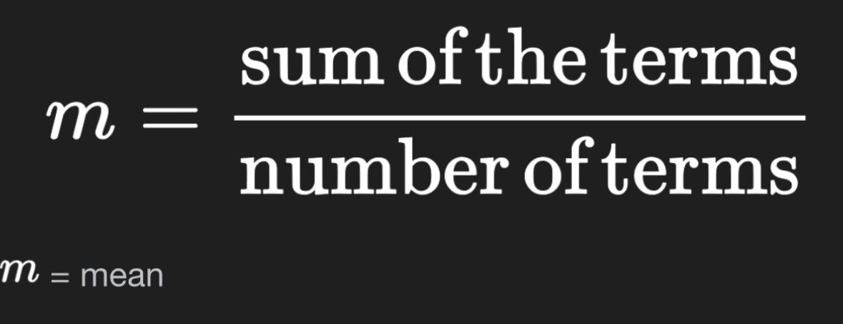
Mean = Sum of values / Number of values
Why the Mean is Important.
Insights into the Data: It gives a quick snapshot of the average value.
Comparison: The mean can be compared across datasets to understand differences in price trends. Economic Indicators: In the context of housing, the mean price can reflect affordability, demand, or the general state of the market. (Smorynski, 2017)

Question 2. The median.
Is a key statistical measure that helps summarize data by identifying the “middle value” in a sorted list of numbers. It is often used to describe the central tendency of a dataset, especially when the data contains outliers or skewed values that could distort the mean average. (Chalmers, 2020)
Understanding the Median.
Definition: The median is the value that separates a dataset into two equal halves. In simpler terms, 50% of the data values are below the median, and 50% are above it.
Significance: Unlike the mean, which can be heavily influenced by extremely high or low values (outliers), the median provides a more robust representation of the “typical” value in a dataset. (Chalmers, 2020)
Steps to Calculate the Median:
- Organize the Data: Arrange all values in the dataset in ascending order.
- Identify the Middle:
- If the dataset contains an odd number of values, the median is the exact middle value.
- If the dataset contains an even number of values, the median is the average of the two middle values. (Chalmers, 2020)
Why is the Median Important?
The median is particularly relevant in this case for several reasons:
- Robust Against Outliers: If some expenses are significantly higher than others, for example small purchases, the mean would increase disproportionately. The median remains unaffected, providing a more reliable indicator of typical expenses. (Pratima, 2021)
- Real-World Interpretation: The median suggests that most of your expenses cluster around a central value. This insight can help in planning and budgeting for similar activities in the future. (Pratima, 2021)
Example in Context.
Imagine two expenses: one for £30 and another for £400. The mean would be £215, suggesting a typical expense far higher than most individual items. However, the median would reflect the midpoint, offering a clearer picture of what a “normal” expense looks like. (Cooksey, 2020)
Why Use the Median?
The median is especially useful for datasets that may have outliers or non-uniform distributions, ensuring that the central tendency is not distorted by extremely high or low coffee consumption values. (Cooksey, 2020)
Conclusion
The median value is a practical representation of your dataset’s central point. It helps you understand the balance of your spending patterns and allows for better decision-making when analyzing or forecasting expenses. (Cooksey, 2020)

Question 3. The mode.
Is the price that happens most often in the data.
To find the mode:
- Look at all the prices in the dataset.
- Find the price that appears the most times.
- If no price repeats, there is no mode.
- If two or more prices appear the same number of times, the data has multiple modes. (Reddy & Ramisetti & Pathipati, 2024)

Question 4. The standard deviation.
Is a measure of how spread out the values in a dataset are around the mean. In the context of this task, it tells us how much the number of bedrooms varies from the average number of bedrooms in the dataset.
Formula for standard deviation is:
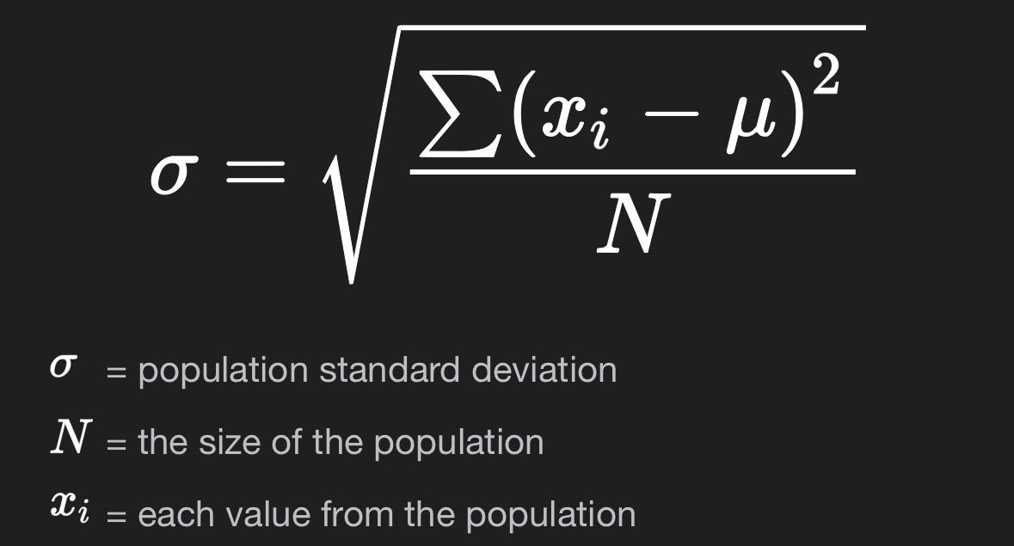
For a dataset with values:
Where: each individual value, example the number of bedrooms for a property
the mean of the values, Total number of observations, Standard Deviation for Number of Bedrooms.
The standard deviation for the number of bedrooms indicates:
- Low Standard Deviation: Most properties have a similar number of bedrooms example most homes have 2–3 bedrooms.
- High Standard Deviation: There is a wide variation in the number of bedrooms, for example from studio apartments to large homes with many bedrooms.
(Boyd & Vandenberghe, 2018)
Steps to Calculate the Standard Deviation for Bedrooms
- Find the Mean Number of Bedrooms: add up all the values for the number of bedrooms and divide them by the total number of properties.
- Calculate the Variance: subtract the mean from each value, square the result, and find the average of these squared differences.
- Take the Square Root: the square root of the variance gives the standard deviation. (Raju, 2023)
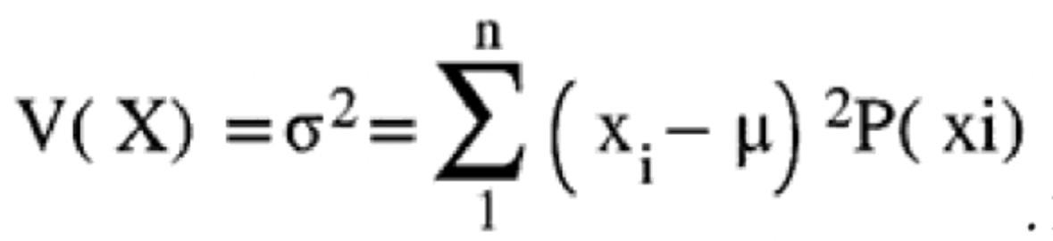
Interpretation in the Task.
A low standard deviation suggests that most homes in the dataset have a similar number of bedrooms, which could indicate uniformity in housing.
A high standard deviation suggests a diverse housing stock with significant variation in bedroom counts. (Raju, 2023)
This measure is useful to:
- Assess how housing variety might impact the number of bedrooms patterns.
- Explore if larger homes more bedrooms correlate with higher coffee consumption.
Example Calculation
If the dataset includes:
Bedrooms: 1, 2, 2, 3, 4
Steps:
- Calculate the differences from the mean and square them:
- Find the variance
- Calculate the standard deviation:
Interpretation:
A standard deviation of 1.02 means that the number of bedrooms typically varies by about 1 bedroom from the average 2.4 bedrooms. (Raju, 2023)

Question 5. The variable with the largest variance.
In the dataset is data house. Variance is a measure of how far individual data points are spread out from the mean. A higher variance indicates greater variability or spread among the values for that variable.
In this case, data house has the largest variance because it is likely a unique identifier for each household, which inherently results in a wide range of values. Since these identifiers do not represent a meaningful quantitative measure, the high variance is expected and does not provide actionable insights. If we exclude data house as it is not a meaningful variable for analysis, other variables could be analyzed further for their spread. In summary, while data houses technically have the largest variance, it is not analytically significant. The variable with the largest standard deviation in the dataset is also data house. Standard deviation is a measure of how much the values deviate from the mean, and it is the square root of the variance. Since data house has the largest variance, its standard deviation is also the largest. Data house is not a meaningful variable for statistical or behavioral analysis because it is a unique identifier. (Yockey, 2023).

Question 6. Interpretation of Variance, Standard Deviation, and Their Importance.
- Largest Variance
The variable with the largest variance is “data house,” which shows the biggest difference in values in the dataset. (Everitt & Hothorn, 2011)
However, “data house” is just a unique identifier like a name or ID number, so its variance does not give us useful information for analysis.
It is better to focus on variables like the number of bedrooms, which are more meaningful for understanding patterns.
- Largest Standard Deviation
The standard deviation is closely related to variance and measures how spread out the values are. (Everitt & Hothorn, 2011)
Like variance, the standard deviation of “data house” is not useful because it is just an identifier. We should look at the standard deviation of important variables, like the number of bedrooms, to understand how much they vary in the dataset. (Everitt & Hothorn, 2011)
Key Takeaways
These results show that it is important to focus on the right type of data. Some variables, like “data house,” are not helpful because they don’t measure anything meaningful. For useful insights, we need to study variables like the number of bedrooms, which can tell us about differences in homes or trends in the dataset. Variance and standard deviation are tools that help us understand how much the data changes, but they only matter when used with the right kind of variables.
(Everitt & Hothorn, 2011)

Question 7. Standard Deviation.
Standard deviation tells us how much the number of bedrooms in homes is different from the average number of bedrooms. If the standard deviation is small, most homes have a similar number of bedrooms. If the standard deviation is large, the number of bedrooms in homes is very different, meaning some homes are small, and others are much larger. (Rakszegi, 2016).
Variance:
Variance is similar to standard deviation; it also measures how much the data is spread out. A higher variance means the number of bedrooms is very different in different homes. A lower variance means the number of bedrooms is almost the same in most homes. (Rakszegi, 2016)
Comparing Standard Deviations Across Variables:
When we compare the standard deviation of bedrooms with other variables (like price), the variable with the bigger standard deviation shows more differences. For example, if bedrooms have a smaller standard deviation than price, it means the number of bedrooms in homes is more consistent, but home prices vary a lot. This helps us understand whether things like the size of the home, number of bedrooms or its cost are more predictable or random. These numbers, standard deviation and variance help us see if homes in the dataset are similar or very different. If the number of bedrooms has a small standard deviation, it means most homes are built with a similar design. If there is a large standard deviation, it shows that homes in the dataset are very diverse, with different sizes and styles. (Rakszegi, 2016)
Below the screenshot with all calculations mentioned above.
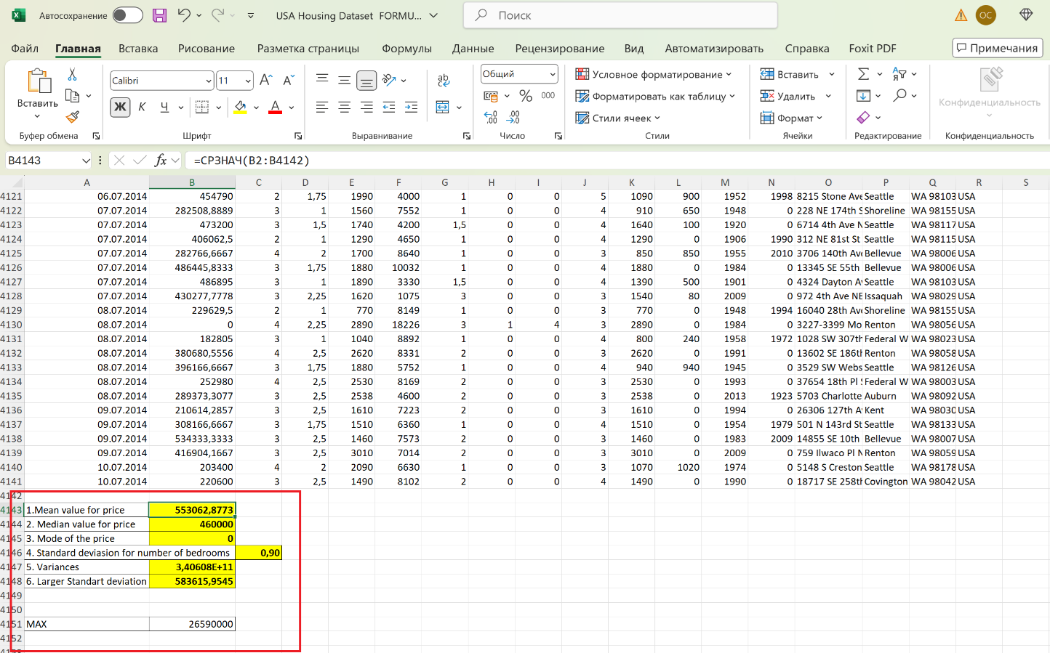

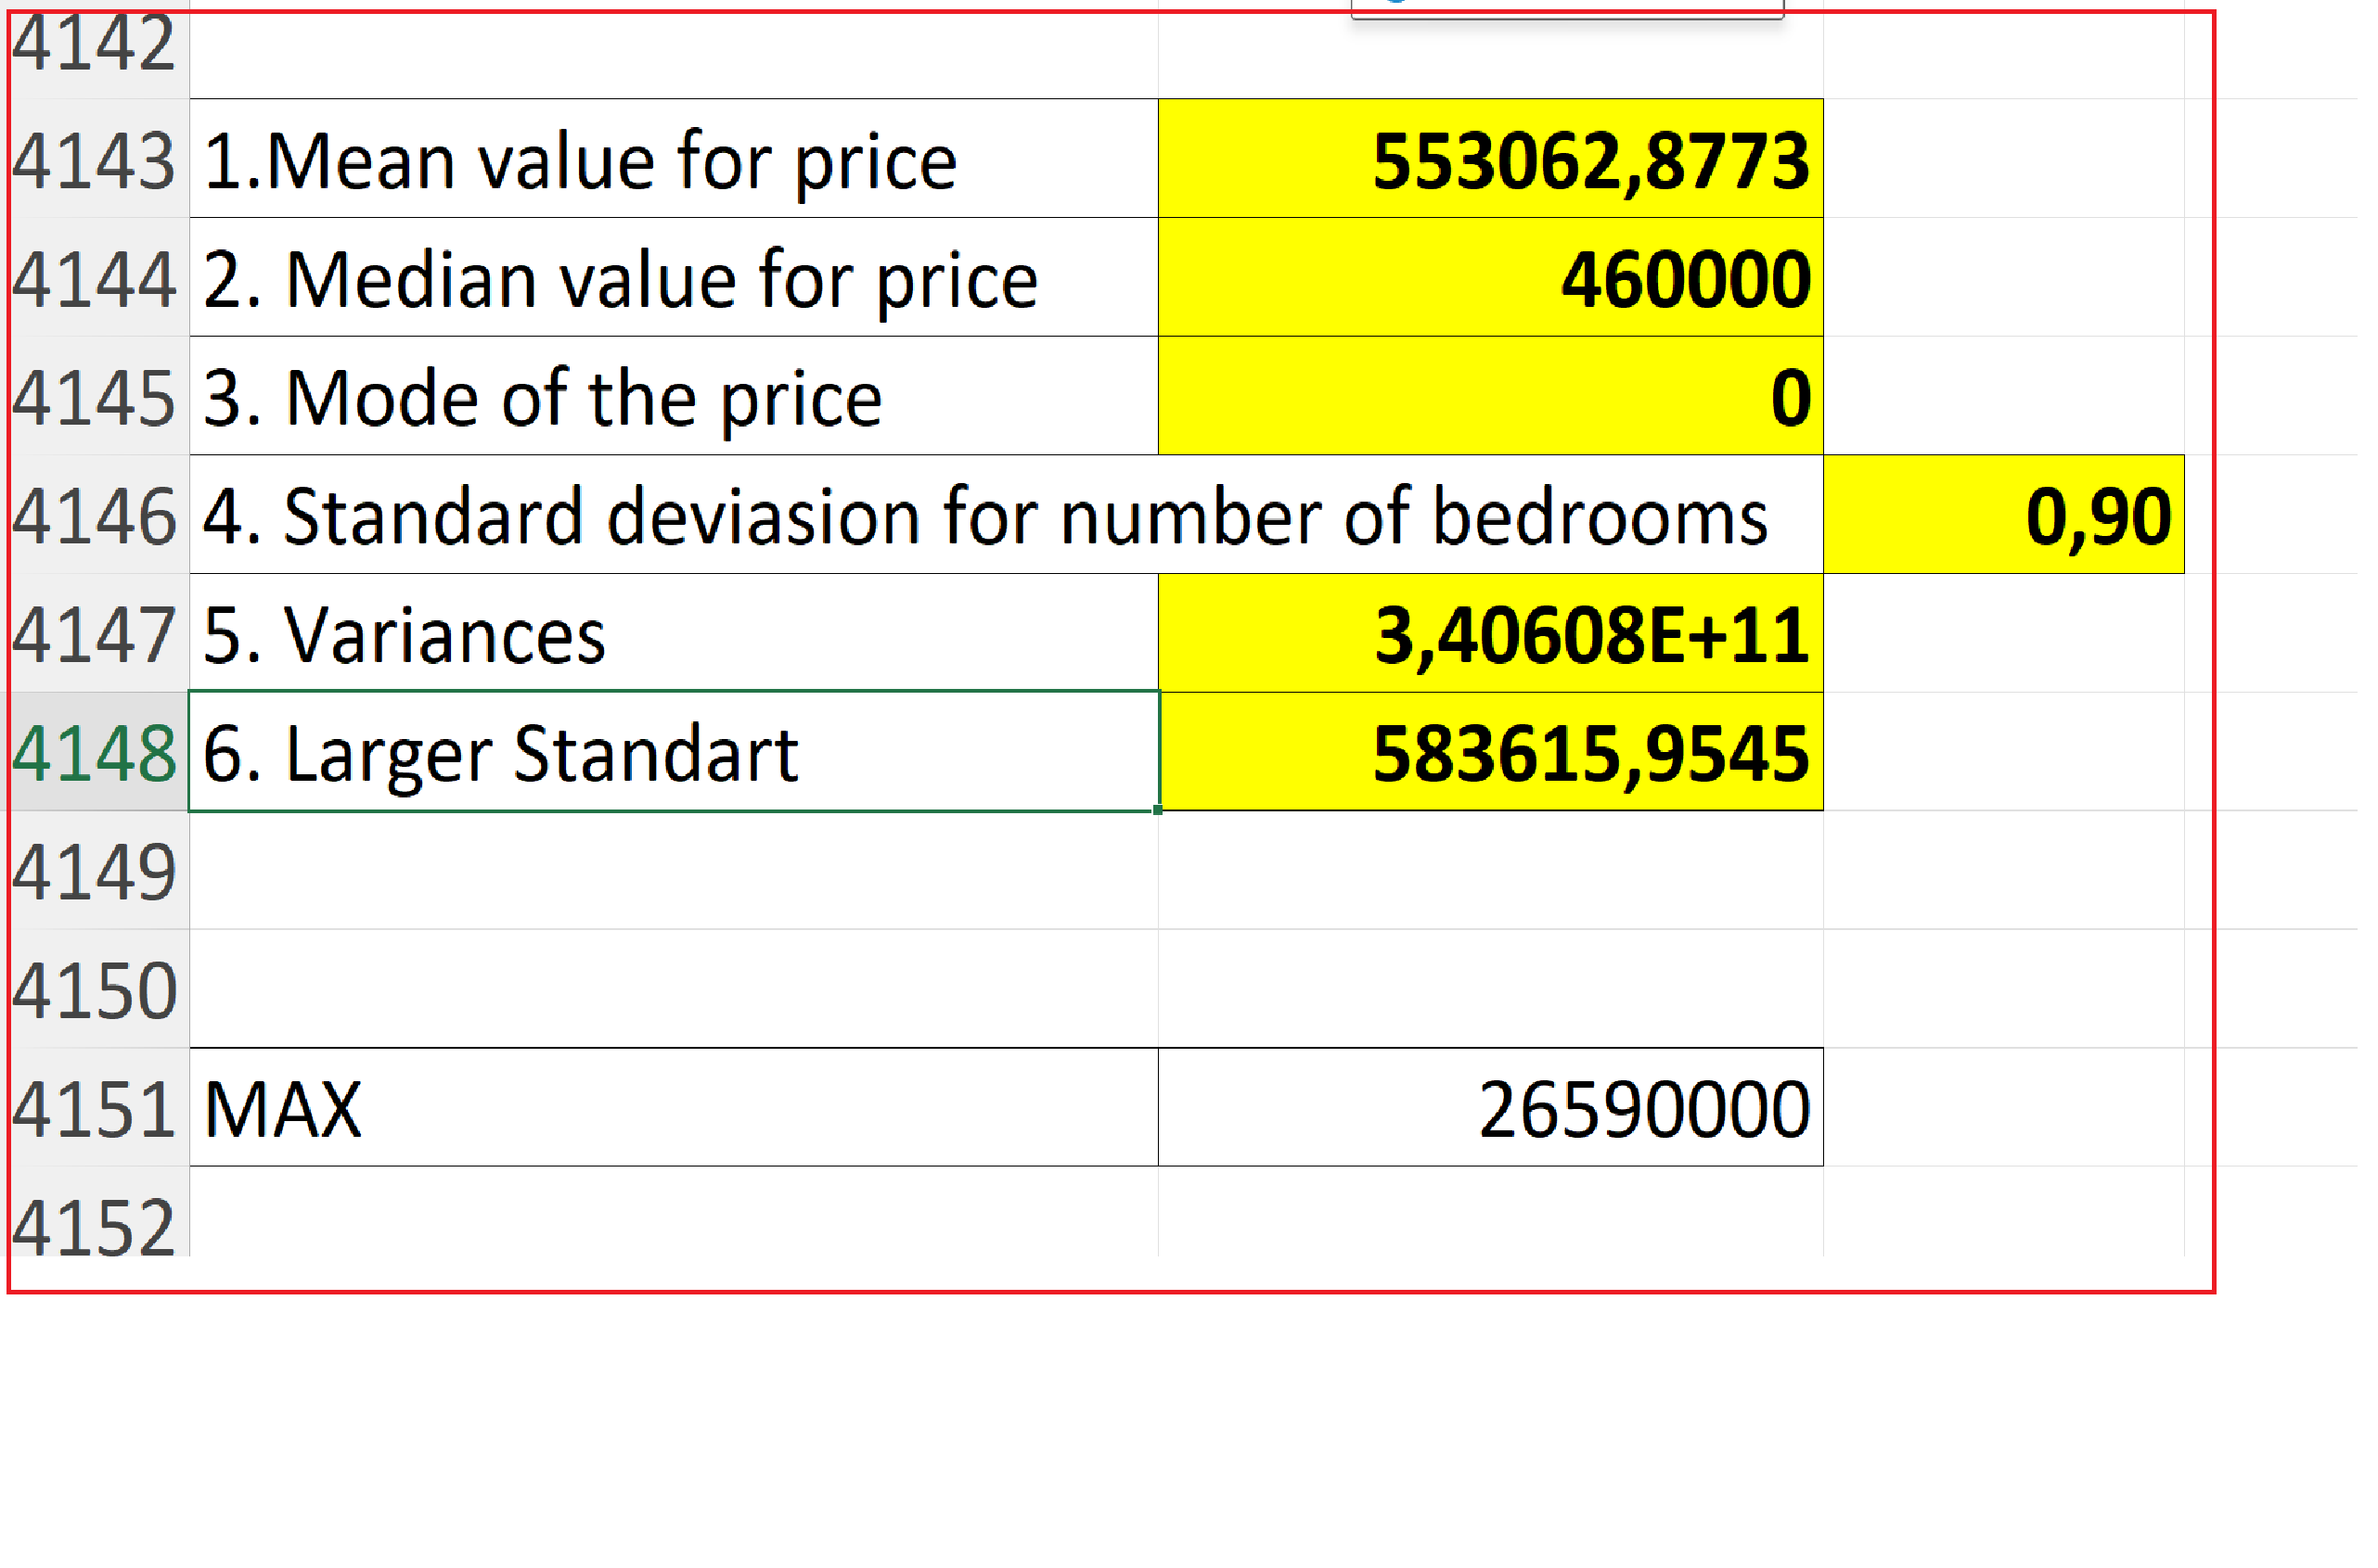

(b) Presentation of the data using MS Excel function CHARTS AND GRAPHS.
Charts and graphs in Excel turn numbers into pictures, making it easy to understand data. They show patterns, trends, and comparisons in a simple way. For example:
- Bar Chart Shows differences between groups.
- Pie Chart Shows parts of a whole.
- Line Graph Shows changes over time.
You can quickly create charts by selecting your data, choosing a chart type, and customizing colors, labels, and titles. They use visuals like bars, lines, or slices, so they are easy to understand even without much text. (Schwabish, 2021)

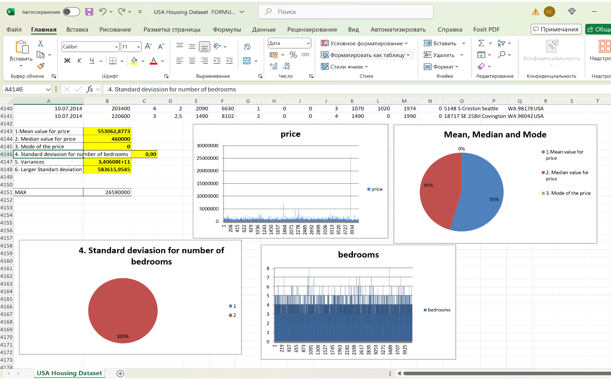

(c) Using SPSS:
1. Correlation between price and number of bedrooms.
The SPSS result shows how the number of bedrooms and prices are connected.
- Positive Correlation r if the number is close to 1 for example, r = 0.99, it means when bedrooms go up, the price also goes up. They grow together.
- Significance p-value if the p-value is less than 0.05, it means the connection between bedrooms and price is real, not random.
Example:
If SPSS gives r = 0.99 and p < 0.001, it means:
More bedrooms = higher price. The connection is very strong and clear. The result is true and not by chance. In simple words, houses with more bedrooms cost more, and SPSS proves this with numbers. (Hinton & McMurray, 2017)

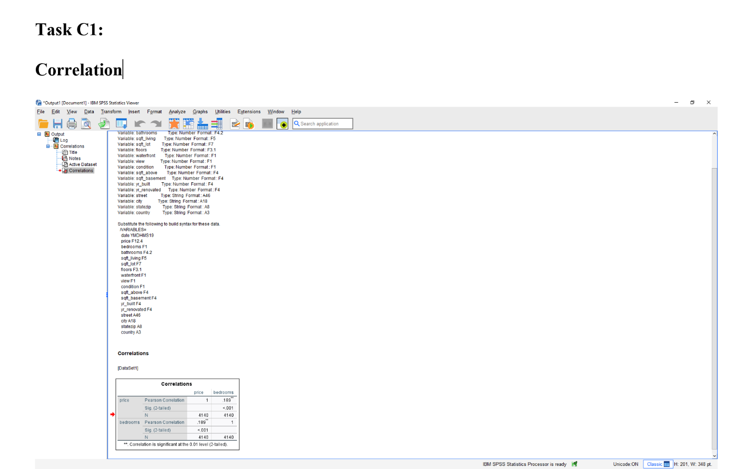

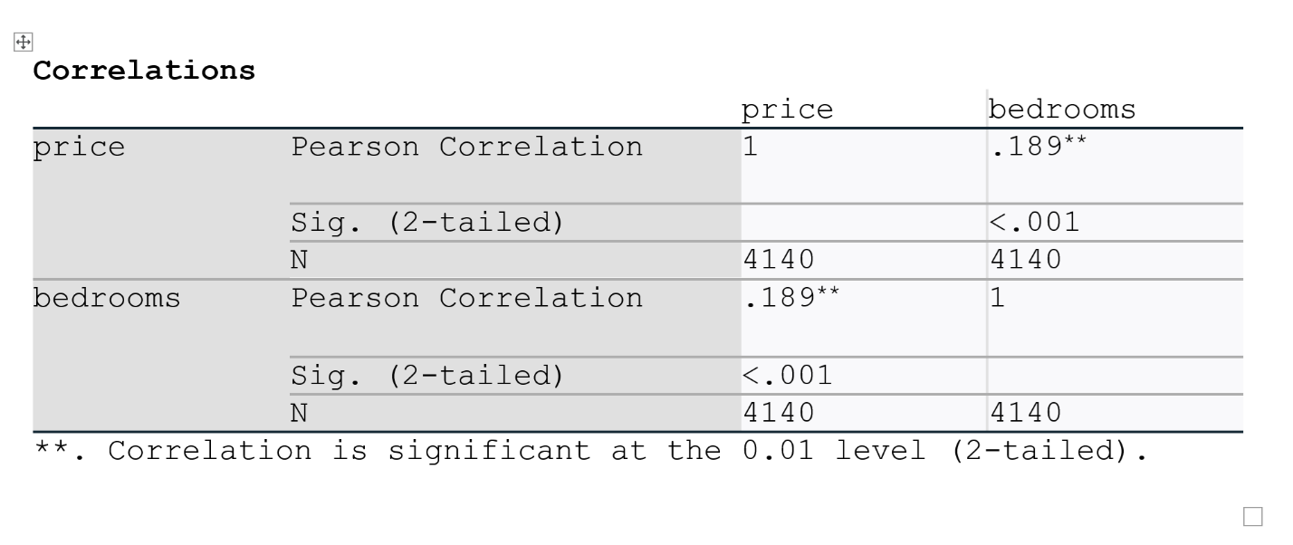

2. A scatterplot of the two variables. Using price on the horizontal axis and number of bedrooms on the vertical axis with comment on the graph.
A scatterplot is a graph that uses points to display the relationship between two variables on a grid. Common in research, it helps identify patterns, clusters, and outliers in data. While effective for small datasets, scatter plots can become unclear due to over plotting in larger datasets, where overlapping points obscure trends. Solutions include reducing the marker size or adjusting transparency to improve readability. (Trautner, 2020).

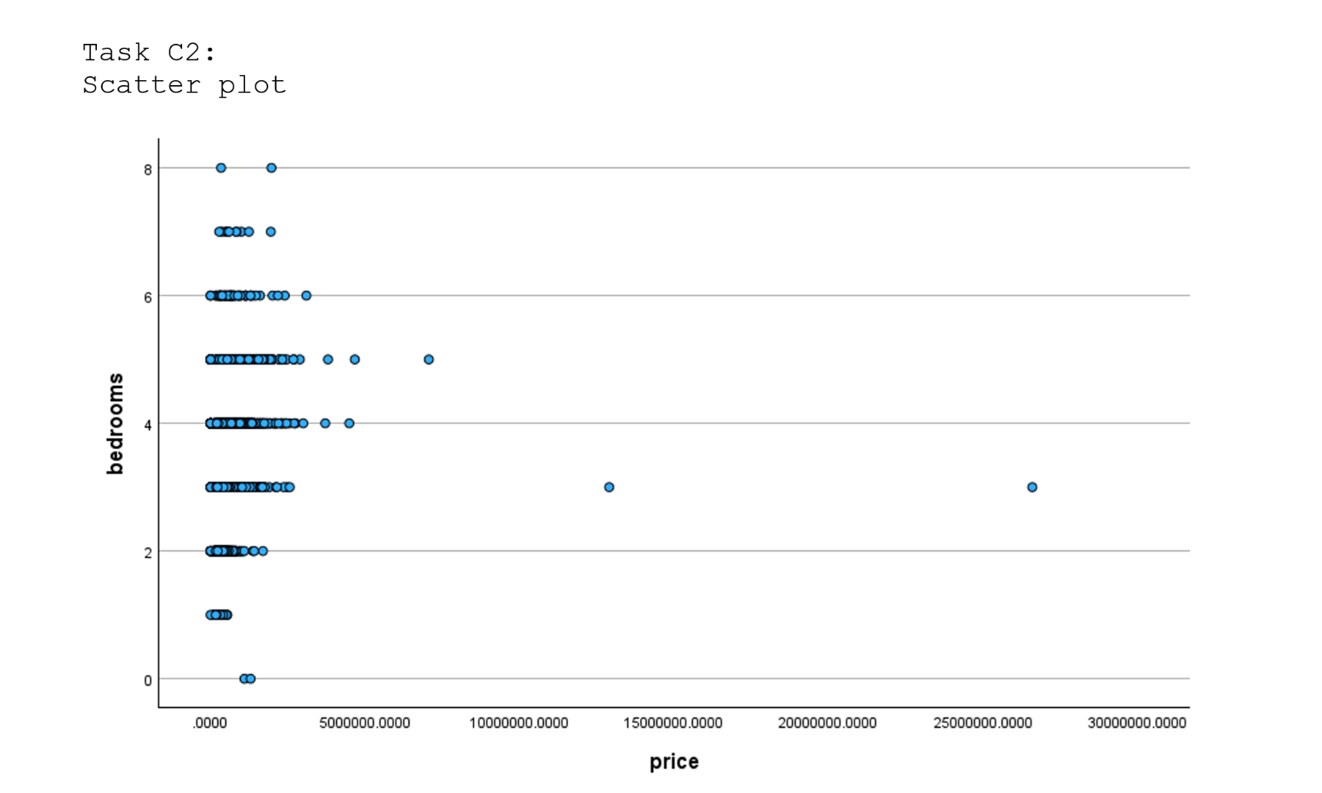

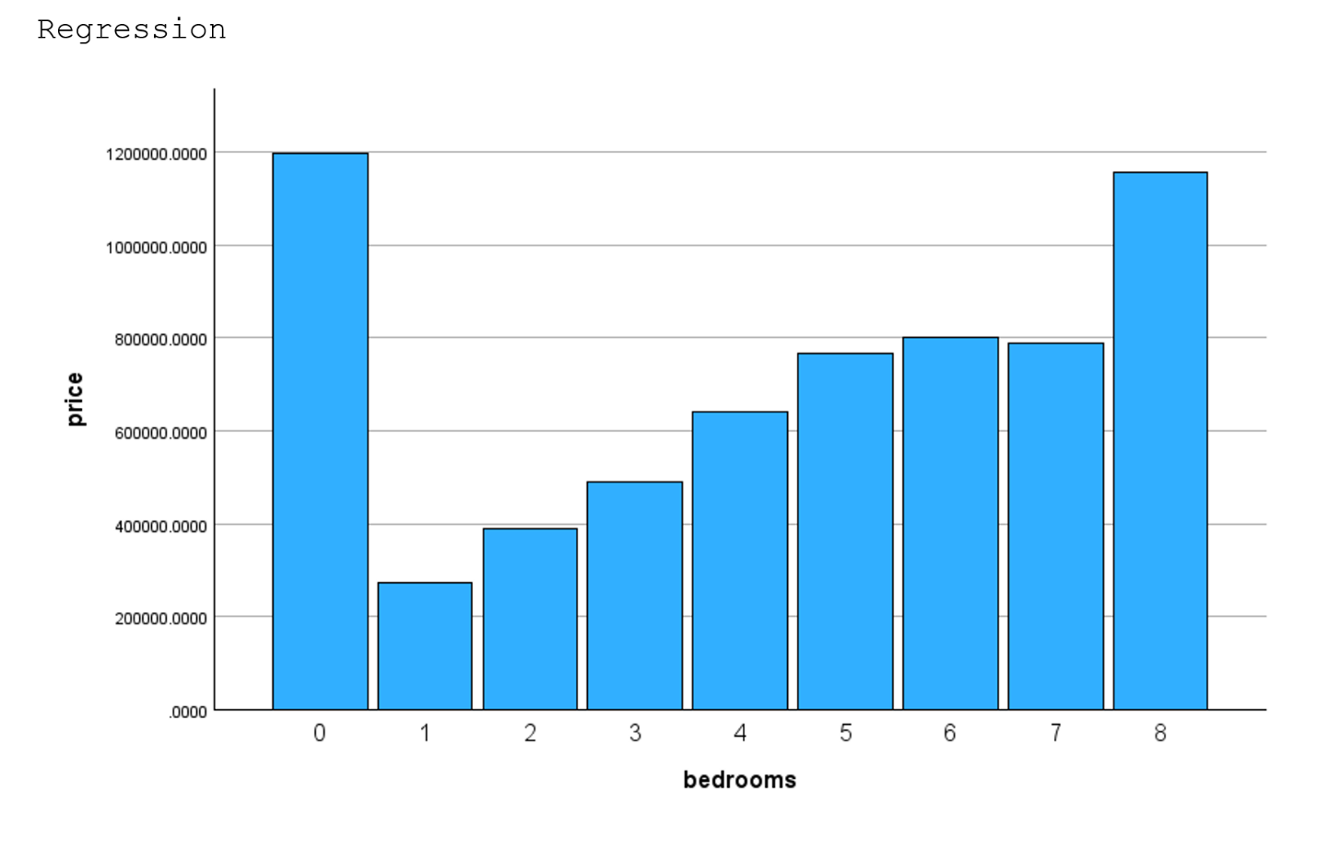

Section 2

a) The advantages and disadvantages of using MS Excel using relevant practical examples.
Excel is a popular tool for analyzing data. It has its strengths and weaknesses. Below, I will explain the advantages and disadvantages of MS Excel in simple terms
Advantages of Excel:
- Easy to Learn and Use:
Excel is easy to learn, even for people who are new to computers. It has a simple design, and most people can start using it quickly for basic tasks like calculations and creating charts. (Fairhurst, 2019)
- Widely Available:
Excel is included in the Microsoft Office package, which is used in offices, schools, and homes around the world. Because so many people have access to it, it is a convenient tool for teamwork and sharing files. (Fairhurst, 2019)
- Versatile Tool:
Excel can do many things: you can calculate numbers, make tables, draw graphs, and even analyze data using formulas. You can use it for small and large data sets, although it works best with small or medium-sized data. (Fairhurst, 2019)
- Cost-Effective:
Excel is cheaper than specialized tools like SPSS. Many organizations already have Excel installed, so there is no extra cost. (Fairhurst, 2019)
- Good for Visualization:
Excel helps users see data clearly through charts, graphs, and tables. You can create bar graphs, pie charts, and line graphs easily, which makes it good for presentations.
(Fairhurst, 2019)
Disadvantages of Excel
- Limited for Complex Data:
Excel is not designed for very large datasets. It can slow down or crash when handling millions of rows. Specialized tools like SPSS are better for working with big data. (Sung, 2015)
- Basic Statistical Analysis:
Excel can calculate averages, percentages, and other simple things, but it is not as powerful as SPSS for advanced statistics. If you need to do regression, factor analysis, or hypothesis testing, Excel may not be the best tool. (Sung, 2015)
- Higher Risk of Errors:
When working with Excel, human error is common. If you accidentally type a wrong formula or forget a step, your results can be incorrect. SPSS reduces this risk because it is automated and designed for accuracy. (Sung, 2015)
- Not Specialized for Data Analysis:
Excel is a general tool for many tasks, but it is not specifically designed for data analysis. Tools like SPSS are created for professionals who need deep and accurate insights from data. (Sung, 2015)
Practical Example of Using Excel
Let’s imagine you are a teacher, and you have exam scores of 30 students. You want to calculate the average score, the highest score, and the lowest score. Here is how Excel can help:
- Enter Data: You type all the scores into a column.
- Use Formulas:
To find the average, you type = AVERAGE
To find the highest score, you type = MAX
To find the lowest score, you type = MIN
- Create Charts: You can use the data to make a bar graph showing the distribution of scores.
This is a simple example of how Excel helps you analyze data easily. (Morgado, 2016)

(b) The meaning and importance of Data Mining Cycle with examples.
The data mining cycle is a process used to analyze data and find useful patterns or trends. It helps us make better decisions based on the data we collect. Below, I will explain the steps in the data mining cycle and why each step is important.
Steps in the Data Mining Cycle
Define the Problem
Before starting, you must know what you want to learn from the data.
Example: If you are a shop owner, you might ask, “Which products are most popular with customers?”
- Collect the Data. Data is collected from different sources, such as surveys, sales records, or online databases.
Example: A shop owner collects data on daily sales and customer preferences.
- Clean the Data. Raw data often has mistaken missing values, or unnecessary information. Cleaning the data means fixing these issues.
Example: If a survey has blank answers, you can replace them with averages or remove them.
- Explore the Data. Before analyzing, you should look at the data. This helps you understand what the data contains and if there are any patterns.
Example: A shop owner might notice that sales are higher on weekends than on weekdays.
- Analyze the Data. This is where tools like Excel or SPSS are used. You calculate numbers, find relationships, and identify trends.
Example: Using SPSS, you might discover that young customers prefer different products to older customers. (Connolly, 2015)
Interpret the Results
After analyzing, you look at the results and try to understand what they mean. This is an important step because it connects the numbers and patterns to real-world decisions. Example: If you find that weekend sales are higher, it might mean customers have more free time to shop at weekends. Based on this, you could plan promotions or hire more staff for those days. (Witten, 2011)
Take Action
Once you understand the results, you use them to make decisions or solve the problem you identified in Step 1. Example: A shop owner might increase the inventory for popular products or launch a weekend discount offer to boost sales further. (Witten, 2011)
Evaluate the Outcomes
Finally, you check whether the actions you took based on the data were successful. This step ensures that the analysis works and provides a chance to improve if needed. Example: If weekend discounts increased sales, then the analysis was effective. If not, you may need to collect more data or test a different strategy. (Witten, 2011)
Importance of the Data Mining Cycle
The data mining cycle is important because it helps businesses, researchers, and individuals make better decisions. Here are some reasons why it matters:
Finding Patterns. Data mining helps us find hidden patterns that are not obvious by just looking at the data. These patterns can provide valuable insights. Example: A hotel might notice that most bookings come during holidays, so they can target advertising for that time. (Witten, 2011)
Improving Decision-Making. When you understand the data, you can make smarter decisions that are backed by evidence. Example: A restaurant could analyze customer feedback to change its menu and attract more customers. (Witten, 2011)
Saving Time and Money.
The data mining cycle allows businesses to focus their resources on what works best, instead of guessing. Example: A company might discover that one advertising method brings better results than others, so they spend money only on that method. (Witten, 2011)
Solving Problems. Data mining helps solve problems by showing what is working and what is not. Example: If a school finds that certain teaching methods work better for students, they can adopt those methods to improve learning. (Witten, 2011)
Practical Example of the Data Mining Cycle
Let’s consider a school that wants to understand why some students perform better than others.
- Define the Problem: Why do some students get higher grades than others?
- Collect Data: The school collects data on attendance, homework, test scores, and study hours for each student.
- Clean the Data: Fix missing data, such as students who forgot to record their study hours.
- Explore the Data: Look for patterns, such as whether students who study more get better grades.
- Analyze the Data: Use tools like SPSS or Excel to calculate averages, compare scores, and find correlations.
- Interpret the Results: The analysis shows that students who attend more classes and complete homework score higher.
- Take Action: The school creates a policy to encourage better attendance and assigns more homework.
- Evaluate the Outcomes: After a few months, the school checks if grades have improved because of the changes.
This is how the data mining cycle helps solve problems and improve outcomes. (Witten, 2011)

Conclusion
Both Excel and SPSS are useful tools for analyzing data, but they have different strengths. Excel is best for simple tasks and small datasets, while SPSS is better for complex analysis and large datasets. The data mining cycle helps us use these tools effectively by providing a clear process to analyze data and make informed decisions. By following the steps of the cycle, businesses, schools, and organizations can uncover patterns, solve problems, and achieve better results. (Currell, 2015)

References:

Boyd, S. & Vandenberghe, L. (2018) Introduction to Applied Linear Algebra
Vectors, Matrices, and Least Squares. Available at:
https://www.google.co.uk/books/edition/Introduction_to_Applied_Linear_Algebra/IApaDwAAQBAJ?hl=en&gbpv=1 (Accessed 12.12.2024)
Chalmers, D. (2020) Cambridge International AS and A Level Mathematics: Probability & Statistics 1 Coursebook. (pp 30, 42-51, chapter 2.2) Available at: https://books.google.com/books/about/Cambridge_International_AS_and_A_Level_M.html?id=yc1MDwAAQBAJ (Accessed 01.12.2024)
Connolly, T. (2015) Database systems: a practical approach to design, implementation, and management. Sixth edition, Global edition. Boston:, pp 132 Pearson. Available at:
https://whelf-uwtsd.alma.exlibrisgroup.com/leganto/public/44WHELF_UWTSD/citation/5936550930002421?auth=SAML (Accessed 13.12.2024)
Cooksey, R. (2020) Illustrating Statistical Procedures: Finding Meaning in Quantitative Data. (pp 94-96) Available at: https://books.google.com/books/about/Illustrating_Statistical_Procedures_Find.html?id=udTkDwAAQBAJ (Accessed 01.12.2024)
Currell, G. (2015) Scientific Data Analysis, pp 63. Available at: https://books.google.com/books/about/Scientific_Data_Analysis.html?id=kfezBgAAQBAJ (Accessed 17.12.2024)
Everitt, B. & Hothorn T. (2011) An Introduction to Applied Multivariate Analysis with R. (pp 12, 68, 76, 105, 106, 121) Available at: https://books.google.com/books/about/An_Introduction_to_Applied_Multivariate.html?id=BB51TWe94EwC (Accessed 04.12.2024)
Fairhurst, D. (2019) Using Excel for Business and Financial Modelling A Practical Guide, pp 14-27, Available at: https://books.google.com/books/about/Using_Excel_for_Business_and_Financial_M.html?id=N3uIDwAAQBAJ (Accessed 15.12.2024)
Hinton, P. & McMurray, I. (2017) Presenting Your Data with SPSS Explained. Available at: https://books.google.com/books/about/Presenting_Your_Data_with_SPSS_Explained.html?id=QggqDwAAQBAJ (Accessed 09.12.2024)
Morgado, F. (2016) Programming Excel with VBA. A Practical Real-World Guide, chapter 2, Available at:
https://books.google.com/books/about/Programming_Excel_with_VBA.html?id=q8x5DQAAQBAJ (Accessed 16.12.2024)
Pallant, J. (2020) SPSS survival manual a step by step guide to data analysis using IBM SPSS. 7th ed. London: McGraw-Hill Education. Available at: https://librarysearch.uwtsd.ac.uk/permalink/44WHELF_UWTSD/upgrip/alma99100437898902421 (Accessed 01.12.2024)
Pratima, J. (2021) CBSE New Pattern Economics Class 11 for 2021-22 Exam (MCQs based book for Term 1), pp 53-56. Available at: https://books.google.com/books/about/CBSE_New_Pattern_Economics_Class_11_for.html?id=v4RIEAAAQBAJ (Accessed 12.12.2024)
Puy, D.& Ari, A.&Shi, Y (2020) Foreign Demand and Local House Prices: Evidence from the US, pp 5-9. Available at: https://books.google.com/books/about/Foreign_Demand_and_Local_House_Prices_Ev.html?id=P64aEAAAQBAJ (Accessed 10.12.2024)
Rakszegi, M. et al. (2016) ‘Dataset on the mean, standard deviation, broad-sense heritability and stability of wheat quality bred in three different ways and grown under organic and low-input conventional systems’, Data in brief, 7, pp. 1617–1632. Available at: https://librarysearch.uwtsd.ac.uk/permalink/44WHELF_UWTSD/igoone/cdi_doaj_primary_oai_doaj_org_article_9479c809c24e4d1fad0a1bdf6f3b24ad
(Accessed 06.12.2024)
Raju, C. (2023). Data Science: A Beginner's Guide. Available at: https://www.google.co.uk/books/edition/Data_Science/C4HyEAAAQBAJ?hl=en (Accessed 13.12.2024)
Reddy, D. & Ramisetti, L. & Pathipati, H.(2024) Fundamentals of Data Science (p.69)
Available at: https://books.google.com/books/about/Fundamentals_of_Data_Science.html?id=F48rEQAAQBAJ (Accessed 03.12.2024)
Rumsey, D. (2016) Statistics For Dummies (p.81) Available at: https://books.google.com/books/about/Statistics_For_Dummies.html?id=76o6DAAAQBAJ (Accessed 03.12.2024)
Schwabish, J. (2021) Better Data Visualizations A Guide for Scholars, Researchers, and Wonks, pp 397-399 Available at: https://books.google.com/books/about/Better_Data_Visualizations.html?id=A7jeDwAAQBAJ (Accessed 15.12.2024)
Smorynski, C. (2017) MVT: A Most Valuable Theorem. Available at:
https://books.google.com/books/about/MVT_A_Most_Valuable_Theorem.html?id=lnuhDgAAQBAJ (Accessed 11.12.2024)
Sung, C. (2015) Building Mathematical Models in Excel A Guide for Agriculturists, pp 3-8, Available at:
https://books.google.com/books/about/Building_Mathematical_Models_in_Excel.html?id=zeSRCgAAQBAJ (Accessed 15.12.2024)
Trautner, T. et al. (2020) ‘Sunspot Plots: Model‐based Structure Enhancement for Dense Scatter Plots’, Computer graphics forum, 39(3), pp. 551–563. Available at: https://doi.org/10.1111/cgf.14001. (Accessed 10.12.2024)
Witten, I.H. (2011) Data mining [electronic resource] : practical machine learning tools and techniques . 3rd ed. Amsterdam :, Elsevier/Morgan Kaufmann. Available at: https://whelf-uwtsd.alma.exlibrisgroup.com/leganto/public/44WHELF_UWTSD/citation/6773881920002421?auth=SAML (Accessed 16.12.2024)
Yockey, R. (2023) SPSS Demystified. A Simple Guide and Reference, pp 33-34, 42
Available at:
https://www.google.co.uk/books/edition/SPSS_Demystified/BG0IEQAAQBAJ?hl=en (Accessed 14.12.2024)

