
Skills for the Workplace
Module Assignment Submission
Student Name: | Jenna Stabler
Student Number: | 2107303
Module No: | BMSK50009
Module Title: | Developing a high performance culture

Statement of Confirmation of Authenticity
By the act of making this submission, the student declares that this is the work of the student named above. The work has not, in whole or in part, been knowingly presented elsewhere for assessment, or where assessment has been built on a previous assessment, this has been identified. Where materials have been used from other sources it has been properly acknowledged. If this statement is untrue, the student acknowledges that an assessment offence has been committed.
Attention is drawn to the plagiarism and unfair practice policies of both the University and of ILM.
Permission for ILM to use this script
ILM uses learners’ submissions – on an anonymous basis – for assessment standardisation. By submitting, both the centre and the learner agree

Contents
Introduction 2
Organizational Culture 2
Models of Culture 2
Shein (1988) 2
Handy’s Cultural Model 2
My Organization 2
Hofstede’s Cultural Dimensions Theory 2
Pestel Analysis 2
SWOT Analysis 2
McKinsey 7s Framework 2
Cultural Behaviour 2
Ethical Behaviour 2
Carroll’s CSR Sustainability Pyramid 2
Conclusion 2
Referencing 2

Introduction
I will have a deeper comprehension of the workplace's context and culture for this assignment, which will improve the workplace's ability to function inside the business. To help me with this, I will be comparing and contrasting a number of cultural models. I will next select a model based on my assessment of its suitability for my business. Using a SWOT pestal analysis, I will evaluate a company in relation to its wider surroundings by applying appropriate organisational and environmental analytic techniques. Environmental analysis helps organisations anticipate change, make informed decisions, and stay competitive in today's rapidly changing corporate world. Finally, I will critically assess the cultural and ethical practises that exist inside one or more organisations.

Organizational Culture
One of the most important factors that affect organizational structure is organizational culture. Organizational culture guides the organization members to feel, learn and set the principles, expectations, patterns, behaviours and norms that promote high levels of achievements by facilitating the acceptable solution in knowing the problems (Schein, 1992; Armstrong, 2004).
In its broadest sense, our understanding of workplace culture is that it embodies the ethos and values of a particular organisation, which are expressed through the way it operates and the practices it undertakes. If the latter are deemed to be wrong, then the former needs to be addressed, in order for any issues to be resolved effectively. Anything else would be superficial change and unlikely to have a lasting impact’. (Mullins 2016).

Models of Culture
Organisational culture models are conceptual frameworks that are employed to characterise, mould, or impact an organization's culture. In this part, I will examine and contrast two models of culture. The first Model I will examine is Edgar Schein’s.

Shein (1988)
Three layers of organisational cultures are described in Edgar Schein's Organisational Culture Triangle: Artefacts, Espoused Values, and Underlying Assumption. They have varying roles in determining an organization's real culture.
1, artefacts. These cover any overt, apparent, and observable organisational features. Consider elements such as office design, dress code, regulations, tools, and branding and logos. Things visible to you.
2. Adopted principles. People's present or aspirational descriptions of the organisation might sound like this. These consist of social contracts, value declarations, missions, and goals. convictions that are incorporated into the thought processes used by group members to defend their acts and behaviours. Honesty, basis of reward, effort and trust.
3. Foundational presumptions. These are parts of the organisation that are difficult to express, unsaid, and unconscious, especially from within. The foundation of respect for people
The foundation of an organization's competitiveness
Is it preferable for people to work together or compete?
Who makes decisions and how?
According to De Jonge (2006), repeated clinical sessions that resemble a therapeutic relationship between a psychologist and a patient may be necessary in addition to surveys and employee interviews to extract these qualities. Furthermore, organisational behaviourists frequently ignore this level, which is the fundamental dynamic component of corporate culture.
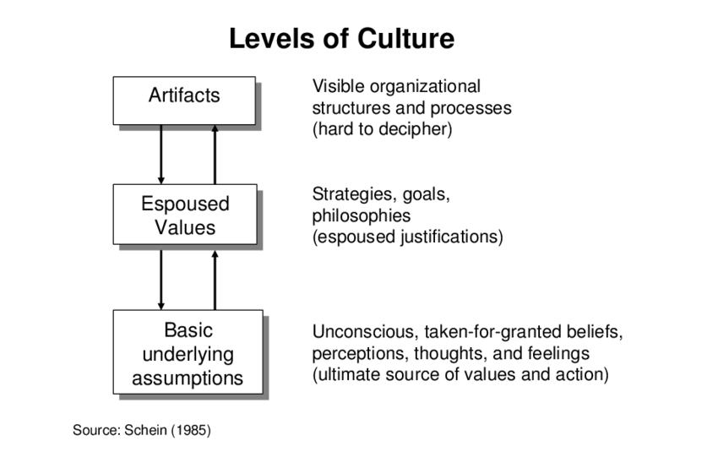
Source: Clark, W. (2002)

Handy’s Cultural Model
Charles Handy, an Irish author and philosopher who focused on corporate culture, behaviour, and management, and Roger Harrison, an occupational psychology professor, created Handy's model of organisational culture. Although Handy introduced the concept in his 1976 book Understanding Organisations, the theory is still applicable today. Researchers began tying organisational structure and culture together by using Charles Handy's approach to examining culture. Handy distinguished between four different kinds of cultures: person culture, task culture, role culture, and power culture.
- Power Culture
Major decision-making authority in organisations with a power culture is vested in a small number of people, usually a leader or firm owner. These people are in complete charge of the organization's operations. These kinds of organisations are hierarchical. Workers receive tasks from above and obey directions. Small enterprises with founders who maintain control frequently exhibit this kind of workplace culture.
- Task Culture
Task-oriented organisations concentrate on finishing particular assignments and projects. Teams of people with the right resources, interests, and abilities get together to collaborate on a project. Individual goals are subordinated to the team's goals, and seniority and position are less important than expertise. While managers possess the ability to assign projects and resources, they are not always in control of daily duties. Organisations like design and advertising companies that handle project-based work frequently exhibit this kind of organisational culture.
- Person Culture
Organisational culture theory describes companies in this category as having very little management and structure. People operate autonomously, and the organisation exists solely to assist them or advance their goals through the sharing of resources like the office space or IT infrastructure, for example. People are more inclined to prioritise their personal careers over the requirements of the larger business.
These organisations are not likely to be hierarchical. This kind of culture can be observed, for instance, in certain institutions, law businesses, and GP practises.
- Role Culture
Role-cultured organisations have distinct protocols and hierarchies, and members are aware of their place in the hierarchy. Roles and duties are delegated to employees based on their qualifications, interests, and areas of specialisation. An individual gains power as they advance up the career ladder. These workplaces typically offer a well-defined professional path. Person culture is a unique kind of culture in which the person is the main focus. In this kind of culture, the organisation exists to assist people, not the people assisting the organisation.
In larger businesses, this is one of the most prevalent forms of working cultures.
Handy (1993) argues that each of the above types of cultures may be fine, but sometimes, employees are often inflexible with regards to culture, meaning that they often believe in the myth that what works well in one organisation may also be successful in another (1993:183). In addition, Handy (1993) adds that an employee who is successful in one type of culture may not always do well in another (1993:204). Moreover, it is up to the executive of the organisation to handle all four cultures, to distinguish and to amalgamate within (Handy 1993:216).
The Handy Model demonstrates how an organisation might have issues dependent on leadership, thus the variances are noteworthy. Simultaneously, in situations when there is no personal or particular group liability, the Schein Model assigns responsibility for any issue to all employees. The organisational culture theoretic reasons are found in the Schein and Handy models. The two models are similar in that they have identified the importance of employees taking on decision-making and responsibility based on their area of specialisation. Regarding distinctions, the Schein model contends that fundamental characteristics of human nature emerge from presumptions about values in which a particular group may experience domination (Coghlan, 2020). The creator of the Handy Model recommended that workers determine their own capabilities by voluntarily taking on difficulties, meaning that each individual is responsible for every task that is allocated to them. Task, power, person, and role cultures are included in the handy model. Schein's technique involves a methodical adjustment of organisational culture to create a single behaviour. The way that an employee engages with different organisational principles is similar in both models. The Schein model is said to provide for flexibility inside an organisation, whilst the Handy Model may have disadvantages for those with strong beliefs.

My Organization
The Casino's organisational culture is examined using Hofstede’s organisational culture model as a framework.

Hofstede’s Cultural Dimensions Theory
Geert Hofstede created the Hofstede's Cultural Dimensions Theory, a framework for comprehending how cultures differ between nations. Power distance, individualism against collectivism, masculinity versus femininity, short-term versus long-term orientation, and uncertainty avoidance are among Hofstede's first six essential aspects.
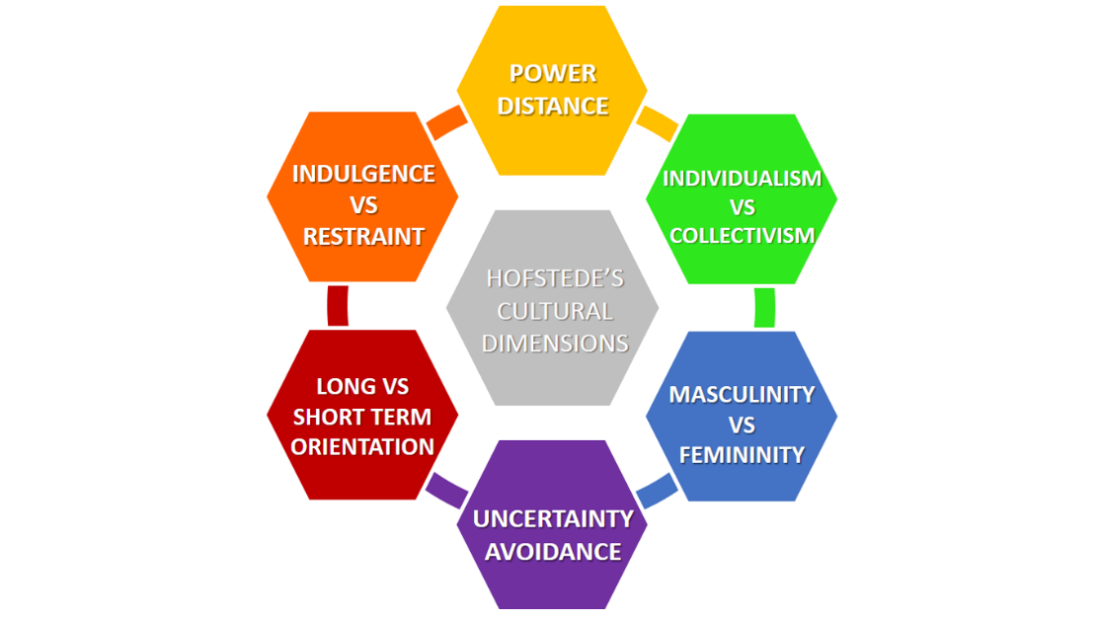
The Casino has effectively struck the correct balance between goal orientation and the mean by encouraging staff to take calculated risks only when they are justified and by highlighting the significance of achieving goals. Because integrity is regarded as a vital value, Casino makes sure that its workers adopt ethical and integrated methods for achieving their assigned goals by emphasising the mean orientation. Employees are urged to only support healthy competition in this way.
By emphasising goal orientation, Casino motivates staff members to give their all in achieving the designated goals. Workers who take chances and share novel ideas are not penalised. Casino has been effective in lowering its staff members' fear of failing in this way.
The organisational culture of the casino is more inwardly focused than outside focused. Top management clearly emphasises the significance of adopting an ethical mindset while responding to market needs, even in the face of guaranteeing a prompt reaction to evolving client expectations. The business is steadfastly committed to integrating ethics and integrity into all aspects of its operations. The company has been able to leverage its ethical brand image as a strategy to gain a significant competitive advantage over other businesses thanks to its internally driven organisational culture.
The organisation and work culture of the Casino are more closely associated with a structured work environment featuring a tall structure and vertical hierarchy. In other words, it indicates that management directly supervises employee behaviour at work and retains decision-making power. Encouraging employees with a range of monetary and non-monetary rewards fosters creative and innovative work behaviours.
The organisation encourages its staff to conduct themselves professionally. You are not required to act in a specific manner. At Casino, individuality is valued and variety is encouraged. The purpose of it is to take advantage of the opportunities that these positive differences present. The example of the Casino demonstrates how crucial it is to develop a formal organisational culture in order to succeed in a highly diverse setting.
Open lines of communication and a flexible, diverse organisational culture are features of Casino. The Casino's capacity to oversee a highly diverse workforce is another factor contributing to its competitive advantage.
The ideology, order of importance, and general focus of management towards the well-being of employees or the achievement of work objectives are reflected in the employee and work orientation. Because the casino management genuinely recognises the worth of its human resources, employee motivation and happiness are given top priority.
The corporate culture of the Casino demonstrates how prosperous companies strive to create an effective culture by striking the correct balance rather than taking an extreme cultural stance. The workforce at Casino is extremely diverse, yet they all share a strong organisational culture that has been effectively established.

Pestel Analysis
To assess my organisation using suitable organisational and environmental analytic methods in relation to its larger surroundings. A SWOT analysis as well as the PESTEL analysis will be used by me. I will be using my current job in my dental practice for the SWOT and Pestel analysis.
An organization's major external influences—political, economic, sociological, technological, legal, and environmental—are examined in a PESTLE analysis. It can be applied in a variety of contexts and aid senior managers and human resource experts in making strategic decisions.
Since the environment in which an organisation operates has a significant impact on it, an environmental audit is essential to determining the company's current state, potential for future growth, necessary modifications,
Political aspects: The UK's political environment is thought to be stable and business-friendly. Brexit has created some uncertainty in the country, but it hasn't had a significant impact on the needs for and operations of the health sector. In order to preserve the rights of the clients, the organisation must take into account a number of healthcare laws, regulations, codes of practise, and guidelines when providing services (Rodrik, 2005).
Economic factors: Despite the UK's modest economic development and the cost of living crises' negative effects, it is evident that people's disposable income is declining, which makes it challenging to expand a clientele. Social networking has led to an increase in orthodontic alignment services and cosmetic dentistry procedures.
Social aspects: People in the UK are highly sensitive of their smile, tooth alignment, and oral health due to sociocultural factors. They know they should get their teeth checked twice a year and are willing to pay for high-quality cosmetic procedures. As a result, there are a lot of potential clients in UK society who should be identified and contacted using an effective marketing plan. People need to be given access to high-quality, reasonably priced treatment options, as stated by (Powell in 1992.)
Technical factors: Dentistry is a profession that is always being investigated, and new techniques and equipment are frequently added. A few of the newest practises and methods include cosmetic dentistry, smile design, laser therapy, etc., thus the company must be current and flexible.
Legal factors: The dentistry practise must take into account a number of laws, rules, and regulations, including the Data Protection Act, the Equality Act, the Anti-Discrimination Act, the Safeguarding Vulnerable People Act, and others. Laws pertaining to minimum wages, corporate social responsibility, employment, and other topics must also be taken into account.
Environmental laws: in order to prevent the negative impacts of a large volume of dental waste on the environment, the organisation must successfully follow waste disposal procedures. They have also changed their supply chain procedures and are fully conscious of their corporate social responsibility (CSR) in order to run a sustainable business (Sadler, 2003).

SWOT Analysis
Strengths, Weaknesses, Opportunities, and Threats are referred to as SWOT. This framework helps identify a company's competitive advantage-giving strengths, weaknesses that are impeding further growth, market opportunities that can be leveraged to improve business, and possible threats that could further impede growth in the future. According to Afonso and Sousa (2012), the organisation can evaluate its present state, plan strategically, and make decisions that will lead to future growth with the aid of this organisational audit.
Strengths | Weakness
- Only branded group offering NHS and Private treatment  - Excellent team of dental professionals  - Clinics have advanced equipment  - Transparent costs of services  - Latest and up to date trends used e.g Invisalign, composite bonding and whitening | - Treatments and services are considered expensive for users  - Set up is very expensive  - Several legislations, laws and health policies working in Favor of people  - Patient can be hard to satisfy
Opportunities | Threats
- Dental professionals, hygienists can be trained further to improve quality and efficiency  - High potential to grow within UK  - Oral surgeries can be increased | - Industry has fierce competition  - Profit margin reduces with such high competition  - Local practices offering cheaper services  - Competition on services that other practices offer

Currently operating a profitable business in the UK, Roderick's Dental Care provides its clients with high-quality, patient-centred dental services for NHS and private. But with the danger of new entrants, the rivalry is fierce in the health sector, particularly in the dentistry area. As a result, in order to attain its objectives of taking the lead in the industry and gaining a competitive advantage over rivals, the organisation must constantly devise new plans and take action.

McKinsey 7s Framework
To assure quality and efficiency in the most economical manner, every healthcare system must be built on an optimised delivery model. Sustainable healthcare models over the long run are those with optimal delivery systems.
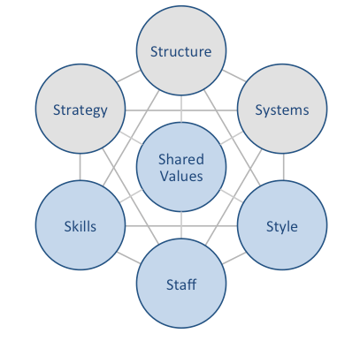
The McKinsey 7S Model was developed in the 1980s by three McKinsey consultants, Tom Peters, Robert Waterman, and Julien Philips. It would go on to become one of the most effective instruments for analysing organisational design. They compiled a list of the following seven internal factors that affect an organization's efficiency:
- Strategy
According to the McKinsey 7S model, strategy is the method a business use to obtain a competitive edge and accomplish its long-term objectives. A great strategy is supported by strong values, a well-defined vision and goal, and both. The strategy of a company should, above all, be in line with the other six McKinsey 7S model components.
- Structure
Put simply, it has to do with understanding the chain of command and who is the source of instructions. It's incredibly hard to run everyday activities properly without a good structure.
- Systems
The methods and procedures that carry out a business's everyday operations are referred to as systems. These processes and workflows are part of an organization's regular operations.
The system we use at Rodericks dental is EXACT, is an effective way for us to communicate within the practice to ensure efficiency.
- Shared values
The fundamental component of this concept is "shared values," around which all other elements are centred. Norms and conduct that are anticipated of every employee are examples of shared values. Employees are expected to become familiar with these before starting work; they are typically addressed in the business rules.
Rodericks Dental values - To create a dental business that serves both its patients and the people who work there, we need strong foundations. Our values provide these foundations enabling colleagues to build careers, patients to build trust and our organisation to build its reputation.
- Skills
Skills refers to the abilities and proficiencies of those that work for the company. An organisation can either acquire new personnel or upskill existing ones to make sure they have the proper skill set to accomplish its goals.
Rodericks places a high value on skills; to make sure that staff members are trained in compliance with rules, frequent workshops and training sessions are held.
- Style
Style describes the typical management approach used by an organisation. It also covers the unwritten policies and culture of the business. In order to guarantee efficiency and work happiness, a strong leadership style is necessary.
At Rodericks, the leadership approach is participative. Seniors interact with staff members at all levels and solicit their opinions in order to enhance operations and strategy or to spot and settle any disputes.
- Staff
This component covers hiring, onboarding, and employee maintenance in addition to actual workforce participation. Other aspects including the workforce's size, diversity, and benefits for employees must also be taken into account.
At Rodericks we are a small team and we treat each other like family, we have regular nights out for team building.
Although each of the seven components in the McKinsey 7S model is equally significant, they are separated into two groups: hard elements and soft elements.
Because they have an impact on a company's management, the first three elements “strategy," "structure," and "systems" are challenging. However, because they are more abstract and focused on culture, the last four “shared values," "skills," "style," and "staff “are classified as soft elements.
To guarantee that an organisation operates efficiently, it is critical to comprehend each of the seven components separately and how to integrate them with one another.

Cultural Behaviour
An organisation can benefit greatly from a company's cultural awareness. For example, cultural sensitivity helps employers hire and retain highly qualified workers from a variety of backgrounds. Furthermore, via encouraging variety, creativity, and innovation, a multicultural workforce can aid in raising performance levels. Recognising cultural differences is helpful in the hiring process as well, as it allows companies to ascertain the expectations of potential employees before making an offer. Understanding cultural norms for behaviour is essential for both attracting and keeping brilliant workers. To prevent communication problems that stem from misunderstandings, businesses need to be aware of these intricacies.
Workers from diverse cultural backgrounds provide fresh perspectives and ways of thinking to the workplace that can aid in problem-solving inside the company.

Ethical Behaviour
The moral standards that guide our actions, words, and conduct at work are known as ethics. Employees utilise ethics as a guidance to behave morally when interacting with coworkers and consumers. Respecting your coworkers, offering any assistance or support you can to customers, and preserving the company's ideals are examples of good behaviour.
Making the best moral and ethical decisions possible is the main goal of ethical behaviour, also known as ethical conduct. Good behaviour as an employee can involve following and comprehending the company's policies and procedures, telling the truth at all times, and showing respect to everyone you interact with at work.
……. “think of successful cultures as engines of human cooperation…”
Coyle, D. (2019)
Ethics consist of:
- Concern for the well-being of others
- Respect for others
- Trustworthiness and honesty
- Compliance with the law
- Preventing harm to others
To motivate the desired behaviours, an organization's mission, ethical principles, and culture must all be clearly linked.
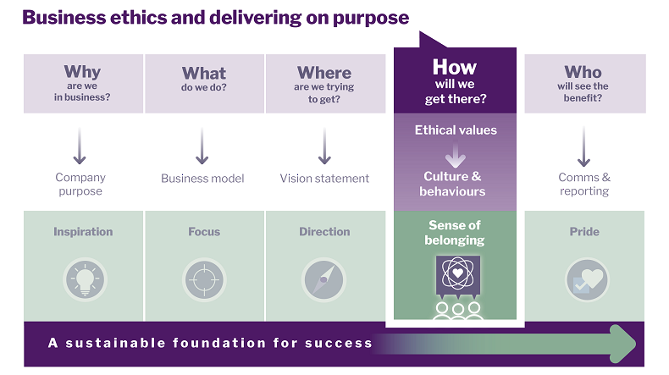
It is crucial to create a distinct connection between the organization's mission (why are we in business) and its ethical principles (how will we get there) in order to guarantee that ethics permeates the organization's culture, directs decision-making at all organisational levels, and encourages the desired behaviours.
Values and purpose form the cornerstone of an ethical programme. Beyond following rules and laws, ethical principles dictate what behaviour is deemed desirable or acceptable in the corporate world.
The organization's values serve as the foundation for all policies, regardless of size, industry, or established policies and programmes. They also serve as the framework for the company's culture and decision-making.

Five fundamental concepts govern dental behavioural ethics: beneficence, justice, honesty, nonmaleficence, and patient autonomy. Under the ethical constraints of the dental licence, these principles guarantee that the demands of the patient are satisfied. Informed consent requirements, patient confidentiality, and the ethics of the dentist-patient relationship are all included in dental ethics. A document outlining the values, norms, and guidelines that apply to every member of the dental team lays out the standards of behaviour, performance, and ethics that regulate dental practitioners.

Carroll’s CSR Sustainability Pyramid
Carroll's CSR pyramid is a conceptual model that elucidates the rationale behind an organization's social responsibility initiatives. Because of its ageless form and ease of use, Archie Carroll's 1991 creation has grown to become one of the most well recognised corporate theories of CSR.
Carroll's CSR pyramid was created to assist businesses in changing their practises to ensure that all of their endeavours are financially successful, morally sound, compliant with the law, and benefit society. The theory states that firms have four levels of duties that they must perform in order to do this: economic, legal, ethical, and philanthropic.
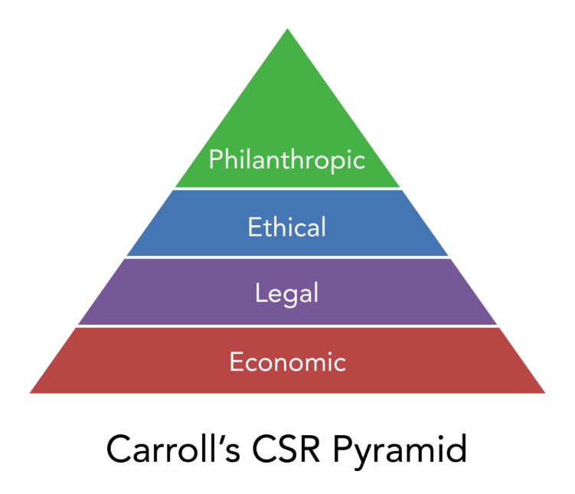

Economic Responsibility
Carroll's Corporate Social Responsibility Pyramid is based on the principle of economic responsibility. This is due to the fact that profitability is the sole means by which a firm can endure and provide long-term support to society. Businesses cannot pay their employees, provide shareholders with a return on their investment, or manufacture high-quality goods and services without a profit.
Legal Responsibility
Legal responsibility is the next rung on Carroll's pyramid of corporate social responsibility. This is a reference to a business's legal duty to follow all applicable rules and laws. This include adherence to rules governing anti-competitive behaviour, tax laws, employee health and safety requirements, and employment laws.
Ethical Responsibility
The ethical responsibility layer is the next layer up the pyramid. It all comes down to acting morally, fairly, and with the intention of causing no harm. This tier of Carroll's CSR pyramid is more focused on morality and ethics than the first two, which are all about legal and shareholder requirements. Being ecologically conscious, treating workers and suppliers according to a code of ethics, and supporting actions and standards that go above and beyond legal requirements are a few examples of ethical responsibility.
Philanthropic Responsibility
The pinnacle of the pyramid represents charitable duty. At this level, the main priorities include improving the community, exceeding stakeholder and shareholder expectations, and going above and beyond to improve the globe. It is more than just doing the right thing; it involves upholding your company's ideals and beliefs and contributing something worthwhile to society. This could take the kind of gifts, volunteer labour, or other charitable endeavours like community development.

Conclusion
I now understand the culture and content of my workplace better. It is obvious that understanding and accepting the fact that every workplace has unique cultures, values, attitudes, and beliefs is necessary for a company to operate well. it can be concluded that having strong values, attitudes, and beliefs that are consistent with the goals and culture of the organisation is necessary for success on both a personal and organisational level at Roderick's. Ethical behaviour also plays a part in how a workplace can achieve success.

Referencing
Abela, S. (2023). Quality, Efficiency and Value in the NHS. In: Leadership and Management in Healthcare. Springer, Cham. https://doi.org/10.1007/978-3-031-21025-9_2
Altaf, A. (2011). The impact of organizational culture on organizational effectiveness: Implication of Hofstede cultural model as organizational effectiveness model. International Journal of Interdisciplinary Social Sciences, 6(1).
Bush, T. (2020, August 22). Pestle analysis explained (with examples). PESTLE Analysis. https://pestleanalysis.com/pestle-analysis-explained-with-examples/
Clark, W. (2002) People Whose Ideas Influence Organisational Work, Kent-UK
Clegg, S. R. et al (2020) Strategy: Theory and practice. 3rd edn. London; Sage Publications Ltd
Coyle, D. (2019) The culture code: The secrets of highly successful groups. Random House Business Books
Coghlan, D. (2020). Edgar Schein on change: Insights into the creation of a model. The Journal of Applied Behavioral Science, 57(1), 11-19.
Dartey-Baah, K. (2013). The cultural approach to the management of the international human resource: An analysis of Hofstede's cultural dimensions. International Journal of Business Administration, 4(2), 39.
De Jonge, J. H. M. (2006) Three Levels of Culture (Schein). 12manage B.V.-The Netherlands [online].
Hofstede Insights (2019). Organizational Culture. Available at: https://www.hofstede-insights.com/models/organisational-culture/
Handy, C. (1993) Understanding Organizations, London-UK, Penguin Books Ltd, 4th Edition.
Jurevicius, O., Nami, A., Saulo, C., Noor, & Rizvi, S. (2023, April 13). McKinsey 7s model: The 7s framework explained - SM insight. Strategic Management Insight. https://strategicmanagementinsight.com/tools/mckinsey-7s-model-framework/
Koch, A. (2000), "SWOT does not need to be recalled: It needs to be enhanced" Swineburne University of Technology. Page no-98-103
Laurie J. Mullins, Gill Christy Pearson, 2013 - Business & Economics -
Our culture. Culture. (n.d.). https://rodericksdentalpartners.co.uk/careers/culture
Purpose, ethical values, Culture & Behaviours. Home. (n.d.). https://www.ibe.org.uk/knowledge-hub/ibe-business-ethics-framework/purpose-ethicalvalues-culturebehaviour.html
Roderick P. Neumann (2005)Political ecology: theorizing scale
Standards - general dental council. (n.d.). https://standards.gdc-uk.org/Assets/pdf/Standards%20for%20the%20Dental%20Team.pdf
Tomas, D. (n.d.). Carroll’s Corporate Social Responsibility Pyramid. Cyberclick. https://www.cyberclick.net/numericalblogen/carrolls-corporate-social-responsibility-pyramid

William E powell (1992) Psychological Social Psychology

