
Environmental Analysis of Automobile Industry Aston Martin
Lecturer: Dr Molly Jack
Student: Sandrina Rangelova
Student number: 1917133
Module code: LCCB4005

Table of Contents
Introduction 1
Overview of the UK Automobile industry 2
SWOT Analysis 2
PESTLE Analysis 4
Porter’s Five Forces Analysis 7
Value Chain 8
Competitive Advantage 9
Conclusion 9
References 10

Introduction
The automobile industry is recognised as one of the most successful industries that involve all kinds of activities related to car production, distribution, marketing and selling. This kind of activity requires a strong idea of how to determine the upcoming challenges and find out the ways of mitigating them (Stubbs, 2015). This report will be highlighting the ways of appreciating the industrial abilities to overcome the negative sides of the pandemic hit. The report will be analysing the automobile industrial factors in the context of Aston Martin Lagonda. It is one of the most prestigious organisations to sell premium sports cars. It is established in Britain and is operating internationally at present. More than 3000 people have been associated with the operations of the company and its revenue was £611.8 million in the fiscal year 2020 (Aston Martin | Iconic Luxury British Sports Cars (United Kingdom), 2021).

Overview of the UK Automobile industry
The automobile industry in the UK is a highly successful part of the UK economy. It generates £82 billion of turnovers and creates an overall value of £18.6 billion in 2018. It tends to manufacture 1.5 million passenger vehicles and the number of commercial vehicles produced by the country is 85,000. At present, more than 823,000 individuals are directly and indirectly associated with this industry. The automotive industry of the country is popular for its luxury sports cars. Some of the luxury brands are Aston Martin, Rolls Royce, Bentley, Jaguar Lagonda, Land Rover, and further on. At present, the UK is considered the second-biggest producer and exporter of cars in the globe. It is estimated that eight out of ten cars manufactured in the country are exported to more than 160 markets all over the world (Pearson, 2021).

SWOT Analysis
SWOT analysis is referred to as one of the most crucial tools for evaluating the internal and external forces of an organisation so that further steps can be taken for the progression of the business (Sarsby, 2017).
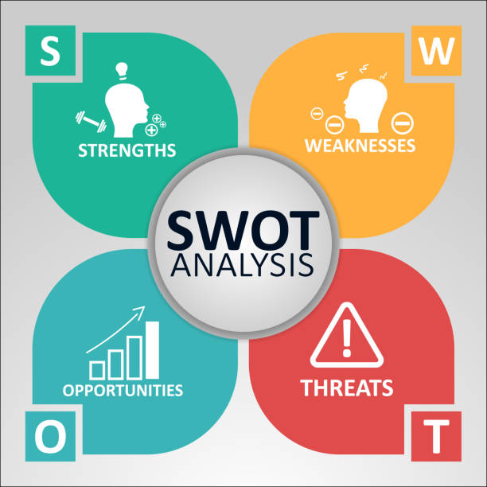
Figure 1: SWOT Analysis
Source: (Sarsby, 2017)
The further discussion will be highlighting the SWOT analysis of Aston Martin so that its current inner and outer state can be recognised.
Strengths | 1. Aston Martin is a British brand that possesses a supreme legacy and strong brand equity.  2. The brand is known for its highly strong and efficient engineering and design team.  3. It provides comfort and luxury through both its products and services.  4. The use of Aston Martin sports cars in racing and sports car events are quite high and frequent.  5. The brand tends to adopt proficient and technical branding and advertising strategies along with the use of a strong and innovative technological edge.
Weaknesses | 1. Aston Martin brand does not have a much-diversified portfolio.  2. This company tends to use less market penetrating strategies (Stanley, 2021).
Opportunities | 1. The increasing market expansion opportunities can be a great advantage for Aston Martin.  2. The strong heritage and supreme historical value carried by the brand can help the company to not only gain new customers but also have a deep market penetration.  3. The company can include active distribution and extensive promotional content in its tactic list for market penetration.  4. It can also look for adopting a competitive pricing strategy to attain customer attention.  5. The current growth in the demand for electronic vehicles can be another useful thing for the brand (Warren, 2021).
Threats | 1. The growing costs of fuels is a big problem for the brand which can significantly affect its sales.  2. Strict rules set by the government can be a big issue for the organisational development of Aston Martin.  3. The other large and successful automobile plants like- Jaguar, Bentley, Porsche, Maserati, etc. are a great threat for the brand to dominate the market (Stanley, 2021).  4. Recently, the competitors are spending a lot on innovative approaches which can cause a problem for the company.  5. Many competitors are focusing on the frugal engineering approach which is another issue for the growth of the brand.
Table 1: PESTLE Analysis of Aston Martin
Source: Author

PESTLE Analysis
PESTLE analysis is a method of demonstrating the macro-environmental factors within an organisation so that it can come up with tactics to avoid all the harms lingering to the environment in which the organisation is operating (Marmol and Feys, 2017).
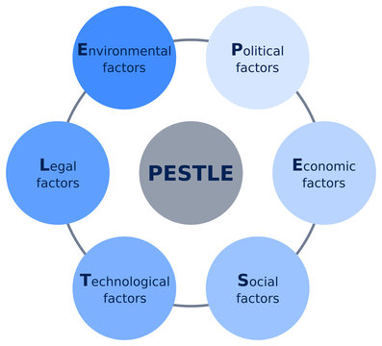
Figure 2: PESTLE Analysis
Source: (Marmol and Feys, 2017)
Political factors: Political factors tend to affect organisational development in other countries, especially, globally operated organisations like Aston Martin are highly influenced by it. The political environment in different countries vary and it creates an impact on the brand. Aston Martin has to develop its business in various countries in Europe and America. The political situations in these countries have a very important role in business expansion. Due to the COVID-19 effects, the cost of labour has inclined which has created a difference in the attitude of expansion of the brand. Besides, lockdown and other pandemic-related measures taken by various countries have hindered the business actions of Aston Martin in global business.
Economic factors: The economic changes that occurred in various countries have more or less influence on the brand. Due to the COVID-19 outbreak, the production of moto vehicles has declined. The following chart will be highlighting this fact.
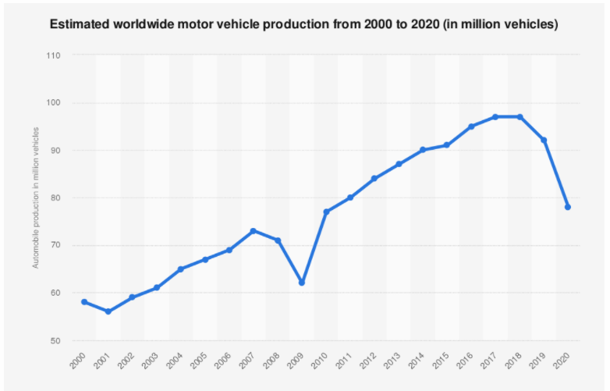
Figure 3: Worldwide Automotive Production from 2000 to 2020
Source: (Teresa, 2021)
Here it is seen that due to the pandemic hit, the production rate in this sector has seen a fall in 2020. As an outcome of it, the sales growth also tend to see a negative impact. The below-given chart will portray the sales growth in the global automotive industry.
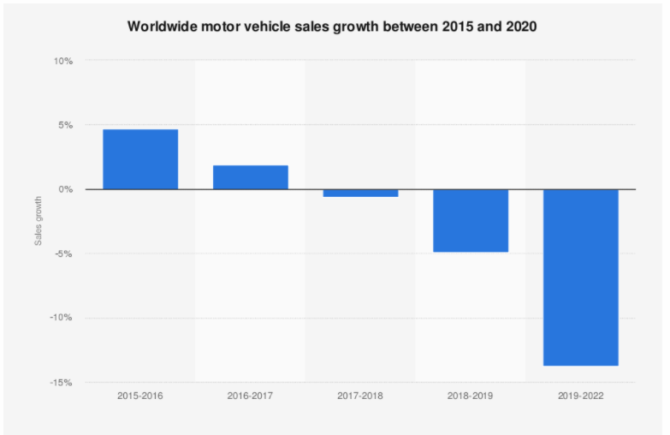
Figure 4: Worldwide Sales Growth in the Automotive Industry from 2015 to 2020
Source: (Covid-19’s impact on the automotive industry worldwide, 2021)
From this chart, it is seen that the pandemic has declined the sales growth in this sector and so the production level and sales of Aston Martin are also predicted to be decreased by this period.
Social factors: Social factors tend to have a deep impact on people and their way of thinking towards a brand. Aston Martin offers premium cars which are usually offered only for a particular segment of people in the society. Its societal impacts include power and performance along with the attitude to attract only a premium group of audience. Due to the pandemic, this significant social group is not much affected and it tends to show fewer impact on Aston Martin as well.
Technological factors: These factors are highly important in an industry like the automobile. Due to the pandemic hit, the activities of the research and development of various sectors had been hindered. However, the use of innovation and new IT products in the automotive sector has been constant in these years which is a good thing for Aston Martin (John and Mike, 2021).
Legal factors: Due to the pandemic, in the global business environment, the laws and rules have become more strict. The health and COVID-19 based laws, consumer laws, etc. have become more important for any business to perform. In the global business, Aston Martin has to deal with all these laws and it might also increase its organisational expenditures as well.
Environmental factors: Various environmental factors have a great influence on the organisations operating within the business area. Pollution and pressure groups are some of the major problems faced by the automobile industry. So, Aston Martin has to be careful enough to avoid these problems.

Porter’s Five Forces Analysis
Porter’s five forces model is known as the process of analysing and representing the market position of a new or established business so that future possibilities can be measured and determined effectively (Brian and Cayan, 2015).
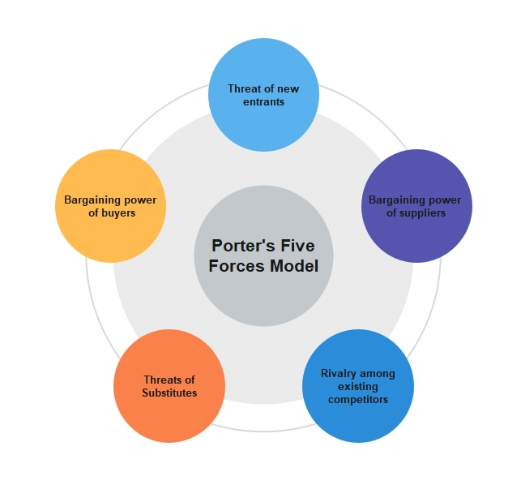
Figure 3: Porter’s Five Forces Model
Source: (Brian and Cayan, 2015)
Now the current position of Aston Martin will be evaluated based on Porter’s five forces theory so that in-depth knowledge in this regard can be gained.

The threat of new entrants (Low): In the automotive sector, a business requires a huge amount of initial investment and also a good amount of working capital. So it is quite tough for an organisation to easily seek entry here. And if any organisation enters it, it will be hard to take the exit with such big investments (Nicholas, 2021).
Bargaining power of buyers (High): As Aston Martin offers luxury and premium cars, all can't buy them. In this case, the bargaining power possessed by buyers tends to be higher. If the buyers have a significant influence on the market price, they tend to bring the price down. However, in the case of luxury brands, such things rarely happen. Still, the car’s buyers are significant in number which make their bargaining power strong.
Bargaining power of suppliers (High): The suppliers, in this case, have strong power to bargain. Here, the number of suppliers is less and so they have a good standing in terms of setting the market price and other factors. It shows the fact that if the suppliers have bargaining power, they will be adopting means to extract a handsome price from Aston Martin (Nicholas, 2021).
The threat of substitutes (High): The threat of having substitute products or services become quite strong in the case of Aston Martin. Though the company offers luxury sports cars, the threat of substitute products will be high if the investment in the research and development sector is not satisfactory.
Rivalry among existing competitors (High): There is extreme competition existing in the automotive market. It means that Aston Martin has to deal with a group of powerful and well-known business rivals like- Bentley, Rolls Royce, Porsche, BMW, etc. in the market (Nicholas, 2021).

Value Chain
To understand the value chain of a particular organisation or industry, first, it is required to analyse the significant changes and progress happening in that sector. The automotive sector in the UK is focusing on the restore manufacturing process and Aston Martin tends to try to develop its flexibility and sustainability (Robert and Ashton, 2021). To ensure a proper supply chain element not only in the domestic market but also in the global economy. Its supply chain operations deal with cost, quality, environmental, and risk management criteria.
Aston Martin has to communicate and deal with approximately 200 suppliers for the acquisition of its car parts and most of them belong to the UK. Moreover, the rest of the suppliers come from various other countries like- Europe, North America, Asia-Pacific, etc. are regarded as strong regions to hold its activities as well (Robert and Ashton, 2021). However, as an internationally operated company, it is not so easy to have a stronghold in foreign markets. It became possible because of the realistic and strong logistics support too. Moreover, high-skilled procurements also take place in competitive markets and the automotive industry, it is quite important to maintain a good sales volume. After the pandemic, the company is also adopting digitalised transformation and supply chain resilience. It not only declines the efforts of workers but also minimises costs. Besides, the company can easily send its products to different parts of the world through its existing line of conduct. It is estimated that this company has more than five thousand lines of supply which made it easier for it to maintain a good supply chain management system.

Competitive Advantage
Competitive advantage is the feature that enables an organisation to dictate a special position in the consumer’s mind and strengthen its position in the market. As for Aston Martin, its competitive standing is quite efficient in the market compared to its competitors. Its tagline bears power, beauty and soul which enables us to predict that it tries to capture audience based on performance and satisfaction parameters. Aston Martin has created a daunted competitive advantage by offering cars with superb performance and ultimate luxury (Stella, 2021).

Conclusion
The report tends to identify the current conditions of the automotive industry in the context of Aston Martin. It demonstrated internal and external analysis of the company along with the evaluation of its macro-environmental perceptions. It also highlighted the fact how the industry got affected due to the pandemic. It concluded all the facts based on the analysis of Aston Martin and its activities.

References
Brian, D. and Cayan, Z., 2015. An Upgrade To Competitive Corporate Analysis: Creation Of A Personal Finance Platform To Strengthen Porters Five Competitive Forces Model In Utilizing. Journal of Business & Economics Research (JBER), 13(1), p.54.
Faistgroup.com. 2021. Covid-19’s impact on the automotive industry worldwide. [online] Available at: <https://www.faistgroup.com/news/covid-19-impact-automotive-industry/> [Accessed 16 December 2021].
John, F. and Mike, K., 2021. UK car production down -29.3% as coronavirus slams brakes on the sector - SMMT. [online] SMMT. Available at: <https://www.smmt.co.uk/2021/01/uk-car-production-down-29-3-as-coronavirus-slams-brakes-on-sector/> [Accessed 18 December 2021].
Marmol, T. and Feys, B., 2017. PESTLE analysis. 4th ed., Pearson: London
Nicholas, L., 2021. Solved Porter 5 Forces: Aston Martin: The Crossover Conundrum Analysis. [online] EMBA Pro for Executive MBA Professionals. Available at: <https://embapro.com/frontpage/porter5forcesanalysis/20674-lagonda-aston> [Accessed 19 December 2021].
Robert, N. and Ashton, K., 2021. What Went Wrong in Aston Martin’s China Supply Chain? | China Checkup. [online] Chinacheckup.com. Available at: <https://www.chinacheckup.com/blog/aston-martin-china-2014-02-12> [Accessed 19 December 2021].
Sarsby, A., 2017. SWOT analysis. 2nd ed. London: Wiley.
Stanley, M., 2021. Aston Martin SWOT Analysis, Competitors & USP | MBA Skool. [online] MBA Skool. Available at: <https://www.mbaskool.com/brandguide/automobiles/4903-aston-martin.html> [Accessed 16 December 2021].
Stella, K., 2021. Aston Martin DBX vs Mitsubishi Express. [online] CarsGuide. Available at: <https://www.carsguide.com.au/aston-martin/dbx/vs/mitsubishi-express> [Accessed 19 December 2021].
Stubbs, A., 2015. Drop Forging and the Automobile Industry. Proceedings of the Institution of Automobile Engineers, 9(2), pp.357-391.
Warren, B., 2021. Global Automotive Megatrends and Markets Sector Overview Report, Q3 2021 Edition - ResearchAndMarkets.com. [online] Businesswire.com. Available at: <https://www.businesswire.com/news/home/20211011005339/en/Global-Automotive-Megatrends-and-Markets-Sector-Overview-Report-Q3-2021-Edition---ResearchAndMarkets.com> [Accessed 18 December 2021].

