

Name: Jevgenija Hlebnikova
Student Number: 1705773
Module Title: Digital skills and research methods BMSK4003
Assignment Title: Digital Skills and Research Methods
Module Lecturer’s Name: Paul Wallin

Table of Contents
Executive Summary 3
Introduction: 4
Digital Skills and Workplace Environment: 4
Types of Digitalization in the Workplace: 4
1. Cloud Based System: 5
2. Mobile Networking: 5
3. Automated Data: 6
4. Self-Monitoring Database and Communication: 6
Skills Needed for Employees in the Workplace: 6
Research Outcome of Digital Skills in the Workplace: 7
Research Topic: 7
Literature Review: 7
Research Questions: 8
Research Methodologies: 8
Data Collection: 8
1. Primary Data: 8
2. Secondary Data: 9
3. Sampling: 9
4. Scales: 9
Research Questionnaire: 9
Findings: 10
Overall Findings of the Data: 12
Conclusion: 13
References: 13

Executive Summary
The aim of this report is to analyze and evaluate the procedures of using digital skills in the workplace in organizations and to sustain competitively in the market. In this report, we will see about the digital skills and the importance of digital skills. To make digital skills effective for every personnel in the organizations, effective analysis with secondary sources of information will also be described in this report. How workplace environment and work efficiency has a positive relationship now a days with the digital skills among the employees and personnel in organizations that will also be discussed in our report. We will also analyze about the workplace data handling like the maintenance of data, security and privacy of the data etc. After all the analysis of the digital skills and the effectiveness about the digital skills in the environment, we will carry out a research. We will make a formal and structured questionnaire about the effectiveness of digital skills in the workplace, why employees should have the skills etc. Our research will be based on the secondary data analysis procedure where we will slightly use primary data like questionnaire, demographic part of the respondents those who are contributing a great role in our research. Our research report is based on four parts. The first part will be discussed about the digital skills and workplace environment of the employees. The second part will be about the importance of digital skills and types of digital skills. Third part will be about the data handling procedure which is actually the security, privacy of the data in the workplace. Fourth part will be a small research with a structured questionnaire which will be developed by the secondary and both primary data analysis.

Introduction:
In this age of globalization, digitalization and technical advancement are the key factors for organizations to achieve goals and objectives. Every big and small companies now a days having technical staffs for their IT and technical support and for respective unit. Digitalization is the process of evaluating and judging a company’s strength now a days. So, employees of an organization should be well organized and trained with the process of digitalization in the organization.

Digital Skills and Workplace Environment:
Due to the modernized and technological advancement of recent years, organizations are mainly dependent on the digitalization of the company. Most of the companies have the IT support team, internal database server and communication system which actually enables the opportunity for the company. According to Taylor, he stated that digitization is an effective factor for the companies to achieve organizational goals (Taylor, 2009). So, digitalization is an important factor for the organizations. In order to keeping a better digitalization in the workplace, employees should be skilled. Employees should have various hard skills like data surfacing, maintaining emails, database handling and many more issues. Staffs and employees should have the knowledge of giving emails, using mobile smartphones with various applications and tools. So, organizations should recruit the best possible candidates.

Types of Digitalization in the Workplace:
There are many types of digitalization are found now a days. According to Maslow, organizations are very much aware and competitive in terms of digital skilled people in the recent past years for the extreme competition and challenges which actually enables the effectiveness in the workplace and in the organization (Maslow, 2009). Digital skills are different from organization, type of work and job description. The basic digitalization which are actually needed for the workplace given below-

Cloud Based System:
Cloud based system actually enables the availability of the information externally or by internally among the employees and users. Organizations now have an internal domain for maintaining cloud services for keeping their data.
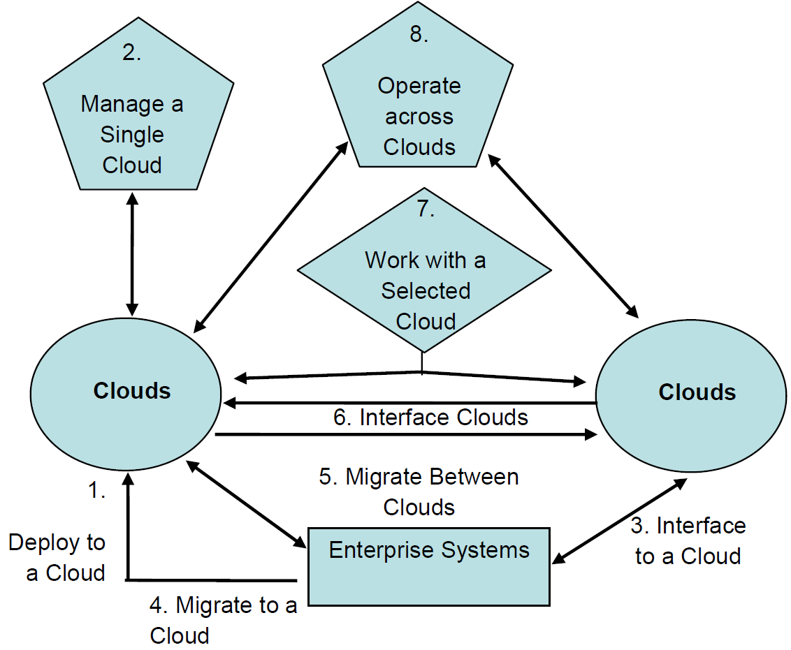
Figure: Cloud Based System
Here, the enterprise has a cloud based system which actually internally interfaced between two clouds.

Mobile Networking:
Smartphones are the best networking platform now a days. According to Fisher, he stated that cellular networking and hi speed internet makes people more active and workplace environment is emerging day by day because of the smooth accessible criteria with smartphones among the employees and users in organizations (Fisher, 2013).

Automated Data:
Information from various sources that are widely being used in the company. According to Hector, he stated that data automation reduces the hassle and errors in the operations and thus organizations are very much effective and efficient which actually enables a better workplace environment for its employee (Hector, 2012).
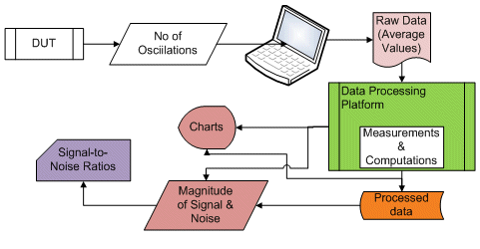
Figure: Automated Data Processing

Self-Monitoring Database and Communication:
Organizations are mainly dependent on the employees. And so, implementing new technology is not actually the current solution for companies. Employees should be knowledgeable about the basic of internet browsing and email checking which actually needed manually by employees. To maintain a better internal and external communication, organizations now a days maintaining employee code for each and every employees, staffs in the organization.

Skills Needed for Employees in the Workplace:
As organizations now a days mostly dependent on the various database, servers and in many technical aspects are implementing, employees should be well skilled and trained in the recruitment procedure by organizations. According to Hofstar, he stated that hard skills like networking, skills for running various tools are important for the employees in an organization to cope up with the organizational culture (Hofstar, 2015). Various skills are needed for the employees in an organization. Skills are divided into two categories. Soft skills and hard skills. Because of the digitalization and technological advancement in the workplace, employees should be well skilled about various skills. The skills which are known as hard skills. Hard skills actually consists of the IT skills among the employees and staffs. In an organization, employees have ID card and they must know about the use of ID card, ho to punch it in the bar code, how to give mail, ho to communication in the external and internal servers (Extranet and intranet) and many more uses of software and applications. Basic coding and software operating, social media managing, SEO (Search Engine Optimization) etc. are the main and most demandable skills for an employee or a candidate.

Research Outcome of Digital Skills in the Workplace:

Research Topic:
“Digital Skills among Employees in Workplace Environment”
Globalization already made organizations more competitive. To cope up with the challenge of globalization, management always thinks one step ahead against its competitor. Due to the digitalization in the workplace, organizations need to appoint and hire skilled employees for achieving the organizational goals. It actually depends on the organizational behavior, management terms and policies. Employees should have the basic skills now a days like networking, MS Office, cloud storage system, database maintenance etc. These things are actually needed for organizations for the work efficiency and effectiveness of the outcome. So, in this part, we are going to analyze whether digitalization is necessary in the workplace environment or not and how employees should be cope up with the digitalization process, implementation strategy with organizations.

Literature Review:
Benzamin said that digitalization is the process of maximizing working efficiency and effectiveness in the workplace (Benzamin, 2014). Here the process is actually maintained by the top tier of the management. Top level management and every personnel in the workplace should be aware and well trained with any implementation of the new technological strategy by the management. Zeithaml stated that employee satisfaction is totally dependent on the company’s overall performance and employee perception should be changed by the digitalization in the workplace environment (Zeithaml, 2010). Skilled employees are the key to management. Digital skills and implementation digitalization is challenging because of the trained and skilled personnel. According to Sarah, workplace environment and digitalization actually interrelated now a days for the effectiveness among the employees (Sarah, 2014). So, digital skills are important for the workplace environment.

Research Questions:
Research questions are actually the problems of the research. Here, we will analyze how digitalization, where to put emphasize and what will be the workplace environment for employees in organizations. Our research questions are-
- Does digital skills affects workplace environment?
- Does digital skills are necessary for the employees?

Research Methodologies:
Research methodologies actually refers to the point of the research, what the research will be. There are two types of research methodologies are found. One is quantitative and another one is qualitative research. We actually do a quantitative research with a casual study. We will analyze whether digitalization is related or not with digital skills and procedures with the workplace environment.

Data Collection:
There are two types of data are found. Primary data and secondary data. Data collection is an important task for a research. According to Hox, J & Boeije H, the accuracy and validity of a research is totally dependent on the data collection procedures and if the data is primary, the research will be more unique and updated (Hox, 2005).

Primary Data:
Primary data are the investigative data and unique data which are newly collected by research questionnaire and by various methods for a research. Primary data collection is very much costly and time consuming. We will make a questionnaire about digital skills and its importance and give the questionnaire to the employees of different companies like banks, IT, investment firms and ad agency. Primary data collection procedure includes focus group interview, telephone survey, personal interview and written questions.

Secondary Data:
Secondary data are available in various sources like websites, journals, and newspapers. Secondary data are quite inexpensive and reliable because of the validity of the data. We will add some secondary data for digitalization, its importance and implementation in organizations.

Sampling:
We will do a quantitative research and our sample size is 20. We will make a structured questionnaire and give the questionnaire among the employees of four reputed organizations about their perception, skills and knowledge about digitalization in their workplace.

Scales:
All constructs are measured by 5 point Likert scale, anchoring from Strongly Disagree to Strongly Agree.
1  Strongly  Disagree | 2  Disagree | 3  Neutral | 4  Agree | 5  Strongly Agree

We will use Microsoft Excel for analyzing our data.

Research Questionnaire:
Please tick (√) the section that represents the appropriate response for the following items:

- Male Female
- Age:
15-25
26-35
36-45
46 and above
- Marital status:
Married Unmarried

Digital Skills among Employees in Workplace Environment | Strongly Disagree | Disagree | Neutral | Agree | Strongly Agree
1. Digitalization in the workplace increases the effectiveness and efficiency of the work. | 1 | 2 | 3 | 4 | 5
2. Staffs and employees should be well trained and should have some basic skills of coding and networking. | 1 | 2 | 3 | 4 | 5
3. Organizations should create better scope for skilled personnel who are effective in technical solutions. | 1 | 2 | 3 | 4 | 5

Findings:
We will analyze the data in excel and for 3 questions, our result is given below-

Figure: Respondent’s Result in Question 01

Interpretation:
Among the 20 employees from different companies in UK including banks and IT Company, we have found that 40% respondents of our surveyed respondents are agreed with the statement that digitalization in the workplace increases the effectiveness and efficiency of the work. So, employees are also have a positive image about the digitalization in the workplace and digital skills in organizations as it actually increases the effectiveness and efficiency and thus organizations will achieve organizational goals and commitment.

Figure: Respondent’s Result in Question 02
Interpretation:
Here, no respondents were disagreed in the statement that staffs and employees should be well trained and should have some basic skills of coding and networking. As technical implementation like database, cloud system and internal domain, employees at least have some coding and networking skills which is mandatory in every organizations. 35% respondents are very much positive about the training and development of employee in digitalization. On the other hand 30% are neutral. They were asked why they are neutral and the responses were quite hypothetical. They sometimes found that system and servers sometimes got crashed or hacked which is actually a tragic situation for them. They also give some solutions regarding the safety and security in the workplace environment for digitalization.

Figure: Respondent’s Result in Question 03
Interpretation:
50% respondents are agreed that organizations should create better scope for skilled personnel who are effective in technical solutions. Organizations should create better opportunity for the employees for implementing any ERP software, applications and web based mail solution.

Overall Findings of the Data:

Figure: Overall Findings
Here, 25% respondents are positive and agreed with the statement that digitalization is very much needed for the organizations. As competition is extreme and to sustain in the global and local market, organizations should take some ERP based software, internal domain for communication, cloud and web based mail for the employees as well as for the customers, clients and shareholders for any information and communication.

Conclusion:
Digital skills are very much needed and a dependent factor for achieving organizational goals and maximize profits. To cope with the digitalization in organizations, employees should have various technique and skills about networking, emailing, data handling and monitoring. Organizations should create a better opportunity for the employees and staffs to cope with the new digitalized strategy and tactics for the effectiveness of the organizational performance. There are several digitalized opportunity are being taken by organizations now a days. So, for candidates, they should be updated and have the capability of working in a workplace which actually monetarized with the latest technology and advancement. Organizations should give opportunity to the clients, shareholders as well as the external partners to understand the core value of the digitalization and various enterprising software for any information regarding company and management, for any financial data etc. In fine, we can say that digital skills are important and an essential element for the personnel in an organization.

References:
Benzamin. (2014). Motivation and Employee Satisfaction. Analysis of Effective Workplace Environment, 4, 90-100.
Fisher. (2013). Digitalization and its Effectiveness. Skills for the Employees, 78-90.
Hector. (2012). Data Automation and System for Managers and Employees. In Workplace Environment and Motivation (Vol. 3, pp. 567-590). Chicago: Pearson Publication.
Hofstar. (2015). Organizatiol Behavior. Hard Skills for the Employees in the Organziation, 5, 78-99.
Hox, J. &. (2005). Data Collection Primary vs Secondary. Encyclopedia of Social Measurement, 1, 593-599.
Maslow. (2009). Organizational Behavior (2 ed., Vol. 2). NY: Hudson Publication.
Sarah. (2014). Organizational Behavior and Digitalization. NY: Sarah & Paul Publication.
Taylor. (2009). Digitalization in the Workplace. An Analysis of Workplace Environment in UK, 2, 56-89.
Zeithaml, V, A. (2010). Employee Satisfcation in the Organization. In Zeithaml, Job Satisfaction and Motivation in the Workplace (Vol. 2, pp. 455-479). Boston: Pearson Publication.

