Name: Ionut Bosoteanu
Student ID: 2437564
Module Name: Introduction to Web and Database Concepts
Module Code: ACCA4023
Lecturer: Sadhana Jha

Table of Contents
Introduction ...................................................... 1
Requirements ..................................................... 2
Implementation ................................................ 3
3.1 Home Page ................................................. 3
3.2 History Page ............................................. 4
3.3 List Page ..................................................... 5
3.4 Validation ................................................. 6
Evaluation ....................................................... 7
4.1 Usability ................................................... 7
4.2 Accessibility ............................................ 8
4.3 Search Engine Optimisation (SEO) ....... 9
Comparison .................................................... 10
Conclusion ....................................................... 11
References ...................................................... 12
Appendices .................................................... 13

INTRODUCTION
This report explains the process behind designing and developing a responsive website using HTML and CSS. The website, titled EURO-BASKETBALL, focuses on the rise and impact of European players in the NBA. It brings together different sections, including a home page, a player ranking page, and a history page, all connected through a clear navigation system to create one complete website experience [1].
The aim of this report is to give an overview of how the website was created, from the initial idea to the final result. It will explain how the pages were structured using HTML and how CSS was used to improve the overall design, layout, and user experience. Screenshots of the website will be included to show how the final product looks and functions.
The report will also look at how the website was tested and validated to make sure it follows proper web standards. This includes checking the HTML and CSS code and fixing any issues found during the validation process.
Finally, the report will evaluate the quality of the website by looking at usability, accessibility, and search engine optimisation. It will also include a comparison with other similar websites to give a better understanding of how this project performs in relation to real world examples.
As a conclusion, this report aims to show both the practical work involved in building a website and an understanding of the key ideas behind good web design.

Requirements
The purpose of this website is to explore and celebrate the impact of European basketball, particularly within the NBA. Over time, European players have progressed from being relatively unknown in the league to becoming some of its most dominant and influential figures. The website aims to document this journey, highlighting how European basketball has developed and how its players have helped shape the modern game.
The subject matter of the website focuses on the history and growth of European involvement in the NBA. It covers key stages, from the early pioneers who first entered the league to the current generation of European superstars. In addition, the website includes a ranked list of top European players, allowing users to better understand both the historical context and the overall impact of these athletes. This combination of historical information and player rankings helps present a clear and engaging overview of the topic [1].
The target audience for the website primarily includes European fans of the NBA who are interested in learning more about the development and influence of European players. However, the website is also designed to appeal to a wider audience, including casual or less informed sports fans from around the world. In particular, it aims to educate users who may not fully understand the significance of European players in the NBA and provide them with a clearer perspective.
The website is intended to both inform and engage users. By showcasing the achievements and influence of European players, it aims to increase interest in the sport while also creating a sense of pride among European basketball fans.

IMPLIMENTATIONS
The website was developed using HTML and CSS in Notepad++. HTML was used to structure the content of each page, while CSS was used to control the design, layout, and overall appearance. The website is made up of three main pages (Home, List, and History), which are all connected through a consistent navigation bar to ensure smooth and easy navigation between sections.
When designing the website, I wanted it to feel familiar but still have its own identity. I took inspiration from the NBA colour scheme, using blue, red, and white, but I chose slightly darker tones to avoid overwhelming the viewer. This helped create a more balanced and comfortable visual experience. The goal was to keep the design simple while also giving it a slight “newspaper” or editorial feel, which matches the idea of presenting information and history.
Before starting the coding process, I planned the colour palette using PowerPoint to experiment with different combinations and decide what looked best. This helped me visualise the design before implementing it in CSS.
The layout of the website was designed to be clear and structured. Each page follows a similar format, with a navigation bar at the top, main content in the centre, and a footer at the bottom. The navigation links were placed at the top right to make them easy to see and access, improving usability and allowing users to move between pages without confusion.
In terms of layout, I used structured sections and consistent spacing to improve readability. On the list and history pages, I used a grid-based layout to organise images and text side by side, which makes the content more engaging and easier to follow. I also used responsive design techniques, such as flexible layouts and media queries, to ensure the website works well on different screen sizes.

Home Page
The home page serves as the main entry point of the website and introduces the overall topic of European basketball in the NBA. It features a large central heading, a subtitle, and a short paragraph that explains the purpose of the website and what users can expect to find. This helps give users a clear understanding of the website from the moment they arrive.
The page also includes a prominent call-to-action button that directs users to the player ranking page. This improves navigation and encourages users to interact with the content rather than just reading the introduction.
At the top of the page, a navigation bar is included, allowing users to easily move between the Home, List, and History pages. The navigation links are placed in a visible and accessible position to improve usability.
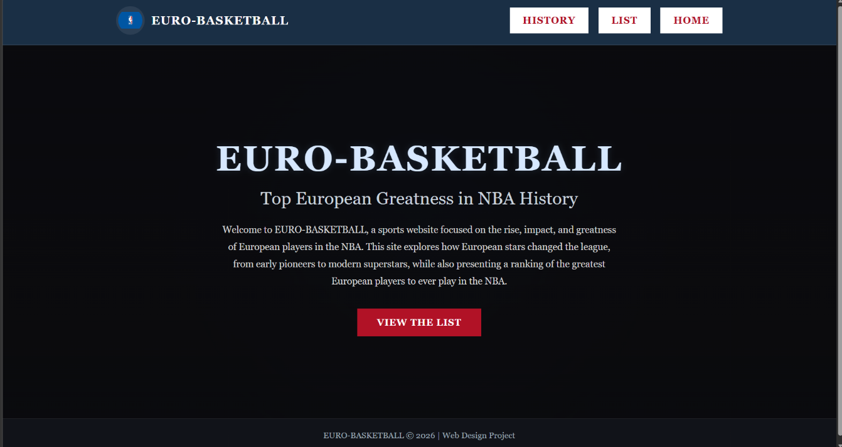
The layout of the home page is designed to be simple and visually clear, with a strong focus on readability. The use of dark background colours combined with lighter text helps create contrast and makes the content easy to read. The overall design reflects the theme of the website while maintaining a clean and organised structure.

History Page
The history page provides background information on the development of European players in the NBA. It is designed to give users a clear understanding of how European basketball has evolved over time and how its players became more influential in the league.
The page is divided into multiple sections, each focusing on a different stage of this development, such as the early NBA period, the arrival of European players, and the modern era. This structure helps organise the information in a logical way, making it easier for users to follow the timeline and understand the progression.
Each section combines text and images to create a more engaging layout. The use of side-by-side positioning for images and text helps break up large amounts of content and improves readability. In some sections, the layout is alternated, which adds visual variety and keeps the page interesting as users scroll.
The design remains consistent with the rest of the website, using the same colour scheme, typography, and navigation bar. This ensures a unified look across all pages and helps users feel familiar with the layout.
The history page is designed to be informative, structured, and easy to navigate, allowing users to learn about the evolution of European basketball in a clear and engaging way.
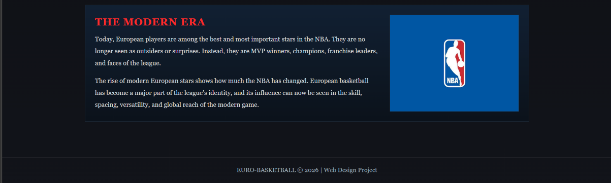
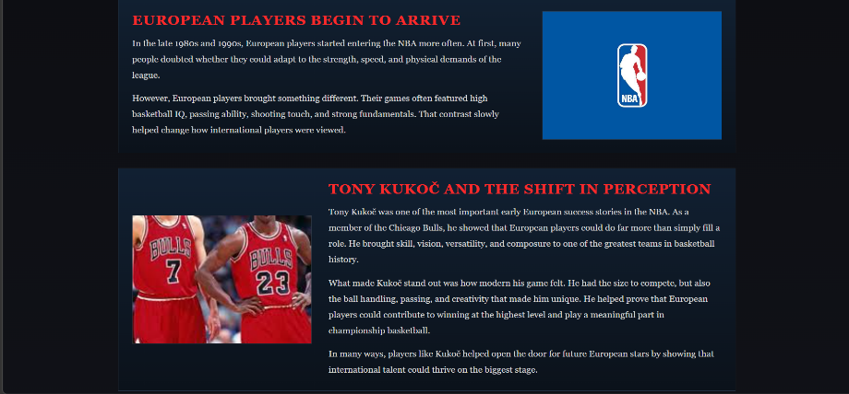
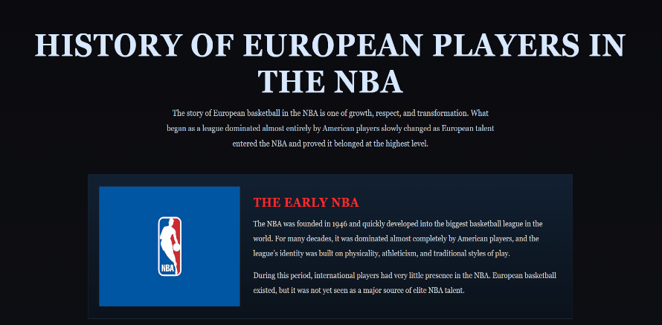

List Page
The list page presents a ranking of the top European NBA players. It is designed to clearly display each player along with key information, including their name, nationality, team, and a short description of their achievements and impact.
Each player is shown in a structured layout that combines an image with text. The content is arranged side by side, which makes it easier to read and visually more engaging. To avoid the page feeling repetitive, the layout alternates between having the image on the left and on the right. This creates variation as users scroll and helps keep the page interesting.
The ranking is organised in a clear order, starting from number five and moving up to number one. This makes it easy for users to follow the list and understand the progression. A short explanation is also included at the top of the page to explain how the ranking was decided, which adds context and makes the content more meaningful.
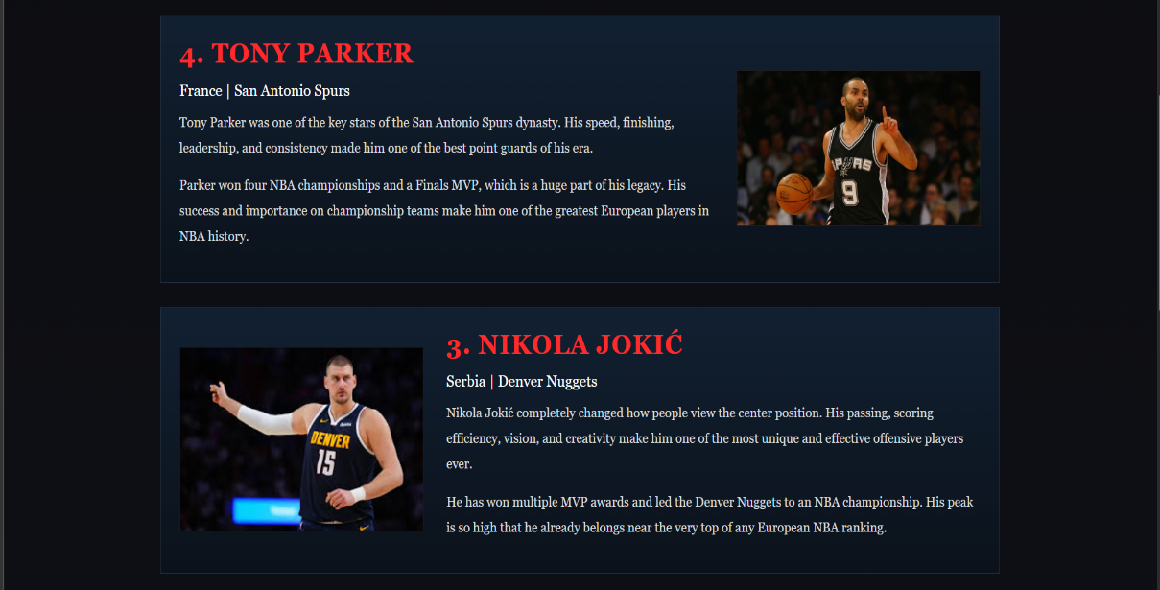
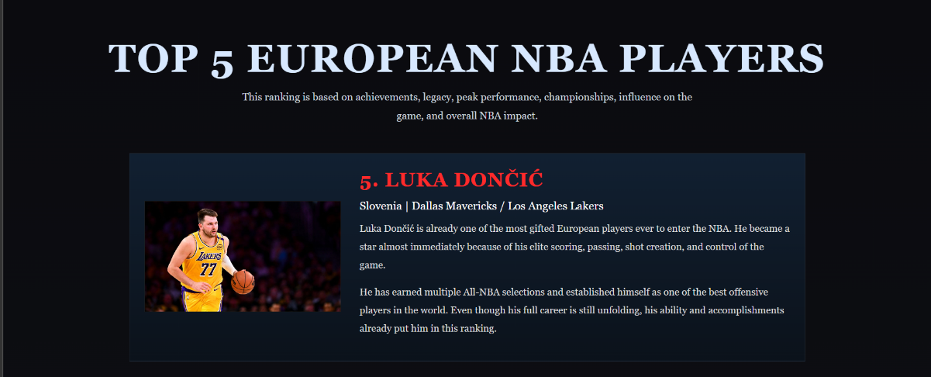
The design of the page follows the same style as the rest of the website, using consistent colours, fonts, and spacing. This helps maintain a unified look across all pages. The use of strong headings, highlighted player names, and clear sections improves readability and allows users to quickly find the information they are looking for.
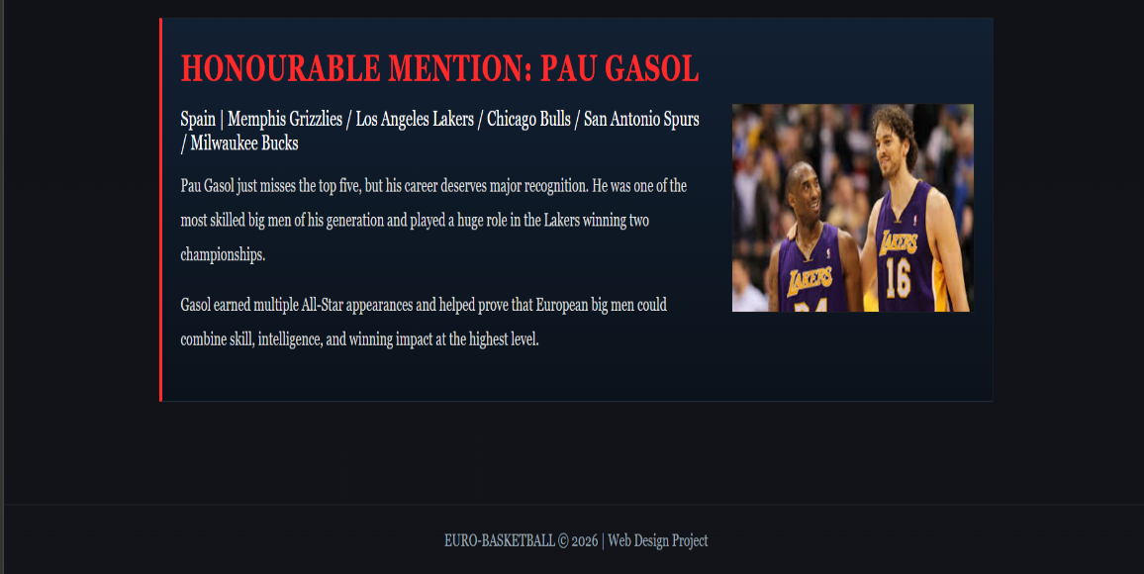
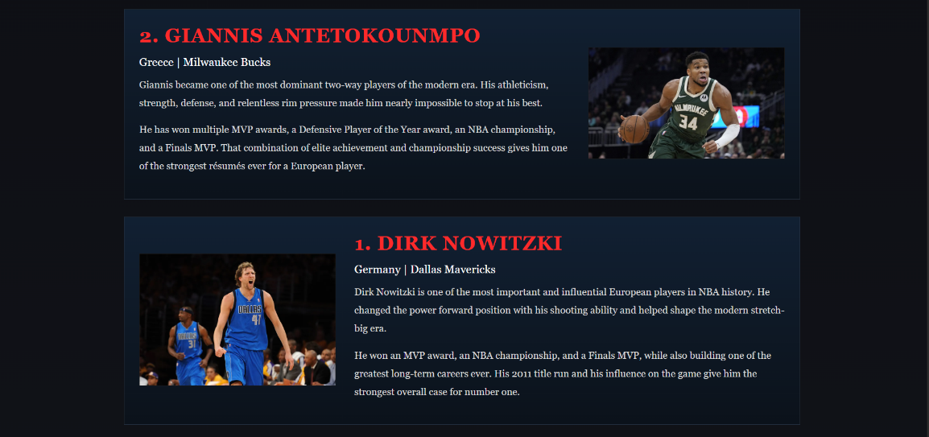
VALIDATION
To ensure the website follows proper web standards, validation tools were used to check both the HTML and CSS code. The W3C HTML Validator and CSS Validator were used to identify any errors and confirm that the code was written correctly.
The HTML was tested using the W3C HTML Validator. During validation, an error was identified related to an image file path. The issue was caused by a space in the file name (nba logo.jpg), which is not allowed in file paths. This was resolved by renaming the file and updating the image source in the code. After correcting this issue, the HTML showed no major errors, with only minor informational warnings that do not affect how the website functions.
The CSS was validated using the W3C CSS Validator, which showed that there were no errors in the styling. This confirms that the CSS follows proper standards and is written correctly.
Validation is important because it ensures that the website works consistently across different browsers and devices, while also improving the overall quality and reliability of the code.
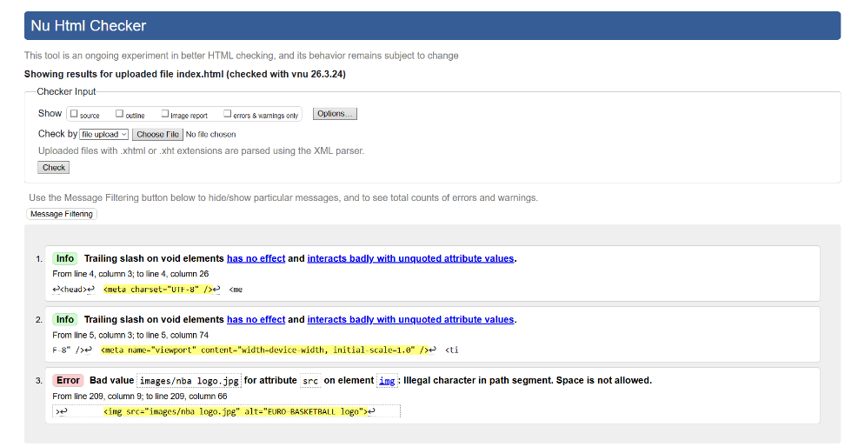

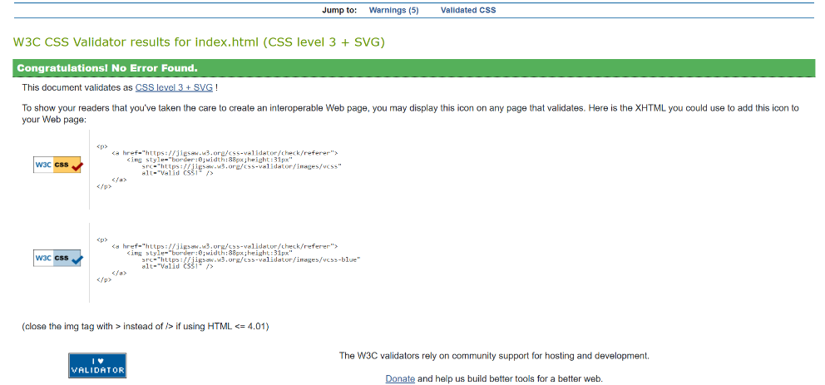

EVALUATION
USABILITY
Usability refers to how easy a website is to use and how efficiently users can navigate through it [2]. A well-designed website should allow users to quickly find information without confusion or unnecessary effort.
Research by Nielsen Norman Group [2] shows that users prefer simple navigation structures and clear layouts, as they reduce confusion and improve task completion speed.
In this website, usability is supported through a clear and simple layout. The navigation bar is placed at the top of every page, making it easy for users to move between the Home, List, and History sections. The structure of the content is also organised using headings and sections, which helps users understand the information more easily. The use of a consistent design across all pages also improves usability, as users become familiar with the layout.
Another factor that improves usability is the readability of the website. The contrast between the dark background and lighter text makes the content easier to read, while the spacing between sections prevents the page from feeling crowded.
One improvement that could be made is adding more interactive elements, such as hover effects or visual feedback, to make the user experience more engaging.
The website is also useful as it provides clear and relevant information about European basketball. The content is structured in a way that allows users to learn both historical and modern aspects of the topic.

Accessibility
Accessibility focuses on making websites usable for all users, including those with disabilities [3]. This includes ensuring that content is readable and that the design supports different types of users.
Research based on WCAG guidelines [3] highlights that clear contrast, readable text, and structured content significantly improve accessibility for users with visual impairments.
The website applies accessibility principles by using clear text, good contrast between background and text, and structured content. The use of simple layouts and readable fonts helps ensure that users can easily access and understand the information. An improvement could be adding more descriptive alternative text for images and ensuring full compatibility with screen readers.
Search Engine Optimisation (SEO)
Search Engine Optimisation (SEO) refers to the process of improving a website so that it can be more easily found and understood by search engines such as Google [4]. This involves using clear structure, relevant content, and appropriate tags to help search engines correctly index the website.
According to Google Search Central [4], properly structured content and the use of relevant keywords improve how websites are indexed and ranked in search results.
In this website, basic SEO principles have been applied using structured HTML. Headings are used to organise content clearly, which helps both users and search engines understand the importance of different sections. Each page also includes a clear title that reflects its content, making it easier for search engines to identify what the page is about.
The website also includes descriptive text and relevant keywords related to European basketball and the NBA. This helps improve visibility by making the content more relevant to search queries. In addition, images include alternative text, which not only supports accessibility but also contributes to SEO by providing additional context for search engines.
However, there are still areas where SEO could be improved. For example, meta descriptions and more detailed meta tags could be added to each page to improve how the website appears in search engine results. Image optimisation and more targeted keyword usage could also further enhance the website’s visibility.

Comparison of Two Live Websites
For this comparison, Sky Sports and ESPN were chosen as both provide sports news, analysis, and updates.

Usability
Sky Sports has a simple and clean layout, making it easy for users to find information quickly. The navigation is clear and not overcrowded.
ESPN has more content on the homepage, including videos and live updates. While this makes it more dynamic, it can feel more complex and harder to navigate.
Sky Sports is easier to use overall.

Accessibility
Sky Sports uses clear text, good contrast, and a simple design, which makes it easier for users to read and navigate.
ESPN also has readable content, but the heavier use of media and more complex layout may make it slightly harder for some users.
Sky Sports performs better for accessibility.

SEO (Search Engine Optimisation)
Sky Sports uses clear headings and structured content, which helps search engines understand the website easily.
ESPN also uses strong SEO techniques, such as frequent updates and detailed content, but its more complex structure can affect indexing slightly.
Both are good, but Sky Sports is slightly more efficient.

Mobile Friendliness
Sky Sports works well on mobile devices and keeps a clean layout that is easy to navigate.
ESPN is also mobile-friendly, but the larger amount of content can sometimes affect loading speed.
Sky Sports provides a more consistent mobile experience.

Conclusion
Both websites are well-designed and provide useful sports content. However, Sky Sports stands out because it is simpler, easier to use, and more accessible, while ESPN offers more content but can feel more complex.

Conclusion
This project focused on the design and development of a responsive website using HTML and CSS, based on the topic of European basketball and its influence on the NBA. The final website consists of three connected pages, each with a clear purpose, allowing users to explore the history of European players, view a ranking of top athletes, and understand their overall impact on the game.
Throughout the development process, attention was given to structure, layout, and consistency. HTML was used to organise the content in a clear and logical way, while CSS was applied to improve the visual appearance and readability of the website. Design decisions, such as using a darker colour palette inspired by the NBA and maintaining consistent navigation across all pages, helped create a more user-friendly experience.
The website was tested using validation tools to ensure the code followed proper web standards. The results confirmed that both the HTML and CSS were correctly implemented, with only minor issues that were identified and resolved. This helped improve the reliability and performance of the website.
The evaluation of the website showed that it performs well in terms of usability, accessibility, and basic search engine optimisation. The layout is simple and easy to navigate, the content is structured clearly, and the website provides useful and relevant information. There are still areas that could be improved, such as adding more advanced SEO techniques and enhancing accessibility features.
This project helped develop a stronger understanding of web development, including both the technical and design aspects. It also highlighted the importance of planning, testing, and making design choices that improve the overall user experience.

References

INTRODUCTION
[1] NBA, “2025–26 International Players on Opening Night Rosters,” NBA.com, 2025. [Online]. Available: https://www.nba.com/news/2025-26-international-players-opening-night

REQUIREMENTS
[1] NBA, “2025–26 International Players on Opening Night Rosters,” NBA.com, 2025. [Online]. Available: https://www.nba.com/news/2025-26-international-players-opening-night

Evaluation
[2] N. Nielsen, “Usability 101: Introduction to Usability,” Nielsen Norman Group, 2020. [Online]. Available: https://www.nngroup.com/articles/usability-101-introduction-to-usability/
[3] World Wide Web Consortium (W3C), “Web Content Accessibility Guidelines (WCAG),” updated 2023. [Online]. Available: https://www.w3.org/WAI/standards-guidelines/wcag/
[4] Google Search Central, “SEO Starter Guide,” Google, 2023. [Online]. Available: https://developers.google.com/search/docs/fundamentals/seo-starter-guide

