ASSESSMENT Cloud Computing Administration ACCA6025

Daniel Popescu (2021265)

A) How the Cloud Supports Aspire Retailers
Aspire Retailers currently runs all of its services on an on-premises datacentre. This creates challenges such as hardware procurement delays, high upfront costs, maintenance responsibilities, and slower response when scaling applications. By moving into the cloud, Aspire Retailers can address these challenges in the following ways:
1. On-Demand Resources
- Cloud computing provides Infrastructure as a Service (IaaS), allowing Aspire Retailers to provision servers, storage, and networking in minutes rather than weeks.
- No need to buy, install, or configure physical hardware.
2. Elasticity & Scalability
- The cloud allows Aspire Retailers to scale up resources (e.g., more servers, storage, or database capacity) during peak shopping seasons or scale down when demand is low.
- This ensures optimal cost and performance without over-provisioning hardware.
3. Pay-as-You-Go Pricing
- Aspire only pays for what they use—reducing unnecessary capital expenditure (CapEx).
- Predictable operational costs (OpEx) help financial planning.

4. High Availability
- Cloud providers replicate data and applications across multiple regions and availability zones.
- This ensures that Aspire’s retail website and video content remain accessible even if one server or datacentre fails.
5. Managed Services
- Instead of managing their own databases, networks, and security updates, Aspire can use Platform as a Service (PaaS) or Software as a Service (SaaS) for specific needs.
- This reduces IT team workload and lets them focus on innovation rather than routine maintenance.
6. Global Reach
- Cloud platforms allow Aspire Retailers to deploy applications closer to their customers in different regions, reducing latency and improving customer experience as they expand into new markets.

Features of Load Balancing in the Cloud
Load balancing is a key feature Aspire Retailers should implement once their retail website and video services are migrated to the cloud.
1. Traffic Distribution
- Load balancers distribute incoming traffic (e.g., user requests to the retail website) across multiple servers.
- This prevents a single server from being overloaded.
2. High Availability & Reliability
- If one server fails, the load balancer redirects traffic to healthy servers.
- This ensures fault tolerance and keeps the retail website running smoothly.
3. Scalability
- Load balancers work hand-in-hand with auto-scaling services.
- When demand increases (e.g., seasonal sales), new servers are automatically launched and added to the pool, and the load balancer directs traffic to them.
4. Performance Optimization
- Requests are intelligently routed based on factors such as server health, response times, or geographical location of the user.
- This improves website performance and reduces latency.
5. Security
- Many cloud load balancers offer built-in DDoS protection, SSL/TLS termination, and firewall integration, enhancing security.

In summary: Moving Aspire Retailers to the cloud enables on-demand computing services, cost efficiency, scalability, and high availability. Load balancing ensures smooth distribution of traffic, prevents downtime, and provides an optimal user experience for both website visitors and video streaming customers.

B) Azure Cloud Solutions for Aspire Retailers
1. On-Demand Computing
- Azure Virtual Machines (VMs): Run Windows/Linux servers on-demand without buying physical hardware.
- Azure App Service: Host the retail website (front-end + APIs) without worrying about server management.
Benefit for Aspire: They can spin up servers within minutes and deploy applications quickly.

2. Scalability & Elasticity
- Azure Virtual Machine Scale Sets (VMSS): Automatically add/remove VMs based on demand (e.g., during holiday sales).
- Azure App Service Autoscaling: Web apps scale automatically depending on traffic load.
Benefit for Aspire: Handles peak traffic without downtime, and reduces cost when traffic is low.

3. Storage & Video Hosting
- Azure Blob Storage: Store product images, documents, and streaming videos at scale.
- Azure Content Delivery Network (CDN): Cache and deliver website content & videos globally with low latency.
Benefit for Aspire: Customers get fast access to videos and product content no matter where they are.

4. Databases
- Azure SQL Database (PaaS): Managed relational database for transactions (orders, payments, customer info).
- Azure Cosmos DB: Globally distributed NoSQL database for product catalogs and real-time data.
Benefit for Aspire: Highly available, scalable, and no need to manage patches or backups manually.

5. Networking & Load Balancing
- Azure Load Balancer: Distributes traffic evenly across VMs to ensure no single server gets overloaded.
- Azure Application Gateway (Layer 7 Load Balancer): Provides URL-based routing, SSL offloading, and Web Application Firewall (WAF) for extra security.
- Azure Front Door: Global load balancing with edge locations to route users to the nearest datacentre for best performance.
Benefit for Aspire: High availability, faster response times, and improved security for the retail website.

6. Monitoring & Security
- Azure Monitor & Application Insights: Track performance, detect bottlenecks, and monitor user activity.
- Azure Security Center & Defender for Cloud: Threat protection, compliance monitoring, and proactive security alerts.
Benefit for Aspire: Detects and prevents issues before they affect customers.

7. Cost Efficiency
- Azure Reserved Instances / Spot VMs: Lower cost options for predictable or flexible workloads.
- Azure Cost Management + Billing: Track spending and optimize usage.
Benefit for Aspire: Keeps IT budget under control with flexible pricing models.

Example Setup for Aspire Retailers
- Retail Website: Hosted on Azure App Service with Application Gateway + WAF.
- Product Videos: Stored in Azure Blob Storage and delivered globally via Azure CDN.
- Databases: Azure SQL Database for orders/payments + Cosmos DB for product catalog.
- Scalability: VM Scale Sets and App Service Autoscaling.
- Load Balancing: Azure Front Door for global customers + Azure Load Balancer for backend VMs.
- Monitoring & Security: Azure Monitor, Application Insights, and Defender for Cloud.

In short: Azure provides Aspire Retailers with a scalable, secure, and cost-efficient cloud solution that ensures their retail website and video services are always available and can expand into new global markets seamlessly.

AWS Cloud Solutions for Aspire Retailers
1. On-Demand Computing
- Amazon EC2 (Elastic Compute Cloud): Run virtual servers in minutes without buying hardware.
- AWS Elastic Beanstalk: Deploy and manage retail web apps without dealing with infrastructure setup.
- Amazon Lightsail: Simplified option for small workloads (e.g., dev/test environments).
Benefit for Aspire: Rapid provisioning of computing resources to deploy applications quickly.

2. Scalability & Elasticity
- Auto Scaling Groups: Automatically add/remove EC2 instances depending on traffic demand.
- AWS Lambda (Serverless): Run code for functions like order confirmation emails without managing servers.
Benefit for Aspire: Handles peak shopping traffic dynamically while reducing costs during low demand.

3. Storage & Video Hosting
- Amazon S3 (Simple Storage Service): Store product images, documents, and streaming videos securely and at scale.
- Amazon CloudFront (CDN): Cache and deliver videos, images, and website content globally with low latency.
- AWS Elastic Transcoder / AWS Elemental Media Services: Optimize videos for streaming on multiple devices.
Benefit for Aspire: Reliable, scalable video delivery and global content distribution.

4. Databases
- Amazon RDS (Relational Database Service): Managed database service for MySQL, PostgreSQL, SQL Server, or Oracle—perfect for orders, payments, and customer data.
- Amazon DynamoDB: Serverless NoSQL database for fast and scalable product catalog access.
- Amazon Aurora: High-performance, fully managed relational database compatible with MySQL/PostgreSQL.
Benefit for Aspire: Reliable, automatically backed-up databases with scalability.

5. Networking & Load Balancing
- Elastic Load Balancing (ELB): Distributes incoming traffic across multiple EC2 instances.
  - Application Load Balancer (ALB): Best for web applications (Layer 7 routing, path-based rules, SSL termination).
  - Network Load Balancer (NLB): Best for high-performance, low-latency connections (Layer 4).
- Amazon Route 53: Global DNS service that routes customers to the nearest AWS region.
Benefit for Aspire: Ensures high availability, efficient traffic distribution, and seamless user experience.

6. Monitoring & Security
- Amazon CloudWatch: Monitor server performance, application health, and usage trends.
- AWS X-Ray: Trace application performance issues.
- AWS Shield & AWS WAF (Web Application Firewall): Protection against DDoS and malicious attacks.
- AWS IAM (Identity and Access Management): Secure access controls for employees and apps.
Benefit for Aspire: Strong monitoring and proactive security protections.

7. Cost Efficiency
- EC2 Spot Instances & Reserved Instances: Save costs for predictable workloads or background processing.
- AWS Cost Explorer & Trusted Advisor: Track usage and optimize cloud spending.
Benefit for Aspire: Flexible cost models, paying only for what they use.

Example AWS Setup for Aspire Retailers
- Retail Website: Hosted on AWS Elastic Beanstalk or EC2 with ALB.
- Product Videos & Images: Stored in Amazon S3, delivered globally via Amazon CloudFront.
- Databases: Amazon RDS/Aurora for transactional data + DynamoDB for fast product catalog queries.
- Scalability: Auto Scaling Groups + Lambda functions for lightweight tasks.
- Load Balancing: Elastic Load Balancing (ALB/NLB) + Route 53 for global DNS routing.
- Monitoring & Security: CloudWatch, AWS Shield, WAF, and IAM.

In short: AWS gives Aspire Retailers on-demand, secure, and globally scalable services, ensuring their retail site and video streaming services are always available, cost-efficient, and capable of supporting business expansion into new markets.

GCP Cloud Solutions for Aspire Retailers
1. On-Demand Computing
- Google Compute Engine (GCE): Virtual machines that can be provisioned quickly to host applications.
- Google App Engine (GAE): Fully managed serverless platform for running web apps without worrying about infrastructure.
- Google Cloud Run: Run containerized applications in a serverless environment.
Benefit for Aspire: Fast deployment of applications with flexible choices (VMs, PaaS, or serverless).

2. Scalability & Elasticity
- Instance Groups with Autoscaling: Automatically scale up/down VM instances depending on traffic.
- Cloud Functions: Run lightweight functions (e.g., order confirmation emails) without provisioning servers.
Benefit for Aspire: Seamlessly handles spikes in demand, like seasonal shopping surges.

3. Storage & Video Hosting
- Google Cloud Storage (GCS): Secure, scalable storage for images, documents, and videos.
- Cloud CDN (Content Delivery Network): Cache and deliver static/dynamic content (website + videos) to users globally.
- Media Solutions (via GCP partners / Transcoder API): Optimize videos for streaming.
Benefit for Aspire: Customers get smooth video playback and fast access to content anywhere in the world.

4. Databases
- Cloud SQL: Managed relational database (MySQL, PostgreSQL, SQL Server) for transactions like orders and payments.
- Firestore (NoSQL): Serverless, real-time database for product catalog and customer activity.
- Cloud Spanner: Globally distributed relational database for very large-scale workloads.
Benefit for Aspire: High availability databases with little admin overhead.

5. Networking & Load Balancing
- Google Cloud Load Balancing: Distributes traffic across multiple backend services. Key features:
  - HTTP(S) Load Balancer (Layer 7): Best for web apps, supports SSL offload and routing by URL/path.
  - TCP/UDP Load Balancer (Layer 4): High-performance networking workloads.
- Cloud DNS: Fast, scalable, and secure domain name service.
Benefit for Aspire: Ensures availability, performance, and security for the retail site and video services.

6. Monitoring & Security
- Cloud Monitoring & Cloud Logging (formerly Stackdriver): Track performance, uptime, and errors.
- Cloud Trace & Cloud Profiler: Identify bottlenecks in application performance.
- Cloud Armor (WAF + DDoS protection): Protects website and applications from malicious traffic.
- Identity and Access Management (IAM): Fine-grained user and app access control.
Benefit for Aspire: Strong monitoring and defense against security threats.

7. Cost Efficiency
- Sustained Use Discounts & Committed Use Contracts: Automatically lower prices for consistent workloads.
- Preemptible VMs: Low-cost option for non-critical or batch workloads.
- Billing Reports & Cost Optimization Tools: Track and manage spending.
Benefit for Aspire: Flexible pricing and automatic cost savings for continuous usage.

Example GCP Setup for Aspire Retailers
- Retail Website: Hosted on App Engine or Compute Engine with HTTP(S) Load Balancer.
- Product Videos & Images: Stored in Cloud Storage, delivered globally via Cloud CDN.
- Databases: Cloud SQL for transactions + Firestore for product catalog.
- Scalability: Instance Groups with Autoscaling + Cloud Functions for lightweight tasks.
- Load Balancing: Cloud Load Balancing (HTTP/S) + Cloud DNS.
- Monitoring & Security: Cloud Monitoring, Logging, Cloud Armor, and IAM.

In short: GCP gives Aspire Retailers scalable, globally distributed services for websites, video hosting, and databases, while also offering built-in cost optimization and strong security for expansion into new markets.

Estimated cost Pay-As-You-Go with Azure
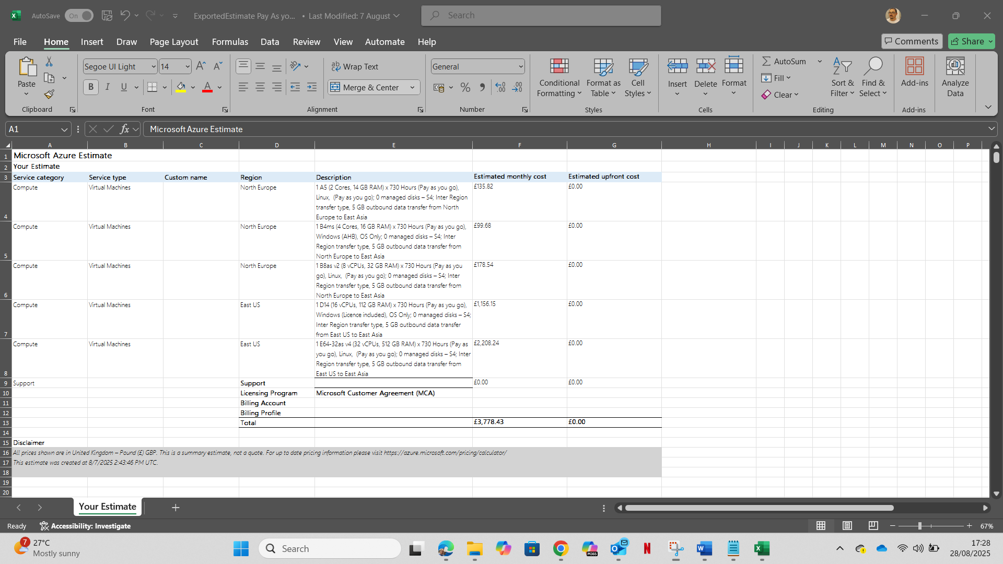

Estimated cost for 3 years with Azure
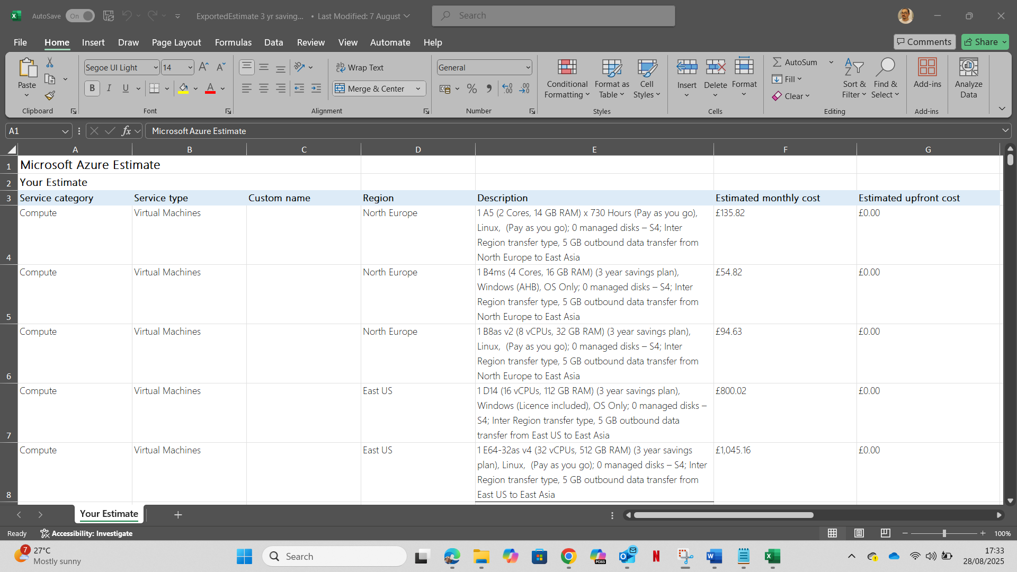

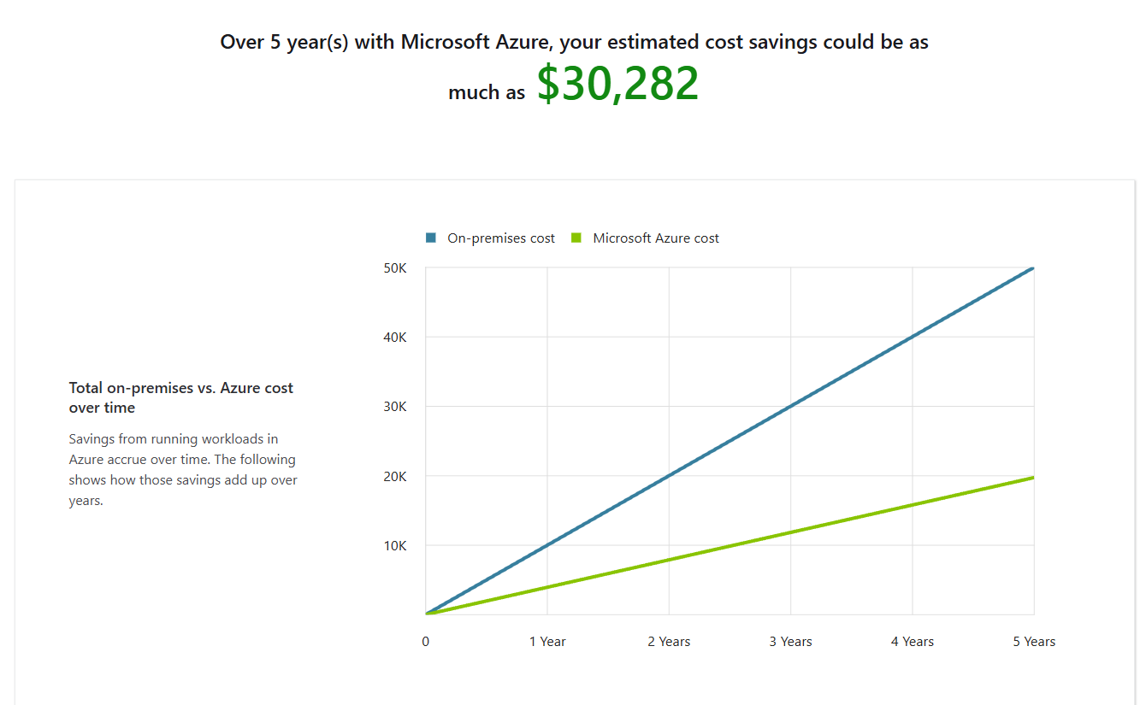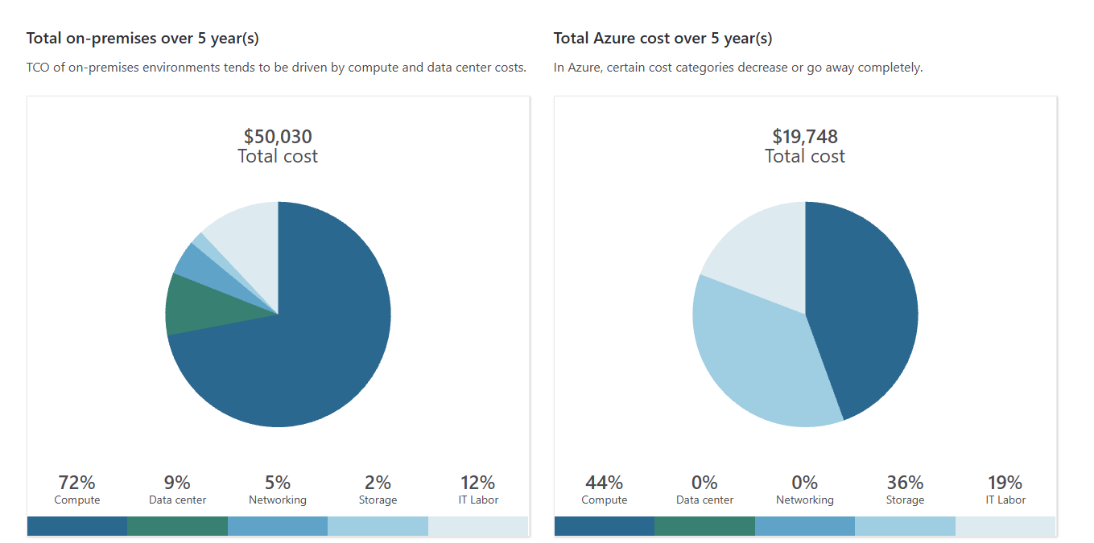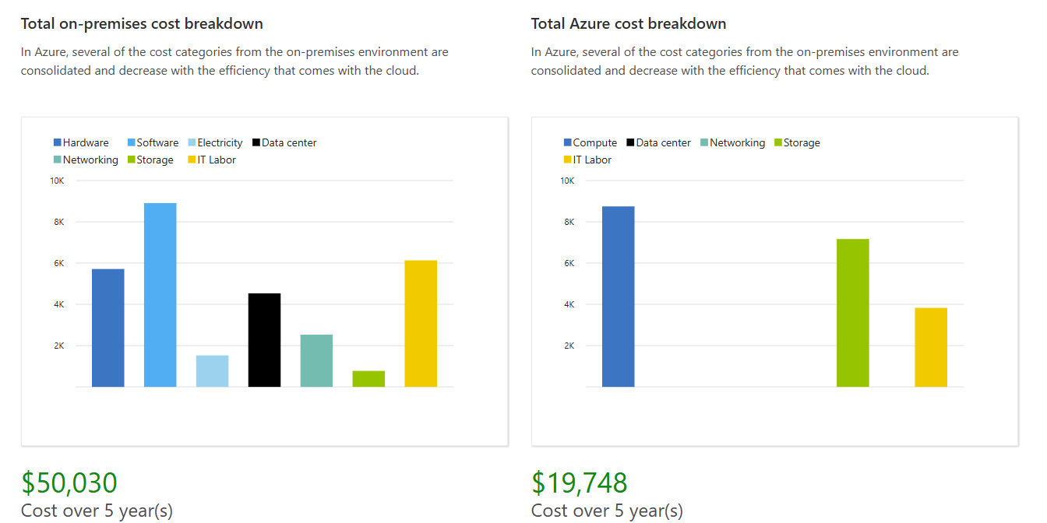

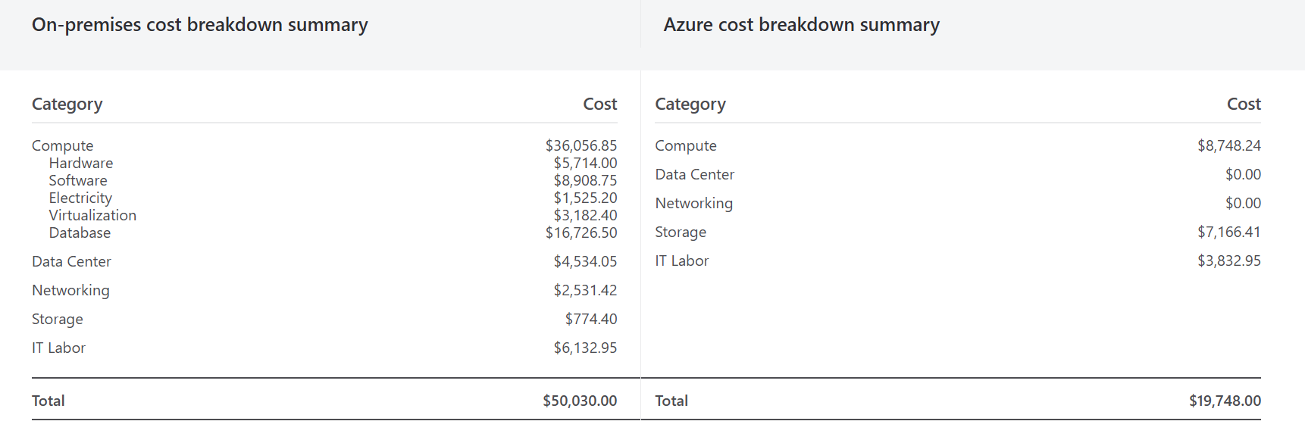

D) Let’s break this into two parts:
- Explanation of Azure AD for Aspire Retailers (concepts, benefits, BYOD support, roles).
- Example lab activity showing how to create users in Azure AD and assign roles (with explanation + step-by-step screenshots substitute since I can’t generate live Azure portal screenshots, but I’ll describe exactly what you’d see).

1. Uses of Azure Active Directory (Azure AD) for Aspire Retailers
Azure AD (now part of Microsoft Entra ID) is Microsoft’s cloud-based identity and access management service. It will help Aspire Retailers in:
🔹 Managing Accounts
- User Accounts: Create accounts for employees, contractors, or outsourced marketing staff.
- Group Accounts: Group users (e.g., Marketing, Logistics, IT) to assign access policies easily.
🔹 Role-Based Access Control (RBAC)
- Global Administrator (Global User): Has access to all Azure AD features (user management, licensing, security settings, app integration).
- Normal User (Member): Has limited rights (e.g., signing in, using applications, creating orders).
This ensures Aspire Retailers’ IT department maintains security boundaries — not everyone gets admin privileges.
🔹 BYOD (Bring Your Own Device) Support
- Azure AD allows employees to securely connect their personal devices (laptops, tablets, phones) to Aspire’s applications.
- Conditional Access Policies can require Multi-Factor Authentication (MFA), device compliance, or trusted networks before granting access.
- This ensures users across the world can safely:
  - Create orders
  - Track deliveries
  - Access schedules
  - Use logistics apps

2. Lab Activity – Creating Users & Assigning Roles in Azure AD
Here’s how Aspire IT administrators would do it:
Step 1: Sign in to Azure Portal
- Go to https://portal.azure.com
- Log in with Global Administrator credentials.

Step 2: Navigate to Azure Active Directory
- From the left-hand menu, click Azure Active Directory.
- You’ll see options for Users, Groups, Roles & Administrators, Devices.

Step 3: Create Two Users
- Click on “Users” → “+ New User”.
- Fill in details for the first user (e.g., John Marketing):
  - User name: john.marketing@aspireretailers.onmicrosoft.com
  - Name: John Marketing
  - Assign temporary password.
  - Click Create.
- Repeat for a second user (e.g., Mary Logistics):
  - User name: mary.logistics@aspireretailers.onmicrosoft.com
  - Name: Mary Logistics
  - Assign temporary password.
  - Click Create.

Step 4: Assign Roles
- Assign Global Administrator Role to John:
  - Go to Azure AD → Users → John Marketing → Assigned Roles → + Add assignment.
  - Select Global Administrator.
  - Save.
John now has full admin rights across Azure AD.
- Assign Normal User Role to Mary:
  - By default, new users are Members (Normal Users).
  - Mary can log in, access apps, and use logistics applications but cannot administer Azure AD.

Step 5: Verify Roles
- Go to Azure AD → Users → Roles.
- You’ll see:
  - John Marketing → Global Administrator
  - Mary Logistics → User (Member)

E) Cloud governance is a framework of policies, roles, responsibilities, and processes that organizations use to control:
- Access → Who can use cloud resources.
- Security → Protecting data, apps, and identities.
- Compliance → Meeting industry regulations (e.g., GDPR, PCI DSS).
- Cost Management → Preventing overspending.
- Consistency → Standardizing how cloud services are deployed and managed.
For Aspire Retailers (with BYOD, outsourced marketing teams, and remote work), cloud governance ensures:
- Only authorized users access applications.
- Identity becomes the new security boundary, not just firewalls.
- Data is protected regardless of location (cloud, mobile, remote).
- Compliance is met for retail operations.

How Microsoft Azure Supports Cloud Governance
Microsoft Azure provides several tools and services that Aspire Retailers can use:
🔹 Identity & Access Security
- Azure Active Directory (Entra ID): Centralized identity management (users, groups, roles).
- Conditional Access Policies: Enforce access rules (e.g., require MFA, allow only compliant devices).
- Privileged Identity Management (PIM): Controls and audits administrator access.
🔹 Policy & Compliance
- Azure Policy: Enforce rules across cloud resources (e.g., only deploy VMs in Europe region, require encryption for storage).
- Azure Blueprints: Create reusable governance templates for compliance.
- Microsoft Defender for Cloud: Continuous monitoring, compliance dashboards, and threat detection.
🔹 Cost & Resource Management
- Azure Cost Management: Monitor spending and optimize cloud usage.
- Management Groups & Role-Based Access Control (RBAC): Organize resources and restrict who can change them.

Suggested Policy for Aspire Retailers
Since Aspire allows BYOD and global access, the most important policy is Conditional Access with MFA.
Policy Example:
- Require Multi-Factor Authentication (MFA) for all users accessing sensitive applications (orders, deliveries, logistics).
- Deny access if the device is not compliant (e.g., outdated OS, no encryption).
- Allow access only from trusted locations (optional — can be global since Aspire has worldwide operations).
This ensures that:
- A stolen username/password alone won’t give attackers access.
- Personal devices meet minimum security standards.
- Global users (marketing, logistics, IT) are protected no matter where they work.

F) Aspire has:
- A retail e-commerce website
- Streaming videos & product media
- Databases (orders, payments, inventory, logistics)
- Global users accessing apps via BYOD
If Aspire faces system failure, data loss, cyberattack, or regional outage, they need to ensure:
- Minimal downtime (RTO – Recovery Time Objective)
- Minimal data loss (RPO – Recovery Point Objective)
- Continuity of operations worldwide

🛠️ Disaster Recovery Plan for Aspire Retailers (on Azure)
1. Assess Critical Workloads
Classify applications:
- Tier 1 (Critical): E-commerce website, orders database, logistics system → Must recover within minutes/hours.
- Tier 2 (Important): Marketing apps, analytics dashboards → Recover in hours/days.
- Tier 3 (Non-critical): Test/dev environments → Recover when convenient.

2. Choose DR Strategy in Cloud
Azure provides multiple recovery options:
- Azure Site Recovery (ASR): Replicates VMs and apps across regions. If the primary region fails, workloads failover to a secondary region.
- Azure Backup: Protects databases, storage, and VMs with point-in-time recovery.
- Geo-Redundant Storage (GRS): Keeps media files and documents available across paired regions.
- Traffic Manager / Front Door: Automatically redirects customer traffic to healthy endpoints in another region.

3. Proposed DR Setup for Aspire Retailers
🔹 Retail Website
- Host on Azure App Service with Geo-redundant deployment (multi-region).
- Use Azure Front Door for global load balancing → automatically reroutes traffic if one region goes down.
🔹 Databases
- Use Azure SQL Database with Geo-Replication for transactions.
- Use Cosmos DB with Multi-Region Writes for product catalog (near real-time global sync).
🔹 Video & Product Media
- Store in Azure Blob Storage with GRS → ensures automatic replication to a secondary Azure region.
- Distribute via Azure CDN, so cached copies are still available even during failover.
🔹 User Accounts & Identity
- Azure AD is global and resilient by design.
- Enable Self-service password reset + MFA to avoid downtime for users.
🔹 Backups & Replication
- Azure Backup configured for:
  - VMs (daily backup, 30-day retention)
  - Databases (point-in-time restore, hourly backups for critical systems)
  - File storage (daily snapshot replication)
🔹 Orchestration
- Azure Site Recovery configured to replicate VM workloads (logistics apps, APIs) to a paired secondary region.
- Run failover tests quarterly to validate readiness.

4. Disaster Recovery Workflow (Failover Steps)
- Detection: Azure Monitor/Defender detects outage in Region A.
- Failover Initiated: ASR triggers automatic failover to Region B.
- Traffic Redirected: Azure Front Door routes users to Region B’s website & apps.
- Databases: Azure SQL + Cosmos DB replicas in Region B go live.
- Media Access: Videos and images are still served from secondary GRS storage + CDN.
- Recovery: Once Region A is restored, failback is performed.

5. Policy Example
- RPO: ≤ 15 minutes for databases (via geo-replication).
- RTO: ≤ 2 hours for Tier 1 apps (via ASR + Front Door failover).
- Testing: Conduct quarterly failover drills using Azure Site Recovery Test Failover.
- Compliance: Ensure backups are encrypted and retained per Aspire’s compliance standards (e.g., PCI DSS).

Summary Recommendation for Aspire Retailers
- Use Azure Site Recovery for app failover across regions.
- Protect data with Azure Backup + Geo-redundant storage.
- Deploy multi-region architecture with Front Door for global resilience.
- Enforce quarterly DR drills to validate the plan.

