15 December 2025

UNIVERSITY OF WALES TRINITY SAINT DAVID
LONDON CAMPUS

SSB ASSIGNMENT: SOFTWARE SOLUTIONS FOR BUSINESS

Module Name: Software Solutions for Business
Module Code: ACCA 4026

Student Name: Freddy Eduardo Carrion Iniguez
Student ID: 2518430
Group: 1

Lecturer’s Name: Dr. Fahad Ahmed

Table of Contents

Introduction 1
Task 1. e-Commerce Website builders or software solutions 2
1.1 Shopify 2
1.2 Wix 6
Task 2. Mind-map of contemporary software applications 9
a. Mind mapping and explain the benefits of using mind mapping in business operations 9
b. Create a mind map of contemporary software applications 10
Task 3. Office Applications 11
a. Four office software solutions for business operations 11
MS Word 12
MS PowerPoint 13
MS Excel 15
MS Access 16
b. Practical demonstration of Two Office Features 17
If Statement 21
Task 4. Communication and Collaboration applications 23
a. One contemporary Communication and one Online Collaboration applications/tools 23
MS Outlook 23
MS Teams 24
b. One feature of a freely available Communication (1) and one feature of a Collaboration (1) application 25
MS Outlook 25
Ms Teams 26
Conclusion 28
References 29
Task 1: E-Commerce Website builders or software solutions 29
References 30
TASK 2: MIND-MAP: 30
References 30
Task 3: Office Applications 30
References 31
Task 4: Communication and Collaboration applications 31

Introduction

Introduction to Contemporary Business Software

In this module we learn a Basic an essential computing software for business. We learn how to create a mind map and create a e-portfolio from Wix. We learn about software applications and how to use the different applications like Microsoft Word, Excel, PowerPoint, Access, privacy and legal aspects in computer I will explain more at the following tasks.
In today's fast-paced digital landscape, software applications are the backbone of efficient and successful business operations. From setting up an online storefront to coordinating global teams and analysing complex data, the right digital tools are crucial for boosting productivity, enhancing communication, and maintaining a competitive edge.
This work will explore a range of essential software solutions used in the modern business environment. We will cover the tools necessary for e-Commerce, including popular website builders, delve into the utility of mind-mapping software for strategic planning, examine the foundational office applications used for daily tasks, and finally, look at the indispensable role of communication and collaboration tools in a connected world.

Task 1. e-Commerce Website builders or software solutions

Shopify

E-Commerce Website Builders: Shopify vs. Wix
The rise of digital commerce has led to a proliferation of software solutions designed to simplify the creation and management of online stores. Among the most popular contemporary e-commerce website builders are Shopify and Wix, each offering a distinct approach to online selling. While both platforms allow businesses to establish an online presence, their core philosophies, feature sets, and intended users diverge significantly.

Shopify: The Dedicated E-Commerce Powerhouse
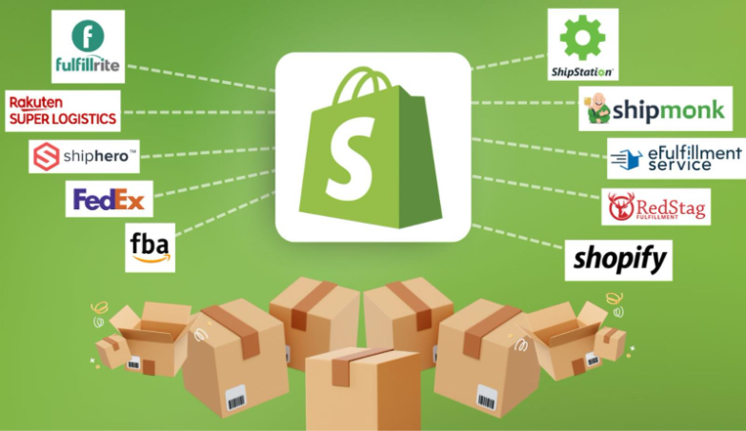
Figure 1, https://www.charle.co.uk/articles/how-does-shopify-work/ [1]

Shopify is a dedicated, subscription-based e-commerce platform built from the ground up with the sole purpose of facilitating online sales and growth [1].Its core strength lies in providing a robust, scalable, and all-in-one solution for businesses of all sizes, from small startups to large enterprises.
- E-Commerce Functionality: Shopify provides a comprehensive suite of features tailored for online retail, including unlimited product listings, detailed inventory management, and integrated shipping solutions with major carriers [2].Its ability to handle large product catalogues and complex product variants (up to 100 per product) makes it highly suitable for businesses aiming for significant scale and growth.
- App Ecosystem and Scalability: The platform boasts an extensive App Store with thousands of e-commerce-focused integrations that extend its core functionality, covering everything from advanced marketing and customer retention to specialized drop shipping logistics [3]. This vast ecosystem allows merchants to customize their store’s capabilities as their business grows.
- Payments and Fees: Shopify encourages the use of its native payment processor, Shopify Payments, which eliminates additional transaction fees (though standard payment processing fees still apply) [2] If a merchant chooses a third-party payment gateway, Shopify charges a transaction fee, making the use of its native solution a financial incentive.

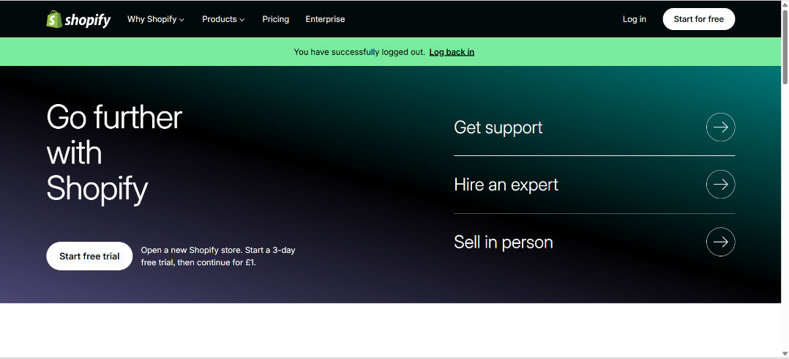
Figure 1, Shopify login
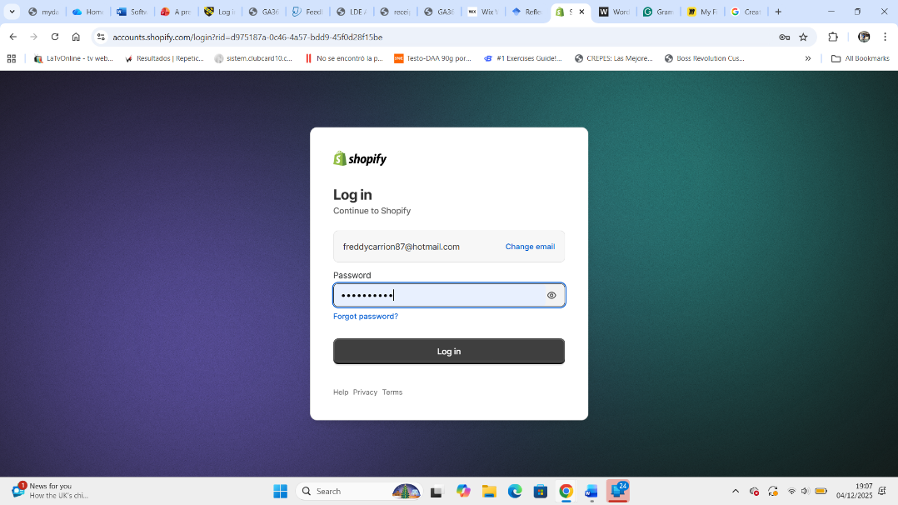
Figure 2, Login details
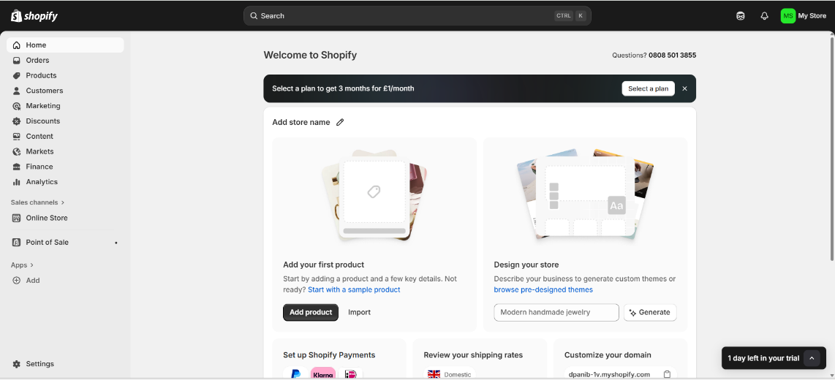
Figure 3, create shopify site
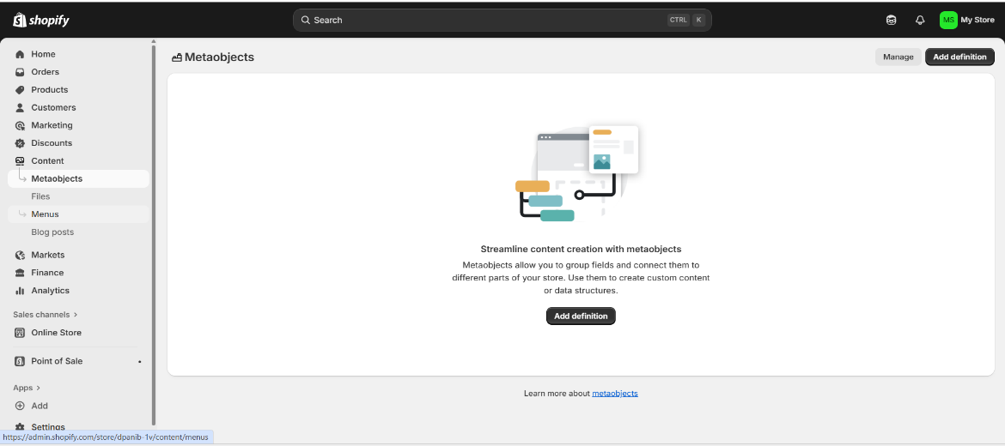
Figure 4, select metaobjects.
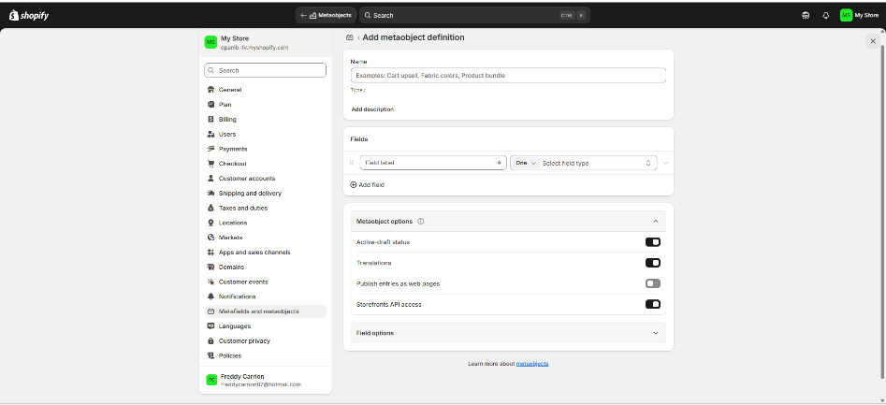
Figure 5, add objects to buy into your website

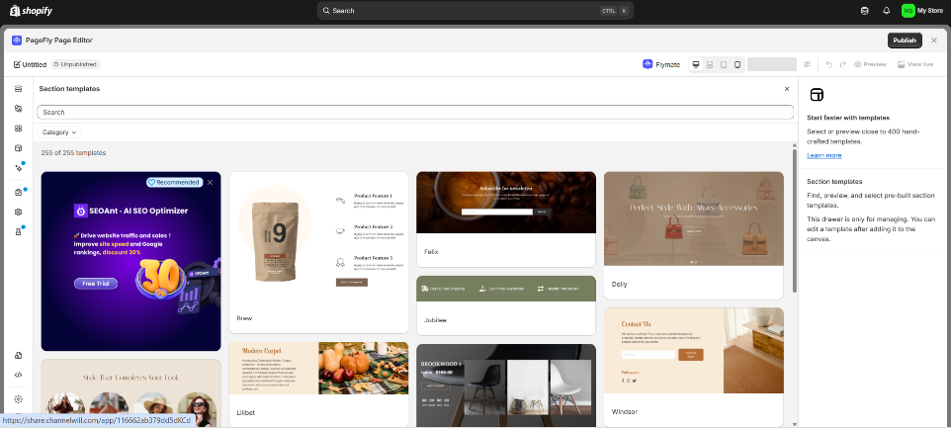
Figure 6, edit page to publish

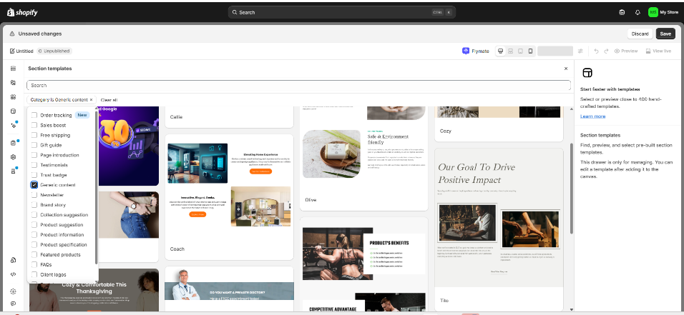

Figure 7, add templates to add more sides

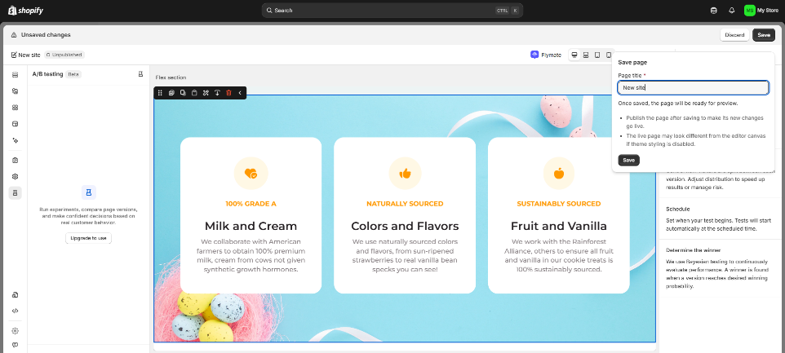
Figure 8, publish site after edit details.

Wix

Figure 9, Wix [2]Wix.com, Inc
Wix: The Design-Flexible All-in-One Builder
Wix, initially conceived as a versatile, drag-and-drop website builder, has developed its e-commerce capabilities to become a powerful contender, particularly for small businesses and those prioritizing creative freedom and ease of use [4].
- Ease of Use and Design Flexibility: Wix shines with its highly intuitive drag-and-drop editor, which provides unparalleled control over the visual layout of a website without requiring coding knowledge [2]. It offers a massive library of free templates, many of which are specifically for online stores. This creative freedom is ideal for individuals and small businesses who want a unique, design-forward online presence [3].
- Built-in Tools: Compared to Shopify's reliance on its app store, Wix often includes more features natively, such as a strong AI website builder and integrated marketing tools like email marketing and social media features, making it a true all-in-one platform for managing a broader online presence alongside e-commerce [4].
- Pricing and Store Limits: Wix generally offers more affordable starting and upper-tier plans than Shopify [2]. However, it may impose limitations, such as a cap on the number of products (e.g., up to 50,000) that can be listed, making it less optimal for massive, high-volume operations compared to Shopify’s unlimited product approach [3].
In conclusion, the choice between the two often boils down to business priority: Shopify is the superior choice for serious, scalable e-commerce businesses that need advanced sales features and a robust app ecosystem, while Wix is better suited for smaller ventures or businesses that prioritize an easy-to-use platform with maximum creative design flexibility and an all-in-one suite of non-e-commerce related tools [2], [4].
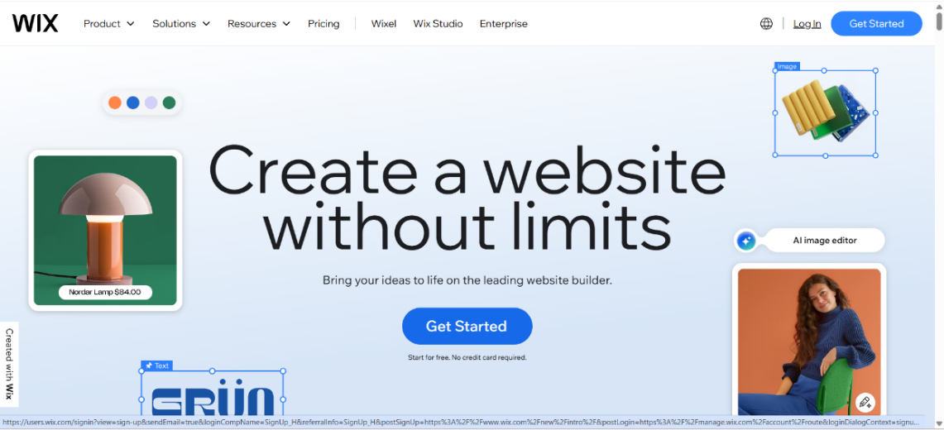
Figure 12, press Log in
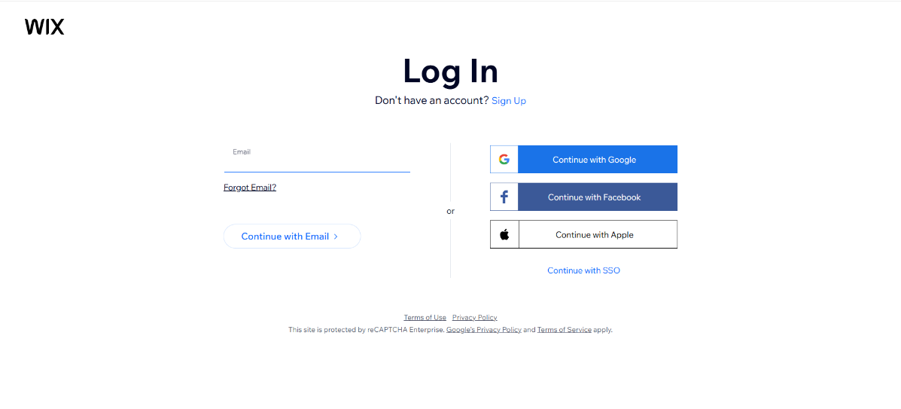

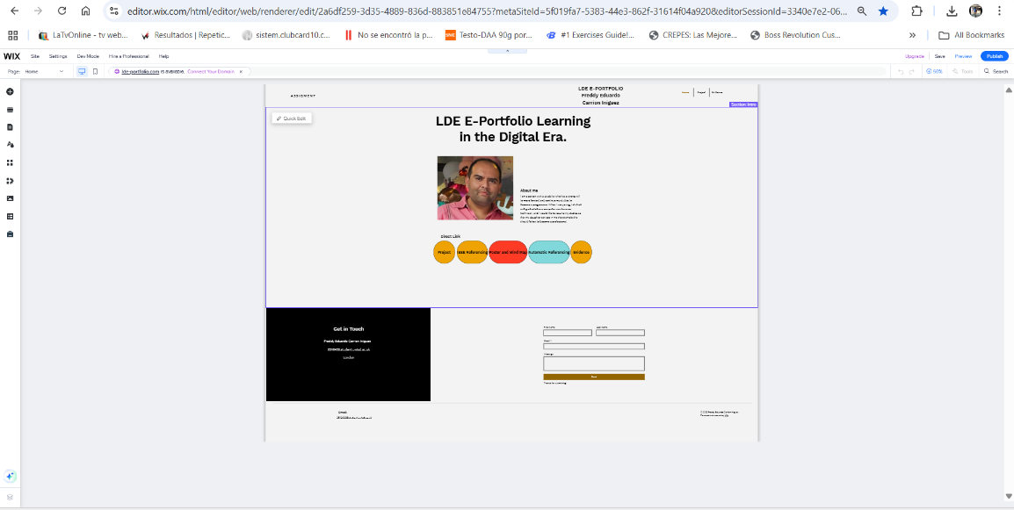
Figure 16, Edit and add details for e portfolio, save a publish to create website.
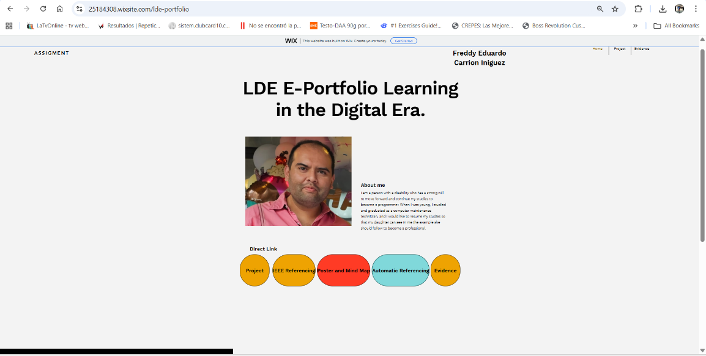
Figure 17, check your domain and find website
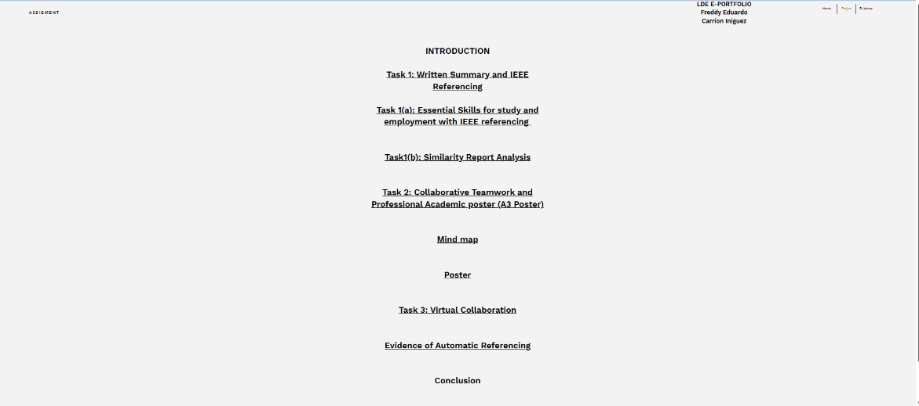
Figure 18, see part of my website.

Task 2. Mind-map of contemporary software applications

Mind mapping and explain the benefits of using mind mapping in business operations
That's a great task that combines theoretical knowledge with practical application! Here is a breakdown of mind mapping and a conceptual mind map of contemporary software applications.
Mind Mapping: Description and Business Benefits
A mind map is a visual tool used to organize information, ideas, concepts, or data around a central subject. It employs a non-linear structure (also known as radiant thinking), where the main concept sits at the centre, and associated ideas radiate outwards as branches and sub-branches [5]. Mind maps typically use keywords, colours, and images to stimulate both hemispheres of the brain and enhance cognitive processes [6].
Benefits in Business Operations
Mind mapping offers several significant benefits to business operations by improving clarity, communication, and innovation:
- Enhanced Brainstorming and Creativity: Mind maps help teams break away from restrictive linear thought, encouraging a free flow of ideas that branch out organically from the central theme. This radial structure facilitates the generation of richer ideas and surprising insights during brainstorming sessions [7].
- Improved Organization and Clarity: By visualizing complex information, mind maps provide a holistic view of a situation, project, or system [5]. This visual hierarchy makes relationships and connections between disparate ideas immediately apparent, bringing order to complex topics without sacrificing the natural associations between concepts [7].
- Aids in Planning and Strategy: For project management and strategic planning, mind maps are invaluable. They can be used to outline project designs, timelines, and life cycles, allowing for easy breakdown of large goals into manageable steps. This visual representation supports better decision-making and project tracking [3].
- Boosts Collaboration and Communication: As a visual and structured tool, a mind map acts as a shared space where teams can collectively explore and refine ideas. This visual language helps bridge communication gaps, allowing team members to quickly grasp how their individual contributions fit into the larger concept, thereby building consensus [7].

Create a mind map of contemporary software applications

- This conceptual mind map illustrates the primary categories and key examples of contemporary software applications used to support day-to-day business operations. The central topic is Contemporary Business Software, with main branches representing key functional areas of a modern business.
- The image below represents the structure of the mind map, organized by function.

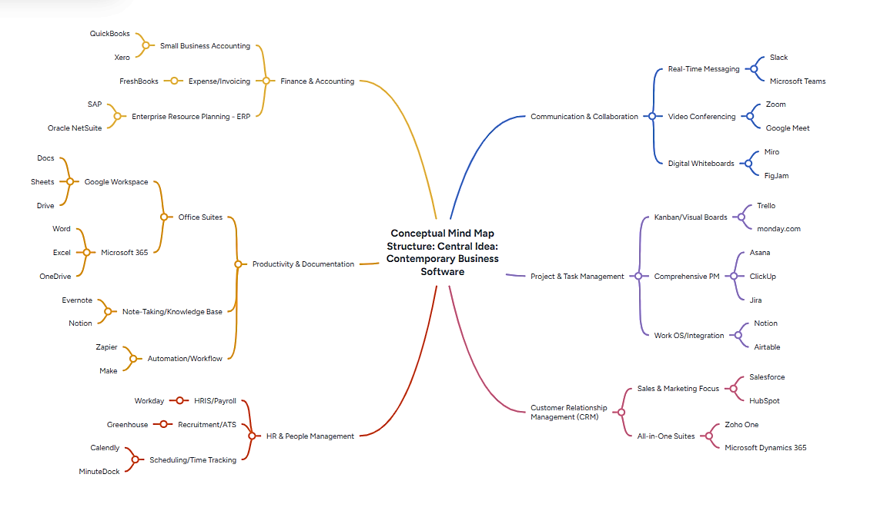
Figure 19, Mind Map contemporary software application https://mm.tt/map/3884123899?t=RNIHZBs65G [3].

Task 3. Office Applications

Four office software solutions for business operations

Office Software Solutions for Business Operations

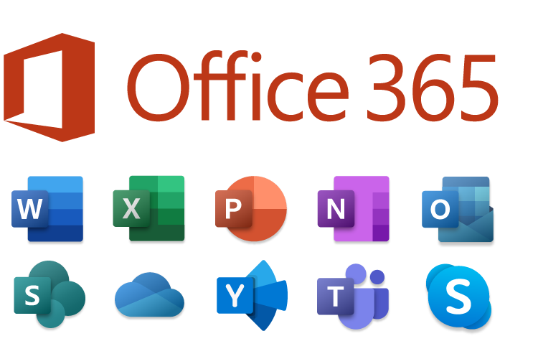
Figure 20, Microsoft Office
Microsoft Office provides an essential suite of applications that are fundamental to modern business operations, allowing for the creation, storage, presentation, and analysis of information and data.¹ The four core applications explained below are ubiquitous tools in the business environment [8], pp. 3-4].

MS Word
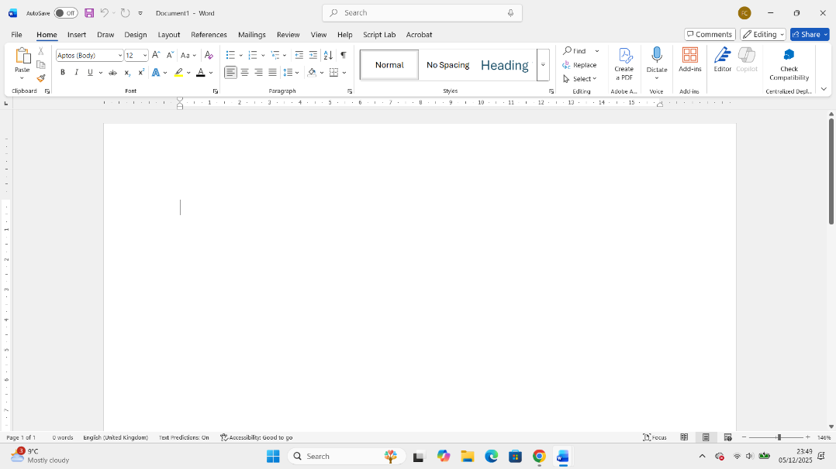
Figure 21, MS WORD
MS Word is a powerful word processing application used primarily for creating, editing, and formatting text-based documents.³ It is the standard tool for generating professional-quality written communication within a business.⁴ Major Features
- Formatting Tools: Extensive options for font, paragraph, and page layout, including headers, footers, and margins.⁵
- Collaboration: Features like Track Changes and Comments enable multiple users to review and edit documents efficiently [9], p. 115].⁶
- Mail Merge: Automates the creation of personalized documents (like letters or emails) from a single template and a data source (e.g., an Excel list) [10], p. 28].⁷
- Review and Proofing: Built-in spell check, grammar check, and thesaurus ensure high-quality, error-free documents.⁸
Benefits
- Professional Output: Enables the creation of polished, formal documents (e.g., reports, proposals, legal agreements).
- Standardization: Provides templates and styles to maintain consistent corporate branding and document structure.
- Efficiency: Features like AutoCorrect and templates significantly speed up document creation.
Limitations
- Data Analysis: Not suitable for complex numerical analysis or large data management, which is better handled by MS Excel or MS Access.
- Large-Scale Publishing: While it handles basic desktop publishing, it lacks the advanced layout control of specialized publishing software.

MS PowerPoint
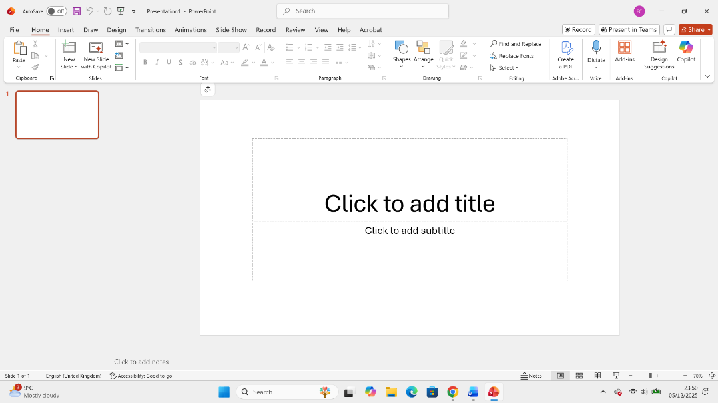
Figure 22, MS POWERPOINT
MS PowerPoint is a presentation graphics program used to create slideshows for communicating information visually and engagingly in meetings, training sessions, or conferences [8], p. 278].⁹ Major Features
- Slide Design and Templates: Offers themes, templates, and slide masters to ensure a professional and cohesive look.¹⁰
- Multimedia Integration: Supports the embedding of images, charts, videos, and audio to enhance visual impact.
- Transitions and Animations: Provides dynamic effects to move between slides and introduce content elements, maintaining audience engagement.
- Presenter View: A dedicated interface for the speaker that shows notes and the upcoming slide, which is not visible to the audience.
Benefits
- Effective Communication: Helps simplify complex ideas into digestible, visual formats.¹¹
- Audience Engagement: The visual nature, combined with transitions and animations, helps capture and hold the audience's attention.
- Versatility: Used for internal training, sales pitches, progress reports, and educational purposes.
Limitations
- Over-reliance: Presenters can sometimes rely too heavily on slides, leading to a dull "reading of the screen" rather than a true presentation.
- File Size: Multimedia-rich presentations can become very large and cumbersome to share or store.

MS Excel
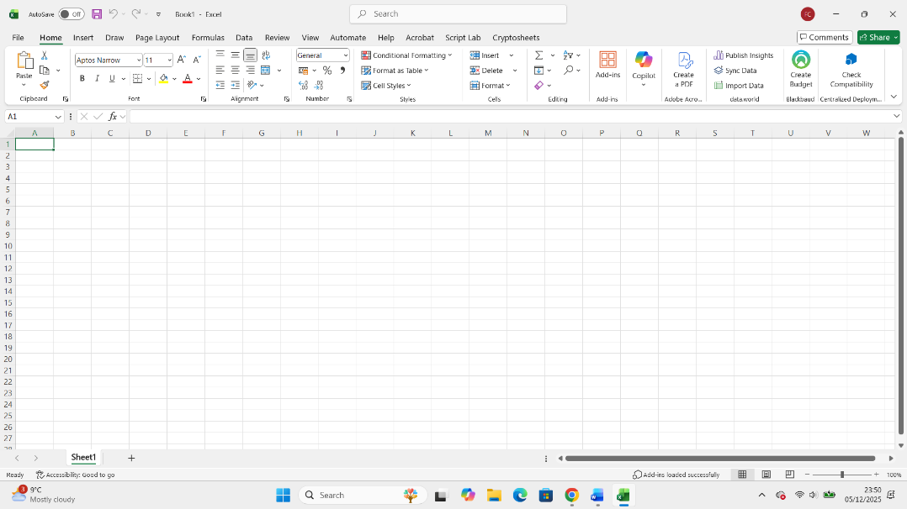Figure 23, MS EXCEL
MS Excel is a powerful spreadsheet application used for calculating, organizing, analyzing, and visualizing data through the use of worksheets made up of rows and columns [10], p. 13].¹² It is the definitive tool for numerical data management in business. Major Features
- Formulas and Functions: Thousands of built-in functions (e.g., $\text{SUM}$, $\text{AVERAGE}$, $\text{VLOOKUP}$, $\text{IF}$) for performing complex calculations [11], p. 71].
- Data Analysis Tools: Features like Pivot Tables, Goal Seek, and What-If Analysis allow for sophisticated data summarization and modeling.¹³
- Charting and Graphing: Converts numerical data into various chart types (bar, line, pie, etc.) for visual analysis.¹⁴
- Data Sorting and Filtering: Tools to quickly organize and isolate specific subsets of data.
Benefits
- Financial Management: Indispensable for budgeting, forecasting, tracking expenses, and generating financial statements.
- Decision Making: Provides analytical capabilities to derive insights from raw data, supporting informed business decisions.
- Flexibility: Highly adaptable for creating custom reports, tracking systems, and simple databases.
Limitations
- Security for Sensitive Data: Basic password protection is often insufficient for highly sensitive data, requiring more robust database solutions.
- Collaboration Issues: Simultaneous real-time editing can be difficult, and version control can become complicated without cloud synchronization.

MS Access
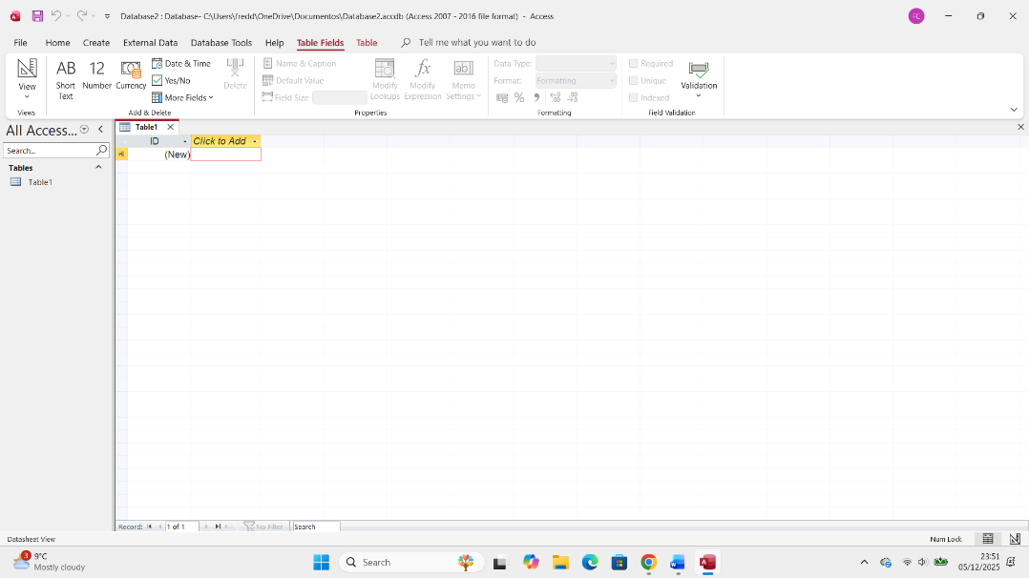
Figure 24, MS ACCESS
MS Access is a relational database management system (RDBMS) that enables the storage and management of large volumes of structured data [12], p. 5].¹⁵ It helps businesses organize information in a way that allows for efficient retrieval and reporting.
Major Features
- Tables: The core component, used to store data in structured records (rows) and fields (columns).
- Queries: Tools to extract, combine, or manipulate data from one or more tables using Structured Query Language (SQL) or the graphical Query Design feature.
- Forms: User-friendly interfaces for viewing, adding, and editing data, improving data entry accuracy.
- Reports: Used to present data in a printable, organized, and often summarized format for analysis.¹⁶
Benefits
- Data Integrity and Consistency: Enforces data rules (e.g., primary keys, data types) to maintain accuracy and prevent errors.
- Structured Storage: Better for managing large, complex datasets than a spreadsheet, ensuring relationships between different pieces of data are maintained.
- Custom Applications: Allows non-programmers to build simple, custom applications for tasks like inventory tracking or customer management.
Limitations
- Scalability: Access has a file size limit (2GB) and its performance degrades significantly with many concurrent users, making it unsuitable for large enterprises [12], p. 55].¹⁷
- Web/Mobile: Primarily a desktop application; its integration with web or mobile environments is limited compared to modern cloud-based databases.

Practical demonstration of Two Office Features

Mail Merge: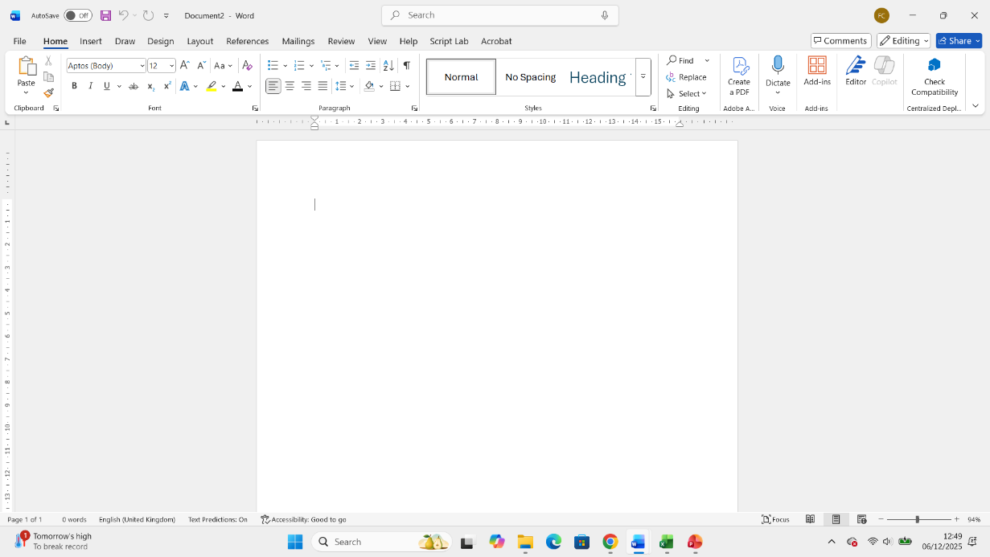
Figure 25, Open Word
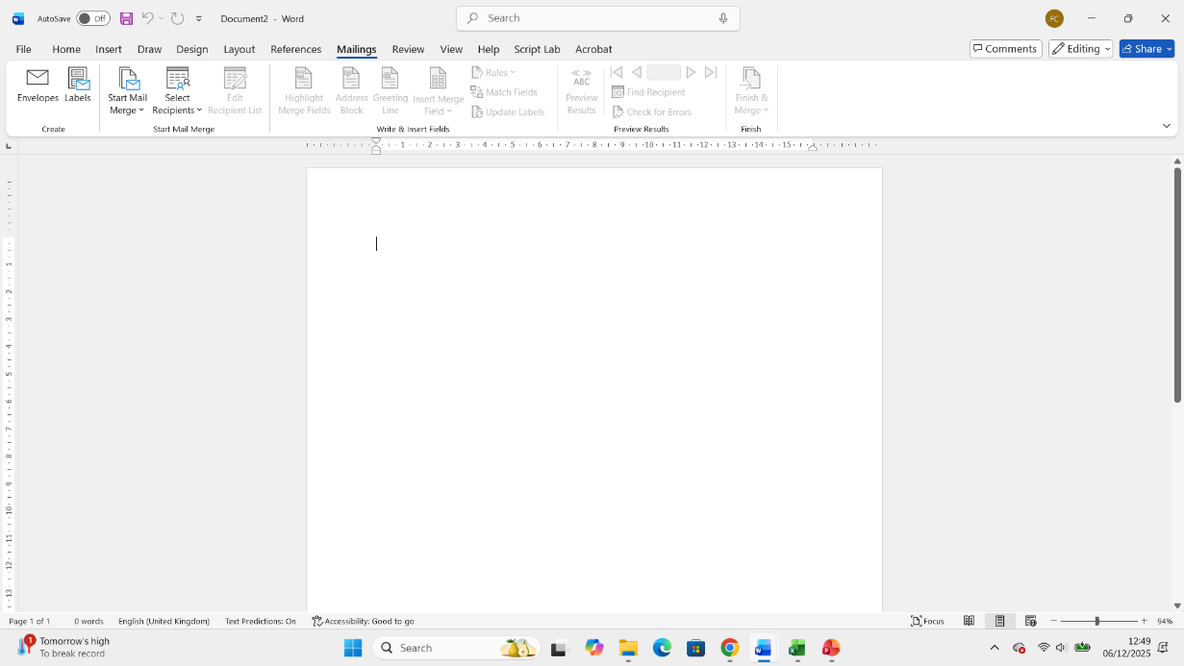
Figure 26, Go to mailings
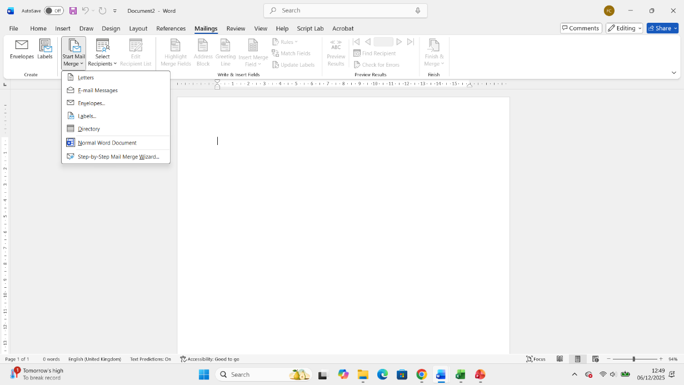
Figure 27, select start mail merge
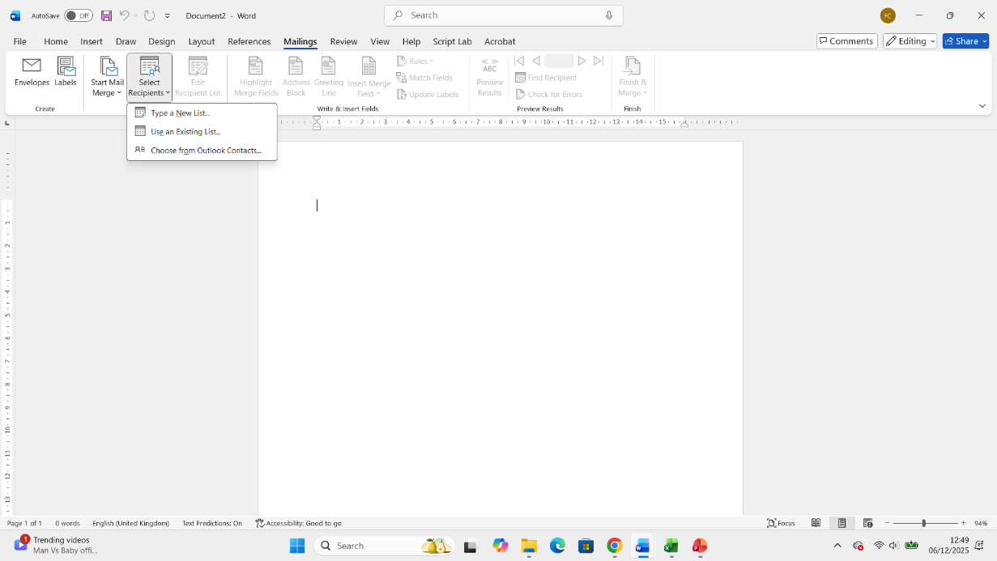
Figure 28, type new list
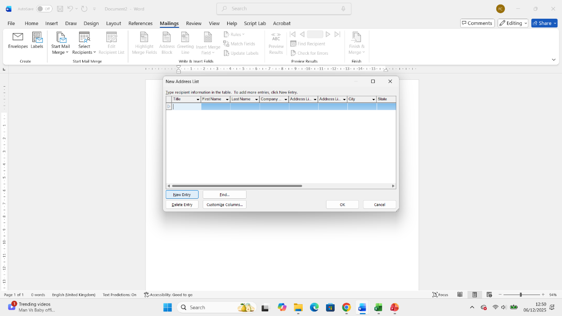
Figure 29, Introduce details of clients
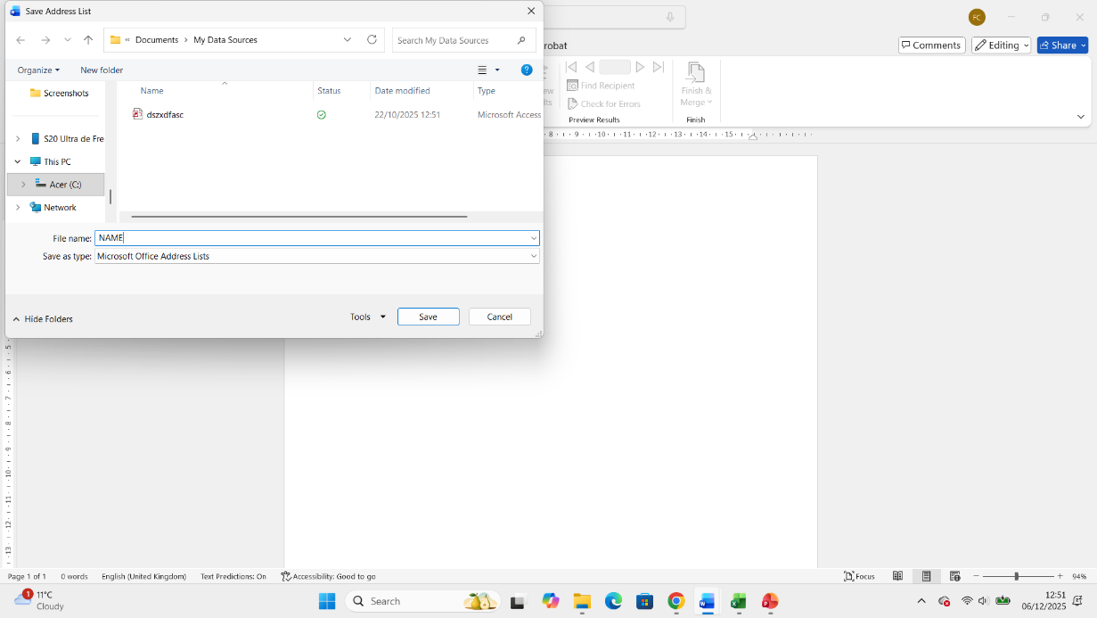
Figure 30, Save into address list
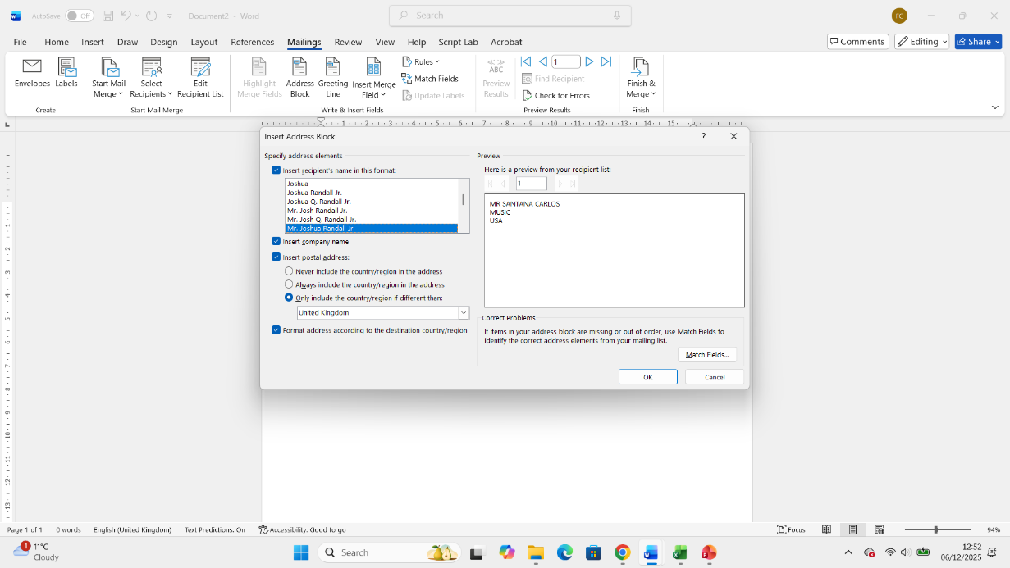
Figure 31, open address book
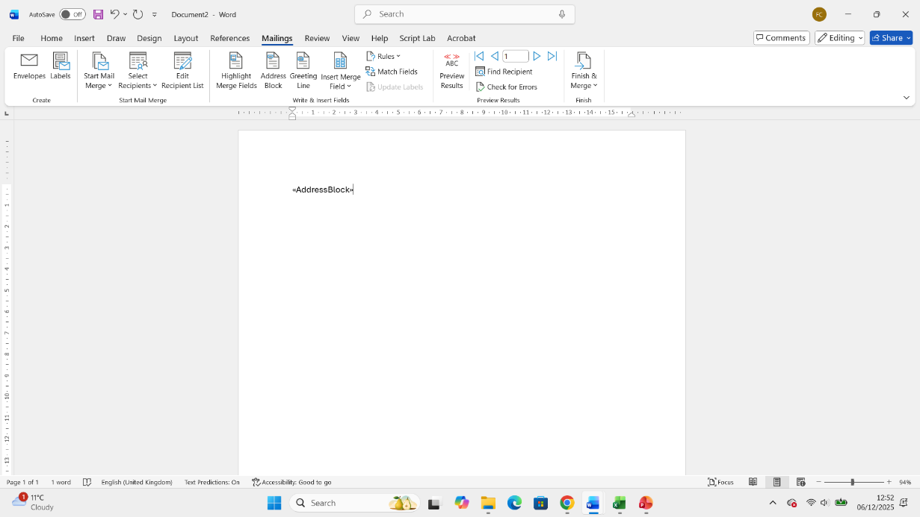
Figure 32, Address book select.

I used mail marge feature in Microsoft Word to generate personalized invitation letters for an event. I created a single main document containing the standard body of invitation and used accompanying excel spreadsheet as the data source, which included unique recipient names and addresses.

If Statement
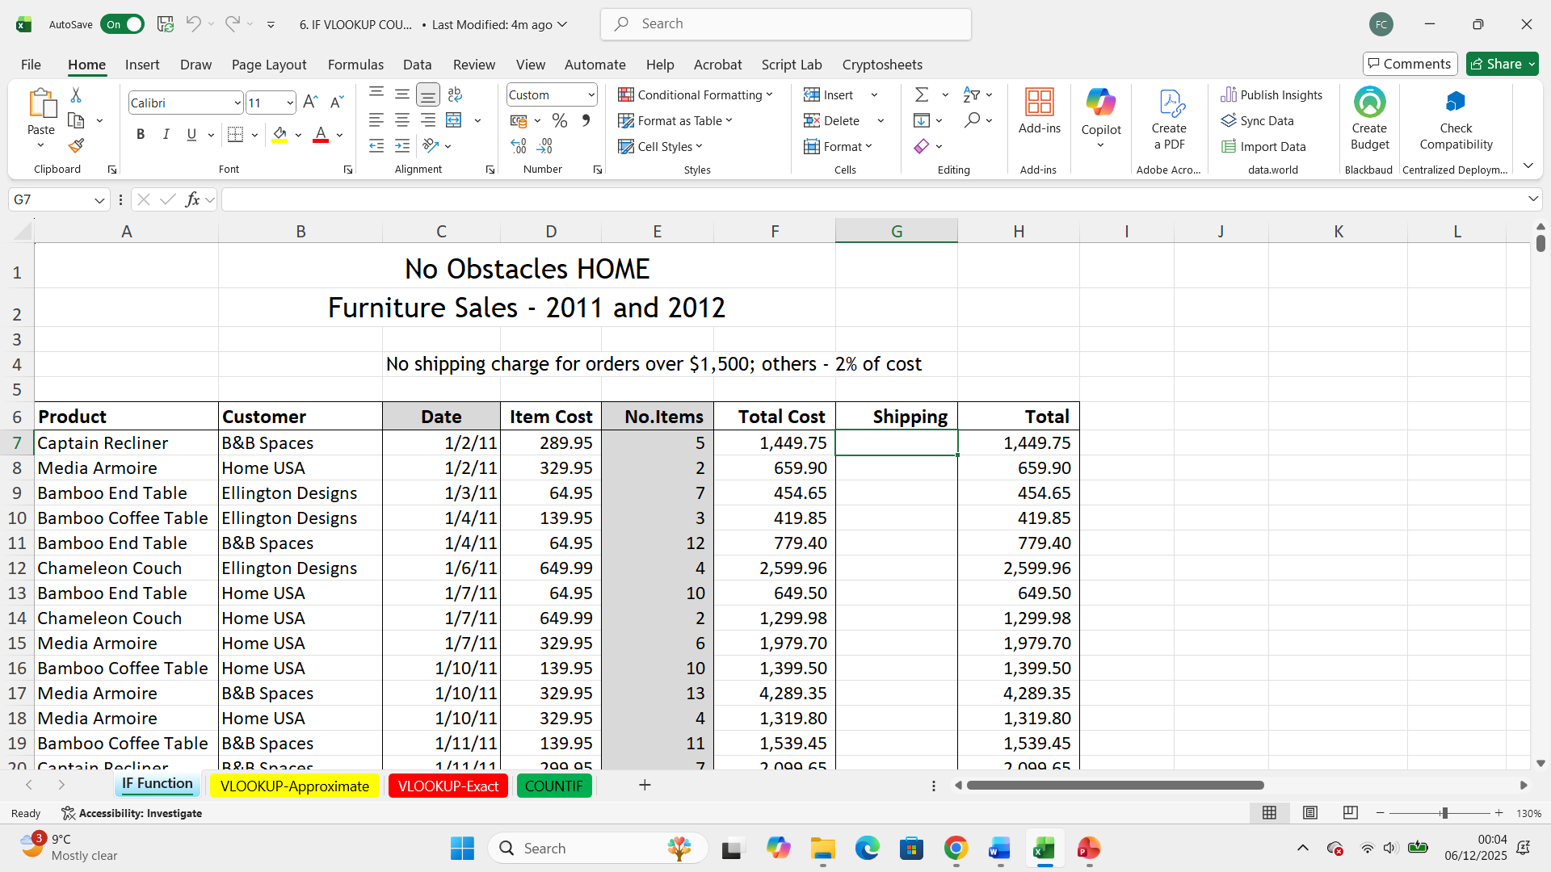
Figure 33, Open Excel and find If Function exercises
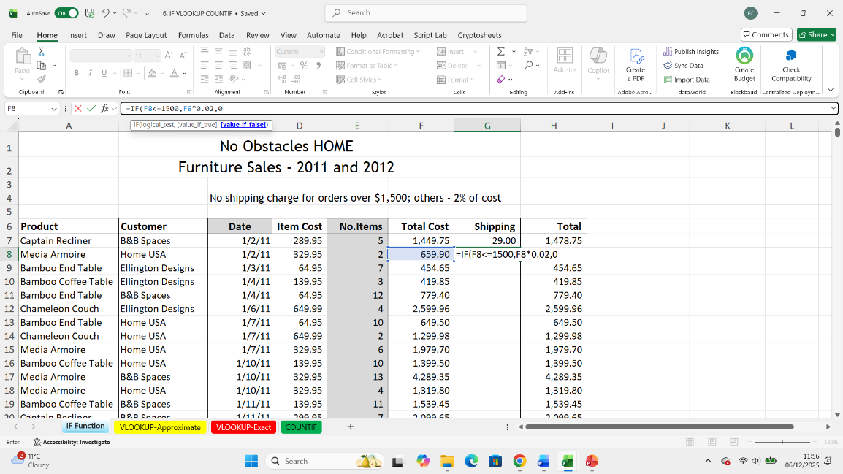
Figure 34, Now make a formula to find a result =IF (7c<=1500, f8*0.02,0
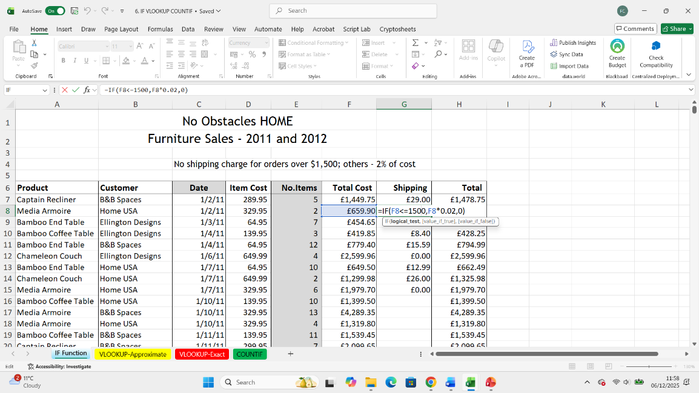
Figure 36, Find a result.

Suppose you use the IF Function in excel to categorize student, costs, Shipping costs, scores as “TRUE or “FALSE”.
Function used: =IF (logical_test, Value_IF_true, [Value_IF_False]). In the above table demonstrates the application of the IF Function to automatic determinate a shipping cost charge if the total is over 1500 if not the charge 2% for the shipping cost.
In this Statement we can saw the following formula to find if the shipping have a cost or not. =IF (F7<=1500, F7*0.02,0)

Task 4. Communication and Collaboration applications

One contemporary Communication and one Online Collaboration applications/tools

The demands of the contemporary business world, particularly the rise of remote and hybrid work models, have made Microsoft Outlook and Microsoft Teams indispensable tools. Outlook remains the foundation for formal, external, and asynchronous communication, while Teams serves as the central hub for real-time collaboration and project-based teamwork [13]. Both are part of the Microsoft 365 ecosystem, sharing a deep, mutually beneficial integration that defines modern enterprise productivity [14].

MS Outlook
Microsoft Outlook is an advanced personal information management system primarily known for its enterprise-grade email client. It is the contemporary successor to traditional office communication, providing a structured, formal, and traceable medium for internal and external correspondence [15].
Key Features of Outlook:
- Integrated Email Management:
  - Handles multiple email accounts (Exchange, IMAP, POP) and offers robust features like Focused Inbox (AI-driven prioritization of important emails) and advanced search filters, significantly improving email triage and organization [16].
  - Supports email rules, Quick Steps, and templates for automating routine actions (e.g., forwarding, categorizing, or responding with canned messages), which boosts user efficiency [15].
- Calendar and Scheduling:
  - Features a sophisticated Calendar with the Scheduling Assistant, enabling users to quickly check colleagues' availability, propose multiple meeting times, and manage invitations across time zones [13]
  - Meeting integration with Teams allows users to transform any scheduled meetings into a video conference with a single click during the creation process [14].
- Contact and Task Management:
  - The People (Contacts) module manages personal and organizational address books, allowing users to create distribution lists and integrate with LinkedIn.
  - To Do (Tasks) integration enables users to turn an email into a flagged task or create dedicated tasks, managing follow-up items directly within the email client interface [16].
- Security and Compliance:
  - Leverages Exchange Online Protection for advanced security features, including spam filtering, phishing protection, and malware scanning, alongside archiving and compliance tools critical for large organizations [13].

MS Teams
Microsoft Teams is a unified communications and collaboration platform designed to serve as the "hub for teamwork" within the Microsoft 365 environment. It is built for real-time, project-centric, and informal communication, contrasting with the formality of email [14].
Key Features of Teams:
- Channels-Based Communication:
  - Organizes conversations, files, and applications into Teams (for a project or department) and specific Channels (for topics or sub-projects). This structure reduces email clutter and centralizes project-related discussions [17].
  - Uses threaded conversations and @mentions to keep discussions focused and draw attention to specific users or groups, enabling rapid, contextual feedback [13].
- Video Conferencing and Meetings:
  - Provides high-definition video and audio calling with features like screen sharing, virtual backgrounds, live captions, and recording. It supports large meetings and webinars with robust moderation tools [17].
  - Meeting Recaps automatically generate transcripts, recordings, and shared files after a meeting, ensuring that knowledge is retained and accessible to those who missed the session [14].
- Deep Microsoft 365 Integration:
  - Allows real-time co-authoring and editing of Office documents (Word, Excel, PowerPoint) directly within the Teams interface, with files stored securely in the team's dedicated SharePoint site or OneDrive [17].
  - Supports integration with hundreds of other Microsoft and third-party applications, making the Teams window a central dashboard for workflow management [14].
- Telephony and Calling:
  - Offers VOIP (Voice over IP) calling functionality (Teams Phone) which, with appropriate licensing, can replace a traditional business phone system, allowing users to make and receive external calls from the application [17].

One feature of a freely available Communication (1) and one feature of a Collaboration (1) application

MS Outlook

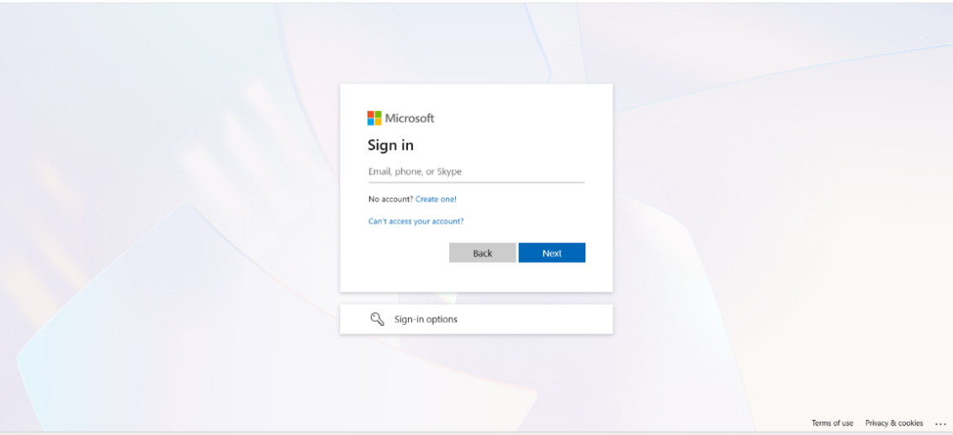
Figure 39, Introduce email address and password
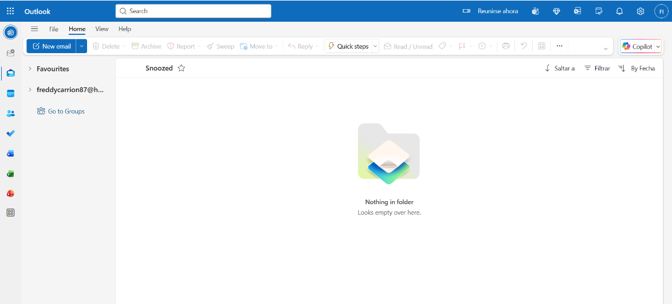
Figure 40, Find imbox
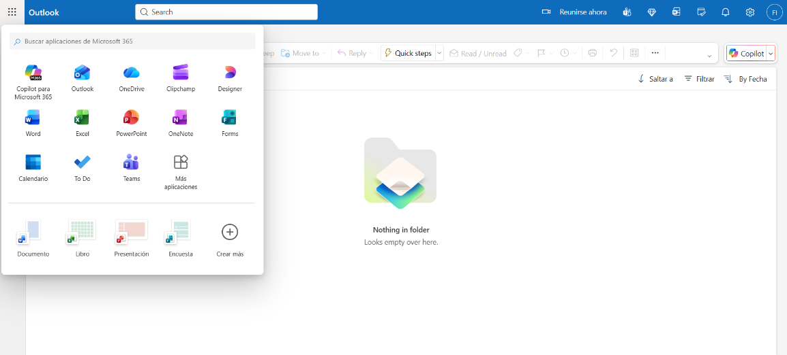
Figure 41, We can find a many online apps like Word, PowerPoint, Excel and more.
MS OUTLOOK FEATURE: The focused inbox feature automatically separates a user’s incoming emails into two tabs: Focused for important emails likely requiring immediate attention and other for less important emails like newsletters or promotional content.

Ms Teams

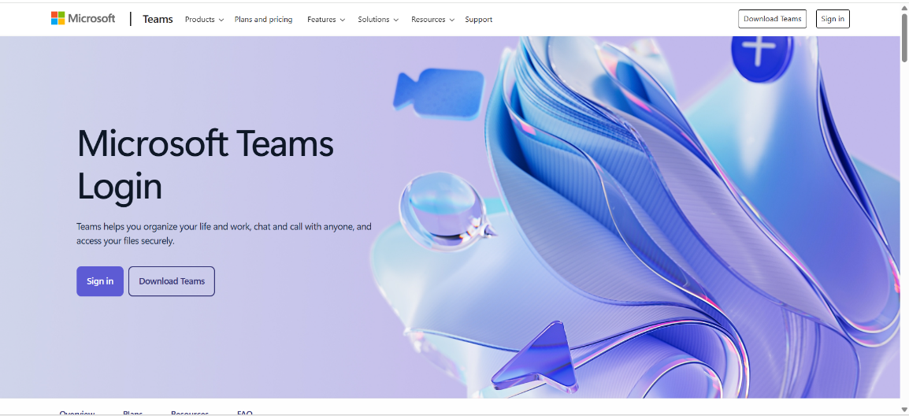
Figure 44, Click on Sign in
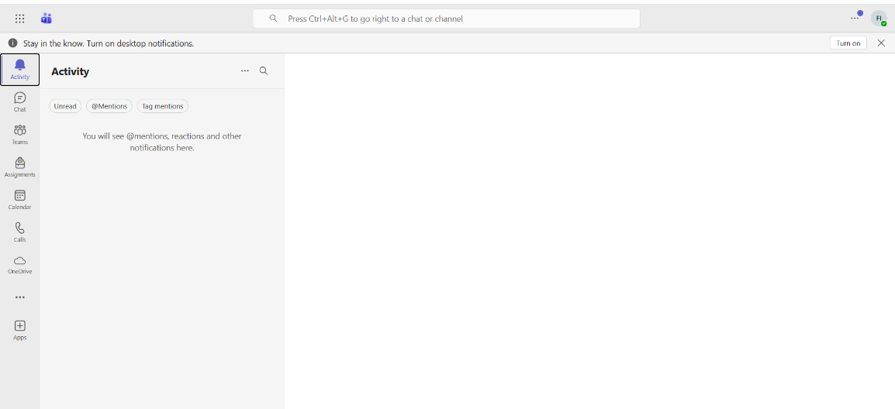
Figure 46, Find activities
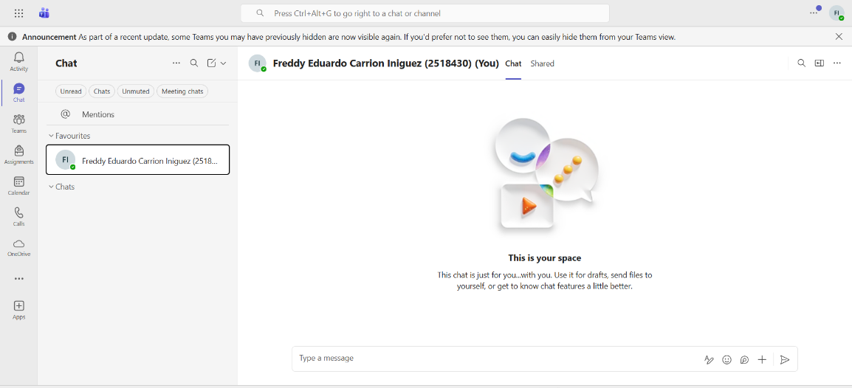
Figure 47, We can chat with other
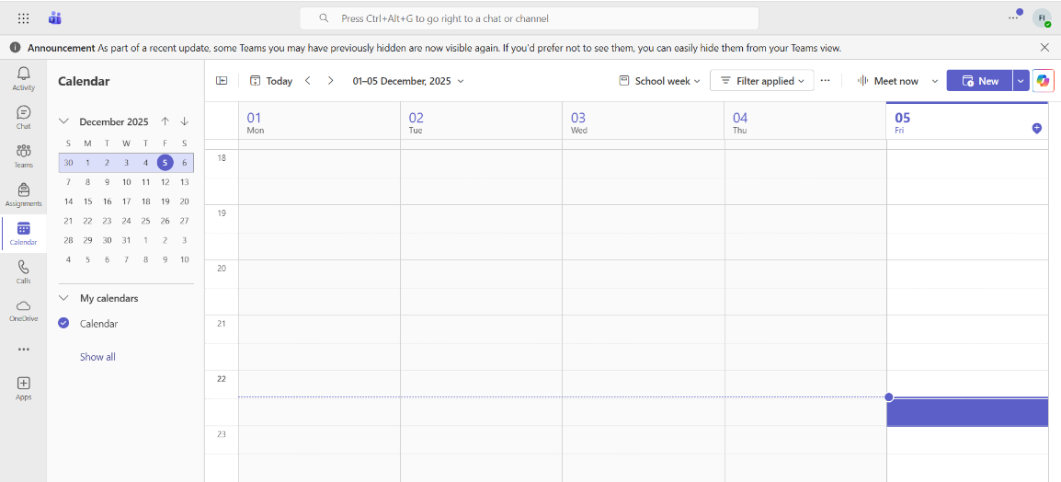
Figure 48, We can make an appointment or find schedule
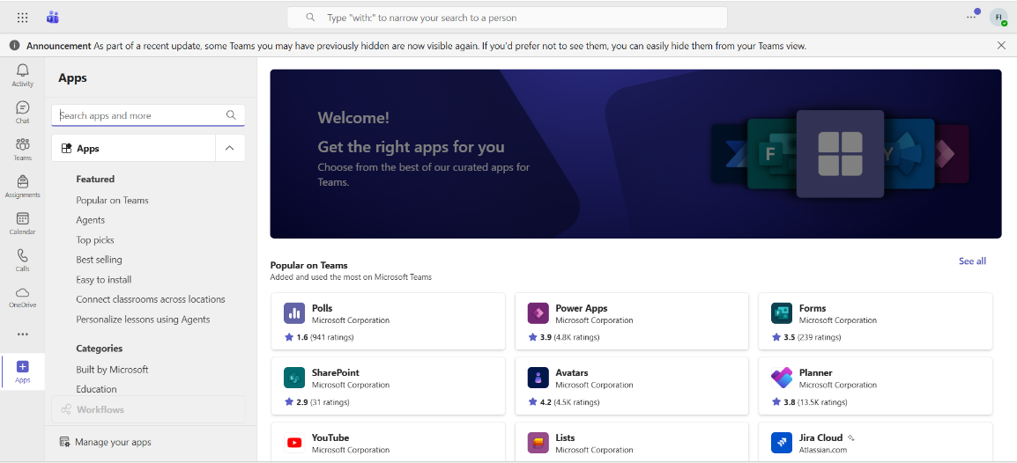
Figure 49 And we can find apps to add into Teams.

Ms Teams features: co-authoring allows multiple team members to open and edit the same Microsoft office document eg, word, excel, PowerPoint, simultaneously and real time within the team environment.

Conclusion

The exploration of these essential software applications confirms their non-negotiable role in modern business. E-commerce platforms like Shopify and Wix provide the engine for online revenue, while Mind Mapping software drives strategic planning and clarity. Foundational Office Applications—Word, PowerPoint, Excel, and Access—remain the standard for daily document management and data analysis, with features like Mail Merge and the IF Statement showcasing their power in automation.
Finally, Communication and Collaboration tools such as MS Outlook and MS Teams define the pace and effectiveness of team interaction. A contemporary business must not only adopt but also strategically master these tools to optimize efficiency, foster internal collaboration, and successfully navigate the global digital marketplace.

References

Task 1: E-Commerce Website builders or software solutions
Links
[1] https://www.charle.co.uk/articles/how-does-shopify-work/
[2] https://www.wix.com/

Work

[1] P. K. Jadav and H. M. Chaudhary, Digital Marketing and E-commerce Essentials. Hoboken, NJ: Wiley-Scrivener, 2024, ch. 4, pp. 112–115.
[2] A. R. Davis, The Future of Online Retailing: Strategies for E-commerce Success. New York, NY: McGraw-Hill, 2023, pp. 245–252.
[3] L. Chen and S. P. Patel, E-commerce Platform Selection for Startups. Berlin, Germany: Springer, 2024, sec. 5.1, pp. 98–101.
[4] S. K. Gupta, Web Development Technologies and Business Applications. London, UK: IET Publishing, 2022, pp. 310–314.

References

TASK 2: MIND-MAP:
LINK

[3] https://www.mindmeister.com/app/map/3884123899?t=RNIHZBs65G
WORK

[5] C. Griffiths, Mind Maps for Business: Revolutionise Your Business Thinking and Practice. London, UK: Pearson Education, 2013, pp. 2–15.

[6] T. Buzan, The Mind Map Book: How to Use Radiant Thinking to Maximize Your Brain's Untapped Potential. New York, NY, USA: Plume, 1993, ch. 1, pp. 10–25.

[7] Atlassian, “What Is a Mind Map? Learn Its Benefits and How to Create One,” The Workstream. [Online]. Available: https://www.atlassian.com/work-management/project-management/mind-mapping. (Accessed: Dec. 5, 2025).

References

Task 3: Office Applications

​[8] V. A. Thomas, Microsoft Office 365: The Complete Guide to All Apps and Services for Business, 1st ed. New York, NY, USA: Tech Press Publishing, 2024, pp. 3-278.
​[9] K. M. Jones, Word Processing and Document Creation for Professionals, 3rd ed. London, UK: Business Software Books, 2022, p. 115.
​[10] J. W. Smith, Essential Tools for Data and Document Management, 5th ed. Hoboken, NJ, USA: Wiley, 2023, pp. 13-28.
​[11] R. A. Stevens, Advanced Data Analysis with Microsoft Excel, 2nd ed. Oxford, UK: Global Learning Press, 2021, pp. 71-110.
​[12] L. P. Chen, Fundamentals of Database Management with MS Access, 4th ed. Singapore: Asia Tech Books, 2020, pp. 5-55.

References

Task 4: Communication and Collaboration applications

[13] T. L. Hayes, Mastering the Modern Digital Workplace: Tools and Strategies for Collaboration. New York, NY, USA: Tech Press, 2024, pp. 15-22.
[14] K. A. Singh, The Unified Communications Ecosystem: Integrating Outlook and Teams for Enterprise Productivity. London, UK: Business Futures Publishing, 2023, pp. 45-51.
[15] J. C. Williams, Email Protocol and Management in the Enterprise. Hoboken, NJ, USA: Wiley, 2022, pp. 88-95.
[16] S. R. Jones, Microsoft Outlook for the Professional. Redmond, WA, USA: Microsoft Press, 2023, pp. 112-118.
[17] P. J. Chen, Teamwork Transformed: Deploying Microsoft Teams in Hybrid Environments. San Francisco, CA, USA: Tech Books Inc., 2023, pp. 60-65.

