
BA Leadership and Management

Developing Workplace Critical Thinking
BMSW5101
Reflective essay

Lecturer: Zahra Mohammadnazari
Student: Nicoleta Damian (2120244)

Executive summary
Reflective practice take place everywhere and at any time during daily activities.
Therefore, meaning that happens at the workplace, where all of us spend an impressive amount of time. The following essay describes the importance of reflection on completed tasks at work, ways of improving and maintaining a high level of productivity and developing reflective skills among the employees.
Many scientists’ models/ theories are being presented and discussed, in order to demonstrate different aspects of reflective practice in management and not only.
Moreover, can be found discussion of how reflective practices develop high standards management, its benefits, and how to ensure conflict resolutions are implemented appropriately.

Table of Contents

Executive summary 2
Introduction 4
Purposes of reflective practice 4
Reflective practice skills vs effective management 5
Benefits of reflection 7
Theories of Reflective Practices 8
Reflective practice in Management 11
Conclusions 13
Reference list 15

Introduction
Reflective practice is a deliberate and systematic application of critical thinking to examine past experiences for learning and improvement. It is essential for developing effective leadership skills and improving personal and organizational performance. It helps managers to confront challenges and conflicts, learn from them, and apply new insights to improve their decision-making and problem-solving abilities. Management involves planning, organizing, leading, and controlling resources, while conflict resolution involves identifying the root cause of the conflict, managing emotions, and using effective communication and negotiation skills to find a mutually acceptable solution. Experiences provide a basis for learning and development, helping managers to enhance their performance and achieve their goals.

Purposes of reflective practice
Reflective activity is the process of considering your job encounters in an attempt to enhance them. At times we spend excessive time focusing on our daily duties and responsibilities that we neglect the moment to pause and reflect about the things we're accomplishing, the manner in which it makes us feel, alongside the ways we may improve or streamline it. Being reflective can help with it. It provides an increased targeted, organised way of reflecting on past work-related activities. (Marshall, 2019)
Reflecting about previous events which occurred on the job has the drawback of making yourself fixed on a conversation either a choice you weren't certain regarding and leave you with persistent concerns regarding those specific events.
Reflective practise does not involve concerning it. It is instead intended to support professionals in reflecting deeper on a specific event, how it affected them, and any lessons they might take out of it. The process of reflection can then be used as an effective technique to aid in decision-making or to generate problem-solving ideas. Therefore, developing assurance, discovering how to depend on one's personal judgment, and improving as a worker constitute the various advantages of practicing reflective thinking. (Ross, 1989)
It can be considered an inherent characteristic of humans to reflect on the past. Even so, contemplative behavior differs from careless "the thought process" in that it calls for deliberate attempts to meditate
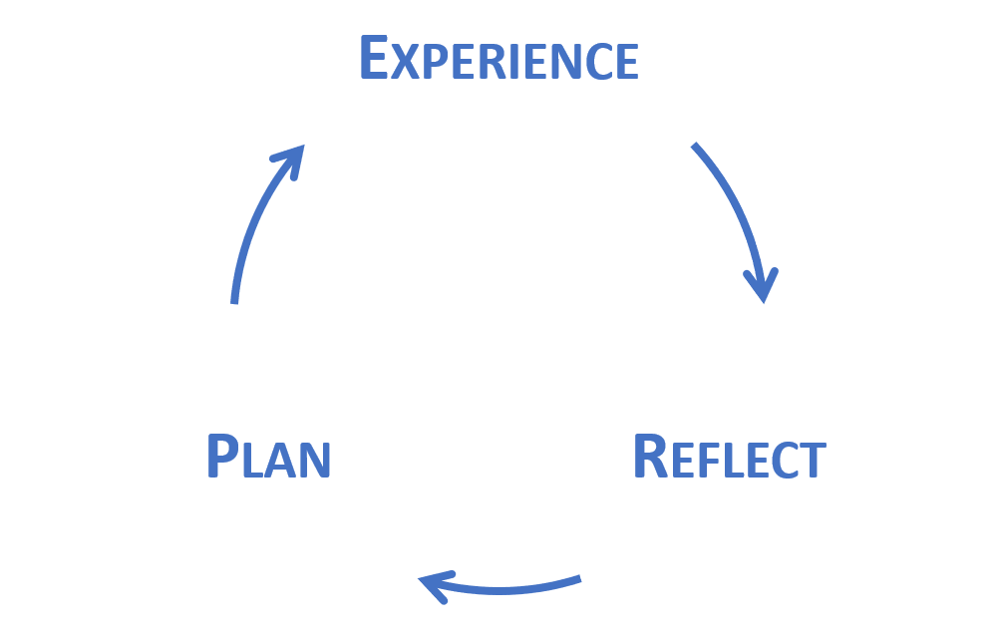
on experiences and gain new understanding from those. You'll certainly consider reflective practise helpful for both job or at household when you start getting established a rhythm of doing it.

Reflective practice skills vs effective management
Over several decades, a variety of scholars have debated reflective practise and practical education to varying degrees.
Almost all present to be in accordance that engaging in thoughtful behavior is a talent which may be developed, making it motivating for everyone in the workforce but notably those in managing. The consensus among scientists is that practice that is reflective helps to close the discrepancy among the “enriched grounds" of concept and the "swampy lowlands" of practise. In simple terms, it facilitates the more systematic exploration of concepts and their application to everyday life. These could be official theories based on scientific research or simply your personal thoughts. It additionally motivates us to investigate our personal expectations and views also to come up with answers to issues. (Smith and Lovat, 1991)

How can the analytical, productive, and imaginative thinking which is needed for reflective activity be applied?
According to Neil Thompson's study papers People Skills, there are a total of
six stages to comply with:
• Study in order to improve yourself in the fields that you are gaining knowledge regarding or desire to find out more about.
•Discover the reasons behind and how other individuals accomplish tasks by questioning them.
•Take notice of your surroundings.
•Sense – be aware of your emotions, what activates hem, and the way you react to less comfortable aspects.
•Talk to people in the organisation and express your thoughts and expertise with them.
•Consider giving value to the amounts of time you spend considering your job.

To put it another way, it's more than what you believe matters. Theories along with different people's practises must be fully understandable, and you must debate opinions among colleagues.
Reflective practise does not have to be strictly performed by one person; it may be accomplished through groups. In fact, many social scientists have hypothesised that acquisition of knowledge takes place whenever the use of language, whether written or verbal, is intentionally constructed. That could help clarify the reason we feel compelled to share a specific discovery aloud, despite the fact that it happens by ourselves at this point. It additionally has consequences for practicing reflection and demonstrates how poorly expressed ideas might not hold up over time.
At a hyperactive place of employment, it may be demanding to seek out chances for collaborative practice in reflection. Obviously, there exist definite evident ones, like evaluations of particular instances or consultations for assessments, but are usually uncommon. Therefore, it is necessary to bring alternative approaches to express findings.
Recording your educational experiences might prove favourable, particularly when initially, although it may look a little forced. It will not be necessary recording formal instruction to accomplish such; but , you must record commonplace behaviours and occurrence, analyse upon them in order to understand the things you gained from them in response, and decide things that you might or shouldn't be doing otherwise.
Not everything needs to change; keeping an educational notebook and engaging in practice of reflection may assist you recognise your and people’s you manage achievements.

Benefits of reflection
The practice of reflection is extremely helpful in improving one's comprehension of others in addition to the individual's personal self-consciousness, making it a crucial element of mental agility.
Reflective behavior supports active participation in workplace procedures that can aid in the development of innovative thinking abilities.
Maintaining an instructional notebook and consistently engaging in reflective practise during job duties will enable more productive meetings regarding job growth along with individual expansion, notably those that take place during individual evaluation period. Additionally, having models that can be utilized within centered around competencies interview settings can be beneficial.
In order to share thoughts, embrace approaches, and comprehend how Reflective Practice may be utilised when combined with various development strategies, terminologies additionally help in establishing straightforward interpretations.

Theories of Reflective Practices
Immanuel Kant (German theorist) is regarded to be one of the firsts reflecting philosophical theory in the West.
In his 1781 research paper “Critique of Reason," Kant argued that rational analysis is desirable to belief and other forms of acquired knowledge from authorities which may be used to progress science.
Meanwhile, English theorist, mathematician, and admirer of Kant's approach to science
Bertrand Russell (1872–1970) believes that intelligence is "the opinion in accordance with evidence." He argued that believing anything without facts is insufficient, so we should rather determine whether there are relevant and widely accepted reasons for believing it and, if thus, by whom. (1926).
American scientist David Kolb accredited for developing the approach of experience-based learning. Developed the theories of Kurt Lewin, Jean Piaget, and others on academic achievement, Kolb improved the practical learning theory, which is frequently illustrated by Kolb's Education Process Diagram, in his 1984 publication “Experiential Learning: Experience as the Source of Learning and Development." The well-known images depicts the 4 biggest stage of the educational process as a never-ending cycle, going from:
•Experience
•Reflection
•Learning or outcomes ,
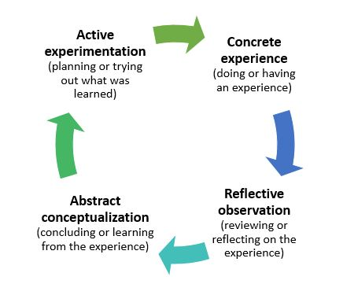
•Planning/experimentations (and back to the first stage)

Kolb claimed that improving when we use every phase of the learning cycle, particularly how we reflected on existing experiences, will assist people becoming better as continuous learners. Therefore, we are going to be more prosperous in job daily experience if there could be a stronger option or strategy and accomplish greater accomplishments.
Kolb's theory is one of several that supports "trial and error" theory by an individual's directly experiences and says this method (the "trial and error" approach) is a key method of effective managing job activities.
A key component of practice that is reflective is objectivity. Such concept has been proposed ever since it first gained popularity in current times, between various places, specifically in the writings of Immanuel Kant.
The personal reasoning naturally seems to be subjective in some way because it is an outcome of the human brain, which is plainly individual. Subjectivity may turn problematic in situations when our reasoning is extremely subjective, such as if we are really sensitive over things. This might be particularly prevalent when we are experiencing pressure, irritation ,disturbance, as these emotions can significantly skew our perceptions.
Reflective thinking needs to be objective in order to be beneficial towards our development and progress as well as for enhancing our choices and decision-making in a certain context. Misinformation often leads to poor conclusions and even poorer consequences.
In order for Reflective Practice to be extremely beneficial, objectivity is crucial.
We ought to reflect concerning what scientists want to say regarding both this and the way we may effectively accommodate reflective practise's natural tendency to accommodate subjectivity in human reasoning.
One of the greatest templates for those in management roles is the Gibbs - Reflective Cycle model.
We have the ability to focus particularly on our own and employees’ emotions, thoughts, and impressions thanks to the Gibbs reflective cycle, which was partly motivated by Kolb's learning cycle. In everyday language, this is referred to as "Being in somebody’s place." It has a direct connection to understanding concepts.
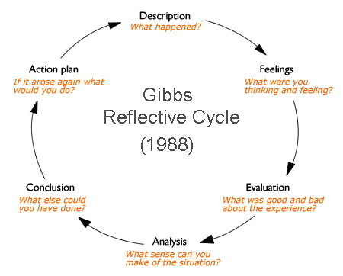
The procedure, which consists of the following components, is effectively an ongoing process: Overviews, Feelings and emotions, Evaluation, Analysis, Conclusions and the Plan of action.

Reflective practice in Management
Reflective practise entails taking the time to reflect critically on the past and draw lessons from it to enhance future actions. Here are some ways that reflective practise can support the growth of efficient management, comprehension of management theories, and conflict resolution skills:
1. Increase self-awareness: Through reflective practice, managers are prompted to consider how they behave and react in situations of conflict. This self-awareness can assist managers in identifying areas for development and creating plans for better conflict management. (Filley, 1975)
2. Gain additional insights: Managers can learn new things about management and conflict resolution theories by thinking back on previous experiences. They might learn novel approaches to resolving disputes or fresh methods for leading their teams.
3. Develop better communication skills: Managers can develop better interpersonal abilities
by reflecting on previous interactions
and identifying areas for improvement. They might pick up fresh conflict-management strategies through new communication skills.
4. Improve problem-solving abilities: Reflective practise encourages managers to consider issues and conflicts critically. They may gain abilities in problem-solving and creative conflict resolution as a result, which will help them manage conflicts effectively.
5. Constantly learn and improve: Managers can improve their management abilities by taking stock of their previous managerial roles. They can have a deeper knowledge about
the topic and stay up to date on management theories as a result, which will improve supervision and resolution of disputes.
There are several theories and management experiences that can be applied to solve managerial challenges. Systems thinking is the process of understanding how different elements of a system work together to achieve a common goal. Lean management is a management philosophy that focuses on minimizing waste in all aspects of an organization's operations. Change management involves preparing, supporting, and helping individuals and groups in an organization to make a transition from the current state to a desired future state. Emotional intelligence is the ability to recognize, understand, and manage one's own emotions, as well as those of others. (Middleton,2017)
Strategic management involves setting goals, developing strategies, and aligning resources to achieve organizational objectives. By applying these concepts, managers can ensure their organization is well-positioned to compete and succeed in the marketplace.

Conclusions
The process of self-awareness and self-evaluation that encourages personal development is self-reflective practice, particularly in management. Managers may better comprehend their management style, pinpoint areas for growth, and create effective team-leading tactics by integrating management theories into reflective practise in the workplace.
Additionally, using conflict resolution techniques in reflective practise can aid managers in guiding their teams through difficult and complex situations. Effective conflict resolution techniques can boost connections, reliability, and communication, which will ultimately result in better teamwork and greater achievement in general.
In general, key elements of efficient management in the workplace include reflective practice, management theories, and conflict resolution techniques. Managers may foster a culture of growth and advancement that is advantageous to both them and their team by regularly evaluating their own performance and using these methods.
However, there are some recommendations regarding reflective practices in management:
Set aside time for reflection: Schedule a specific time for self-reflection on a regular basis.
Keep a reflective journal: Write down your thoughts and reflections in a journal.
Be open-minded: Reflective practice requires an open-minded approach.
Focus on the big picture: Reflective practice should be driven by an understanding of the organization's goals and objectives.
Use reflection as a learning opportunity: Reflective practice should be viewed as a learning process

Reference list
Filley, A. C. (1975). Interpersonal Conflict Resolution, Scott, Foresman, Glenview. ( Accessed: March 10. 2023)
Gibbs, G. (1988). Learning by doing: A guide to teaching and learning methods. Oxford: Oxford Further Education Unit. ( Accessed: March 8, 2023)
Kant, I. (1781/87) 2nd ed., Critique of Pure Reason, tr. and ed. by P. Guyer and A. Wood, (1998) Cambridge University Press. ( Accessed: March 10, 2023)
Kolb, D.A. (1984): Experiential learning: experience as the source of learning and development [internet]. ( Accessed: March 16, 2023)
Marshall, T. (2019). The concept of reflection: a systematic review and thematic synthesis across professional contexts. Reflective Pract. 20, 396–415. ( Accessed: March 16, 2023)
Middleton, R. (2017). Critical reflection on practice development: The struggle of a practice developer. International Practice Development Journal, 7(1), 41-46. ( Accessed: March 10, 2023)
Piaget, J. (1969) The Mechanisms of Perception, London: Routledge & Kegan Paul, original work 1961. ( Accessed: March 20, 2023)
Ross, D. D. (1989). First steps in developing a reflective approach. 22–30. ( Accessed: March 14, 2023)
Russell, B. (1926) On Education, Especially in Early Childhood, London: George Allen and Unwin; repr. as Education and the Good Life, New York: Boni and Liveright, 1926. ( Accessed: March 20, 2023)
Smith, D., and Lovat, T. (1991). Curriculum: Action on reflection (2nd edtn.). Wentworth Falls: Social Science Press. ( Accessed: March 26, 2023)
Thompson, N. (2002). People Skills.( 2nd edtn) ( Accessed: March 16, 2023)

