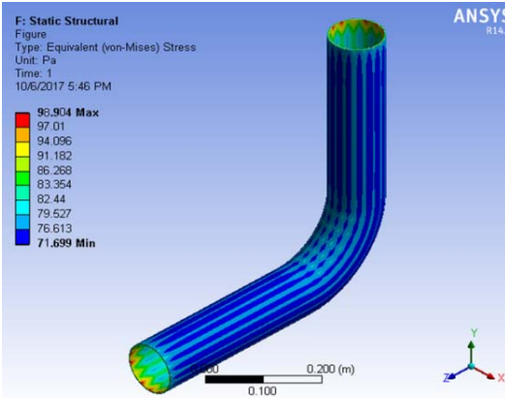  Theories of elastic failure  [Document subtitle] | Advanced stress and fea  Abi Price  BEng Mechanical and Manufacturing Engineering

Executive Summary

This report is written to explore methods of elastic failure how they are used and what type of failure can be expected. How certain methods have been developed and are used to assist in engineering.

Contents
Executive Summary 1
Introduction 3
Task 1 4
Task 2 6
Task 3 9
Bibliography 11

Introduction

Many designed structures or components have been subject to simple stress tests during the design process. The most utilised test is a tensile test, this is to determine either the value of stress at yield or when the component fails. Theories have been proposed for both brittle and ductile materials.
Now stress and strain is tested before components are modelled on computer programmes before they are made to see if they meet the criteria prior to construction. Failure theories are important for design as they allow components to be designed with a margin of safety.
According to (Thories of Elastic failure ) When dealing with designing structures or objects and testing elastic failure most failures are usually found when tensile tests are being undertaken in a laboratory environment. The test is simple and consist of a tensile test which illustrates the value of stress at yield or point of fracture. Though these tests are common there are also theories that can determine when an object is likely to fail. Every material has a certain strength expressed in terms of stress or strain, beyond which is fractures or fails to carry the load.
I work for the oil industry; we model all our pipe systems using computer aided design (CAD) and then model them in Caesar which is a stress analysis package. This allowing us firstly to see if the pipe system will fulfil the requirements and if the pipe stress is within the acceptable limits.

Task 1

The first theory of elastic failure that will be discussed in this report is Rankine’s Maximum Principal Stress Theory. Rankins theory was developed in 1850 and is thought to be reliable to brittle materials and therefore should not be used for ductile materials. (Grieve, n.d.) Rankin’s theory states that if maximum principal stress is equal to yield stress then the material is likely to fail, likewise is the minimum principal stress is equal to the yield stress then the material again is likely to fail under compressive stress. This theory is known to be reliable for brittle materials such as Ceramics and not so reliable to ductile materials so therefore should not be used on materials such as steel or aluminium. A brittle material for example glass or cold metal will fracture with a clean break without any appreciable plastic deformation. This theory is applicable to brittle materials as brittle materials are weak in tension.
The second theory of elastic failure that will be discussed is the Guest or Tresca theory of Maximum Shear stress theory. This theory states that when maximum principal stress minus the minimum principal stress is equal to the yield stress of the material then it is likely that failure will occur. It is saying that yielding will occur at a critical value of the maximum shear stress (N.Wright, 2011). This theory dates to 1868 and is thought to be conservative for all materials but predominantly ductile materias. As said by (Maximum Shear Stress Criterion, n.d.) the yield in ductile materials is commonly caused by the slipping of crystal planes which occurs along the maximum shear stress surface. This meaning that a certain point on the object is deemed safe if the maximum shear stress remains under the yield shear stress. However, it is an old theory and has now been superseded by the Von Mises theory. A ductile fracture or failure is not described as a clean break, instead it will be more of a shearing failure along the planes. The failure will commonly occur 45 degrees to the direction of loading.
The last theory that will be discussed in this report is the Von Mises theory, this theory was derived in 1913 and is commonly used to estimate the yield of ductile materials. The theory concentrates on the point that material becomes subject to elastic deformation, followed by what’s known as “yielding” or “necking” before reaching breaking point which is known as ultimate stress (What is Von Mises stress?, 2020)
This theory is regarded as the most reliable theory especially for ductile materials. The Von Mises theory states can be written as.
$(σ1-σ2)2+(σ2-σ3)2+(σ3-σ1) 2=2σy$²
When sigma 1minus sigma 2 squared plus sigma 2 minus sigma 3 squared plus sigma 3 minus sigma 1 squared is equal to 2 times yield stress squared then there is likely to be a failure.
Von Mises theory is based on the idea that failure of a material which is subject to any form of stress will happen when the sum of the squares from the above equation is equal to the yield stress. This theory is similar to the Guest or Tresca theory, it compares well. However according to (Failure of elastic materials ) the Guest or Tresca theory will predict that the material will fail at a lower stress than Von Mises . It is thought that the Von Mises theory is more accurate for ductile materials. According to a paper by (Xian-Kui Zhu, 2003) Both Tresca and von Mises criterion are classic strength criterion, are both simple yet extensively used in engineering analysis and design. The von Mises stress theory is based on effective stress where the Tresca theory is based on the maximum shear stress.
Von Mise theory is now extensively used for product design. It has been developed and is now present in many simulation design packages. When designing components, it is paramount to design them so that they are well within their elastic limit, and in turn do not yield.
Figure 1 Below shows a grapical representation of Von Mises stress. If theresulting principal stress is inside the cylinder then the material has not yielded, if it is found on the surface then the maerial is yielding.
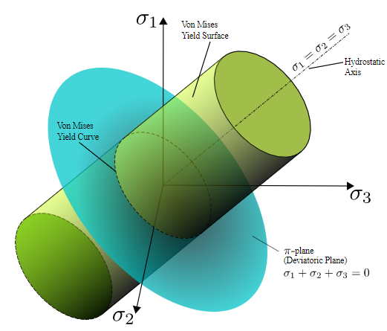.
(Figure 1)

Task 2
The component chosen to be discussed in this task is pipe that you would typically find in the oil and gas industry. The material of the pipe is Carbon steel, the standard for this pipe is ASTM A106 Seamless Steel pipe, Grade B standard schedule. This grade of pipe is commonly used on refineries and places that gasses and fluids are transported at high temperatures and pressures. (ASTM A106 Seamless Steel Pipe Specifications, 2020).
As said by (Qiang Bai, 2014) the Von Mises criteria is a formular for combining three principal stresses, resulting in what is known as equivalent stress. It is a number used as an index. Von Mises number is one of the most commonly used criteria when it comes to checking the yield condition in pipeline engineering.
Von Mises theory can be and is used when designing pipelines according to (What is Von Mises stress?, 2020) it is used in situations when pipelines are going to be subject to high pressure and combined loading conditions. Von Mises is written as figure 2 shows when relating to pipe stress.
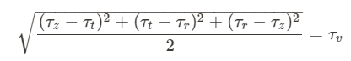
(Figure 2)
In the above equation z,r and t relate to the axial, radial and tangential stresses. The outcome will be that if the von Mises stress is equal or greater than the tension or yield stress of the material then the pipe will fail.
This is backed up by (Line results: Pipestress/strain , 2020) looking at figure 3 below, suggesting that in order to use von Mises for stressing pipelines $σ1,σ2 \& σ3$ are the principal stresses. In the 3X3 matrix the stresses relate to $σRR, σCC \& σZZ$ (Radial, Circumferential/radial and axial).
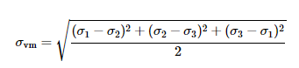
(Figure 3)
Von Mises stress is a theory that is used to work out if the stress combination at a certain point will lead to failure. Combination of stresses meaning the 3 principal stresses. It was discovered that even though none of the principal stresses may exceed the yield stress individually the material may still yield from a combination of the principal stresses. The combination of stresses being referred to as equivalent stress which is then compared to the yield stress.
When stressing pipe stress and strain readings are at the mid-segment points and at the end points. The stresses that are taken into consideration when stressing pipes are tension, bending, shear stress and hoop stress. The internal pressure that the pipe is subject to will act the same way that pressure would act in a sealed cylinder. When generating a stress matrix it is assumed that the shear stress is uniformly distributed across the cross sectional section of pipe, this is because it is assumed that the shear stress is negligible according to (Line results: Pipestress/strain , 2020). Along the pipe the loads are taken by essentially taking a slice of the pipe. Von Mises stress is a metric measurement which will determine whether the component has started to yield at any point.
Von Mises has been developed and incorporated in many computer design packages. This is handy when designing pipework as it allows the design engineers to highlight any areas of concern on a piping system. It will show where the pipe is likely to fail and whether the pipework is correct for the application it is intended for.
As an example, in Finite Element Analysis (FEA) Von Mises stress is used to identify problem areas, allowing for the Von mises stress to be directly compared to tensile and yield stress. This providing a good indication of how the component may plastically respond (Stress in FEA: Part 3, 2020). On the other hand a disadvantage when using Von Mises for design would be the fact that all the stresses are being condensed into one value, meaning .
Von Mises has been found to be particularly good at predicting when a pipeline will fail due to corrosion. Carbon steel is likely to fail after a long period of service due to corrosion. Therefore, this should be taken into consideration when designing pipework. When a pipe is inspected the wall thickness is taken, if the minimum thickness before failure is known it enables engineers to know when the pipe is in need of repairing.
A paper written by (N N Idris, 2020) explores how Von Mises can be used to help predict when the pipe will fail due to a reduction in wall thickness mainly from defects caused by corrosion. It was assumed that failure of the pipe would occur when von Mises stress was equal to ultimate tensile strength. Figure 4 below shows Von mises stress distribution when corrosion arrangement was modelled. Von mises stress was thought to have been at its highest around the corroded areas.
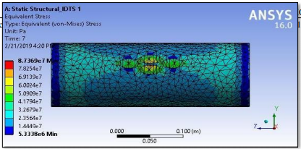
(Figure 4)
Figure 5 below shows von Mises stress increasing respectively as the pipeline walls internal pressure. 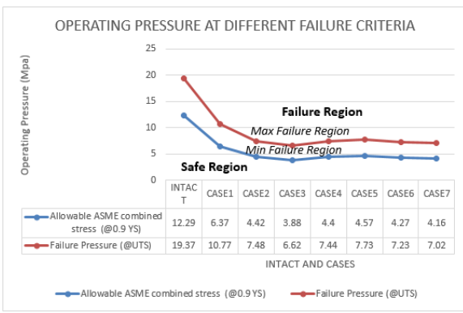
(Figure 5)
It was concluded that pipe stress increases as the internal pressure on the pipeline increases. It is shown that radial corrosion does in fact effect the integrity of pipelines failure pressure, corresponding with von Mises theory.

Task 3

The paper chosen which discusses Von Mises theory of elastic failure is Reflection of torsional T(0,1) guided waves from defects in pipe bends. (S.Heinlein, 2018). This paper identifies that circumferential crack reflections are shown to be proportional to von Mises stress at their locations.
This paper discusses the reflection of the torsional T(0,1) mode from defects in pipe bends. It discusses how the varying circumferential angular position along the pipe bend has an effect on pipe failure as well as the bend radius.
Guided wave inspection is commonly used and has been for over a decade to detect corrosion along with other defects in pipelines. It is most utilised in the oil and gas industry. The pipe walls act as a one-dimensional waveguide, this allowing the signals to travel tens of meters in both directions from the location being measured. Advantages of this mean unlike the other ultrasonic inspection methods, much larger areas are covered from one point. If a defect is found, it will cause part of the input wave to spike. The defect is able to be located as it uses the time travel of the wave pulse. It is thought that the smallest defect able to be picked up is 5% cross sectional area loss of the pipe wall. Pipe bends have been found to be more difficult to interpret as the signals received back are harder to read. There is an interest of permanent installation of guided wave structural health monitoring (SHM).
An investigation was undertaken on 8” diameter Carbon Steel pipe, the set up included a 90 degree 1.5 D bend. Various defects were introduced to the set up along the pipe in order to see how reliable the SHM method was.
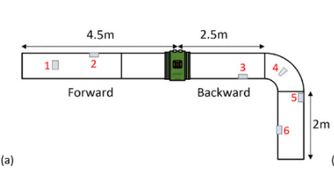

A 3D Finite Element model was constructed to investigate the way the guided wave behaved through the bend and reflecting from defects located on the pipe bend. The von Mises stress distribution was plotted to explain the stresses in the bend. To obtain a single stress value on each monitoring element the von mises stress was calculated using the equation presented in figure 7 below.
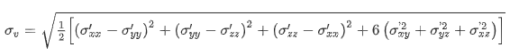
(Figure 7)
From this equation the maximum von Mises stress from each monitoring element individually was squared and plotted against its angular and circumferential position.
In Summary it was concluded that circumferential cracks, the variation of the torsional guided wave inspection around a pipe bend follows the von Mises stress distribution. This supporting the investigations into von Mises being accurate at predicting where a pipe will fail due to corrosion as discussed in task 2. This showing that the defects are where von Mises criterion expected them to occur. It was found that the square of the von Mises stress shows that the reflection from defect is proportional to stress.
This paper suggests that there is to a strong correlation between the crack reflection map which can be seen in figure 8 below, and von Mises stress distribution. Meaning that there is a satisfactory measure of relative reflections from the cracks at different locations around a bend. However, according to (S.Heinlein, 2018)this can only be assumed for circumferential cracks. 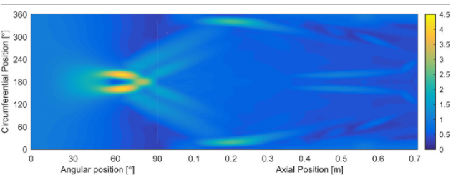
(Figure 8)
In conclusion, the Finite element study results confirmed that for circumferential cracks, the guided wave inspection around a bend follows the von mises stress distribution. It is also thought that the same corelation would be seen for small corrosion defects.

Bibliography
Abdalla, H. F. (2014). Shakedown Bpundary of a 90 degree back to back pipe bend subject to steady internal pressure . PVP.
ASTM A106 Seamless Steel Pipe Specifications. (2020). Retrieved from Fedsteel.com: https://www.fedsteel.com/astm-a106-carbon-steel-pipe-tube/
Celal Cakiroglu, A. K. (2012). Numerical analysis of high pressure cold bend pipe to investigate the behaviou of tension side fracture .
Failure of elastic materials . (n.d.). Retrieved from Engineering.aukland.ac.nz: http://homepages.engineering.auckland.ac.nz/~pkel015/SolidMechanicsBooks/Part_I/BookSM_Part_I/09_Failure/09_Failure_01_Failure.pdf
Grieve, D. J. (n.d.). Failure Theories . Retrieved from Mechanical Engineering Design.co.uk: http://www.mechengdesign.co.uk/PlannedWeb/lec5fail.htm
Line results: Pipestress/strain . (2020). Retrieved from orcina.com: https://www.orcina.com/webhelp/OrcaFlex/Content/html/Lineresults,Pipestressstrain.htm
Maximum Shear Stress Criterion. (n.d.). Retrieved from efunda.com: https://www.efunda.com/formulae/solid_mechanics/failure_criteria/failure_criteria_ductile.cfm#:~:text=The%20maximum%20shear%20stress%20criterion,the%20yielding%20of%20ductile%20materials.&text=Therefore%2C%20a%20given%20point%20in,from%20a%20uniaxial%20te
Mirdad, M. A. (2015). investigation of the behavious of pipe elbows due to the bourdon effect for different boundary conditions.
N N Idris, Z. M. (2020). Burst capacity due to corrosion acting at radial orientation of pipeline. Journal of physics .
N.Wright, R. (2011). Mechanical properties of wire and related testing. In Wire Technology (pp. 127-155).
Qiang Bai, Y. B. (2014). Thermal Expansion Design . In Subsea Pipeline Design, Analysus and installation (pp. 187-220). GPP.
S.Heinlein, P. T. (2018). Reflection of torsional T90,1) guided waves from defects in pipe bends. In NDT & E International Vol 93 (pp. 57-63). Elsevier.
Spencer, A. (1965). A theory of the failure of ductile materials reinford by elastic fibres pages 197-209. Elsevier.
Stress in FEA: Part 3. (2020). Retrieved from digitalengineering247.com: https://www.digitalengineering247.com/article/stress-in-fea-part-3
Thories of Elastic failure . (n.d.). Retrieved from idc-online.com: http://www.idc-online.com/technical_references/pdfs/mechanical_engineering/Theories_of_Elastic_Failure.pdf
What is Von Mises stress? (2020). Retrieved from Simscale.com: https://www.simscale.com/docs/simwiki/fea-finite-element-analysis/what-is-von-mises-stress/#:~:text=Von%20Mises%20stress%20is%20a,material%20will%20yield%20or%20fracture.&text=The%20von%20Mises%20yield%20criterion,then%20the%20material%20will%20yield.
Xian-Kui Zhu, B. N. (2003). Strength Criteria and Analytic Predictions of Failure Pressure in Corroded Line pipes. Ohio, USA: The international society of offshore and polar Engineers.

